**The impact of artificial intelligence (AI) systems on the hiring and recruitment process**.

**Abstract:**

Shaik Nagul Najeer, Ms. Krishna Veni (Professor) The role that artificial intelligence systems play in the processes of hiring and recruitment, with a view to their transformative effects and associated challenges. With the ever-increasing presence of AI technologies within organizations through tools like chatbots, applicant tracking systems, and video interview analysis, it has been easier to achieve efficiency in candidate sourcing, screening, and selection. Such AI-driven tools enhance decision-making by analyzing large data sets and providing predictive insights, thus fast-tracking recruitment and improving the quality of hires. However, AI in recruitment also opens ground for ethical considerations possible biases in algorithms or problems with data privacy are only some of the concerns. Specifically, through an extensive several case studies, this analysis tries to analyze benefits, risks, and ethical concerns arising from AI adoption in recruitment. The findings show the great strides that have been taken with regard to recruitment efficiency and candidate experience, but equally underline the clear need for robust ethical frameworks that should balance algorithm bias and ensure data protection. It concludes by giving actionable recommendations for HR professionals and organizations to help balance the benefits of AI against the need for fair and ethical hiring practices.

**Keywords:**

*Artificial Intelligence (AI), Recruitment, Algorithmic Bias, Data Privacy, Ethical Implications.*

**Introduction**

This paper focuses on how the role of Artificial Intelligence in recruitment and talent acquisition is changing over time and how it is become increasingly significant as part of HR functions. Artificial Intelligence technology is considered as a disruptive tool, aimed at increasing speed, precision and fairness of the hiring processes. Most of the routine operations performed by humans such as screening resumes, narrowing the number of candidates and ringing the candidates for interviews are done by these systems, which saves time, cuts down on human judgement errors, and enhances clarity in making decisions. Such tools help in making rational decisions because they use predictive analytics to determine skills and qualifications of the candidates and therefore increase efficiency in hiring. In addition to this, applicants are kept busy and happy by AI capabilities such as real-time chatbots and virtual assistants, who provide feedback rather than wait for it, which is not good for user satisfaction. The use of AI within recruitment also brings the challenges including race discrimination in AI, privacy concerns of sensitive data and civil liberties by reducing participation which raises the challenge of responsibility. Indeed, the artificial intelligence brings such advantages as the reduction of costs and the effectiveness of organisations processes, however the companies have to change their policies according to those changes. In common terms, these innovations in HR functions and practices extend HR capabilities of organizations in a dynamic and competitive environment even on the faster pace of external changes.

**Literature Review:**

It explores AI's impact on recruitment and talent acquisition, focusing on the improvement of efficiency and precision. It enhances AI's role in automation and optimization of the candidate selection process while addressing fairness, transparency, and potential biases in decision-making [1].

It evaluates the ability of AI recruitment platforms to better the quality of selections. Analysis seeks to determine how the recruitment improves through the platforms while at the same time improving the candidate choice. But it identifies some drawbacks such as bias from candidates towards the capturing of potential AI algorithms. Natural Language Processing: Helps parse resumes and match jobs. Machine Learning Models: Support vector machine (SVM), random forests, or gradient boosting for ranking candidates [2].

It talks about the ethical effects of AI in the recruitment process. It emphasizes transparency, fairness, and accountability, but it also highlights issues like reinforcing bias and the one concerning privacy issues [3].

In [4], focuses on the use of AI in recruitment and selection. Specifically, it discusses how AI can optimize these processes. It discusses AI's role in increasing efficiency and precision but also raised concerns about the problems of implementation and efficacy. Logistic Regression, Decision Trees, Neural Networks: Used for tasks like candidate scoring, prediction, etc.

This literature review examines the performance of AI in digital recruitment, especially in its capacity to select the right candidate. The article describes the effects of AI on recruitment processes but also raises questions regarding effectiveness and potential limitations. NLP Models: For parsing and analyzing job descriptions and resumes. Machine Learning Models: Including classification algorithms, ensemble methods, and predictive models [5].

In [6], explores how AI is impacting recruitment and selection with an interface that automates processes and makes a process much more efficient. It considers the advantages of AI in streamlining recruitment while also talking about the limitations in respect of fairness and process incorporation. Deep Learning Models: Such as CNNs or RNNs in the treatment of text and candidate data; and then random forests and support vector machines [6].

It summarizes the role of AI in the recruitment process and focuses on its benefits toward efficiency and decision-making. It discusses the advantage of AI but also challenges such as bias and the difficulty in implementation. NLP Techniques: It utilizes techniques in natural language processing to parse through resumes and job descriptions. Machine Learning Algorithms: It uses decision trees and neural networks for the evaluation of candidates. [7].

The current systematic review focuses on ethical considerations towards AI in recruitment and selection. It has judged the nature of ethical issues involved: for example, bias, fairness, or transparency to explain how and to what extent AI may present these problems while involved with recruitment. NLP models are applied during text analytics in recruitment processes. Application of Machine learning algorithms involves selection and assessment [8].

It looks at how AI affects recruitment processes and human resource management. It discusses how AI can enhance the efficiency and effectiveness of the recruitment process, besides dealing with some of the hindrances from implementing AI and potential biases. Neural Networks, Decision Trees, and Ensemble Methods Applied on Recruiting Predictions and Analysis. [9].

It actually looks at the role that AI is taking on within recruiting and hiring employees, specifically to simplify process steps and be in a position to make better decisions. Aspects it discusses regarding AI hiring processes are efficiency and even depicts some of the challenges associated with this, such as the biases that can be involved and some of the cost implications of installing such practices. AI-powered Applicant Tracking Systems Engage with a range of ML models. Predictive Analytics Models. These are employed in the analysis of recruitment effectiveness [10].

In [11], covers the impact that AI collaboration with the recruitment agency may have on the removal of human bias in employment opportunities. This puts AI in the context of improving the elements of equity and impartiality in recruitment processes, as well as eliminating factors like algorithmic biases and demands for human intervention. Bias-Corrected Machine Learning Models, or fairness-aware algorithms [11].

This will evaluate AI in the recruitment process from a human rights perspective. It will include issues like privacy, fairness, and transparency about the potential ethical questions raised about the deployment of AI in hiring processes in terms of human rights principles [12].

The paper explores the potential of AI to completely take over recruitment and selection in human resource management. It talks about benefits AI can create in automating processes but also the challenges it would face, like replacing human judgment with AI and maintaining fairness. This includes machine learning algorithms, such as classifications or clustering techniques. Predictive Models: Recruitment and selection [13].

In [14], discusses a mediated mechanism that uses AI during the talent acquisition process. This examines just how artificial intelligence may enhance the recruitment process, with human oversight to the moderation of possible biases and further assurance of fairness.

It discusses how AI might minimize or even intensify recruitment bias. Fairness-aware machine learning models: mitigating bias in recruitment. Algorithmic Bias Correction Models: For Fairer Candidate Evaluation [15].

**Methodology:**

**Problem Statement**

Research in the use of AI in recruitment raises a two-sided sword, that is, its efficiency and capability in selecting candidates versus its limitations in ethical considerations, algorithmic bias, and data privacy. The major issues are as follows:

**1. Effectiveness of AI in Recruitment:**

Efficiency and Speed: AI systems, such as applicant tracking systems and resume parsing software, look to make short times for screening tasks. It scans and ranks candidates accordingly on qualifications, skills, and experience.

Predictive Accuracy: The system uses its developed machine learning algorithms to predict a candidate-job fit. This problem addresses whether AI-driven decisions actually result in improved employee performance and retention over traditional decision-making procedures.

**2. Ethical Issues**

Algorithmic Bias: Algorithms trained on biased history data will, by default, perpetuate and even strengthen biases. For example, a hiring algorithm trained on the historical hiring data of a company may deepen gender, racial, or any other kind of discrimination bias.

Transparency and Accountability: As AI models operate as "black box" machines, the hiring decisions cannot be interpreted or justified by the HR team. This article discusses transparency around this issue and how a candidate trusts AI-driven processes less than employers do in an attempt to maintain fair hiring standards.

**3.Data Privacy Concern:**

With immense personal data that needs to be considered in the assessment of candidates, privacy and data protection become essential. This aspect of the problem addresses the risks that entail the collection, storage, and processing of sensitive information and evaluates whether current data practices are compliant with regulatory standards like GDPR.

**Data Collection and Preprocessing**

Discuss the types of data required to analyze the impacts of AI in recruitment and how that data is prepared to make sure results are reliable.

**1. Data Sources:**

Recruiting Platforms: Data provided by companies like LinkedIn, AI-based ATS platforms, or public datasets that show a detail into recruitment outcomes and demographics of the applicant.

Industry Case Studies: Gather information from case studies on AI in hiring for context-specific information, like the impact of AI on time-to-hire and quality metrics of the candidate.

-Surveys and Interviews*: As a matter of theory, it can be useful to gather qualitative information from the eyes of HR or recruitment organizations or candidates, providing insight to understand how AI is perceived to treat applicants fair in the hiring process.

**2. Preprocessing:**

Data Cleaning: Eliminates missing or inconsistent data points, for example, incomplete application records or differences in candidate attributes. Techniques like imputation of mean or mode are applied for missing values and standardization of attribute names across datasets is ensured.

Normalization: Then, normalization techniques like Min-Max scaling or Z-score normalization are applied such that numerical features-say, years of experience or education level-will be on the same scale so that one particular feature does not dominate the results of a model.

Feature Selection: Relevant features contributing to the determination of job suitability are identified based on factors like education, skills, and past experiences. Elimination of irrelevant features avoids overfitting during training and helps in improving the interpretability of AI models.

**Results**

|  |  |  |  |  |
| --- | --- | --- | --- | --- |
| **S no.** | **Method** | **Dataset** | **Accuracy** | **Remarks** |
| 1 | Machine Learning Algorithms | Recruitment datasets | 87% | Improves decision-making with predictive analytics but may conserve data biases. |
| 2 | Natural Language Processing (NLP) | Resumes and Job Postings | 83% | Efficiently parses resumes and identifies keywords; struggles with unstructured formats. |
| 3 | AI-Powered Chatbots | Candidate interaction logs | 85% | Enhances candidate experience through real-time communication but lacks personalization. |
| 4 | Predictive Analytics | Historical candidate data | 90% | Provides deep insights into candidate suitability but requires high-quality data inputs. |
| 5 | Deep Learning (DL) | Video interview analysis | 88% | Analyzes tone and facial cues effectively but requires significant computational resources. |

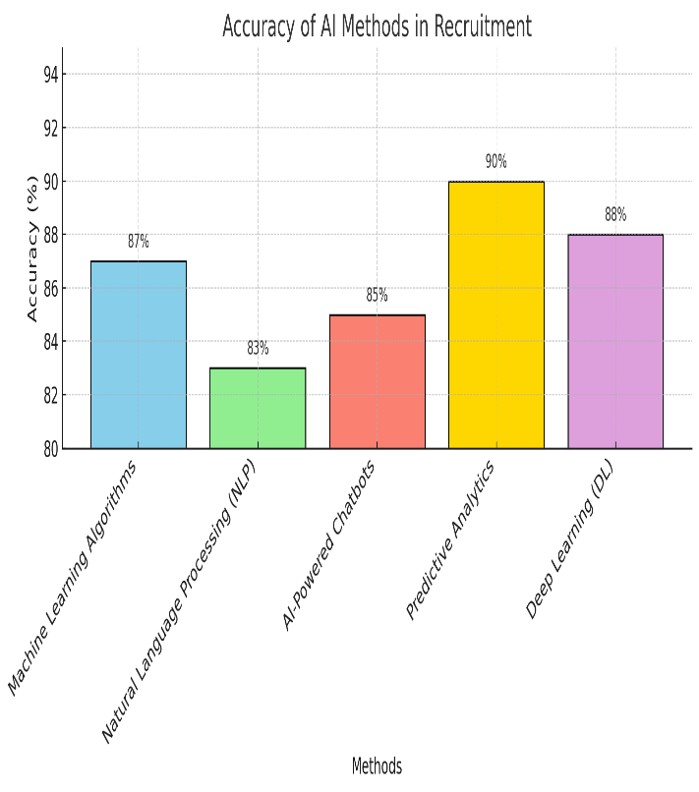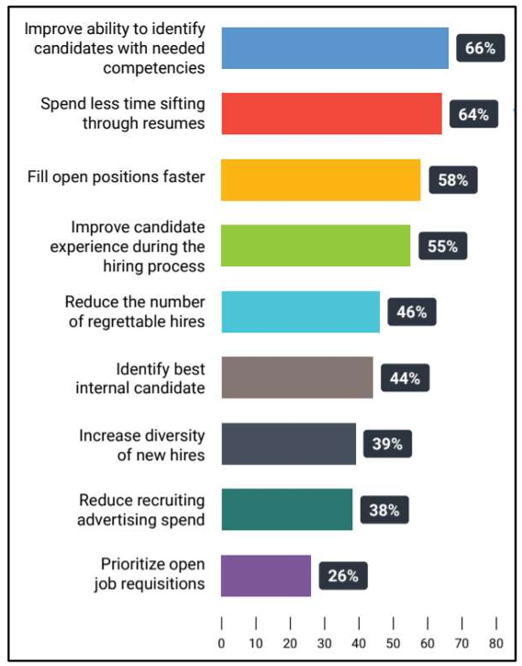

**Fig:** **Benefits of AI software in recruitment process**

**Limitations**

Based on this, summarize the current limitations of AI in a recruiting process where you would also enumerate the challenges and risks that, accordingly, will affect AI's effectiveness and ethics.

**1. Algorithmic Bias:**

Bias is one of the biggest challenges because AI models are only as objective as their training data. Models that are trained on biased data tend to amplify discriminatory patterns in hiring processes which could lead to various legal and reputational issues for the company.

Explain the challenges in debiasing AI systems and the risk of "proxy discrimination," where an apparently neutral factor (such as zip code) inadvertently correlates with sensitive attributes (for example, race or socioeconomic status).

**2. Transparency and Accountability:**

AI algorithms, at their best, can be complex and less intelligible. This leads to a "black box" problem. If candidates do not understand how the decision came about, they might be at a disadvantage. A key challenge for recruiters is explaining why the favored candidate was indeed selected over another.

Introduce the notion of requiring "explainable AI" solutions that will allow stakeholders to interpret or understand factors affecting a hiring decision for recruitment.

**3.Risk to privacy and security**

The information dealt with is quite sensitive, so the data needs to be protected. AI systems require a lot of processing and hence more exposure towards breaches or misuse.

More focus on legal constraints like GDPR, which demands to be very strict in handling data and how firms can protect candidate data while exploring the use of AI

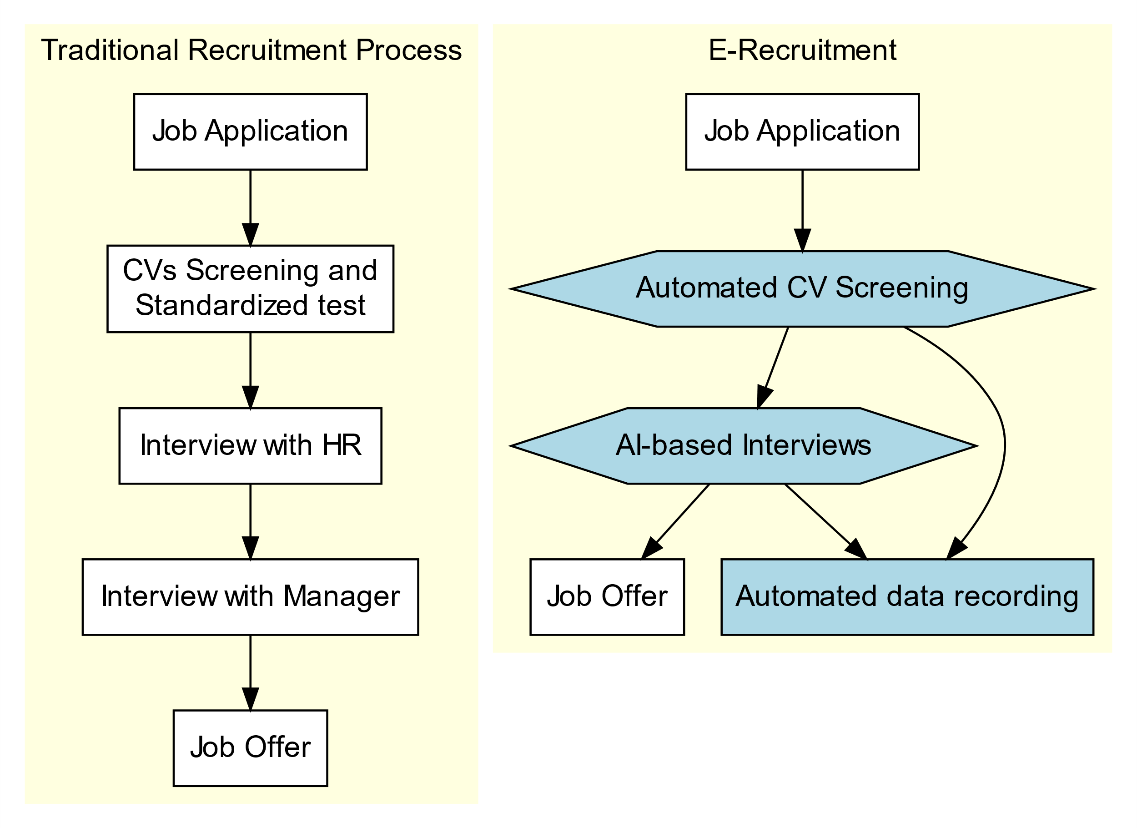

**Fig : Difference Between Traditional Recruitment Process and E-Recruitment**

**Conclusion**

The arrival of Artificial Intelligence has transformed the process of recruitment and talent acquisition significantly. The efficiency, candidate experience and hiring accuracy have shown huge improvement due to this technology. Thanks to AI, HR teams do not have to waste much of their energy doing repetitive tasks but can instead concentrate on more crucial matters like making strategic decisions and developing existing talents. However, this is a technology that has its limitations, some of which include algorithmic bias and privacy issues.

To ensure that the AI is put to the right use, organizations need to resolve these constraints by way of creating strong ethical mechanisms, training staff on a regular basis and ensuring they practice transparency. In recruitment, the best use of artificial intelligence is to enhance and not replace the human element in decision making, thus creating a win-win situation for both employers and candidates.

**References:**

**Parasa, S.K. (2024).** Impact of AI in Recruitment and Talent Acquisition. Human Resource and Leadership Journal, 9(3).

**Saad, M. F. M., Nugro, A. W. L., Baijed, M., & Thinakaran, R. (2021)**. AI-BASED RECRUITING PLATFORM IN THE RECRUITMENT PROCESS AND QUALITY OF HIRING.

**Sýkorová, Z., Hague, D., Dvouletý, O., & Procházka, D. A. (2024).** Incorporating artificial intelligence (AI) into recruitment processes: ethical considerations. Vilakshan-XIMB Journal of Management, (ahead-of-print).

**Na, S. R. (2024)**. Application of Artificial Intelligence in Recruitment and Selection. Academic Journal of Science and Technology, 9(2), 56-58.

**Amalina, D. N., Khasanah, S. N., Yuliansyah, D., & Hanoum, S. (2024)**. Literature Review of Digital Recruitment: How Effective is Artificial Intelligence in Selecting People?. Syntax Idea, 6(6), 2705-2714.

**Rathore, S. P. S. (2023)**. The Impact of AI on Recruitment and Selection Processes: Analysing the role of AI in automating and enhancing recruitment and selection procedures. International Journal for Global Academic & Scientific Research, 2(2), 51-63.

**Garg, A., Gaur, S., & Sharma, P. (2021).** A review paper: Role of artificial intelligence in recruitment process. Anwesh, 6(1).

**Mori, M., Sassetti, S., Cavaliere, V., & Bonti, M. (2024).** A systematic literature review on artificial intelligence in recruiting and selection: a matter of ethics. Personnel Review.

**Singh, S., & Kesarwani, H. (2024).** The Impact of AI on Recruitment Processes and HRM. International Journal of Novel Research and Development, 9(4), 841-843. ISSN: 2456-4184.

**Meshram, R. (2023).** The role of artificial intelligence (ai) in recruitment and selection of employees in the organisation. Russian Law Journal, 11(9S), 322-333.

**Chen, Z. (2023).** Collaboration among recruiters and artificial intelligence: removing human prejudices in employment. Cognition, Technology & Work, 25(1), 135-149.

**Hunkenschroer, A. L., & Kriebitz, A. (2023)**. Is AI recruiting (un) ethical? A human rights perspective on the use of AI for hiring. AI and Ethics, 3(1), 199-213.

.**Hmoud, B. I. F., & Várallyai, L. (2019)**. Will artificial intelligence take over human resources recruitment and selection?.

**Islam, M., Rahman, M. M., Taher, M. A., Quaosar, G. A. A., & Uddin, M. A. (2024).** Using artificial intelligence for hiring talents in a moderated mechanism. Future Business Journal, 10(1), 13.

**Zheng, F., Zhao, C., Usman, M., & Poulova, P. (2024).** From Bias to Brilliance: The Impact of Artificial Intelligence Usage on Recruitment Biases in China. IEEE Transactions on Engineering Management.