**PERSONAL EXPENSE MANAGEMENT SYSTEM**

# Dr. G. GIFTA JERITH{1},M.ADIESHWAR REDDY

**{2},M.SHIVA RAJ{3},M.HARINI{4},**

# M.DEVA HARSHINI{5},PROFESSORS MAIRAJ UNISA BEGUM{6}

*1,6 Professors, Dept. of AIML, MRUH(Deemed to be University), MRUH HYDERABAD ,2,3,4,5 Students*

*,Dept. of MRUH(Deemed to be University),TELANGANA ,HYDERABAD, India*

**Abstract:**

Expense Tracker is an everyday expense control application designed to track effortlessly and efficiently each day costs. This helps us to get rid of the need of paper responsibilities that systematically maintains information. This device can be utilized by any individual to govern their income expenditure from each day to annual basis and to hold an eye on their spending, Including the person to whom the payments were made and the purpose for the payment*.*On a weekly, monthly, and yearly basis, details of expenses will be displayed in the form of a pie chart. It aids us in remembering and adding information about what money we receive from others and what costs or payments we must make on a given date or month. We have categories in the expense tracker such as add expense, monthly expenses, add new expense, and so on. It gives the daily remainder about the savings we need to do.

**keywords—** User Account Registration, Add Income, Add Expense, Exporting Income, Daily Reminders, Budget Analysis, View Expenses, Delete a record.

## INTRODUCTION

Expense management system is a web application used to track user expenses and generates periodical reports about the savings and expenditure. In this project, we propose an application known as "Expense Tracker," which is helpful to manage our income and expense daily or periodically or else whenever we want to remind. It also acts as an indicator or reminder example in the fastest world in which we cannot remember what the things we have to do for the end of the month are and the payments we have to pay for the particular month. Due to some conflict or other stress, we sometimes forget what the income is, where the money has to come from, or the payments we have to pay.

This app will assist you in keeping track of what you need to do at the end of the month. For instance, what are the monthly expenses, and how much do they cost? Food expenses, phone, power, taxation, and other personal charges are some of the expense features.

If we are a businessman with a multi-business, we do not know from which part of the business income has come and how much income has come for us, but with the help of this application, we can divide and store all of the income and set a reminder for a specific date to remain so that we can manage and finalize the income for us.

## PROBLEM STATEMENT

It helps user to manage all their expenses in an efficient way and track budget. This would avoid

budget handling difficulties and gives us efficient results on our savings.

In everyone's life, money plays an important role. A person who cannot manage his expenses cannot successfully lead a household and fulfill his goals. In the current world where mobile phones and laptops have become a part of living, such an app would be handy to deal with all our expenses. A person generally cannot keep track of all his expenses through the traditional pen and paper method and might miss a few of his small expenditures and may even miss some bills. Such a situation will never arise when we use an app. We can make easy comparisons by seeing the graphs, which is impossible in the rigorous methods.

## LITERATURE SURVEY

1. Abhishek Dadhich, Siddhartha jain, Shreya Mathur (Author) year 2023 Title Expense Tracker Methodology

2. The methodology for the 2023 Expense Tracker Application by Abhishek Dadhich, Siddhartha Jain, Shreya Jain, and Shreya Mathur involved defining requirements through stakeholder interviews, designing the system architecture and UI, developing both front-end and back-end components, and testing the application extensively. They deployed the app, provided documentation, and iterated based on user feedback for continuous improvement.

Result: The result of the 2023 Expense Tracker Application by Abhishek Dadhich, Siddhartha Jain, Shreya Jain, and Shreya Mathur was a functional and user-friendly application that effectively tracks personal expenses, categorizes transactions, and provides financial insights

Limitations: The 2023 Expense Tracker Application has limitations including limited integration with financial institutions, potential scalability issues with growing data volumes, and possible constraints in advanced features. Additionally, it may face compatibility issues across different devices or operating systems.

1. Lavesh Lingayat, Neha Yadav, Prajwal Rathod, Pranay Durutkar(Year2024)

Title: Design and Implementation of a Real-Time Expense Tracker Using Machine Learning Algorithms (SVM and Random

Methodology: Collected user salary, historical expenses and insurance policy data.SVM and Random Forest models trained on historical data to predict future costs.Implemented a real-time system with a user interface to input data and access estimates and insurance recommendations.

Forest)

Result: SVM and Random Forest models both showed high accuracy in estimating costs with low error rates.Monitored

real-time forecasts for financial planning and suggested suitable plans for insurance recommendation tool.

LIMITATION: The accuracy of the system depends on the quality provided by the user.Focuses only on life insurance policies while limiting financial products.Real-time predictions require significantcomputational

1. Achintya Pandey,Harsha Vardhan, Ishank Verma,Sushank Pathak,Subhdeep kushwah(Author) year(2023)

Title: Xpense Tracker An Expense Tracking Using Ocr and ML

The methodology for "Xpense Tracker: An Expense Tracking Using OCR and ML" likely involves using Optical Character Recognition (OCR) to extract text from receipts or invoices, followed by applying machine learning algorithms to categorize and analyze the extracted data. The system would then track and manage expenses automatically, providing users with insights into their spending patterns through a user- friendly interface.

RESULT: A functional prototype was developed, allowing users to track, categorize, and visualize their expenses, helping them better understand their spending habits.

Limitations: The application may face challenges with accurately categorizing products not recognized by the AI, and it requires further integration with payment methods for comprehensive tracking.

## PROPOSED METHOD

In proposed system user has more number of added features to the existing features like

* Weekly Budget Planner
* Weekly and Monthly Analysis
* App Authentication
* Pictorial representation of Expense

Weekly Budget Planner to track their expenses. Automated message Alert is generated when they cross their budget. UPI linkup to track their online transactions. Weekly and Monthly Analysis are generated in the form of pie chart. App Authentication for security of the user. Income, Expenses, and Wish List are the three data entry choices available to the user.

1. 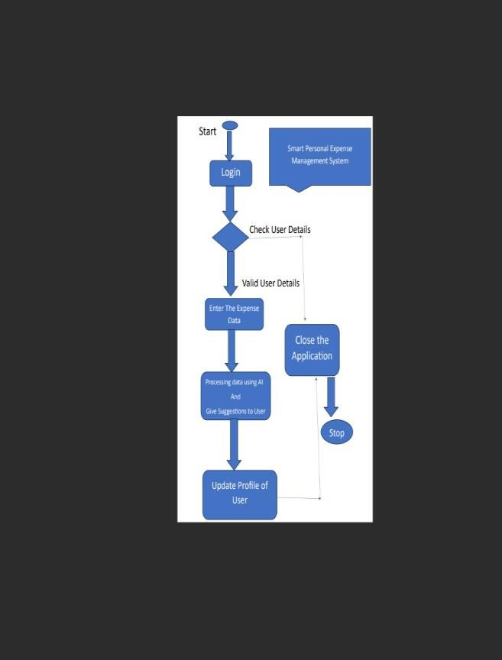**ARCHITECTURE**

## SCOPE OF THE PROJECT

The objective of this app is to act as a remainder to help user track their budget. Through this online application students, small business and family members and individual will be benefited the most in today's fast-paced environment. Many people today are looking for efficient ways to track their expenses because we live in a hurry-up and get-it-done culture. Some research on household budgets has been conducted in recent years which says Budget tracking is challenging in most circumstances since budget management is done verbally rather than on paper..

It will contain a variety of record-keeping choices (for example, food, travel fuel, salary, and so on).

It will continue to deliver notifications on its ownto cover our daily expenses.

We are in a great hurry to make money in today's hectic andexpensive world, but we broke off at the end of the monthas we spend money on titles and things we do not need. Asa result, we have devised a strategy for pursuing our profit. The app allows us to clearly understand our expenses tokeep track of our earnings and better plan for the nextcoming month

## CONCLUSION

Daily spending tracking can not only help you save money, but it can also help you set financial objectives for the future. If you know exactly where your money goes each month, you can quickly see where you can make some savings and compromises. We have designed a project that is more efficient than other income and expense trackers. The project succeeds in avoiding manual calculations for estimating monthly revenue and expenses. The modules have been designed to be both efficient and appealing.

1. **REFERENCE**

## "Personal Finance Management Systems: A Systematic Review" (2020) - International Journal of Advanced Computer Science and Applications.

* 1. **"Expense Tracking and Budgeting Systems: A Survey" (2019) - Journal of Financial Technology.**

## "Machine Learning in Personal Finance: A Review" (2020) - Journal of Artificial Intelligence Research.

* 1. **"Secure Data Storage in Cloud-based Personal Finance Systems" (2019) - International Journal of Cloud Computing.**

## "User-Centric Design for Personal Finance Systems" (2018) - Journal of Human-Computer Interaction.

**Additional**

## Meta AI: Here's a potential conclusion, future scope, and references for a Smart Personal Expense Management System project: