MONITORING AND CONTROLLING

OF TEMPERATURE IN POULTRY FARMS

# P. Prakash1, Rathish S2, Mohammedshah K3, Mohan raj S4, Sabareeswaran V5

## 1Assistant Professor, EEE, P. A. College of Engineering and Technology, Pollachi, Coimbatore, Tamilnadu, India.

2,3,4,5UG student, EEE, P. A. College of Engineering and Technology, Pollachi, Coimbatore, Tamilnadu, India.

# ABSTRACT

Effective temperature regulation is a critical factor in maintaining optimal conditions for poultry farming, as it directly influences bird health, growth, and overall productivity. This project presents a system for monitoring and controlling temperature in poultry farms using automated heater control and cooling motor control. The system employs temperature sensors strategically placed within poultry enclosures to continuously monitor ambient temperature. Based on the real-time temperature data, a feedback loop is established to adjust the operation of heating and cooling mechanisms. When the temperature drops below a predefined threshold, the heating system is activated to ensure warmth, while if the temperature exceeds an upper limit, cooling motors are triggered to lower the temperature. The system utilizes a microcontroller-based control unit to process sensor data and drive the heating and cooling equipment. Manual temperature adjustments are often slow, imprecise, and energy-inefficient, exacerbating operational costs and contributing to poor farm management practices. The system minimizes the need for human intervention, providing consistent environmental conditions that support poultry welfare and reduce stress, and improve the overall productivity of the chicken poultry farm.

# INTRODUCTION

Temperature control is one of the most critical aspects of poultry farming, as it directly impacts the health, growth rate, and productivity of the birds. Maintaining an optimal thermal environment is essential for the comfort and well-being of poultry, particularly in large-scale operations where fluctuating weather conditions and inefficient temperature management can lead to significant losses. This paper presents a system for monitoring and controlling the temperature in poultry farms through automated heating and cooling mechanisms. Temperature regulation is one of the most crucial aspects of poultry farming. The need for effective temperature monitoring and control in poultry farms arises from several factors that directly impact the health, and overall well-being of the birds, as well as the efficiency of farm operations.

# LITERATURE SURVEY

### [1]. Mr. Pratik Landge., Ms. Gloria Kiplinger., Ms. Vaishnavi Sakhare., Prof. Omprakash Rajankar., Prof. Bhausaheb Shinde. (2024) “Smart Poultry Farm Automation”, (IJARSCT).

Our case-study paper entitled "Smart Poultry Farm Automation" aims to enhance the efficiency and productivity of poultry farming through the application of advanced automation technologies. Poultry farming plays a crucial role in meeting the growing global demand for poultry products. However, traditional farming methods often face challenges related to labor intensity, resource management, and monitoring. This project proposes the design and implementation of a comprehensive automation system for poultry farms. The system will integrate sensors, actuators, and IoT (Internet of Things) technologies to automate various tasks such as environmental control, feeding, watering, and health monitoring of poultry. Real-time data collection and analysis will enable farmers to optimize farm conditions, improve bird health, and minimize resource wastage. Key components of the proposed system include environmental sensors for monitoring temperature, humidity, and ventilation; automated feeders and waterers controlled by IoT devices; and health monitoring systems utilizing image processing or sensor data for early disease detection. The expected outcomes of this project include increased productivity, reduced operational costs, improved animal welfare, and better decision-making for farmers. By leveraging automation and IoT technologies, the proposed system will contribute to the modernization and sustainability of poultry farming practices.

### [2]. Dr. Suma, Ashwin, S., Chitty Babu, S., Deepak, R., Kushal, GS. (2023) “Automation of Poultry Farm”, International Journal of Advanced Research in Science, Communication and Technology (IJARSCT).

The automation of poultry farming has become increasingly popular in recent years due to its potential to increase efficiency, reduce labor costs, and improve animal welfare. This paper aims to provide an abstract that summarizes the benefits and challenges associated with the automation of poultry farms. The paper begins by defining automation and providing an overview of the technologies that are commonly used in poultry farming, such as sensors, robots, and artificial intelligence. The benefits of automation are discussed, including increased productivity, reduced labor costs, improved animal welfare, and enhanced data collection and analysis. Additionally, the difficulties brought on by automation are looked at, including the initial investment costs, technical difficulties, and the need for skilled personnel to operate and maintain the systems. The paper concludes that while automation can bring significant benefits to poultry farming, careful planning and implementation are necessary to ensure its success.

### [3]. Satyabrata Mishra, Abhisek Bera, Jayanta Kumar Behera Jyostnamayee Behera. (2022 ) “WEATHER MONITORING SYSTEM”, UGC Care Group I Journal.

We propose an IoT and cloud-based Weather Monitoring System here that aims, building a system to detect, record, and display different weather data like temperature, humidity, pressure and rain. This system employs sensors to detect and monitor meteorological factors, after which the collected data is transferred to Arduino cloud that can be accessed over the internet. It is possible to examine and report the data displayed as an output on a dashboard. A NodeMCU board, sensors, and an inbuilt esp8266 module are used in the system, which feeds data to Arduino cloud platform. In addition, a dashboard is constructed that presents the data to users.

### [4]. Puja Sharma and Shiva Prakash. (2021) “Real Time Weather Monitoring System Using Iot”, ITM Web of Conferences 40, 01006.

In Today’s World, knowing live environmental condition is one of the biggest issues because there is an IoT of hurdles arrives when live environmental condition is measured. The proposed system will remove this problem since it monitors real-time weather conditions. In this proposed work we will monitor the live weather’s parameter of the Gorakhpur Region. The proposed system will work on the client-server architecture model using IoT. The system is organized in Two-tier Architecture. Our proposed system contains a various sensor which will monitor the temperature of the region, humidity, Rain value and pressure of the system. The sensor captured data and send it to the node MCU controller. Arduino ide is used to upload the sensed data. The serial monitor has worked as a gateway between the sensor and the cloud. The data is pushed by the sensor on a serial monitor. The serial monitors an IP address. Using a webserver, everyone can monitor the weather’s condition from anywhere without depending on any application or website. The data is available publicly. With the help of this proposed system, we measure the weather condition of the Gorakhpur Region. After getting results from the various sensor, it is observed that our proposed model achieves better results in comparison with the standard weather parameter.

# METHODOLOGY

Existing methodologies for monitoring and controlling temperature in poultry farms typically involve basic manual systems or simple thermostatic controls, where temperature is monitored using standalone sensors and adjustments to heating or cooling are made manually or through basic mechanical systems. Many farms rely on traditional ventilation and heating systems, which can result in uneven temperature distribution across large enclosures, leading to inefficiencies and increased energy consumption. While some advanced farms have adopted digital systems with remote monitoring capabilities, most solutions still fall short in providing a comprehensive, automated feedback loop that ensures constant optimization of the poultry environment. The proposed methodology for monitoring and controlling temperature in poultry farms utilizes an ESP8266 microcontroller connected to DHT11 temperature and humidity sensors, raindrop sensors, and an LCD display. The DHT11 sensors continuously measure the temperature and humidity inside the poultry house, while the raindrop sensors monitor external weather conditions, such as rain, to adjust the internal climate accordingly. The ESP8266 processes this data and controls the heaters and cooling to maintain an optimal temperature for the poultry, turning on the heater when it’s too cold or activating the cooling motor when the temperature rises above the threshold. The LCD display provides a real-time readout of the current temperature, humidity, and system status, allowing operators to easily monitor the environment directly at the farm. This automated, energy-efficient system adjusts the heating and cooling based on real-time data, ensuring optimal conditions for poultry health and reducing energy consumption and operational costs.



**LCD Display**

**ESP**

**8266**

**Heater and cooling motor Control**

**Power Supply (+5V)**

**Rain deduction Sensor**

**Temperature & Humidity Sensor (DHT11)**

**Figure 1:** Block Diagram of Proposed System.

DHT11 Sensor: Measures temperature and humidity inside the poultry house and sends this data to the ESP8266. Raindrop Sensor: Detects external weather conditions (e.g., rain) and informs the ESP8266 for adjusting the cooling motor or ventilation system accordingly. ESP8266 MCU (Microcontroller): Central processing unit that receives data from the sensors and controls the heater and cooling motor based on predefined thresholds for temperature and humidity. It also updates the LCD display. Heater: Activated when the temperature is too low inside the poultry house (below the set threshold). Cooling Motor: Activated when the temperature is too high (e.g., 33°C), or if external environmental conditions (like high humidity or rain) suggest a need for better ventilation. LCD Display: The LCD display shows real-time data such as the current temperature, humidity, and external weather conditions (via the raindrop sensor). It is updated continuously by the ESP8266 to provide the farm operator with immediate feedback.

# CIRCUIT DIAGRAM

The circuit diagram for monitoring and controlling temperature in poultry farms using an ESP8266 (NodeMCU) integrates several key components for environmental control and data display.

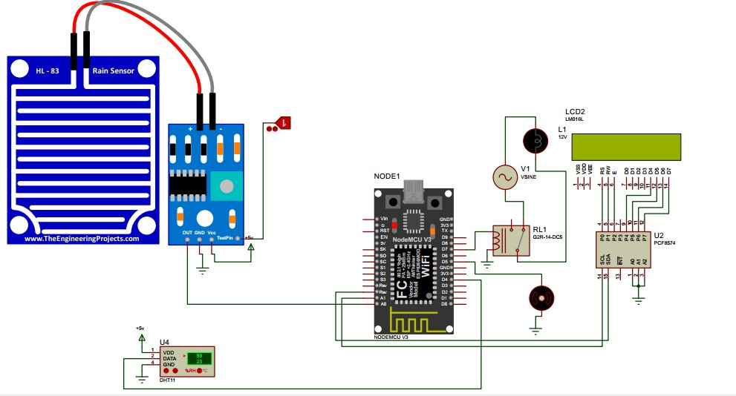

**Figure 2:** Circuit Diagram of Proposed System

**HARDWARE**

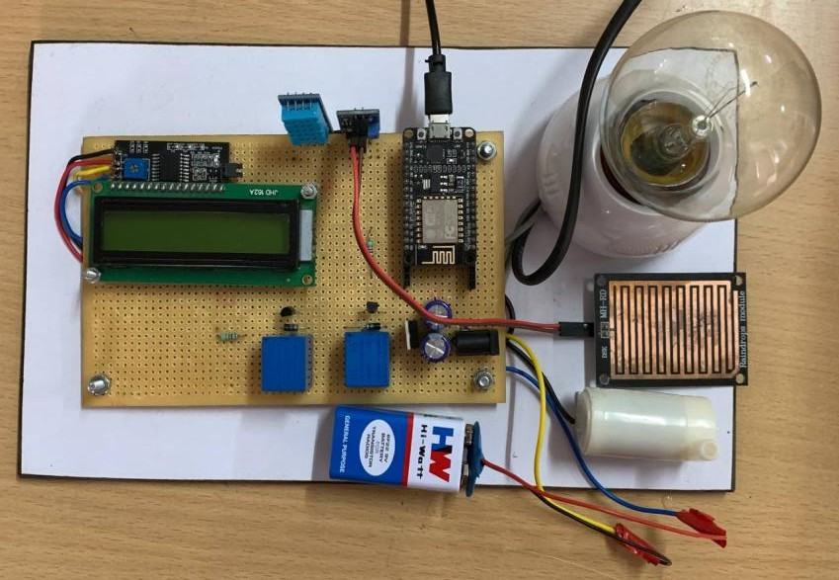

# CONCLUSION

**Figure 3:** Hardware

In conclusion, the poultry farm temperature monitoring and controlling system using ESP8266, DHT11, Raindrop sensor, and an LCD display offers an effective, low-cost solution for maintaining optimal environmental conditions in poultry farms. By continuously monitoring temperature, humidity, and external weather conditions, the system enables real-time adjustments to heating, cooling, and ventilation systems, ensuring the health and productivity of the poultry. The LCD display provides immediate feedback, while the ESP8266 allows for automation and potential remote monitoring, enhancing efficiency, reducing energy consumption, and minimizing human intervention. Overall, this system improves farm management, promotes better poultry welfare, and contributes to increased operational efficiency.

# REFERENCES

1. Dr. Suma, Ashwin, S., Chitty Babu, S., Deepak, R., Kushal, GS. (2023) ‘Automation of Poultry Farm’, International Journal of Advanced Research in Science, Communication and Technology (IJARSCT).
2. Puja Sharma and Shiva Prakash. (2021) ‘Real Time Weather Monitoring System Using IoT’, ITM Web of Conferences 40, 01006.
3. Mr. Pratik Landge., Ms. Gloria Kiplinger., Ms. Vaishnavi Sakhare., Prof. Omprakash Rajankar., Prof. Bhausaheb Shinde. (2024) ‘Smart Poultry Farm Automation’, (IJARSCT).
4. Satyabrata Mishra, Abhisek Bera, Jayanta Kumar Behera Jyostnamayee Behera. (2022) ‘WEATHER MONITORING SYSTEM’, UGC Care Group I Journal.
5. Rao, B., Rao, K., & Ome, N. (2016) ‘Internet of Things (IoT) based weather monitoring system’, international journal of advanced research in computer and communication engineering, 5(9), 312-319.