**SMART REAL ESTATE ADVISOR**

|  |  |  |
| --- | --- | --- |
| C.Nikhila  B.*Tech*  *School of Engineering*  Computer Science – AI&ML  Malla Reddy University, India. | C.Aditya  *B. Tech*  *School of Engineering*  Computer Science – AI&ML  Malla Reddy University, India. | C.Tharangini  *B. Tech*  *School of Engineering*  Computer Science – AI&ML  Malla Reddy University, India. |
| D.Allabakash  *B. Tech*  *School of Engineering*  Computer Science – AI&ML  Malla Reddy University, India. | D.Santhan  *B. Tech*  *School of Engineering*  Computer Science – AI&ML  Malla Reddy University, India.  Guide: Prof.Malleswar Rao  *Asst Professor*  *School of Engineering*  Computer Science – AI&ML  Malla Reddy University, India. |  |

***Abstract:***

Combines AI with real estate market analysis to provide personalized property recommendations.

Aims to simplify the property search process for buyers, renters, and investors.Offers real-time market data and predictive trends for smarter decision-making.

Integrates user preferences to deliver highly customized results, also it features an intuitive and user-friendly interface for seamless navigation.

Supports multiple property types including residential, commercial, and investment options.

Provides virtual tours and augmented reality features for immersive property viewing.

Includes a built-in communication platform for direct contact with agents or property managers.

***I. INTRODUCTION***

The real estate market is overwhelming with information overload and complex data.

Difficulty in finding accurate, up-to-date listings and property valuations is increasing a lot so our app "Smart Real-Estate Advisor" reduces this difficulty by providing the users with right and accurate data.

Buyers and renters often spend too much time sifting through irrelevant options which will now be given a break as we provide them with perfect and suitable options.

Personalized insights tailored to specific buyer needs and preferences.

High dependence on real estate agents for decision-making, will be trustworthy in our app.

Market research and property investment analysis are time-consuming and complicated, so we provide the users with best and trustworthy details of the properties that they can trust without any doubt.

***II. REQUIRED TOOLS***

***a) Software Requirements***

Introduction & Purpose: The virtual assistant aims to improve user convenience by handling tasks like setting reminders, answering queries, and managing smart devices, fitting seamlessly into everyday life.

Functional Requirements: Key features include accurate voice recognition, natural language processing for understanding user intent, and integration with third-party services for enhanced functionality.

1. Non-Functional Requirements: Focus on performance (fast response times), security (robust data protection), and usability (intuitive design) to ensure a positive user exp

Front end : React JS

Back end : python

Operating system : Windows 10

IDE : VS code

***b) Hardware Requirements***

Processor : intel CORE i5

RAM : 8GB

Hard disk : 150 gb

III. MODULES

***a) Natural Language Processing (NLP) Libraries:***

A comprehensive library for NLP tasks, including tokenization, stemming, lemmatization, and sentiment analysis.

1. ***Machine Learning Libraries:***

PyTorch: Another widely used deep learning library that provides flexible tools for sentiment analysis, including building and training neural networks.

Keras: A high-level neural networks API that runs on top of TensorFlow, simplifying the process of building and training sentiment analysis models.

1. ***Data Processing and Analysis:***

pandas: A powerful library for data manipulation and analysis, often used for preprocessing and organizing data for sentiment analysis.

NumPy: A fundamental library for numerical computing, useful for handling arrays and performing mathematical operations

IV. ARCHITECTURE

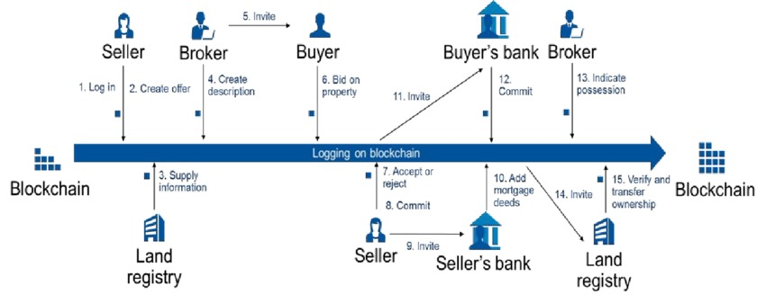

1. Seller and Buyer Login: Both the seller and buyer need to log into the system, either through a website or a mobile app. This could involve verifying their identities using biometric or other secure authentication methods.

2. Seller Creates Offer: The seller initiates the process by creating an offer for their property, specifying details like price, terms, and any conditions.

3. Broker Adds Property Description: A real estate broker or agent may be involved in adding a detailed description of the property to the system, including information about its location, size, features, etc.

4. Buyer Bids on Property: The buyer can view the property details and make a bid for the property. This bid is recorded on the blockchain.

5. Logging on Blockchain: The offer and bid information, along with other relevant details, are recorded on the blockchain. This creates a permanent and transparent record of the transaction.

6. Buyer's Bank Commits: The buyer's bank commits to the transaction, ensuring that the funds are available for the purchase.

7. Accept or Reject: The seller can either accept or reject the buyer's bid. If accepted, the transaction proceeds to the next step.

8. Seller Commits: The seller commits to the sale, indicating that they agree to the terms of the transaction.

9. Seller Invites Seller's Bank: The seller invites their bank to participate in the transaction, ensuring that the funds from the sale are transferred to their account.

10. Add Mortgage Deeds: If the buyer is taking a mortgage, the mortgage deeds are added to the blockchain, ensuring that the lender's interest in the property is recorded.

11. Buyer Invites Buyer's Bank: The buyer invites their bank to participate in the transaction, ensuring that the funds are transferred to the seller's bank.

12. Commit: The buyer's bank commits to the transaction, ensuring that the funds are transferred to the seller's bank.

13. Indicate Possession: Once the funds are transferred and the transaction is complete, the possession of the property is transferred to the buyer. This is also recorded on the blockchain.

14. Seller Invites Land Registry: The seller invites the land registry to update the ownership records.

15. Verify and Transfer Ownership: The land registry verifies the transaction and updates the ownership records on the blockchain, reflecting the transfer of ownership from the seller to the buyer.

* 1. **RESULTS**

This Smart Real-Estate Advisor is mainly used for throwing a perfect view on lands or properties which the buyer is searching for. It filters the lands and properties according to the needs that the buyer has mentioned and shows them the accurate properties at the reasonable price and best locations. It also helps the buyers to get an eye on history or value of that land or property so that they have a brief idea on that land.

* 1. **CONCLUSION**

In the end we want to conclude that Smart Real-Estate Advisor - Using AI aims to expand its capabilities by incorporating even more advanced technologies. Integrating blockchain for secure property transactions and smart contracts could streamline the buying process, providing greater transparency and trust between parties. Additionally, AI-powered virtual assistants could be developed to offer real-time consultations, answering user queries and guiding them through every step of their real estate journey.

**ACKNOWLEDGMENT**

My Major project would not have been successful without the help of several people. I would like to thank the personalities who were part pf my major project in numerous ways, those who gave us outstanding support from the beginning of the project. I am extremely thankful to our honorable pro-vice chancellor,VSK Reddy sir for providing necessary infrastructure and resources for the accomplishments of my project . I highly indebted to Prof.Kailasa Rao sir Dean, School Of

Engineering,for his support during the tenure of the project. I am very much obliged to our beloved Prof.Thayyaba Khatoon, Head od the Department of Artificial Intelligence & Machine Learning for providing the opportunity to undertake this project and encouragement in completion of this project . I here by wish to express our deep sense of gratitude to Prof.Balaiah for the esteemed guidance , moral support and invaluable advice provided by them for the success of the project .

***REFERENCES***

* 1)Emile , L. (2018).29 Best Real Estate Software & Tools for Top Agents in 2018., Available:https://fitsmallbusiness.com/best-real-estate-software/. (Accessed: 28th June 2018)

.

* 2) Williams , E. Best Apps for Real Estate Agents and Agencies. Retrieved june 26, 2018, [Online]. Available:https://pdf.wondershare.com/business/apps-for-real-estate-agents.html. (Accessed: 28th June 2018)