**Green staining: natural dye extraction and application for cytogenetic research**

**Sagari Gowda L.1, Anjali V.1, Amrutha R.A.1 , Rama T.\***

1 Student, Department of Biotechnology, Nrupathunga University, Bengaluru, Karnataka, India

* Associate Professor, Department of Biotechnology, Nrupathunga University, Bengaluru, Karnataka, India

**ABSTRACT**

The use of synthetic dyes in chromosomal staining poses environmental and health hazards, prompting a search for natural alternatives. This study explores the potential of green staining using natural dyes extracted from plant for cytogenetic applications. The study investigated the extraction and characterization of a natural dye from *Phyllanthus reticulatus* and its effectiveness in staining chromosomes in various cytogenetic studies, including mitosis, meiosis, and polytene chromosomes. Phytochemical screening of the *Phyllanthus reticulatus* extract revealed a rich composition of bioactive compounds, including anthocyanins and tannins, which are known to exhibit staining properties and mordant activity respectively, contributing to the natural dye's efficacy in chromosomal staining. The results show that the natural dye successfully stained chromosomes in various cells, offering a safer alternative to synthetic dyes like saffranin, aceto-carmine, aceto-orcein, and lacto-aceto-orcein. This finding has significant implications for reducing the environmental impact and health risks associated with synthetic dyes in cytogenetic research, particularly in studies of cell division and chromosome structure.

**Keywords:** Natural dye, Synthetic dye, Green staining, *Phyllanthus reticulatus*, Chromosome staining, Anthocyanin, Aceto-orcein, Lacto-aceto-orcein.

1. **INTRODUCTION**

The growing concern for environmental protection and the harmful effects of synthetic dyes have driven the scientific community to explore natural dyes as a safer and more eco-friendly alternative. Synthetic dyes pose a number of health and environmental risks and are extensively used in a number of industries, such as scientific research, food, and textiles. Since these dyes are not biodegradable, they contribute to environmental pollution in addition to being linked to a possible cancer risk [1].

India, with its rich biodiversity, particularly in plants, offers abundant sources for natural dye extraction. Natural dyes have a long history that dates back to ancient civilizations. For centuries, people have utilized natural dyes that are derived from different plant parts, including leaves, roots, seeds, flowers, and bark [2]. The molecules that give plants their color, called chromophores, are the source of these dyes. The vivid colors and more eco - friendly manufacturing processes made them valuable to ancient civilizations [3],[4] .This study focuses on extracting natural dyes from the fruits of *Phyllanthus reticulatus* (Black honey shrub) for chromosomal staining, aiming to develop an effective and sustainable alternative to synthetic dyes used in cytogenetic studies.

Our research has led to the successful extraction of a natural dye from *Phyllanthus reticulatus* fruits, which has demonstrated efficacy as a chromosomal stain in various cytogenetic studies. Notably, this novel stain has been shown to effectively replace synthetic stains such as safranin, aceto-carmine, aceto-orcein, and lacto-aceto-orcein in histological, mitotic, meiotic, and giant polytene chromosome studies, respectively. The extracted dye has exhibited comparable staining efficiency and contrast, enabling clear visualization of chromosomal structures and cellular processes in onion epithelial cells, root tips, flower buds, *Drosophila melanogaster* salivary gland cells and human chromosomes. This development emphasizes how natural dyes have the potential to displace synthetic dyes in scientific research, fostering sustainability and mitigating negative effects.

1. **METHODOLOGY**
   1. **Extraction of natural dye from *P. reticulatus***

The fruits of *P. reticulatus* were collected from Dhoddamudigere, Karnataka. The plant material was taxonomically identified and authenticated by Central Ayurvedic Research Institute, Bengaluru (Authentication/ SMPU/ CARI/ BNG/ 2023-24/ 353). The collected fruits were gently washed with tap water and single distilled water to remove impurities. 1g of fruits were crushed with 10 mL of different solvents (Acetone, Distilled water, Ethanol, Methanol, 45% Acetic acid) in pestle and mortar separately [5]. The extract was centrifuged at 5000 rpm for 5 minutes at 4°C to remove cellular debris. The supernatant was collected in microfuges and stored in refrigerator (4° C) for further usage [6], the duplicate of the extracted sample was taken and one of them was subjected to solvent evaporation using dry bath heater to concentrate the plant extract.

* 1. **Standardisation of the extracted natural dye from *P. reticulatus* to stain chromosomes**

The dye extracts sometimes may contain mixtures of compounds with minor differences in their constitution. Because of this, they may not exhibit significant difference in polarity, acidity etc. [7]. In this study, extracts are chemically modified by acidification using glacial acetic acid [8], 2N hydrochloric acid [9] and alkylation by 0.1M sodium hydroxide

**2.2.1: Standardisation protocol for the dye extracted from *P. reticulatus* using methanol as solvent**

20µL of extract was added with 30µL of glacial acetic acid.

20µL of extract was added with 5µL of 2N hydrochloric acid.

20µL of extract was added with 5µL of 0.1M sodium hydroxide.

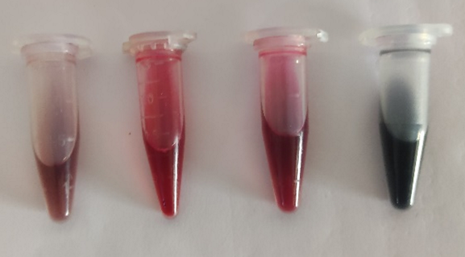

**A B C D**

Figure 1: A. Plant extract; B. Plant extract + 2N HCl; C. Plant extract + glacial acetic acid; D. Plant extract +0.1M NaOH

* 1. **Phytochemical screening of extracted natural dye**

Methanol extracted dye (concentrated and non-concentrated) samples were used for different phytochemical tests with the help of different reagents to detect phytochemical groups present in the samples. Nature is a unique source of structures with high phytochemical diversity, comprising major groups of phytochemicals such as phenolics (45%), terpenoids and steroids (27%) and alkaloids (18%) [9]. In this study, test for alkaloids, steroids and triterpenoids, phenolic compounds, flavonoids, tannins, saponins, phlobatannins, proteins, amino acids, reducing sugars [9], quinones [10], anthocyanins [11] and cardiac glycosides[12] were performed.

* 1. **Analysis of metabolites, concentration and chemical properties of extracted dye using UV-visible spectroscopy**

Generally, anthocyanins are the coloured pigments in the natural dye which absorb photons in the series of UV-visible-IR region. The absorbance spectrum of the *P. reticulatus* dye was measured using UV-visible range of spectrum (510 and 520nm) [13]. The absorbance was taken for each 100-300µL for plant dye extracted using methanol as a solvent. The absorbance for 3 forms of standardized dyes namely, plant extract + 2N hydrochloric acid, plant extract + glacial acetic acid and plant extract + 0.1M sodium hydroxide was taken for each 20 – 100 µL. [Steps mentioned in the standardization of dye were followed]

* 1. **Chromosomal staining using extracted natural dye**

**Preparation of *P. reticulatus* dye**

In 3 microfuges 500µL of plant extract was taken. To these tubes 250µL of glacial acetic acid, 150µL of 2N hydrochloric acid and 150µL of 0.1M sodium hydroxide were added separately to first, second and third tube respectively. These prepared stains were used for further experimental staining.

**2.5.1. Histological staining of *Allium cepa* peel**

The histological staining of onion peel sections was performed according to the protocol of Bhakta [14]. Thin sections of Allium cepa inner peels were mounted on clean glass slides. The sections were stained with the extracted P. reticulatus dye for 30 minutes, followed by rinsing with single distilled water to remove excess stain. The slides were subsequently examined under a light microscope at 10X and 40X magnification [15].

**2.5.2. Mitosis study on *Allium cepa* root tips**

**2.5.2.1: Preparation of *Allium cepa* root tips**

The locally available Allium cepa specimens were cultivated in the laboratory setting, and after 7 days of growth, root tips measuring approximately 2cm were excised and fixed in a 3:1 solution of absolute alcohol and glacial acetic acid (Cornoy’s fluid) for a duration of 48 hours. Subsequently the samples were rinsed with distilled water 2-3 times to remove excess fixative [8] and then transferred to a 70% methanol solution for storage.

**2.5.2.2: Preparation of chromosomal slide of root tips**

The root tips underwent hydrolysis in 2N hydrochloric acid at 60°C for 4-5 minutes to break the cell wall. This process enabled the subsequent staining of the chromosomes. The hydrolyzed root tips were then subjected to staining with various natural dye samples, obtained through different treatments, as well as the synthetic dye aceto-orcein [16]. Metaphase chromosomes were prepared using the squash technique [17], [18]. The stained slides were examined under a light microscope, allowing for a comparative analysis of the chromosome staining efficacy between the natural dye and aceto-orcein.

**2.5.3: Meiosis study using *Allium cepa* flower buds**

**2.5.3.1: Preparation of *Allium cepa* flower buds**

*Allium cepa* flower buds of varying sizes were obtained from the inflorescence purchased at K.R. Market, Bengaluru. The buds were subsequently fixed in Cornoy's fluid for a duration of 24 hours, followed by rinsing with distilled water 2-3 times to remove excess fixative. The samples were then transferred to a 70% methanol solution for storage and further processing.

**2.5.3.2: Preparation of slide**

A preserved flower bud was selected and mounted on a clean glass slide. The anthers were carefully isolated and the remaining bud structures were discarded. The anthers were then stained with the extracted natural dye and allowed to incubate for 1 hour 30 minutes. Subsequently, all stages were examined under a light microscope. The chromosome staining efficacy of the natural dye extract was compared to that of the synthetic dye aceto-orcein, enabling an evaluation of their relative staining abilities [16].

**2.5.4: Staining of salivary gland chromosomes of *Drosophila melanogaster***

**2.5.4.1: Culturing of *Drosophila melanogaster***

By using banana and curd medium *Drosophila melanogaster* larvae were cultured for a period of 4-5 days.

**2.5.4.2: Preparation of slide**

Third-instar larvae were selected from the culture, and their salivary glands were dissected on a clean glass slide with a few drops of 0.67% saline solution. The dissected glands were subsequently treated with 1N hydrochloric acid for a duration of 1 minute. The extracted natural dye was then added, and was allowed to incubate for 30 minutes to facilitate staining. The polytene chromosomes were then observed under a light microscope [16]. The chromosome staining efficacy of the natural dye extract was compared to that of the synthetic dye lacto-aceto-orcein, enabling an evaluation of their relative staining abilities.

**2.5.5: Staining of human chromosomes**

A karyotype was prepared according to Chattopadhyay [19], as modified by Hliscs [20]. A sample of peripheral blood (5 ml) is drawn and coagulation was prevented by the addition of sodium heparin. Mononuclear cells (lymphocytes and monocytes) were purified from the blood by centrifugation at low speed (4000 x g) which allow mononuclear cells only to remain in the supernatant. The mononuclear cells were cultured for 72 hours in the presence of mitogen such as phytohemaggultinin (PHA) which stimulates the lymphocytes to proliferate[21],[22]. At the end of the incubation period, the culture was treated with colchicine for 40 minutes which disrupts mitotic spindles and prevents completion of mitosis [23]. This greatly enriches the population of metaphase cells. The cells then resuspended in 0.075M KCl hypotonic buffer for 15 minutes at room temperature. This makes the nuclei swell osmotically and greatly aids in getting preparations in which chromosomes do not lie on top of each other [24], [25], [26]. A small volume 3:1 methanol: acetic acid fixative was added to the cell suspension and three more fixative washes were subsequently performed. Cell pellet(s) were stored at -20ºC in a fixative. To the stored cell pellet plant extract with glacial acetic acid was added and kept for 30 minutes, later it was centrifuged. A drop of centrifuged stained cell suspension was taken on a clean glass slide, fixed and observed under microscope with 40X magnification.

1. **RESULTS AND DISCUSSION**

Natural dyes offer a safe and cost-effective alternative to synthetic dyes, as they can be extracted from natural sources without the need for complex synthesis techniques [5]. In this study, Phyllanthus reticulatus dye was extracted by variations in the type of solvent treatment like acetone, distilled water, ethanol, methanol and 45% glacial acetic acid. Use of different types of solvents aims to compare and evaluate the ability of the solvents to extract the majority of bioactive phytochemicals from plant sample.

Phytochemical analysis of both non-concentrated and 50% concentrated methanol extracts revealed a diverse array of secondary metabolites. These included alkaloids, steroids, triterpenoids, phenolic compounds, flavonoids, tannins, saponins, phlobatannins, anthocyanins, cardiac glycosides, reducing sugars, proteins, amino acids, and quinones (Table 1). The methanol extract showed a higher concentration of phytochemicals compared to extracts using other solvents, aligning with previous findings that methanol and ethanol are effective at extracting phenolic compounds from plant seeds (fruit) [6]. These findings corroborate the potential of methanol as a solvent for extracting major bioactive phytochemicals. Phytochemical analysis is crucial and provides a foundation for targeted isolation. Multiple tests are recommended to confirm the presence of specific phytochemicals [9]

Table 1: Results of phytochemical screening

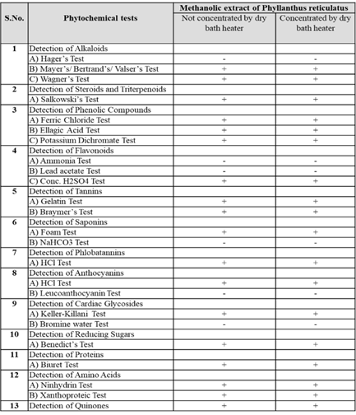

The absorption spectrum of the dye confirmed the absorption of photon in the range of 510 - 520nm [13] confirming the presence of anthocyanin, which has been shown to have immunoprotective properties against viral infection [11]. The effectiveness of plant-derived dyes is contingent upon various parameters like pH and solvent composition [8]. The results demonstrate a pronounced impact of pH alterations on anthocyanin content. After making the plant dye slightly acidic by 2N hydrochloric acid, glacial acetic acid and basic by 0.1M sodium hydroxide, the absorbance shifted from 510-520nm indicating the increased anthocyanin content. Specifically, acidification of the plant extract with 2N hydrochloric acid yielded the highest anthocyanin content, in contrast with the addition of glacial acetic acid, 0.1M sodium hydroxide, and the plant extract alone (Figure 2).

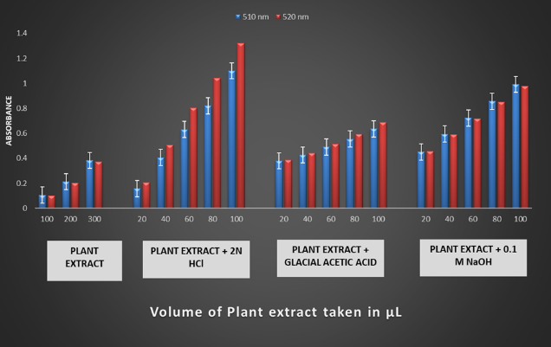

Figure 2: Results of anthocyanin content estimated at 510-520 nm using UV spectroscopy

Cytogenetic research heavily relies on the development of biological stains and advancements in microscopic technology [8]. Histological staining techniques have enabled cytologists to visualize specific organelles within cells, facilitating a deeper understanding of cellular constituents [27].The binding of dyes to tissues is governed by non-ionic interactions, leading to an equilibrium between the dye and the tissue [28]. Synthetic nuclear stains, such as ethyl violet and giemsa, are known to interact with DNA [29]. A study on histological staining of *Allium cepa* epithelial cells using *P. reticulatus* dye extracted from various solvents revealed that the nucleus was stained in all samples except for the acetone-extracted samples, both concentrated and non-concentrated [15]. Notably, the methanolic extracts which were standardized using 2N hydrochloric acid and glacial acetic acid yielded the best results (Figures 3B). This suggests that the choice of solvent plays a crucial role in the efficacy of histological staining, with methanol being a superior solvent for extracting dye from *P. reticulatus*. These findings have significant implications for cytogenetic research, highlighting the importance of optimizing staining techniques to achieve accurate and reliable results.

To observe the mitotic cell division of Allium cepa root cells, the natural dyes extracted from *P. reticulatus* were used. Aceto – orcein was used as the control to compare the efficacy of results obtained from the *P. reticulatus* extract. The results showed that the P. reticulatus extract yielded applicable and clear preparations {Figures 3(D1, D2, D3 and D4)}. The stages of mitosis, including interphase, prophase, metaphase, anaphase, and telophase, were distinctly visible. Optimal results were obtained using the methanolic extract of *P. reticulatus* with 2N hydrochloric acid, with a staining duration of 1 hour and 30 minutes. The acidic pH of the *Allium cepa* root cell nuclei allows staining with basic dyes [30].

The study of meiotic cell divisions in Allium cepa flower buds using the methanolic extract of P. reticulatus which was standardised with 0.1M sodium hydroxide yielded satisfactory results, with a staining time of 1 hour and 30 minutes {Figures 3(F1 and F2)}.

The natural dye (methanolic extract standardised with glacial acetic acid) effectively stained the giant chromosomes of 3rd instar larvae of Drosophila melanogaster, with a staining duration of 30 minutes (Figure 3H).

The dye extracted from P. reticulatus (methanolic extract standardised with glacial acetic acid) was used to stain the human chromosome and study was based on microscopic observations (Figure 3I). This test yielded the stained chromosomes, but was not able to stain the chromosomes of the cells that were fixed on the slide.

This research successfully achieved its objective of obtaining a chromosomal stain from a plant source. The findings are consistent with previous reports [31], [32] that pH levels influence staining. The presence of tannins in the sample acts as a mordant [4]. Future studies should focus on improving and characterizing the natural dye from P. reticulatus, as well as elucidating the detailed mechanism involved. This could potentially lead to the replacement of costly and harmful synthetic dyes with natural dyes from plants, which are safer to use and more easily broken down by bacteria [33].

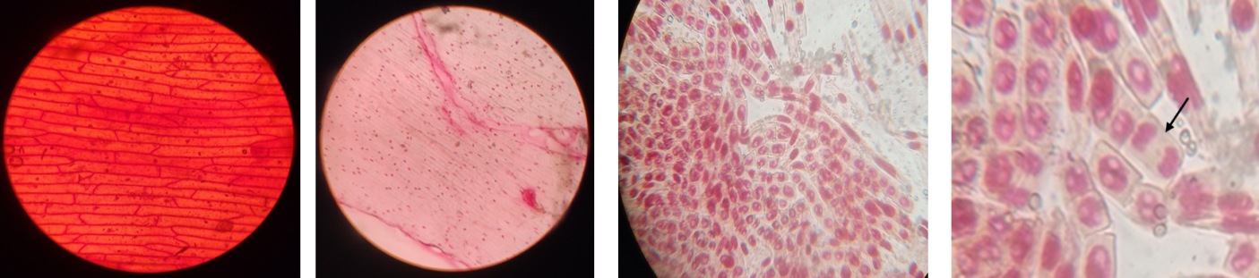

A B C1 C2

C

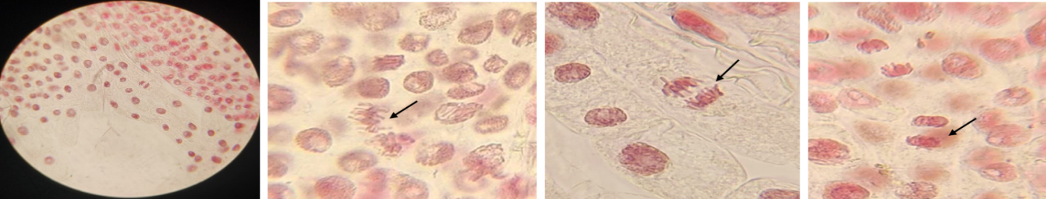

D1 D2 D3 D4

D

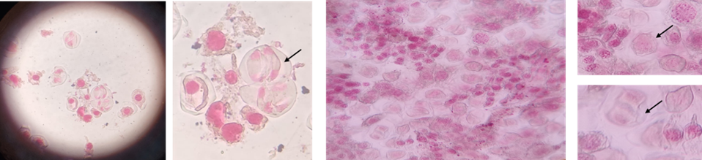

E1 E2 F1 F2

E F

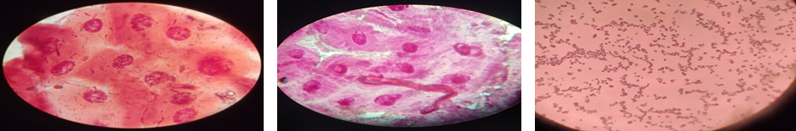

G H I

Figure 3: A- Histological study using safranin as standard (10X); B- Histological study using natural dye (10X); C- Mitosis study on *Allium cepa* root tips using aceto-orcein as standard (40X), C2- Late anaphase; D- Mitosis study on *Allium cepa* root tips using natural dye, D2- Metaphase, D3- Anaphase, D4-Teophase; E- Meiosis study using *Allium cepa* flower buds using aceto-orcein as standard (40X), E2- Anaphase Ⅱ; F- Meiosis study using *Allium cepa* flower buds using natural dye, F2- Prophase, Telophase; G- Study of polytene chromosomes of *Drosophila melanogaster* using Lacto-aceto-orcein as standard (40X); H- *Study* of polytene chromosomes of *Drosophila melanogaster* using natural dye. I- Study of human chromosomes using natural dye.

1. **CONCLUSION**

The synthetic dyes used so far have been linked to various health hazards, including skin and eye damage, corrosion, and irritation, as well as unknown toxicity effects such as bioaccumulation, carcinogenicity, germ cell mutagenicity, and reproductive toxicity. Additionally, these dyes pose environmental concerns due to their difficulty in decomposing. To address these issues, it's essential to develop safer alternatives and tackle the challenges associated with synthetic dyes, ensuring a healthier environment and mitigating potential harm to humans and ecosystems.

This study marks a significant breakthrough in the quest for sustainable alternatives to synthetic dyes in cytogenetics, successfully developing a green chromosomal stain from Phyllanthus reticulatus. The natural dye extracted from this plant has proven effective in various cytogenetic studies, replacing synthetic stains like safranin, aceto-carmine, aceto-orcein, and lacto-aceto-orcein. Adopting natural dyes in academic studies marks a significant milestone in the transition of synthetic dyes to natural dyes. By transitioning to natural dyes, we can foster a greener and more sustainable e research culture worldwide. Future studies need to be done on improvising these green stains

**ACKNOWLEDGEMENTS**

We thank all the members of Biotechnology Department, Nrupathunga University for their support. We thank Smitha Murthy, Director of "CREDORA life sciences" and Dr. Manohar Jebakumar for laboratory and equipment assistance. We thank Dr. Jayarama S. Kandandale, "Centre for Human Genetics" for their assistance in staining human chromosomes. We also thank “Central Ayurvedic Research Institute” for authenticating our plant sample.

1. **REFERENCES**

[1]. Elgubbi H, Asayh E. Chromosome staining with natural dyes from Punica granatum and Beta vulgaris. EC Nutrition. 2017;11(4):142-146.

[2]. Adeel M, Zia UIH, Sultan S, et al. Natural dyes: A review. J Clean Prod. 2009;17(5):462-469.

[3]. Taylor G. The art of natural dyeing. London: Thames & Hudson; 2004.

[4] Futragul P, Piromthammasiri K. Natural dyes: Sources, chemistry, and applications. J Nat Prod. 2019;82(1):14-25.

[5]. Sanjay P, Deepa K, Madhavan J, et al. Fabrication of DSSC with nanostructured TiO2 photoanode and natural dye sensitizer extracted from fruits of Phyllanthus reticulatus. Int J Sci Res Sci Technol. 2018;4(5):1-9.

[6]. Mugheri MH, et al. Natural dyes for textiles: A review. J Text Apparel Technol Manag. 2022;14(1):1-18.

[7]. Sivakumaran S. Natural dyes for textiles. J Soc Dyers Colour. 1989;105(10):351-355.

[8]. Chingangbam DS, et al. Natural dyes for textiles: A review. J Text Apparel Technol Manag. 2023;14(1):1-18.

[9]. Shaikh JR, Patil MK. Natural dyes for textiles. J Nat Fibers. 2020;17(1):56-65.

[10]. Ramya I, et al. Natural dyes for textiles: A review. J Text Apparel Technol Manag. 2015;9(2):1-12.

[11]. Savithramma N, et al. Natural dyes from plants for textiles. J Nat Fibers. 2011;8(2):147-155.

[12]. Apoorva M, et al. Natural dyes for textiles: A review. J Text Apparel Technol Manag. 2021;14(1):1-13.

[13]. Arulraj A, et al. Photovoltaic performance of TiO2 using natural sensitizer extracted from Phyllanthus reticulatus. J Mater Sci Mater Electron. 2017;28(18):13241-13249.

[14]. Bhakta D, Siva R. Morindone, an anthraquinone, intercalates DNA sans toxicity: A spectroscopic and molecular modeling perspective. Appl Biochem Biotechnol. 2012;167(4):885-896.

[15]. Hemachandran H, et al. Interaction of Catechu Dye with DNA: Spectroscopic and In Silico Approach. Nucleosides Nucleotides Nucleic Acids. 2015;35(4):195-210.

[16]. Harisha S. Natural dyes for textiles. J Soc Dyers Colour. 2006;122(10):342-346.

[17]. Chaiyasut K. Cytogenetics and cytotaxonomy of the family Zephyranthes. Chulalongkorn University; 1989.

[18]. Campiranon A. Cytogenetics. 2nd ed. Kasetsart University; 2003.

[19]. Chattopadhyay S, et al. Ovarian cancer: Protocol for the preparation of banded metaphases from tumor tissue. Cancer Genet Cytogenet. 1992;59(2):210-212.

[20]. Hliscs R, et al. The spreading of metaphases is a slow process which leads to a stretching of chromosomes. Cytogenet Cell Genet. 1997;76(3-4):167-171.

[21]. Barch MJ, Lawce HJ, Arsham MS. Peripheral blood culture. In: Barch MJ, editor. The ACT Cytogenetics Laboratory Manual. 2nd ed. New York: Raven Press; 1991. p. 123-127.

[22]. Gibas LM, Grujic S, Barr MA, et al. A simple technique for obtaining high-quality chromosome preparations from chorionic villus samples using FdU synchronization. Prenat Diagn. 1987;7(5):323-327.

[23]. Sasai K, Tanaka R, Kawamura M, et al. Chromosome spreading techniques for primary gastrointestinal tumors. J Gastroenterol. 1996;31(4):505-511.

[24]. Gustashaw KM. Chromosome stains. In: Barch MJ, editor. The ACT Cytogenetics Laboratory Manual. 2nd ed. New York: Raven Press; 1991. p. 205-296.

[25]. Moorehead PS, Nowell PC, Mellman WJ, et al. Chromosome preparations of leukocytes cultured from human peripheral blood. Exp Cell Res. 1960;20(3):613-616.

[26]. Hirsch B, Mack R, Arthur D. Sequential G-to R-banding for high-resolution chromosome analysis. Hum Genet. 1987;76(1):37-39.

[27]. Alfert M, Geschwind II. A selective staining method for the basic proteins of cell nuclei. Proc Natl Acad Sci USA. 1953;39(10):991-999.

[28]. Kiernan JA. Nuclear stains. Cold Spring Harb Protoc. 2008;3(7).

[29]. Dutt MK. Basic dyes for the staining of DNA in mammalian tissues and absorption spectra of stained nuclei in the visible light. Microscopica Acta. 1982;86:59-68.

[30]. Azizah AN, Agustina P, Suparti, et al. The use of natural dyes from beetroot skin extract (Beta vulgaris) as teaching material on cell division for senior high school students. Int J Learn Educ. 2020;2(1):1-9.

[31]. Sukhumanpan, et al. Natural dyes from plants for textiles. J Nat Fibers. 2002;1(2):155-164.

[32]. Wonkaonoi, et al. Natural dyes for textiles. J Soc Dyers Colour. 2004;120(10):342-346.

[33]. Mahayana IM. Exploration of natural dyes as alternatives to synthetic dyes in textile industry. J Environ Sci Technol. 2012;5(2):101-108.