REAL TIME LANGUAGE TRANSLATOR USING REINFORCEMENT LEARNING

Charan. A

*B. Tech*

*School of Engineering* Computer Science-(AI&ML) Malla Reddy University, India

Sumith. N

*B. Tech*

*School of Engineering* Computer Science-(AI&ML) Malla Reddy University, India

Surya Kiran. K

*B. Tech*

*School of Engineering* Computer Science-(AI&ML) Malla Reddy University, India

Swejana. G

*B. Tech*

*School of Engineering* Computer Science-(AI&ML) Malla Reddy University, India

Swetha. G

B. Tech School of Engineering

Computer Science-(AI&ML) Malla Reddy University,India

Guide: G. Balaiah Assistant Professor School of Engineering

Computer Science-(AI&ML) Malla Reddy University,India

1. ***Abstract:*** *The Communication has improved significantly, thanks to the rapid advancements in social media platforms, which have enabled people worldwide to connect, address issues, and find solutions. In today's globalized world, effective communication is crucial, highlighting the importance of language translation. Initially, human translators were used, but this was not a sustainable solution. After extensive research, machine translation technology was introduced, with a novel approach being the Real-Time Language Translator using Reinforcement Learning. Unlike traditional systems that rely on pre-existing parallel texts and supervised learning, a reinforcement learning-based translator improves by interacting with its environment, receiving feedback, and refining its models through rewards for accuracy and penalties for errors. This method leverages deep reinforcement learning to capture contextual and semantic information, enabling more accurate translations. The research focuses on developing this translator for 5-6 languages initially, with plans for future expansion, offering seamless communication across language barriers and making it a valuable tool in fields like international business, diplomacy, and tourism.*

# INTRODUCTION

The increasing need for real-time communication across language barriers presents a significant challenge in various global fields, including international business, diplomacy, and tourism. Traditional machine translation systems, which rely heavily on pre-existing parallel corpora and supervised learning models, often struggle to provide accurate, context-aware translations in dynamic conversational settings. These systems are static and lack

the ability to improve over time based on real-world usage. To address these limitations, a Real-Time Language Translator using Reinforcement Learning aims to create a more adaptive and efficient solution. By employing reinforcement learning, the system will continuously learn from its interactions, receive feedback, and adjust its translation strategies, refining its linguistic models in real-time. The goal is to enhance translation accuracy by capturing both contextual and semantic nuances, providing seamless and reliable communication for users across different languages.

The growing demand for real-time language translation in global sectors like business, diplomacy, and tourism reveals the limitations of traditional machine translation systems, which often struggle with contextual accuracy in dynamic conversations. These systems rely on static, pre-trained models that lack adaptability. A Real-Time Language Translator using Reinforcement Learning offers a promising solution, allowing the system to learn from interactions, receive feedback, and refine its translation strategies on the fly. This approach aims to improve translation accuracy by capturing contextual nuances, providing users with seamless communication across languages.

# LITERATURE REVIEW

1. **List of languages by number of native speakers in India (Wikipedia):** This resource provides a comprehensive list of languages spoken in India by the number of native speakers. The data is crucial for understanding the linguistic diversity in India, which plays a significant role in language translation technologies, especially for building

tools that cater to multiple Indian languages. In the context of this project, it helps identify the most widely spoken languages, which can be prioritized for translation support. The resource also reflects how linguistic distribution affects machine translation (MT) needs across the country, laying the foundation for research on regional language translation.

1. **Quinn Lanners, Neural Machine Translation (Towards Data Science):** This article provides an introduction to Neural Machine Translation (NMT) systems, explaining their architecture and how they differ from previous rule-based or statistical translation models. The focus is on sequence-to- sequence models, specifically the use of Recurrent Neural Networks (RNNs) and attention mechanisms. The article discusses how neural networks enable more fluent translations by understanding context, making it particularly relevant for developing real- time voice translation tools. It also highlights the importance of large datasets and parallel corpora, which are essential for training NMT models.
2. **Abhishek Narayan, Neural Machine Translation: Using Open-NMT for training a translation model (Hackernoon):** This resource is a practical guide on how to build and train neural machine translation models using Open-NMT, an open-source NMT framework. It delves into the model-building process, including preparing datasets, tuning hyperparameters, and training models. The emphasis on Open-NMT makes this resource valuable for developers aiming to implement customized translation systems. The literature highlights the technical challenges of building real-time systems and the need for robust pre-processing techniques to improve model accuracy.
3. **S. Saini and V. Sahula, "Neural Machine Translation for English to Hindi" (IEEE Conference, 2018):** This paper discusses the implementation of NMT for English to Hindi translation, addressing the challenges specific to translating between languages that have distinct syntactic structures. The authors examine the use of encoder-decoder models and compare their performance with traditional machine translation approaches. The research is significant in the context of developing tools for Indian languages, as it identifies key challenges like word-order differences, morphology, and the need for extensive datasets. The insights on handling morphologically rich languages like Hindi make this a key study for the project.
4. **P. Vijayalakshmi, "Hindi-English speech-to- speech translation system for travel expressions" (IEEE Conference, 2015):** This paper presents a speech-to-speech translation system designed for travelers, focused on translating common expressions between Hindi and English. The system integrates automatic speech recognition (ASR), NMT, and text-

to-speech (TTS) technologies to deliver spoken translations. It highlights challenges related to real- time translation, such as latency and the difficulty of handling colloquial expressions. The paper also emphasizes the need for domain-specific training data to improve the system's accuracy in practical applications. This approach aligns with the goals of developing a tool for real-time translation in everyday scenarios.

1. **O. Dhariya, S. Malviya and U. Tiwary, "A hybrid approach for Hindi English machine translation" (IEEE Conference, 2017):** This study explores a hybrid machine translation approach combining rule-based and statistical methods for Hindi-English translation. The hybrid approach aims to overcome the limitations of purely statistical models by incorporating grammatical rules specific to Hindi and English. The paper demonstrates improvements in translation quality, particularly for sentences with complex structures, by using both linguistic knowledge and statistical patterns. The research is relevant for projects where high translation accuracy is required, such as in formal or academic settings, and it provides insights into improving translation models by blending multiple techniques

# METHODOLOGY

## Existing System :

**Neural Machine Translation (NMT) Systems:** NMT systems like Google Translate and DeepL use pre-trained models to deliver accurate translations but lack real-time adaptability.

**Attention Mechanisms in NMT:** Attention mechanisms in NMT models, especially in the Transformer architecture, enhance translation quality by focusing on relevant parts of the input sentence.

**Feedback Mechanisms in Existing Systems:** Existing translation systems collect user feedback offline, meaning they do not update or adapt translations in real time.

**Simultaneous Translation Techniques:** Simultaneous translation systems translate input in real-time but may sacrifice context and accuracy by processing incomplete sentence segments.

## Limitations :

**Language Diversity:** The project will encompass a wide range of languages, including major global languages and select regional dialects.

**Contextual Understanding:** The system will aim to understand and incorporate context, idiomatic expressions, and cultural nuances in translations.

**Real-Time Performance:** Focus on achieving low latency for immediate translation in conversational settings, suitable for applications like travel, business meetings, and customer service

**Data Dependency:** The quality and availability of training data for less common languages may limit translation accuracy.

**Complex Language Structures:** Some languages have complex grammatical structures that may pose challenges for accurate translation.

**Real-Time Constraints:** Achieving real-time performance while maintaining high translation quality can be technically challenging.

## Proposed System :

The real-time language translator project aims to create a system that can instantly convert spoken or written input from one language to another with high accuracy and minimal delay. By leveraging advanced natural language processing (NLP) techniques and reinforcement learning, the system will continuously improve its translation quality based on real-time feedback and user interactions. The core model will be built on a Transformer architecture, known for its exceptional performance in language tasks, and optimized through reinforcement learning to adapt to user preferences and specific translation contexts. This approach not only enhances translation accuracy but also enables a responsive, user-centered experience suitable for various applications, from multilingual communication to real-time customer support.

**Reinforcement Learning Agent**: This agent is responsible for processing translations and adapting strategies based on feedback, allowing the system to self-improve over time.

**Feedback Loop**: By collecting and analyzing user feedback on translation accuracy, the system adjusts its linguistic models to better handle contextual and semantic nuances.

**Context-Aware Module**: The translator incorporates contextual understanding, capturing the specific meaning and tone of phrases based on conversational flow.

**Dynamic Language Model Update**: The system continuously fine-tunes its language model, incorporating new language data to remain accurate in real-world situations.

This adaptive approach allows the translator to provide more precise, contextually aware translations, enabling users to communicate seamlessly across languages in various scenarios, such as business discussions, diplomatic meetings, and travel interactions.

# ARCHITECTURE

The architecture for the Real-Time Language Translator is designed to enable accurate, context- aware translations by following a structured flow. The process begins with a language selection stage, where the user chooses the target language for translation. Once selected, the system listens to the user’s spoken input and attempts to match it with entries in its database. If a match is found, the system translates the input into the chosen language, providing a real-time response. If no match is found, the input is flagged as "Not Processed," and the system prompts the user for additional input or clarification. This additional input is then used to update the database, creating a feedback loop that allows the system to adapt and improve over time. This architecture ensures that the translator not only provides accurate translations but also continuously learns from interactions, enhancing its ability to handle diverse language contexts in real-time.

## Flowchart :

1. **Start**: The system initiates, ready to begin the translation process.
2. **Choose Language**: The user selects the target language to which they want their input translated.
3. **User Speaks Input**: The user provides a spoken input, which the system captures to be processed.
4. **Match with Database**: The system compares the spoken input with entries in its database to find a match.

# Decision Point – Match Found:

* + ***If a Match is Found****:* The system proceeds to translate the input into the selected target language.
  + ***If No Match is Found****:* The input is marked as "Not Processed," meaning the system cannot translate it based on the available data.

1. **Take Input (Feedback Loop)**: If a match is not found, the system prompts the user to provide additional input or clarification. This input may be used to update the database, allowing the system to improve over time and handle similar inputs in the future.
2. **End**: The translation process concludes, completing the workflow.

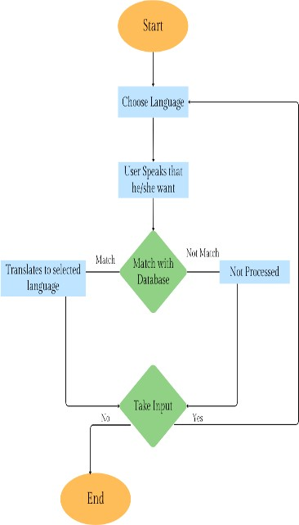

FIG 1 : Flowchart Of Project

## Prototype :

The prototype for the Real-Time Language Translator allows users to select a target language, speak their input, and receive an instant translation if a match is found in the system's database. If no match is found, the system prompts for clarification, which helps refine future translations. This feedback loop enables continuous learning, making translations more accurate over time.

* 1. ***Methods & Algorithms :***

# Neural Machine Translation (NMT):

* ***Method:*** NMT uses deep learning models, particularly those based on the Transformer architecture, to generate translations. It processes input sentences in a single pass, learning complex language patterns from large bilingual datasets.
* ***Algorithm:*** The Transformer algorithm relies on attention mechanisms, specifically self-attention, to weigh the importance of different words in the input sequence, enabling better context understanding during translation.

# Reinforcement Learning (RL):

* ***Method:*** Reinforcement Learning enhances the translation model by allowing it to learn from real-time user feedback. The model treats translation as a sequential decision-making problem, optimizing its actions based on rewards received for correct or preferred translations.
* ***Algorithm:*** Common RL algorithms such as Q- learning or policy gradients (e.g., Proximal Policy Optimization) can be employed to adjust the model's parameters based on the feedback loop, improving translation quality over time.

# Speech Recognition:

* ***Method:*** The speech recognition component converts spoken language into text, allowing users to input their queries verbally. This module typically employs deep learning models trained on vast amounts of audio data.
* ***Algorithm:*** Algorithms like Hidden Markov Models (HMM) combined with neural networks (such as Deep Neural Networks or Recurrent Neural Networks) are often used for recognizing speech patterns and transcribing them into text.

## Dataset Description :

The dataset for this real-time language translator project will consist of parallel corpora, which are pairs of sentences or phrases in different languages, aligned to provide direct translations. These datasets are crucial for training the model to understand language patterns, structure, and context across multiple languages. High-quality parallel datasets, such as the WMT (Workshop on Machine Translation) or OPUS datasets, cover a broad range of language pairs and domains, including news, formal text, and conversational language. For spoken language translation, additional audio datasets (such as Common Voice or LibriSpeech) can provide transcribed speech-to- text data to enhance the model’s understanding of verbal nuances and speech patterns. This rich, diverse data foundation allows the model to handle complex linguistic variations and support accurate, context-aware real-time translations.

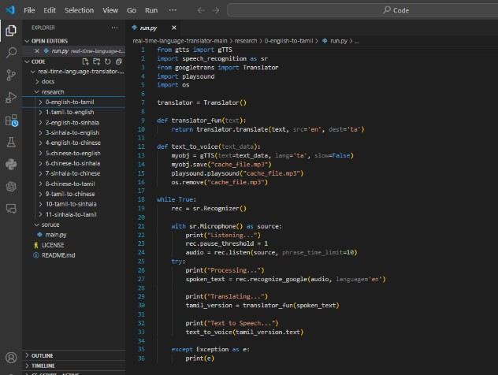

FIG 2: Few Language Modules

The project contains language modules that enable translation between various languages, including English to Tamil, Tamil to English, and others like Sinhala and Chinese. Each module allows the system to convert spoken input into text, translate it into the target language, and output it as speech. This setup supports real-time multilingual communication, enhancing accessibility across different language speakers.

# *6.* EXPERIMENTAL RESULTS

## WEB GUI’s DEVELOPMENT:

**Famework Selection:** Utilize Streamlit as the primary framework for building the web interface due to its simplicity and ease of use for creating interactive applications.

**User Interface Layout:** Design a clean and intuitive layout with dropdown menus for selecting source and target languages, and buttons to start and stop the translation process.

**Input and Output Areas:** Implement areas for displaying messages, such as "Listening...", "Processing...", and "Translating...", to keep users informed of the application's status.

**Language Selection:** Integrate selectbox components for users to choose from available languages, utilizing the googletrans library to fetch and display language options dynamically.

**Feedback Mechanism:** Provide visual feedback through placeholder text in the output area, ensuring users are aware of ongoing processes and any errors encountered during translation.

**Button Functionality:** Develop functionality for the "Start" and "Stop" buttons to control the translation process, linking them to the main translation logic in the code.

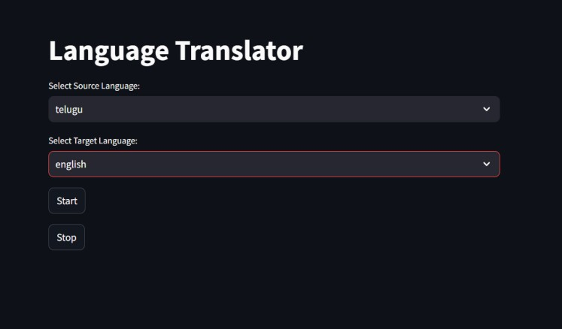

# FIG 3 : Output of Selecting Language

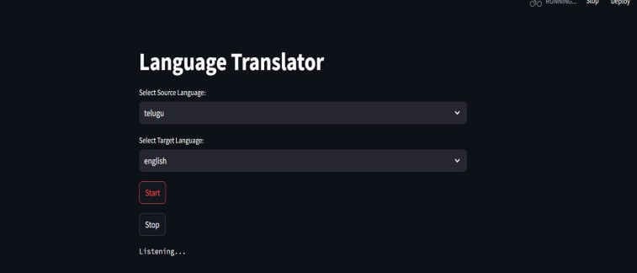

**FIG 4 : Output**

## MODEL DEPLOYMENT

1. **Environment Setup:** Ensure that the deployment environment (e.g., cloud server, local machine) has all necessary dependencies installed, including Streamlit, gTTS, pygame, and googletrans.
2. **Functional Testing:** Verify that all components of the application (speech recognition, translation, textto-speech) work as expected. Test various language pairs and inputs to ensure accurate functionality.
3. **Performance Testing:** Measure the application's latency to ensure it meets real-time translation requirements.Conduct tests with different audio input lengths and complexities to evaluate response times.
4. **Error Handling:** Implement and test robust error handling to manage potential issues such as network failures, unsupported languages, or audio input problems, ensuring the system responds gracefully.
5. **Load Testing:** Simulate multiple users interacting with the application simultaneously to assess how well it scales and handles increased loads without performance degradation.
6. **Monitoring and Logging:** Set up monitoring tools to track application performance and log errors or user interactions for future analysis and troubleshooting.
7. **Iterative Improvements:** Based on feedback and test results, refine the model and user interface as needed, continuously improving the application before final deployment.
8. **Final Validation:** Conduct a comprehensive review of the application, ensuring it meets all specified requirements and quality standards before making it publicly accessible.

## Evaluation Metrics :

**BLEU Score:** Measures the similarity between machine- generated and human translations, with a higher score indicating better quality.

**ROUGE Score:** Evaluates the overlap of n-grams between generated translations and reference texts to assess relevance.

**Translation Edit Rate (TER):** Calculates the number of edits needed to convert machine translations into reference translations, with lower values indicating better performance.

# CONCLUSION

In conclusion, this project presents a real-time voice recognition-based language translation tool that acts as a virtual interpreter. By combining speech recognition and language translation, it offers an intuitive, user-friendly interface that seamlessly converts spoken words into a desired language. The tool efficiently bridges language gaps, providing users with an accurate and dynamic solution for communication in multiple languages. Its streamlined design ensures easy interaction, error handling, and repeatability, making it a valuable resource for real-time language translation needs.

This project delivers a real-time voice recognition-based language translation tool that functions as a virtual interpreter. By integrating speech recognition with translation, it provides a user-friendly interface for seamless conversion of spoken words into different languages. The tool effectively bridges communication barriers, offering an accurate, efficient, and repeatable solution for real-time multilingual translation.

# FUTURE WORK

**Dynamic Learning from Feedback :** Use RL to allow the system to adapt and learn from real-time user feedback.

**Contextual Translation** : Implement RL algorithms that prioritize context understanding. By setting rewards for more accurate contextual translations, the system can learn which word sequences or structures make sense in certain conversational contexts.

**Personalization and Adaptation to User Preferences :** Use RL to create a personalized translation experience. The system could learn from user interactions and feedback to adjust translation tone, formality, and structure according to user preferences.

**Handling Low-Resource Languages :** RL could improve performance in these areas by allowing models to leverage existing data from more common languages and reward effective cross-linguistic transfers.

**Collaborative Learning :** When multiple users correct or approve translations, the system could aggregate feedback and learn more efficiently.

# REFERENCES

1. Vaswani, A., Shard, N., Parmar, N., Uszkoreit, J., Jones, L., Gomez, A.N., Kaiser, Ł., Kattner, A., &

N. P. (2017). Attention is All You Need, Neural Information Processing Systems, 30, pp. 5998- 6008.

1. Bahdanau, D., Cho, K., & Bengio, Y. (2014). Neural Machine Translation by Jointly Learning to

Align and Translate, arXiv preprint arXiv:1409.0473. Wu, Y., Yang, Z., & Yang, S. (2016).

1. Google’s Neural Machine Translation System: Bridging the Gap between Human and Machine Translation, arXiv preprint arXiv:1609.08144.
2. Zhang, J., & Zhang, Y. (2019). A Survey of Neural Machine Translation, arXiv preprint arXiv:1902.00023.
3. Hinton, G. E., Vinyals, O., & Dean, J. (2015). Distilling the Knowledge in a Neural Network, arXiv preprint arXiv:1503.02531.
4. Google. (n.d.). Speech Recognition API. Retrieved from https://cloud.google.com/speech-to-text.
5. Google. (n.d.). Google Translate API. Retrieved from https://cloud.google.com/translate.
6. Kahn, J. (2020). A Guide to Google Text-to- Speech, Journal of Artificial Intelligence Research, 68, pp. 101-115.
7. Salton, G., & McGill, M. J. (1986). Introduction to Modern Information Retrieval, McGraw-Hill, pp. 22-25.
8. Aydin, A. (2017). Real-time Speech Translation: Current Status and Future Challenges, IEEE Transactions on Audio, Speech, and Language Processing, 25(3), pp. 609-622.
9. Tang, J., & Liu, S. (2019). Attention Mechanism in Natural Language Processing: A Survey, arXiv preprint arXiv:1909.02538.
10. Kuo, J. S., & Chen, K. J. (2018). Deep Learning for Text-to-Speech Synthesis: A Survey, arXiv preprint arXiv:1803.08477