**INTELLIGENT SMART CART FOR SUPERMARKETS**

**Aarthi M.S1, Jay Chandhirikha AB2, Anshiya S3 , Pooja S4 , Sandhiya N5**

1Assistant Professor, EEE , P .A .College of Engineering and Technology ,Pollachi ,Coimbatore, TamilNadu ,India

2,3,4,5UG Student , EEE ,P .A .College of Engineering and Technology ,Pollachi ,Coimbatore ,TamilNadu,India

**ABSTRACT**

The Intelligent smart cart for supermarkets is a smart basket which uses an embedded chip with a RFID reader and a battery to allow users to Self-progress at the supermarkets .The main theme of the project is to decrease the time consumption in the billing counters at the supermarkets by designing a smart cart which allows users to checkout from the malls .A smart cart system that uses an Arduino Nano microcontroller, RFID reader, load cell, IR sensor, 12volt motor cycle battery and LCD to automatically generate the bill and follow the customer .The IoT kit which contains the barcode scanner will automatically detects the product dropped into the basket using loadcell sensor .RFID sensors require a wireless connection. One element is the RFID tag attached to each product, while the other is the RFID reader that efficiently reads the product information .The information for each product appears in the Phone app. On the mobile application, the user can quickly change their shopping list based on preferences. The shopping information is then digitally taken as input, which generates bills automatically. In the future, the proposed technique might be simply applied and tested in mass manufacturing in a real-world setting

.Keywords: load cell , RFID reader

**INTRODUCTION**

IoT based connected smart things in the field of consumer applications it makes better sense to ensure such technologies are put to use in addressing with the increasing reliability and cost effectiveness of Internet of Things the day to day concerns of the common man. Framework, portray the execution of a dependable, reasonable and cost-effective smart shopping cart. At the present time, representatives remain on lifts that go here and there the stacks, and output things to ensure that containers are in the perfect place. As indicated by Walmart’s patent demand, clients will have the capacity to summon one of these truck pullers each furnished with cameras and sensors with their user interface gadget, maybe a Smartphone application and a mechanized unit. The intelligent shopping cart will be an across the board shopping cart. It will enable the client to monitor the aggregate cost also, when things are added to the shopping cart. The client will remotely with an instore segment to make simple installments in a hurry. The client has choice to make easy online payments through the application. The customer will have the alternative of going up to the checkout counters. This new framework would diminish the long hold up times at the checkout counters, increment the productivity of the checkout technique, would furnish the customer with a low mode cost and aggregate data, which makes the entire experience more helpful. This way it minimizes the labor required at billing counters reducing the amount spent on the labor. The application can promote live offers and 2 can be updated as the season changes. This framework addresses one of the common issues that clients face in the existing system such as unable to find the items in the inventory or employee for any help. The application will help the clients to find items at the right inventory by providing the information about the items in the list along with a route map of the super market thereby providing new experience to the clients. This will also have the history of the items bought by the client. This will enable client to use the data for next purchase. The standardized identification scanner separates the standardized tag which is transmitted to the microcontroller through an USB association. The microcontroller peruses data from a SD card embedded into the microcontroller. The carts inbuilt programmed charging framework makes shopping a breeze and has other positive turn offs, liberating staff from tedious checkout filtering, lessening an aggregate number of staffs required and expanding operational effectiveness of the framework. The about open doors for enhancing the proposed. the stock control less demanding for the store administration. Clever shopping basket can possibly make shopping more pleasurable, effective for the customer and the stock control less demanding for store administration.

**2.LITERATURE SURVEY**

**[1].Mobeen Shahroz, Muhammad Faheem Mushtaq, Maqsood Ahmad1, Saleem Ullah, Arif Mehmood, And Gyu Sang Choi ‘IoT-Based Smart Shopping Cart Using Radio Frequency Identification’, 2020.**

The modern age of technology in which most of the customer needs to wait in the supermarket for shopping because it is a highly time-consuming process. A huge crowd in the supermarket at the time of discount offers or weekends makes trouble to wait in long queues because of a barcode-based billing process. In this regard, the Internet of Things (IoT) based Smart Shopping Cart is proposed which consists of Radio Frequency Identification (RFID) sensors. The customer easily manages the shopping list in Mobile application according to preferences. Then shopping information sends to the server wirelessly and automatically generates billing. This experimental prototype is designed to eliminate time-consuming shopping process and quality of services issues. The proposed system can easily be implemented and tested at a commercial scale under the real scenario in the future. That is why the proposed model is more competitive as compared to others.

**[2] T.R. Lekhaa, S. Rajeshwari, J. Aiswarya Sequeira, S. Akshayaa ‘Intelligent Shopping Cart Using Bolt Esp8266 Based on Internet of Things’, 2019.**

In the living world technology is evolving day by day in different fields like artificial intelligent, machine learning, virtual 1 reality, touch commerce, internet of things and so on. The main motive of the paper is focus to the customer needs and purpose because time is more important to everyone in the real world. But the people spend the more time in the supermarket. For example, consumers purchase the number of items in the supermarket using trolley. After purchasing they can face some problems like waiting the long queue in billing section and without knowing about the calculation of purchased items. So, we can consider these problem to find the remedies called as "Intelligent shopping cart using BOLT based on IOT". Our IOT kit consists of barcode scanner, LCD display, Bolt ESP8266. The broad clarification of its process is, when consumer takes an item and put inside the trolley, that time barcode scanner scans the item barcode and value as well as gain to show into the digital display panel. Later than consumer concluded their purchasing and the bill is sent to the counter section. It will save the time and consumer early itself knowing the calculation of purchased items.

**[3].Mohit Kumar, Jaspreet Singh, Anju, Varun Sanduja. ‘Smart Trolley with Instant Billing to Ease Queues at shopping malls using ARM7 LPC2148’ , 2018.**

The modern technology has increased the standard of living for the humans. Every one of us craves for a quality in everything we use in our daily lives. So, this has resulted in large crowds at shopping malls which have led to long lines at the billing counter because the cashier has to scan every product item and then enter it into the billing record. The prevailing billing 6 system is a bit time consuming. So, we thought of inventing a remedial electronic product to catch-up with this problem. We call it “Smart Trolley with Instant Billing to Ease Queues at Shopping Malls using ARM7 LPC2148: A Review’’. This is based on arm7 microcontroller fitted with a LCD and RFID scanner and a wireless technology called Zigbee. The LCD used is a 16x2 and ZigBee modules make the wireless network to work even at long distance due to its wide range. The brief description of its operation is, when you pick a product and drop it into the trolley, the RFID scanner scans the product’s unique code and its price. And it gets displayed on the LCD screen. So, after costumer has finished with the shopping, he/she has to visit the counter and pay the bill as displayed on the LCD screen fitted on the trolley. This will save the time that was earlier being consumed to scan each item**.**

**[4].Vaishali Rane, Krutik Shah, Kaushal Vyas, Sahil Shah, Nishant Upadhyay ‘Smart Trolley Using RFID’ ,2019**. Buying and searching at huge malls is turning into a daily activity in subway cities. We can see large rush at malls on holidays and weekends. The rush is even a lot of once there are special offers and discount. People purchase totally different things and place them in trolley. After total purchase one needs to go to cashier for payments. The cashier prepares the bill victimization bar code reader that could be a time overwhelming method and leads to long queues at charge counters. This paper targeted to minimize the Queue at a billing counter in a shopping complex. Smart Trolley does the same by displaying the total price of the product kept inside the cart. In this way the customer can directly pay the amount at the billing counter and leave with the commodities he/she has bought. The hardware is based on Arduino Uno, RFID Reader Module, RFID Card and Buzzer. It eliminates the traditional scanning of products at the counter and in turn speeds up the entire process of shopping, 7 also with this system the customer shall know the total amount to be paid and hence can accordingly plan his shopping only buying the essential commodities resulting in enhanced savings. Since the entire process of billing is automated it reduces the possibility of human error substantially. Also, the system has a feature to delete the scanned products by customer to further optimize the shopping experience**.**

**3.METHODOLOGY**

To develop the intelligent smart cart for super market metro cities, buying and shopping at broad malls has been a regular occurrence. On holidays and weekends, these malls would be crowded. People buy various things and place them in a trolley or a basket. The payments must be rendered at the billing counter until purchase is done. The cashier at the counter places the bill using a RFID scanner, which is the time reducing procedure that result in a length queue at billing counter. An RFID reader at the basket side in the proposed scheme and each commodity in the store has its own special RFID tag with unique ID. When a consumer puts a commodity in the trolley, the RFID reader reads the tag connected to the product and transfers it to the controller. The Wi-Fi receiver got the bill number and sent it to the PC which displayed it in the hyper Terminal. The name and price of the product the controller gets and displayed on the LCD of the smart basket, where people can see the item data, store the product price the total billing data, microcontroller memory is used in the basket. These modules are checked for functionality before being incorporated into a smart sealed device, The customers will be required to search good and the number will be updated on the shopping carts LCD panel. This would benefit department stores because more shoppers would love their customer experience and buy more often as a result. Large enough for shoppers with shopping carts to walk across during the creation and discussion of the intelligent smart cart.

* 1. **BLOCK DIAGRAM**

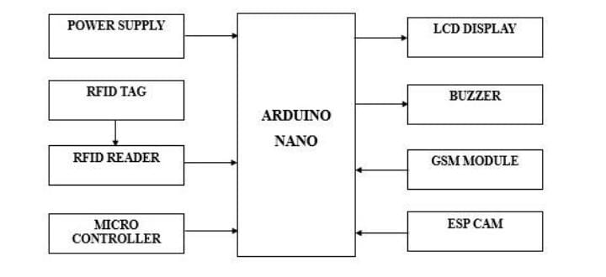

Figure 1:Block diagram

It Consists of Arduino NANO ,1 barcode scanner,100V battery kit,16*2 LCD display, RFID tag, RFID reader, Microcontroller, GSM Module, ESP cam, buzzer and customized basket. The Automated Shopping cart system integrates a Shopping cart (trolley) with two sets of barcode scanners placed at two different checkpoints the entry and exit points respectively. Wrongful entries can be corrected by making use of a that changes the functionality of the machine from addition of products to removal of products and activates the other barcode scanner at the opposite end. A wireless smart device makes note of all the scanned commodities of the particular trolley and is with the supermarket's backend database which contains details of the products such as cost price, reducing and transmitted to the Shop's central billing program. The tray in which the two barcode scanners are embedded is fitted with a lock and keys for which are with the people at the billing section

**4.CIRCUIT DIAGRAM**

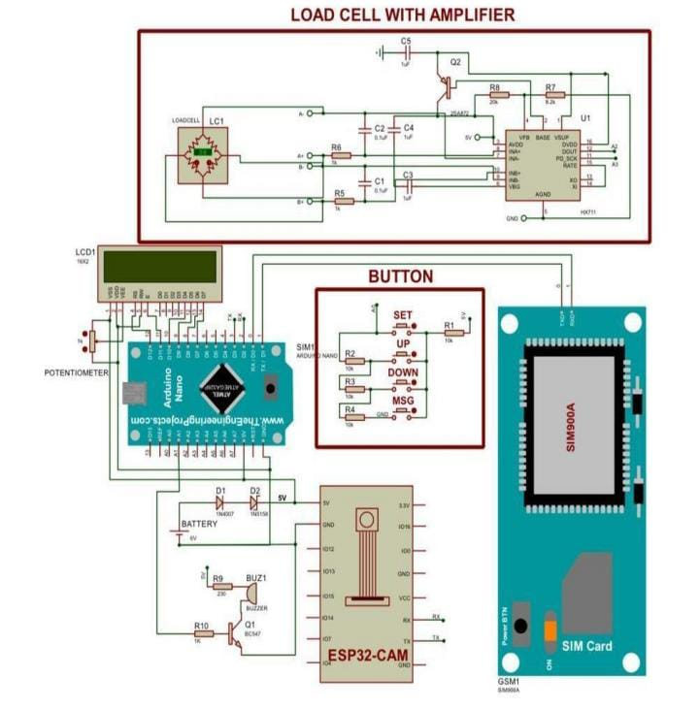

**Figure 2: Circuit diagram**

Arduino Nano is the major component in this circuit diagram, the microcontroller is also connected in this Arduino NANO 16*2 LCD and it is connected with the i2 c protocol. I2 c means required wires such as Scl, VCC and Gnd. The Scl pin is connected to the pin A5 in Arduino Nano, HDA is connected to the pin A4 in Arduino Nano, Gnd will be common and VCC is connected to analog 5 in Arduino Nano. We use 2 LED indication light. First one is Red and second is green. LED red will be connected to the pin no A1 in Arduino Nano. LED green will be connected to the pin no E3 in Arduino Nano. The ESP32-CAM communicates with the GSM module using serial communication. This involves connecting the TX pin of the ESP32-CAM to the RX pin of the GSM module and vice versa. The VCC pins of these components are connected to the positive terminal of the battery, while the Gnd pins are connected to the negative terminal. The ESP32-CAM controls an LCD display, likely using I2C protocol or SPI communication. The ESP32-CAM is connected to several buttons (SET, UP, DOWN, MSG) which are used for user input. The output of the amplifier is connected to an analog input pin of the ESP32-CAM, allowing it to measure the amplified signal from the load cell. The load cell is connected to an amplifier circuit, which amplifies the weak signal from the load cell to a usable level. The output of the amplifier is connected to an analog input pin of the ESP32- CAM, allowing it to measure the amplified signal from the load cell. The GSM module requires a SIM card to be inserted for cellular network connectivity. A potentiometer might be used to adjust certain parameters of the system, such as the brightness of the LCD display. Here, we are using this identification for sound and we connected a small buzzer(2volt) which is connected to the pin no 82. We use the RFID (Radio Frequency 15 Identification) reader module is only required 3 wires like VCC, Gnd and TX pin. TX pin is connected with RX pin in Arduino Nano. The push button for removing the product. If any customer scans the product and place it in the basket and they think that want to remove the product that was placed in the basket for this purpose we are using the push button. This push button, remove the product from the basket for billing. Push button is connected to the pin no D6 and GSM is connected to pin no D5. GSM module is used for the purpose of sending SMS. If the customers total purchase will be completed then this GSM module sends an SMS for the particular number

**5.RESULT AND DISCUSSION**

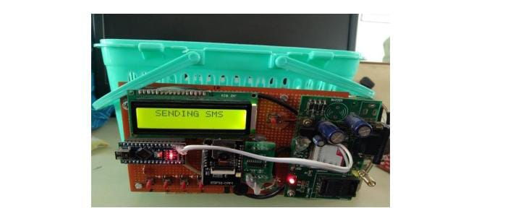

**Figure 3: Hardware**

As items are added to the cart, the weight sensors and RFID readers identify them automatically, updating the total cost. The cart can provide directions to products based on a user’s shopping list, helping shoppers find items efficiently. Promotions and Recommendations: The cart can suggest deals or complementary items based on what’s already in the cart or a shopper’s purchase history. A QR code (Quick Response code) on a product is a matrix barcode that can be scanned using a smartphone or QR code reader Additionally, businesses can track how many times a QR code has been scanned, offering insights into customer behavior and the effectiveness of marketing campaigns. Overall, QR codes improve the user experience by providing quick access to information and services directly from the product.

The process of sending a bill to a mobile phone via SMS from an intelligent smart cart in a supermarket involves several key steps. As customers add items, the cart's built-in scanner, using RFID or barcode technology, detects and records the products, continuously updating the total price. Once shopping is complete, the smart cart generates a digital bill that includes an itemized list of products, their prices, any discounts, and the total amount due. The system then prompts the customer to enter their mobile phone number through the user interface to ensure the bill is sent to the correct recipient. Connected to an SMS gateway, the smart cart can send text messages through mobile networks. The generated bill is formatted into a concise SMS, including essential details like the total amount, payment confirmation, and a thank-you note. The cart then uses the SMS gateway to send this message to the customer's mobile phone. After sending, the system logs the transaction for record-keeping and analytics, enabling the supermarket to track customer interactions and preferences. This automation of the billing process enhances the shopping experience by providing customers immediate access to their purchase details without needing paper receipts

**6.CONCLUSION**

The IoT based smart shopping cart with an automatic billing system using an RFID reader and a location tracing system is an innovative solution to simplify the shopping experience for customers. With the use of RFID technology, the system can quickly and accurately identify the products placed in the cart, and the wireless communication system helps update the shopping cart with the location of the items as the shopper moves around the store. The system provides an efficient billing and payment option, where the authorized card can be used to pay for the purchased items. The system also sends an SMS to the customer's mobile number after the bill is paid, providing an additional layer of convenience and security. Overall, this project has demonstrated the potential of IoT based systems in automating and streamlining various aspects of our daily lives, including shopping

**7.REFERENCE**

1. Athauda, T., Marin, J. C. L., Lee, J., & Karmakar, N. C. (2018), ‘Robust low-cost passive UHF RFID based smart shopping trolley’, IEEE journal of radio frequency identification, 2(3), 134-143.
2. Das, T. K., Tripathy, A. K., & Sriniasan, K. (2020), ‘A Smart Trolley for Smart Shopping’, In 2020 International Conference on System, Computation, Automation and Networking (ICSCAN) (pp. 1-5), IEEE.
3. Gunawan, A. A., Stevanus, V., Farley, A., Ngarianto, H., Budiharto, W., Tolle, H., & Attamimi, M. (2019), ‘Development of smart trolley system based on android smartphone sensors’, Procedia Computer Science, 157, 629-637.
4. Kajol, S., Holla, A. K., Abhilash, C. B., Amrutha, P. V., & Manohar, Y. V. (2017), ‘An IOT based smart shopping cart for smart shopping’, International Conference on Cognitive Computing and Information Processing (pp. 373-385).
5. Kowshika, S., Varshini, G. M., Megha, V., & Lakshmi, K. (2021),’IoT based smart shopping trolley with mobile cart application’. In 2021 7th International Conference on Advanced Computing and Communication Systems (ICACCS) (Vol. 1, pp. 1186-1189), IEEE.
6. Ramkumar, S., Saravanan, R., Venusamy, K., Jabbar, R., & Jeevitha, N. (2024), ‘Smart Shopping and Cart Billing System Using Deep Learning’, In 2024 Second International Conference on Intelligent Cyber Physical Systems and Internet of Things (ICoICI) (pp. 601-605), IEEE.
7. Shailesh, S., Deb, P. S., Chauhan, R., & Tyagi, V. (2021), ‘Smart trolley’, In 2021 International conference on advance computing and 31 innovative technologies in Engineering (ICACITE) (pp. 242-245), IEEE.
8. Shankar, S. K., Balasubramani, S., Basha, S. A., Ahamed, S. A., & Reddy, N. S. K. (2021),’Smart trolley for smart shopping with an advance billing system using IoT’. In 2021 5th International Conference on Computing Methodologies and Communication (ICCMC) (pp. 390- 394), IEEE.
9. Sutagundar, A., Ettinamani, M., & Attar, A. (2018),’ IoT based smart shopping mall’. In 2018 Second International Conference on Green Computing and Internet of Things (ICGCIoT) (pp. 355-360), IEEE.
10. Vallabhuni, R. R., Lakshmanachari, S., Avanthi, G., & Vijay, V. (2020). ‘Smart cart shopping system with an RFID interface for human assistance’, In 2020 3rd International Conference on Intelligent Sustainable Systems (ICISS) (pp. 165-169). IEEE.
11. Vivek, P. S., Rahul, P. V. S., Dyuthy, E. S., & Yadav, S. (2021). ‘Arduino based Smart System for Control and Effective Billing’, In 2021 International Conference on Artificial Intelligence and Smart Systems (ICAIS) (pp. 1706-1709). IEEE.
12. Viswanadha, V., & Reddy, C. (2018). ‘Smart shopping cart’, In 2018 International Conference on Circuits and Systems in Digital Enterprise Technology (ICCSDET) (pp. 1-4). IEEE.
13. Yadav, B. K., Burman, A., Mahato, A., Choudhary, M., & Kundu, A. (2020) ‘Smart cart’, A distributed framework. In 2020 IEEE 1st International Conference for Convergence in Engineering (ICCE) (pp. 210-213). IEEE