**Personalized Diet Planning And Health Tracker Using AI**

*Guide: Dr. R. Nagaraju*

M. R. Krithika

*School of Engineering(AIML)*

*B Tech*

*Malla Reddy University*

M. Uday Kiran

*School of Engineering(AIML)*

*B Tech*

*Malla Reddy University*

M. Yuktha Sri

*School of Engineering(AIML)*

*B Tech*

*Malla Reddy University*

M. Sireesha

*School of Engineering(AIML)*

*B Tech*

*Malla Reddy University*

M. Ishitha

*School of Engineering(AIML)*

*B Tech*

*Malla Reddy University*

---------------------------------------------------------------------***---------------------------------------------------------------------

**Abstract -** *This project analyzes an individual’s dietary intake data, it can pinpoint specific vitamins, minerals, or macronutrients that are lacking in their diet. For instance, if someone consistently consumes too few sources of vitamin C, it can flag this deficiency, enabling targeted dietary interventions. These platforms consider the foods you enjoy and those you’d rather avoid. These recipes aim to maximize the intake of essential vitamins, minerals, and antioxidants while minimizing less nutritious options. This level of precision is essential for individuals with specific dietary restrictions or medical conditions, such as vegans or people with celiac disease. it ensures that their dietary plans are not only aligned with their preferences but also meet their nutritional needs. It even offers feedback and recommendations to individuals while selecting their personalized diet in case someone selects foods which risks your health. . It helps in managing chronic conditions through nutrition for individuals with conditions like diabetes or hypertension, maintaining a specific dietary regimen is paramount. It can continuously monitor their dietary choices, providing real-time feedback and adjustments to help keep their conditions under control.*

**1. INTRODUCTION**

In the current digital age, individuals are increasingly seeking personalized solutions to manage their health and well-being. Despite the availability of numerous diet and fitness applications, users often encounter significant challenges in achieving and maintaining optimal health through diet planning. To address these challenges, we propose the development of a comprehensive diet planning application to develop a user-centric app that offers personalized and actionable diet recommendations and also to create seamless integration with health tracking tools and devices for comprehensive monitoring. A well balanced diet with an estimated nutrient intake is vital for infants and children which reduces the risks of deadly diseases namely cancer, diabetes, obesity and cardiovascular diseases. It also improves overall user satisfaction and health outcomes through a holistic and integrated approach to diet planning.

## 2. LITERATURE REVIEW

The integration of diet planning and health tracking has gained considerable attention in health research, emphasizing personalized nutrition as a vital component for disease prevention and wellness. Studies reveal that diet plays a crucial role in managing chronic conditions like diabetes, hypertension, and cardiovascular disease, with tailored dietary interventions showing significant health improvements. Mobile apps have made dietary adherence more accessible, with studies showing that those with AI-powered personalization features achieve higher engagement and improved adherence rates. Overall, integrating diet planning with real-time health tracking holds promise for promoting sustained healthy behaviors and improving public health outcomes.

**3. METHODOLOGY**

**Project Planning and Analysis**

The goal of the Personalized Diet Planning and Health Tracker project is to create an application that assists users in achieving their health and fitness goals through tailored diet plans and health tracking features.

**Market Analysis**: The health and wellness industry is growing rapidly, with an increasing number of consumers seeking personalized solutions for their dietary needs. Research indicates that applications offering tailored meal plans have a higher user engagement and retention rate. Competitors like MyFitnessPal and Noom highlight the demand for features such as user-friendly interfaces, nutritional insights, and community support.

**User Needs**: Surveys reveal that users want:

* Custom meal plans based on dietary preferences (e.g., vegan, gluten-free).
* Integration with fitness devices for seamless tracking.
* Educational resources on nutrition and healthy eating habits.

**Risk Assessment**: Identified risks include data privacy concerns and potential inaccuracies in AI recommendations. A comprehensive data protection strategy and continuous model training will mitigate these risks.

**3.1 Software & Hardware Requirements**

**Software Requirements**

User Interface: The application will feature a clean, modern UI that supports both mobile and web platforms. Essential features will include: A dashboard summarizing user progress. Easy navigation for meal logging and health tracking.

**Hardware Requirements**

**Minimum Requirements:**

CPU: Intel Core i3 or equivalent.

RAM: 4 GB.

Storage: 1 GB of free disk space.

**Recommended Requirements:**

CPU: Intel Core i5 or higher for better processing speeds.

RAM: 8 GB or more to handle multiple users and data efficiently.

Storage: SSD recommended for faster data access.

**3.2 System Architecture**

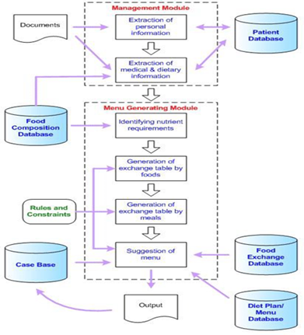

**3.3 Dataflow Diagram**

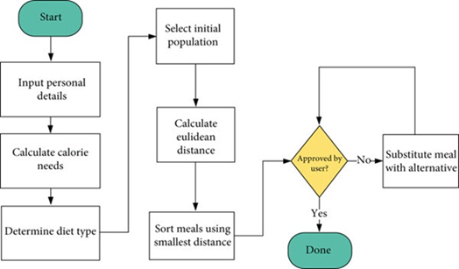

**3.4 Model Evaluation Metrics**

Model evaluation metrics are essential for assessing the effectiveness and reliability of the Personalized Diet Planning and Health Tracker. This section outlines the key metrics used to evaluate the model's performance, along with their significance in the context of personalized diet planning.

**Mean Absolute Error (MAE)**: MAE measures the average absolute difference between predicted values and actual values. It is a straightforward metric that provides insight into the accuracy of the model’s predictions.

**Root Mean Squared Error (RMSE)**: RMSE is another vital metric that quantifies the differences between predicted and observed values

**R-squared (R²)**: This metric indicates the proportion of variance in the dependent variable that can be explained by the independent variables in the model

**Precision and Recall**: In cases where specific dietary restrictions must be met (e.g., allergies), precision and recall metrics become important

**4. RESULT**

The use of AI in personalized diet planning and health tracking has shown significant potential in improving individual health outcomes. By analyzing user data such as dietary preferences, activity levels, and health metrics, AI systems can generate tailored meal plans, track nutrient intake, and provide actionable insights for lifestyle optimization. These systems promote better adherence to health goals by integrating real-time feedback, habit tracking, and predictive analysis. Overall, AI-driven health trackers demonstrate a promising approach to enhancing nutritional awareness, encouraging physical activity, and fostering sustainable health practices.

**5. CONCLUSIONS**

In summary, the future of the "Personalized Diet Planning and Health Tracker using AI" project is promising, with numerous opportunities for expansion and enhancement. By integrating advanced AI techniques, wearable technology, and community features, the application can evolve into a more comprehensive health management tool that not only meets users’ dietary needs but also empowers them to lead healthier lives. The ongoing commitment to user feedback and data security will further strengthen the application’s role as a trusted resource for personalized health and wellness.

**REFERENCES**

1.Ghelani D.P., Moran L.J., Johnson C., Mousa A., Naderpoor N. Mobile Apps for Weight Management: A Review of the Latest Evidence to Inform Practice. Front. Endocrinol. 2020;11:412. doi: 10.3389/fendo.2020.00412.

2.Philippou E., Nikiphorou E. Are we really what we eat? Nutrition and its role in the onset of rheumatoid arthritis. Autoimmun. Rev. 2018;17:1074–1077. doi: 10.1016/j.autrev.2018.05.009.

3.Kant A.K. Dietary patterns and health outcomes. J. Am. Diet. Assoc. 2004;104:615–635. doi: 10.1016/j.jada.2004.01.010.

4.Schwingshackl L., Hoffmann G. Diet Quality as Assessed by the Healthy Eating Index, the Alternate Healthy Eating Index, the Dietary Approaches to Stop Hypertension Score, and Health Outcomes: A Systematic Review and Meta-Analysis of Cohort Studies. J. Acad. Nutr. Diet. 2015;115:780–800.e5. doi: 10.1016/j.jand.2014.12.009.

5.Schwingshackl L., Bogensberger B., Hoffmann G. Diet Quality as Assessed by the Healthy Eating Index, Alternate Healthy Eating Index, Dietary Approaches to Stop Hypertension Score, and Health Outcomes: An Updated Systematic Review and Meta-Analysis of Cohort Studies. J. Acad. Nutr. Diet. 2018;118:74–100.e11. doi: 10.1016/j.jand.2017.08.024.

6.Ministry of Health and Welfare . The 4th Health Plan 2020. Ministry of Health and Welfare Korea; Sejong, Korea: 2015.

7.Fedele D.A., Cushing C.C., Fritz A., Amaro C.M., Ortega A. Mobile health interventions for improving health outcomes in youth: A meta-analysis. JAMA Pediatrics. 2017;171:461–469. doi: 10.1001/jamapediatrics.2017.0042.

8.Chen J., Cade J.E., Allman-Farinelli M. The Most Popular Smartphone Apps for Weight Loss: A Quality Assessment. JMIR mHealth uHealth. 2015;3:e104. doi: 10.2196/mhealth.4334.

9.Yeager S.F., Heim R., Seiler J., Lofton H. Self-Monitoring: The Way to Successful Weight Management. Obesity Action Coalition; Tampa, FL, USA: 2009. Resource Articles.

10.Curtis K.E., Lahiri S., Brown K.E. Targeting Parents for Childhood Weight Management: Development of a Theory-Driven and User-Centered Healthy Eating App. JMIR mHealth uHealth. 2015;3:e69. doi: 10.2196/mhealth.3857.