”**Therapeutic Properties and Health Benefits of Chia Seeds (Salvia hispanica L.): A Comprehensive Review”**

**Abstract**

Brief summary of chia seeds as a functional food.

Overview of their therapeutic effects, including antioxidant, anti-inflammatory, and cardioprotective properties.

Conclude with potential applications in nutraceuticals and diet therapy.

**1.Introduction to Chia Seeds**

Chia seeds come from the plant Salvia Hispanics, a member of the mint family. This plant is native to the regions of southern Mexico and Guatemala. The seeds have been a staple in the diet of ancient civilizations, particularly the Aztecs and Mayans, who prized them for their endurance-boosting properties, which is where the word chia (meaning “strength”) originates. Over time, chia seeds have become a popular superfood, renowned for their high nutritional value and versatility in various diets, particularly among those seeking plant-based options.

**2.Nutritional Profile**

Chia seeds are considered a “superfood” due to their exceptional nutritional content. They are a rich source of:

**Omega-3 Fatty Acids**: Chia seeds are an excellent plant-based source of omega-3 fatty acids, particularly alpha-linolenic acid (ALA), which is essential for heart health and reducing inflammation.

**Protein**: Chia seeds provide a high-quality, plant-based protein, making them an excellent option for vegetarians and vegans. About 4.7 grams of protein are found in a single 28-gram serving.

**Fiber**: With approximately 10.6 grams of fiber per 28 grams of seeds, chia seeds are an excellent source of both soluble and insoluble fiber. This fiber helps improve digestive health, maintain regular bowel movements, and promote feelings of fullness.

**Minerals**: Chia seeds are rich in several key minerals, including calcium, magnesium, phosphorus, potassium, and iron. These minerals are essential for bone health, muscle function, and overall cellular processes.

**Antioxidants**: Chia seeds contain high levels of antioxidants, including flavonoids, chlorogenic acid, and caffeic acid. These antioxidants help protect the body from oxidative stress, which can damage cells and contribute to chronic diseases.

**Low in Sugar:** Chia seeds are naturally low in sugar, making them an ideal food for people following low-carb or ketogenic diets.

**Vitamins**: In addition to minerals, chia seeds contain a variety of B vitamins such as thiamine (B1), niacin (B3), and riboflavin, all of which play essential roles in metabolism and energy production.

**3.Therapeutic Effects and Properties**

3.1. **Cardiovascular Benefits**

High omega-3 fatty acid content lowers triglycerides and improves heart health.

Fiber helps in cholesterol reduction.

Studies indicating antihypertensive effects.

3.2. **Antioxidant Activity**

Phenolic compounds scavenge free radicals.

Role in preventing oxidative stress-related diseases, including cancer and neurodegenerative disorders.

3.3. **Anti-Inflammatory Properties**

Reduction in inflammatory markers like C-reactive protein.

Potential benefits for conditions like arthritis.

3.4. **Weight Management**

High fiber and protein content promote satiety and reduce overall caloric intake.

3.5. **Glycemic Control**

Soluble fiber slows glucose absorption, reducing postprandial glucose spikes.

Suitable for managing diabetes mellitus.

3.6. **Digestive Health**

Insoluble fiber promotes bowel regularity.

Prebiotic properties enhance gut microbiota

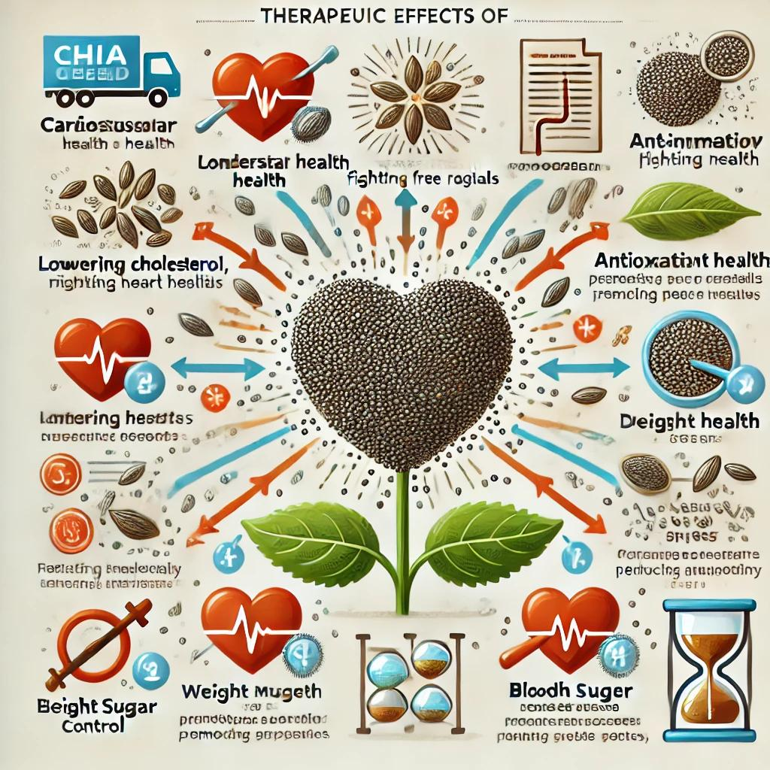

**4**. **Mechanisms of Action**

Omega-3 fatty acids: anti-inflammatory and cardioprotective effects.

Antioxidants neutralizing free radicals.

Fiber aiding in cholesterol excretion and glycemic control.

**5.Applications in Nutraceuticals and Functional Foods**

Use in dietary supplements, beverages, and health bars.

Role in weight-loss diets and therapeutic interventions.

**6. Limitations and Safety**

Potential allergenicity.

Risk of choking if not consumed with adequate liquid due to high water absorption.

Interaction with anticoagulant medications due to high omega-3 content.

**7. Future Perspectives**

Need for more clinical studies to substantiate health claims. Exploration of novel therapeutic uses.

Integration into personalized nutrition plans.

**8. Conclusion**

Summarize the therapeutic potential of chia seeds.

Highlight their role as a sustainable and versatile superfood.

**References**

Ensure all references are from peer-reviewed journals and books. Below are examples of sources:

1. Ullah, R., Nadeem, M., Khalique, A., Imran, M., Mehmood, S., Javid, A., & Hussain, J. (2016). Nutritional and therapeutic perspectives of Chia (Salvia hispanica L.): A review. *Journal of Food Science and Technology, 53*(4), 1750–1758.

2. Martínez-Cruz, O., & Paredes-López, O. (2014). Phytochemical profile and nutraceutical potential of chia seeds (Salvia hispanica L.) by ultrahigh-performance liquid chromatography. *Journal of Chromatography A, 1346*, 43-48.

3. Oliveira-Alves, S. C., Vendramini-Costa, D. B., Betim Cazarin, C. B., et al. (2017). Characterization of phenolic compounds in chia (Salvia hispanica L.) seeds, fiber flour, and oil. *Food Chemistry, 232*, 295-305.

If you’d like, I can help format this as a complete paper or assist in searching for more recent references.