**An Overview on Various Pharmaceutical Advances in Targeted Cancer Therapies.**

Dipshikha Arun Kandekar1, Miss. Aaditee A. Gore2, Dr. Megha T. Salve3.

Department of B. Pharmacy.

Shivajirao Pawar College of B. Pharmacy, Pachegaon,

Ahilyanagar-413725.

**ABSTRACT:** Cancer is a multifactorial disease and is one of the leading causes of death worldwide. The contributing factors include specific genetic background, chronic exposure to various environmental stresses and improper diet. All these risk factors lead to the accumulation of molecular changes or mutations in some important proteins in cells which contributes to the initiation of carcinogenesis. Chemotherapy is an effective treatment against cancer but undesirable chemotherapy reactions and the development of resistance to drugs which results in multi-drug resistance (MDR) are the major obstacles in cancer chemotherapy. Strategies which are in practice with limited success include alternative formulations e.g., liposomes, resistance modulation e.g., PSC833, antidotes/toxicity modifiers e.g., ICRF-187 and gene therapy. Targeted therapy is gaining importance due to its specificity towards cancer cells while sparing toxicity to off-target cells. The scope of this review involves the various strategies involved in targeted therapy like-monoclonal antibodies, prodrug, small molecule inhibitors and nano-particulate antibody conjugates.

**KEYWORDS:** Chemotherapy; Multidrug resistance; Targeted therapy; Prodrug; Small molecule inhibitors; Nano-particulate antibody conjugates.

**INTRODUCTION:** Cancer is the second leading cause of deaths all over the world. Globally 7.6 million deaths are caused by cancer which represents 13% of all global deaths [1]. Surgery, chemotherapy, and irradia tion are the mainstream therapeutic approaches for cancer, che motherapy being an important component of treatment for cancer patients. However, its success is limited due to lack of selectivity for tumor cells over normal cells resulting in insufficient drug concentrations in tumors, systemic toxicity and the appearance of drug-resistant tumor cells [2]. Several strategies have been proposed which include alternative formulations e.g., liposomes [3], resistance modulation e.g., PSC833 [4], antidotes/toxicity modifiers e.g., ICRF-187 [5] and gene therapy. Recently targeted therapy is gaining importance due to its specificity towards cancer cells while sparing toxicity to off-target cells. Targeted therapy aims at delivering drugs to particular genes or proteins that are specific to cancer cells or the tissue environ ment that promotes cancer growth. Effectiveness of the therapy lies in targeted release of therapeutics at the disease site while minimizing the off-target side effects caused to normal tissues. It is often used in conjunction with chemotherapy and other cancer treatments. Targeted therapy involves developing drugs that block cancer cell proliferation, promote cell cycle regulation or induce apoptosis or autophagy and targeted delivery of toxic substances specifically to cancer cells to destroy them. Targeted therapy involves the use of monoclonal antibodies or oral small drugs [6]. Monoclonal antibodies are the focus of intense research in the field of cancer therapeutics since mid 1970s when the customized monoclonal antibody production was reported. Monoclonal anti body production, antibody engineering with display and screening innovations such as phage display meant the binding of antibody to a wide range of targeted antigens with exceptional specificity. Cancer immunotherapy involves the use of gemtuzumab (Mylotarg®; Wyeth, CT, USA), a CD-33 specific monoclonal antibody conju gated to a calicheamicin used for the treatment of acute myeloid leukemia [7]. On a similar note, radioisotope conjugated target ing antibodies have been developed for imaging (immunoscin tigraphy) and radioimmunotherapy strategies. 90Y metal isotope based anti-CD20 ibritumomabtiuxetan (Zevalin®; Spectrum Phar maceuticals, CA, USA) has been developed for use in clinical therapy [8, 9]. Moreover, apart from being used as therapeutic agents anti bodies also serve as targeting agents. They are used in targeted therapy for the delivery of active therapeutics [10], prodrug activation enzymes [11, 12] and chemotherapy toxins [13-15]. Monoclonal antibodies block a specific target on the outside of cancer cells or in the tissue surrounding it. Monoclonal antibod ies are used to deliver chemotherapeutic drugs and radioactive substances, directly to cancer cells. Being large compounds these drugs are usually given intravenously. Prodrug cancer therapy involves selective activation of prodrug(s) in tumor tissues by exogenous enzyme(s) which can be accomplished by several methods which include: gene-directed enzyme prodrug therapy (GDEPT), virus-directed enzyme pro drug therapy (VDEPT), and antibody-directed enzyme prodrug therapy (ADEPT). The important aspect of prodrug cancer therapy is to deliver drug-activating enzyme or gene or functional protein to tumor tissues, followed by systemic administration of a prodrug [2]. Prodrug cancer therapy is a two step process, the first step involves, targeting the drug-activating enzyme and its expression in tumors followed by the systemic administration of the nontoxic prodrug, which is the substrate for the exogenous enzyme that is targeted and expressed in tumors [16-18]. This in turn helps in localization of activated anticancer drug (toxic drug) in high con centration in tumors. The success of the prodrug therapy requires that both enzymes and prodrugs should meet certain criteria: the enzyme should be of nonhuman origin or a human protein either absent or has low expression levels in normal tissues [19, 20] but should find sufficient expression in tumors with high catalytic activity [21]. The prodrug should not be activated by the en dogenous enzymes in non-tumor tissues but must be a good sub strate for the expressed enzyme in tumors. The prodrug should be highly diffusible and be activated in the tumor cell with high cytotoxic potential. Further, it must exhibit ‘bystander’ killing ef fect by being actively taken up by the nonexpressing neighboring cancer cells. The half life of the prodrug should be long enough to exhibit bystander effect but should not permit drug leakage to systemic ciruculation [22]. The targeting strategies for enzyme/ prodrug can be divided into two major classes: (a) delivery of genes that encode prodrug-activating enzymes to tumor tissues (GDEPT, VDEPT, GPAT etc.); and (b) delivery of active enzymes onto tumor tissues (ADEPT). Gene directed enzyme prodrug therapy, is a technique that in volves delivery of a gene that encodes a foreign enzyme to tumor cells where it finds expression and activates a systemically ad ministered nontoxic prodrug [16, 23, 24]. The enzyme/prodrug systems applied in GDEPT include: HSV-TK/GCV, Escherichia coli CD/5-FC and E. coli NTR/CB1954 which act intracellularly by converting prodrugsinto active drugs within cancer. Cell-cell contact is essential for this mode of action for effective killing. An extra-cellular cytotoxic effector system includes the conver sion of an inactive glucuronidated derivative of doxorubicin (HMR 1826) to the cytotoxic doxorubicin in the tumor cells by the secreted form of lysosomal human glucuronidase. In the ex tracellular system the hydrophilic prodrug gets converted into a lipophilic, cell-permeable cytotoxic drug outside cells and hence targets both transduced and nontransduced cells. It exhibits en hanced cytotoxic potential as cell-cell contact is not required for a bystander effect [16]. Virus directed enzyme prodrug therapy (VDEPT) uses viral vectors to deliver a gene that encodes an enzyme that can convert a systemically administrated nontoxic prodrug into a cytotoxic agent within tumor cells. The NTR/CB1954 combination is used against colorectal and pancreatic cancer cells to sensitize them to CB1954 after retro-viral transduction and expression of the E. coli NTR gene [25, 26]. The viruses used for VDEPT include: retroviruses, adenoviruses, HSV [27], adeno-associated virus [28-30], lentivirus and EBV [31]. Over the years, many drug-activating enzyme gene/ prodrug combinations have been delivered into tumors in vitro or in vivo by VDEPT, the majority using CD/5-FC or HSV-TK/GCV with the involvement of retroviral and adenoviral vectors [32]. Genetic prodrug activation therapy (GPAT) induces the selec tive expression of a drug-metabolizing enzyme for activation of prodrug into a toxic moiety using the known transcriptional dif ferences between normal and tumor cells [33, 34]. Several tumor specific Transription responsive elements (TREs) have been used, which include genes that are either tumor specific or tumor as sociated antigens, such as CEA for colorectal cancer or N-myc for neuroblastoma [2]. Antibody directed enzyme prodrug therapy (ADEPT) uses a conjugate which consists of tumor specific antibody linked to a drug-activating enzyme which when administered systemically targets tumor tissues. This targeted enzyme which is localized on the tumor surface, converts the systemically administered nontox ic prodrug into a toxic drug resulting in cytotoxic effects in tumor cells [12, 35-40]. The ideal drugs for ADEPT include diffusible small molecules, which can diffuse in to both antigen-positive and antigen-negative tumor cells, and cause a bystander effect [35-37]. The interval between enzyme and prodrug administrations should be optimized to enhance the conjugate accumulation in tumors and avoid their leakage to blood and normal tissues, to avoid sys temic toxicity. The important criteria for ADEPT include: the target antigen should be accessible, therefore it should preferably be a mem brane bound antigen associated with the tumor cell membrane or secreted into the extracellular matrix of the tumor [41], and the antibody should be a monoclonal antibody with high affinity [35]. The enzyme should have optimal activity at a pH close to that of the tumor extracellular fluid. The interval between enzyme and prodrug administrations is important for ADEPT, studies carried out in animals regarding the optimal interval showed that with the enzyme CPG2 linked to the anti-CEA antibody A5B7, the prodrug CMDA can be safely given 48 h or 72 h after antibody-enzyme administration [36]. In human subjects, the prodrug can be administered safely after 7 days to avoid systemic toxicity due to the activation of prodrug in plasma, as it takes 7 days for the adequate clearance of antibody enzyme conjugate from the plasma [35]. The Phase I clinical trials carried out with CMDA/CPG2 prodrug/ enzyme system in colorectal carcinoma patients has revealed promising results. The bacterial enzyme CPG2 was conjugated to the F(ab)2 fragment of murine A5B7 monoclonal Ab, and a galactosylated second clear ing Ab against CPG2 was also used to lower levels of conjugate in the circulation and other nontumor tissues. The plasma levels of the prodrug CMDA and active drug CJS11, a bifunctional alkylating agent, released from prodrug by the action of CPG2 localized in tumors were measured. The results showed that after applying the clearing agent, CPG2 activity was found in meta static tumor biopsies, but not found in normal tissues. Further, a rapid appearance of the active drug with half-life of 36 ± 14 min in plasma was encouraging [42]. The limitations of ADEPT include: restricted delivery of the large conjugate in poorly vascularized tumors, therefore it is not possible to deliver antibody/enzyme conjugate to all of the tumor cells [43]. With low levels of the enzyme, adequate quantities of active drug to reach the cytotoxic concentration cannot be achieved. The antigen heterogeneity does not permit the bind ing of the conjugate to the cell surface. Other disadvantages of ADEPT include cost and availability of purified antibodies, im munogenicity of antibodies, accessibility of tumor to the enzyme/ antibody conjugate, and the conversion of prodrugs in nontumor tissues [41]. The main problem being the immunogenicity of the antibody-enzyme conjugate, which limits multiple cycles of its application this can be overcome with the use of humanized proteins and concomitant administration of immunosuppression [35].

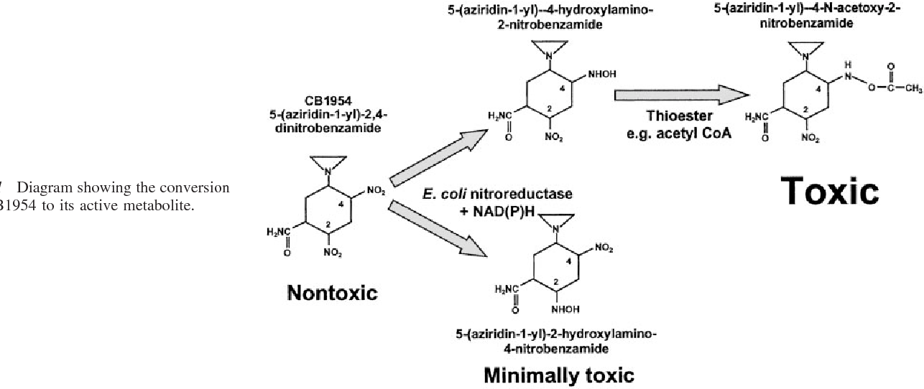

*Fig. Conversion of CB1945 to its active metabolite.*

* **Small molecule inhibitors in cancer therapy:**

Small drugs constitute a pill that a patient takes orally. As they are smaller chemical components than monoclonal antibodies, the body absorbs them better. The small drugs usually are targeted against specific molecular targets which are important for cancer cell proliferation or metastasis or angiogenesis. The current state of cancer drug discovery and development focuses on small molecule inhibitors which act against new molecular targets that determine therapeutic outcome. The molecularly targeted cancer therapies have resulted in improving the lives of a large number of cancer patients. The successful treatment of patients with acute promyelocytic leukaemia harbouring translocations in the RARα retinoic acid receptor gene with all-trans retinoic acid [44] and chronic myeloid leukaemia in which the malignancy is driven by the BCR-ABL translocation with the ABL inhibitor imatinib [45, 46] serve as the proof of the concept of molecular targeting of pathogenetic driver abnormalities with a small molecule in the clini- cal setting. The other small molecule inhibitors of cancer targets include, e.g. the gefitinib - inhibitor of epidermal growth factor re ceptor (EGFR) kinase and erlotinib- the inhibitor of EGFR in non small cell lung cancer (NSCLC) patients; the lapatinib- inhibitor of EGFR/ERBB2 for ERBB2-positive breast cancer; and the sorafenib- inhibitor of vascular epidermal growth factor receptor (VEGFR) kinase, in renal cancer [47]. The recent addition to the list is, abiraterone- the CYP171A1 inhibitor which blocks andro gen synthesis, approved for treatment of late stage, castration resistant prostate cancer [48], crizotinib -inhibitor of the protein kinase ALK approved for the treatment of NSCLC patients with a pathogenic rearrangement of the ALK gene [49] and vemurafenib – inhibitor of BRAF kinase [50] for metastatic melanoma with the BRAF V600E mutation. The progress with small molecule drugs is mirrored by the successful introduction of protein-based therapeutics, particularly antibodies, as exemplified by the anti ERBB2 monoclonal antibody trastuzumab in ERBB2-positive breast cancer [51, 52]. These examples provide ample evidence of the success in targeting the pathogenic drivers to which cancer cells are ‘addicted’ [53, 54]. Despite the considerable progress in cancer therapy with the advent of new molecularly targeted therapies, therapeutic options are still limited for many patients and the process of new drug development is frustratingly slow with high failure rates [52, 55], The reasons for slow progress is that, frequently, a patient with a particular anatomically and histologically defined solid tumor respond to the treatment with a particular class of kinase inhibi tor that matches the predominant pathogenic driver mutation e.g., NSCLC patients with EGFR mutations respond to EGFR inhibitors while those with ALK translocations respond to ALK inhibitors [47, 56]. Which necessitates understanding the value of specific gene targeting and selection of patient specific companion bio markers on cancer drug discovery. Another important task is identification of specific molecular targets through the sequencing of various cancer genomes which revealed extraordinary complexity with several genetic alterations and considerable genetic heterogeneity, not only between different tumours but also within an individual cancer [57-59]. Further, the heterogeneous population of tumors also include drug-resistant stem [60] and other host cells which aid in tumour progression [47]. This heterogeneity leads to drug resistance and the need for combinatorial therapy. After identification of a potential novel therapeutic target, the next challenge is that of selecting and validating the best targets. This requires establishing a causal linkage of the proposed target and target modulation to deliver a therapeutically meaningful biological effect in relevant experimental models. ‘Druggability gap’ is the main concern in the drug discovery for medicinal chemists using small molecules. Frequently, the promising tar gets are regarded as technically undruggable as they cannot be targeted with small molecules which is referred to as ‘druggability gap’ e.g., RAS proteins, c-MYC or hypoxia inducible factor (HIF) [61]. Unfortunately, sometimes, cancer cells develop resistance for drugs with therapeutic efficacy as proved by the successful completion of clinical trials as shown recently by crizotinib [62] and vemurafenib [63]. This could be due to the mutation of the target gene [64], or activation of feedback loops [65] or develop ment of alternative oncogenic pathways [66, 67]. In such cases combinatorial regimen helps to overcome such problems [68].

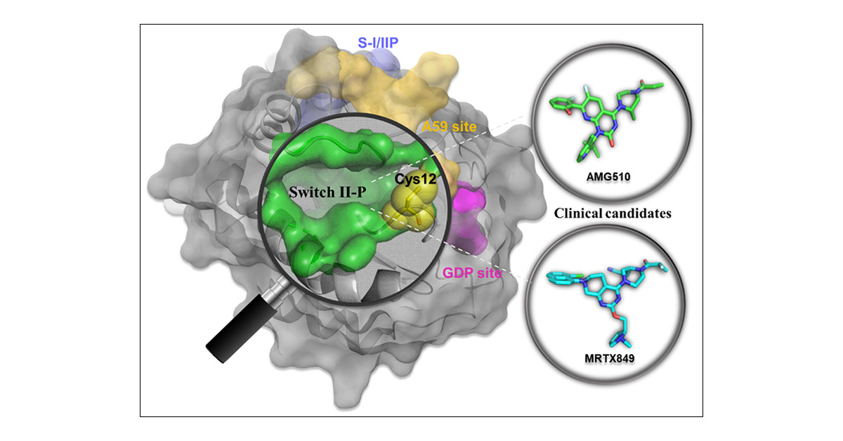

*Fig. Small molecules directly targeting KRAS as anti-Cancer agent.*

* **Antibody-conjugated Nanoparticles for targeted Cancer Therapy:**

Recently research in nanoparticle based targeted therapy has gained momentum which saw the use of a full spectrum of nano particles in diagnostic and therapeutic applications of cancer [69]. Antibody-NP conjugates are being used for targeted de livery of chemotherapeutics and are considered as better thera peutic agents compared to NP conjugates due to their ability to circumvent some of the problems associated with direct conju gates, such as possible inactivation of the drug and the release of the drug in nonspecific areas once internalized into endosomal/ lysosomal vesicles through pH labile or reducible linkers [70, 71]. Moreover, the limitation with respect to the amount of drug that can be delivered to targeted area with direct antibody con- jugated drug can be overcome by the use of antibody-NP com plexes, which maximize the concentration of drug that can be targeted to the disease site. Recent studies focused on the de- velopment of antibody-coated lipid and non-lipid based nanopar ticulates for antitumor research. The nanoparticulate antibody targeting research is focused on antitumor strategies, where the antibody is used to target cell-surface markers of disease which are frequently upregulated or are specifically expressed in tumor cells [70-72]. Thus, the cancer drug discovery involves genome wide se quencing, understanding molecular pathology through bioinfor matics and systems biology approaches for understanding how cancer cells can be targeted through single agents or on several fronts through drug combinations [73-75]. Although targeted treatment is considered a breakthrough in cancer treatment, latest research findings show that tumor heterogeneity with respect to molecular targets cause failure in many cases. This lead to evolution of concept of matching a patient to treatment which in other words is known as personalized medicine. In order to find the most effective treatment, the patient will be screened for the genes, proteins, and other factors unique to your tumor. After identifying the appropriate molecular targets the best suitable treatment will be recommended. Personalized medicine is gain ing importance which ensures that the right drug is given to the right patient at the right time whereby maximum therapeutic ben efit to patients is achieved. Pharmacologists and basic researchers are working together towards the discovery of effective and safe clinical candidates against the new targets trying to bridge the gap frequently referred to as technically druggable.

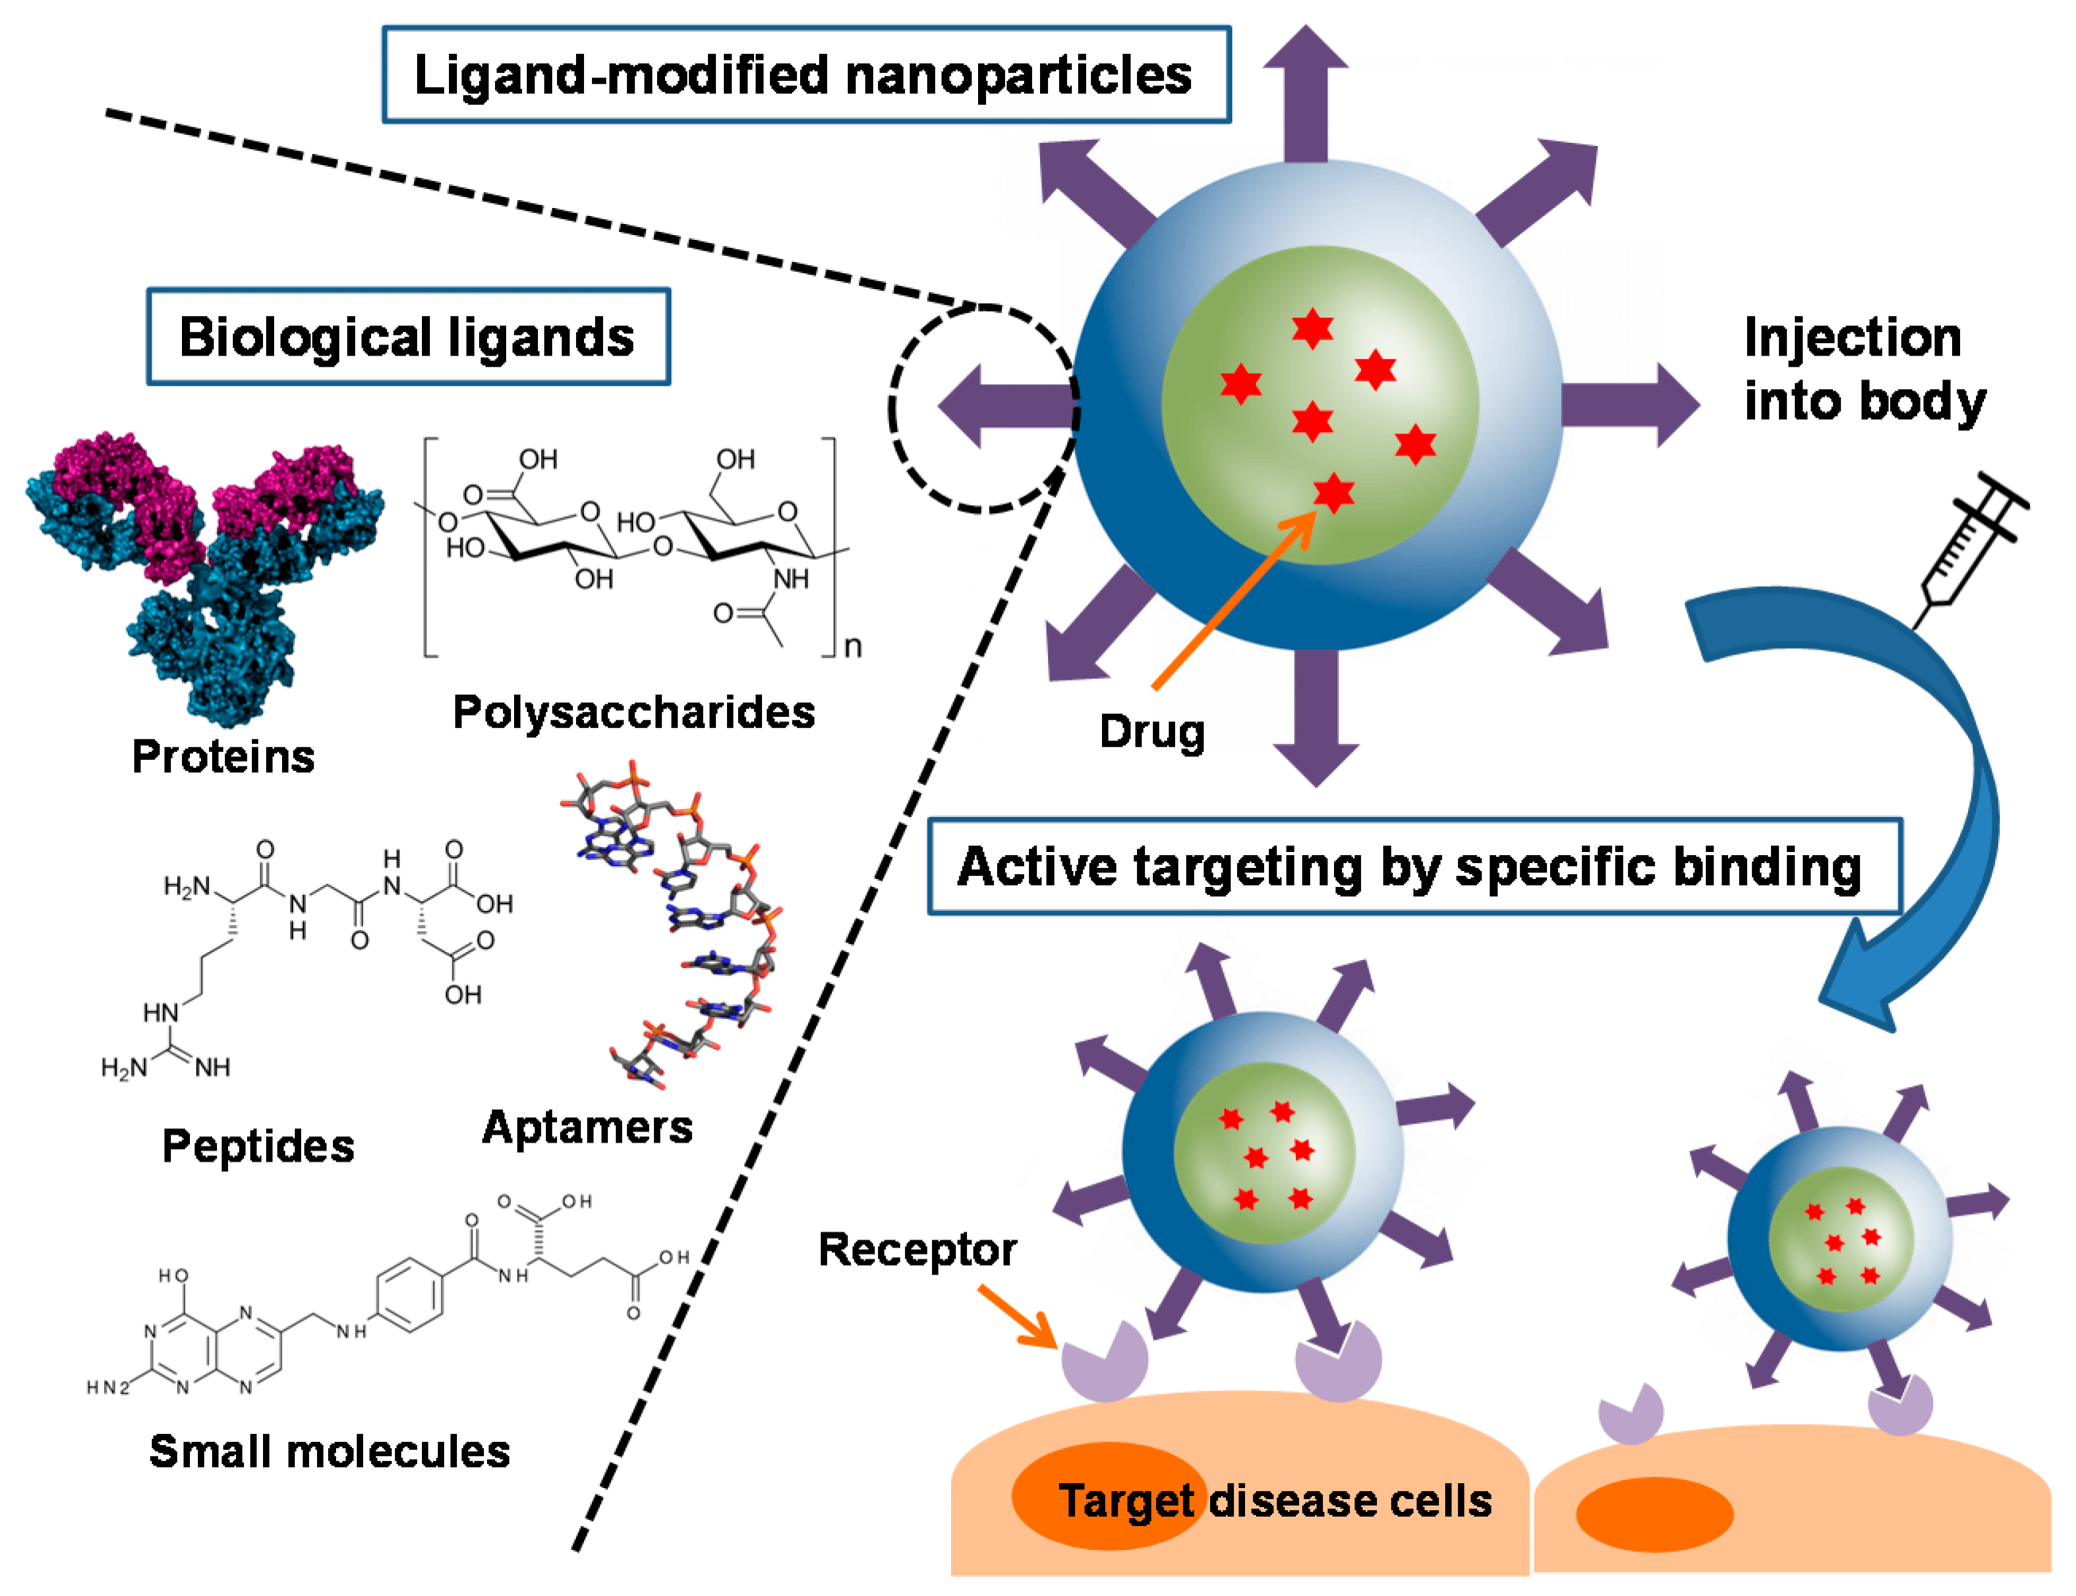

*Fig.**Antibody-conjugated Nanoparticles for targeted Cancer Therapy.*

**CONCLUSION:** Current methods in oncology focus on the development of safe and efficient cancer nanomedicines. Targeted medical care helped rising the biodistribution of recent or already tested chemotherapeutical agents around the specific tissue to be treated; different methods, such as sequence medical care, siRNAs delivery, therapy, and inhibitor molecules, supply new potentialities to cancer patients. Gene therapy acts by direct in situ insertion of exogenous genes into benign tumors. Noticeably, stem cells can be used as regenerative medicine, therapeutic carriers, drug targeting, and generation of immune cells because of having unique biological actions on other cells. On the opposite hand, thermal ablation and magnetic hyperthermia are promising alternatives to the growth surgical process. Finally, radionics and pathomics approaches facilitate the management of huge knowledge sets from cancer patients to enhance prognosis and outcomes. Much progress has been made, but many others are likely to come soon, producing more and more ad hoc personalized therapies. Further development and refinement of drug delivery systems are essential for improving therapeutic outcomes.

Although conventional chemotherapy has been the cornerstone in the fight against cancer, is far from being totally satisfactory due to problems related with their formulation and pharmacokinetics, the acquired resistance to some cytotoxic agents, and, overall, their toxicity and indiscriminate action, that make necessary a more selective therapy. This selectivity is being achieved with the development of targeted chemotherapeutics that specifically target the biologic transduction pathways

**AKNOWLEDGEMENT:** The corresponding author would like to express sincere gratitude to Miss. Aaditee A. Goremam for their aspiring guidance, valuable contributions and support throughout the preparation of this review article. Her dynamic vision, genuine sincerity, and unwavering motivation have been a profound source of inspiration for me. It was a tremendous privilege and a source of great honour to have the opportunity to learn and collaborate under their exceptional guidance.

**REFERENCES:**

[1] Jemal A, Bray F, Center MM, Ferlay J, Ward E, Forman D. Global cancer statistics. CA Cancer J Clin 2011; 61: 69-90.

[2] Xu G, McLeod HL. Strategies for enzyme/prodrug cancer therapy. Clin Cancer Res 2001; 7: 3314-24.

[3] Krishna R, Mayer LD. Liposomal doxorubicin circumvents PSC 833-free drug interactions, resulting in effective therapy of multi drug-resistant solid tumors. Cancer Res 1997; 57: 5246-53.

[4] Fracasso PM, Westervelt P, Fears CL, Rosen DM, Zuhowski EG, Cazenave LA, et al. Phase I study of paclitaxel in combination with a multidrug resistance modulator, PSC 833 (Valspodar), in refractory malignancies. J Clin Oncol 2000; 18: 1124-34.

[5] Hasinoff BB, Chee GL, Thampatty P, Allan WP, Yalowich JC. The cardioprotective and DNA topoisomerase II inhibitory agent dexra zoxane (ICRF-187) antagonizes camptothecin-mediated growth inhibition of Chinese hamster ovary cells by inhibition of DNA syn thesis. Anticancer Drugs 1999; 10: 47-54.

[6] Gerber DE. Targeted therapies: a new generation of cancer treat ments. Am Fam Physician 2008; 77: 311-9.

[7] Sorokin P. Mylotarg approved for patients with CD33+ acute my eloid leukemia. Clin J Oncol Nurs 2000;4:279-80.

[8] Jacobs SA. Yttrium ibritumomab tiuxetan in the treatment of non Hodgkin’s lymphoma: current status and future prospects. Biologics 2007; 1: 215-27.

[9] Vitolo U, Ladetto M, Boccomini C, Evangelista A, Gamba E, Russo E, et al. Brief Chemoimmunotherapy R-FND with Rituximab Con solidation Followed by Randomization Between Rituximab Main tenance Vs. Observation As First Line Treatment in Elderly Patients with Advanced Follicular Lymphoma (FL): Final Results of a Pro spective Randomized Trial by Italian Lymphoma Foundation (FIL). Blood 2011; 118: 352-53.

[10] Lode HN, Xiang R, Becker JC, Gillies SD, Reisfeld RA. Immunocy tokines: A promising approach to cancer immunotherapy. Pharmacol Ther 1998; 80: 277-92.

[11] Kerr DE, Vrudhula VM, Svensson HP, Siemers NO, Senter PD. Comparison of recombinant and synthetically formed monoclonal antibody-beta-lactamase conjugates for anticancer prodrug activa tion. Bioconjug Chem 1999; 10: 1084-89.

[12] Wolfe LA, Mullin RJ, Laethem R, Blumenkopf TA, Cory M, Miller JF, et al. Antibody-directed enzyme prodrug therapy with the T268G mutant of human carboxypeptidase A1: In vitro and in vivo studies with prodrugs of methotrexate and the thymidylate synthase inhibi tors GW1031 and GW1843. Bioconjug Chem 1999; 10: 38-48.

[13] Kawakami K, Nakajima O, Morishita R, Nagai R. Targeted antican cer immunotoxins and cytotoxic agents with direct killing moieties. Thescientific World Journal 2006; 6: 781-90.

[14] Hamann PR, Hinman LM, Hollander I, Beyer CF, Lindh D, Holcomb R, et al. Gemtuzumab ozogamicin, a potent and selective anti-CD33 antibody-calicheamicin conjugate for treatment of acute myeloid leukemia. Bioconjug Chem 2002; 13: 47-58.

[15] Henry MD, Wen S, Silva MD, Chandra S, Milton M, Worland PJ. A prostate-specific membrane antigen-targeted monoclonal antibody chemotherapeutic conjugate designed for the treatment of prostate cancer. Cancer Res 2004; 64: 7995-8001.

[16] Weyel D, Sedlacek HH, Muller R, Brusselbach S. Secreted human beta-glucuronidase: a novel tool for gene-directed enzyme prodrug therapy. Gene Ther 2000; 7: 224-31.

[17] Hamstra DA, Rehemtulla A. Toward an enzyme/prodrug strategy for cancer gene therapy: endogenous activation of carboxypeptidase A mutants by the PACE/Furin family of propeptidases. Hum Gene Ther 1999; 10: 235-48.

[18] Springer CJ, Niculescu-Duvaz I. Prodrug-activating systems in suicide gene therapy. J Clin Investig 2000; 105: 1161-67.

[19] Riggs CD. Meiotin-1: the meiosis readiness factor? BioEssays 1997; 19: 925-31.

[20] Rainov NG, Dobberstein KU, Sena-Esteves M, Herrlinger U, Kramm CM, Philpot RM, et al. New prodrug activation gene therapy for cancer using cytochrome P450 4B1 and 2-aminoanthracene/4-ipom eanol. Human Gene Ther 1998; 9: 1261-73.

[21] Niculescu-Duvaz I, Spooner R, Marais R, Springer CJ. Gene-directed enzyme prodrug therapy. Bioconjug Chem 1998; 9: 4-22.

[22] Friedlos F, Court S, Ford M, Denny WA, Springer C. Gene-directed enzyme prodrug therapy: quantitative bystander cytotoxicity and DNA damage induced by CB1954 in cells expressing bacterial ni troreductase. Gene Ther1998; 5: 105-12.

[23] Clark AJ, Iwobi M, Cui W, Crompton M, Harold G, Hobbs S, et al. Selective cell ablation in transgenic mice expressing E-coli nitrore ductase. Gene Ther 1997; 4: 101-10.

[24] Bridgewater JA, Knox RJ, Pitts JD, Collins MK, Springer CJ. The bystander effect of the nitroreductase CB 1954 enzyme prodrug sys tem is due to a cell-permeable metabolite. Human Gene Ther 1997; 8: 709-17.

[25] McNeish IA, Green NK, Gilligan MG, Ford MJ, Mautner V, Young LS, et al. Virus directed enzyme prodrug therapy for ovarian and pancreatic cancer using retrovirally delivered E-coli nitroreductase and CB1954. Gene Ther 1998; 5: 1061-69.

[26] Grove JI, Searle PF, Weedon SJ, Green NK, McNeish IA, Kerr DJ. Virus-directed enzyme prodrug therapy using CB1954. Anti-Cancer Drug Des 1999; 14: 461-72.

[27] Nakamura H, Mullen JT, Chandrasekhar S, Pawlik TM, Yoon SS, Tanabe KK. Multimodality therapy with a replication-conditional herpes simplex virus 1 mutant that expresses yeast cytosine deami nase for intratumoral conversion of 5-fluorocytosine to 5-fluoroura cil. Cancer Res 2001; 61: 5447-52.

[28] Warrington KH, Teschendorf C, Cao LG, Muzyczka N, Siemann DW. Developing VDEPT for DT-diaphorase (NQO1) using an AAV vector plasmid. Int J Radia Oncol Biol Phys 1998; 42: 909-12.

[29] Kanazawa T, Urabe M, Mizukami H, Okada T, Kume A, Nishino H, et al. gamma-Rays enhance rAAV-mediated transgene expres sion and cytocidal effect of AAV-HSVtk/ganciclovir on cancer cells. Cancer Gene Ther 2001; 8: 99-106.

[30] Fukui T, Hayashi Y, Kagami H, Yamamoto N, Fukuhara H, Tohnai I, et al. Suicide gene therapy for human oral squamous cell carcinoma cell lines with adeno-associated virus vector. Oral Oncol 2001; 37: 211-5.

[31] Westphal EM, Ge JQ, Catchpole JR, Ford M, Kenney SC. The ni troreductase/CB1954 combination in Epstein-Barr virus-positive B 4 BioMedicine | http://biomedicine.cmu.edu.tw/ December 2015 | Volume 5 | Issue 4 | e46 cell lines: Induction of bystander killing in vitro and in vivo. Cancer Gene Ther 2000; 7: 97-106.

[32] Curiel DT. The development of conditionally replicative adenovi ruses for cancer therapy. Clin Cancer Res 2000; 6: 3395-99.

[33] Rigg A, Sikora K. Genetic prodrug activation therapy. Mol Med Today 1997; 3: 359-66.

[34] Pandha HS, Martin LA, Rigg A, Hurst HC, Stamp GWH, Sikora K, et al. Genetic prodrug activation therapy for breast cancer: A phase I clinical trial of erbB-2-directed suicide gene expression. J Clin Oncol 1999; 17: 2180-89.

[35] Syrigos KN, Epenetos AA. Antibody directed enzyme prodrug therapy (ADEPT): A review of the experimental and clinical consid erations. Anticancer Res 1999; 19: 605-13.

[36] Stribbling SM, Martin J, Pedley RB, Boden JA, Sharma SK, Springer CJ. Biodistribution of an antibody-enzyme conjugate for antibody-directed enzyme prodrug therapy in nude mice bearing a human colon adenocarcinoma xenograft. Cancer Chemother Phar macol 1997; 40: 277-84.

[37] Syrigos KN, Rowlinson-Busza G, Epenetos AA. In vitro cytotoxicity following specific activation of amygdalin by beta-glucosidase con jugated to a bladder cancer-associated monoclonal antibody. Int J Cancer 1998; 78: 712-19.

[38] Florent JC, Dong X, Gaudel G, Mitaku S, Monneret C, Gesson JP, et al. Prodrugs of anthracyclines for use in antibody-directed enzyme prodrug therapy. J Med Chem 1998; 41: 3572-81.

[39] Pedley RB, Sharma SK, Boxer GM, Boden R, Stribbling SM, Davies L, et al. Enhancement of antibody-directed enzyme prodrug therapy in colorectal xenografts by an antivascular agent. Cancer Res 1999; 59: 3998-4003.

[40] Haisma HJ, Sernee MF, Hooijberg E, Brakenhoff RH, van den Meulen-Mulleman IH, Pinedo HM, et al. Construction and charac terization of a fusion protein of single-chain anti-CD20 antibody and human beta-glucuronidase for antibody-directed enzyme prodrug therapy. Blood 1998; 92: 184-90.

[41] Mason DW, Williams AF. The Kinetics of Antibody-Binding to Membrane-Antigens in Solution and at the Cell-Surface. Biochem J 1980; 187: 1-20.

[42] Martin J, Stribbling SM, Poon GK, Begent RHJ, Napier M, Sharma SK, et al. Antibody-directed enzyme prodrug therapy: Pharmacoki netics and plasma levels of prodrug and drug in a phase I clinical trial. Cancer Chemother Pharmacol 1997; 40: 189-201.

[43] Denny WA, Wilson WR. The design of selectively-activated anti cancer prodrugs for use in antibody-directed and gene-directed enzyme-prodrug therapies. J Pharm Pharmacol 1998; 50: 387-94.

[44] Huang ME, Ye YC, Chen SR, Chai JR, Lu JX, Zhoa L, et al. Use of All-Trans Retinoic Acid in the Treatment of Acute Promyelocytic Leukemia. Blood 1988; 72: 567-72.

[45] O’Brien SG, Guilhot F, Larson RA, Gathmann I, Baccarani M, Cervantes F, et al. Imatinib compared with interferon and low-dose cytarabine for newly diagnosed chronic-phase chronic myeloid leu kemia. N Engl J Med 2003; 348: 994-1004.

[46] Druker BJ, Guilhot F, O'Brien SG, Gathmann I, Kantarjian H, Gat termann N, et al. Five-year follow-up of patients receiving imatinib for chronic myeloid leukemia. N Engl J Med 2006; 355: 2408-17.

[47] Yap TA, Workman P. Exploiting the cancer genome: strategies for the discovery and clinical development of targeted molecular thera peutics. Annu Rev Pharmacol Toxicol 2012; 52: 549-73.

[48] de Bono JS, Logothetis CJ, Molina A, Fizazi K, North S, Chu L, et al. Abiraterone and increased survival in metastatic prostate cancer. N Engl J Med 2011; 364: 1995-2005.

[49] Kwak EL, Bang YJ, Camidge DR, Shaw AT, Solomon B, Maki RG, et al. Anaplastic lymphoma kinase inhibition in non-small-cell lung cancer. N Engl J Med 2010; 363: 1693-703.

[50] Chapman PB, Hauschild A, Robert C, Haanen JB, Ascierto P, Larkin J, et al. Improved survival with vemurafenib in melanoma with BRAF V600E mutation. N Engl J Med 2011; 364: 2507-16.

[51] Slamon DJ, Leyland-Jones B, Shak S, Fuchs H, Paton V, Bajamonde A, et al. Use of chemotherapy plus a monoclonal antibody against HER2 for metastatic breast cancer that overexpresses HER2. N Engl J Med 2001; 344: 783-92.

[52] Kola I, Landis J. Can the pharmaceutical industry reduce attrition rates? Nat Rev Drug Discov 2004; 3:711-16.

[53] Weinstein IB. Cancer. Addiction to oncogenes--the Achilles heal of cancer. Science 2002; 297: 63-4.

[54] Weinstein IB, Joe A. Oncogene addiction. Cancer Res 2008; 68: 3077-80; discussion 80.

[55] DiMasi JA, Grabowski HG. Economics of new oncology drug de velopment. J Clin Oncol 2007; 25: 209-16.

[56] Collins I, Workman P. New approaches to molecular cancer thera peutics. Nat Chem Biol 2006; 2: 689-700.

[57] McDermott U, Downing JR, Stratton MR. Genomics and the con tinuum of cancer care. N Engl J Med 2011; 364: 340-50.

[58] Sellers WR. A blueprint for advancing genetics-based cancer therapy. Cell 2011; 147: 26-31.

[59] De Palma M, Hanahan D. The biology of personalized cancer medi cine: facing individual complexities underlying hallmark capabili ties. Mol Oncol 2012; 6: 111-27.

[60] Jordan CT, Guzman ML, Noble M. Cancer stem cells. N Engl J Med 2006; 355: 1253-61.

[61] Verdine GL, Walensky LD. The challenge of drugging undruggable targets in cancer: lessons learned from targeting BCL-2 family mem bers. Clin Cancer Res 2007; 13: 7264-70.

[62] Sasaki T, Koivunen J, Ogino A, Yanagita M, Nikiforow S, Zheng W, et al. A novel ALK secondary mutation and EGFR signaling cause resistance to ALK kinase inhibitors. Cancer Res 2011; 71: 6051-60.

[63] Poulikakos PI, Persaud Y, Janakiraman M, Kong X, Ng C, Moriceau G, et al. RAF inhibitor resistance is mediated by dimerization of aberrantly spliced BRAF(V600E). Nature 2011; 480: 387-90.

[64] Gibbons DL, Pricl S, Kantarjian H, Cortes J, Quintas-Cardama A. The rise and fall of gatekeeper mutations? The BCR-ABL1 T315I paradigm. Cancer 2012; 118: 293-9.

[65] Rodrik-Outmezguine VS, Chandarlapaty S, Pagano NC, Poulikakos PI, Scaltriti M, Moskatel E, et al. mTOR kinase inhibition causes feedback-dependent biphasic regulation of AKT signaling. Cancer Discov 2011; 1: 248-59.

[66] Johannessen CM, Boehm JS, Kim SY, Thomas SR, Wardwell L, Johnson LA, et al. COT drives resistance to RAF inhibition through MAP kinase pathway reactivation. Nature 2010; 468: 968-U370.

[67] Nazarian R, Shi HB, Wang Q, Kong XJ, Koya RC, Lee H, et al. Melanomas acquire resistance toB-RAF(V600E) inhibition by RTK or N-RAS upregulation. Nature 2010; 468: 973-U377.

[68] Whitehurst AW, Bodemann BO, Cardenas J, Ferguson D, Girard L, Peyton M, et al. Synthetic lethal screen identification of chemosen sitizer loci in cancer cells. Nature 2007; 446: 815-19. 5 BioMedicine | http://biomedicine.cmu.edu.tw/ December 2015 | Volume 5 | Issue 4 | e46

[69] Gleysteen JP, Newman JR, Chhieng D, Frost A, Zinn KR, Rosenthal EL. Fluorescent labeled anti-EGFR antibody for identification of re gional and distant metastasis in a preclinical xenograft model. Head and Neck-Journal for the Sciences and Specialties of the Head and Neck 2008; 30: 782-89.

[70] Fay F, Scott CJ. Antibody-targeted nanoparticles for cancer therapy. Immunotherapy 2011; 3: 381-94.

[71] Vanniasinghe AS, Bender V, Manolios N. The Potential of Liposomal Drug Delivery for the Treatment of Inflammatory Arthritis. Semin Arthritis Rheum 2009; 39: 182-96.

[72] Cirstoiu-Hapca A, Buchegger F, Lange N, Bossy L, Gurny R, Delie F. Benefit of anti-HER2-coated paclitaxel-loaded immuno-nanopar ticles in the treatment of disseminated ovarian cancer: Therapeutic efficacy and biodistribution in mice. J Control Release 2010; 144: 324-31.

[73] Stratton MR. Exploring the Genomes of Cancer Cells: Progress and Promise. Science 2011; 331: 1553-58.

[74] MacConaill LE, Garraway LA. Clinical Implications of the Cancer Genome. J Clin Oncol 2010; 28: 5219-27.

[75] Kitano H. Cancer robustness - Tumour tactics. Nature 2003; 426: 125-25