**WORK TASK MOTIVATION FRAMEWORK AMONG CONTRACT OF SERVICE ENGINEERS**

Achacoso, Mae Jean

Curzon, Mainz Clare

Gelig, Ella Kim

Gumapac, Alexis May

Jamili, Kristine Mae

Samson, Marienelle

**University of Southeastern Philippines College of Development Management Graduate Program Mintal Campus, Davao City**

**ABSTRACT**

This study aimed to determine dimensions of work task motivation among contract service engineers. The research was carried out using a random sampling method upon 150 structural engineers who worked as contractual employees in some private and government agencies within Davao Region. Data was collected from the respondents using the 30-item questionnaire. Exploratory Factor Analysis (EFA) was used in the study. The researchers identified constructs the work motivation of the contract of service engineers such as motivation and engagement, personal growth and collaboration, professional excellence, and work-life balance. these findings align with the research objective by revealing the complex nature of motivation in this specific workforce context. The framework on the work task motivation among contract of service was developed.

**Keywords:**

Work Motivation, Contract of Service (COS), Engineers



**INTRODUCTION**

Contract employees' negative effect on work motivation is mediated by organizational identity, and unmotivated contract employees are associated with self-centered reactions to injustice compared to the company's permanent workers (Lheureux & Parmentier, 2022). Engineers who operate on contractual or on temporary basis like Contract of Services (COS) engineers are faced with unique challenges pertaining to the retention of motivation and performance levels, because of the nature of their work contracts. Most people associate engineering with problem-solving, creativity, and technical competencies. But it is also essential to understand what motivates and encourages engineers to perform better (Gagné et al., 2018; Lee & Kim, 2019).

Motivation is a key factor that has an effect on both job performance and employee engagement (Bakker & Albrecht, 2018). In areas such as engineering where high skill levels are required to perform complex tasks, understanding the psychological determinants becomes critical in achieving productive output. For engineers working under a Contract of Services (COS), who are typically engaged in short-term or project-based employment, the motivational factors may be different from those of the permanent employees. Employing the individual on a temporary basis creates a variety of problems such as lack of job security and lack of attachment to the organization which may undermine work satisfaction and ability to perform tasks.

While motivation has been extensively studied in various contexts (Gagné et al., 2018), there is limited research on the specific motivational factors influencing COS engineers. Recent motivational theories, such as Self-Determination Theory (SDT), Goal Setting Theory, and the Job Demands-Resources (JD-R) Model, provide valuable frameworks for understanding how both intrinsic and extrinsic factors affect motivation. This paper aims to develop a Work Task Motivation Model tailored to COS engineers, providing insights into the key factors that drive their motivation and performance.

**OBJECTIVE**

This research aims to identify the work task motivation constructs among contract of service engineers employed on a contractual basis. It aims to develop a comprehensive motivation framework that highlights both motivating and demotivating factors, providing actionable insights for organizations to enhance productivity and satisfaction through targeted interventions.

**METHODOLOGY**

The research was carried out using a random sampling method upon 150 structural engineers who worked as contractual employees in some private and government agencies within Davao Region. Data was collected from the respondents using the 30-item questionnaire. This questionnaire along with its results was then presented to the evaluator for the evaluation and validation purpose.

The researchers carried out Exploratory Factor Analysis (EFA) because they wanted to find out the factors that motivated engineers to work within private and government agencies. EFA is a type of complex multivariate statistical techniques that is used for scale development in cases where it is difficult to establish a priori the number and nature of the common factors. The process is said to contain a number of well-defined and successive stages (Taherdoost, Sahibuddin, & Jalaliyoon, 2022). The Kaiser-Meyer-Olkin (KMO) measure was introduced to evaluate sampling sufficiency through the values of shallow correlations among the variables. Additionally, the purpose of Bartlett's test of sphericity was to test whether the correlation matrix was an identity matrix. In addition, a scree plot was provided to show the motivators relating to the work task of engineers within the government sector.

**RESULTS AND DISCUSSION**

The following table provides the KMO Measure of Sampling Adequacy and Bartlett's Test of Sphericity. The KMO value of .943 demonstrates an appreciable degree of inter-correlations among the samples, thus making the variable analysis very appropriate. Also, Bartlett Test of Sphericity obtained a value of 2035.641 with a p value of less than .001 which proves that the collected data is fit for analyzing the work motivations of engineers working for governmental agencies. In addition, the tests imply that the null hypothesis should be rejected indicating that there are indeed factors that affect the work motivations of the engineers working in these government organizations.

|  |  |  |
| --- | --- | --- |
| **KMO and Bartlett's Test** | | |
| Kaiser-Meyer-Olkin Measure of Sampling Adequacy. | | .826 |
| Bartlett's Test of Sphericity | Approx. Chi-Square | 2035.641 |
| df | 435 |
| Sig. | .000 |

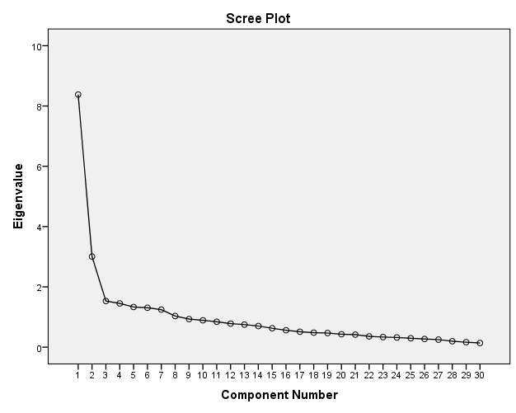

*Figure 1. Scree Plot*

The graph comparison between Eigenvalues and components is shown in the figure above, indicating the relevance of each component. The scree plot exhibits an ideal pattern of a straight line, a bend, and a steep curve in succession. This scree plot illustrates that after the seventeenth component, the eigenvalues begin to form a straight line. Consequently, the remaining components contribute to very little of the variability and are probably insignificant. The number of factors extracted before the curve flattens shows the significant number of factors taken from the investigation and is described in the component matrix.

**Motivation and Engagement.** Table 1 demonstrates the seven attributes of motivation and engagement among Contract of Service Engineers. Firstly, *I find the task important for the completion of the project* with the highest factor score of 0.752. Secondly, *Engineers are mandated to perform their studies* with a factor score of 0.721. Thirdly, *I am learning from other people* with a factor score of 0.650. The fourth one is *The task allows us to attain work objectives that are considered important* with a factor score of 0.593. Next is *It feels pleasant to carry out a task* with a factor score of 0.587. Then, *Our office encourages us to thoroughly accomplish our tasks* with a factor score of 0.547. And lastly, *I know how to follow the procedures of a certain task* with the lowest factor score of 0.527.

***Table 1. Rotated Component Matrix with Grouped Attribute Related to Motivation and Engagement***

|  |  |  |
| --- | --- | --- |
| Factors | Attributes | Loadings |
| Motivation and Engagement | Item 8. I find the task important for the completion of the project. | 0.752 |
| Item 20. Engineers are mandated to perform their studies | 0.721 |
| Item 9. I am learning from other people. | 0.650 |
| Item 7. The task allows us to attain work objectives that are considered important. | 0.593 |
| Item 1. It feels pleasant to carry out a task. | 0.587 |
| Item 2. Our office encourages us to thoroughly accomplish our tasks. | 0.547 |
| Item 10. I know how to follow the procedures of a certain task. | 0.527 |

Contract of service engineers find their tasks important for the completion of their project. Additionally, the offices they are working with encourage them to thoroughly accomplish their tasks. They accomplished their task because they knew how to follow the procedures for completing it. They also feel that they are mandated to perform their studies. It supposed that the tasks allow them to attain work objectives that they considered important. Further, they learn something from other people and feel pleasant to carry out a task.

These findings support Ryba (2021) that employee engagement is the force of the emotional and mental connection workers feel toward their work. With high employee engagement, employee motivation and productivity surge. Additionally, it aligns with Dobrydney (2023), which stated that employee engagement balances what employees want from their work experience and the organization's needs. It involves both contribution to the organization and personal satisfaction. This can be influenced by the organization's leaders with whom the contract of service engineer works.

**Personal Growth and Collaboration.** Table 2 shows the personal growth and collaboration among contract of service engineers. The following are the five attributes for personal growth and collaboration. Firstly, *I feel guilty if I can’t accomplish tasks given to me on time* with the highest factor score of 0.627. Secondly, *It is important for me to carry out tasks* with a factor score of 0.625. Followed by, *I would feel good to be a part of a development in my community* with a factor score of 0.542. The next attribute is that *I am aspiring for promotion to a higher position and its respective benefits* with a factor score of 0.509. Lastly, *I like doing tasks with a team* with a factor score of 0.508.

***Table 2. Rotated Component Matrix with Grouped Attribute Related to Personal Growth and Collaboration***

|  |  |  |
| --- | --- | --- |
| Factor | Attributes | Loadings |
| Personal Growth and Collaboration | Item 14. I feel guilty if I can’t accomplish tasks given to me on time. | 0.627 |
| Item 6. It is important for me to carry out task | 0.625 |
| Item 12. I would feel good to be a part of a development in my community. | 0.542 |
| Item 27. I am aspiring for promotion to a higher position and its respective benefits. | 0.509 |
| Item 3. I like doing tasks with a team | 0.508 |

Contract of service engineers feel guilty if they cannot accomplish the task given to them on time. Completing these tasks is important for them. They actually feel good to be part of a development in their community. Contract of service engineers also aspire for promotion to a higher position and its respective benefits. In addition, they like to do tasks with a team.

The results align with Campbell (2024) that positive relationships are key to personal growth and success at work. Personal growth at work is not only an individual effort but is also connected with the quality of collaborative relationships. Effective teamwork creates a positive work environment for contract of service engineers that boosts their personal development, fosters sharing of knowledge and increases their job satisfaction. Contract of service engineers are more likely motivated by an environment that has a strong sense of accountability, supports their personal and professional growth and allows opportunities for collaboration.

**Professional Excellence.** Table 3 presents the six attributes related to professional excellence with their corresponding loadings. Per tabulation, the item *‘I have developed a deep attachment to my work’* attained the highest loading coefficient of 0.644. And it was followed by item *‘It can be seen that engineers have their ways of motivating others to work’* that reached 0.615 loading coefficient. The item *‘I am confident in my interpersonal skills to achieve my tasks*’ obtained a loading coefficient of 0.598. While the item *‘My work equips me with knowledge and skills to further my career’* obtained a 0.529 loading coefficient. Moreover, the item *‘Contractors/workers follow tasks given to them’* obtained a loading coefficient of 0.527. Lastly, the item *‘Help contractors/workers achieve tasks necessary to complete the project’* acquired the lowest loading coefficient of 0.526.

***Table 3. Rotated Component Matrix with Grouped Attributes Related to Professional Excellence***

|  |  |  |
| --- | --- | --- |
| Factor | Attribute | Loading |
| Professional Excellence | Item 21. I have developed a deep attachment to my work. | 0.644 |
| Item 25. It can be seen that engineers have their ways of motivating others to work. | 0.615 |
| Item 22. I am confident in my interpersonal skills to achieve my tasks. | 0.598 |
| Item 19. My work equips me with knowledge and skills to further my career. | 0.529 |
| Item 15. Contractors/workers follow tasks given to them. | 0.527 |
| Item 24. Help contractors/workers achieve tasks necessary to complete the project | 0.526 |

Considering the foregoing data gathered regarding the respective attributes, contract of service engineers developed a deep attachment to their work, and they have their ways of motivating others to work. They are also confident in their interpersonal skills to achieve their tasks, and their work equips them with knowledge and skills to further their career. In addition, contractors/workers follow tasks given to them, as contract of service engineers help contractors/workers achieve tasks necessary to complete the project.

In light of the foregoing, these attributes are vital, according to Hosen et al. (2024), and significantly affect employee performance and the overall success of the organization. The infectious correlation between career development opportunities, organizational commitment, and work performance is evident because when employees perceive strong support for their career growth, their commitment to the organization deepens, resulting in higher productivity. In the same vein, Pahala et al. (2024) posited that leadership styles that prioritize employee development and support their career aspirations can significantly improve both individual and organizational outcomes. To recapitulate, contract of service engineers manifests a high level of work commitment, foster dynamic and collaborative work relationships, and prioritize career development, all of which contribute positively to the success of their organizations.

**Work-Life Balance.** Table 4 illustrates that the factor analysis shows that work-life balance and job security are closely related in the current employment scenario. The following are the four attributes for work-life balance of contract of service engineers. Firstly, *My work allows me to have sufficient family bonding opportunities* with the highest factor score of 0.864. Secondly, *My work allows me to have a balanced work-leisure lifestyle* with a factor score of 0.837. Next is *My work provides me extra time to have a side hustle for extra income* with a factor score of 0.822. And lastly, *I feel secure that my job provides me a stable income* with a factor score of 0.583.

***Table 4. Rotated Component Matrix with Grouped Attribute Related to Work-Life Balance***

|  |  |  |
| --- | --- | --- |
| Factor | Attribute | Loading |
| Work-life Balance | Item 16. My work allows me to have sufficient family bonding opportunities. | 0.864 |
| Item 5. My work allows me to have a balanced work-leisure lifestyle. | 0.837 |
| Item 11. My work provides me extra time to have a side hustle for extra income. | 0.822 |
| Item 26. I feel secure that my job provides me a stable income. | 0.583 |

Contract of service engineers’ work allows them to have sufficient family bonding. It also allows them to have a balanced work-leisure lifestyle. Furthermore, they feel that their work provides them extra time to have a side hustle for extra income. Additionally, they feel secure that their job provides them a stable income.

The reality is that remote working, flexible working hours, as well as making some extra cash on the side, has become a necessity for many employees. Jobs that involve family time, work-leisure balance, and side hustles have all been found to load heavily pointing out that a majority of the employees consider time and job security as basic factors to enjoying the job (Kossek et al., 2020). On the other hand, the lesser emphasis on employment security in this analysis indicates that even though stability is still valued, employees are likely to consider enjoyment derived from workplace flexibility and the balance between work and home more readily than employment security in the current job market.

**Framework Developed Based on the Findings**

Presented in Figure 2 is the framework based on the findings. The following dimensions are presented and discussed based on the identified factor loadings.

**Motivation and Engagement.** Contract of service engineers believe that their work is crucial to the project's success. Furthermore, the offices they collaborate with support them in completing their assignments completely. They were able to complete their assignment because they understood how to follow the right processes. Additionally, they believe that they must complete their studies. It is assumed that the tasks enable people to achieve job goals that they deem significant. Moreover, they gain knowledge from others and find it enjoyable to complete tasks.

**Personal Growth and Collaboration.** Contract of service engineers experience guilt if they are unable to complete the assigned assignment before the deadline. For them, doing these responsibilities is crucial. Being a part of a collective development truly makes them feel wonderful. They also hope to advance to a higher position and enjoy the perks that come with it. Furthermore, they also prefer working in teams to complete assignments.

**Professional Excellence.** Given the aforementioned information on the corresponding qualities, contract of service engineers have a strong sense of commitment to their work and have unique methods for inspiring people to work hard. They also have faith in their ability to work well with others to accomplish their goals, and their work gives them the information and abilities they need to advance in their careers. Additionally, contractors and workers fulfill their responsibilities because contract of service engineers assist them in completing the duties required to finish the project.

**Work-Life Balance.** The work of contract of service engineers enables them to have adequate family time. It enables them to lead a well-balanced work-life balance. In addition, many believe that their jobs give them the time they need to pursue a side business to increase their income. They also feel safe knowing that they have a steady salary from their job.

**STUDY FRAMEWORK**

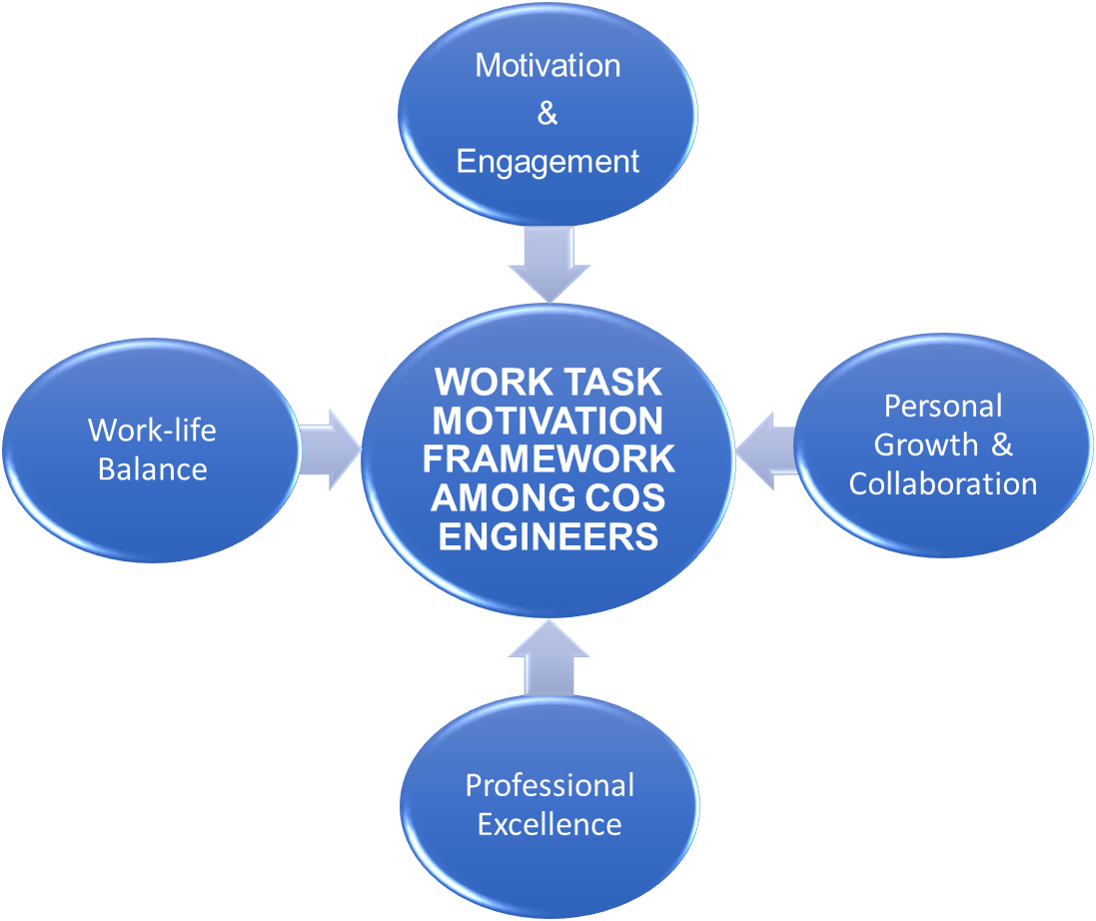

**CONCLUSION**

In conclusion, the factor analysis identified constructs the work motivation of the contract of service engineers such as motivation and engagement, personal growth and collaboration, professional excellence, and work-life balance. these findings align with the research objective by revealing the complex nature of motivation in this specific workforce context. The results demonstrate that effective motivation strategies must extend beyond traditional incentives to include both professional development opportunities and personal well-being considerations. Organizations aiming to enhance productivity and satisfaction among contract of service engineers should implement comprehensive interventions that address all four key factors identified. This comprehensive understanding enables targeted approaches to workforce management, potentially leading to improved retention, performance, and overall job satisfaction among contract of service engineers. The framework on the work task motivation among contract of service was developed.

**ACKNOWLEDGEMENT**

The researchers are extremely thankful to all the individuals who contributed towards the successful completion of this study. First and foremost, we thank Dr. Gaudencio G. Abellanosa for his constant supervision, valuable inputs, and overall assistance during the course of the study. His knowledge and motivation have played a critical role in the course of this paper. We also appreciate the engineers working under contract of services, to help us in our undertaking who were kind enough to share their expert opinions. We sincerely appreciate their time and effort.

**REFERENCES**

Bakker, A. B., Demerouti, E., & Sanz-Vergel, A. I. (2020). **Burnout and work engagement: The JD-R approach**. *Annual Review of Organizational Psychology and Organizational Behavior, 7*, 417-440. https://doi.org/10.1146/annurev-orgpsych-020518-115634

Bakker, A. B., & Albrecht, S. L. (2018). Work engagement: Current trends. Career Development International, 23(4), 303-323. https://doi.org/10.1108/CDI-12-2017-0264

Barling, J., Kelloway, E. K., & Frone, M. R. (2018). *Handbook of work stress*. Sage Publications.

Campbell, M. (2024). How to Maximize Personal Growth in the Workplace. *Growth Tactics*. <https://www.growthtactics.net/personal-growth-in-the-workplace/>

Gagné, M., Forest, J., Gilbert, M., & Blanchard, C. M. (2018). The motivation of employees in contract-based work: A self-determination theory approach. *Journal of Organizational Behavior, 39*(6), 749-767. <https://doi.org/10.1002/job.2279>

Harris, M. A., Lee, J., & Zhou, Y. (2020). Enhancing job satisfaction in temporary workers: The role of organizational culture and recognition. *Journal of Business Research, 120*, 45-56. <https://doi.org/10.1016/j.jbusres.2019.11.040>

Hosen, S., Hamzah, S. R. A., Ismail, I. A., Alias, S. N., Abd Aziz, M. F., & Rahman, M. M. (2024). Training & development, career development, and organizational commitment as the predictor of work performance. *Heliyon*, *10*(1).

Kossek, E. E., & Ozeki, C. (2018). Work-family conflict, policies, and the job-life satisfaction relationship: A review and directions for organizational behavior-human resources research. *Journal of Applied Psychology, 103*(3), 318-340. <https://doi.org/10.1037/apl0000318>

Kossek, E. E., Kalliath, T., & Kalliath, P. (2020). *Work and family: An international research perspective.* Routledge.

Lee, Y., & Kim, S. (2019). The effect of goal setting on job satisfaction and motivation of contract employees: Evidence from the construction industry. *Journal of Construction Engineering and Management, 145*(5), 04019035. https://doi.org/10.1061/(ASCE)CO.1943-7862.0001602

Lheureux, F., & Parmentier, C. (2022). Work Motivation and Reactions to Injustice of Temporary Workers: Roles of Social Identities, Autonomy, and Compensations. *Europe's journal of psychology*, *18*(4), 403–421. <https://doi.org/10.5964/ejop.3755>

Pahala, Y., Agusinta, L., Nasution, N. A., Lermatan, E. E., & Octaviani, R. D. (2024). Determination of Employee Engagement: Analysis of Servant Leadership, Organizational Commitment, Compensation, and Career Development in Middle-Class College. *Dinasti International Journal of Education Management And Social Science*, *5*(3), 241-251.

Ryan, R. M., & Deci, E. L. (2020). Self-determination theory and the facilitation of intrinsic motivation, social development, and well-being. *American Psychologist, 55*(1), 68-78. <https://doi.org/10.1037/0003-066X.55.1.68>

Ryba, K. (2021). How to Use Employee Engagement to Increase Motivation.

<https://www.quantumworkplace.com/future-of-work/how-to-use-employee-engagement-to-increase-motivation>

Smith, J., Williams, L., & Chen, H. (2021). Understanding motivation in contract-based engineering roles: A conceptual framework. *Journal of Organizational Psychology, 34*(3), 215-229. <https://doi.org/10.1002/jop.239>

Van der Lippe, T., & Lippényi, Z. (2020). *Flexibility in work arrangements and the work-life balance: Evidence from international studies.* In J. M. Buchanan & M. M. Gärtner (Eds.), *The work-life balance: An international perspective* (pp. 19-42). Springer.