Brain Tumor Detection of MRI Images using CNN implemented on VGG16 based Architecture

Tarun Tiwari1, Sandesh Mahajan2, Gautam Nimase3, Prof.Chudaman Sukte4

Dept. of Information Technology

Vishwakarma Institute of Information Technology Pune, India

[tarun.22210506@viit.ac.in1](mailto:tarun.22210506@viit.ac.in1), [sandesh.22211636@viit.ac.in2](mailto:sandesh.22211636@viit.ac.in2), [gautam.22211018@viit.ac.in3](mailto:gautam.22211018@viit.ac.in3), [chudaman.sukte@viit.ac.in](mailto:chudaman.sukte@viit.ac.in)

*Abstract*— From a medical perspective, brain cancer can be considered one of the most lethal diseases due to the damage to major blood vessels and the increased risk of death. Therefore, early and accurate diagnosis is important for the best treatment of the disease. In this paper, we describe a new method for automatic problem detection based on the VGG16 neural network, which recognizes the deep structure and good image distribution. Our model involves the enhancement of MRI scan images and then the classification of images into tumor and non-tumor using transformations with VGG16. We build models that achieve satisfactory accuracy, sensitivity and specificity using large-scale MRI images and their annotations. Our results show that the VGG16 mathematical model can assist radiologists in brain diagnosis and make brain diagnosis more efficient and reliable. Additionally, we provide an overview of the possibilities of deep learning in modern medicine and the prospects for the development of medical imaging.

Keywords— Brain Tumor Detection, MRI, CNNs, VGG16 Architecture, Transfer Learning.

# Introduction

Many patients around the world are going through an end-of-plan analysis that glaringly affects survival costs.

Brain tumors are life-threatening and cause globally unique neurological problems with a high mortality rate. Early will is critical to convincing treatment and advanced survival fees. MRI is the standard non-invasive strategy used to distinguish brain tumors, advertising and marketing stupid and crude images of mind tissue. In any case, post-examination of MRI filters is time-consuming and prone to human error, especially for large data sets or subtle abnormalities. Millions of mind tumor sufferers regularly face delayed willpower due to the need for assets or radiologists, especially in underserved areas such as provincial parts of Asia.

The early end is huge because appropriate treatment increases overall survival costs and improves knowledge outcomes. Orientation examination of the appearance of MRI, which is a modern general strategy for the detection of brain tumors, is unfortunately not lengthy, but is also prone to human error, especially when there is a large amount of information, or inconspicuous anomalies that lend themselves to being ignored. This occurs around a delayed or incorrect examination, which can extremely affect the quality of care and prognosis.

Our goal is to create a proficient mind tumor discovery machine utilizing VGG16 deep mastering reveal to return appropriate determination.

Our proposed framework, built on VGG16 engineering and using business knowledge, considers handling these challenging situations by mechanizing the discovery of brain tumors in MRI filters. The intention of the program is to catch really the smallest and most inconspicuous tumors and ensure that no key element is missed. By joint mechanization, we reduce the burden on radiologists, speed up demonstrative processing and increase the accuracy of symptoms. This framework will turn out to be particularly important in places with limited access to filling specialists, bridging the hole in healthcare administration and saving lives with timely and accurate mind tumors.

Utilizing the advanced and profound tactics that VGG16 encompasses, we point out the creation of a robotic, remedial, and accessible framework for mind tumor location. This gadget will assist healthcare professionals in faster and remarkably more accurate examinations, ultimately improving chronic outcomes and taking care of the global health hole.

Our aim is to make brain tumor localization faster, more robust and manageable for everyone, regardless of geological or financial constraints, thereby contributing to higher survival fee and much higher knowledge outcomes across the sector.

This project will contribute to the research and society in a remarkable way:

1. Advances in Therapeutic Imaging: By engineering VGG16 and acquiring alternative knowledge, it includes expansion into the evolving framework of deep study techniques for therapeutic imaging, particularly brain tumor discovery. It explores how pre-trained models can be best tuned for specialized tasks, pushing the boundaries of existing strategies in radiology and AI-assisted prognostication.

2. Advances in demonstrative accuracy: Our images highlight how thorough mastery can distinguish subtle deviations from the norm in MRI filters, likely bypassing traditional guided investigations. This will open up a modern exploration of approximately paths in growing larger contemporary models that could deal with complicated healing photos.

3. Benchmarking and replicability: By sharing and approximately derived techniques, we provide a gadget that can help improve fate analysts, cultivate collaboration and progress within the subject of automated recovery diagnostics.

This paper is prepared as follows: phase II affords the literature overview and associated works in mind tumor detection using deep learning. segment III describes the methodology & the VGG16 model utilized in our study. segment IV discusses the results received from the experimental assessment, even as phase V interprets the findings and highlights key insights. In the end, phase VI concludes the paper with a precise capability for future paintings

# Literature Survey

|  |  |  |  |
| --- | --- | --- | --- |
| **Author(s)** | **Focus of the Paper** | **Key Points in Coverage** | **Methodology(s) Used** |
| Al-Ayyoub et al. | Machine Learning for Brain Tumour Detection | Comparing the performance of different machine learning algorithms for brain tumour detection using MRI images. | Image Processing: Conversion of RGB images to greyscale. Machine Learning Algorithms: ANN, Tree J48, Naive Bayes, and LazyIBk. |
| Hemanth et al. | Brain Tumour Detection using Machine Learning | Proposing a brain tumour detection system using machine learning. | The specific machine learning approach used is not specified. |
| Shishir et al. | Brain Tumour Detection using CNN | Using Convolutional Neural Networks (CNN) for brain tumour detection. | Convolutional Neural Networks (CNN) |
| Nandpuru et al. | MRI Brain Cancer Classification | Classifying brain cancers from MRI data. | Support Vector Machine (SVM) |
| Chandra & Kolasani | Brain Tumour Detection | Detecting brain tumours. | Genetic Algorithm |
| Varuna Shree & T.N.R. Kuma | Brain Tumor MRI Image Identification and Classification | Identifying and classifying brain tumour MRI images using feature extraction. | Discrete Wavelet Transform (DWT)Probabilistic Neural Network |
| Younis et al. | Brain Tumour Analysis | Analysing brain tumours. | Deep Learning |
| Irmak | Brain Tumour MRI Image Multi-classification | Multi-class classification of brain tumour MRI images. | Deep Convolutional Neural Network |
| Jia & Chen | Brain Tumour Identification and Classification | Identifying and classifying brain tumours from MRI images. | Deep Learning |
| Byale et al. | Brain Tumour Segmentation and Classification | Automatic segmentation and classification of brain tumours. | Machine Learning |
| Alqudah et al. | Brain Tumour Classification Techniques | Comparing different brain tumour classification techniques. | Deep Learning |
| Amin et al. | Brain Tumour Detection and Classification | Surveying methods for brain tumour detection and classification. | Machine Learning |

The subject of brain tumour detection and classification using MRI images has benefited greatly from recent developments in machine learning (ML). Al-Ayyoub et al. investigate a number of machine learning techniques, such as Artificial Neural Networks (ANN), Decision Trees (J48), Naive Bayes, and LazyIBk. They show that once MRI data are converted to greyscale format, the performance of various algorithms can differ for cancer identification tasks. Despite without naming the exact approach, Hemanth et al. offer a broad ML-based detection framework. Shishir et al. demonstrate the efficacy of deep learning models in managing intricate image-based tasks by using Convolutional Neural Networks (CNN) specifically to MRI images for more complex models.

# METHODODLOGY

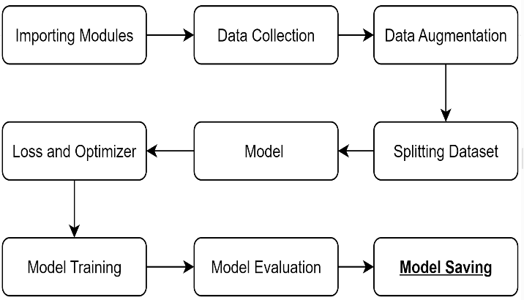

**1.Dataset Collection:**

In our study, we used the brain tumor MRI image dataset from Kaggle [21], which contains 3064 MRI images containing one of the 17 unique features that define brain tumors. The image is then converted to 224 x 224 pixels, which is required to enter the VGG16 standard. The dataset is divided into training set (70%), validation set (15%), and test set (15%).

**2.Data Augmentation:**

**RandomHorizontalFlip(p=0.5):**which behaves the same as above horizontally flipping with 50% probability i.e., augments model to generalize against flipped objects also but meantime we wanted our model to recognize the view irrespective of its position and hence there was no need of rotation.

**RandomVerticalFlip(p=0.5):** It will randomly paste Image vertically with 50% Acknowledgment and Will help to add more diversity into the dataset

**RandomRotation(degrees=15) :** Application of this performs a random rotation to our image with an angle within 15 degrees which can sometimes be helpful in minor rotations and real-world distortions of an image.

**ColorJitter(brightness=0.2, contrast=0.2):** randomly change the brightness and contrast of the image to simulate lighting effects

**RandomResizedCrop(size=(224, 224), scale=(0.8, 1.0)):** This will randomly crop image to the specified dimension then resize it to that size but keep the whole area from the original image in which it was cropped at least scaled by 80% and scaled up to 100%.

**ToTensor():** This will convert the image into a tensor that your model can take as an input.

**Normalize(mean=[0.485, 0.456, 0.406], std=[0.229, 0.224, 0.225]):** Normalize an image to the mean and standard deviation specified by ImageNet-trained models

This augmentation helps the model to learn more complex images in order to gain high accuracy for over 17 classes

.

**3.Model Architecture:**

The convolutional neural network model originating from the brain detection VGG16 framework has 5 groups, each group has a series of convolutional processes, and the most common process is used for subtraction after batch normalization. The number of filters in the first block is as many as 64, and the filters in the deep blocks are 512, which can detect low and high levels. This model is separated by three connections of all layers, and then RELU activation and batch recovery. The urine process to distribute the MRI section as much as possible.

Clearly! The following is an explanation of each layer in the VGG16-based model and how it fits into the steps of brain tumor detection and classification;

**Model Architecture:**

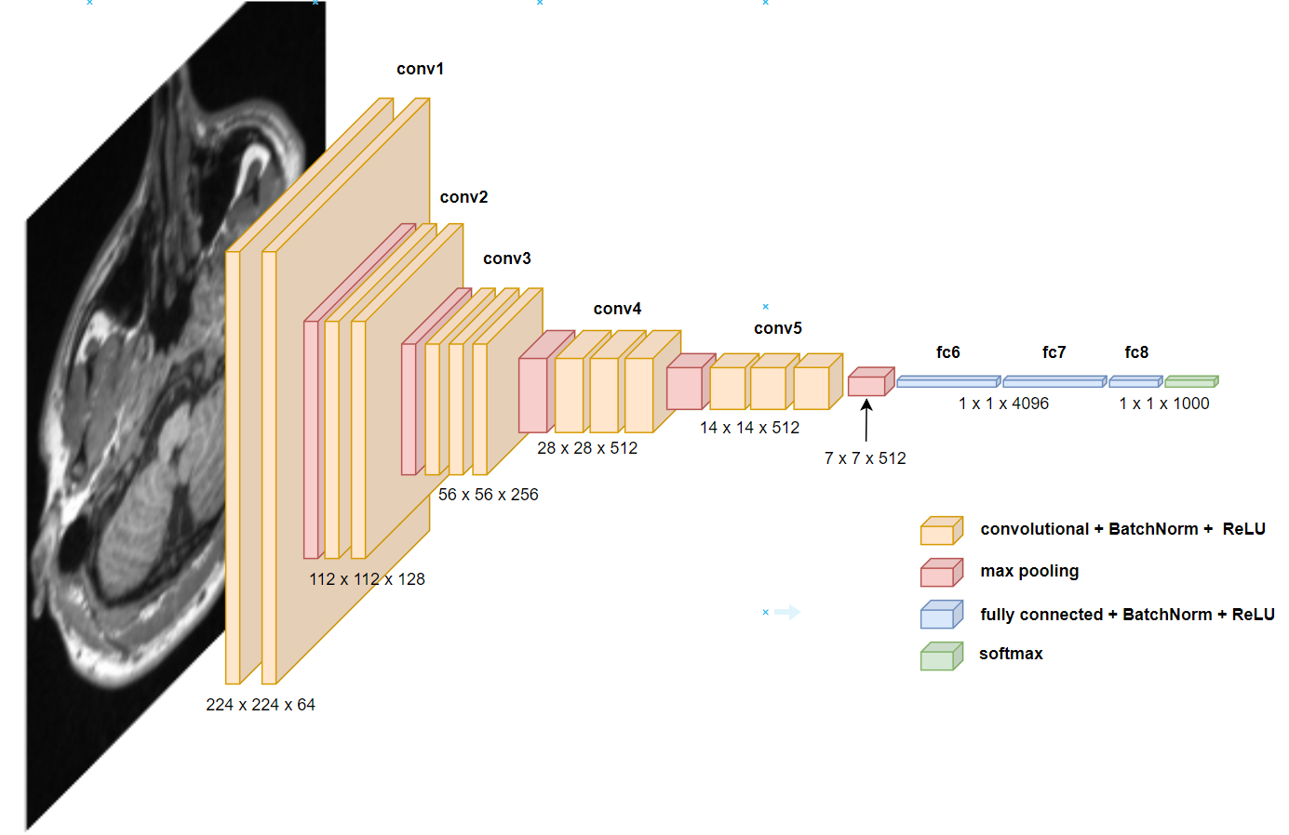

**Layer descriptions:**

**1.Convolution layer: (feature extraction)**

***nn.Conv2d* layers :** The current layer extracts features from the input image by creating a set of filters on it. These filters look for specific local patterns such as edges, textures, and other simple image elements. As we move through the network, these filters learn to pick up more sophisticated patterns, such as features that are specific to tumors.

***nn. BatchNorm2d*:** Normalization for each batch after convolution. It normalizes its performance so that the next layer has more stable values, which helps with faster training and resistance to weight initialization.

**Activation function (*F.relu*):** ReLU is a building block = applied between each pair of convolutions. It introduces non-linearity, making the network model complex functions.

**2. Pooling layers (reducing dimensions)**

***nn. MaxPool2d* layers:** Max Pool2d layers reduce the spatial dimensions of feature maps, reduce computation, and focus on critical features. This increases performance by making the model computationally efficient and avoids overfitting and suppression of less important details.

**3.Classification — Fully connected layers:**

***nn. Flatten* Layer :** Merges the output of the last convolution block so that it is fed into fully connected layers.

***nn. Linear* layers:** These layers are the classifier. They take the features learned by the convolutional layers and map them to the output classes, which in this case, are the different kinds of brain tumor. The first two fully connected layers, that is, the fc1 and fc2, help the model learn complex patterns & combine the different features. Finally, the features are mapped to the output classes with the last fully connected layer, fc3.

***nn. BatchNorm1d* layers:** for fully connected layers that stabilize and accelerate learning with batch normalization

.

**4. Output layer:**

The final output layer (the attention layer) predicts the label relative to the brain tumor class. Additional probabilities can be derived based on the outputs by using them depending on the loss function that was used during training (e.g. CrossEntropyLoss).

**Role Summary:**

**Feature extraction** **(*Conv2d + ReLU + BatchNorm2d*):** Convolutional operations capture a hierarchy of spatial features starting from edges and finally capture tumor-centered features.

**Dimensional reduction (*MaxPool2d*):** Maximum pool layers gradually reduce dimensions, which helps the network to be more compact in terms of depth, and also helps to keep only the necessary components.

**Classification (*Flatten + Linear + BatchNorm1d*):** These are computational components involved in deriving associations between classes mapped by brain tumors and features obtained from convolutional layers.

The above feature extraction followed by classification was constructed for brain tumor detection and classification using the VGG16 feature representation.

**4. Loss and optimizer:**

When constructing the display, we don't forget the truth that CrossEntropyLoss() is the maximum counseled misfortune work, for the reason that that is a multi-magnificence classification demonstrated. This misfortune is precious in deciding how remote the expected yield is from the real taking a toll, and this makes a distinction in the widespread mastering of the version.

The optimizer applied for our show is **Adam(version.Parameters(), lr=zero.001, weight_decay=1e-4, betas=(0.Nine, zero.999)):**

**lr (learning price=zero.001):** Controls the step measure at each cycle whilst shifting to the least misfortune paintings. A little esteem like zero.001 makes the gaining knowledge extra solid.

**Weight_decay=1e-four**: An administrative term that makes a distinction to avoid overfitting by penalizing expansive weights.

**Betas=(0.9, 0.999):** Coefficients applied to calculate the running midpoints of the slope and its square:

**beta1=zero.9:** Rate of decrease for the first of all moment (normal of gradients).

**Beta2=0.999:** Decay fee for the instant second (uncentered fluctuation of gradients).

**5.Performance Metrics:**

**Accuracy:**

**Mathematical definition:**

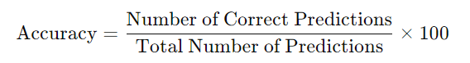

**Description**: Exactness measures the volume of modified expectations made by means of the display out of the upload as much as quantity of events. It is a not unusual diploma of show execution, but may not be pretty enlightening if the records set is choppy (e.g. whilst one route is more go to than others).

**Confusion Matrix:**

**Description:** The disarray network offers a nitty gritty breakdown of display expectancies in comparison to real names, appearing actual positives, wrong positives, proper negatives, and unfaithful negatives for each class.

The disarray network permits you to visualize execution over various instructions of mind tumors, creating a distinction to determine which sorts are bewildered by using the exhibit. This can also lead to changes in information series or exhibit structure.



**Mathematical representation:**

**True Positive (TP):** Accurately anticipated high-quality cases.

**True Negative (TN):** Accurately anticipated terrible cases.

**False fine (FP):** Inaccurately expected nice instances.

**False bad (FN):** Erroneously expected negative instances.

**Structural Closeness File (SSIM)**

**Description**: SSIM assesses the likeness among two photographs and offers a picture quality metric. It takes brightness, differentiate and surface into account.

SSIM may be applied to assess the exceptional of the yield images produced by your show, in particular in case you utilize photograph amplification methods. It can provide assistance to decide whether or not the show jam crucial fundamental factors of interest in the pix.

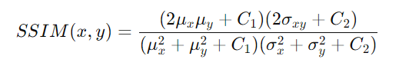

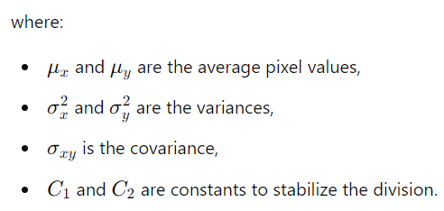

**F1 Score:**

**Description:** The F1 rating is a consonant cruel of exactness and evaluation and gives a adjust among the two

The F1 rating is in particular treasured in restorative programs along with mind tumor class, wherein wrong poor comes about may have proper outcomes. A tall F1 score implies your show has a brilliant modification between exactness and evaluation over numerous instructions.

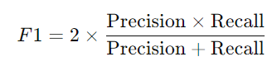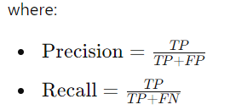

**Calibration curve:**

**Description:** Calibration curves show how well the predicted probability matches the correct results and distinguish whether the demonstration is well calibrated or not.

The calibration curve plots the predicted probabilities as opposed to the distribution of positive values.

# RESULTS AND DISCUSSION

The sequel is going to demonstrate the display design that has been in the making for a hundred and fifty for a long time, using the NVIDIA Tesla T4 GPU in the Google Colab. Robust GPU computing manipulation with a potential of 64GB/s of reminiscence transfer and 16GB of VRAM allowed the show to effectively process a large amount of statistics for more than an hour and achieve results after a characteristic execution. metrics.

**Evaluation of performance metrics:**

**1. Accuracy**

It measures charge as it should be categorized by occasion, which usually proves to reveal performance.

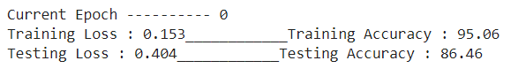

**2. Specificity**

It quantifies the ability of the version to appropriately discriminate against non-tumor cases, demonstrating viability in minimizing false positives.

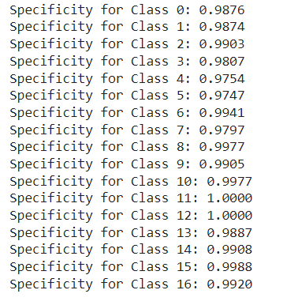

**3. F1 score**

It combines precision and insight to provide an adjusted degree of type execution, with high values ​​showing much better results

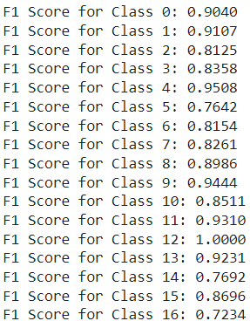

**4. Confusion Matrix**

Visualizes true positives, false positives, authentic negatives and false negatives for each lesson, differentiates understanding of misclassification patter

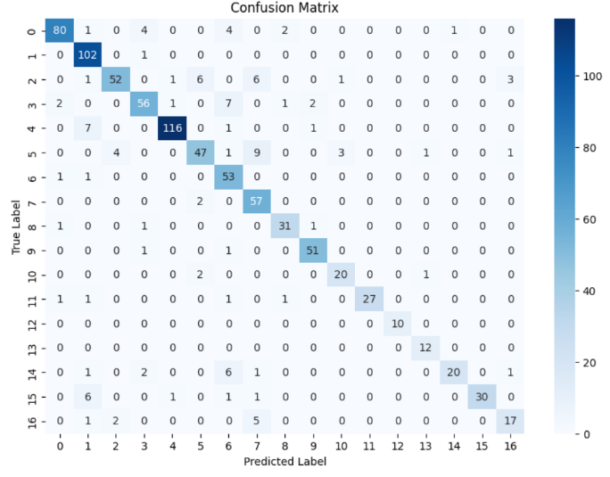

**5. Calibration curve**

It evaluates the arrangement of expected probabilities with actual consequences; focus close to the tilted exhibit large calibration.

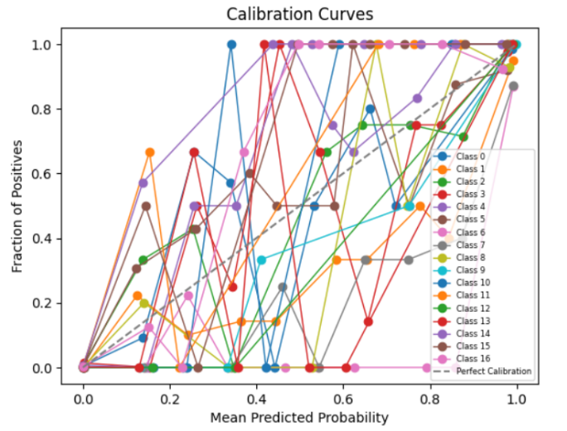

**6. Basic Similarity Record (SSIM)**

It assesses the similarity between exact and expected images; higher values ​​indicate advanced preservation of additional lights.

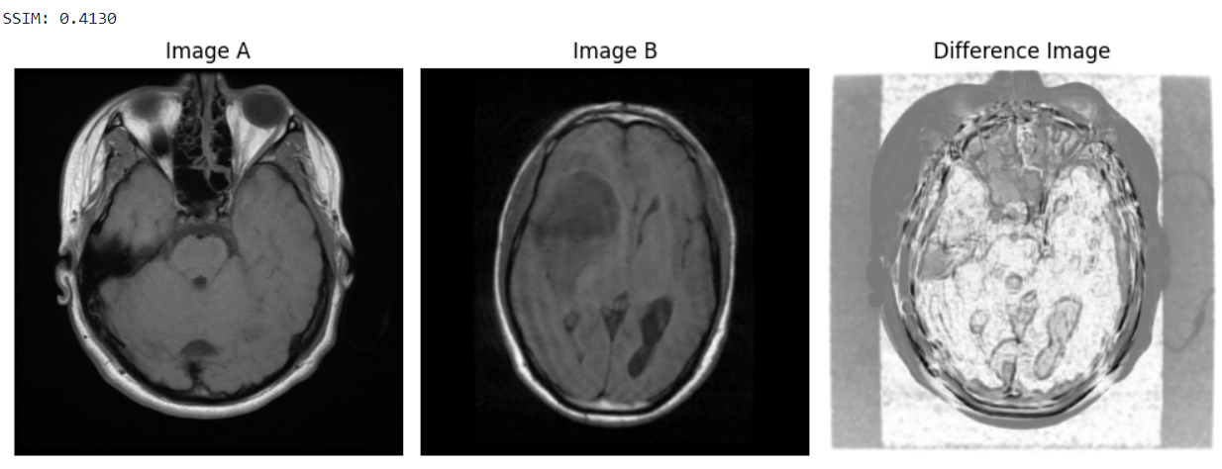

**Discussion:**

**1. Key Findings:**

**Model execution:** Highlight the model's ability to accurately classify brain tumors using CNN engineering and highlight the high accuracy and typical fit of your method

**Metrics Achievements:** Seemingly noteworthy, achieved with metrics such as accuracy, F1 rating, SSIM, and calibration bends, providing accurate reports on model accuracy and unwaveringly exceptional in real global programs.

**Optimization Strategy:** Explore the impact of using optimizers like Adam with properly tuned hyperparameters (gain knowledge of charge, mass, beta) for incremental merging and overall performance.

**Computing Prowess:** Be aware that it is part of using a GPU (*NVIDIA Tesla T4*) to speed up preparation and boost successful large-scale recording preparation.

**2. Model performance:**

**Strengths:**

1. **High preparation accuracy (ninety-five.06%)**: The display learned to effectively understand the designs within the preparation facts, showing that the design is properly perfect for the task and data set. This high accuracy reflects excellent study skills.
2. **Strong class performance:** F1 scores for several classes are greater than 0.90 (e.g. class zero: 0.9040, class 1: zero.9107, course four: 0.9508), indicating the adjusted accuracy and ranking for these classes. Publish behaves quite correctly when looking ahead to these classes.
3. **Balanced F1 scores in most classes:** Classes that include nine (0.9444) and 11 (0.9310) appear to be reliable and stable performers, illustrating the version's potential to generalize well across categories.

**weaknesses:**

1. **Testing Accuracy (86.46%):** The difference between preparation and testing accuracy (approximately 9%) suggests reassembly. The show probably learned to draft stats by rote, causing it to underperform on subtle control information.

2. **Characteristic Biased Class**: Lower F1 scores in instructions that contain 16 (zero.7234) and 5 (0.7642) may be the end result of lesson imbalance or insufficient statistical tests for these categories, causing the display to struggle with accurate predictions.

3. **Higher trial calamity (0.404):** The comparison of prepared calamity (-0.153) and reported calamity seems to be trying to generalize. A high calamity harbinger regularly focuses on issues with shouting or hazing in connection with an impending calamity.

**Possible reasons:**

**1. Training Time and Complexity:** The sample took 2 hours to compile over a hundred and fifty on an Nvidia Tesla T4 GPU. The delayed setup time suggests that the show may be complicated and more tuning (e.g. regularization techniques) may also relieve overfitting.

**2. Imbalanced information:** A few lessons are likely underrepresented in the dataset, causing the display to behave worse than the views considered in the F1 score, and distort grid inconsistencies.

**3. Challenges they face:**

Over the course of my show, I've done a few challenges that I've won through inspection and specialized upgrades.

**Low accuracy without augmentation:**

* Initial preparation without expanding the records introduced in about lousy accuracy.
* The display tried to generalize due to the limited variability of the data set.
* Information dissemination methods explored and updated, with advances showing robustness.

**Extended preparation time:**

* Exercising on a nearby machine has turned into a waste and a waste of time.
* It used an NVIDIA Tesla T4 GPU from Google Colab, which reduced preparation time to honesty by hours.

**Insufficient ranking metric:**

* The initial performance evaluation required accurate evaluation metrics.
* Explore advanced metrics (eg SSIM, F1 score, specificity, calibration curve) for comprehensive performance evaluation.
* The implementation of these measurements made it possible to correctly recognize the qualities and shortcomings of the program.

# CONCLUSION

In this paper, we faced many challenges in building a strong classification sample. Initially, our show struggled with execution due to missing information that occurred with moo accuracy when using raw information without augmentation. After viewing several investigative documents, we created a flood of information that overall moved forward and showed generalization and accuracy. The long preparation time was another challenge that we overcame by using the Google Colab GPU (NVIDIA Tesla T4), reducing the total preparation time to 2 hours.

Moreover, despite the fact that the initial demonstration yielded great accuracy, the need for in-depth implementation measurements limited the investigation. To address this, we unified measures such as F1 score, approach record (SSIM), specificity, and calibration bend, driven by a paper reference query, to gain a more comprehensive experience of the model's qualities and shortcomings. These extraordinary measurements revealed areas where the demonstration exceeded expectations and where progress could be made, such as the tendency for over-fitting and course imbalance.

We also tested with the VGG16 design, including unused features that contributed to significant improvements in highlighting extractions and general classification performance. By combining advanced evaluation metrics and combining well-known deep learning with enhancements, this reasoning lays the groundwork for future optimization and progress in image classification matching.

# REFERENCES

1. Siar, Masoumeh, and Mohammad Teshnehlab. "Brain tumor detection using deep neural network and machine learning algorithm." *2019 9th international conference on computer and knowledge engineering (ICCKE)*. IEEE, 2019.
2. Deshmukh, Aishwarya V., and M. R. Bendre. "Multiclass Brain Tumor Detection using Deep Transfer Learning." *2024 MIT Art, Design and Technology School of Computing International Conference (MITADTSoCiCon)*. IEEE, 2024
3. Ramprakash, B., et al. "Comparative Analysis of Deep Learning and Machine Learning for Detection and Classification of Brain Tumors at Multiple Stages." *2024 Second International Conference on Emerging Trends in Information Technology and Engineering (ICETITE)*. IEEE, 2024..
4. Rehman, Amjad, et al. "Detection of Lungs Tumors in CT Scan Images Using Convolutional Neural Networks." *IEEE/ACM Transactions on Computational Biology and Bioinformatics* 21.4 (2023): 769-777
5. Preetha, R., M. Jasmine Pemeena Priyadarsini, and J. S. Nisha. "Automated Brain Tumor Detection from Magnetic Resonance Images Using Fine-Tuned EfficientNet-B4 Convolutional Neural Network." *IEEE Access* (2024).
6. Wageh, Mohamed, et al. "Brain Tumor Detection Based on Deep Features Concatenation and Machine Learning Classifiers With Genetic Selection." *IEEE Access* (2024).
7. Lin, Xiaoyi, et al. "Improving tumor classification by reusing self-predicted segmentation of medical images as guiding knowledge." *IEEE Journal of Biomedical and Health Informatics* (2023)
8. Liu, Huabing, et al. "Multimodal Brain Tumor Segmentation Boosted by Monomodal Normal Brain Images." *IEEE Transactions on Image Processing* (2024).
9. Neamah, Karrar, et al. "Brain Tumor Classification and Detection Based DL Models: A Systematic Review." *IEEE Access* (2023).
10. Asiri, Abdullah A., et al. "Optimized Brain Tumor Detection: A Dual-Module Approach for MRI Image Enhancement and Tumor Classification." *IEEE Access* 12 (2024): 42868-42887.
11. Liu, Min, et al. "Brain Image Segmentation for Ultrascale Neuron Reconstruction via an Adaptive Dual-Task Learning Network." *IEEE transactions on medical imaging* (2024).
12. Pattanaik, Sudeshna, et al. "A MIoT Framework of Consumer Technology for Medical Diseases Prediction." *IEEE Transactions on Consumer Electronics* (2024)