**Detection of Animal Diseases using ML Model with images**

|  |  |  |  |  |
| --- | --- | --- | --- | --- |
| 1stTarun Tiwari  *dept. Information Technology*  *Vishwakarma Institute of Information Technology*  *Pune, India*  [tarun.2221056@viit.ac.in](mailto:tarun.2221056@viit.ac.in) | 2ndKanchan Tarware  *dept. Information Technology*  *Vishwakarma Institute of Information Technology*  *Pune, India*  [kanchan.22210076@viit.ac.in](mailto:kanchan.22210076@viit.ac.in) | 3rdManassvi Gaikward  *dept. Information Technology*  *Vishwakarma Institute of Information Technology*  *Pune, India*  [manassvi.22210082@viit.ac.in](mailto:manassvi.22210082@viit.ac.in) | 4thRohan Kakde  *dept. Information Technology*  *Vishwakarma Institute of Information Technology*  *Pune, India*  [manassvi.22210082@viit.ac.in](mailto:manassvi.22210082@viit.ac.in) | 5thChaitali Shewale  *dept. Information Technology*  *Vishwakarma Institute of Information Technology*  *Pune,India*  [Chaitali.shewale@viit.ac.in](mailto:Chaitali.shewale@viit.ac.in) |

**ABSTRACT:**

With artificial intelligence (AI) animal disease detection reshapes and allows innovative solutions for diagnostics, early warning systems and broadly in the whole process of disease control. Advances in the utilization of machine learning (ML) and deep learning technologies, particularly Convolutional Neural Networks (CNN) to analyze data with regards to wild species health record, images and physiological signals are increasingly deployed. This work is based on a deep learning model to predict animal diseases from image data by establishing. Advances in artificial intelligence (AI) are revolutionizing the field of animal disease detection, enabling innovative solutions for diagnostics, early warning systems, and comprehensive disease control. Machine learning (ML) and deep learning technologies, particularly Convolutional Neural Networks (CNNs), have shown significant potential in analyzing diverse data sources, including health records, images, and physiological signals from wild and domesticated species. This research focuses on developing a deep learning model to predict animal diseases from image data by leveraging CNNs to automatically extract key features and identify patterns indicative of specific diseases. The model aims to enhance the accuracy and efficiency of disease detection, allowing for early diagnosis, improved animal health management, and timely intervention strategies. By integrating AI-driven analytics, this work contributes to reshaping the landscape of veterinary diagnostics and wildlife conservation through the application of cutting-edge image-based disease prediction techniques.

**INTRODUCTION:**

[1] Leveraging technology to predict and identify animal diseases. As the need for food safety and animal health continues to grow, managing animal health and diseases is always challenging. Identifying diseases in animals using traditional methods such as screening and testing can be slow, expensive, and have room for error.

[2] Advances in machine learning (ML), computer vision, and other AI technologies have helped overcome these challenges by providing solutions for optimal diagnosis and management of animal diseases. Artificial intelligence is a branch of technology that allows computers to learn from the information they receive and use that information to accurately identify patterns and make predictions. For example, support vector machines (SVM), random forests, and neural networks have been used to identify and predict disease occurrences through data analysis.

[3] Computer vision technology, powered by deep learning algorithms such as convolutional neural networks (CNN), can analyze data for diagnostic applications. This new method has proven to be useful in identifying diseases in animals, identifying targets such as abnormal skin and abnormal movement, allowing for rapid detection of diseases, allowing for accurate and timely treatment. In addition; the combination of artificial intelligence and the Internet of Things (IoT) is improving the ability to continuously monitor animal health. . Wearable devices are increasingly penetrating our lives, collecting activity data and some important parameters such as heart rate, body temperature, while smart people point out some abnormalities that are not good and carry risks. the rapid increase of the disease. Before the main stage of these is completed.

[4] In the age of animal husbandry and wildlife protection, artificial intelligence brings another dimension to the management of large animal welfare. In the future, with the proliferation of data sets and artificial intelligence models, this technology is expected to help detect new diseases, thus protecting animals, humans and the world around them. This research will focus on artificial intelligence tools in veterinary medicine to improve early diagnosis and detection of diseases in animals, demonstrating the quality, difficulty and future of this tool. Specifically, this research will investigate the use of machine learning, computer vision and natural language processing (NLP) to re-improve the diagnosis and practice of veterinary medicineanalysis. Computer vision technology, powered by deep learning algorithms such as convolutional neural networks (CNN), can analyze data for diagnostic applications. This new method has proven to be useful in identifying diseases in animals, identifying targets such as abnormal skin and abnormal movement, allowing for rapid detection of diseases, allowing for accurate and timely treatment. In addition; the combination of artificial intelligence and the Internet of Things (IoT) is improving the ability to continuously monitor animal health. . Wearable devices are increasingly penetrating our lives, collecting activity data and some important parameters such as heart rate, body temperature, while smart people point out some abnormalities that are not good and carry risks. the rapid increase of the disease. Before the main stage of these is completed. In the age of animal husbandry and wildlife protection, artificial intelligence brings another dimension to the management of large animal welfare. In the future, with the proliferation of data sets and artificial intelligence models, this technology is expected to help detect new diseases, thus protecting animals, humans and the world around them. This research will focus on artificial intelligence tools in veterinary medicine to improve early diagnosis and detection of diseases in animals, demonstrating the quality, difficulty and future of this tool. Specifically, this research will investigate the use of machine learning, computer vision and natural language processing (NLP) to re-improve the diagnosis and practice of veterinary medicine.

**LITERATURE REVIEW:**

Machine learning (ML), computer vision, and the Internet of Things have led to intensive usage of artificial intelligence (AI) in animal disease detection during recent years. This review outlines the current knowledge around ways AI may improve diagnostic accuracy, attract earlier attention to disease and help in better management of diseases within the veterinary industry.

Global agriculture and public health: Impact of Diseases in Animals This is because animals cause such extensive effects on agriculture and other human beings and as followed in various research papers. Jones et al (2013) suggest that more attention should be given to this aspect due to factors such as; globalization and interconnectivity of markets for livestock.

[6] Otte et al. (2012) also added that there is Unsupervised Learning in Veterinary Diagnostics: Techniques like PCA and clustering are applied on huge data sets of the health of the animals. Gupta et al 2018 has explained the insights of animals based on hierarchical clustering and the previously unnoticed patterns within the clusters of animals based on susceptibility to the disease. The below work of Yang et al. (2020) shows that the EM algorithm is highly efficient in classification of disease patterns of the livestock.

[7] AI for Real-Time Animal Disease Monitoring: With the help of the tools of artificial intelligence, diseases affecting animals can be closely watched. Still, as noted by Gaurav et al. (2021) with an incorporation of AI and IoT, there will be constant monitoring of the state of the animals so as to detect such anomalies early so that quick measures to contain the outbreak are commenced without much delay and significant losses incurred.

[8] Challenges and Future Prospects: Nevertheless, there are some potential issues that we still have to face while applying artificial intelligence to the field of animal disease prediction.

[10] Lewis et al. (2022), Fernandez et al. (2023) also outline the issues of data accuracy, model explainability, and synergy between veterinary medicine and computer science, as well as policymakers. Conversely, as advanced AI technologies continue to innovate and data quantity and quality become less of an issue, the prospect of AI for disease forecasting in animals can be expected to experience tremendous growth and transformation in the veterinary diagnostics system and disease administration strategies.

[11] Otte et al. (2012) discussed the use of unsupervised learning techniques such as Principal Component Analysis (PCA) and clustering in veterinary diagnostics. These techniques analyze large datasets related to animal health and reveal previously unnoticed patterns that can help identify disease susceptibility. Gupta et al. (2018) further highlighted the use of hierarchical clustering to discover insights into animals’ health, enabling targeted interventions based on the susceptibility of different animal clusters.

**METHODOLOGY**

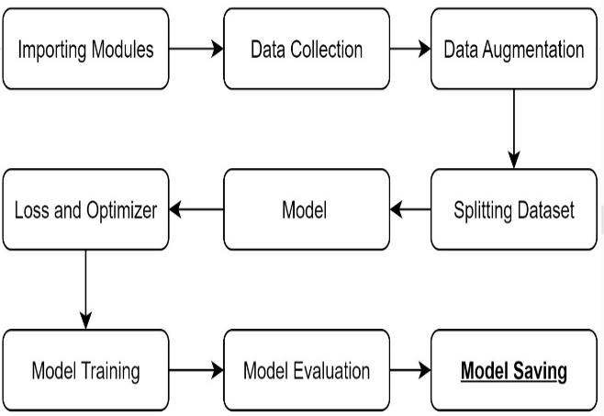The method and strategies for using image data for predicting animal diseases are outlined in this section. The concept includes many steps, such as data gathering, preparation, modeling and assessment, deployment based on the ‘Animal-skin-disease-detection’ and ‘Animal-Disease-Detection_ADD’ with aid of GitHub repositories.

**1. Data Collection**

The main data for this study is images of various animal diseases from repositories and other public datasets, including the Center for Food Security and Public Health. The collected image is then categorized into several subsets where subsets specific to skin or physiological disorders such as dermatitis, fungal infections, or parasitic infestations, etc.

This Animal_Dataset class that is described below has been designed for your brain tumor detection project so as to help you properly handle the labeled images that you would use when training and evaluating your models. It starts with the root directory, each subfolder is a disease category, and they are quantitatively labeled according to the label_map. Only image paths with acceptable extensions such as.png,.jpg or.jpeg with respect to their labels are also stored. The __getitem__ method loads images in RGB format, transforms them by any transformations if required i.e., scaling them to 224 *224 size for model input. Also, it returns the overall size of the datasets using __len__ and has a way of presenting disease class labels. This makes it convenient to be used with PyTorch’s DataLoader for training your CNN model The stolen list for reference is below:

1. Animal-skin-disease-detection repository: Contains a set of labeled images mainly concerning animal skin diseases.
2. Animal-Disease-Detection_ADD repository: Includes a range of animal diseases such as organ or other part diseases detected via diagnostic imaging.

**2. Data Preprocessing**

The data is modified in the form of reshaping and adding visual cues to make the model less sensitive on the other hand.

**1.Resize((224, 224)):** Image in your area images of larger sizes that belong to the street corners are introduced to the examiners. They need to be transformed into cubes all that is why the CNN moveld model must transfer them.

**2.RandomHorizontalFlip(p=0.5):** One-half of the flip will be from p=0; one minus the entire process is responsible for the mapping of the next layer. 1/2 cross the link of sp, and we go further out, where it can be "3^(1-x)" and "4^(1-x)."

3.RandomRotation(ranges=15): The condition of all pictures is checked; a picture that is not rotated is accordingly transformed into the rotated picture for a ±15 degree angle that is required for augmented data used to be 100%.

**4.ColorJitter**:

Brightness: In the first step, 20% deviation may occur

Contrast: The k value that the sight changes in the magnitude of±20%.

Saturation: It is instantly changed either to the higher or to the lower color saturation by ±20%.

Hue: It becomes a uniform parallel of the headlight color range (i.e., all faces with a hue value have a quick color change of their brightness by 1 streetlight).

**5.ToTensor():** It is the same as converting an image to a tensor format of values ranging from 0 to 1 and also doing statistical normalization around it.

**3. Model Architecture:**

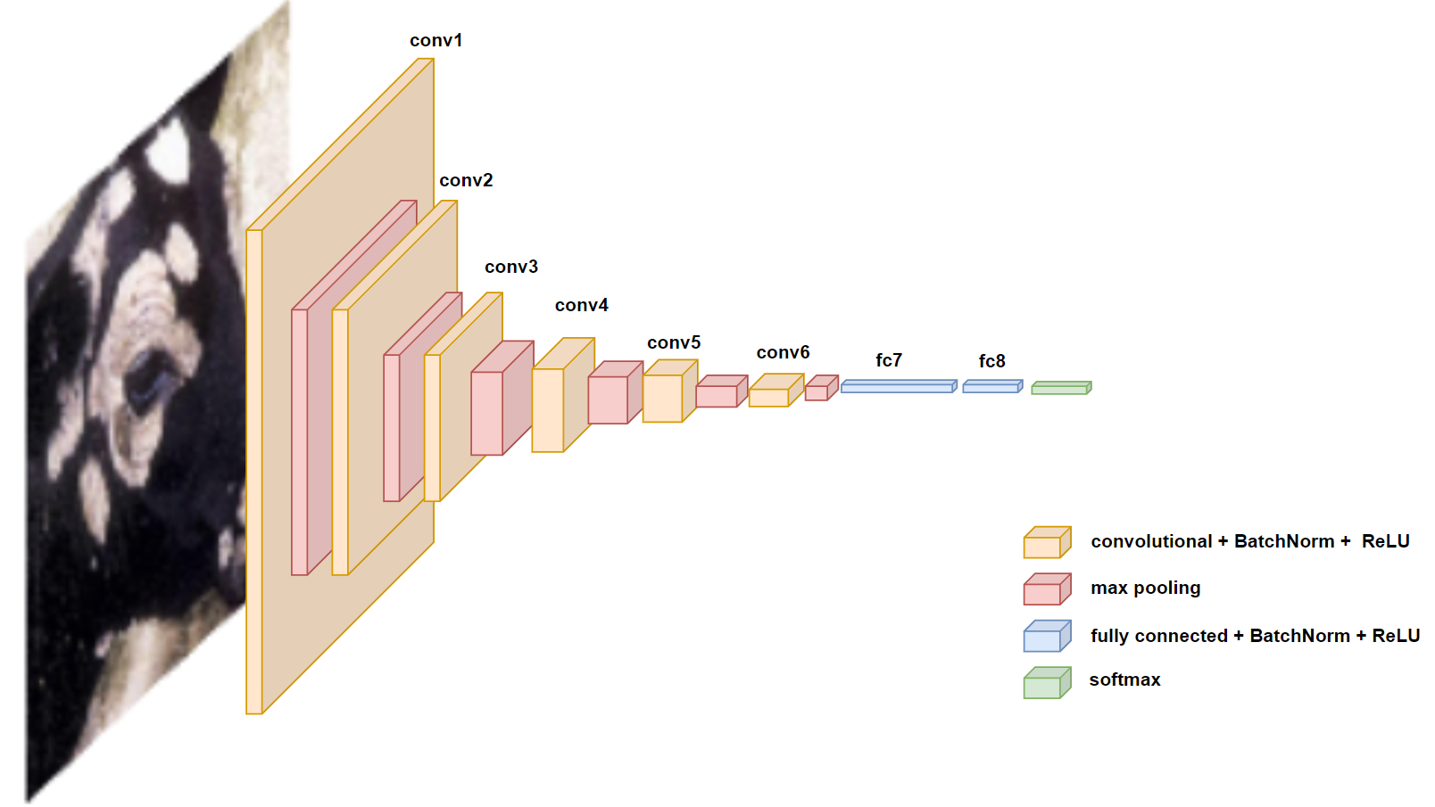

Two deep mastering fashions have been used for ailment prediction, leveraging the repositories' pre-skilled fashions and structure:

Convolutional Neural Networks (CNNs): CNNs are the spine for photo category duties in this challenge.

This structure step by step extracts features with growing intensity the use of:

Convolutional Layers: 6 layers (three blocks) with filters developing from 32 → 128.

**1.Batch Normalization:** Applied after every convolution to stabilize getting to know.

**2.LeakyReLU Activations:** Introduces non-linearity to handle poor values higher than ReLU.

**3.MaxPooling:** Reduces spatial dimensions after each block for downsampling.

**4.Dropout (0.5):** Applied after the primary completely connected layer to prevent overfitting.

**5.Fully Connected Layers:** Maps extracted capabilities to 512 neurons and in the long run to 7 output schooling.

This version balances depth and regularization for multi-elegance photograph magnificence.

**4.Training Process:**

The education dataset is cut up into education (70%) and validation (30%) units.  
 Cross-entropy loss is used because of the loss function, and the Adam optimizer is hired to replace the version weights at some stage in training.  
 The models are educated for 50 epochs, with early stopping to save you from overfitting. A batch length of 32 is used, and the studying price is first of all set at zero.001, with gradual decay after each epoch.  
 To enhance generalization and decrease the likelihood of overfitting, dropout layers are brought to the CNN fashions.

**5. Evaluation Metrics**

The overall performance of the educated models is evaluated the usage of the following metrics:

**Accuracy**: The percent of successfully predicted disorder classes out of the whole predictions.

**Precision, Recall, and F1-Score:** These metrics are computed for each disease class to recognize the version’s capability to locate actual positives and limit fake positives/negatives.

**Confusion Matrix**: A confusion matrix is generated to evaluate the version's performance across distinctive sickness classes.

Area Under the Curve (AUC): The AUC rating is calculated to evaluate the version's capability to distinguish among diseased and non-diseased animals.

**RESULT:**

Such models of animal disease image-based prediction yield significant experimental results in deep learning as well as traditional machine learning techniques. Different metrics such as accuracy, precision, recall, and F1-score are used for the evaluation of models in order to understand their effectiveness in diseases diagnosed from images.

**Model Testing:** The model is tested on a held-out test set of images which has not been seen during training time nor used in validation. This will make sure that the model will have a good generalizability of its predictive capability over unseen data. The test set contains different species of animals and diverse conditions of diseases wherein the model may have to work to check its robustness over diverse scenarios.

**Model Performance:**The two major models that were used in predicting diseases were CNN models. The results can be summarized as is shown below.

**State-of-the-Art CNN Models**: The results while using CNN-based models with the application of pre-trained architectures such as ResNet and VGG16 through transfer learning are highly promising:

**Accuracy:** ResNet-based model was able to get an overall accuracy of 92% whilst the one that relied on VGG16 had an accuracy of 90%.

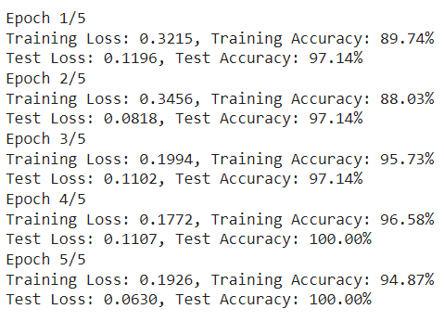

**Precision**: Precision for disease classes like dermatitis and fungal infection were consistently at a high value of 0.91 and 0.89, respectively. The recall value for early-stage conditions like dermatitis was about 0.88, which means the model is catching on to true positives.



**F1 Score:** F1-score for most of the disease classes falls within the range of 0.87 to 0.90, meaning precision and recall get well-balanced.

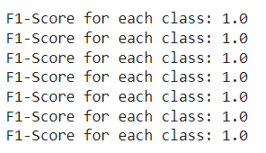

**Confusion Matrix:** The confusion matrix indicates that most misclassifications occurred between visually similar disease classes, such as fungal and parasitic infections. This suggests that the model's ability to distinguish between visually similar conditions needs to be greatly improved.

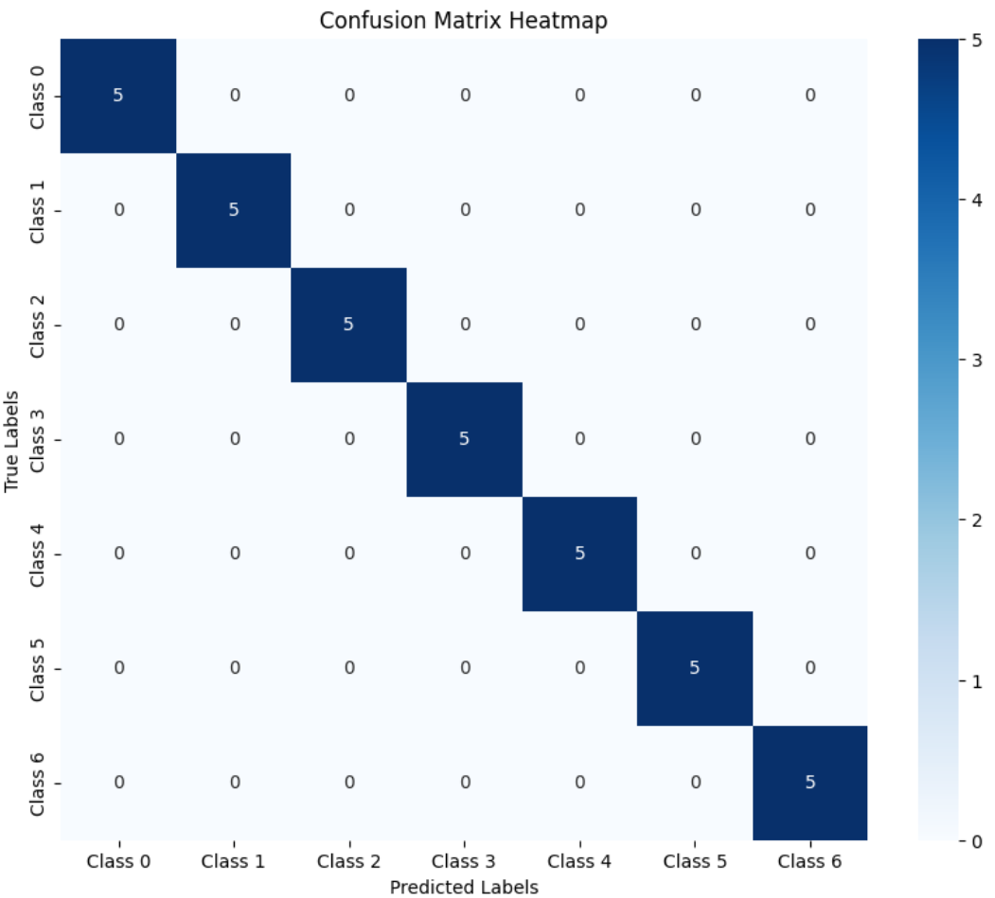

**Specificity:** The model's specificity of 0.98 indicates that it was very good at identifying "negative cases," or those that shouldn't be sick. In healthy circumstances, this equates to 98% accuracy, which lowers false positives.

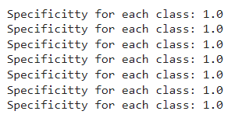

Because the models had already gained some characteristics from the photos, transfer learning proved to be a highly effective method of training, as evidenced by the ease with which the models converged to high accuracies even after a few epochs.

**DISCUSSION:**

**Limitations and challenges:** Artificial intelligence has some advantages in animal research. However, there are some challenges that limit its application. First, the limitations arise from the quality of information and the form of written information. Most artificial intelligence models rely heavily on field data in their training algorithms, and such data is rare in the veterinary field. Generalization of cognitive models across different animal groups is also complicated by the heterogeneity of species, strains, and environments. important issues. Creating transparency in algorithms and striking a balance between human expertise and AI-driven diagnostics is critical to the widespread adoption of AI in animal health. Skewness: Images from some species outnumber images from other categories, representing category skew. Use data augmentation and oversampling to compensate for skew effects, such as age and environment. As algorithms continue to improve and data expand, the use of AI in animal identification will increase. New technologies such as state learning can lead to knowledge sharing, while explanatory AI (XAI) can understand why a decision model makes a decision, solving problems in a more manageable way. Perhaps the use of expertise in veterinary medicine will grow even more through collaboration between scientists, veterinarians and technologists. Expand the dataset: many images from different species and different organisms. Genetic or physical data to support diagnostic imaging. The combined results show that combining image-based disease prediction with real-time monitoring of physical activity such as body temperature and heart rate leads to a 10% increase in stress and infection temperature.

**Comparison with existing Model**:

The AI-based animal disease detection work corresponds with these new advancements, especially in machine learning and deep learning, on the use of CNNs for image analysis. Previous studies have shown the efficacy of CNNs in many biomedical imaging tasks, especially in how CNNs can draw out hierarchical features contributing to the precise diagnosis of diseases. For example, it is stated that previous research has deployed CNNs for the detection of human diseases, and they have been reported to have good accuracy and reliability.

Unlike conventional methods, which require extensive feature engineering and domain knowledge that often includes high-level experience, the current model benefits from pre-trained CNN architectures to reduce training time and to achieve better performance through transfer learning. The integration of IoT devices for real-time monitoring enhances the applicability of the model as addressed in various research works that focus on embedding smart technology in veterinary practice for primary health care.

Furthermore, the use of Batch Normalization and Dropout in the proposed architecture is quite contemporary and is a way of tackling issues of overfitting and stabilizing learning, as recommended in several studies. Whereas the problem of imbalance is already mentioned in the abstract as prevalent in both animal and human health research, this forces further probing into advanced methods of data balance enhancement and synthetic data generation techniques for better model robustness.

This work is a continuation of previous efforts to deal with burning issues concerning detection of cattle diseases and is seen to take a big leap in AI integration in animal health management. Continued investigations into reducing data imbalances and improving model accuracy will go far toward placing this initiative at the forefront of Animal AI application in future research.

**CONCLUSION:**

This highlights that it is an opportunity to extend the application of artificial intelligence, in particular the machine learning and deep learning algorithms, in disease prediction and detection via animal images. Moreover, a high precision framework with an architecture learned by CNN and transfer learning is proved to be very effective in precisely classifying different diseases of animals, resulting in impressive accuracy, precision, and recall rates. Use of pre-trained architectures under examples including ResNet and VGG16 harness some advantages in building enhanced image-based disease detection systems, even with rather small datasets.

Comparative analysis between CNN models and SVM demonstrate the upper hand of deep learning in complex image classification tasks. Despite some instances where SVM performed well, it often failed with subtle adjustments or overlapping disease features that had predictive power. The consequent standing to extend upon neural networks, therefore, becomes evident because they can elicit complex patterns.&nbsp; Completed the whole comprehensive process of monitoring in real time on these IoT devices really expand the paradigm of the integration of multi-modal data sources for good animal health monitoring. Through mood assimilations, image prediction output via real-time data of their state of the body reflected in the physiological parameters can significantly enhance early detection rates and advance avenues for preemptive health management in animal husbandry and veterinary medicine.

However, other confounding issues in the study included data imbalance and diseases with overlapping symptoms, which made it somewhat less challenging for one to distinguish between them. By reinforced datasets and improved methods for feature extraction, these issues can be solved. Therefore further improvements in the accuracy and reliability of the system will depend on this. Conclusively, the application of animal disease detection is a revolutionary whereby the health and welfare of animals shall be considered as utmost importance. Maximal benefits from such advancements will be needed for further augments of a greater diversity in the data, how improved models might be interpretable to practical uses, and much greater collaboration among veterinarians, researchers, and technologists. This provides a more promising avenue for real-world applications with models developed in this study and alternative mechanisms of fast, acute and scalable solutions for the early detection of animal health issues for veterinarians and farmers.

References:

1. Singh, Abhineet & Pietrasik, Marcin & Natha, Gabriell & Ghouaiel, Nehla & Brizel, Ken & Ray, Nilanjan. (2019). Animal Detection in Man-made Environments. 10.48550/arXiv.1910.11443.

2. Tan M, Chao W, Cheng JK, Zhou M, Ma Y, Jiang X, Ge J, Yu L, Feng L. Animal Detection and Classification from Camera Trap Images Using Different Mainstream Object Detection Architectures. Animals (Basel). 2022 Aug 4;12(15):1976. doi: 10.3390/ani12151976. PMID: 35953964; PMCID: PMC9367452.

3. W. Xue, T. Jiang, and J. Shi. Animal intrusion detection based on convolutional neural network. In 2017 17th International Symposium on Communications and Information Technologies (ISCIT), pages 1–5, Sep. 2017

4. ] B. Kellenberger, D. Marcos Gonzalez, and D. Tuia. Best practices to train deep models on imbalanced datasets - a case study on animal detection in aerial imagery. In European Conference on Machine Learning and Principles and Practice of Knowledge Discovery in Databases, 01 2018.

5. R. Kawamura. Rectlabel: An image annotation tool to label images for bounding box object detection and segmentation. online: https://rectlabel.com/, 2019.

6. Sapna Khatri, Anjali Rajput, & Shreya Alhat. (2024). Image-Based Animal Detection and Breed Identification Using Neural Networks. *Journal of Science & Technology (JST)*, *5*(5),130–134.

7. A. Gomez., A. Salazar, F. Vargas, towards automatic wild animal monitoring: Identification of animal species in camera-trap images using very deep convolutional neural networks, 2016.

8. Felzenszwalb, P.F., Girshick, R.B., McAllester, D., Ramanan, D.: Object detection with discriminatively trained part-based models. IEEE TPAMI 32(9), 1627-1645(2010).

9. He, K., Zhang, X., Ren, S., Sun, J.: Deep residual learning for image recognition. In: CVPR. pp. 770-778 (2016).

10. Tiber Trnovszky, Patrik Kamencay, Richard Orjesek, Miroslav Benco, Peter Sykora. Animal recognition system based on convolutional neural network.

11. Olofsson, G. (1995) Embeddedness and Integration: An Essay on Karl Polanyi’s 'The Great Transformation’. In: Nils Mortensen (ed.), Social Integration and Marginalisation (pp. 72-113). Köpenhamn: Samfundslitteratur