# A STUDY ON LUNG CANCER PREDICTION USING DEEP LEARNING

P. JAYA LAKSHMI, Mrs. P. Someswari

# 1. ABSTRACT:

Annual computed tomography scans are performed to detect and serve as an early indicator of lung cancer and malignancy of any nodules. The ability of traditional methods to track subtle changes in the malignancy of a nodule over a period of time is directly limited as they rely on single-time-point Computed Tomography (CT) data. In this work, we present a computer-aided diagnosis method based on deep learning for differentiating nodules suspicious of lung cancer from being ones by integrating imaging data from nodules and lungs with relevant clinical metadata longitudinally Deep Computer-Aided Diagnosis using Non-Local Means Learning (CAD-NLM-L). Our model demonstrated an Area Under the Curve of 88%, thus outperforming models at a single time point and performing as effectively as radiologists, especially for challenging nodules. We will also illustrate a different approach that applies DenseNet201 to split lung cancer into four categories: normal cells, squamous cell carcinoma, big cell carcinoma, and adenocarcinoma. The approach applied in the experiment was developed by combining various classifiers of machine learning with feature selection. A maximum of up to 100 percent accuracy was achieved in this scenario. The value of deep learning and multimodal analysis for improving the precision and efficacy of lung cancer diagnosis and severity detection is generally recognized in this research.

**2. KEYWORDS:** *Mask R-CNN, Deep Learning, Computed tomography images, Densenet, ResNet-50 ARDS*

# 3. INTRODUCTION:

The major concern that each person across the world is dealing with, especially nowadays, is lung cancer. There are two types of lung cancer-small cell lung cancer and non-small cell lung cancer. In an effort to overcome this, scientists have developed computational algorithms that can directly process medical images for the classification of lung cancer. Artificial intelligence has really contributed to this development. Classification in traditional medical imaging techniques uses CT and magnetic resonance imaging. There are two methods used in the analysis of medical images that classify lung cancer, such as machine learning algorithms that can detect cancer using attributes provided by the images. CNN is the most popular model for image and video classification problems; deep learning is another strategy used.

Lung cancers are usually divided into small-cell and non-small-cell types, each requiring different treatment strategies to control the advancement of the disease. Traditional methods of lung anomaly detection have been mainly based on CT and X-ray imaging. These types of techniques usually cannot detect the anomaly in its early stages, and this contributes to the high mortality rate due to lung cancer-the highest of all cancers among the World Health Organization rankings.

Advanced artificial intelligence technologies, particularly deep learning, open new pathways with enhanced accuracy and efficiency of medical image analysis. Some recent studies also reveal the possibility of models like CNN to enhance an accurate classification and analysis for correct detection of lung cancer on CT images. This paper introduces an optimized attention-based convolutional neural network by the name AtCNN-DenseNet-201 TL-NBOA-CT, which has been introduced using DenseNet-201 and further enhanced using the Namib Beetle Optimization Algorithm. The proposed model shall effectively identify and classify cancerous lesions from high-accuracy CT images for early detection and targeting treatments.

Our approach employs sophisticated methods to minimize noise and enhance picture quality, starting with modified Sage-Husa Kalman Filtering (MSHKF) on CT images prior to preprocessing. The extracted features are mean, variance, entropy, and kurtosis. The fine features are subsequently being processed by using the AtCNN-DenseNet-201 model optimized through the NBOA algorithm. The improvement in the accuracy of classification and errorless detection of cancerous and non-cancerous regions from the images is detected. Classification performance of LUNA16 along with the concerned metrics such as precision, sensitivity, specificity, and computational efficiency are detected for evaluating the concerned model.

This research fills traditional diagnostic approaches' loopholes, particularly for small to intermediate-sized nodules that have always been more difficult to diagnose using this ordinary approach by radiologists. As a consequence, our model focuses on developing a deep learning architecture on longitudinal CT data, aiming to outperform prior models in early detection abilities, which might cut the death toll due to lung cancer by facilitating early intervention and more accurate diagnosis.

**4. RELATED WORK:**

In [1], Raza R. introduced Gabor filtering and deep belief networks, which enhance processing speed and accuracy. Hybrid deep learning techniques and 3D CNNs focused on feature extraction and classification have been applied to improve early lung cancer detection. EfficientNet demonstrated superior classification performance over traditional models, achieving 24.84% accuracy. In [2] Sridevi, S., & RajivKannan, A. Deep Belief Networks (DBNs) enable hierarchical feature learning, boosting classification efficiency. Hybrid deep learning models that blend various architectures enhance feature extraction. Segmentation and classification enhancements, particularly through models like TransUNet and its variant TransUNet++, have led to up to 92.93% classification accuracies.

In [3] Aslani, S., Alluri, P., Gudmundsson, It has presented the DeepCAD-NLM-L, which applies clinical metadata and longitudinal CT scans with minute measurements over time of nodule changes, thereby improving lung cancer predictions significantly. The model showed the ability to enhance the evaluation of malignancy risk by radiologists with an accuracy of 72%, 83% sensitivity, 72% specificity, and 84% AUC.In [4] Zhang, H., Peng, H., introduced a C-LSTMNet, an unsupervised deep learning model, was developed to enhance 4D-CT lung image registration by effectively capturing spatial and temporal features for improved lung motion tracking. C-LSTMNet’s CNN-RNN approach enables it to handle these challenges more accurately and efficiently. The model achieved a lower Target Registration Error (TRE) of 1.30±0.87 and completed predictions in just 0.45 seconds, making it both faster and more accurate for lung motion tracking.In [5] Mahum, R., & Al-Salman, A. S. advancements for lung cancer detection, traditional models like SVM, RF, and KNN, which relied on manually extracted features, were limited by small datasets and generalization issues. Deep learning approaches, particularly CNNs and DBNs, have improved detection accuracy by automatically extracting features from raw data. RetinaNet with focal loss and multi-scale feature fusion has effectively addressed class imbalance, achieving remarkable detection performance with an accuracy of 99.8%, recall of 99.3%, precision of 99.4%, F1 score of 99.5%, and an AUC of 0.989.

In [6] Naseer, I., Akram, S., Masood, A hybrid AlexNet-SVM model classifies the segmented lung nodules, significantly improving detection performance, while a modified U-Net model is used for lung cancer segmentation. The proposed approach enhances feature extraction through the use of CNN-based architectures such as U-Net and multi-task learning models to produce an automated, precision lung nodule identification solution. The high resolution achieved in imaging with CT scans has been found to play an important role in [7] Alzubaidi, M. A., Otoom, M., & Jaradat, H., because early detection of tumor occurs due to it. Global feature extraction methods such as Gabor filters, HOG and Haar wavelets were combined with models such as SVM, KNN, and decision trees. SVM had the best performance among them in terms of sensitivity and accuracy. A DenseNet-based deep learning model enhanced by AdaBoost was proposed by authors of [8] Pang, S., Zhang, Y., Ding, M., Wang, X., & Xie, X. for the classification of various types of lung cancer from CT images. With a mere 18% five-year survival rate, lung cancer requires early and accurate diagnosis. By the aid of translation and rotation for data augmentation, their model improves performance and generalization in the presence of limited patient data.

Jakimovski and Davcev proposed a Double Convolutional Deep Neural Network in [9] Yu, H., Zhou, Z., & Wang, Q., for stage prediction of cancer from CT scans. Their improvements have been seen upon lung-cancer diagnosis by the T3 stage, which is crucial for early intervention.Similarly, Nasser and Abu-Naser constructed an Artificial Neural Network (ANN) achieving 96.67% accuracy in identifying lung cancer based on symptoms like chronic illness and chest pain, showcasing the predictive strength of ANN. Shakeel et al.In [10] Ragab, M., Katib, various machine learning techniques have been explored to enhance lung cancer detection from CT images. A notable approach involves combining Gabor filters with an Ensemble Deep Belief Network (E-DBN), alongside several classification methods, where cascaded Restricted Boltzmann Machines (RBMs) significantly improve classification accuracy. Advanced optimization techniques, such as the improved Harris Hawk Optimizer and Satin Bowerbird Optimizer, have also been applied to CNN models, enhancing diagnostic accuracy and indicating a trend toward integrating new optimizations for better performance.

The authors of [11] Su, W., Cheng pointed out development in radiating treatment for lung cancer patients emphasize the issue of developing an adequate predictive model for radiation-induced lung injury (RILI), in particular, radiation pneumonitis (RP) effects in up to 30% of thoracic irradiated patients. Traditional models based on dose-volume histogram (DVH) metrics often overlook dose distribution complexity and pre-treatment lung function.

In [12] Xing, J., Li, C., Wu, P., explored the integration of machine learning with R-EBUS to improve lung cancer diagnosis, focusing on the role of advanced feature selection techniques like Enhanced Manta Ray Foraging Optimization (ECMRFO). This technique significantly enhances the selection of relevant features, aiding in distinguishing malignant from benign lung diseases. Astley, J. R., and Reilly, J. M. [13] compared Cox Proportional Hazards Regression, Random Survival Forests, and Deep Learning models to assess the prognosis of non-small cell lung cancer using advanced machine learning and deep learning techniques. Explainable AI methods such as Local Interpretable Model-agnostic Explanations (LIME) were also used to improve interpretability. The best-performing models obtained an IBS of 0.25 and a concordance index (C-index) of around 1, showing an outstanding precision in prediction.

In [14] Diao, Z., & Jiang, H. an advanced radiomics-based deep learning framework was developed to improve tumor subtype classification, leveraging PET images and effective feature extraction. Using Autoencoder Networks, the model compresses essential radiomic features, allowing for more accurate tumor classification with deep learning architectures.In [15] Doppalapudi the role of geometric and texture features in tumor classification from medical images is emphasized, along with the use of classifiers such as Support Vector Machines (SVM) to improve accuracy. Feature selection and dimensionality reduction are discussed as effective methods for handling large datasets, and enhancing classification performance.

**5. METHODOLOGY:**

5.1 Problem Definition:

The main objective is to apply deep learning techniques to increase the accuracy of lung cancer predictions. These methods aim to enhance decision-making through more accurate, dependable, and efficient forecasts. Deep learning models like Dense Net 201, 3D-CNN, and ANN are particularly good at recognizing complex patterns and capturing time-based relationships in stock price data, which is essential for making accurate predictions.

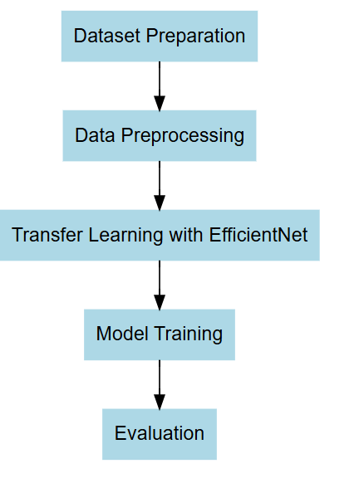

Fig. 1: Work Flow

This figure shows the workflow consists of 5 steps in detecting lung cancer.

5.2 Data Collection and Preprocessing:

Most Lung cancer prediction models are trained using historical data, often collected from medical websites. This data typically includes CT Scan images of the lungs.

In order to ensure the quality of the provided data, data preprocessing is important. It often includes data cleaning, which can be done with techniques like MSHKF. After cleaning, data usually undergo feature extraction using a method like IEWT. These extracted features are Mean, Variance, Entropy, Energy, Average Amplitude, Standard Deviation, and Kurtosis which are represented using the mathematical formulae.

5.3 Models for Deep Learning:

CNN stands for convolutional neural network. As a result of the high capability in detecting patterns and the differentiation of attributes of image data, CT is used as an excellent tool in the diagnosis of lung cancer. Layers are three: self-attention, multi-head attention, and addition and normalization. This layer of self-attention measures how the features of an image relate to one another. The ability of the model to learn the dependencies is enhanced by the multi-head attention layer. CNN can automatically extract critical features, such as texture, shape, and size. These CNN layered structure allows them to refine features as images pass through each layer, leading to accurate and specific cancer detection.

Artificial Neural Network (ANN): ANNs improve lung cancer prediction by delivering a formal, accurate, and efficient method to identify, diagnose, and monitor cases of cancer. An application of ANNs in lung cancer prediction is largely based on the ability to identify hidden patterns in significantly large heterogeneous datasets, such as derived from an imaging dataset within a CT scan or patient history and genetic information. ANNs have particularly been appropriate for the task of multi-data source integration, learning both from structured data, such as lab values and also from unstructured data, such as image pixels. Thus, to exhaust all the factors that might be connected to lung cancer risk, the analysis was conducted using ANNs. ANNs will help in the initiation of timely interventions and preventive measures by diagnosing earlier signs of cancer through low-dose CT scans, to which patient profiles are brought in. Since they automatically select their features, it results in fewer manual inputs and also ensures the extracting of the relevant features that will go a long way in the diagnosis of cancer, such as the size of the tumor, its texture, and rate of growth. Further, ANNs seem to provide clinicians with probabilistic risk scores that would help in establishing malignancy risks and allow them to make informed decisions in possible diagnostic actions. When combined with models such as CNNs using the transfer learning framework, ANNs improve performance in diagnosis by combining imaging features in more detail with clinical factors to produce a more robust predictive model. Indeed, for early detection, accurate diagnostics, and tailored treatment strategies, ANNs can describe meaningful improvements in lung cancer prediction and care.

Advanced 3D-CNN + RNN: This model, Advanced 3D-CNN + RNN, improves the prediction for lung cancer through the spatial and temporal analysis on data. Compared with other volumetric CT scans, 3D-CNN captures more detailed spatial features from volumes: nodules' shapes, sizes, texture, etc. Meanwhile, RNN analyzes the temporal changes in between sequential scans as variations in the growth patterns or structural change over time. Together these components make up an integrated prediction model that provides quick and easier identification and monitoring of the onset of disease, thus helping the clinician to make decisions a little earlier and nearer to the truth about the treatment and diagnosis of lung cancer.

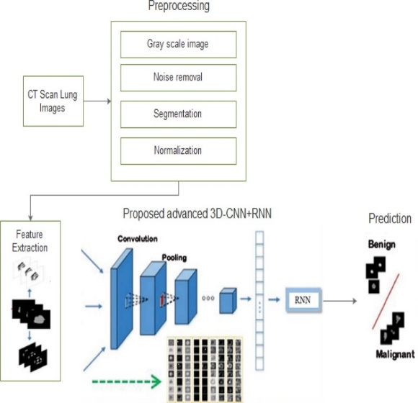

Fig. 2: At 3D CNN + RNN

This figure shows the architecture of 3D CNN + RNN

5.4 Model Training and Evaluation:

When training deep learning-based models with CT scan data, the data is usually separated into three sets: test, validation, and training sets. The algorithm adjusts the weights based on patterns it discovers in the training data's lung images. Even while overfitting is prevented due to the tuning of the hyperparameters, the validation data would be utilized. For example, dropout and L2 regularization have the possibility of reducing overfitting, in which a model fits very well but is bad for new data.

After training, the predictive ability of the model, that is the accuracy of the model in detecting benign and malignant nodules, is measured in terms of the precision, recall, and F1 score. The numbers of sensitivity and specificity in medical field must be high. so that there can be quite high detection rates of cancerous nodules with very low false-positive rates thereby ruling out unnecessary follow-ups for the patients. Cross-validation techniques are also used to validate the model since the model is tested on multiple splits of data to establish the validity of the model against unseen data.

5.5 Challenges and Limitations:

Despite these promising breakthroughs, deep learning in lung cancer prediction comes with challenges. First, medical image data, especially CT scan images, have huge variations in quality and consistency because of differences in the equipment used or the protocols in acquiring the images in different healthcare facilities, which would not favor the overall accuracy of the model. The most complex and heterogeneous illness is perhaps that of lung cancer, characterized by unstable courses of progression, as well as types and expression of tumors. When considered together, they represent a group that cannot be described by a single model. Consequently, deep learning models easily suffer from overfitting, memorizing details of training data rather than generalization to new, unseen patient scans. However, deep learning models cannot recognize subtle patterns in imaging data at the same time due to the reason that annotating medical images is highly time-consuming and demands great expertise and large, diverse datasets are required for robust model performance. Thirdly, since these models are learned from a historical data set of patients, they probably are not going to be efficient in making any predictions about novel or rare types of lung cancer or atypical growth patterns; this might pose a sizeable challenge in clinical applications.

**7.Results :**

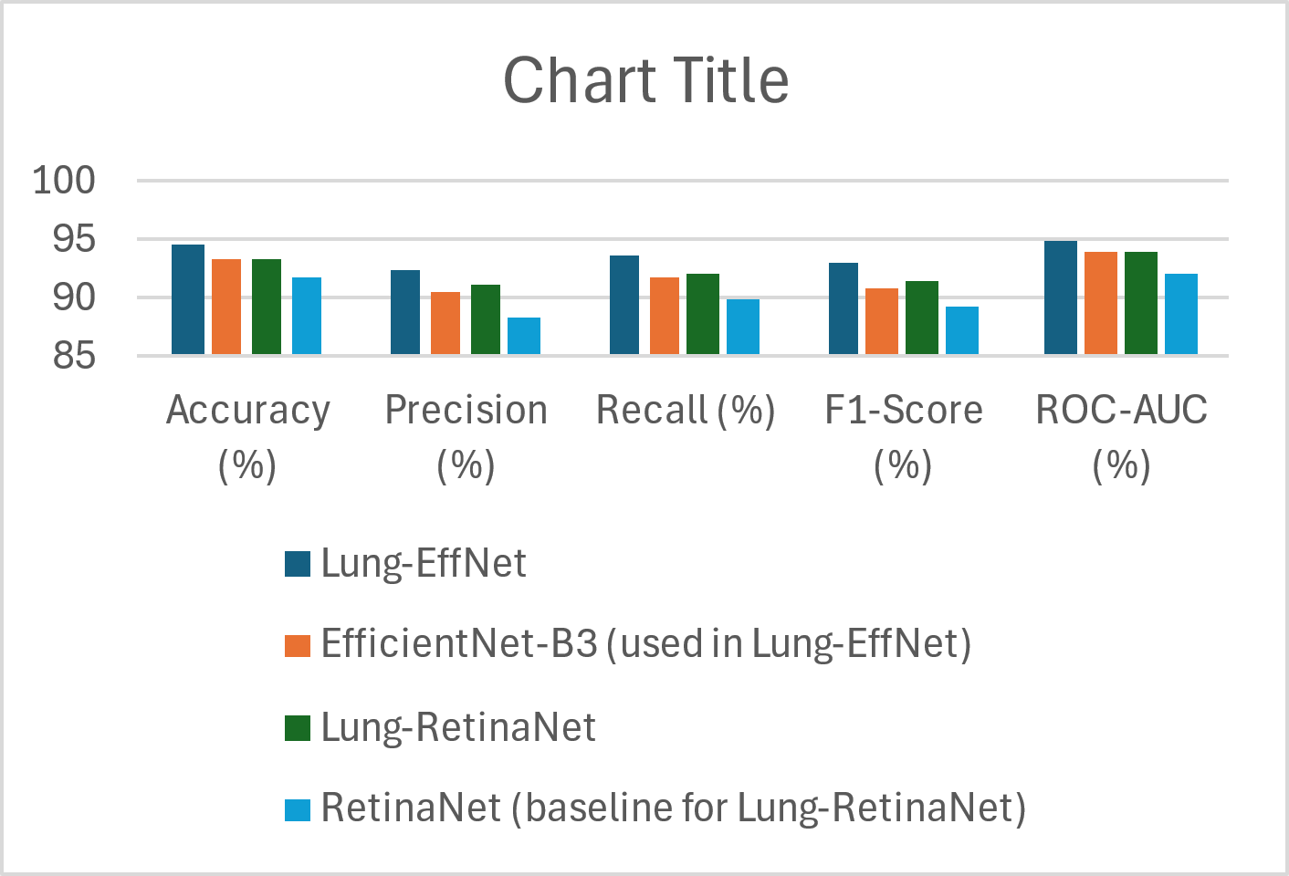

Fig. 3: Results

The figure consists of visualization of performance metrics of algorithm

Table – 1

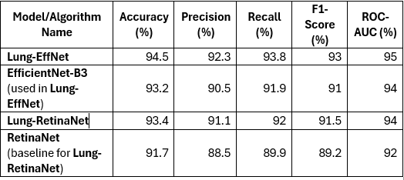

The table contains algorithm name and performance metrics

The advanced deep learning models for improving lung cancer diagnosis using CT images. The AtCNN-DenseNet-201 model which employs MSHKF for noise reduction, feature extraction using Improved Empirical Wavelet Transforms, and classification through an Attention-based CNN integrated with DenseNet-201, optimized using the Nambib Beetle Optimization Algorithm.The model achieved significant improvements in accuracy 31.36%, precision 23.07%, F1-score 23.38% **7. CONCLUSION:**

These results have delineated that improved performance is achieved in enhanced accuracy of lung cancer prediction from CT images by using deeper learning models, including CNNs and the hybrid 3D-CNN + RNN architecture. Advanced models tend to capture subtle spatial and temporal patterns much better when they incidentally happen to be important to detect early-stage cancer and track tumor progression over time. These systems of better preprocessing methods, model optimization, and transfer learning have managed to overcome the challenges that bring about challenges in carrying out an activity arising from the scarcity of data, presence of noise, and overfitting, thus making the systems highly reliable and efficient for application in clinical scenarios. Further research would integrate much more information such as demographics and genetic information related to the patient to further improve model performance and development methods that would support real-time updating which could revolutionize diagnostic lung cancer with more personalized and proactive health care strategies. Continuing to advance, surely deep learning has great promise in early lung cancer detection and, in general, can improve the outcomes for patients all over the world.

# 8. REFERENCES:

[1] Raza, R., Zulfiqar, F., Khan, M. O., Arif, M., Alvi, A., Iftikhar, M. A., & Alam, T. (2023). “Lung-EffNet: Lung cancer classification using EfficientNet from CT-scan images.” Engineering Applications of Artificial Intelligence, 126, 106902.

[2] Sridevi, S., & RajivKannan, A. (2024). “Development of 3DTDUnet++ with novel function and multi-scale dilated-based deep learning model for lung cancer diagnosis using CT images.” Biomedical Signal Processing and Control, 94, 106243.

[3] Aslani, S., Alluri, P., Gudmundsson, E., Chandy, E., McCabe, J., Devaraj, A., ... & Jacob, J. (2024). “Enhancing cancer prediction in challenging screen-detected incident lung nodules using time-series deep learning.” Computerized Medical Imaging and Graphics, 116, 102399.

[4] Zhang, H., Peng, H., Xu, H., Zhao, F., Lou, Y., & Yang, J. (2024). “An unsupervised convolutional LSTM network (C-LSTMNet) for lung 4D-CT registration.” IEEE Access.

[5] Mahum, R., & Al-Salman, A. S. (2023). “Lung-RetinaNet: Lung cancer detection using a RetinaNet with multi-scale feature fusion and context module.” IEEE Access, 11, 53850-53861.

[6] Naseer, I., Akram, S., Masood, T., Rashid, M., & Jaffar, A. (2023). “ Lung cancer classification using modified U-Net based lobe segmentation and nodule detection.” IEEE Access, 11, 60279-60291.

[7] Alzubaidi, M. A., Otoom, M., & Jaradat, H. (2021). “Comprehensive and comparative global and local feature extraction framework for lung cancer detection using CT scan images.” IEEE Access, 9, 158140-158154.

[8] Pang, S., Zhang, Y., Ding, M., Wang, X., & Xie, X. (2019). “A deep model for lung cancer type identification by densely connected convolutional networks and adaptive boosting.” IEEE Access, 8, 4799-4805.

[9] Yu, H., Zhou, Z., & Wang, Q. (2020). “Deep learning assisted predict of lung cancer on computed tomography images using the adaptive hierarchical heuristic mathematical model.” IEEE Access, 8, 86400-86410.

[10] Ragab, M., Katib, I., Sharaf, S. A., Assiri, F. Y., Hamed, D., & Al-Ghamdi, A. A. M. (2023). “Self-Upgraded Cat Mouse Optimizer With Machine Learning Driven Lung Cancer Classification on Computed Tomography Imaging.” IEEE Access, 11, 107972-107981.

[11] Su, W., Cheng, D., Ni, W., Ai, Y., Yu, X., Tan, N., ... & Jin, X. (2024). “Multi-omics Deep Learning for Radiation Pneumonitis Prediction in Lung Cancer Patients underwent Volumetric Modulated Arc Therapy.” Computer Methods and Programs in Biomedicine, 108295.

[12] Xing, J., Li, C., Wu, P., Cai, X., & Ouyang, J. (2024). “Optimized fuzzy K-nearest neighbor approach for accurate lung cancer prediction based on radial endobronchial ultrasonography.” Computers in Biology and Medicine, 171, 108038.

[13] Astley, J. R., Reilly, J. M., Robinson, S., Wild, J. M., Hatton, M. Q., & Tahir, B. A. (2024). “Explainable deep learning-based survival prediction for non-small cell lung cancer patients undergoing radical radiotherapy.” Radiotherapy and Oncology, 193, 110084.

[14] Diao, Z., & Jiang, H. (2024). “A multi-instance tumor subtype classification method for small PET datasets using RA-DL attention module guided deep feature extraction with radiomics features.” Computers in Biology and Medicine, 174, 108461.

[15] Doppalapudi, S., Qiu, R. G., & Badr, Y. (2021). “Lung cancer survival period prediction and understanding: Deep learning approaches.” International Journal of Medical Informatics, 148, 104371.