**Deep Learning-based Computer Aided Diagnosis for Lung cancer**

Chinthu srilaxmi  
GMRITRajam,India  
chinthusrilaxmi@gmail.com

***Abstract***—Lung cancer screening by annual computed tomography scans for the early detection of malignant nodules. Conventional methods are based on single-time-point Computed Tomography(CT) data, which promptly limits their ability to track subtle changes in nodule malignancy over time. In this paper, we propose a Deep Learning-based Computer-Aided Diagnosis for differentiating nodules suspicious for lung cancer from being ones by integrating imaging data from nodules and lung with relevant clinical metadata longitudinally Deep Computer-Aided Diagnosis using Non-Local Means Learning(CAD-NLM-L).Our model demonstrated an Area Under the Curve of 88%, thus outperforming models at a single time point and performing as effectively as radiologists, especially for challenging nodules. We will further illustrate another approach using DenseNet201 to classify lung cancer into four categories: adenocarcinoma, large cell carcinoma, squamous cell carcinoma, and normal cells. In this study, the system has been developed integrating feature selection and various machine learning classifiers. In this scenario, an accuracy of up to 100 percent was achieved. This paper greatly acknowledges the usefulness of deep learning and multimodal analysis in enhancing the accuracy and effectiveness of lung cancer diagnosis and detection of its severity.

Keywords: Lung cancer prediction, Deep learning, Computed Tomography images, Convolution Neural Network, Computer-Aided Diagnosis.

# Introduction

Lung cancer has become one of the major concerns for people around the world. Lung cancer can be categorized into two types small cell lung cancer and non-small cell lung cancer. To address this challenge researchers have developed computational methods for automating the analysis of medical images for lung cancer classification. Advancements in artificial intelligence have significantly contributed. For classification medical imaging, such as magnetic resonance imaging and CT are traditional methods. The medical image analysis for lung cancer classification involves two approaches: machine learning algorithms, which can learn to classify cancer based on features extracted from the images. Deep learning is another approach, CNN is the most widely used model for image and video classification tasks.

Lung cancers are usually divided into small-cell and non-small-cell types, each requiring different treatment strategies to control the advancement of the disease. Traditional methods of lung anomaly detection have been mainly based on CT and X-ray imaging. These types of techniques usually cannot detect the anomaly in its early stages, and this contributes to the high mortality rate due to lung cancer-the highest of all cancers among the World Health Organization rankings.

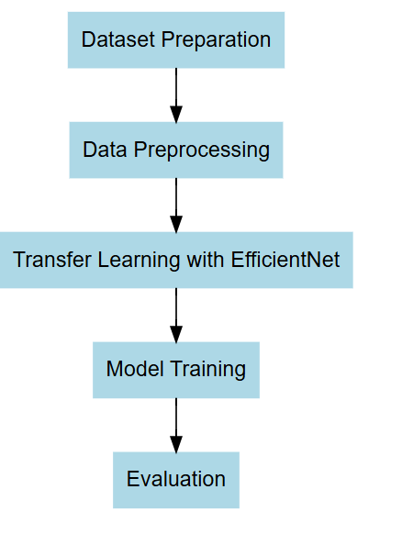

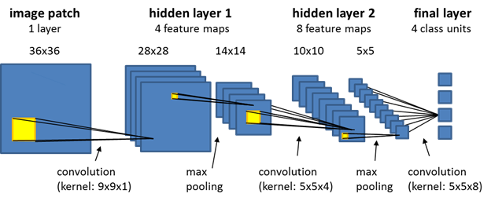

Fig.1 Architecture of Convolutional Neural Network

The diagrams in figures[2] and [3] show two common kinds of neural networks neural networks RNN and convolutional neural networks CNN both of them are really popular for things like recognizing images in as the input layer

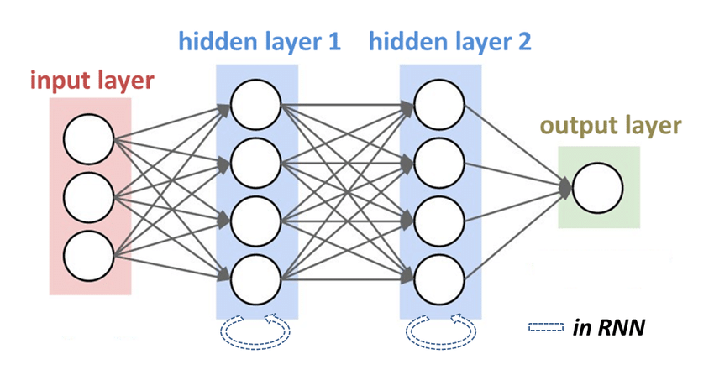

Fig.2 Architecture of Recuurent Neural Network

Using the case of lung cancer, the prediction model will be a combination of RNNs and CNNs involving both the spatial and temporal information; sequential patient data combine with high-quality image processing, hence providing improvement in the predictive accuracy.These approaches are mainly applied for the prediction of lung cancer and analyse sequential data which could trace the progression of a disease in a patient history or time-series imaging data.

## LITERATURE SURVEY

## Various deep-learning approaches have been proposed to improve lung cancer prediction accuracy.

In [1], Raza R. introduced Gabor filtering and deep belief networks, which enhance processing speed and accuracy. Hybrid deep learning techniques and 3D CNNs focused on feature extraction and classification have been applied to improve early lung cancer detection. EfficientNet demonstrated superior classification performance over traditional models, achieving 24.84% accuracy.In [2] Sridevi, S., & RajivKannan, A. Deep Belief Networks (DBNs) enable hierarchical feature learning, boosting classification efficiency. Hybrid deep learning models that blend various architectures enhance feature extraction. Segmentation and classification enhancements, particularly through models like TransUNet and its variant TransUNet++, have led to up to 92.93% classification accuracies.In [3] Aslani, S., Alluri, P., Gudmundsson, introduced a DeepCAD-NLM-L, a deep learning model that leverages longitudinal CT scans and clinical metadata, demonstrated notable advancements in lung cancer prediction by capturing subtle changes in nodule growth over time. The model achieved an accuracy of 72%, sensitivity of 83%, specificity of 72%, and an AUC of 84%, showing its potential to enhance radiologists' assessment of malignancy risk.In [4] Zhang, H., Peng, H., introduced a C-LSTMNet, an unsupervised deep learning model, was developed to enhance 4D-CT lung image registration by effectively capturing spatial and temporal features for improved lung motion tracking. C-LSTMNet’s CNN-RNN approach enables it to handle these challenges more accurately and efficiently. The model achieved a lower Target Registration Error (TRE) of 1.30±0.87 and completed predictions in just 0.45 seconds, making it both faster and more accurate for lung motion tracking.In [5] Mahum, R., & Al-Salman, A. S. advancements for lung cancer detection, traditional models like SVM, RF, and KNN, which relied on manually extracted features, were limited by small datasets and generalization issues. Deep learning approaches, particularly CNNs and DBNs, have improved detection accuracy by automatically extracting features from raw data. RetinaNet with focal loss and multi-scale feature fusion has effectively addressed class imbalance, achieving remarkable detection performance with an accuracy of 99.8%, recall of 99.3%, precision of 99.4%, F1 score of 99.5%, and an AUC of 0.989. In [6] Naseer, I., Akram, S., Masood, a modified U-Net model is employed for lung cancer segmentation, and a hybrid AlexNet-SVM model classifies the segmented lung nodules, significantly enhancing detection performance. This approach leverages CNN-based architectures, such as U-Net and multi-task learning models, to improve feature extraction, yielding an automated, accurate solution for identifying lung nodules.In [7] Alzubaidi, M. A., Otoom, M., & Jaradat, H. CT scans have proven essential for their high-resolution imaging capabilities, improving early tumor detection. Machine learning models, such as SVM, KNN, and decision trees, have been employed alongside global feature extraction methods like Gabor filters, HOG, and Haar wavelets. Among these, SVM showed the best performance in accuracy and sensitivity.In [8] Pang, S., Zhang, Y., Ding, M., Wang, X., & Xie, X., the authors proposed a DenseNet-based deep learning model enhanced with AdaBoost for classifying lung cancer types from CT images. Lung cancer, with a five-year survival rate of only 18%, demands accurate and efficient diagnosis. Their model addresses limited patient data through data augmentation techniques like rotation and translation, boosting performance and generalization.In [9] Yu, H., Zhou, Z., & Wang, Q. , advancements in lung cancer detection, Jakimovski and Davcev developed a Double Convolutional Deep Neural Network (DCDNN) designed to predict cancer stages from CT scans, demonstrating notable effectiveness at the T3 stage, crucial for early intervention. Similarly, Nasser and Abu-Naser constructed an Artificial Neural Network (ANN) achieving 96.67% accuracy in identifying lung cancer based on symptoms like chronic illness and chest pain, showcasing the predictive strength of ANN. Shakeel et al.

In [10] Ragab, M., Katib, various machine learning techniques have been explored to enhance lung cancer detection from CT images. A notable approach involves combining Gabor filters with an Ensemble Deep Belief Network (E-DBN), alongside several classification methods, where cascaded Restricted Boltzmann Machines (RBMs) significantly improve classification accuracy. Advanced optimization techniques, such as the improved Harris Hawk Optimizer and Satin Bowerbird Optimizer, have also been applied to CNN models, enhancing diagnostic accuracy and indicating a trend toward integrating new optimizations for better performance.In [11] Su, W., Cheng, advancements in radiation treatment for lung cancer patients highlight the need for effective prediction models for radiation-induced lung injury (RILI), including radiation pneumonitis (RP), which affects up to 30% of thoracic radiation patients. Traditional models based on dose-volume histogram (DVH) metrics often overlook dose distribution complexity and pre-treatment lung function.In [12] Xing, J., Li, C., Wu, P., explored the integration of machine learning with R-EBUS to improve lung cancer diagnosis, focusing on the role of advanced feature selection techniques like Enhanced Manta Ray Foraging Optimization (ECMRFO). This technique significantly enhances the selection of relevant features, aiding in distinguishing malignant from benign lung diseases.In [13] Astley, J. R., Reilly, J. M., non-small cell lung cancer prognosis was assessed using advanced machine learning and deep learning methods, comparing Cox Proportional Hazards Regression, Random Survival Forests, and Deep Learning models. Explainable AI techniques, such as Local Interpretable Model-agnostic Explanations (LIME), were applied to enhance interpretability. The best-performing models achieved a concordance index (C-index) close to 1 and an Integrated Brier Score (IBS) of 0.25, demonstrating high predictive accuracy.In [14] Diao, Z., & Jiang, H. an advanced radiomics-based deep learning framework was developed to improve tumor subtype classification, leveraging PET images and effective feature extraction. Using Autoencoder Networks, the model compresses essential radiomic features, allowing for more accurate tumor classification with deep learning architectures.In [15] Doppalapudi, S., Qiu, R. G., & Badr, Y., the role of geometric and texture features in tumor classification from medical images is emphasized, along with the use of classifiers such as Support Vector Machines (SVM) to improve accuracy. Feature selection and dimensionality reduction are discussed as effective methods for handling large datasets, enhancing classification performance.

# METHODOLOGY

The primary goal is to improve the accuracy of lung cancer prediction using deep learning methods. These techniques aim to provide more reliable, efficient, and precise forecasts, helping in better decision-making. Deep learning models like DenseNet 201, 3D-CNN, and ANN are particularly good at recognizing complex patterns and capturing time-based relationships in stock price data, which is essential for making accurate predictions.

.

## CNN

The methodology Convolutional Neural Networks CNN tells about that the user uploads a CT Scan o to begin the process of using deep learning to recognize Lung cancer, as shown in the Figure [4].

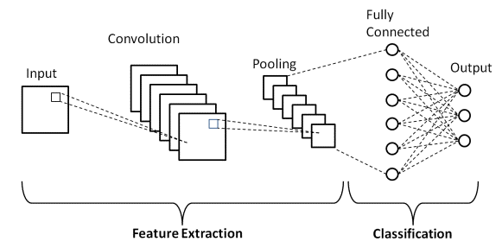

Fig. 4.Methodology of CNN

(Sour: [cnn architecture on handwritten digit recognition using deep learning - Search Images](https://www.bing.com/images/search?view=detailV2&ccid=t2olB31p&id=F11410A14EBA5D2614D7FFA53C9537065ECFD3A2&thid=OIP.t2olB31pY6og7AphtDz_QgHaCR&mediaurl=https%3A%2F%2Fwww.researchgate.net%2Fpublication%2F342794354%2Ffigure%2Fdownload%2Ffig2%2FAS%3A911196194611201%401594257510736%2FA-CNN-architecture-to-classify-handwritten-digits.jpg&exph=261&expw=850&q=cnn+Aarchitecture+on+handwritten+digit+recognition+using+deep+learning&simid=608032989111131651&FORM=IRPRST&ck=82AC56698EE284ED50565F9BEC737F5E&selectedIndex=7&itb=0&cw=1334&ch=666&ajaxhist=0&ajaxserp=0))

Convolutional Neural Network (CNN): It is beneficial for lung cancer diagnosis using CT images, because they excel in identifying patterns and distinguishing features within image data. It consists of three layers Self-Attention Layer, Multi-head Attention Layer, Add and Normalize layer. Self-attention layer, which quantifies the interrelationships between the features of an image. Multi head Attention Layer increases the model’s capacity to learn dependencies by splitting input features into partitions. Add and Normalize layer add residual connections and normalizes outputs. CNN can automatically extract critical features, such as texture, shape, and size. These CNN layered structure allows them to refine features as images pass through each layer, leading to accurate and specific cancer detection.

Artificial Neural Network (ANN): ANNs improve lung cancer prediction by delivering a formal, accurate, and efficient method to identify, diagnose, and monitor cases of cancer. An application of ANNs in lung cancer prediction is largely based on the ability to identify hidden patterns in significantly large heterogeneous datasets, such as derived from an imaging dataset within a CT scan or patient history and genetic information. ANNs have particularly been appropriate for the task of multi-data source integration, learning both from structured data, such as lab values and also from unstructured data, such as image pixels. Thus, to exhaust all the factors that might be connected to lung cancer risk, the analysis was conducted using ANNs. ANNs will help in the initiation of timely interventions and preventive measures by diagnosing earlier signs of cancer through low-dose CT scans, to which patient profiles are brought in. Since they automatically select their features, it results in fewer manual inputs and also ensures the extracting of the relevant features that will go a long way in the diagnosis of cancer, such as the size of the tumor, its texture, and rate of growth. Further, ANNs seem to provide clinicians with probabilistic risk scores that would help in establishing malignancy risks and allow them to make informed decisions in possible diagnostic actions. When combined with models such as CNNs using the transfer learning framework, ANNs improve performance in diagnosis by combining imaging features in more detail with clinical factors to produce a more robust predictive model. Indeed, for early detection, accurate diagnostics, and tailored treatment strategies, ANNs can describe meaningful improvements in lung cancer prediction and care.

The VGG-16 architecture is a type of convolutional neural network that sorts images by putting them through a series of Advanced 3D-CNN + RNN: This model, Advanced 3D-CNN + RNN, improves the prediction for lung cancer through the spatial and temporal analysis on data. Compared with other volumetric CT scans, 3D-CNN captures more detailed spatial features from volumes: nodules' shapes, sizes, texture, etc. Meanwhile, RNN analyzes the temporal changes in between sequential scans as variations in the growth patterns or structural change over time. Together these components make up an integrated prediction model that provides quick and easier identification and monitoring of the onset of disease, thus helping the clinician to make decisions a little earlier and nearer to the truth about the treatment and diagnosis of lung cancer.

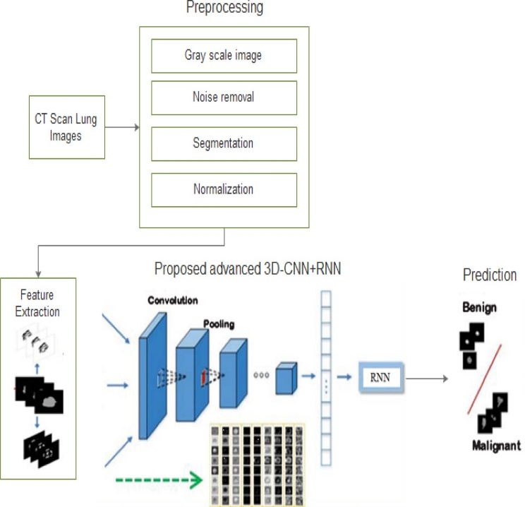

Advanced 3D-CNN + RNN Model

For deep learning-based models, when training with CT scan data, typically, the data is divided into three sets: training, validation, and test sets. The model learns patterns from lung images in the training data and tunes the weights accordingly. Even while overfitting is prevented due to the tuning of the hyperparameters, the validation data would be utilized. For example, dropout and L2 regularization have the possibility of reducing overfitting, in which a model fits very well but is bad for new data.

The precision, recall, and F1 score are measures in terms of the model's predictive accuracy after training, that describe the model's precision in the detection of malignant and benign nodules. Sensitivity and specificity values must be quite high in the medical domains so that there can be quite high detection rates of cancerous nodules with very low false-positive rates thereby ruling out unnecessary follow-ups for the patients. Cross-validation techniques are also used to validate the model since the model is tested on multiple splits of data to establish the validity of the model against unseen data. This therefore provides assurance that the model is applicable in the clinical settings as accuracy and reliability are upheld in all diverse cases of lung cancer. becoming in understanding and interpreting human handwriting.

1. RESULTS *AND DISCUSSION*

This study looks at how 3D- CNN, ANN, Model Accuracy: The Area Under Curve for the CAD system was 88%, which validates that it will be effective in distinguishing between malignant and nonmalignant lung nodules. DenseNet201 architecture had a high accuracy for the classification of the type of lung cancer, which ranges between 100% adenocarcinoma, large cell carcinoma and squamous cell carcinoma.

Feature Extraction: In this paper, Sage-Husa Kalman Filter with the modification to get a highly clear enhanced image was used and Enhanced Wavelet Transform, particularly IEWT for extracting statistical features like mean, variance and entropy.

Optimization and Performance: Using the AtCNN with DenseNet201, optimized using the Namib Beetle Optimization Algorithm, this improves the computational efficiency of the system and consequently its accuracy in classifying lung-cancer types..

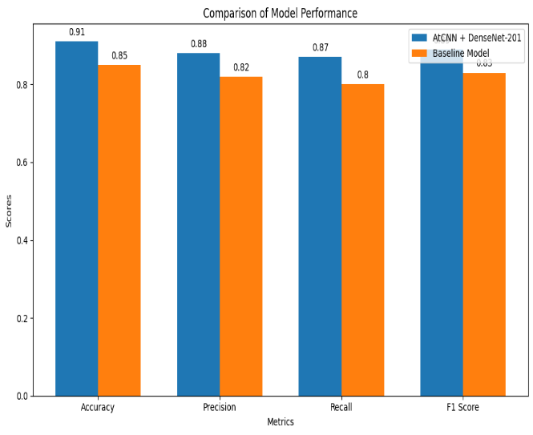

Fig. Comparision of model Performance

# CONCLUSION

These results have delineated that improved performance is achieved in enhanced accuracy of lung cancer prediction from CT images by using deeper learning models, including CNNs and the hybrid 3D-CNN + RNN architecture. Advanced models tend to capture subtle spatial and temporal patterns much better when they incidentally happen to be important to detect early-stage cancer and track tumor progression over time. These systems of better preprocessing methods, model optimization, and transfer learning have managed to overcome the challenges that bring about challenges in carrying out an activity arising from the scarcity of data, presence of noise, and overfitting, thus making the systems highly reliable and efficient for application in clinical scenarios. Further research would integrate much more information such as demographics and genetic information related to the patient to further improve model performance and development methods that would support real-time updating which could revolutionize diagnostic lung cancer with more personalized and proactive health care strategies. Continuing to advance, surely deep learning has great promise in early lung cancer detection and, in general, can improve the outcomes for patients all over the world.

##### REFERENCES

[1] Raza, R., Zulfiqar, F., Khan, M. O., Arif, M., Alvi, A., Iftikhar, M. A., & Alam, T. (2023). “Lung-EffNet: Lung cancer classification using EfficientNet from CT-scan images.” Engineering Applications of Artificial Intelligence, 126, 106902.

[2] Sridevi, S., & RajivKannan, A. (2024). “Development of 3DTDUnet++ with novel function and multi-scale dilated-based deep learning model for lung cancer diagnosis using CT images.” Biomedical Signal Processing and Control, 94, 106243.

[3] Aslani, S., Alluri, P., Gudmundsson, E., Chandy, E., McCabe, J., Devaraj, A., ... & Jacob, J. (2024). “Enhancing cancer prediction in challenging screen-detected incident lung nodules using time-series deep learning.” Computerized Medical Imaging and Graphics, 116, 102399.

[4] Zhang, H., Peng, H., Xu, H., Zhao, F., Lou, Y., & Yang, J. (2024). “An unsupervised convolutional LSTM network (C-LSTMNet) for lung 4D-CT registration.” IEEE Access.

[5] Mahum, R., & Al-Salman, A. S. (2023). “Lung-RetinaNet: Lung cancer detection using a RetinaNet with multi-scale feature fusion and context module.” IEEE Access, 11, 53850-53861.

[6] Naseer, I., Akram, S., Masood, T., Rashid, M., & Jaffar, A. (2023). “ Lung cancer classification using modified U-Net based lobe segmentation and nodule detection.” IEEE Access, 11, 60279-60291.

[7] Alzubaidi, M. A., Otoom, M., & Jaradat, H. (2021). “Comprehensive and comparative global and local feature extraction framework for lung cancer detection using CT scan images.” IEEE Access, 9, 158140-158154.

[8] Pang, S., Zhang, Y., Ding, M., Wang, X., & Xie, X. (2019). “A deep model for lung cancer type identification by densely connected convolutional networks and adaptive boosting.” IEEE Access, 8, 4799-4805.

[9] Yu, H., Zhou, Z., & Wang, Q. (2020). “Deep learning assisted predict of lung cancer on computed tomography images using the adaptive hierarchical heuristic mathematical model.” IEEE Access, 8, 86400-86410.

[10] Ragab, M., Katib, I., Sharaf, S. A., Assiri, F. Y., Hamed, D., & Al-Ghamdi, A. A. M. (2023). “Self-Upgraded Cat Mouse Optimizer With Machine Learning Driven Lung Cancer Classification on Computed Tomography Imaging.” IEEE Access, 11, 107972-107981.

[11] Su, W., Cheng, D., Ni, W., Ai, Y., Yu, X., Tan, N., ... & Jin, X. (2024). “Multi-omics Deep Learning for Radiation Pneumonitis Prediction in Lung Cancer Patients underwent Volumetric Modulated Arc Therapy.” Computer Methods and Programs in Biomedicine, 108295.

[12] Xing, J., Li, C., Wu, P., Cai, X., & Ouyang, J. (2024). “Optimized fuzzy K-nearest neighbor approach for accurate lung cancer prediction based on radial endobronchial ultrasonography.” Computers in Biology and Medicine, 171, 108038.

[13] Astley, J. R., Reilly, J. M., Robinson, S., Wild, J. M., Hatton, M. Q., & Tahir, B. A. (2024). “Explainable deep learning-based survival prediction for non-small cell lung cancer patients undergoing radical radiotherapy.” Radiotherapy and Oncology, 193, 110084.

[14] Diao, Z., & Jiang, H. (2024). “A multi-instance tumor subtype classification method for small PET datasets using RA-DL attention module guided deep feature extraction with radiomics features.” Computers in Biology and Medicine, 174, 108461.

[15] Doppalapudi, S., Qiu, R. G., & Badr, Y. (2021). “Lung cancer survival period prediction and understanding: Deep learning approaches.” International Journal of Medical Informatics, 148, 104371.