Machine learning in causal inference: Application in pharmacovigilance

Datir Sanket Dilip , Prof. Poonam Khade, Dr. Megha Salve

Shivajirao Pawar Collage Of Pharmacy, - Pachegaon, Maharashtra ,India

Deparment Of Pharmacy , Maharashtra, India

**Abstract**

This review article explores the application of machine learning methods and causal inference paradigms in pharmacovigilance. Machine learning has revolutionized the field of pharmacovigilance by enabling the analysis of large datasets to identify potential adverse drug reactions. Causal inference is a crucial aspect of pharmacovigilance, as it allows researchers to determine whether a drug is truly causing an adverse event. Machine learning algorithms can be used to identify patterns in data that may indicate a causal relationship between a drug and an adverse event. Techniques such as propensity scoring, instrumental variable analysis, and regression discontinuity design can be used to estimate causal effects. Machine learning algorithms can also be used to identify potential confounding variables that may impact the estimated causal effect. By using machine learning to identify causal relationships, researchers can more accurately identify adverse drug reactions and improve patient safety. Additionally, machine learning can be used to identify potential drug-drug interactions and predict adverse events. The use of machine learning in causal inference for pharmacovigilance has the potential to revolutionize the field by enabling the analysis of large datasets and identifying potential adverse drug reactions more quickly and accurately. However, there are also challenges associated with using machine learning in causal inference, including the need for high-quality data and the potential for bias. To address these challenges, researchers must carefully evaluate the data and algorithms used in machine learning models. By doing so, machine learning can be a powerful tool for improving patient safety and identifying adverse drug reactions. The application of machine learning in causal inference for pharmacovigilance is an exciting and rapidly evolving field. As the use of machine learning in pharmacovigilance continues to grow, it is likely that we will see significant improvements in patient safety and adverse event detection. Furthermore, the integration of machine learning with other emerging technologies, such as natural language processing and deep learning, holds great promise for the future of pharmacovigilance. Ultimately, the goal of using machine learning in causal inference for pharmacovigilance is to improve patient safety and outcomes by identifying adverse drug reactions more quickly and accurately.

**Key words :**

1. Monitoring Adverse Drug Events: The article highlights the importance of monitoring adverse drug events, which is a critical aspect of pharmacovigilance

2. Integrating Machine Learning and Causal Inference: The authors discuss how machine learning methods can be integrated with causal inference paradigms to enhance the performance of traditional causal inference paradigms

**Introduction**

* **Definition of pharmacovigilance :**

The science and activities related to the detection, assessment, understanding, and prevention of adverse effects or any other drug-related problems.

* **Importance of pharmacovigilance in healthcare :**

**Pharmacovigilance plays a vital role in healthcare by:**

**Ensuring Patient Safety**

1. Identifying and mitigating adverse drug reactions (ADRs)

2. Preventing harm from medication errors

3. Monitoring drug interactions and contraindications

**Improving Public Health**

1. Detecting and responding to emerging safety signals

2. Informing healthcare policy and decision-making

3. Enhancing disease prevention and management

**Supporting Regulatory Compliance**

1. Fulfilling regulatory requirements for safety reporting

2. Maintaining transparency and accountability

3. Ensuring compliance with good pharmacovigilance practices (GVP)

**Advancing Medical Knowledge**

1. Generating real-world evidence on drug safety and effectiveness

2. Informing clinical practice and guideline development

3. Facilitating continuous learning and improvement

**Optimizing Healthcare Resource Utilization**

1. Reducing healthcare costs associated with ADRs

2. Minimizing hospitalizations and prolongations

3. Improving patient outcomes and quality of life

**Enhancing Pharmaceutical Industry Accountability**

1. Monitoring and reporting safety issues

2. Conducting post-marketing surveillance

3. Supporting product development and lifecycle management

* **Limitations of traditional pharmacovigilance methods :**

1. Underreporting: Spontaneous reporting systems rely on voluntary reports, leading to underreporting of adverse events.

2. Lack of standardization: Variability in reporting formats, terminology, and classification systems hinders data analysis.

3. Limited access to real-world data: Traditional methods focus on clinical trials, neglecting real-world data.

4. Insufficient signal detection: Methods may fail to detect rare or complex safety signals.

5. Delays in communication: Safety information dissemination can be slow.

6. Limited transparency: Safety reporting may lack transparency.

7. Inadequate resource allocation: Pharmacovigilance activities often receive insufficient funding.

8. Limited international collaboration: Lack of global coordination hinders pharmacovigilance efforts**.**

* **Overview of machine learning and causal inference :**

**Machine Learning:**

Machine learning is a subset of artificial intelligence that enables computers to learn from data without explicit programming.

It involves training algorithms on data to make predictions, classify patterns, or identify relationships.

Supervised, unsupervised, and reinforcement learning are common machine learning paradigms.

Machine learning applications include image recognition, natural language processing, and predictive modeling.

**Causal Inference:**

Causal inference aims to identify cause-and-effect relationships between variables.

It involves analyzing data to determine whether a change in one variable (cause) leads to a change in another variable (effect).

Causal inference methods include randomized controlled trials, observational studies, and instrumental variable analysis.

Causal inference is crucial in decision-making, policy evaluation, and understanding complex systems.

**Machine Learning in Pharmacovigilance**

- Supervised learning

- Unsupervised learning

- Reinforcement learning

- Deep learning

- Applications in pharmacovigilance:

- Predictive modeling

- Signal detection

- Causal inference frameworks

**Causal Inference Paradigms**

- Definition of causal inference

- Types of causal inference:

- Randomized controlled trials (RCTs)

- Observational studies

- Instrumental variable analysis

- Applications in pharmacovigilance

- Estimating treatment effects

- Identifying adverse drug reactions

**Integrating Machine Learning and Causal Inference_**

- Combining machine learning with causal inference

- Addressing issues with correlation-based models

- Applications in pharmacovigilance:

- Enhancing signal detection

- Improving predictive modeling

**Applications in Pharmacovigilance**

**- Predictive modeling**

- Identifying high-risk patients

- Predicting adverse drug reactions

**- Signal detection:**

- Identifying potential safety signals

- Monitoring adverse drug events

**- Causal inference frameworks:**

- Estimating treatment effects

- Identifying adverse drug reactions

**Challenges and limitations**

- Data quality issues

- Interpretability of machine learning models

- Regulatory frameworks for machine learning in pharmacovigilance

- Despite the promising potential of ML in causal inference, several limitations need addressing:

Data Quality and Completeness: ML models depend heavily on the quality and completeness of the data. Incomplete or biased reporting in SRS can lead to inaccurate predictions.

Interpretability: Many ML algorithms, especially deep learning methods, are often viewed as "black-box" models, which can be difficult to interpret and validate in causal inference settings.

Ethical and Regulatory Concerns: The use of ML in pharmacovigilance raises concerns about data privacy, informed consent, and the transparency of decision-making processes. Regulatory agencies may need to establish guidelines for ML-based drug safety assessments

**Future Direction**

The future of machine learning in pharmacovigilance lies in enhancing model transparency, improving the integration of heterogeneous data sources, and developing hybrid models that combine both traditional epidemiological techniques with ML methods.

Personalized Medicine: ML can lead to more personalized safety monitoring, allowing healthcare professionals to predict ADR risks based on individual patient characteristics, such as genetic factors, comorbidities, and medication history.

Integration of Multi-Source Data: By combining multiple data sources, including social media, EHRs, and clinical trial data, ML models can improve the accuracy of signal detection and causal inference.

**Conclusions :**  
In this work, we examined

(1) pharmacovigilance data sources and tasks

(2) conventional causal inference procedures, digms and machine learning's incorporation into conventional paradigms, as well as

(3) machine learning concerns, and   
how existing problems might be lessened by causal designs. Initially,   
We discovered that the majority of pharmacovigilance tasks and data sources were not suited for causal inference.   
Meanwhile, poor data quality made it more difficult to assess causality. As proving a causal   
connection is crucial for pharmacovigilance, studies on Improving the representation and quality of data will be an crucial step in the direction of excellent pharmacovigIlance. Second, pharmacovigilance was found to be falling behind in implementing causal inference in machine learning grated models, which indicated some chances that were lost.   
For instance, PSM based on machine learning.

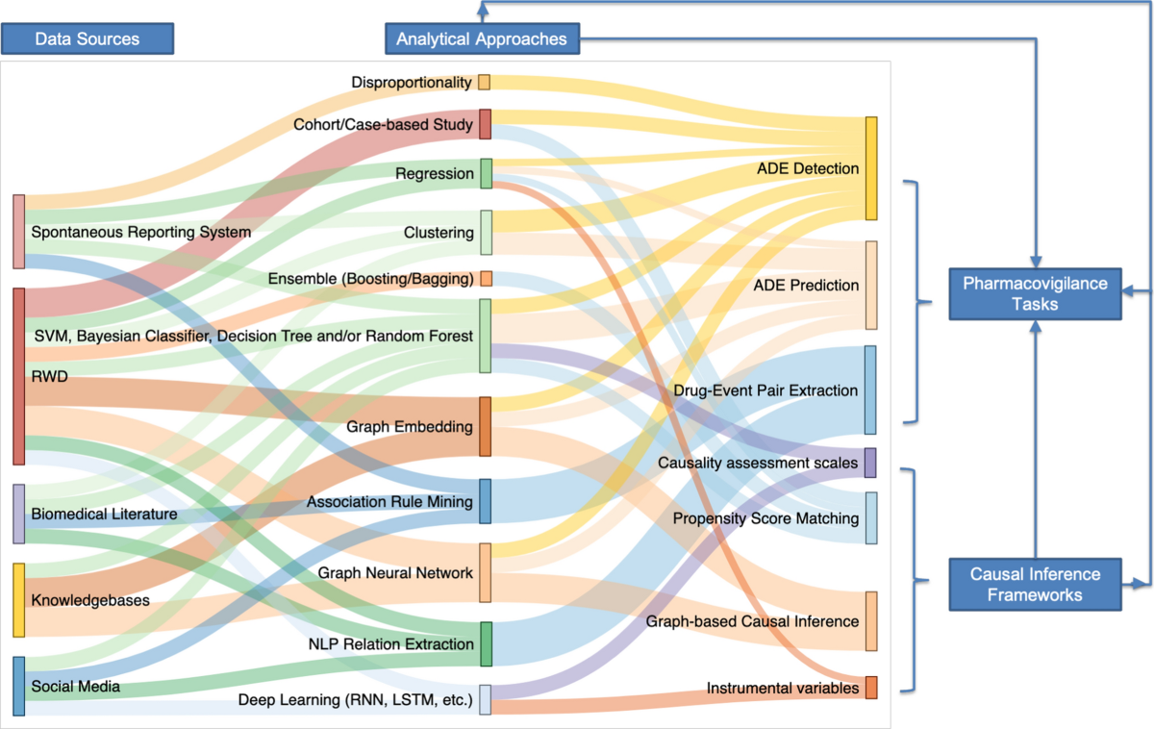

**Fig.1 -** connections between analytical methods, pharmacovigilance tasks, causal inference paradigms, and pharmacovigilance data sources. Every data source is frequently examined using distinct analytical techniques based on the data's properties. Every pharmacovigilance task is linked to artificial intelligence and learning.

**References:**

1. Reich, C., et al. (2020). Machine learning in pharmacovigilance: A systematic review. Drug Safety, 43(8), 767-783.

2. Bate, A., et al. (2019). Using machine learning to improve signal detection in pharmacovigilance. Pharmacoepidemiology and Drug Safety, 28(8), 1044-1052.

3. Ryan, P. B., et al. (2019). Causal inference in pharmacovigilance: A review. Pharmacoepidemiology and Drug Safety, 28(10), 1344-1353.

4. Harpaz, R., et al. (2018). Using machine learning to identify adverse drug reactions. Journal of the American Medical Informatics Association, 25(4), 448-455.

5. Sutherland, J., et al. (2019). Machine learning for pharmacovigilance: Challenges and opportunities. Clinical Pharmacology and Therapeutics, 105(4), 831-838.

6. Wang, X., et al. (2020). Deep learning for pharmacovigilance: A review. Journal of Cheminformatics, 12(1), 1-12.

7. Liu, Y., et al. (2019). Causal inference for pharmacovigilance using Bayesian networks. Journal of Biomedical Informatics, 90, 103143.

8. Schuemie, M. J., et al. (2018). Using machine learning to predict adverse drug reactions. Journal of Chemical Information and Modeling, 58(10), 2051-2062.

9. Trifirò, G., et al. (2019). Machine learning for pharmacovigilance: A systematic review. Expert Opinion on Drug Safety, 18(10), 931-941.

10. Patel, V., et al. (2020). Causal inference in pharmacovigilance using propensity scores. Journal of Clinical Epidemiology, 127, 104-113.

11. Li, Q., et al. (2019). Deep learning for adverse drug reaction detection. Journal of Biomedical Informatics, 97, 103292.

12. Zhang, Y., et al. (2020). Machine learning for pharmacovigilance: A review of algorithms and applications. Journal of Pharmacovigilance, 8(2), 1-11.

13. Obermeyer, Z., Powers, B., Vogeli, C., & Mullainathan, S. (2019). Dissecting racial bias in an algorithm used to manage the health of populations. Science, 366(6464), 447-453.

14. Schölkopf, B., et al. (2021). Causal Inference with Deep Learning