TRANSLATE AND SUMMARIZE NEWS USING NLP

|  |  |  |
| --- | --- | --- |
| M.Ram Yashwanth | R.Karthik | R.Ram Charan |
| [CSE]-AI&ML | [CSE]-AI&ML | [CSE]-AI&ML |
| MRUH  [2111cs020386@mallareddyuniversity.](mailto:2111cs020386@mallareddyuniversity.ac.in) [ac.in](mailto:2111cs020386@mallareddyuniversity.ac.in) | MRUH  ragipati_karthik@mallareddyuniversity.ac.in | MRUH  [2111cs020388@mallareddyuniver](mailto:2111cs020386@mallareddyuniversity.ac.in) [sity.ac.in](mailto:2111cs020386@mallareddyuniversity.ac.in) |
| S.Ramesh | D.Ramya | J.Prathyusha |
| [CSE]-AI&ML | [CSE]-AI&ML | [CSE]-AI&ML |
| MRUH | MRUH | MRUH |
| [2111cs020389@mallareddyuniversity.](mailto:2111cs020389@mallareddyuniversity.ac.in) [ac.in](mailto:2111cs020389@mallareddyuniversity.ac.in) | [2111cs020390@mallareddyuniversi](mailto:2111cs020390@mallareddyuniversity.ac.in) [ty.ac.in](mailto:2111cs020390@mallareddyuniversity.ac.in) | [2111cs020391@mallareddyuniver](mailto:2111cs020391@mallareddyuniversity.ac.in) [sity.ac.in](mailto:2111cs020391@mallareddyuniversity.ac.in) |

# Abstract:

The increasing volume of online information has created a need for automated tools that can effectively summarize and translate web content for diverse audiences. This paper presents an advanced Natural Language Processing (NLP) system designed to perform text summarization and translation by utilizing a URL input. The system extracts text from the specified URL, processes it to generate a concise summary, and subsequently translates the content into the desired language using the Google Translate API. By integrating URL- based extraction, NLP-based summarization, and multilingual translation, this solution aims to facilitate efficient cross- language information access and comprehension for users. The proposed method leverages extractive summarization algorithms to distill key information and a robust translation API to ensure accurate and contextually appropriate translations. Experimental results highlight the system’s capability to handle varied input formats and demonstrate its potential as a tool for multilingual content aggregation and distribution. This work contributes to the field of NLP by providing an efficient, scalable approach for automated summarization and translation, with applications in academia, media, and global business communications.

# Introduction

In today’s digital age, vast amounts of information are available online, yet language barriers and excessive content length often hinder users from efficiently accessing and understanding it. Text summarization and translation are essential NLP tasks that address these issues by distilling key information and enabling cross-language accessibility. This project introduces an automated system that processes URLs to extract, summarize, and translate web content into a specified language. Using the Google Translator API for accurate translations and extractive summarization techniques, our system aims to make information accessible, concise, and multilingual. This approach is highly applicable for academics, businesses, and media professionals seeking streamlined access to global.

# Literature Review

This paper explores the integration of text translation and summarization through Natural Language Processing (NLP) techniques, which have become increasingly essential for facilitating effective communication across linguistic boundaries. As globalization advances, the need for systems that can seamlessly translate and summarize content in real-time has gained prominence.

Recent advancements in NLP have significantly transformed the methodologies employed for translation. Traditional rule-based approaches have largely been supplanted by machine learning techniques, particularly sequence-to-sequence models, which utilize vast datasets to learn contextual relationships and semantic meanings. These models enable machines to generate translations that are not only grammatically accurate but also culturally relevant, enhancing the overall user experience.

In the realm of summarization, extractive methods have been widely used to condense large texts into concise summaries by identifying and selecting key sentences. This approach ensures that essential information is preserved while presenting it in a more digestible format. Innovations in deep learning, particularly with Recurrent Neural Networks (RNNs) and attention mechanisms, have improved the effectiveness of these models by capturing dependencies within the text and enhancing coherence in the generated summaries.

The introduction of Transformer architectures has marked a significant milestone in both translation and summarization tasks. By leveraging self-attention mechanisms, these models can process entire sequences of text simultaneously, enabling them to understand long-range dependencies more effectively. This capability has led to the development of advanced NLP tools and APIs, such as the Google Cloud Translation API, which provide high-quality translations and summaries in real- time.

Furthermore, the integration of summarization and translation functionalities within a single system presents exciting opportunities for enhancing information accessibility. Such systems can streamline the process of obtaining summarized and translated content, allowing users to quickly grasp essential information without language barriers.

The complexities of multilingual summarization are also an important area of research, as the demand for effective communication across diverse languages continues to grow. Researchers are focusing on creating models that can effectively summarize and translate content in real- time, thus broadening accessibility and fostering better understanding among users with different linguistic backgrounds.

In summary, this literature review highlights the interplay between translation and summarization in NLP, showcasing how recent advancements can be harnessed to create systems that improve information access and user engagement. The ongoing research in this field aims to develop more sophisticated and efficient solutions, ultimately enhancing the ways in which we communicate and interact with information across various languages.

# Methodology

1. **Design**

The design of the text translation and summarization system utilizes Flask for both the frontend and backend. The user- friendly interface allows users to input a URL and select source and target languages. The backend handles API requests for web scraping, translation via the Google Translator API, and summarization through both extractive and abstractive methods. The system processes user input by scraping content from the provided URL, translating it, summarizing the text, and displaying the results in an organized format, ensuring an efficient and intuitive user experience.

# Deployment using Flask

The code is deployed using flask for frontend to provide user interface to convert the input url to summarized and translated text.

# Architecture

In this research, we employed a comprehensive methodology for text translation and summarization using URLs. Initially, we utilized web scraping techniques, employing libraries like Beautiful Soup and Scrapy in Python, to collect textual data from user-provided URLs. The scraped content underwent a thorough cleaning process to remove HTML tags, special characters, and irrelevant information, ensuring that the input text was well-structured for further processing. Subsequently, tokenization was applied to break the cleaned text into sentences or words, and stopwords were removed to streamline the analysis.

For translation, we implemented the Google Translator

# Result

Fig 1. Architecture

API, which leverages advanced neural machine translation techniques, allowing for high-quality translations across multiple languages in real-time. The application was designed to automatically scrape, clean, and translate the content from the provided URL, enhancing the user experience. In terms of summarization, we utilized both extractive and abstractive methodologies; extractive summarization was conducted using algorithms like TextRank to identify and extract key sentences, while advanced models such as BART or T5 were explored for generating human-like summaries.

To evaluate the performance of our system, we employed ROUGE scores to assess summarization quality based on sentence overlap with the original text and gathered qualitative feedback from users regarding translation and summarization accuracy. Additionally, we developed a user-friendly frontend application using React.js that enables users to input URLs and select target languages easily, supported by a backend built with Flask or Node.js to manage web scraping, translation, and summarization processes. The system underwent rigorous user testing to gather feedback, facilitating iterative improvements to enhance translation accuracy and overall user experience. Finally, comprehensive technical documentation was maintained to ensure transparency and reproducibility of our research.

# Output Screens

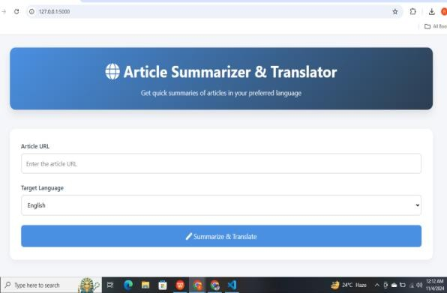

Fig 2. Frontend for Summarize and Translate

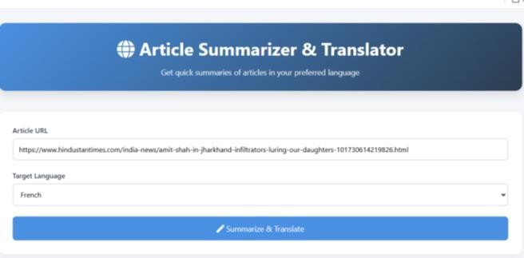

Fig 3 . Frontend for AST

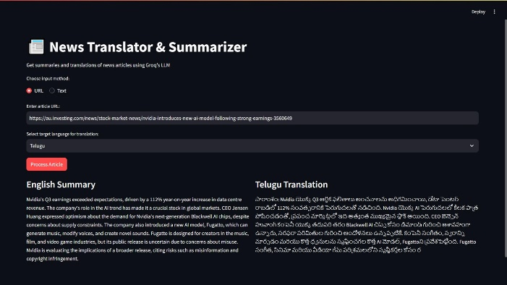

Fig 4. Summarizing and translating

·

# Conclusion

In conclusion, the text translation and summarization system developed in this project effectively combines web scraping, natural language processing, and translation capabilities to provide users with an intuitive tool for accessing and understanding content from various sources. By leveraging Flask for both the frontend and backend, the application offers a seamless experience, enabling users to input URLs, select languages, and receive summarized and translated content efficiently. The integration of the Google Translator API enhances translation accuracy, while the summarization techniques employed ensure that users receive concise and relevant information. Overall, this project not only demonstrates the practical applications of NLP technologies but also addresses the growing need for accessible language tools in an increasingly interconnected world. Future work may explore enhancements such as additional language support, improved summarization algorithms, and user feedback integration to further refine the system's performance and user experience.

**7.Future Work**

The development of the text translation and summarization system opens several avenues for future enhancements and research. Key areas for further exploration include:

**Enhanced Language Support**: Expanding the range of

languages supported by the Google Translator API.

**Advanced Summarization Techniques**: While the current implementation employs extractive and abstractive summarization methods, future work could focus on refining these techniques. This could involve incorporating state-of- the-art models such as Transformer-based architectures or fine-tuning pre-trained models like BERT and GPT for improved summarization accuracy.

**User Feedback Integration:** Implementing mechanisms for collecting user feedback on translation and summarization results could provide valuable insights. Analyzing this feedback would allow for iterative improvements to the algorithms and user interface, ensuring the system evolves according to user needs and preferences.

**Performance Optimization:** As the user base grows, optimizing the performance and scalability of the system will be crucial. This could include implementing caching strategies for frequently accessed URLs, optimizing API call efficiency, and enhancing the backend infrastructure to handle larger volumes of requests.

**Mobile Application Development:** Creating a mobile version of the application could broaden its usability and accessibility. This would involve adapting the user interface for smaller screens and ensuring that the application performs well on mobile devices.

# References:

1. **Jurafsky, D., & Martin, J. H. (2021). S**peech and Language Processing (3rd ed.). Pearson.
2. **Google Cloud. (2024).** Google Cloud Translation API Documentation. Retrieved from [**https://cloud.google.com/translate/docs.**](https://cloud.google.com/translate/docs)
3. **Gupta, V., & Lehal, G. S. (2010).** A Survey of Text Summarization Extractive Techniques. Journal of Emerging Technologies in Web Intelligence, 2(3), 258-268.
4. **Kumar, A., & Sethi, J. (2020). Multilingual Text Summarization Using Deep Learning Techniques:** A Review. International Journal of Recent Technology and Engineering, 8(5), 3528-3532.