**Ciclopirox Based Nail Lacquer On Onychomycosis**

1. Miss. Jyotika Jadhav (Author),
2. Mr. Ganesh Gophane (Guide),

Department name:- Pharmacy,

College Name:- Lokmangal College of Pharmacy,wadala, Solapur, Maharashtra ,India

**Ciclopirox Based Nail Lacquer on Onychomycosis**

**ABSTRACT:-**

Ciclopirox is an antifungal medication made of synthetic Hydroxypridoze. Cycloproxidase's metabolic route involves glucuronidation. Wide range antibacterial activity of Ciclopirox against all common Dermatophytes. in addition to yeast and non-Dermatophytes forms moulds. Onychomycosis is a quite prevalent illness. More so on toenails than fingernails. Dermatophytes are the main cause of it. To treat Onychomycosis, a fungal infection of the toenail, Ciclopirox Nail Lacquer Solution is effective and safe.

**KEYWORD**:- Onychomycosis, Ciclopirox , Nail lacquer, toenail, fungal infection, Antifungal agent

**INTRODUCTION:-**

Onychomycosis is main fungal infection affecting primarily finger and toe nail.

Fungi that infects the nail plate or nail bed causes Onychomycosis, which causes the nail plate to gradually destroy. Yeast, non-Dermatophytes moulds, or Dermatophytes are the causes.

Involved in 2-11% of cases of Onychomycosis have been shown to include non-Dermatophytes fungi, including Alternation, Fusarium, and Acremonium spp.[3]

Comparatively , foot ulcers caused by tinea pedis are linked to more severe symptoms than Onychomycosis. [1] Onychomycosis is considered one of the most frequent dermatological disorders. Enhanced survey on the incidence of the disease and inventions of effective treatment due to their lack of effectiveness.

Onychomycosis treatment is still in its infancy, through as a formulation for safe and efficient topical application is currently being developed. Given the topical therapy may focus the medication at its site of action. [6]

] 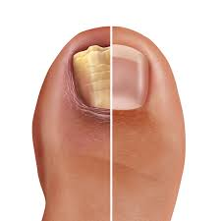

Fig.1 Onychomycosis on toenail

**Etiology and Classification:**-

Candida, nondermatophytic moulds, and dermatophytes are the pathogens that cause onychomycosis. While Candida and nondermatophytic moulds are more usually implicated in the tropics and subtropics with hot and humid climates, dermatophytes are the fungus most commonly responsible for onychomycosis in temperate western countries. The dermatophytes The most prevalent dermatophyte associated with onychomycosis is Trichophyton rubrum. Trichophyton interdigitale, Epidermophyton floccossum, Trichophyton violaceum, Mycosporum gypseum, Trichophyton tonsurans, and Trichophyton soudanense are additional dermatophytes that could be implicated. Additional pathogens Candida and non-dermatophytic moulds, including those belonging to the mould generation Scytalidium (recently renamed Neoscytalidium), and Scopulariopsis, are additional causal infections. Fingernail onychomycosis is primarily caused by Candida in those whose hands are frequently in water**. [**3,21]

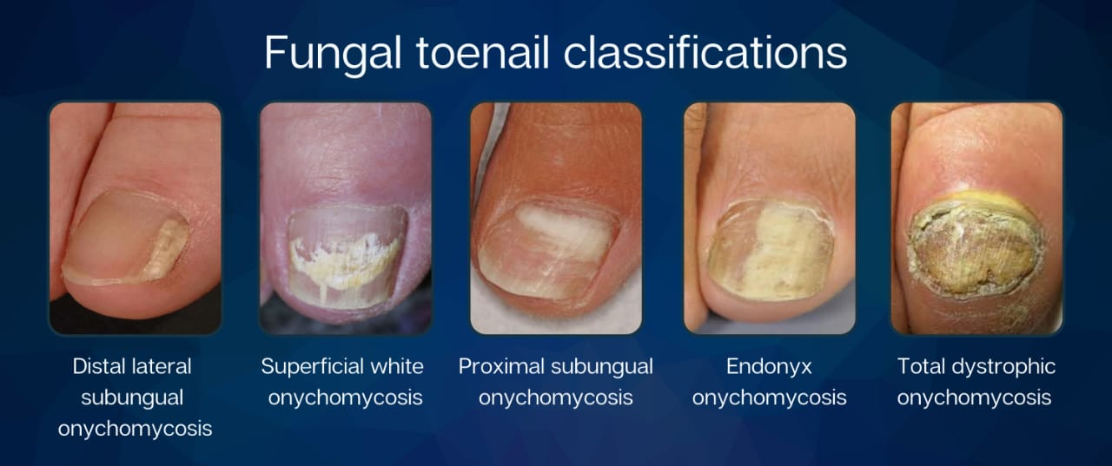

Fig.2. Classification of Onychomycosis

**Diagnosis Of Onychomycosis:-**

Traditional procedures include direct microscopy (after potassium hydroxide solution incubation), fungal culture, and histology (using Periodic Acid Schiff stain). The current gold standard for diagnosing Onychomycosis is surgical pathology testing using PAS stain on the subungual nail bed and/or nail plate, which has a high sensitivity of almost 100%. Newer diagnostic methods for Onychomycosis include polymerase chain reaction (with high specificity), optical coherence tomography, confocal laser scan microscopy, MALDI-TOF MS, and phase contrast hard x-ray microscopy. Before incorporating emerging approaches for diagnosing Onychomycosis into clinical practice, it's important to confirm observations, consider availability and cost.[21,22]

**Treatments Of Onychomycosis:-**

1.Nail removal, avulsion

2.Oral Therapy

3.Topical Therapy

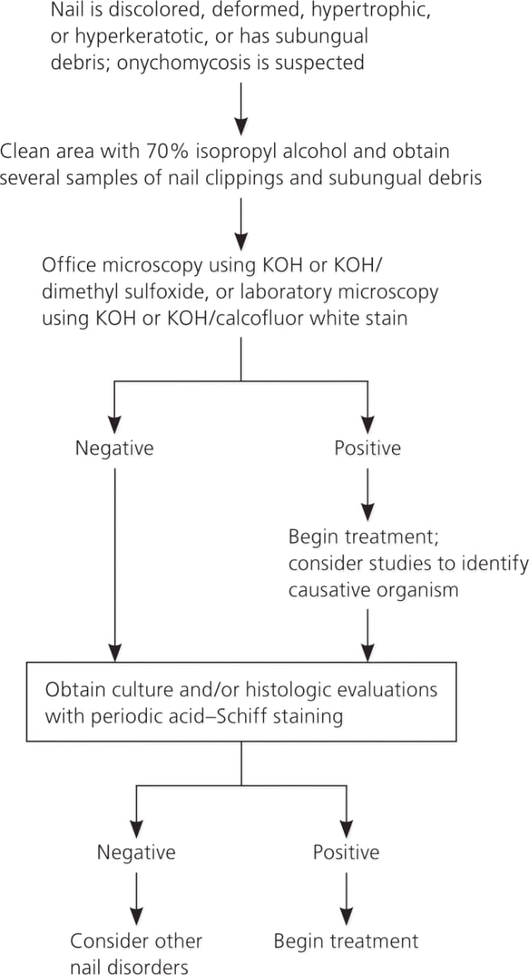

fig.3 flow Chart of Diagnosis

**Drug :- Ciclopirox Olamine**

A synthetic Hydrosperidone antifungal agent is called Ciclopirox.

Broad-spectrum antibiotic Ciclopirox is active against all common Dermatophytes.

Ciclopirox demonstrates both fungicidal and fungal inhibitory action (<4 ug/ml for Dermatophytes). A delivery method for nail lacquer has been developed that contains the fungicidal effect Ciclopirox. Even after chronic use, very low quantities of Ciclopirox can still be recovered systemically, despite its quickly absorbed nature.[2]

* **Chemical structure**

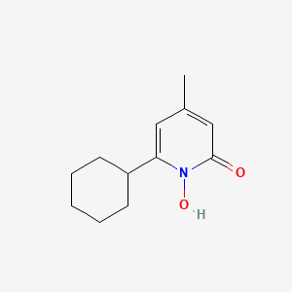

Fig.4.ciclopirox olamine

* **Properties**

1. IUPAC name:- 2-aminoethanol;6-cyclohexyl-1-hydroxy-4-methylpyridine-2-one
2. Molecular formula :- C12H17NO2
3. Molecular weight :- 268.35g/mol
4. Appearance :- white powder
5. CAS no. :- 41621-49-2

* **Mechanism of action** :-

The metal ions Fe3+ and Al3+, which are essential for fungal development, are bound by ciclopirox olamine. The growth of metal-dependent enzymes, such as cytochromes, catalase, and peroxidase, which are necessary for fungal cellular functions, is inhibited by chelating these metal ions. By interfering with mitochondrial electron transport, energy production, and nutrition absorption across the cell membrane, it also impacts fungal growth and survival. It alters the fungal cell membrane's permeability and prevents vital precursors and nutrients from being transported. Higher amounts have the potential to damage the cell membrane, allowing potassium ions and other intracellular materials to seep out and impacting the internal structures of fungi.

* **Pharmacokinetics:-**

Ciclopirox olamine is readily absorbed into the bloodstream when taken orally. However, absorption is restricted when applied directly to the skin or nails. After absorption, it spreads throughout the body, penetrating numerous tissues such as hair, epidermis, hair follicles, sebaceous glands, and dermis before reaching the site of infection and exerting its therapeutic effect. Ciclopirox olamine is predominantly metabolised by glucuronidation, which transforms the medication into a glucuronide conjugate. This metabolic pathway accounts for the majority of drug removal from the body. It is removed from the body via the kidneys, with the majority remaining unaltered or as glucuronide conjugates. This elimination reduces the likelihood of unwanted consequences on the human body.

* Antifungal activity:-

Ciclopirox inhibits all strains of mould, yeast, and dermatophytes within a specific concentration range. Its spectrum of activity is well-balanced. Their significant feature—their ability to be fungicidal even against non-growing cells—sets them apart from the azole class. This characteristic is crucial because infections caused by fungi arise in environments that do not favour the pathogen's ideal growth.[1]

* Anti bacterial activity

Under certain condition bacterial infections may exacerbate dematomycoses such as Onychomycosis. In order to fight a variety of gram- positive and gram negative aerobic and anaerobic bacteria that are essential for mixed infectins, Ciclopirox should ideally exhibit strong antibacterial action in addition to its broad spectrum antifungal activity.

* Anti Inflammatory activity

Anti inflammatory properties it has been demonstrated that Ciclopirox the production of the cyclo-oxygenase-mediated synthesis of prostaglandin,the relase of cyclooxygenase inflammatory mediator 5-HETE and leukotrine B4.[1]

**Transungual drug delivery :-**

To treat nail diseases, transungual drug delivery refers to a technique that uses medication transport across the nail to achieve targeted drug delivery. In transungual, "trans" means "through," and "unguis" means "nails." Because of its improved adherence and localized action, which give minimal systemic adverse effects, the transungual medication transport system is believed to be highly helpful in managing nail disorders.[11] Compared to oral dosage forms like pills, ungual treatment offers a number of advantages over oral or systemic medication delivery, including ease of preparation. There are no systemic side effects or drug interactions. Periungual erythema of the proximal nail fold is one of the less frequent adverse effects of local rash that normally goes away after a few minute.

**Nail lacquer for Transungal Drug Delivery :-**

Nail lacquers are used as a cosmetic to protect and adorn the nails. Medicated nail lacquers are a novel type of formulation used for transungual drug delivery. These preparations include a solution of a film-forming polymer and medication. The film left behind after solvent evaporation functions as a drug repository. This drug store allows the medicine to be released and penetrated over the nail for an optimal period of time. A large diffusion gradient is established for drug passage into the nail plate. Film creation on a nail plate also reduces water loss from the nail's surface into the atmosphere. Hyperhydration of the upper nail plate layers occurs, which aids in drug diffusion.[6,11]

From in vitro research, ciclopirox exhibits efficacy against significant pathogenic dermatophytes and has a high concentration gradient that facilitates the transport of antifungal agents across the nail plate.[2] Healthy subjects' toenail surfaces after daily treatment have good penetration and distribution throughout all nail layers.[2]

**Table.1. A compilation of commercially available nail lacquers.**

|  |  |  |
| --- | --- | --- |
| **Therapeutic agent** | **Brand Name** | **Company Name** |
| Ciclopiroxamine 8% Penlac® | Roche Lab | Australia |
| Ciclopiroxamine 8% Onlyac® | Dermic | Canada |
| Ciclopiroxamine 8% Nailon® | Protech Biosystem | India |

**Table2. Method of preparation of Nail Laquer**

|  |  |  |
| --- | --- | --- |
| **Excipient** | **Example** | **Role** |
| Polymer and film forming agent | Nitrocellulose Ethyl cellulose | Good adherent properties |
| Solvent | Ethyl Acetate | Produce smooth and uniform solution |
| Plasticizer | Propylene glycol | Uniform film making |
| Penetration enhancer | Urea | Increase drug permeability and effectivness |
| Adhesive Agent | Thioglyclic acid | Help the film former |
| Surfactant and co surfactant | Sodium chloride  Sodium cholate | Stabilize |
| Emulsifier | Soya lectin | Create stable emulsion |

**Evalution** **of Nail Laquer**

1.Film Drying time

The drying time test, which has been used to initial lacquer formulations, is a common test that has been extensively utilized in nail lacquer research. Using a brush applicator, the lacquer is applied to a 2-cm section of a glass slide as part of the characterization method. Every 15 seconds, the film is touched with a gloved finger, and the amount of time it takes to get a dry-to-the-touch film is noted .[6]

2.Non-volatile content

A glass Petri dish with a diameter of approximately 8 cm is filled with one (1) g of the sample. Utilising tared wire, the sample is distributed uniformly and measured. Afterward the dish is removed, cooled, and weighed.

3.Gloss and smoothness.

To assess the sample's visual smoothness, it is spread out on a glass plate and allowed to rise vertically after being poured to a height of nearly 1.5 inches. One way to assess the film's gloss is to compare it to a popular nail lacquer.

4.Water Resistance

Resistance to Water Using a brush applicator, the lacquer is put on a glass slide that has been previously weighed and let to dry. It is computed how much the completely dry film weighs. For a 24-hour period the slides are submerged vertically in deionised water, ensuring that the film is entirely covered. After a day, the slides were taken out, cleaned with lint-free cloths, and weighed once again.

5.Blush Test

The specimen was arranged on a glass surface Blush Test After being spread out on a glass plate, the sample was allowed to air dry. The entire film was submerged by placing the plate in the beaker filled with water. For a full day, the plate remained in its original state. After being removed and cleaned with tissue paper, the plate was left to air dry for four hours. The plates were then inspected for blush

.

6.Viscocity

The viscosity Using a Brookfield viscometer at room temperature and a spindle at various RPMs, the viscosity of the prepared nail lacquer is measured .

7. Drug content

A weighed amount of Nail laquer is dissolved in methanol. The solution is Sonicated and diluted properly. The solution is analyzed using suitable analytical techniques i.e UV spectrophotometric analysis. [6]

**Mechanism of drug penetration via nail lacquer as shown in fig.5**

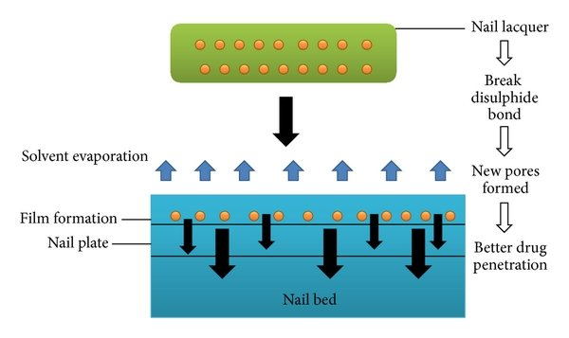

**Mechanism of Drug Penetration Through Nail Lacquer**.

Nail lacquer is an efficient medium for improving drug administration through the nail plate to treat a variety of nail problems.

The mechanism consists of several crucial steps:

1. Nail Lacquer Application: Apply a Ciclopirox nail lacquer containing the active medicine to the nail plate's surface.

2. Breakage of Disulphide Bonds: Lacquer components interact with the nail's keratin structure, breaking disulphide bonds. This structural modification makes the nail more porous.

3. Pore Formation: Disrupting disulphide bonds opens up new pores in the nail plate, allowing the medication to penetrate more efficiently.

4. Solvent Evaporation: Following application, the solvent in the lacquer evaporates, leaving a thin, durable layer embedded with the active

5. Film Formation: The drug-loaded film sticks to the nail plate and serves as a reservoir for long-term, continuous medication release.

6. Improved Drug Penetration: Deeper drug penetration into the nail bed is made possible by the enhanced porosity and extended drug presence, which enhances therapeutic results. Because of this mechanism, nail lacquers are the recommended option for effective and targeted drug administration for treating nail infections or other disorders that impact the structure of the nail.

**Efficacy in Onychomycosis Treatment :-**

A]Clinical Trials:

1. Myco-81 Study: 49% of 195 participants had a mycological cure at 12 months.

2. The clinical cure rate at 12 months for the Ciclopirox Topical Solution Study was 34.5% (n=357).

3. Penlac Study: 45.5% of 100 participants had a mycological cure at 12 months.

B]Rates of Success:

1. Mycological Cure: 40–50% (fungi infection elimination)

2. Clinical Cure: 30–40% (nail appearance improvement)

3. Total Recovery: 20–30% (including clinical and mycological recovery)

C]Elements Affecting Effectiveness:

1.Type of Nail: Fingernails are more responsive than toenails

2. Fungal Species: Ciclopirox is effective against Candida albicans, Trichophyton rubrum, and Trichophyton mentagrophytes.

3.Nail Severity: Onychomycosis that is mild to moderate reacts better than severe cases. 4. Treatment Duration: Better outcomes are obtained after 6–12 months of treatment.[8]

**Safety and tolerability :-**

Common Adverse reaction:-

1.Local irritation (10-20%)

2. Redness(5-10%)

3.Itching (5-10%)

4.Allergic reaction(rare)

5.skin rashes

Serious skin rashes

Hypersensitivity

**Dosage Considerations:-**

Fingernail and toenail The following onychomycosis, mild to moderate

Dosage for adults:

Topical nail lacquer solution: Using the supplied applicator brush, apply evenly over the entire nail plate once day(ideally in the evening or eight hours before bathing) to all afflicted nails.

Paediatric Dosage:

Children under 12: efficacy and safety have not been shown

Youngsters over 12: They can use lacquer solution just like adults.[8]

**Need for the study**:

Onychomycosis is an ongoing disease that requires long-term treatment. Topical medicines are limited by low penetration and the nail plate's limiting barrier, whereas oral medications have systemic side effects. Medicated nail lacquer forms an occlusive layer on the nail that acts as a medication depot, providing prolonged antifungal release during therapy. In this work, we attempted to produce an antifungal nail lacquer formulation. Miconazole is commonly used as an antifungal, however there has been little research on improving its permeability in nail lacquer formulations. The goal of this study aims to investigate how an optimal permeation enhancer can improve medication penetration over the nail plate, potentially increasing bioavailability of antifungal drugs.[21]

**Future Prospective of Nail Laquers**

Human nails serve as an outlet for the transfer of drugs to treat nail-related issues, hence their uses extend beyond defence and aesthetic appeal. Different kinds of transungual products are marketed. There is a lot of promise for treating nail illnesses with modern transungual technologies such patch-based delivery, water-based lacquers, or even more recent penetration enhancers. But it's crucial to turn their promise into a tangible outcome.[6,8]

Treatment for onychomycosis is seen to be challenging because to its chronic nature, difficulty in curing, and propensity for recurrence. In recent years, it has been discovered that improving the delivery of medications requires more than just creating new treatments. The research that attempted to show association between in vitro and in vivo were rife with mistakes. The creation of efficient drug carrier systems is a constructive way to address this problem.[20]

**Conclusion:-**

Topical preparations in the form of lacquers applied on the nail plate are a valuable tool in the treatment of Onychomycosis. Ciclopirox-based nail lacquer is a safe and effective treatment option for Onychomycosis. Its efficacy, convenience, and localized delivery make it an attractive choice. Further studies are needed to optimize treatment regimens and improve patient outcomes.

**Reference:-**

1.Manfred Bohn Karl Th.kraemer,"Dermato pharmacology of Ciclopirox nail lacquer topical solution 8% in the treatment of Onychomycosis." Journal of American Academy of Dermatology. Volume 43, Issue 4 supplement, October 2000 Pages S57-S6

<https://doi.org/10.1067/mjd.2000.109072>

2.Dyanne p. westerberg, Do and michaely. Voyack, DO "Onychomycosis: current Trends in Diagnosis and Treatment Am Fam Physician, 2013 Page-762-720

<https://pubmed.ncbi.nlm.nih.gov/24364524/>

3. J. Thomas, G. A. Jacobson, C.K. Narkowicz G.M. Peterson, toenail Onychomycosis: an important global disease burden. 17 se Journal of Clinical Pharmacy and Therapeutics, vol. 35, Issue 5,2010 Page no.-497-519.

<https://doi:10.1111/j.1365-2710.2009.01107>.

4. A.K Gupta, P.Fleckman, R Baras "Ciclopirox nail lacquer topical solution 8% in the treatment of toenail Onychomycosis. J Am Acad Dermatol 2000, Oct 43 S.

<https://doi.org/10.1067/mjd.2000.109071>

5.Katarzyna Tabra, Anna E Szewczyk, Wojciech Bienias, Agnieszka Wojciechowska 1, marra pastuszka, magdalena oszukowsko Andrzej Kaszuba.6002Amorphine Vs. Ciclopirox.the treatment of Onychomycosis. Post september Alergol 2015 page no.40-45

<https://doi.10.5114/pdia.2014.40968>

6. Chauhan A et al. 2023. Exhaustive Review on Nail Lacquer in the Treatment of Nail Diseases. Philipp J Sci 152(5): 1895–1909.

https://doi.org/10.56899/152.05.30.

7. Nail lacquer as transgunal drug sudaxshina murdan ,"Drug delivery to the nail following topical application." International Journal of Pharmaceutics. Volume 236.Issue 1-2 2 April 2004 page 1-26

8. Gupta, A. K., et al. (2013). Onychomycosis: A Review of the Latest Treatment Options. Skin Therapy Letter, 18(3), 1-8

https://doi.org/10.5713/13495291.1833.

9. Sudaxshina Murdan, Drug delivery to the nail following topical application, International Journal Of Pharmaceutics, volume 236,Issue 1-2,2002,pages 1-26 ISSN0378-5173,

<https://doi.org/10.1016/S0378-5173(01)00989-9>.

10. Sakurai K, Sakaguchi T, Yamaguchi H, Iwata K. Mode of action of 6-cyclohexyl-1-hydroxy-4-methyl-2(1H)-pyridone ethanolamine salt (Hoe 296). Chemotherapy. 1978;24(2):68-76. https://doi:org/10.1159/000237762. PMID: 340169.

11. Akhtar N, Sharma H, Pathak K. Onychomycosis: Potential of Nail Lacquers in Transungual Delivery of Antifungals. Scientifica (Cairo). 2016;2016:

<https://doi.org/10.1155/2016/1387936> Epub 2016 Mar 30. PMID: 27123362; PMCID: PMC4829734.

12. Kumar P. T., Narayana R. P. Transungual drug delivery: a promising rote to treat nail disorders. International Journal of Pharmaceutical Research. 2013;2:22–23. [Google Scholar]

13. Elewski BE (2000) Onychomycosis: treatment,quality of life, and economic issues. American Journalof Clinical Dermatology, 1, 19–26.

14. Baran R, Kaoukhov A (2005) Topical antifungal

drugs for the treatment of onychomycosis: an overview of current strategies for monotherapy and

combination therapy. Journal of the European Academy of Dermatology and Venereology, 19, 21–29.

15. Gupta AK, Baran E, Robert SRC (2003) Non-dermatophyte onychomycosis. Dermatologic Clinics, 21,257–268.16. Rajendra V. B., Baro A., Kumari A., Dhamecha D. L., Lahoti S. R., and Shelke S. D., Transungual drug delivery: an overview, Journal of Applied Pharmaceutical Science. (2012) 2, no. 1, 203–209, 2-s2.0-84875907002. <https://doi.org/10.1067/mjd.2000.109071>

17. AHMADI P, JAHANBAN-ESFAHLAN A, AHMADI A, TABIBIAZAR M, MOHAMMADIFAR M. 2020. Development of Ethyl Cellulose-based Formulations:

a Perspective on the Novel Technical Methods. Food Reviews International 38(4): 685–732. <https://doi.org/10.1080/87559129.2020.1741007>

18. CHANDRA S, DAS A. 2019. The science of nail

polish, nail polish remover, and nail moisturizers. Nail Disorders. p. 497–501.

<https://doi.org/10.1201/9781351139724-35>

19. NAMRATA ASHWINBHAI P, AJAY TALELE MN, ANURADHA PRAJAPATI DP, SACHIN NARKHEDE DB. 2021. Formulation Development and Evaluation

of Nail Lacquer of Posaconazole for Treatment of Onchomycosis. IJARIIE 2: 2395–4396

20. FARSANA BP, SHAHANAS B, SEBASTIAN A. 2018. Formulation and Evaluation of Medicated Tolnaftate Nail Lacquer. Global Journals Online, Vol. 18

21. Formulation and Evaluation of a medicated Nail laquer for the treatment of Onychomycosis

<https://core.ac.uk/download/pdf/235664552.pdf>

22. Westerberg DP, Voyack MJ. Onychomycosis: current trends in diagnosis and

treatment. American family physician. Dec 2013. 88 (11): 762–70