**Natural Convection in A Square Enclosure With**

**Embedded Objects Through Porous Media**

**N. G. Rao,** Assistant Professor of Mechanical Engineering, GMR Institute of Technology, Rajam 532127, Andhra Pradesh, India.

**N. G. Rao, P.Mani Kanta**,**M.V.S. Tanai,** GMR Institute of Technology, Rajam 532127, Andhra Pradesh, India.

**ABSTRACT**

A numerical investigation on free convection in a Porous wavy chamber with non-uniform side wall will be conducted, with findings for various Rayleigh numbers and various Darcy number of the porous medium. Here, Rayleigh number changes from 103≤ Ra ≤ 106 and Darcy number is changed from 1%<Ҩ<5%. Streamline and isotherm plots will be monitored for changes. In this project, an enclosed square porous fluid chamber with thermally insulated walls and unusual side wall is studied. Heat transfer rate is calculated for three different cases: case 1 is a flat wall, case 2 is a sinusoidal side wall and Case 3 is a zig zag side wall, the rate of heat transfer is calculated based on the number of undulation (d=0,1,2,3) of the side wall. All of the cases will be compared to see which has the best heat transfer rate.

**Keywords**: Free convection, Enclosure, Porous media, Nusselt number, non-uniform, heat transfer.

1. **Introduction**

Natural convection is a free convection in which heat and mass transport mechanism takes place and flow of fluid generated solely by differences in density and temperature within the fluid. Natural convection is an important phenomena which occurs in many engineering applications and scientific fields like building design, electronics cooling , food, geophysical fluid dynamics and geo thermal systems . For designing successful heat transfer systems require good understanding of natural convection. Nowadays there are several published papers that are discussed on the topic of free convection through porous media. Mohsen Izadi et al.[1] studied on the free convection that effects hybrid porous fluid inside a porous medium. The results showed on this study are parameters of periodic magnetic field can have non-monotonic impact on performance of heat transfer. Additionally, different factors like Hartmann number, Rayleigh number, Periodicity of magnetic field, Darcy number, and medium porosity had an impact on flow and thermal patterns. A.S. Dogonchiet al.[2] investigated numerically by the method using control volume finite element method and observed that Rayleigh number and Darcy number has direct relation with vigorous convective flow while it has an inverse relation with the magnetic field’s inclination angle of Hartmann number. B. Pekmen Geridonmez and Hakn F. Oztop [3] has done research on the Natural convection in partially effected magnetic field in a cavity that is filled in unit square with porous medium and observed that partial magnetic field has an impact on the development of vortices and convective heat transport in porous media it was found that middle-centered magnetic fields can suppress convective heat transmission .Zehba A.S. Raizahet al.[4] analysed the free convection flow of v-shaped space with a porous-fluid filled within a diverse porous medium. The findings demonstrated that horizantal diverse porous media has the highest average Nusselt number where as similar porous media had the lowest rate of heat transmission. Omar Rafae Alomar et al.[5] studied convective heat transfer between two right angled plates enclosed in a square porous hollow by employing (LTNE) local thermal non equilibrium and non-Darcian flow assumption.

The study of the behaviour of materials containing interconnected void spaces, such as rocks, soils, biological tissues and manufactured materials is a fascinating and interdisciplinary area. Some flows that are moved by upthrust effects that may occur when steeping fluid flow of temperature is not uniform. These flows also known as free or natural convection movements that are influenced by density differences caused by temperature gradients and boundary conditions.Payam Gholamalipouret al.[6] has done numerical analysis on entropy production of cu-water porousfluid inside circular completely filled in presence of cylindrical heat source with a porous foam inside. Results showed that heat transfer can be bettered or collapsed by depending on the value of Rayleigh number, Darcy number and the direction of inner cylinder movement according to the various figures of eccentricity. Xiangjuan Yang et al.[7] analysed the free convection processes in three dimensions(3D) mixed porous medium and also connected with energy loss and mixing processes. The third dimension effect is used to compare the effect of convective Stream, Entropy production and heat transfer and observed that entropy variation indicators not changed in response to change in heterogeneity.T.R. Vijaybabu [8] has analysed the impact of a magnetic field in two different density gradients free convection. Entropy generation, which is measured using the lattice Boltzmann method and is done in enclosure.

It is a way of describing how useful energy is lost and how engineering systems such transport and rate processes degrade either time Lattice Boltzmann method is one of the method to solve the current numerical problem.This method has significant achievement in simulating fluid streams or fluid flows . They learned through the numerical analysis that the magnetic fields intensity and direction,buoyancy force and permeability of the porous cylinder

M. Sheikholeslami and S.A. Shehzad et.al[9] shows the results on simulations in porous embedded with porousfluid convective stream by using two temperature models show that stream function maximum increases augment of porousfluid confluence heat transfer variable and porous media’s porosity but stream function is inversely proportional to Hartman number. Dhananjay Yadav [10] explained the use of linear and non-linear stability analysis to determine how chemical reactions affect convective instability and heat transfer in porousfluid-saturated porous enclosures. The results demonstrate that for rectangular enclosures the amount of heat transmission increases with increasing heat capacity ratios, while it decreases with aspect ratio for slender and square enclosures results are opposite.

Fernando J. Guerrero et.al [11] has carried out impermanent simulations numerically to evaluate the heat transfer and convective mass in a void medium that is heated from below and salted from above and it is also subjected to an inclination angle. Focusing on a set of some governing variables and equations determined by two lightness ratios. The results provided are quantitative insights into how mixing improves as buoyancy forces increases. Most of the times FEM is used to solve the problems and determine the solutions. Finite element method (FEM) is mostly used method to solve differential equations that are arises in fields like mathematical modelling and engineering. it is mainly used to solve the problems those are associated with heat conduction, incompressible viscous flows and convective heat flow. S. Sivasankaran et. al [12] has done numerical study of non-Newtonian fluid in a porous embedded with heat radiation and irregular heating on convection. It is aimed to numerical simulation and explore the flows like laminar, incompressible, buoyant induced convection drift in the existence of heat radiation.Jayesh Subhash Chordiya and Ram VinoySharma[13] has studied on the free convection in a fluid-soaked void embedded with a couple of vertical diathermal separation . The results shows that partition ratio is inversely proportional to Nusselt number in porous enclosures. Seyyed Masoud Seyyedi [14] has studied on the behaviour of heat transfer in the cardioid structured porous activity. S.A. Shehzad [15] has recognised the impact of the heat transfer of unique inorganic porousmaterial inside an absorbant medium and used CVFEM method to obtain the outputs .the results were compared with the previous articles and concluded that by reducing the temperature and increasing the Rayleigh number gives better cooling performance for high buoyancy forces.

The widely spaced component of surface appearance is measured as waviness. Waviness is used to indicate abnormalities or changes in material surface on a millimetre to centimeter scale. waviness in particular can have substantial impact on a product functioning and performance.Ching-Chang Cho [16] studied on the effects of wavy surface and void medium on the free convection of copper water porousfluid and the creation of disorder in a squared space with a partially heated surface. The results shows that when Darcy number and Rayleigh number are high then mean Nusselt number and non-dimensional total entropy production is rises.

A. Sattar Dogonchiet.al[17] analysed the heat transfer using buoyancy-driven flow and entropy formation of porous liquid inside a porous enclosure employing two square cylinders is described in this paper. The results shows that higher fluid density differences are caused by a rise in the enclosure velocity gradient brought on by rising Rayleigh number, if Rayleigh number increases the rate of heat transmission may increases but as Hartman increases the reverse effect occurs. the formation entropy is slowed down by the presence of porous matrix. The wavy side walls in containers can interfere with fluids natural convection flow. The buoyant forces and the flow patterns may be affected by the waves and the ability to produce areas of greater and lower temperature. The flow will often tend to follow the walls outlines and could get more complicated as the waviness rises.

**2. Physical Model**

A square porous enclosure with side length L has been studied in this problem, where the top and bottom walls are insulated and the right-side wall is regarded non-uniform, the left side wall is considered cold wall Tc, while the right-side wall is considered hot wall Th (Fig. 1). Three different cases have been considered, in case 1: the non-uniform wall is a flat wall with zero undulation. In case 2: the non-uniform wall is sinusoidal in nature with undulation (d = 1, 2, 3) and in case 3: the non-uniform wall is zig zag in nature with undulation (d = 1, 2, 3).

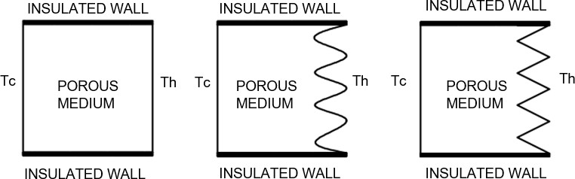

**POROUSFLUID**

**POROUSFLUID**

**POROUSFLUID**

**Fig 1:** The physical model's schematic representation

**2.1 Governing Equations:**

Considering the flow within the enclosure as incompressible, 2 dimensional and laminar. The dimensionless governing equations such as momentum (*x* and *y*), energy conservation and mass can be stated as:

$\frac{∂U}{∂X} + \frac{∂V}{∂Y}= 0$

$\frac{∂U}{∂τ}$*+ $U\frac{∂U}{∂X}$ + $V\frac{∂U}{∂Y}$ = - $\frac{∂P}{∂X}$ + $\frac{μ_{nf}}{ρ_{nfα_{f}}}\left(\frac{∂^{2}U}{∂X^{2}}+\frac{∂^{2}U}{∂Y^{2}}\right)$*

$\frac{∂V}{∂τ}$*+ $U\frac{∂V}{∂X}$ + $V\frac{∂V}{∂Y}$ = - $\frac{∂P}{∂Y}$ + $\frac{μ_{nf}}{ρ_{nf}α_{f}}\left(\frac{∂^{2}V}{∂X^{2}}+\frac{∂^{2}V}{∂Y^{2}}\right)$ + $\frac{β_{nf}}{ρ_{nfβ_{f}}}$ Pr.Ra. $θ$*

$\frac{∂θ}{∂t}+U\frac{∂θ}{∂X}+V\frac{∂θ}{∂Y}$*= $\frac{α_{nf }}{α_{f}}\left(\frac{∂^{2}θ}{∂X^{2}}+\frac{∂^{2}θ}{∂Y^{2}}\right)$*

The dimensionless parameters in the preceding equations are as follows:

X= $\frac{x}{L}$, Y= $\frac{y}{L}$, U= $\frac{uL}{α_{f}}$, V= $\frac{vL}{α_{f}}$, $θ=\frac{T-T_{c}}{T_{h}-T_{c}}$, $τ=\frac{α_{f}}{L^{2}}t$, $P=\frac{L^{2}}{ρ_{nf}α_{f}^{2}}p$, $Ra=\frac{gβ\left(T_{h}-T_{c}\right)L^{3}}{v_{f}α_{f}}$, $Pr=\frac{v_{f}}{α_{f}}$

where x and y are the horizontal and vertical Cartesian coordinates, and *u* is the velocity component in x-direction and v is the velocity component in y-direction along these coordinates. Respectively, Some of the parameters of the heat transfer are thermal diffusivity, thermal conductivity are denoted as α and *k*. other parameters like thermal expansion coefficient, permeability, fluid density and momentum diffusivity are denoted as β,υ, *p*. respectively; Rayleigh, Prandtl, and Darcy numbers are denoted as Ra, Pr.

2.2 Boundary conditions:

The following are the boundary conditions for governing equations (1), (2), (3), and (4): For hot side wall Th:

*U⁕* = 0, *V⁕* = 0, *θ⁕*= 1 (5)

For cold side wall Tc:

*U⁕* = 0, *V⁕* = 0, *θ⁕*= 0 (6)

2.3 Initial considerations:

Throughout the domain, atmospheric pressure is used as a starting condition. The following are the other beginning conditions used in the simulation:

*U⁕* = 0, *V⁕* = 0 and *θ⁕*= 0 (7)

2.4 Nusselt number:

A dimensionless metric, Nusselt number that measures convective movement rate of heat energy as bucked to diffusive movement, it is used to express threat of heat transfer. The average Nusselt number on the heated side wall is calculated as follows:

Nu = hL / k (8)

Nut = (1 / A) * ∫ (h(x) dx) / k

**3. Results and discussions**

The current research looks on buoyancy-induced thermal transport in a square porous enclosure with unusual side wall. The right-side wall is a non-uniform side wall with undulation (d = 0, 1, 2, 3) and is referred to as the hot wall Th, whereas the left side wall is referred to as the cold wall Tc, and the top and bottom walls are insulated. For each undulation’s calculations were accomplished for the values 1%<Ҩ<5% and103 ≤ Ra ≤ 106. The outcomes of the investigation are presented in 3.1 Streamlines and isotherm plots, 3.2 Nusselt number. temperature fields and flow designs are represented by streamline, isotherm plots as well as by an average Nusselt number expressing heat transfer from a non-uniform side wall.

Streamline and isotherm plots:

The effects of the medium non-uniform side wall on the flow and temperature fields are illustrated using streamlines and isotherms. The highly symmetric structure of streamlines and isotherms about both the horizontal and vertical axes for all undulations observed indicates that conduction dominates over convection in the enclosure at Ra = 103. The streamlines and isotherms plot for DA=10­3for varied Rayleigh numbers and undulations of sinusoidal and zigzag wall cases are shown in Figures 3, 4, 9 and 10. Conduction suppresses the convection mode at Ҩ 3%, even at large Rayleigh numbers. From Ra 103 to 105, the streamlines and isotherms are nearly symmetrical, and at Ra = 106, minor convection currents are observed in both cases. Convection currents form at DA=10­^-3i n both cases as a result of the associated influence by increasing buoyancy forces and Darcy number (observe Figures 5, 6, 11, and 12). As the Darcy number is raised to Ҩ 3%, resistance of the flow decreases and fluid flows through the voids, resulting in enhance due to thrust. As a result, when compared to DA=10­^-2, circulating cells are somewhat distorted.

The streamline and isotherm plots at DA=10­^-2 for different Rayleigh numbers and undulations of sinusoidal and zigzag side wall cases are shown in Figures 7, 8, 13 and 14. Because of the combined effect of high Rayleigh and increased porosity at da=10^-2, the convection method of heat transmission becomes more prominent when the Ra value rises from 103 to 106.When compared to the flat side wall case with zero undulation, the non- uniform wall pattern causes the fluid flow to become more chaotic. Because the wall pattern creates vortices and secondary flows, which mix the fluid more effectively. Circulating cylinders form in the centreline at Ra = 106 as the undulation increases. At d = 1, one cell forms at the right-side wall, and when the undulation increases to d = 2 and 3, two circulating cylinders form in the enclosure's centreline. According to the isotherm plot, when the Rayleigh number increases, the temperature gradients appear to become more intense, indicating higher convective heat transfer. Convection becomes stronger at Ra = 106 and DA=10­2, resulting in more distorted isotherms and streamlines.

|  |  |  |  |  |
| --- | --- | --- | --- | --- |
| **Ra=103** | **d= 0** | **d= 1** | **d= 2** | **d= 3** |
|  |  |  |  |
| **Ra=104** |  |  |  |  |
| **Ra=105** |  |  |  |  |

**Fig 3.** Streamlines at da=10-4 with different undulations from (d=0 to d=3) and Rayleigh number 103≤Ra≤ 106 sinusoidal wall case.

|  |  |  |  |  |
| --- | --- | --- | --- | --- |
| **Ra=103** | **d= 0** | **d= 1** | **d= 2** | **d= 3** |
|  |  |  |  |
| **Ra=104** |  |  |  |  |
| **Ra=105** |  |  |  |  |
| **Ra=106** |  |  |  |  |
| **DA=10­4** | | | |

**Fig 4.** Isotherms at da=10-4 with different undulations from (d=0 to d=3) and Rayleigh number 103≤Ra≤ 106sinusoidal wall case.

|  |  |  |  |  |
| --- | --- | --- | --- | --- |
| **Ra=103** | **d= 0** | **d= 1** | **d= 2** | **d= 3** |
|  |  |  |  |
| **Ra=104** |  |  |  |  |
| **Ra=105** |  |  |  |  |
| **Ra=106** |  |  |  |  |
| **Da=10-3** | | | |

**Fig5.**Streamlines at da=10-3with different undulations from (d=0 to d=3) and Rayleigh number 103≤Ra≤ 106 sinusoidal wall case.

|  |  |  |  |  |
| --- | --- | --- | --- | --- |
| **Ra=103** | **d= 0** | **d= 1** | **d= 2** | **d= 3** |
|  |  |  |  |
| **Ra=104** |  |  |  |  |
| **Ra=105** |  |  |  |  |
| **Ra=106** |  |  |  |  |

**Fig 6.** Isotherms at Darcy number da=10-3 with different undulations from (d=0 to d=3) and Rayleigh number 103≤Ra≤ 106in the case of sinusoidal wall.

|  |  |  |  |  |
| --- | --- | --- | --- | --- |
| **Ra=103** | **d= 0** | **d= 1** | **d= 2** | **d= 3** |
|  |  |  |  |
| **Ra=104** |  |  |  |  |
| **Ra=105** |  |  |  |  |
| **Ra=106** |  |  |  |  |
| **10** | | | |

**Fig7.**Streamlines at da=10-2 with different undulations from (d=0 to d=3) and Rayleigh number 103≤Ra≤ 106 in case of sinusoidal wall.

|  |  |  |  |  |
| --- | --- | --- | --- | --- |
| **Ra=103** | **d= 0** | **d= 1** | **d= 2** | **d= 3** |
|  |  |  |  |
| **Ra=104** |  |  |  |  |
| **Ra=105** |  |  |  |  |
| **Ra=106** |  |  |  |  |
| **Da=10-2** | | | |

**Fig 8.** Isotherms at DA=10­2with different undulations from (d=0 to d=3) and Rayleigh number 103≤Ra≤ 106in case of sinusoidal wall.

Nusselt number:

Fig15 illustrates combined outcome of Ra, Ҩ, and d on heat transmission for each sinusoidal side wall example from DA=10­4 to Ҩ 5%. At any given Ra and Da, the rate of Nut is smaller for the sinusoidal side wall case with undulation d = 1 to d = 3 than for the case with undulation d = 0 and as the number of undulations increases, the Nut value decreases further. This is because the sinusoidal side wall introduces additional complexity and irregularity to the flow, which could lead to increased turbulence and mixing. This may cause more heat transfer across the boundary layer and into the bulk fluid, resulting in lower Nut. Another possible reason is that the sinusoidal side wall may cause the flow to become more asymmetrical or oscillatory, which could interfere with the natural convection patterns and reduce heat transfer.

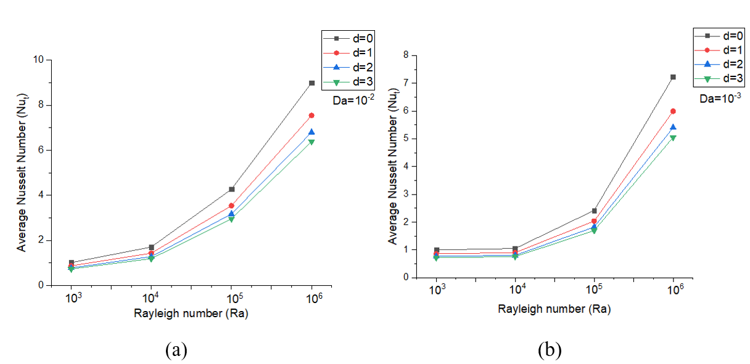

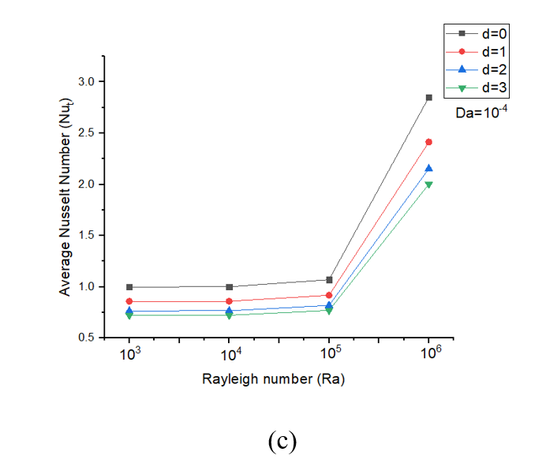

**Fig 15.** Average Nusselt number variations w.r.t different undulations from (d=0 to d=3) for sinusoidal side wall and Rayleigh number Ra=103 to 106 at (a) DA=10­4 (b) DA=10­3(c) DA=10­4

Fig. 16 shows the variation of Nut with respect to Ra for different undulation (d =0, 1, 2, 3) and different Ҩ, for zig zag side wall case. In this for each Ҩ, the Nut value for zig zag side wall when d = 0 increases with Ra, while for d = 1, 2, 3 undulations, the Nut value is lower than that of d = 0 case. This is because the undulation causes increase in flow resistance in flow path, this increased resistance may result in reduced fluid flow and heat transfer rate, which leads to lower value of Nut.

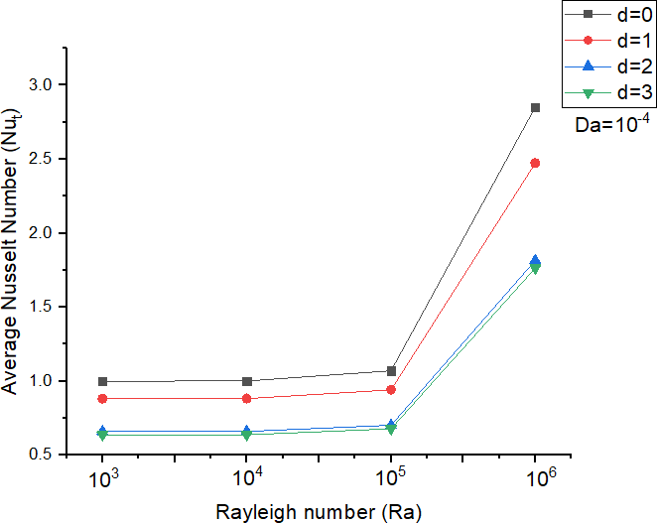 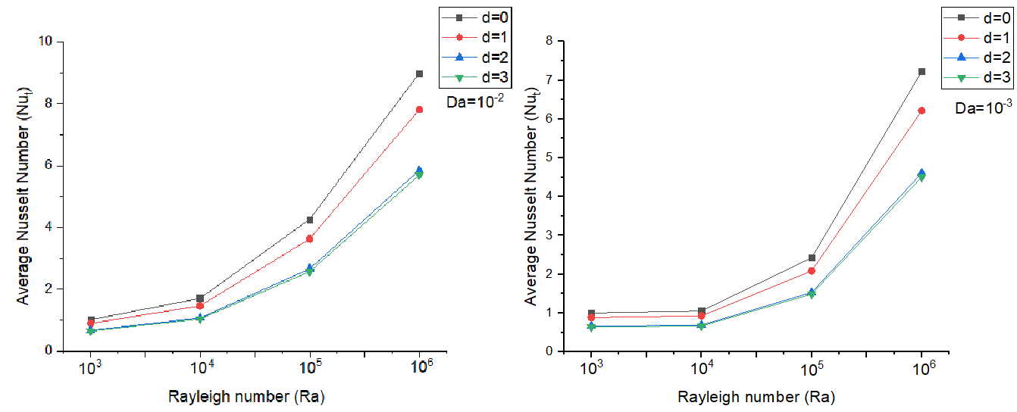

**Fig 16.** Average Nusselt number variations w.r.t different undulations from (d=0 to d=3) for zig zag side wall and Rayleigh number 103 ≤ Ra ≤ 106at (a)**DA=10­2**(b) **Ҩ 3%**(c) **DA=10­4**

The Da, which represents the ratio of viscous forces to inertial forces have a considerable impact on flow and heat transmission properties. At higher Da, the flow is more dominated by viscous forces and less affected by the presence of the sinusoidal or zig zag side wall. And at lower Da, the flow is more inertial and more sensitive to the irregularities introduced by the sinusoidal or zig zag side wall.

**4. Conclusion**

The current numerical work looks at natural convection heat transfer in a square porous enclosure with non-uniform side wall with different undulation that operate as a hot wall Th. The outcomes are displayed through streamline isotherm plots, and average Nusselt number for 103 ≤ Ra ≤ 106, DA=10­4 to 3%and for different undulation (0 ≤ d ≤ 3) for sinusoidal and zig zag wall case. The following are the key findings of the current study:

* At DA=10­4, the conduction mode of heat transmission dominates in the enclosure. Because conduction dominates over convection, temperature fields and heat stream for all undulations and Rayleigh numbers are almost symmetrical, at Rayleigh number 106 minor convection currents are observed.
* The effect of convective heat movement is most visible when Ҩ 3%. The flow and temperature fields break symmetry when Ra ≥105.
* At DA=10­2Nut increases more vigorously for higher Rayleigh number.
* A faster rate of heat transmission has been observed on sinusoidal wall case at d ≥ 2 compare to zig zag wall case, whereas at d≤ 1 heat transmission rate is more in zig zag wall case.
* The heat transmission rate is higher at flat side wall case compare to non-uniform side wall, greater Nusselt number (Nut) value is observed at d=0 undulations from DA=10­4 to Da=10-2 in all the cases.
* With the increase in Rayleigh number (103 ≤ Ra ≤ 106) and Darcy number (10-4 ≤ Da

≤ 10-2) there is increase in heat transmission rate in the porous enclosure.

* That is because as the Ҩ is increased the porous medium become more permeable which allows the fluid to flow more easily through it and as the Ra increases the buoyancy force become more stronger than viscous forces this leads to the formation of larger and more vigorous convection cell this help to transport heat more efficiently

**References**

1. Izadi, M., Sheremet, M. A., &Mehryan, S. A. M. (2020). Natural convection of a hybrid porousfluid affected by an inclined periodic magnetic field within a porous medium. *Chinese Journal of Physics*, *65*, 447-458.
2. Dogonchi, A. S., Seyyedi, S. M., Hashemi-Tilehnoee, M., Chamkha, A. J., &Ganji, D.D. (2019). Investigation of natural convection of magnetic porousfluid in an enclosure with a porous medium considering Brownian motion. *Case Studies in Thermal Engineering*, *14*, 100502.
3. Geridonmez, B. P., &Oztop, H. F. (2019). Natural convection in a cavity filled with porous medium under the effect of a partial magnetic field. *International Journal of Mechanical Sciences*, *161*, 105077.
4. Raizah, Z. A., Aly, A. M., & Ahmed, S. E. (2021). Natural convection flow of a porousfluid-filled V-shaped cavity saturated with a heterogeneous porous medium: Incompressible smoothed particle hydrodynamics analysis. *Ain Shams Engineering Journal*, *12*(2), 2033-2046.
5. Alomar, O. R., Basher, N. M., & Yousif, A. A. (2020). Analysis of effects of thermal non-equilibrium and non-Darcy flow on natural convection in a square porous enclosure provided with a heated L shape plate. *International Journal of Mechanical Sciences*, *181*, 105704.
6. Gholamalipour, P., Siavashi, M., &Doranehgard, M. H. (2019). Eccentricity effects of heat source inside a porous annulus on the natural convection heat transfer and entropy generation of Cu-water porousfluid. *International Communications in Heat and Mass Transfer*, *109*, 104367.
7. Yang, X., Shao, Q., Hoteit, H., Carrera, J., Younes, A., & Fahs, M. (2021). Three- dimensional natural convection, entropy generation and mixing in heterogeneous porous medium. *Advances in Water Resources*, *155*, 103992.
8. Vijaybabu, T. R. (2021). Influence of porous circular cylinder on MHD double- diffusive natural convection and entropy generation. *International Journal of Mechanical Sciences*, *206*, 106625
9. Sheikholeslami, M., & Shehzad, S. A. (2018). Simulation of water based porousfluid convective flow inside a porous enclosure via non-equilibrium model. *International Journal of Heat and Mass Transfer*, *120*, 1200-1212.
10. Yadav, D. (2019). Impact of chemical reaction on the convective heat transport in porousfluid occupying in porous enclosures: a realistic approach. *International Journal of Mechanical Sciences*, *157*, 357-373.
11. Guerrero, F. J., Prol-Ledesma, R. M., & Karimi, N. (2020). Transient thermo-solutal convection in a tilted porous enclosure heated from below and salted from above. *International Communications in Heat and Mass Transfer*, *118*, 104875.
12. Sivasankaran, S., Bhuvaneswari, M., &Alzahrani, A. K. (2020). Numerical simulation on convection of non-Newtonian fluid in a porous enclosure with non-uniform heating and thermal radiation. *Alexandria Engineering Journal*, *59*(5), 3315-3323.
13. Chordiya, J. S., & Sharma, R. V. (2019). Natural convection in a fluid-saturated porous enclosure with a pair of vertical diathermal partition. *International Journal of Thermal Sciences*, *144*, 42-49.
14. Yang, X., Shao, Q., Hoteit, H., Carrera, J., Younes, A., & Fahs, M. (2021). Three- dimensional natural convection, entropy generation and mixing in heterogeneous porous medium. *Advances in Water Resources*, *155*, 103992.
15. Vijaybabu, T. R. (2021). Influence of porous circular cylinder on MHD double- diffusive natural convection and entropy generation. *International Journal of Mechanical Sciences*, *206*, 106625
16. Sheikholeslami, M., & Shehzad, S. A. (2018). Simulation of water based porousfluid convective flow inside a porous enclosure via non-equilibrium model. *International Journal of Heat and Mass Transfer*, *120*, 1200-1212.
17. Yadav, D. (2019). Impact of chemical reaction on the convective heat transport in porousfluid occupying in porous enclosures: a realistic approach. *International Journal of Mechanical Sciences*, *157*, 357-373.
18. Guerrero, F. J., Prol-Ledesma, R. M., & Karimi, N. (2020). Transient thermo-solutal convection in a tilted porous enclosure heated from below and salted from above. *International Communications in Heat and Mass Transfer*, *118*, 104875.
19. Sivasankaran, S., Bhuvaneswari, M., &Alzahrani, A. K. (2020). Numerical simulation on convection of non-Newtonian fluid in a porous enclosure with non-uniform heating and thermal radiation. *Alexandria Engineering Journal*, *59*(5), 3315-3323.
20. Chordiya, J. S., & Sharma, R. V. (2019). Natural convection in a fluid-saturated porous enclosure with a pair of vertical diathermal partition. *International Journal of Thermal Sciences*, *144*, 42-49.
21. Seyyedi, S. M. (2020). On the entropy generation for a porous enclosure subject to a magnetic field: different orientations of cardioid geometry. *International Communications in Heat and Mass Transfer*, *116*, 104712.
22. Shehzad, S. A., Sheikholeslami, M., Ambreen, T., &Shafee, A. (2020). Convective MHD flow of hybrid-porousfluid within an elliptic porous enclosure. *Physics Letters A*, *384*(28), 126727.
23. Cho, C. C. (2020). Effects of porous medium and wavy surface on heat transfer and entropy generation of Cu-water porousfluid natural convection in square cavity containing partially-heated surface. *International Communications in Heat and Mass Transfer*, *119*, 104925.
24. Dogonchi, A. S., Mishra, S. R., Chamkha, A. J., Ghodrat, M., Elmasry, Y., &Alhumade, H. (2021). Thermal and entropy analyses on buoyancy-driven flow of porousfluid inside a porous enclosure with two square cylinders: Finite element method. *Case Studies in Thermal Engineering*, *27*, 101298.
25. Bhardwaj, S., Dalal, A., & Pati, S. (2015). Influence of wavy wall and non-uniform heating on natural convection heat transfer and entropy generation inside porous complex enclosure. *Energy*, *79*, 467-481.
26. Boukendil, M., El Moutaouakil, L., Zrikem, Z., &Abdelbaki, A. (2021). Natural convection and surface radiation in an insulated square cavity with inner hot and cold square bodies. *Materials Today: Proceedings*, *45*, 7282-7289.
27. Aly, A. M., & Ahmed, S. E. (2014). An incompressible smoothed particle hydrodynamics method for natural/mixed convection in a non-Darcy anisotropic porous medium. *International Journal of Heat and Mass Transfer*, *77*, 1155-11