**Natural convection of nanofluids medium in a cavity in presence of magnetic field**

Pappu Praveen Kumar , Pilaka Vinay , Ampolu Bhanu Prakash

department of Mechanical Engineering, GMR Institute of Technology, Rajam, 532127, India

Dr.N.Govinda Rao

Asst. Professor, Department of Mechanical Engineering, GMR Institute of Technology, Rajam, 532127, India

**A R T I C L E I N F O**

**Keywords:**

Natural convection

Rayleigh number

Nusselt number

Darcy number

**A B S T R A C T**

Natural convection in a square cavity filled with electrically conducting nanofluid subjected to a periodic temperature profile on one vertical wall is numerically investigated. The top and bottom horizontal walls are kept adiabatic, while the right wall is set at low temperature. The left vertical wall varies sinusoidally with time around a mean temperature. The analysis considers the impacts of oscillation amplitude and frequency of the thermal forcing, Hartmann number, Rayleigh number, and solid volume fraction on the flow and heat transfer characteristics. The Prandtl number is held constant at 6.2  
Pr=6.2 throughout.  
The results indicate that the oscillation amplitude ( A) and frequency ( f) significantly affect the heat transfer performance. In the case of A>0.5, the system response exhibits a nearly constant forcing frequency of 2.5.  
f=2.5, whereas for ???? ≤  
0.5  
A≤0.5, the leading frequency moves to ????  
= 5  
f=5.

At very small values of Rayleigh number, Nusselt number is independent of both Rayleigh and Hartmann numbers, meaning it is conduction dominated. At larger values of Rayleigh numbers, due to predominant convective effects, the Nusselt number is found independent of Hartmann number but being proportional to the square root of Rayleigh number as expected in classical natural convection with an exponent of 1/4.  
  
The effect of the solid volume fraction depends on the interactions of the Hartmann and Rayleigh numbers. At some ranges of parameters, an increasing concentration of nanoparticles increases the heat transfer coefficient, but the opposite is seen at other parameter ranges. Such results make this qualitative understanding of magnetic influence on nanofluid thermal behavior comprehensive with respect to time-dependent thermal forcing, being valid for engineering applications**.**

**1.Introduction**

Nomenclature

|  |
| --- |
| Be Bejannumber  Cp specificheatcapacity(Jkg-1K 1)  D widthof thechannelwall (m)  g gravitationalacceleration(ms 2)  H distance between upper and lower wall of the  channel (m)  k thermalconductivity(Wm-1K 1)  L lengthof thechannel (m)  Nu AverageNusseltnumber  n normaldirection  Pr Prandtlnumber  P0 Pressurescale,qu2 |

Natural convection in enclosures has drawn much attention since it plays a crucial role in various industrial and engineering applications like electronic cooling, solar collectors, nuclear reactors, and crystal manufacturing. This research area was further broadened by the study of electrically conducting fluids under the influence of magnetic fields, because magnetic fields were believed to provide control over the convection processes. In material manufacturing, external magnetic fields are often applied to suppress convection currents, enabling enhanced control over crystal quality. For instance, Oreper and Szekely demonstrated that magnetic fields effectively reduce natural convection, with field strength playing a pivotal role in crystal formation. Similarly, Alchaar et al. investigated two-dimensional natural convection in shallow cavities heated from below, revealing the significant impact of inclined magnetic fields. These studies highlight the importance of understanding convection and magnetic field interactions for improved design and process control in thermal systems.

Figure-1

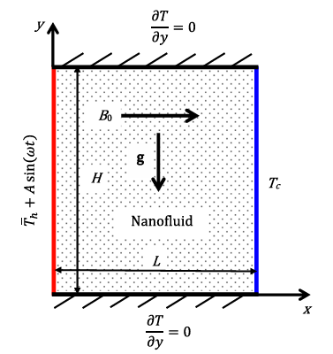

Despite the wide range of studies involving the study of heat transfer properties of nanofluids, the effects of magnetic fields on their behavior have been less studiously examined. Interaction of nanofluids with magnetic fields has great potential for applications, such as manufacturing materials and cooling processes in nuclear reactors. Despite the impressive progress in the study of natural convection and magnetohydrodynamic (MHD) flows in nanofluids, the combined effect of a time-varying sinusoidal temperature profile, magnetic field strength, known as Hartmann number, and oscillation parameters such as amplitude and frequency on heat transfer characteristics within the enclosure has not yet been explored. Obviously, these factors introduce even more complexity to the dynamics of heat transfer, opening up new avenues for optimizing thermal management in engineering systems.  
  
The present investigation fulfills the above gap by investigating the interplay of sinusoidal thermal forcing and effects of the magnetic field in an electrically conducting nanofluid-filled square cavity. This study will endeavor to understand the influence of the combined effect on variations of key parameters such as Hartmann number, Rayleigh number, amplitude, and frequency of the sinusoidally varied temperature profile. The findings will lead to the development of advanced thermal systems where control over convective flows needs to be highly tuned, such as electronic cooling, material processing, or energy-efficient designs.

**2.Problem definition and mathematical formulation**

The system considered is a two-dimensional H square cavity height width, as seen in Fig. 1, with an electrically conducting nanofluid and Pr =6.2. The horizontal walls of the cavity are assumed to be insulated, while the right wall is maintained at a uniform low temperature. anuniformlowtemperatureTc and the left verticalwall is maintained at a sinusoidal temperature variation in timewith an Under this approximation the fluid temperature is related linearly to the density via a thermal expansion coefficient αand theenergyequationreduces toa scalar advection Diffusionequation for temperature which is evolved in conjunction with the velocityfield[ themomentumequation. Under this approximation the fluid temperature is related linearly to the density via a thermal expansion coefficient α and the energy equation reduces to a scalar advection diffusion equation for temperature which is evolved in conjunction with the velocity field.Under these assumption, the conservation equations of mass,momentum and energy for laminar and unsteady state natural convection in a two-dimensional Cartesian coordinate system.

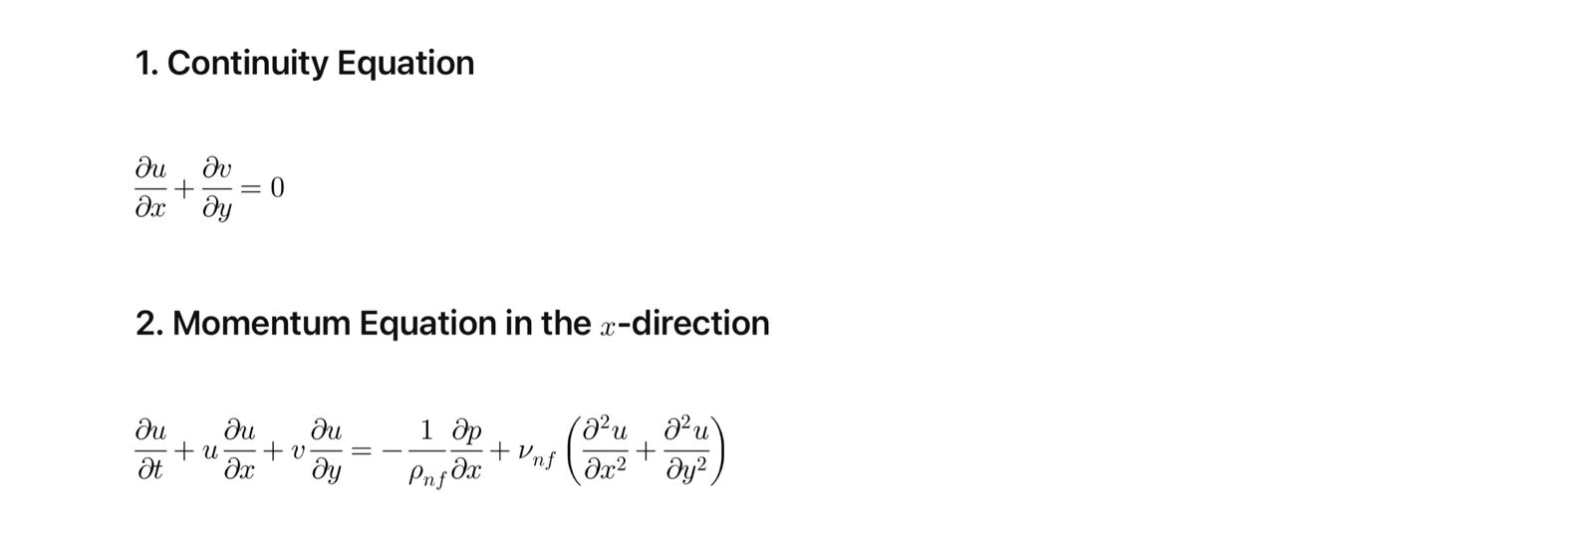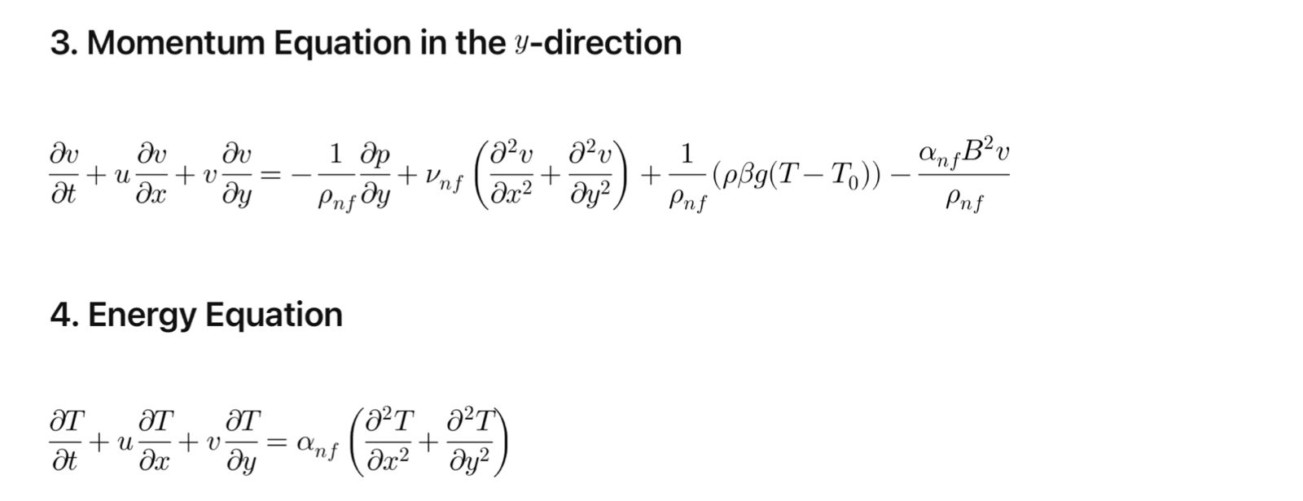

**3.Numerical methodology :**

The governing flow and energy equations, along with the prescribed initial and boundary conditions, are solved numerically using an in-house high-order solver. Results were awaited for existing benchmark studies for natural convection and magnetohydrodynamic flows, thus testing the robustness of the numerical framework in capturing the intricate coupling between oscillatory boundary conditions, magnetic field effects, and nanofluid heat transfer. The high-order spectral-element approach resolves boundary layer phenomena and flow instabilities with superior accuracy; thus, it provides a reliable tool for the study of complex parametric dependencies in this investigation. Convergence tests were carried out on two cases chosen at the upper end of the parameter range of this study. The nanofluid,  
f 0.1 and pure water at various Rayleigh numbers. Since the heat source is located at the middle of the bottom wall, it results in symmetric flow and temperature profiles for the enclosure. Streamlines two counter rotating circulating cells have been reported for all Rayleigh numbers.  
In fact, the buoyant forces developed due to fluid temperature  
differences causes the fluid to rise in the middle and to descend on the  
sides of the enclosure. This motion of the fluid generates counter  
rotating circulating cells inside the enclosure. It can easily be seen  
that although the shape of the circulating cells do not depend on Ra,  
their strength increases with an increase of the buoyant forces. It should be remarked that the contact line of the symmetrical  
Circulation zones is consistent with the symmetry axis of the heat  
source for all Rayleigh numbers.

**4.Numerical approach and validation**

The non-dimensional governing equations with the boundary conditions were discretised using a control volume formulation. The SIMPLE algorithm was used to handle the pressure-velocity coupling. The convection diffusion terms were handled using a power-law scheme. The numerical method was implemented in a FORTRAN program. The influence of grid resolution was studied in order to choose the suitable griddensity.

**5.Conclusion**

Numerical study of natural convection of an oscillating wall temperature on the left wall of an enclosure filled by a nanofluid and under a magnetic field. Impact of several relevant parameters, such as oscillation amplitudes and forcing frequencies, Hartmann number, Rayleigh number, and solid volume fraction. International Journal of Heat and Mass Transfer. Contour of temperature (left) and streamlines (right) at one period of oscillation. Each case is presented at the rate that would yield maximum heat transfer for A = 2, ϕ = 0.2, and Ha = 100 for several Rayleigh numbers as cited. Streamline fields: light and dark contours denote high and low velocities, respectively. Temperature fields: dark and light contours are assumed to denote cold and hot fluid, respectively. It is shown that there is a significant improvement in heat transfer for higher amplitudes, where an increase with the peak Nusselt number is observed as increasing the forcing amplitude of the hot wall. With the oscillation amplitude, the frequency of the peak Nusselt number occurrence remains nearly constant. The structure for the frequency at which the peak Nusselt number occurred was characterized by a clockwise rotating primary cells located at the center of enclosure which were different strengths for both amplitudes and in the position for the greater amplitude. A second weaker cell was also observed at the upper left and right corners of the enclosure at the greater amplitude.  
For lower Rayleigh number, where the flow is diffusion dominated, the  
Nusselt number depends explicitly on the both Rayleigh and Hartmann number independence. In Rayleigh numbers above critical value, the Nusselt number collapses to single curves independent of Hartmann number, consistent with the theory.  
A strong circulation of flow and strong isotherm were witnessed near  
the oscillating vertical wall for higher Rayleigh numbers and lower  
Hartmann numbers for a fixed solid volume fraction of ϕ=0.2. The y Velocity and temperature distributions along the horizontal mid-span of the enclosure represent more intense flow fields in the enclosure and higher temperature gradient near the vertical oscillatory hot wall at larger Rayleigh numbers and lower Hartmann numbers. In addition , the rate of decline of the Nusselt number with the solid volume fraction is higher at high Ha .Effect of the solid volume fraction on the response of the heat towards the value of the Rayleigh number and the Hartmann number. It is noted that when the Hartmann number increases from Ha=0 up to Ha=50, the Nusselt number increases linearly with the increment of the solid volume fraction. The rate of increase is more for Ha<50 but steady in variation of the Nusselt with the solid volume fraction when Ha=75 and decreases slightly as Hartmann number increases to Ha=100. In addition, the rate of Nusselt number decrease with the solid volume fraction is stronger at high Ha.

**References:**

1. S. Ostrach, "Natural convection in enclosures," *Journal of Heat Transfer*, vol. 110, pp. 1175–1190, 1988.

2. M.M. Ganzarolli and L.F. Milanez, "Natural convection in rectangular enclosures heated from below and symmetrically cooled from the sides," *International Journal of Heat and Mass Transfer*, [full details missing in the provided information].

3.M.Z. Swalmeh, H.T. Alkasasbeh, A. Hussanan, and M. Mamat, "Numerical investigation of heat transfer enhancement with Ag-GO water and kerosene oil based micropolar nanofluid over a solid sphere," *Journal of Advanced Research in Fluid Mechanics and Thermal Sciences*, vol. 59, no. 2, pp. 269–282, 2019.

4. M. Awais, M. Saad, H. Ayaz, M.M. Ehsan, and A.A. Bhuiyan, "Computational assessment of Nano-particulate (Al₂O₃/Water) utilization for enhancement of heat transfer with varying straight section lengths in a serpentine tube heat exchanger," *Thermal Science and Engineering Progress*, vol. 20, Article 100521, Dec. 2020. https://doi.org/10.1016/j.tsep.2020.100521

5. M. Suleman, M. Ramzan, S. Ahmad, D. Lu, T. Muhammad, and J.D. Chung, "A numerical simulation of silver-water nanofluid flow with impacts of Newtonian heating and homogeneous-heterogeneous reactions past a nonlinear stretched cylinder," *Symmetry*, vol. 11, no. 2, Article 295, 2019. <https://doi.org/10.3390/sym11020295>.