Traffic Management using Vehicle Detection

Mr.A.Ramesh Khanna1 Y.Abhilash2, S.SakethReddy3,B.Dathu Patel4

Computer Science & Engineering-Cyber Security, Malla Reddy University, Hyderabad, India

**ABSTRACT:** This project presents a comprehensive dynamic traffic management system designed to enhance realtime communication and analysis between traffic authorities and police. By integrating technologies such as PHP and Flask for the backend, along with AJAX for seamless user interactions, the system offers dedicated dashboards for two distinct regions. These dashboards feature live vehicle detection powered by the YOLO model and OpenCV, facilitating accurate vehicle identification and counting. A video capture loop optimizes performance, while a custom Tracker class ensures consistent vehicle identity tracking. Users can log in to access alerts and manage emergency notifications through intuitive interfaces, all without page reloads. The robust database structure supports efficient data retrieval, allowing for timely alerts to be sent to traffic police. Ultimately, this project aims to improve traffic monitoring, communication, and response strategies in traffic management

# INTRODUCTION

As cities grow and traffic congestion worsens, the demand for more advanced, real-time traffic management solutions is increasing. This project introduces a dynamic and intelligent traffic management system designed to streamline communication and coordination between traffic authorities and law enforcement, ultimately enhancing the efficiency of traffic monitoring and response.

The system leverages cutting-edge technologies, including PHP and Flask for a robust backend framework, along with AJAX to ensure seamless, real-time user interactions without the need for page reloads. These technologies support a comprehensive and responsive user interface, specifically designed for region- based traffic management.

At the heart of the system is live vehicle detection powered by the YOLO (You Only Look Once) model, a state-of-the-art object detection algorithm integrated with OpenCV for image processing. This enables accurate vehicle identification and counting in real-time, allowing authorities to maintain an up-to-date understanding of traffic conditions. The video capture loop ensures high-performance processing, while a custom Tracker class ensures the system reliably tracks vehicles without losing their identities as they move through camera frames.

The system features dedicated dashboards tailored for different user roles, particularly for traffic authorities and traffic police. Each dashboard offers region-specific access, where users can log in to view live traffic data, manage traffic flow, and respond to emergencies. For enhanced efficiency, the traffic authority can send immediate alerts to police in the event of excessive congestion or emergencies, while traffic police can send real-time alerts back to the traffic authority.

With an underlying robust database structure, the system supports efficient data retrieval and timely alert management. Overall, this project is designed to

transform the way traffic is monitored, controlled, and managed, facilitating faster response times and improving communication between the two key stakeholders in urban traffic management: authorities and law enforcement. By providing a seamless, real-time traffic management solution, this system aims to alleviate congestion, reduce response time in emergencies, and ultimately make city roads safer and more efficient.

# LITERATURE SURVEY

The development of intelligent traffic management systems (ITMS) has been a focal point of research in recent years, with a primary goal of optimizing traffic flow, reducing congestion, and enhancing safety. Early studies, such as Varaiya's work (1993), laid the foundation for real- time control systems, while more recent advancements have integrated artificial intelligence and computer vision techniques for dynamic traffic monitoring. Among these advancements, the YOLO (You Only Look Once) model, introduced by Redmon et al. (2016), has gained prominence for its ability to detect objects in real-time, offering significant improvements in vehicle detection accuracy and speed. Similarly, OpenCV has become a versatile tool in image processing and vehicle tracking, often employed alongside custom tracking algorithms like SORT (Bewley et al., 2016) to ensure consistent vehicle identification. In parallel, the role of AJAX (Garrett, 2005) in modern web applications has been transformative, allowing for seamless real-time communication without page reloads, an essential feature for interactive dashboards in traffic management systems. Research by Yu et al. (2011) highlights the benefits of AJAX in traffic monitoring, enabling continuous updates and user interaction. Effective database

management further supports the performance of such systems, with studies like those by Dimitriou and Tsekeris (2005) underscoring the importance of robust data structures for storing and retrieving traffic data in real-time. Lastly, emergency notification systems play a critical role in traffic management, ensuring timely communication between authorities and enforcement agencies, as explored by Baraka and Hamed (2016). Altogether, the combination of these technologies—real- time vehicle detection, dynamic web interfaces, and efficient data management—forms the basis of a comprehensive traffic management solution, which aims to enhance both monitoring capabilities and communication efficiency.

# SYSTEM ANALYSIS

## Existing System:

Current traffic management systems include various solutions that combine sensor-based monitoring, traffic cameras, and human-controlled traffic lights. Many cities employ Intelligent Traffic Management Systems (ITMS) integrated with GPS data, traffic signals, and CCTV to monitor traffic conditions and manage congestion. These systems often include fixed sensors for vehicle counting, traffic light optimization algorithms, and GPS- based applications such as Google Maps or Waze for real-time traffic flow analysis. Some systems also utilize Automatic Number Plate Recognition (ANPR) to enforce rules, and existing machine learning models for vehicle detection, such as traditional convolutional neural networks (CNNs) or basic object detection models.

## Proposed System:

The proposed system leverages advanced technologies such as the YOLO (You Only Look Once) model for real-time vehicle detection and OpenCV for image processing, enabling precise vehicle identification and tracking. The system features two interactive dashboards—one for traffic authorities and one for traffic police—facilitating communication between both entities. Traffic authorities can send alerts regarding high congestion, while police can respond to emergencies through a real-time alert system. This system integrates AJAX, PHP, and Flask to provide dynamic, non-reload user interfaces, ensuring seamless interaction and live updates. A robust database structure supports real-time data retrieval, allowing for efficient management of alerts and vehicle statistics. Additionally, it utilizes a custom tracker class to ensure consistent vehicle identity tracking across video frames, optimizing vehicle counting and identification accuracy.

# METHODOLODY

This dynamic traffic management system leverages PHP and Flask for backend functionality, integrating AJAX for seamless, real-time user interactions without page reloads. It features live vehicle detection using the YOLO model and OpenCV, enabling accurate vehicle identification and counting across video feeds, with a custom Tracker class ensuring consistent tracking across frames. The system provides dedicated dashboards for two regions, allowing traffic authorities and police to monitor traffic conditions, receive alerts, and manage emergency notifications. A robust database structure supports efficient data retrieval and automated alerts, ensuring timely

communication and responses, while the video capture loop and optimized performance enable real-time, scalable traffic monitoring and management.

# IMPLEMENTATION

## 5.1 Architecture

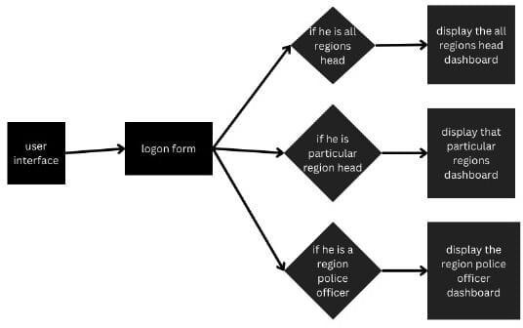

1. **Data Acquisition Layer**

**Cameras and Sensors**: High-resolution cameras are deployed at strategic locations to capture real-time video footage of traffic. These cameras are capable of detecting vehicles using computer vision algorithms. Additional sensors may include induction loops or radar sensors for vehicle counting.

**YOLO Model**: The YOLO object detection model processes the video feed from the cameras to identify and track vehicles in real time. This model ensures accurate vehicle detection and classification.

## Processing Layer

**Video Processing Module**:

**OpenCV**: This library processes the video feed, extracting frames for analysis. It applies the YOLO model to detect vehicles and track their movement.

**Custom Tracker Class**: A dedicated class is used to maintain vehicle identity across frames, ensuring that the same vehicle is tracked consistently as it moves through the camera’s view.

**Database Management System**: A robust database (e.g., MySQL or PostgreSQL) is employed to store traffic data, vehicle counts, alerts, and historical records. It allows for efficient data retrieval and updates.

## Application Layer

**Backend Framework (Flask or PHP)**: The backend is responsible for handling requests from the user interface, processing data, and communicating with the database. It manages the logic for alerts, notifications, and data retrieval.

**Alert Management System**: This component allows traffic authorities to send alerts based on vehicle counts or incidents detected by the system. It processes incoming requests and sends notifications to the appropriate dashboards.

## User Interface Layer

**Traffic Authority Dashboard**: A web- based dashboard where traffic authorities can monitor real-time vehicle counts, traffic conditions, and send alerts to police. This dashboard is built using HTML, CSS, and JavaScript, with AJAX for dynamic updates.

**Traffic Police Dashboard**: A separate interface for traffic police to receive alerts from authorities, monitor traffic conditions, and respond to emergencies. It also utilizes AJAX for real-time communication.

**Notification System**: Both dashboards include a notification system that displays alerts and updates without requiring a page refresh, enhancing user experience and responsiveness.

# RESULTS

* 1. start server

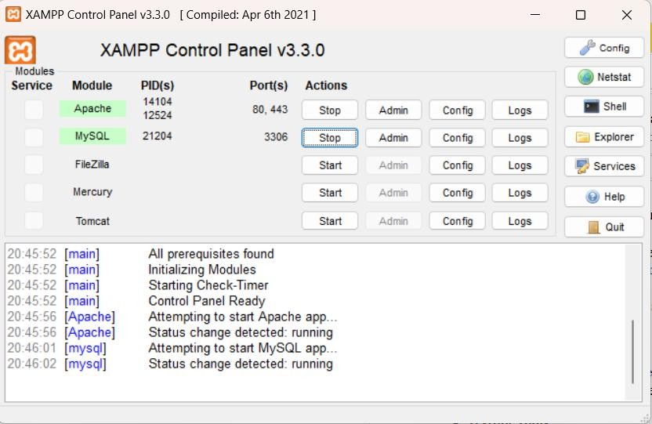

* + 1. Home page

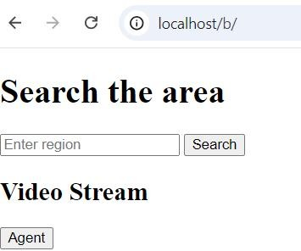

* + 1. login page

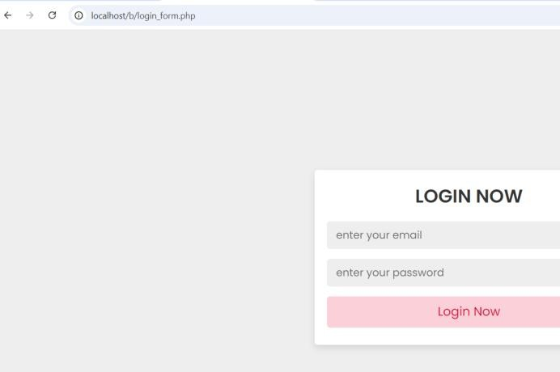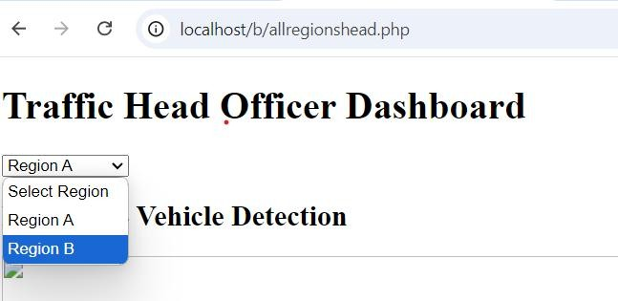

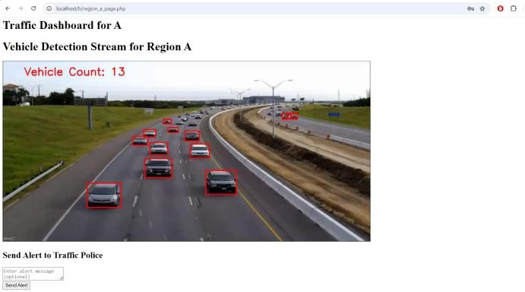

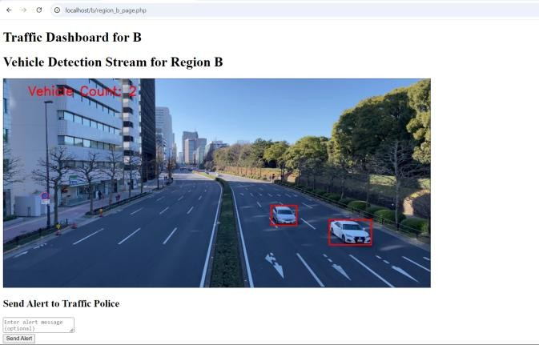

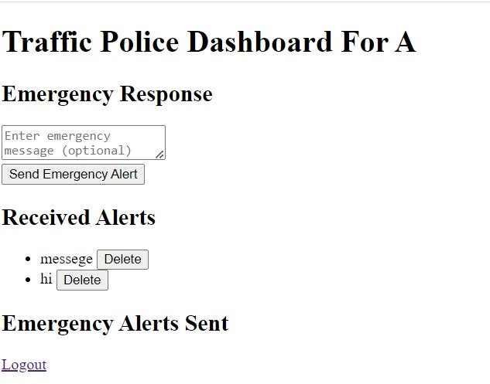

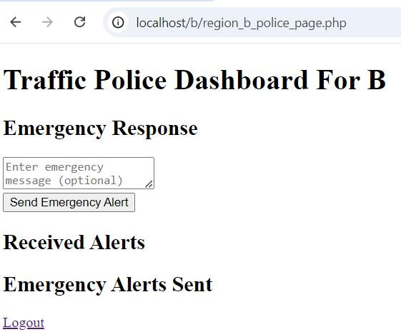

1. **Conclusion**

In conclusion, this dynamic traffic management system significantly advances the capabilities of real-time communication and analysis between traffic authorities and police. By leveraging advanced technologies such as PHP, Flask, AJAX, and cutting-edge vehicle detection methods, the system ensures accurate monitoring and efficient management of traffic flow across distinct regions. The integration of the YOLO model and OpenCV enhances the precision of vehicle identification and tracking, while the intuitive user interfaces streamline alert management and emergency notifications. This project not only optimizes the response strategies of traffic authorities and police but also fosters a collaborative environment that ultimately leads to improved traffic safety and management. By continuously adapting to real-time conditions, the

system sets a new standard for traffic monitoring and communication, paving the way for smarter, more responsive urban environments.

# REFERENCES

1. S. K. Gupta, & S. Kumar. (2021). *Real-Time Traffic Management Using IoT and Big Data Analytics.* Journal of Traffic and Transportation Engineering.
2. M. J. A. A. & M. Al-Sharif. (2021).

*Vehicle Detection and Counting using YOLO and OpenCV.* IEEE Access.

1. T. A. A. (2019). *AJAX: A Beginner's*

*Guide.* McGraw-Hill Education.

1. W. J. & M. S. (2016). *PHP and*

*MySQL Web Development.* Addison- Wesley.

1. M. G. (2018). *Flask Web Development: Developing Web Applications with Python.* O'Reilly Media.
2. A. R., & M. H. (2020). *A Review on*

*Real-Time Traffic Management Systems.* Transportation Research Part C: Emerging Technologies.

1. L. X. & Y. Zhang. (2022). *Traffic Flow Analysis Using Machine Learning Techniques.* Transportation Research Record.
2. T. Y., L. L., & Z. Q. (2020). *Deep*

*Learning for Vehicle Detection: A Comparative Study.* International Journal of Computer Applications.

1. OpenCV Foundation. (n.d.). OpenCV Documentation.
2. J. Redmon, et al. (2016). *YOLO: You Only Look Once: Unified Real-Time Object Detection.* arXiv preprint arXiv:1506.02640.
3. B. S. & K. D. (2021). *Dynamic Traffic Signal Control Using Reinforcement Learning.* Transportation Research Part C: Emerging Technologies.
4. D. T. & D. M. (2017). *Web*

*Application Architecture: Principles, Protocols and Practices.* Springer.

1. R. P. & K. S. (2022). *Improving Traffic Management Using Predictive Analytics.* Journal of Transportation Engineering.
2. P. S. et al. (2019). *Vehicle Tracking System Based on Raspberry Pi and OpenCV.* International Journal of Engineering Research & Technology.
3. J. A. (2015). *Understanding AJAX.*

Web Development Magazine.

1. R. P. (2018). *Database Management Systems.* McGraw-Hill Education.
2. M. D. (2017). *Flask RESTful:*

*Building a REST API.* Packt Publishing.

1. S. G. et al. (2021). *An Introduction to Object Detection.* arXiv preprint arXiv:2104.04167.
2. Z. W. & Q. L. (2021). *Real-time*

*Vehicle Counting Using Deep Learning.* Journal of Transport Geography.

1. A. H. et al. (2022). *Traffic Management Systems: Current Practices and Future Directions.* Transport Reviews.
2. A. N. et al. (2020). *Using Computer Vision for Traffic Surveillance.* Proceedings of the IEEE.
3. H. K., & K. A. (2015). *Database*

*Systems: The Complete Book.* Pearson Education.

1. J. T. et al. (2021). *Machine Learning for Intelligent Transportation Systems: A Review.* Transportation Research Part C: Emerging Technologies.
2. D. C. et al. (2021). *OpenCV and YOLO for Vehicle Detection.* International Journal of Computer Science and Information Security.
3. A. S. (2011). *The Architecture of Open Source Applications.* Lulu Press.