**HR COLLEGE OF COMMERCE AND ECONOMICS**

**F.Y.M.COM (BANKING AND FINANCE): RESEARCH METHODOLOGY**

TOPIC:- MENTAL HEALTH IN ORGANISATIONS

**SUBMITTED TO: *PROF. RIFA PATEL & PROF MAMTA RAJANI***

**SUBMITTED BY: *MANASVI JAIN***

**ROLL NO: *HFPMCBF023***

# Abstract

Mental health refers to the behavioural and emotional well-being of a human being. It is about how people think and behave. Nowadays we have been seeing many issues relating to mental health and well-being of the young working adults. Work can be one of the main sources of stress in a young adult. This stress comes when there is a difference between one’s intellect and skill level and the complexity and demands of the job. But a good and healthy relationship between the organisation or the employer and the employee can make the

employees feel free to share their viewpoint or opinion on a matter. New ideas and opinions should always be appreciated in the organization. Leadership or managerial roles play an

important role in employee engagement. Keeping employees engaged is the toughest job for a manager. Because if an employee is not engaged, they will not be able to give their 100% in

the betterment of the organization. As the working pattern has changed completely due to Covid19, it is quite challenging to keep their personal life separate from professional life.

Studies state that as there is no workplace environment while working from home, even small failures in the job affect the employees in a negative way.

Mental health problems affect many employees, but for some reason these sorts of problems are not recognised at work. So from our research we are ging to help you understand the

impact of different stressors on individuals working in an organisation with special focus on the changing work environment due to the ongoing pandemic and the new challenges faced by employees, understand the levels of workplace well-being among working young adults with respect to the domains of Job Satisfaction, Organizational Commitment, Job

Involvement & Engagement, Stressors & Stress Management at workplace, Work-Family enrichment, Work-Family conflicts, Work-Life Balance. From this project we hope to give you a heads up on the mental health and well-being of the young working adults.

|  |  |
| --- | --- |
| **Particulars** | **Page No.** |
| Preface | 2 |
| Acknowledgement | 2 |
| Abstract | 3 |
| About TCS | 5 |
| Rationale | 5 |
| The impact of Covid-19 on the Consulting Industry | 5 |
| Objectives | 6 |
| Literature Review | 7 |
| Methodology | 8 |
| Data Collection and Data Analysis | 9 |
| Learnings | 17 |
| Limitations and Challenges | 18 |
| Conclusion | 19 |
| References | 20 |
| Work Allocation | 20 |

# About TCS

Tata Consultancy Services (TCS) is an Indian MNC organization that expertise in data

innovation (IT) services and consulting. It has its headquarters in Mumbai, Maharashtra, India and has its biggest workforce situated in Chennai, Tamil Nadu, India. As of February 2021 TCS, is biggest organization in the IT area on the planet by Market capitalization of

$169.2 billion. It is an auxiliary of the Tata Group and works in 149 areas across 46 countries. The Slogan of TCS, officially, is **Experience certainty**

TCS functions on an easy philosophy — the range of its customer base should reflect in its workforce too. TCS features a talent pool of 384,792 employees, over a 3rd of which are women. With 134,000 women in its global workforce, the corporation is among the world's largest private sector employers of female STEM talent. the maximum amount as 85% of its

employees belong to Gen Y. TCS understands that diversity comes in many forms — gender, race, religion, sexual orientation, age, culture, etc.

The five **core Tata values** underpinning the way **TCS** do business are: **Integrity, Responsibility, Excellence, Pioneering and Unity**

# Rationale

There is a large contribution of millennials in the workforce, however, there is a lack of understanding on what they expect from work and what are their conceptions of happiness and well-being with respect to work. These are the millennials who would bring in new changes in the existing systems, and this calls for reviewing and creating job opportunities for them. A recent report has found that Indian millennials spend more time at work than their counterparts in 25 other countries — an average of 52 hours a week. It is a competitive work environment and those who can’t match up to it would really suffer. The personal life and workplace wellbeing of working millennials is often overlooked. Career becomes a significant part and the workplace environment affects an individual’s life and the community at a larger level. Further, deriving meaning from work and workplace has impact on

individual well-being, need fulfilment, motivation and contribution. In the current times, organisations are now having to deal with an entirely new spectrum of issues, much of it having to do with the mental health of their employees. Unfortunately, isolation from society, the inflow of bleak coronavirus-related information, the fear of contracting Covid-19, the

looming economic recession and a sense of helplessness are all impacting people’s mental well-being adversely, causing a lot of stress, anxiety, depression and other mental health concerns.

# The impact of Covid-19 on the Consulting Industry

The Coronavirus pandemic has had a huge impact on all spheres of the economy, the

consulting services sector has seen a significant change- both changes, in the way employees interact with each other and with their clients.

The Indian government enforced a lot of regulations like social distancing, travel restrictions, state wide lockdowns for an extended period etc. The Pandemic minimised face to face

interaction to a bare minimum, which is, really crucial in this industry.

All consultants have resorted to operating remotely in these extenuating circumstances. The consulting industry are working from different parts of the country, the flow of ideas as well all forms of communication has shifted to a digital space. New age technology has made it really easy for individuals to stay connected to each other, regardless of the physical distance.

“Work from Home” took the centre stage this year, from all the different surveys taken this year, shifting to WFH was not a big challenge for most of the employees. The concept of WFH kept employees agile, secure and productive.

Furthermore, substantial cut downs in both activity and new work opportunities have been seen as lockdown restrictions were seen being lifted. The were a massive decrease in demand which forced companies to shut down operations or cut down on the number of employees.

The impact of all this is that these firms have had to a manage a fluctuating workforce (due to the on and off fluctuating requirements). The consulting industry survives on the inherent

talent of their employees. A sense of employee well-being and mental health has taken the centre stage, bringing all the employees of a firm closer on a more personal level and

instilling a sense of belongingness and community.

For many organisations, this was the first instance for them to be working at a remote scale.

With the government implementing travel restrictions in the country, consultants are

improving their skills at meeting their clients remotely and also hold meetings with the other employees using technology like Video Conferencing and Instant Messaging. Even Recruitment of new talent is continuing via Video Conferences paired with the usage of online assessments and psychometric techniques to provide and in-depth view of the new candidates.

Speaking of statistics, there has been a major reduction in the size of the Global Consulting Industry from $160 billion in FY19 to ~$130 billion by the end of 2020, a decline of 19.0% on year-on-year basis. However Asian economies like Chine, Korea and especially India have been able to deal with the Coronavirus Pandemic effectively.

After looking at all these changes that firms had to deal with during the pandemic, it has changed the course of how employees interact internally as well as externally. With so many shifting factors, the one we plan to focus on in this research paper is how the pandemic has

impacted the mental health of employees in the service sector.

# Objectives

1. To understand how Covid and Work from home has affected the mental health of employees and how that has changed their attitude towards their work
2. To understand the impact of different stressors on individuals working in an organisation with special focus on the changing work environment due to the ongoing pandemic and the new challenges faced by employees.

# Literature Review

Paul E. Spector (1997) summarizes the findings concerning how people feel towards work, including: cultural and gender differences in job satisfaction and private and organizational

causes; and potential consequences of job satisfaction and dissatisfaction. He provides with a pithy overview of the appliance , assessment, causes and consequences of job satisfaction.

Sophie Rowan (2008) reveals the way to create a happier work life, without changing career.

She provides practical and realistic guidance on how one are able to do optimal job satisfaction and overcome the obstacles that make numerous folks unhappy at work.

Organizational commitment, then again, addresses how much the representatives relate to the association where they work, how connected with they are in the association and whether

they want to leave it (Greenberg and Baron, 2008). A few examinations have exhibited that

there is a solid association between authoritative responsibility, work fulfilment and variance (Porter et al., 1974), just as that individuals who are more dedicated to an organization are

less inclined to find employment elsewhere. Organizational commitment can be considered as an add on of job fulfilment, as it focuses on the positive attitude that a worker has, not

towards his own work, but rather towards the company. It's about how much an employee is attached to his work and how readily he is able to sacrifice things for the

organization/company.

The connection between job satisfaction and organizational commitment has been researched often (Mathieu and Zajac, 1990; Martin and Bennett, 1996; Meyer et al., 2002; Falkenburg and Schyns, 2007; Moynihan and Pandey, 2007; Morrow, 2011). The research shows that the connection exists, however there is debate about the course of the relationship. Some researchers bolsters the speculation that work fulfilment predicts organizational commitment (Stevens et al., 1978; Angle and Perry, 1983; Williams and Hazer, 1986; Tsai and Huang, 2008; Yang and Chang, 2008; Yücel, 2012; Valaei et al., 2016). Different studies suggest that commitment to an organization is a precursor to job fulfilment/satisfaction. (Price and

Mueller, 1981; Bateman and Strasser, 1984; Curry et al., 1986; Vandenberg and Lance, 1992).

Peter (2009) in his study on "Work life balance and subjective well being" talks about the equilibrium between work life and the well being of the employees. In this examination, the theory that was studied was the adequate amount of free time increases the well being of the

employees as it helps in fulfilling individual requirements. The finding in this exploration was that the apparent adequacy of time available for individual life tells the degree of prosperity only if the person's necessities are satisfied in the given time.

Sarah Holly and Alwine Mohnen (2012) in their research named "Impact of working hours on Work Life balance" their primary objective was to inspect the impact of the working hours of the employees on their satisfaction at work. They stated that overall number of the workers want to decrease their working hours is primarily influenced by the extra time remuneration.

Their study result shows that generally the long working hours don't prompt the

disappointment among the workers, but long working hours positively affect the worker's life and job satisfaction and the craving to lessen the long working hours have a negative affect on the work satisfaction of the workers.

# Methodology

Sample Characteristics

The data was originally collected from a sample of 25 people, of which 3 responses were rejected due to data insufficiency. The final sample size for this study was 22, from the cities of Mumbai, Nagpur and Noida.

Distribution of different Sample Characteristics among the respondents:

|  |  |
| --- | --- |
| Age Range | Number of  Employees |
| 22 | 4 |
| 23 | 8 |
| 24 | 6 |
| 25 | 2 |
| 26 | 2 |
| Total | 22 |

Inclusion Criteria:

On the basis of the Objectives of the current study, the following were decided upon as the criteria for sample selection: -

* 22 participants residing in the cities of Mumbai, Nagpur and Noida with a work experience ranging from 6 months-3 years in the corporate sector.
* Should be in the age group of 18-25 years.
* Should have at least completed their graduation degree.
* Should have moderate proficiency in the English language, since the questionnaire has been made only in English.

Method of Sample Selection:

The process of Snowball sampling was used; which involves approaching some initial participants who further nominate or refer other participants from their social networks who meet the eligibility criteria for the research study. It also involves relying on previously

identified group members who help to identify others who have the same characteristics as that of the group which is already in place Snowball sampling enabled the researcher to collect the study sample using the referral networks of friends and family.

Tools for Data Collection:

Given the quantitative nature of the current research study, Questionnaires were used as the

tools for data collection. A questionnaire is basically a research instrument which consists of a series of questions or prompts, for the purpose of gathering some information from the

participants in the research sample. Questionnaires are mostly self-administered, which allows the participants to fill out the responses themselves.

Self- designed questionnaire:

To meet the objectives of the study, a questionnaire was developed with Likert scale statements. The responses of the participants on these statements were utilized for scoring. These statements were used to assess the well-being of the participants in their workplace.

# Data Analysis

Q1) What is your age?

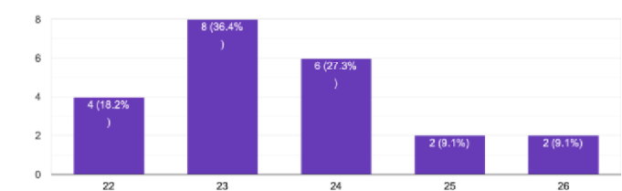

Ans) We asked the respondents their age to understand the range of the young adults we interviewed; the ages spanned from 22 (being the youngest) to 26 (being the oldest). A

majority of respondents were of the age 23-24. Age was an important factor for us to consider while conducting our research, in fact, it was a pivotal factor for us, given, our research focussed solely on young working adults.

Q) What is your gender?

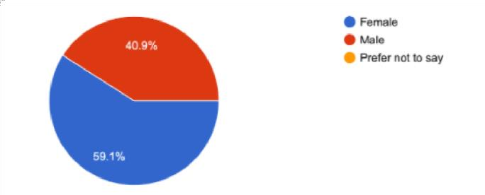

Ans) Since our report is not focussing on a particular gender, we asked this question just for

the sake of understanding the demographic of our interviewees. 59% of our respondents were females and 41% of our respondents were male. We are aware of the fact that challenges faced by both genders at the workplace could be different, however, our report tries to focus on workplace challenges from a broader perspective and does not assume a myopic gender focused approach.

Q) What are your educational qualifications?

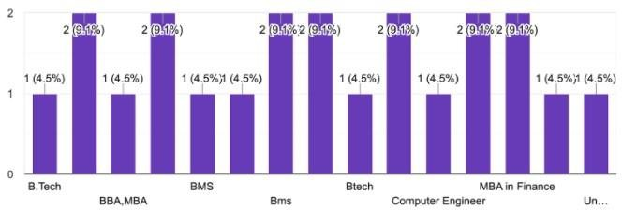

Ans) Since our research was focused on young adults, we found it essential to ask them about their educational background to understand the level of work and life experience they actually had. A majority of our respondents were from backgrounds such as B. Tech, BBA, MBA and BMS in the ungraduate level and MBA in Finance in the Post Graduate level.

Q) Which City are you from?

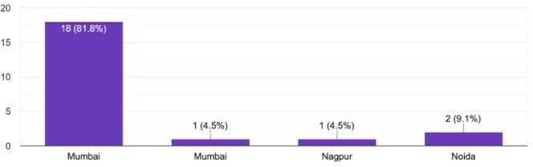

Ans) Our research wasn’t specific to a particular city but a majority of our respondents turned out to be from Mumbai, given, our questionnaire was given to most employees of the Mumbai branch

Q) Which department are you placed in?

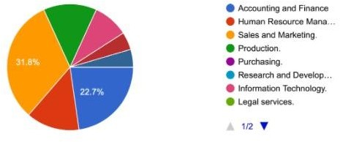

Ans) Almost corresponding to the number of BBA graduates we interviewed, we had the

largest pool (32%) of respondents placed in the sales and marketing department, followed by a large number of respondents (22%) in the accounting and finance department. It is

important to note that while sales and marketing departments are more interaction oriented and require stronger qualitative skills, accounting and finance departments are more detail oriented and require a stronger quantitative acumen. The level and kind of stress that

employees in both these departments undergo would vary

(sometimes, in relation to the aforementioned factors). The other employees belonged to other departments almost evenly namely- HR, Purchasing, Legal services, Production and IT.

Q) For how many years have you been with this organisation?

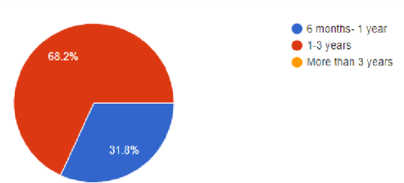

Ans) We have questioned the employees about their tenure in the company because it establishes grounds for employee loyalty and dedication towards the company, if the company’s overall success takes precedence over their own success. An employee with working with a company for a long period of time is likely to have formed an emotional bond with said organisation.

Q) How many jobs have you changed before you joined this organisation?

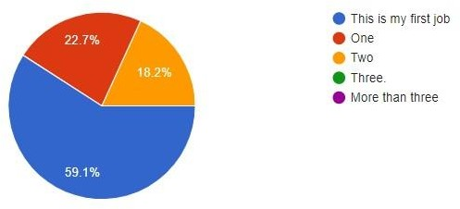

Ans) We asked this question to again, understand the level of organisational loyalty in our employees, if better opportunities hold more value for them or the stability of being in a company, they are accustomed to.

Q) How many days a week are your required to work?

Ans) Since, our research is based on how stress and burnout effects the mental health conditions and workplace well-being of young working adults, asking them how many days they need to work was a critical question, the amount and level of work you have directly

impacts your stress levels. We found out that a majority of our respondents had to work 6 days a week i.e., Monday to Saturday.

Q) How many hours a day are your required to work?

Ans) As we mentioned in our previous question, the amount of time you spend working and the level of stress and burnout you face are correlated. Hence, to understand the levels of work place well-being of the employees, this question was critical. We found out that a

majority of our respondents had a 10-hour work day followed by some having a 4 hour and a 5-hour work day. The position and the level of responsibility you acquire in a firm also somehow decide the amount of time you spend in the office.

Q) Do you think there has been a change in your attitude towards work post COVID-19?

Ans) Since our research sheds light on the changes in the metal health conditions and workplace well-being of the employees post the changes in the work environment, like WFH being the biggest of them all. Almost 69% of employees reported a change in their disposition post the pandemic.

Most employees felt like they had lost their motivation and will to work with the change in their work environment and losing their sense of normalcy. A lot of employees were discontent with the increase in the screen time, which is making them more irritable and fatigued and in turn making them inept at giving 100% to work. Employees have also reported issues with their family and not being able to give enough time to their personal obligations.

1. Has WFH increased the mental stress?

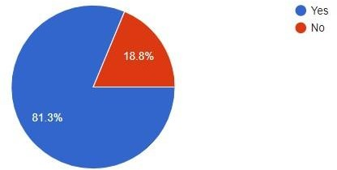

Ans) Work from Home or WFH which is the new normal after the coronavirus pandemic forced offices to operate remotely from the safety of the employees’ homes. WFH has

increased mental stress for as many as 81% of the respondents, with new norms like video conferencing, instant messaging and virtual meetings taking the forefront in the employees’ work life.

The following questionnaire covers five aspects that might affect mental health in an organisation. They are:

## Job satisfaction (1-9) Organisational Commitment (10) Job involvement and engagement (11-12) Stressors and stress management at workplace(13-17) Work-life balance(18-20)



* 1. 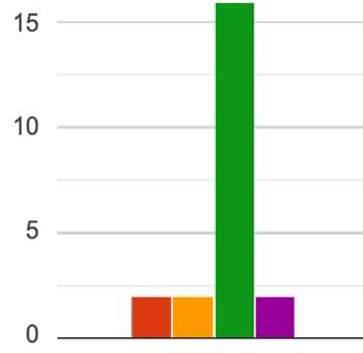I find the work I do meaningful and challenging

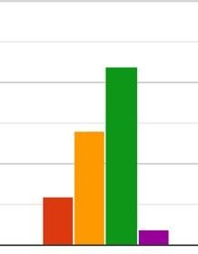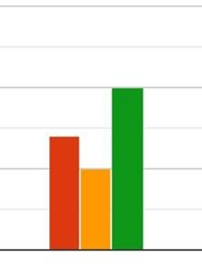

* 1. I feel that the job demands exceed

my abilities.

 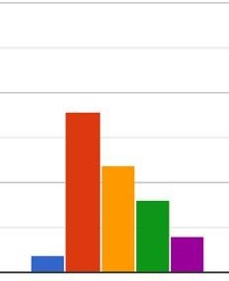

* 1. I enjoy the freedom to use my own judgement, while at work.
  2. My supervisor is quite approachable.
  3. My co-workers and I work collaboratively.

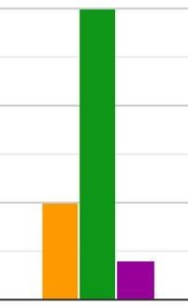

* 1. I feel uncertain about how much

authority I have in the position that I’m at.

 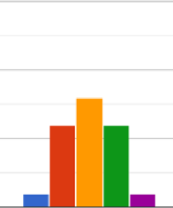  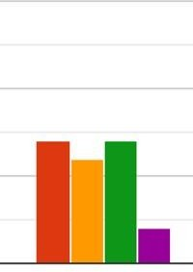

* 1. 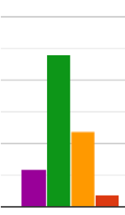My organisation is dedicated to diversity and inclusiveness
  2. The conflict resolution in our  company is satisfactory

 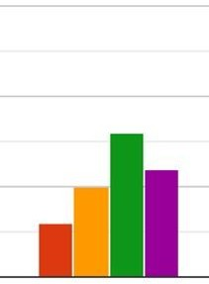

* 1. 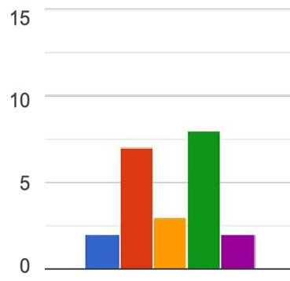My friends and family have a positive image of the company I work in.

 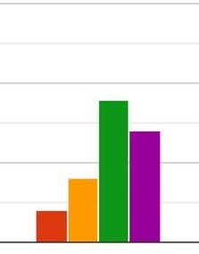

* 1. I sense a congruence in my values and the organisation’s values.

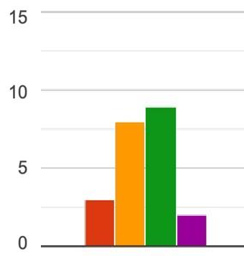

* 1. I feel enthusiastic to go to work every morning.
  2. If I fail at something at work, I lose my perseverance.

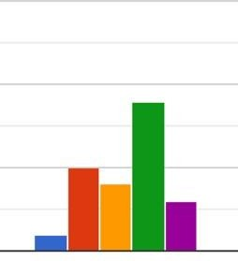

* 1. I have faced discrimination and harassment at my workplace.

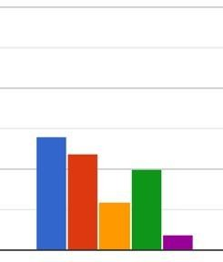

* 1. I am unable to work under time pressure and strict deadlines.
  2. 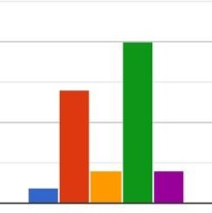I get exhausted because of the commute to work.
  3. 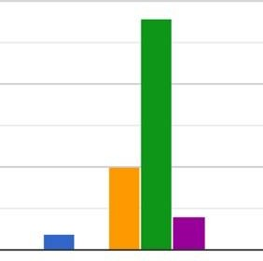I get emotionally and mentally

exhausted because of the nature of my job.

## Job satisfaction

19. At the end of my work hours, there is not much time left to indulge in

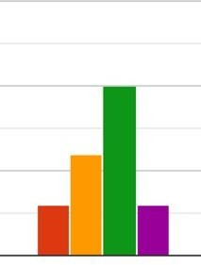personal hobbies and leisure time.

* 1. We have an Employee Assistance Program that equips me to deal with my stress. (Examples

could include counselling services, family support programs, etc.)

 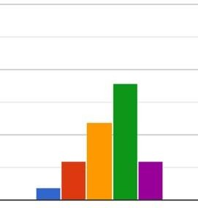

* 1. The demands of my work interfere with my home and family life.

20. Taking all things together, I am happy at my current workplace.

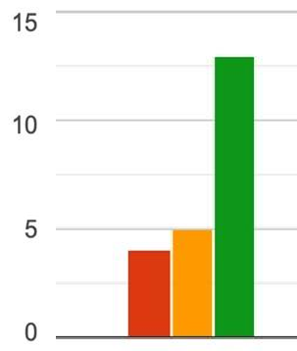Job satisfaction is a measure of workers' contentedness with their job, their perception of their job or individual aspects or facets of jobs, such as nature of work, supervision,

organisational culture etc. It is a state of emotional wellbeing achieved by an individual when he/she has a positive self-appraisal and attitude towards job along with an affective reaction

to his/her job. Job satisfaction can be considered an attitude, however, it is an attitude developed through a combination of feelings, beliefs and behaviours. However, job satisfaction is dependent also on opportunities for job enrichment, level of autonomy,

involvement and empowerment and also on the organization’s management style and culture

According to the responses to the questionnaire, most people agree that their jobs at TCS has given them job satisfaction at some level. The work environment seems to be positive and

they have a positive image of their organisation and their job profile which is very important a positive well-being in the workplace.

## Organisational Commitment

An individual’s ability to commit to one’s work organization or organizational commitment is largely affected by one’s Perceived Organizational Support. Organizational commitment instils a feeling of safety and security in the employee and also works positively for the organization

The employees seem to believe in the organisations values and are committed to the organisation.

## Job involvement and engagement

employee engagement is the cognitive, emotional, and behavioural energy an employee directs toward positive organizational outcomes. employees who are engaged are more likely to be productive and more likely to continue with their current employer. Hence, these

individuals are more likely to be secure in their job and therefore happy and adjusted

The responses show that employees are really affected by failure and that can lead to a serious dip in their mental health. They also say that they are not motivated to go to work every day from which we can infer that maybe the work is repetitive and monotonous.

## Stressors and stress management at workplace

Work can be the main source of stress in a young adult. This stress comes when there is a conflict between one’s intellect and skill level and the complexity and demands of the job. For those who are stimulated by challenges, completing or being engaged in a difficult task could translate into great job satisfaction and higher organizational commitment

These statements assessed the workload, physical and emotional exhaustion faced, and stress related to the job role or the work environment. It also included statements to assess the personal coping mechanisms of the respondents and stress management mechanisms initiated by their company. job autonomy is directly correlated to employee well-being because high

job autonomy gave the employee more opportunities to cope with work related stress. This is because job autonomy gives an employee an opportunity to work independently from other employees, gives flexibility and allows the employee to pace his work according to his/her capacity and convenience.

## Work-life balance

Job autonomy is directly correlated to employee well-being because high job autonomy gave the employee more opportunities to cope with work related stress. This is because job autonomy gives an employee an opportunity to work independently from other employees, gives flexibility and allows the employee to pace his work according to his/her capacity and convenience.

The employees seem to have been able to manage their work and personal relationships and are happy with how things are.

# Learnings

1. To understand the impact of different stressors on individuals working in an organisation with special focus on the changing work environment due to the ongoing pandemic and the new challenges faced by employees.

We followed a qualitative approach to understand this objective and found out that most people preferred going to work to working from home. This was due to chaos at home due to children, uncertain working hours, maintaining the work-personal life balance.

1. To understand the levels of workplace well-being among working young adults

We followed a quantitative approach and asked the employees to rate questions on Job Satisfaction, Organizational Commitment, Job Involvement & Engagement, Stressors & Stress Management at workplace, Work-Family enrichment, Work-Family conflicts,

Work-Life Balance from strongly agree to strongly disagree. We saw that even though

the employees were satisfied with their positions, they don’t feel fulfilled with their roles in the organisation. Most of them are committed to the organisation, however still are affected by the stressors.

**Limitations and Challenges**

The findings of this study must be seen in light of some limitations. There is no way to perform research without meeting barriers and, at times, significant limitations.

1. Issues with sample and selection-

When we first started with the research subject, we found it difficult to collect data from the 30-40 age group for the working population. We had to base our subject on the young working population because of this challenge. We attempted to collect data for the older working population, but we found it difficult to collect data and only a few answers could be obtained.

1. Inability to generalize the research findings –

TCS employees provided us with the details. It was difficult to generalise the data obtained for young working adults to the general public because we can't generalise public opinion based on a few responses.

1. Limited access to data-

As mentioned earlier, we found it difficult to find answers from the working population of the middle aged and therefore we had to change the whole focus of the research subject due to restricted access to the data.

1. Lack of previous research studies on the topic-

The literature review for your thesis or analysis is based on citing and referencing prior research studies, and these prior studies provide the theoretical basis for the research

issue you're investigating. We discovered that very little or very basic and limited research has been done on this subject. 5. Falsified data –

We can see that most of our responses have been positive and the employees haven’t really said anything wrong about their organization. So there is a possibility that the employees

tend not to express their opinions about the organization while filling out the responses from

the questionnaire. Due to this there is a chance to have collected the data which in some sort is falsified and hence can result in accuracy of the research

6. Scope of discussions –

We as group are certainly new to conducing researches and producing academic papers of large sizes. The scope the scope and depth of discussions in this paper is compromised in many levels compared to the works of experienced scholars. Hence there is always a scope for new findings and improvement in this research.

# Conclusion

The aim of the current study was to examine the levels of overall well-being and workplace well-being (with respect to seven domains namely Job Satisfaction, Organisational

Commitment, Job Involvement and Engagement, Stressors and stress management at workplace, Work-family enrichment, Work-family conflicts, and Work-life balance), in young adults working in the corporate sector, in the metropolitan cities of Noida, Nagpur

/and Mumbai. The study examined the relationship between the components of workplace wellbeing and overall well-being in these young adults.

Further, to determine whether the domains of overall well-being (i.e., Emotional, Social and Psychological well-being) were associated with the domain’s workplace well-being (Job Satisfaction, Organizational Commitment, Job Involvement & Engagement, Stressors &

Stress Management at workplace, Work-Family enrichment, Work-Family conflicts, Work Life Balance), Spearman’s rank correlation test was done. All the three domains of overall well-being had a statistically significant positive correlation of moderate degree with six domains of the workplace well-being namely, Job satisfaction, Organisational commitment, Job involvement and engagement, Stressors and SM, work family enrichment and work-life balance; indicating an association between a person’s mental health and their well-being at the workplace. The Covid-19 pandemic has been a contributing factor towards a significant increase in the stress faced by employees on a day-to-day basis. The work and family life balance has also gone for a toss with employees’ work life encroaching their homes now.

However, we can gradually see things going back to normal and physical offices coming back to the picture, we could see things, getting back to normal soon.

To conclude, Man is a social animal and craves social support. As a great part of an

individual’s work life is spent in an office, social support at office is very important. This goes much beyond the concept of official support from supervisors and co-workers. Cole and colleagues suggest that social interactions with the team, seniors and the organization as a whole is important to instil a feeling of belonging, happiness, and comfort. Social

interactions as these three levels helps employees understand each other, become aware of strengths and weaknesses and become more involved and develop friendships beyond the office boundaries. Hence organizations should focus on team building activities, workshops, motivational talks, off-site picnics and recreational activities.

# Bibliography

(Mental Health and Work)

https:/[/www.who.int/mental_health/prevention/guidelines_mental_health_work/en/](http://www.who.int/mental_health/prevention/guidelines_mental_health_work/en/)

(Mental well-being at the workplace)

https:/[/www.ncbi.nlm.ni](http://www.ncbi.nlm.nih.gov/pmc/articles/PMC3062016/)h[.gov/pmc/articles/PMC3062016/](http://www.ncbi.nlm.nih.gov/pmc/articles/PMC3062016/)

(Mental health and employers)

https://www2.deloitte.com/content/dam/Deloitte/uk/Documents/consultancy/deloitte- ukmental-health-and-employers.pdf (Mental health in the workplace)

https:/[/www.who.int/teams/menta](http://www.who.int/teams/mental-health-and-substance-use/mental-health-in-the-workplace)l[-health-and-substance-use/mental-health-in-the-workplace](http://www.who.int/teams/mental-health-and-substance-use/mental-health-in-the-workplace)