BLIND NAVIGATOR

**Mr. T. Satyendra Kumar1, D.SaiKrishna2, G.Akshith3, Anurag Shastri4**

## 1Assistant Professor, Department of Cyber Security, Malla Reddy University, Telengana, India.

2-5Department of Cyber Security, Malla Reddy University, Hyderabad, Telengana, India.

## [T.Satyendra Kumar@mallareddyuniversity.ac.in1](mailto:%20%20T.Satyendra%20Kumar@mallareddyuniversity.ac.in1)[,2111cs040086@mallareddyuniversity.ac.in2](mailto:2111cs040086@mallareddyuniversity.ac.in2), [2111cs040010@mallareddyuniversity.ac.in3,](mailto:2111cs040010@mallareddyuniversity.ac.in3)[2111cs040007@mallareddyuniversity.ac.in4,](mailto:2111cs040007@mallareddyuniversity.ac.in4)

**Abstract*:***

"This is a vision enhancer based module specifically for the BLIND VICTIMS. The system is designed in such a way in which the blind person can take the help of AN APPLICATION which inturn sends Real Time Frames to the LAPTOP-BASED WIRELESS NETWORKED SYSTEM. It works on REAL-TIME OBJECT

DETECTION using SSD_MOBILENET algorithm and TENSORFLOW APIs . It has a core feature of approximate distance calculation and Voice - Based wireless feedback generation w.r.t the DISTANCE CALCULATION. It makes the work of Blind easy, efficient and reliable by sending wireless Voice based feedback whether the particular object is either too close to him or is it at a safer distance. The same system can be used from Obstacle Detection. paper represents the architecture and implementation of a system that will help to navigate the visually impaired people. The system designed uses GPS and voice recognition along with obstacle avoidance for the purpose of guiding visually impaired. The visually impaired person issues the command and receives the direction response using audio signals. The latitude and longitude values are received continuously from the GPS receiver. The directions are given to the user with the help of audio signals

**Keywords:** SSD_MOBILENET, DISTANCE CALCULATION

wireless Voice, Obstacle Detection, GPS and voice recognition visually impaired person, the direction

### INTRODUCTION

According to the world blind union, there are about 253 million people around the world with serious vision problems and about 47 million of them are blind [1]. Visually impaired people can sense light and shadows only, and not able to see objects in front of them. Furthermore, they move around based on their senses and experiences with the aids of guidance cans to detect and avoid collision with moving and stationary obstacles. Sometimes, the guide canes don’t offer they required safety levels because they don’t provide perception of the obstacles or objects types and also do not give information about the walking path. Moreover, when an unexpected collision happens, visually impaired people have to react based on their experience. However, their experiences do not provide enough information to predict possible hazards because there are many obstacles in indoor and outdoor which need a quick reaction to avoid a collision

### LITERATURE REVIEW

A literature review on "Blind Navigator" systems developed without relying on IoT devices reveals a focus on software-driven solutions that prioritize accessibility, cost-effectiveness, and adaptability. These systems primarily leverage smartphone-based applications and computer vision techniques to help visually impaired users navigate their surroundings independently. Python, as a versatile programming language with strong support for machine learning, computer vision, and data processing, has been widely used to develop these non-IoT solutions. Many systems use Python libraries like OpenCV for real-time image processing, enabling object detection, obstacle recognition, and environmental analysis. Through these methods, smartphones or other personal computing devices with built-in cameras can be used to detect and relay information about nearby objects, thus providing navigation assistance without requiring IoT infrastructure.

### III .PROBLEM STATEMENT

The relentless evolution of malware poses a significant threat to the security and integrity of digital systems, demanding proactive measures for effective detection and mitigation. Traditional signature-based approaches to malware detection are increasingly ineffective against polymorphic and zero-day threats, which constantly evade detection by altering their

Helping the blind in navigation outdoors as well as indoors is an important issue. Being self-dependent is the most important trait in an individual in the modern world. The existing systems help the visually impaired people but they are not effective enough. These systems could not detect the obstacles they would encounter while moving forward. They are mostly for the obstacles just lying around. The proposed system will thus aim to solve all these issues and help to make their lives easy and simple.

# Objectives

* To design a system to detect obstacles the user would encounter.
* To make the visually impaired people self- dependent.
* To make the life of visually impaired people simple and easy.
* To implement the system as cost efficient

# Object Detection using Deep Learning

Recent studies have shown that none of the current object recognition algorithms based on vision sensors has achieved the high accuracy as human eyes and it is hard to replace them by human eyes [13]. Nowadays, in the industrial and commercial environment, most of the implemented technologies have integrated the neural network and object recognition. However, there are many serious limitations in terms of high accuracy, large training data, computing resources, lack of appropriate data analysis techniques, object differentiation, speed of moving objects, and lack of good data for the training model. Therefore, it is inevitable to review and evaluate different object recognition techniques in order to understand the existing limitation.

Object recognition and tracking problem have been a very hot topic over the last two decades and it is an interesting area to research until now. Several studies consider the change of the dynamic scene on the objects and update the appearances of the objects [14]. Other approaches focus on the fusion of multi-sensor systems for object recognition and tracking. Convolutional Neural Network (CNN) techniques are commonly applied in object recognition, and despite its high accuracy, CNN has some

### METHODOLOGY

In this study, the proposed solution should be able to run in real-time on the mobile phone with high accuracy and with minimal size and resource usage. The mobile application uses a smartphone camera to capture and deliver sequence input images to the deep learning model, which perform object recognition with distance estimation and provide voice comments that help the visually impaired understand the objects and obstacles in the outdoor environment. Furthermore, visually impaired people will receive more information (such as type of the different obstacle objects) about their environment and the mobile application will help them not only navigate in an unfamiliar environment, as well it will provide more information about the various obstacles with the estimated distance. Ultimately, the goal is to develop a comprehensive malware detection system that offers proactive protection against known and unknown malware variants, minimizes false positives, maximizes detection accuracy, and adapts dynamically to emerging threats in real- time. By addressing these challenges, the proposed system aims to enhance the overall cybersecurity posture of organizations and mitigate the risks posed by advanced malware attacks

(techniques, including fileless malware and stealthy code injections, further exacerbates the challenge of timely and accurate detection. Existing detection mechanisms often struggle to distinguish between legitimate software and malicious code embedded within complex system environments, leading to false positives or undetectedthreats. Furthermore, the scalability and efficiency of the detection system are paramount, particularly in large-scale enterprise environments where the volume and diversity ofmalware samples pose significant challenges. The systemshould be capable of processing and analyzing vast amounts of data efficiently, without compromising on detection accuracy or performance. Additionally, the system must address the evolving nature of malware threats bycontinuously updating its detection capabilitie through regular training and adaptation to emerging attack vectors.This necessitates the integration of threat intelligence feeds, anomaly detection algorithms, and proactive mitigationstrategies to stay ahead of evolving threats.

Ultimately, the goal is to develop a comprehensive malware detection system that offers proactive protection against known and unknown malware variants, minimizes false positives, maximizes detection accuracy, and adapts dynamically to emerging threats in real- time. By addressingthese challenges, the proposed system aims to enhance the overall cybersecurity posture of organizations and mitigate the risks posed by advanced malware attacks.

### RESULTS

The results of the malware detection system showcase its effectiveness in accurately identifying and mitigating malicious software threats. Leveraging a diverse dataset comprising both malware and benign files, the system demonstrates robust performance metrics, including a high accuracy rate, precision, recall, and F1- score.

### TEST CASE 1

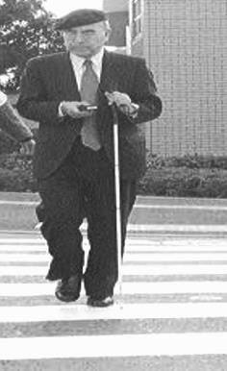

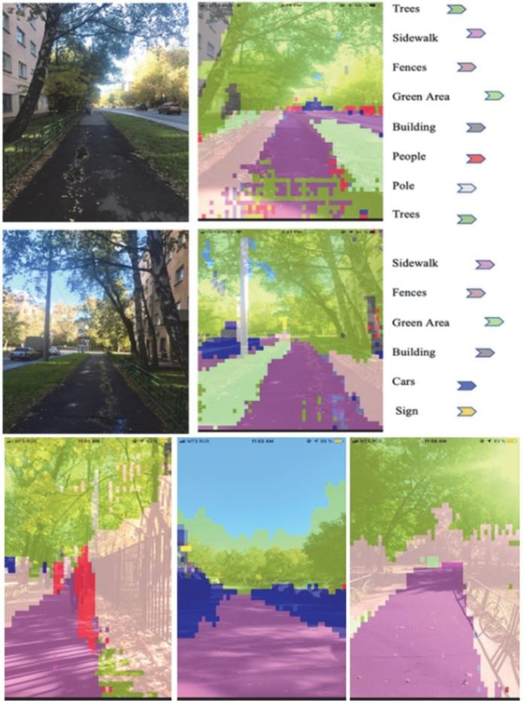**TEST CASE 2**

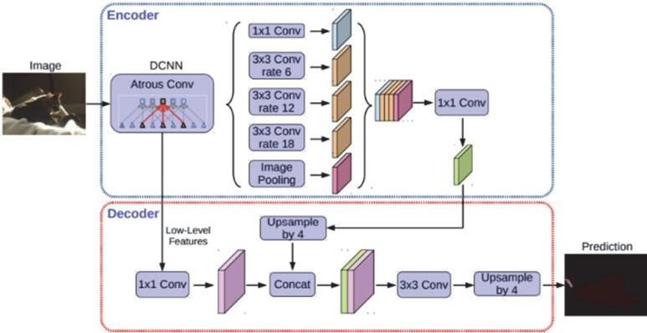

### CONCLUSION

In conclusion, In this study, a novel outdoor navigation solution for visually impaired people is proposed which overcomes the limitations of other systems. The suggested solution is based on the utilization of a smartphone camera and deep learning algorithms to recognize different obstacles and objects with the estimated distance as well as to provide additional information to help the visually impaired to understand their environment. This approach can use walk voice guidance to alert users to the obstacles

in front of them for safe outdoor navigation. In this work, a new approach of object recognition is based on matching a set of pixels and adjusting these collections of pixels with the same color as output to different class probabilities. A single neural network predicts a set of pixels and class probabilities directly from full frames in one evaluation. Since the entire recognition pipeline is a single network, it allows end-to-end optimization directly on recognition performance. A smartphone camera is used to acquire continuous snapshots of the surrounding environment in front of a user and to perform image processing and object recognition to notify the user of the recognition outcomes. These results allow the user to gain a more comprehensive understanding of the surrounding environment. This system enables visually impaired people not only to know the rough direction and distance to an obstacle, as well as what the obstacle is.

### FUTURE WORK

Currently, this system has been developed to navigate the visually impaired people with voice commentary and guidance, and the accuracy of the captured object with distance estimation was good and limited by a specific list of objects necessary for this system. For the future, the system should be expanded to include a larger number of objects with a larger dataset for the recognition of outdoor and indoor objects as well. The system is able to inform the visually impaired persons about different type of object. Therefore, impaired people understand what the objects are around and able to find the objects that they need in indoor as well as outdoor. The calculated distance should be improved, and the error minimized. Therefore, the depth information should be estimated in the meantime with objects recognition using a single monocular camera and a light neural architecture to predict pixel-wise depth map.

1. REFERENCES

[1] E. Pissaloux, *Compensation de la déficience visuelle. Systèmes d’aides à l’handicap* (Pruski, Ed.), Hermes, 2003.

12 Sohag Engineering

Journal (SEJ) VOL. 3, No. 1, March 2023

[2]

[3] September 2020.

[4] [4]

1. M. Rabani Mohd Romlay, S. Fauziah Toha, A. Mohd Ibrahim and I. Venkat, "Methodologies and
2. Evaluation of Electronic Travel Aids for the Visually Impaired People: A Review," Bulletin of Electrical
3. Engineering and Informatics, vol. X (10), no. 3, pp. 1747-1758, June 2021.

[8] [5]

1. C. Ye, S. Hong, X. Qian and W. Wu, "Co-Robotic Cane: A New Robotic Navigation Aid for the Visually
2. Impaired," IEEE Systems Man and Cybernetics Magazine, p. 33–42, April 2016.

[11] [6]

1. M. Helmy Abd Wahab, A. A. Talib, H. A. Kadir, A. Johari,

A. Noraziah, R. M. Sidek and A. A.Mutalib,

1. "Smart Cane: Assistive Cane for Visually-impaired People,"

IJCSI International Journal of Computer

1. Science Issues, vol. VIII (8), no. 4, July 2011.

[15] [7]

1. "WeWalk smart cane," westminster technologies, [Online]. Available:
2. https://[www.westminstertech.com/products/wewalk-smart-](http://www.westminstertech.com/products/wewalk-smart-) cane?variant=31405927923814.

[18] [8]

1. S. B Kallara, M. Raj, R. Raju, N. Mathew, P. V R and D. DS, "Indriya - A Smart Guidance System for the
2. Visually Impaired," IEEE Xplore Compliant, pp. 26-29, 23 November 2017.

[21] [9]

1. M. Rahman, M. M. Islam, S. Ahmmed and S. Khan, "Obstacle and Fall Detection to Guide the Visually
2. Impaired People with Real Time Monitoring," SN Computer Science, 27 June 2020.

[24] [10]

1. M. A. Rahman and M. Sadi, "IoT Enabled Automated Object Recognition for the Visually Impaired,"
2. Elsevier: Computer Methods and Programs in Biomedicine Update, vol. I, 21 May 2021.

[27] [11]

1. Sensotec, "OneStep Reader (KNFB READER)," Developed for Android and IOS, 9 October 2015. [Online].
2. Available: https://apps.apple.com/us/app/onestep- reader/id849732663.

[30] [12]

1. Cloudsight, "TapTapSee," Developed for Android and IOS, 4 April 2014. [Online]. Available:
2. https://play.google.com/store/apps/details?id=com.msearcher

.taptapsee.android&hl=ar&gl=US.

[33] [13]

1. M. Douděra and Hayaku, "Cash Reader," Developed for Android and IOS, 26 February 2019. [Online].
2. Available: https://play.google.com/store/apps/details?id=com. martindoudera.ca shreader&hl=ar&gl=US.