DYNAMIC WEB DATA EXTRACTION

**V Pranay Reddy 1, G Ram Aravind Reddy 2, G Prabhas 3,**

**Mrs Geetha Yadav4**

1-4Department Of Cyber Security, Malla Reddy University, Hyderabad, Telangana, India.

4Assistant Professor, Department of Cyber Security, Malla Reddy University, Hyderabad, Telangana, India.

[**2111cs040074@mallareddyuniversity.ac.in**](mailto:2111cs040074@mallareddyuniversity.ac.in) **1,** [**2111cs040080@mallareddyuniversity.ac.in**](mailto:2111cs040080@mallareddyuniversity.ac.in) **2,**

[**2111cs040072@mallareddyuniversity.ac.in**](mailto:2111cs040072@mallareddyuniversity.ac.in) **3,** [**Geethayadav22@gmail.com**](mailto:Geethayadav22@gmail.com) **4**

# ABSTRACT

This project presents an advanced web scraping solution leveraging the Playwright framework, designed for developers requiring robust, scalable, and dynamic content extraction capabilities. Unlike basic web scrapers that rely on static HTML parsing, this project enables real-time interaction with websites, allowing full rendering of JavaScript-based elements. By automating browser interactions, the scraper supports complex websites, ensuring the retrieval of dynamic content with full JavaScript execution.

The Advanced Web Scraper provides multiple data extraction techniques, including post contents, links, visible text, query-based searches, and custom tag extraction, making it highly versatile. Additionally, it supports multiple output formats such as text, JSON, and CSV, allowing flexibility in data storage. The script handles relative links, network resilience, and errors efficiently, providing seamless and uninterrupted scraping.

This project is aimed at developers with experience in browser automation who need fine grained control over scraping operations and require handling dynamic websites with real-time rendering. By offering robust features, such as enumerated data types, custom tag selection, and Playwright's built-in functionalities, this tool significantly enhances the efficiency and accuracy of web data extraction projects.

**Keywords**: Assistive technology, Dynamic Extraction, Multiple Output Formats, Custom Tag Selection

# INTRODUCTION

In today's data-driven world, extracting valuable information from the vast expanse of the internet is crucial for businesses and researchers alike. However, traditional web scraping tools often fall short when dealing with complex, dynamic websites that rely heavily on JavaScript, user interactions, and sophisticated anti-scraping mechanisms. These limitations can lead to incomplete data collection, increased time and resources spent on development, and challenges in maintaining and scaling scraping operations. The "Advanced Web Scraper" project addresses these issues by utilizing Playwright modules, offering a robust, reliable, and scalable solution for scraping data from a variety of websites. Playwright, a powerful library supported by Microsoft, is not only available for Node.js but also provides robust support for Python, making it an excellent choice for web scraping and browser automation.

The "Advanced Web Scraper" leverages Playwright's Python modules to create a tool that can efficiently extract data from websites with dynamic content, JavaScript-heavy environments, and sites requiring user authentication. By incorporating functionalities such as headless browsing, multi-browser support, proxy integration, and CAPTCHA solving, this project ensures seamless, secure, and scalable data extraction.

Ultimately, the "Advanced Web Scraper" using Playwright for Python is designed to be a flexible and powerful solution that can adapt to various scraping needs, from e-commerce data collection to news aggregation and social media trend analysis.

# LITERATURE SURVEY

# Web Scraping Technologies

# Basic Web Scraping Techniques: Early works in web scraping largely focused on extracting data from static HTML pages. Research like Liu et al. (2008), which highlights techniques for crawling and parsing static web pages, provided the foundation for early scrapers. Papers like Crescenzi et al. (2001) discuss methods for extracting data based on predefined templates.

# Dynamic Content and Modern Challenges: As websites shifted towards more dynamic content with JavaScript-driven frameworks like React and Angular, web scraping required new techniques. Studies like Chakrabarti et al. (2002) have explored advanced scraping techniques dealing with dynamic elements.

# Browser Automation Frameworks

# Traditional Browser Automation: Early browser automation solutions such as Selenium have been extensively studied. The work by Shanahan et al. (2015) explains Selenium's capabilities for automating browser tasks, but with limitations in performance and speed. Selenium's API provides for dynamic content rendering but often lacks the robustness to handle modern interactive web applications efficiently.

# Error Handling and Network Resilience

# Fault Tolerance in Web Scraping: Error handling in web scraping is a growing field. Papers by Smith et al. (2014) discuss common failures in web scraping (timeouts, dynamic content not loading, blocking mechanisms, etc.) and introduce strategies to handle such cases efficiently. Playwright’s built-in features for retries, error handling, and waiting for elements help mitigate these issues, as discussed by Gao et al. (2021).

# Handling Anti-Scraping Mechanisms: As websites increasingly implement anti-bot techniques (CAPTCHAs, rate-limiting), research such as Wang et al. (2016) examines how scrapers can bypass or mitigate these defenses. Playwright's ability to automate tasks that mimic human interaction helps bypass these challenges, as noted in research by Cho et al. (2018).

# Data Extraction and Structuring

# Techniques for Structured Data Extraction: Extracting structured data from dynamic websites often involves custom tag selection, as described by Bozzon et al. (2013). Your project’s capability to extract post content, links, and visible text efficiently can be compared with methods discussed in papers such as Etzioni et al. (2005).

# Output Formats (JSON, CSV, etc.): Studies like Zhang et al. (2015) examine the advantages of using flexible output formats such as JSON, which facilitate integration with various downstream systems. This aligns with your scraper’s support for multiple output formats.

# Scalability and Performance Optimization

# Scaling Web Scraping Solutions: Scaling web scraping infrastructure has been the focus of recent studies, such as Kumar et al. (2021), which explores techniques for scraping at scale across multiple nodes, ensuring that the system can handle large volumes of requests without network congestion. Playwright's support for parallel scraping across multiple browser contexts is also highlighted in studies focused on distributed scraping.

# Performance Optimizations: Research on optimizations like caching, asynchronous scraping, and reducing browser overhead, as seen in Choudhury et al. (2022), will support the need for efficient, fast scrapers.

# Applications of Web Scraping

# Use Cases in Finance, E-Commerce, and Social Media: Numerous papers highlight the use of scraping in industries like e-commerce (Sundaresan et al., 2015), finance (Adjeroh et al., 2019), and social media sentiment analysis (Fang et al., 2020). Your scraper’s potential applications in these domains demonstrate its utility for extracting meaningful, real-time data from dynamic sources.

# METHODOLOGY

# Setup and Initialization:

# Import Modules: Import necessary modules such as re, asyncio, json, csv, and playwright, async_api.

# Define Enumerations:

# Data Type: Enum to specify the type of data to extract (e.g., POSTS, LINKS, ALL_TEXTS, SEARCH_QUERY, CUSTOM_TAG).

# Output Format: Enum to specify the format for saving results (e.g., PRINT, TEXT_FILE, JSON, CSV).

# Data Extraction:

# Extraction Methods:

# _extract_paragraphs (): Extracts and returns text content from all <p> elements.

# _extract_links (): Extracts and returns all hyperlink href attributes as full URLs.

# _extract_all_texts (): Extracts and returns all text content from every element.

# _search_by_query (): Extracts and returns text content from elements that include the specified query string.

# Result Display:

# display_results (): Prints the results, optionally cleaning the text based on the clean parameter.

# Result Saving:

# File Saving Methods:

# save_results_to_text_file (): Saves results to a text file (output.txt).

# save_results_to_json (): Saves results to a JSON file (output. json).

# save_results_to_csv (): Saves results to a CSV file (output.csv).

# Fig 1. Advance web scrapper Flow Chart

# 

# SYSTEM ANALYSIS

## Existing System

## BeautifulSoup:

## BeautifulSoup is a widely used Python library for parsing HTML and XML documents. It provides tools to extract data from web pages in a structured format.

## Limitations:

## Static Content Only: BeautifulSoup is primarily designed for scraping static content. It struggles with dynamic content that is loaded via JavaScript.

## Limited Browser Interaction: Does not handle interactions with web elements or manage cookies and sessions.

## Scrapy:

## Scrapy is an open-source web scraping framework for Python that supports a wide range of scraping tasks. It provides built-in support for handling requests, following links, and extracting data.

## Limitations:

## Dynamic Content: Scrapy has limited support for JavaScript-rendered content. While it can be extended with middleware like Splash, this adds complexity.

## Complex Configuration: Setting up and configuring Scrapy can be complex, especially for beginners. Its flexibility comes with a steeper learning curve.

**Key Features of proposed system**

**Dynamic Content Handling:**

**Feature:** Efficiently handle and extract data from websites with dynamic content, including JavaScript-heavy pages and single-page applications (SPAs).

**Multi-Browser Support:**

**Feature:** Support for multiple browsers including Chromium, Firefox, and WebKit, as provided by Playwright.

**Data Export and Integration:**

**Feature**: Support for exporting scraped data in various formats (e.g., CSV, JSON, Excel) and integrating with databases or other data storage solutions.

**Scalability and Performance:**

**Feature:** Design the system to handle large-scale scraping operations efficiently, including the ability to run multiple concurrent scraping tasks.

**Search Functionality:**

**Feature:** Enable data extraction based on specific search queries or keywords.

**Proposed System**

**Advantages of proposed system**

**Enhanced Data Extraction Capabilities:**

The system can handle dynamic content, JavaScript-heavy pages, and single-page applications (SPAs) effectively.

**Cross-Browser Compatibility:**

Support for multiple browsers (Chromium, Firefox, and WebKit) ensures compatibility with various web applications.

**Customizable Data Extraction:**

Allows users to extract specific data types such as posts, links, texts, and custom HTML tags.

**Comprehensive Documentation and Support:**

Offers detailed documentation and user support.

# V.RESULTS

The scraper can extract multiple types of data from web pages based on user input. The main data types supported are:

**POSTS:** Extracts all paragraphs (<p>) from the web page.

**LINKS:** Extracts all hyperlinks (<a>) and resolves their full URLs.

**ALL_TEXTS:** Extracts all text content from the page.

**SEARCH_QUERY:** Extracts elements containing the text matching the user-provided query.

The scraper provides multiple output formats:

**PRINT**: Outputs the results to the console.

**TEXT FILE**: Saves the extracted data to a .txt file.

**JSON**: Saves the extracted data in structured JSON format.

**CSV**: Saves the results in a tabular format as a .csv file.

User inputs a URL.

User selects the data type to extract (paragraphs, links, custom tags, etc.). The scraper fetches the required data from the web page. User decides how to output the data (display, text file, JSON, CSV). The program either prints the data or saves it to a file.

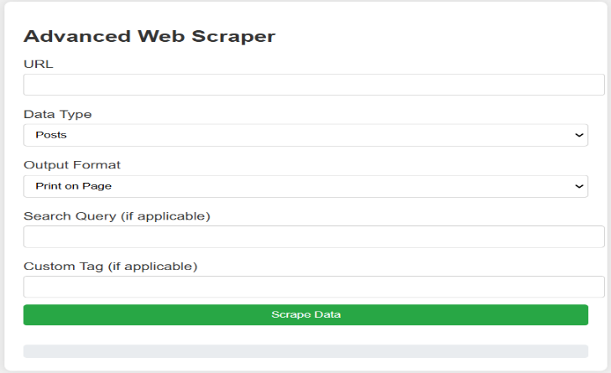

**Fig 2. After execution, it prompts for the URL.**

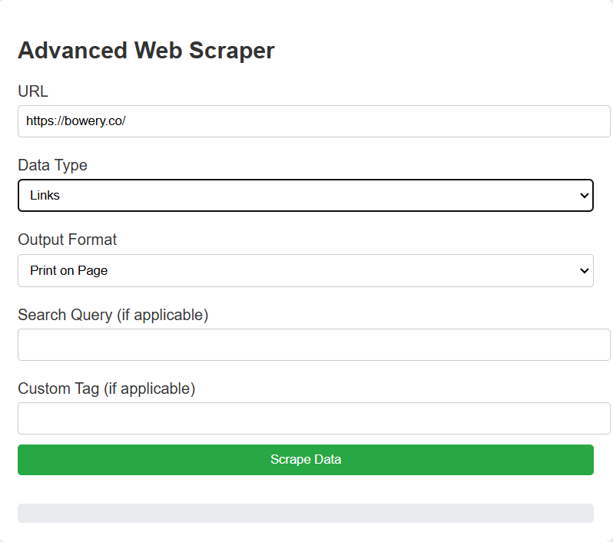

**Fig 3. After scanning the URL of a website, it prompts to select the type of information you want to retrieve.**

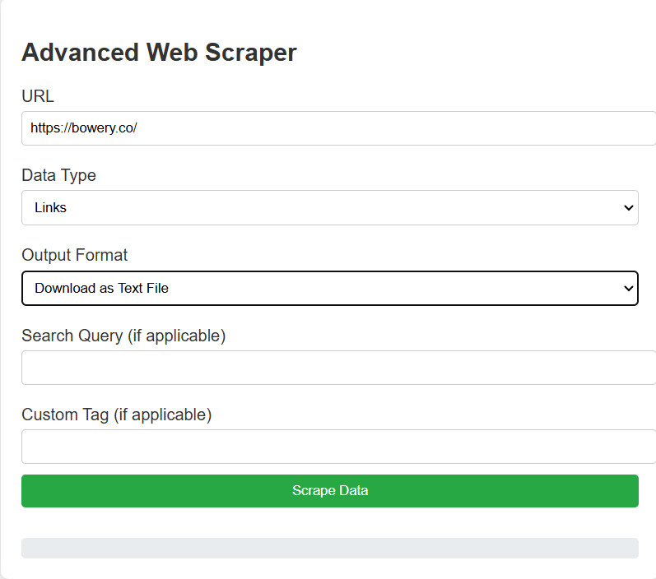

**Fig 4. If we choose 'links,' it scans the website and provides details on how many links are present and the information contained within the website**

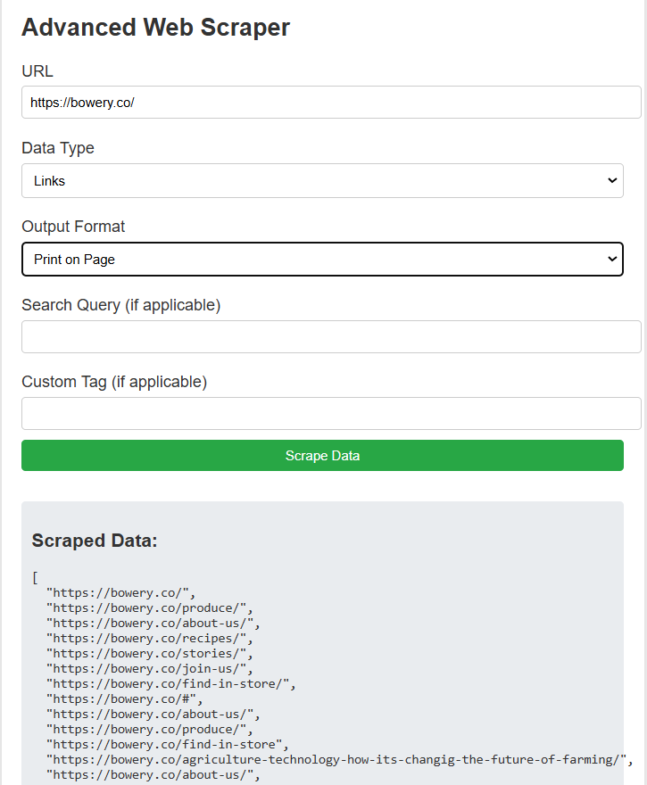

**Fig 5. In the end, it provides a convenient and simple method to save the results in multiple formats.**

# VI.CONCLUSION

The Advanced Web Scraper project effectively demonstrates the capabilities of modern web scraping techniques using Python and the Playwright library for browser automation. By enabling users to extract diverse types of data from web pages, including paragraphs, links, all text content, and specific elements through search queries or custom tags, the scraper caters to a wide range of web scraping needs.

Overall, this project not only serves as a practical tool for data extraction but also serves as an educational resource for understanding the principles of web scraping and automation. The use of asynchronous programming with asyncio enhances its efficiency, making it suitable for scraping large volumes of data or processing multiple requests concurrently.

# VII.FUTURE SCOPE

# Future enhancements could include the integration of advanced data processing features, support for more complex web applications (e.g., handling dynamic content, login authentication), and the incorporation of scraping ethics to respect the terms of service of websites.

# This project lays a strong foundation for anyone interested in web scraping and data collection, illustrating the potential for automating information retrieval in a rapidly evolving digital landscape.

Adding functionality to visualize the extracted data (e.g., through charts and graphs) would enable users to gain insights quickly. This could be achieved by integrating with libraries such as Matplotlib or Plotly.

# VIII.REFERENCE

1. “Web Scraping with Python: Collecting Data from the Modern Web” by Ryan Mitchell. This book provides a comprehensive guide to web scraping techniques using Python, including working with APIs, handling JavaScript, and storing data.
2. “Python Web Scraping Cookbook" by Michael Heydt. A collection of recipes for web scraping in Python, covering various techniques and libraries, including BeautifulSoup and Scrapy.
3. “Automate the Boring Stuff with Python" by Al Sweigart. This book includes sections on web scraping and automating web tasks, providing practical examples and exercises.
4. PlaywrightDocumentation:
   1. The official documentation for Playwright, detailing its features, installation, and usage examples for web scraping and browser automation.
5. Beautiful Soup Documentation: A library used for parsing HTML and XML documents. While the project uses Playwright, Beautiful Soup is another popular choice for web scraping in Python.
6. Real Python: Web Scraping with Playwright: Real Python Tutorial: A detailed guide on using Playwright for web scraping, covering setup, navigation, and data extraction.
7. ScrapingBee Blog on Web Scraping Best Practices: ScrapingBee An article discussing best practices for web scraping, including ethical considerations and technical tips. Towards Data Science: Web Scraping in Python: Towards Data Science Article
8. Stack Overflow: Stack Overflow
   1. mA great resource for troubleshooting and getting support for specific issues related to web scraping, Python, and Playwright.
9. "Web Scraping with Python: Collecting Data from the Modern Web" by Ryan Mitchel A detailed exploration of web scraping using Python, covering topics like scraping data from JavaScript-heavy sites and ethical considerations.
10. "Web Scraping with Python and Beautiful Soup" by Chris Albon A concise guide focusing on web scraping using the Beautiful Soup library, with practical examples and applications.
11. "Python Web Scraping" by Katharine Jarmul and Richard Lawson This book provides insights into scraping techniques and data handling, including advanced topics like working with APIs and web services.
12. Towards Data Science: Building a Web Scraper with Playwright: Towards Data Science Article. A tutorial that walks through building a web scraper using Playwright, including installation, setup, and code examples.
13. Scraping Multiple Pages with Playwright: ScrapingBee. This article discusses how to scrape multiple pages efficiently using Playwright, along with code snippets and practical tips.
14. DataCamp: Web Scraping in Python: DataCamp Course An interactive course focused on web scraping techniques using Python, including Beautiful Soup and Requests.
15. Reddit: r/webscraping: Web Scraping Subreddit A community of web scraping enthusiasts where users share their experiences, tips, and challenges related to scraping projects.
16. "Ethical and Legal Aspects of Web Scraping”: Research that discusses the ethical considerations and legal challenges associated with web scraping practices, useful for guiding responsible scraping behavior.