**SPARK: Smart Personal Assistant for Resourceful Knowledge Department of Cyber Security**

**Malla Reddy University, Hyderabad Maisammaguda, Dulapally, Hyderabad, 500100, Telangana, India**

N. Bala Suresh School of Engineering

Malla Reddy University Hyderabad, India

2[111cs040018@mallareddyuniversity.ac.in](mailto:2111cs040018@mallareddyuniversity.ac.in)

T.Koushik

School of Engineering Malla Reddy University Hyderabad, India

2[111cs040048@mallareddyuniversity.ac.in](mailto:2111cs040048@mallareddyuniversity.ac.in)

CH.Anurag

School of Engineering Malla Reddy University Hyderabad, India

2[111cs040011@mallareddyuniversity.ac.in](mailto:2111cs040011@mallareddyuniversity.ac.in)

Dr.Ome Nerella School of Engineering

Malla Reddy University Hyderabad, India

omenerella@gmail.com

Abstract

SPARK (Smart Personal Assistant for Resourceful Knowledge) is a dynamic AI- driven assistant designed to streamline daily tasks with intelligent voice commands. Developed in Python SPARK utilizes libraries like pyttsx3 for text-to-speech, speech_recognition for interpreting commands and smtplib for email automation. It performs productivity functions, including sending emails, conducting web searches, delivering real-time information, and interacting with WhatsApp, with added security prompts for message confirmation. SPARK also features intuitive natural language processing for user-friendly interactions.

Beyond productivity, it offers entertainment

and utility features such as joke-telling, note management, coin flips, dice rolls, and system monitoring.

Advanced capabilities like real-time translation, Wikipedia queries, and media control make SPARK a comprehensive virtual assistant tailored for diverse user needs.

# Keywords

AI Virtual Assistant

Voice Command Processing Python Automation

Natural Language Processing Productivity Automation Speech Recognition

Text-to-Speech (TTS)

-Email Automation

Real-Time Information Retrieval WhatsApp Integration

System Performance Monitoring Utility and Entertainment Features Real-Time Translation

Media Control

-Smart Personal Assistant

# Literature review

1. A Virtual Personal Assistant (VPA) or Intelligent Virtual Assistant (IVA) responds to user commands or inquiries, offering services like managing emails, calendars, and home automation. VPAs can communicate through text or speech, using speech recognition systems (ASR) for voice commands. They are a key application of artificial intelligence, enabling users to delegate tasks and interact with software through tools like Python and text-to-speech technology (Manojkumar, 2023)
2. Jarvis is a Python programming companion that automatically detects code changes and executes functions upon saving. It displays exceptions in an error panel and debugging statements in a debug panel. Using OpenSceneGraph Python bindings, Jarvis also visualizes 3D scenes in real-time. Inspired by Bret Victor's "Inventing on Principle," Jarvis aims to shorten the feedback loop in programming for faster iteration and immediate code results. (Rani, 2023)
3. JARVIS is an AI personal assistant that uses natural language processing and machine learning to simplify tasks for individuals and businesses. Inspired by the Marvel character, JARVIS integrates with social media, messaging apps, and productivity tools, centralizing task management. It adapts to user habits, handling tasks like reminders, appointments, emails, and smart home controls. JARVIS is flexible, integrating with third-party APIs to meet specific needs. (Gorade, 2023)
4. An AI-based virtual assistant designed to reduce workload, allowing users to execute commands through voice activation on a Windows system. It helps manage tasks efficiently without using keyboard or mouse, enabling multitasking. (N, 2023)

# Existing system

Today’s famous virtual assistants—along with Amazon Alexa, Google Assistant, Apple Siri, and Microsoft Cortana—are used for voice- activated obligations like scheduling, sending messages, and retrieving actual-time facts. These assistants offer productivity tools and home automation aid, but they have got barriers that SPARK seeks to cope with.

One foremost predicament is internet dependence; most assistants rely on cloud offerings, making offline usage difficult. Additionally, those structures are often platform-specific: Siri is tied to Apple gadgets, Alexa to Amazon, or even Cortana, though first of all Windows-centric, is not actively developed for the platform. This limits

accessibility for users throughout different structures.Customization options are also restrained in these assistants, as they're largely proprietary. Entertainment and application functions, inclusive of system performance monitoring, are minimum, at the same time as interactive elements (e.G., coin flips, jokes) are typically absent.SPARK counters those boundaries by using supplying strong offline capability, Windows compatibility, and Python-primarily based customizability. It includes unique features, inclusive of CPU and reminiscence tracking, real-time translation, and enjoyment alternatives, making it a bendy and person-focused alternative to existing assistants

# Proposed System

SPARK distinguishes itself from mainstream virtual assistants like Siri, Alexa, and Cortana by its unique combination of customizability, modular design, and functionality. Unlike proprietary systems that are typically locked into a specific ecosystem (such as Siri with Apple devices or Cortana with Windows), SPARK is built with open source Python libraries, which evolve to platforms This open approach ensures that SPARK is only for specific projects -It is not restricted in the system, allowing flexibility for users who need cross-platform support.

One of the unique features of the SPARK is its superior fit. The modular architecture allows developers or users to modify or add additional functionality, tailoring the assistant to their specific needs. This is in contrast to many mainstream assistants, which offer few optional options and often require users to work within the constraints of a proprietary system

In addition to standard productivity tasks such as sending emails, performing web searches and generating real-time reports, SPARK offers a number of new features rarely found in traditional assistants such as including system management tools that provide them with a users monitor CPU and memory usage can, which gives them insights into how their machines are performing.

SPARK also integrates and values multilingual users with real-time translation capabilities, providing smooth communication without the need for external translation tools

By combining advanced features— customizability, system monitoring, real-time translation, and entertainment tools— SPARK offers a more holistic solution. It stands apart from other virtual assistants that tend to focus mainly on basic productivity or limited device control, making SPARK a more versatile, user-centric assistant that can cater to a wider variety of tasks and preferences

# Results

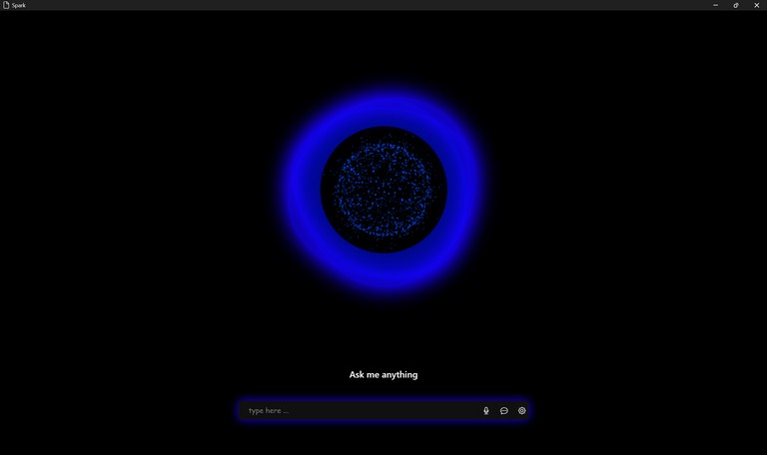

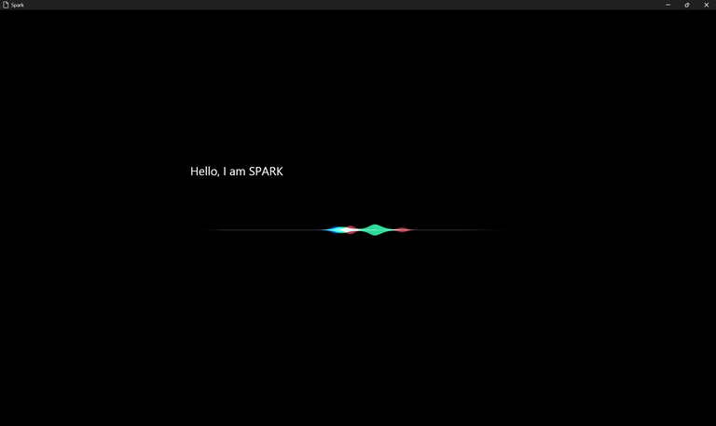

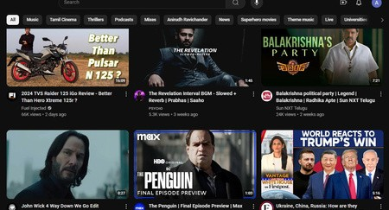

**Conclusion & Future Scope**

SPARK (Smart Personal Assistant for Resourceful Knowledge) is a versatile and capable AI assistant designed to meet the needs of different users. It stands out among existing virtual assistants by offering a rich combination of high customization, offline functionality, productivity, functionality, and entertainment features Offered Built with an open-source Python library, SPARK delivers flexibility and flexibility to System performance monitoring, real-time translation By integrating features such as , and communication tools, SPARK increases productivity and user engagement, positioning itself as a unique and valuable solution in the virtual assistant space

Spark has significant future growth and expansion. Future improvements could include:

Cross-Platform Extensibility: While currently optimized for Windows, SPARK can be extended to support other platforms such as macOS and Linux, extending its functionality

Integrating more services: Adding support for more third-party applications (e.g., project management tools, social media platforms, etc.) can enhance SPARK usability and make it more comprehensive text

Advanced AI and Machine Learning: Combining highly advanced machine learning algorithms for personalized interactions, intelligent recommendations and a better understanding of context will improve the user experience over time

Voice Customization: The ability for users to customize SPARK’s voice can make interactions more engaging and personalized. Extended Natural Language Processing (NLP): Becomes more flexible and efficient by enhancing SPARK’s NLP capabilities to process complex commands and multi-step programs

Smart home integration: By adding IoT support, SPARK can expand its role as a smart home assistant, controlling lights, thermostats, security systems, and other connected devices.

# Refernces

[https://www.ijraset.com/best-journal/ai-based-](https://www.ijraset.com/best-journal/ai-based-virtual-assistant-using-python-a-systematic-review) [virtual-assistant-using-python-a-systematic-](https://www.ijraset.com/best-journal/ai-based-virtual-assistant-using-python-a-systematic-review) [review](https://www.ijraset.com/best-journal/ai-based-virtual-assistant-using-python-a-systematic-review)

[https://ijtre.com/wp-](https://ijtre.com/wp-content/uploads/2023/05/20231009010.pdf) [content/uploads/2023/05/20231009010.pdf](https://ijtre.com/wp-content/uploads/2023/05/20231009010.pdf)

[https://ijrpr.com/uploads/V4ISSUE12/IJRP](https://ijrpr.com/uploads/V4ISSUE12/IJRPR20157.pdf) [R20157.pdf](https://ijrpr.com/uploads/V4ISSUE12/IJRPR20157.pdf)

[https://ijrpr.com/uploads/V4ISSUE12/IJRPR](https://ijrpr.com/uploads/V4ISSUE12/IJRPR20157.pdf) [20157.pdf](https://ijrpr.com/uploads/V4ISSUE12/IJRPR20157.pdf)