#### UNVEILING CUSTOMER OPINIONS: SENTIMENT ANALYSIS ON AMAZON REVIEW DATA

A report submitted in partial fulfillment of the requirements for the Degree of

**Bachelor of Technology**

In

Computer Science & Engineering (Cyber Security)

by

N.Prashanth – 2111CS040075

M.Rakesh Babu – 2111CS040079

N.Pranava Kumar – 2111CS040073

Under the esteemed guidance of

**Dr.M.V.N.Srujan Manohar Associate Professor CSE(Cyber Security)**



**Department of Computer Science & Engineering (Cyber Security) School of Engineering**

# MALLA REDDY UNIVERSITY

Maisammaguda, Dulapally, Hyderabad, Telangana 500100

### 2024



**Department of Computer Science & Engineering (Cyber Security)**

#### CERTIFICATE

This is to certify that this is the project report entitled **“UNVEILING CUSTOMER OPINIONS: SENTIMENT ANALYSIS ON AMAZON REVIEW DATA”**

**submitted by N.Prashanth (2111CS040075) M.Rakesh Babu (2111CS040079) N.Pranava Kumar (2111CS040073)** towards the fulfilment for the award of **Bachelor’s Degree in Cyber security** from the **Department of Computer Science & Engineering (Cyber Security), Malla Reddy University,** Hyderabad, is a record of bonafide work done by N.Prashanth, M.Rakesh Babu, N.Pranava Kumar. The results embodied in this report have not been submitted to any other university or institute for the award of any degree or diploma.

Internal Guide Head of the department

Dr.M.V.N.Srujan Manohar Dr.G.Anand Kumar Associate Professor CSE(Cyber Security & IOT)

CSE(Cyber Security & IOT)

**External Examiner**

#### DECLARATION

We hereby declare that the project report **“UNVEILING CUSTOMER OPINIONS: SENTIMENT ANALYSIS ON AMAZON REVIEW DATA”,** has been carried out by us and this work has been submitted to the Department of Computer Science Engineering (Cyber Security) , Malla Reddy University, Hyderabad in fulfilment of the requirements for the award of degree of Bachelor of Technology .We further declare that this project work has not been submitted in full or part for the award of any other degree in any othereducational institutions.

Place:

Date:

N.Prashanth 2111CS040075

M.Rakesh Babu 2111CS040079

N.Pranava Kumar 2111CS040073

#### ACKNOWLEDGEMENT

We extend our sincere gratitude to all those who have contributed to the completion of this project report. Firstly, we would like to extend our gratitude to **Dr. V. S. K Reddy, Vice- Chancellor,** for his visionary leadership and unwavering commitment to academic excellence.

We would also like to express my deepest appreciation to our project guide **Dr. G. Anand Kumar**, **Head of the Department** whose invaluable guidance, insightful feedback, and unwavering support have been instrumental throughout the course of this project for successful outcomes.

We extend our gratitude to our **PRC – convenor**, **Dr. G. Latha,** for giving valuable inputs and timely guidelines to improve the quality of our project through a critical review process. We thank our project coordinator, **Mrs. Geetha Yadav**, for her timely support.

We are also grateful to **Dr. G. Anand Kumar**, **Head of the Department** of Cyber Security, for providing us with the necessary resources and facilities to carry out this project.

We would like to thank **Dr. Harikrishna Kamatham, Dean, School of Engineering**, for his encouragement and support throughout my academic pursuit.

We are deeply indebted to all of them for their support, encouragement, and guidance, without which this project would not have been possible.

N.Prashanth 2111CS040075

M.Rakesh Babu 2111CS040079

N.Pranava Kumar 2111CS040073

### ABSTRACT

.

Everyday we come across various products in our lives, on the digital medium we swipe across hundreds of product choices under one category. It will be tedious for the customer to make selection. Here comes 'reviews' where customers who have already got that product leave a rating after using them and brief their experience by giving reviews. As we know ratings can be easily sorted and judged whether a product is good or bad. But when it comes to sentence reviews we need to read through every line to make sure the review conveys a positive or negative sense. In the era of artificial intelligence, things like that have got easy with the Natural Langauge Processing(NLP) technology.

Following are the modules we are going to work on

1. Optimization Approach
2. Logical Thinking Algorithms
3. Decision Making Models while reviewing feedback data

|  |  |
| --- | --- |
| **List of figures:** |  |
| Figure 3.3.1 Complete Architecture | 12 |
| Figure 3.3.2 Data Flow Diagram | 14 |
| Figure 3.3.3 Class Diagram | 15 |
| Figure 3.3.4 Use case Diagram | 18 |
| Figure 3.3.5 Sequence Diagram | 20 |
| Figure 3.3.6 Activity Diagram | 21 |

#### INDEX

|  |  |
| --- | --- |
| **CONTENTS** | **Page No** |
| **Chapter 1 Introduction** | 1-3 |
| 1.1 Problem Definition & Description | 1 |
| 1.2 Objectives of the Project | 2 |
| 1.3 Scope of the Project | 3 |
| **Chapter 2 SystemAnalysis** | 4-9 |
| 2.1 Existing System | 4 |
| 2.1.1 Background &Literature Survey | 4-5 |
| 2.1.2 Limitations of Existing System | 5-6 |
| 2.2 Proposed System | 6-7 |
| 2.2.1 Advantages of proposed system | 7 |
| 2.3 Software & Hardware Requirements | 8 |
| 2.3.1 Software Requirements | 8 |
| 2.3.2 Hardware Requirements | 8 |
| 2.4 Feasibility Study | 8 |
| 2.4.1Technical Feasibility | 8 |
| 2.4.2 Robustness & Reliability | 8 |
| 2.4.3 Economic Feasibility | 9 |

|  |  |
| --- | --- |
| **Chapter 3 Architectural Design** | 10-21 |
| 3.1 Modules Design | 10-11 |
| 3.1.1 Review Sentiment Analysis Model | 10 |
| 3.1.2 Duplicate Review Detection | 10 |
| 3.1.3 Positive Review Promotion Analysis | 10 |
| 3.2 Methods & Algorithms | 11 |
| 3.3 Project Architecture | 12-21 |
| 3.3.1 Architectural diagram | 12-15 |
| 3.3.2 Data Flow diagram | 16 |
| 3.3.3 Class Diagram | 17-18 |
| 3.3.4 Use case Diagram | 19-20 |
| 3.3.5 Sequence Diagram | 21 |
| 3.3.6 Activity Diagram | 21 |

|  |  |
| --- | --- |
| **Chapter 4 Implementation & Testing** | 22-37 |
| * 1. Coding Blocks      1. Code Block 1      2. Code Block 2 | 22-31  22-24  22-31 |
| 4.2 Sample Code | 31-34 |
| 4.3 Execution Flow | 34-37 |

|  |  |
| --- | --- |
| **Chapter 5 Results** | 38-39 |

* 1. Resulting Screens
     1. Login Page
     2. Review Page
     3. Review Page

38-39

38

38

39

|  |  |
| --- | --- |
| 5.4 Result Analysis | 40-43 |
| 5.4.1 Time Complexity | 40 |
| 5.4.2 Space Complexity | 41 |
| 5.4.3 Results Summary | 43 |
| **Chapter 6. Conclusions & Future Scope** | 44-46 |
| 6.1 Conclusion | 44 |
| 6.2 Future Scope | 45-46 |
| Bibliography | 47-48 |
| Paper Publication | 49-54 |

Poster 55

# CHAPTER - 1

#### INTRODUCTION

Online reviews are essential in today's digital age. Role in shaping and influencing customer opinions purchasing decision Platforms like Amazon Host Offers millions of user-generated product reviews. Lots of insights into the consumer experience at Etani. Reviews don't just act as a feedback mechanism. sellers, but also serves as a decision-making tool for Potential buyers However, with the huge amount of data generated It is impossible to carry out manual analysis often and All reviews are annotated to draw actionable insights. A subfield of natural language is sentiment analysis. Processing (NLP) provides automated solutions. The process of classifying reviews based on these sentiments Both positive, negative and neutral. Using sentiment analysis techniques with Amazon Review: Businesses can measure results quickly and efficiently. customer satisfaction Identifying product weaknesses and improve marketing strategies The purpose of this study was to analyze feelings. Amazon examines data to reveal trends, analyze... Spread the mood and find customers Response to different types of products The goal is to provide the best for the business. Understand and identify customer opinions Opportunities to improve product offerings and Customer service .

##### Problem Definition & Description

The project *Unveiling Customer Opinions: Sentiment Analysis on Amazon Review Data* aims to derive meaningful insights from customer feedback through a series of targeted analytical modules. The first module, **Review Sentiment Analysis Model**, focuses on developing a robust machine learning solution to categorize customer reviews as positive or negative, providing valuable sentiment classification. This involves leveraging a labeled dataset of product reviews, employing text preprocessing techniques, and deploying models like logistic regression or Naive Bayes for classification.

The second module, **Duplicate Review Detection**, addresses the issue of repetitive or spammed reviews by identifying potential duplicates based on user IDs, timestamps, or content similarity. This step ensures the reliability and authenticity of analyzed data.

Lastly, the **Positive Review Promotion Analysis** module evaluates positive feedback to highlight products with high customer satisfaction, supporting targeted marketing efforts and improving user experience. Combined, these modules offer a comprehensive approach to understanding and leveraging customer opinions on Amazon's vast product ecosystem.

##### Objectives of the Project

The objective of the *Unveiling Customer Opinions: Sentiment Analysis on Amazon Review Data* project is to enhance decision-making capabilities for businesses and improve customer engagement by effectively analyzing and leveraging customer review data from Amazon. The project seeks to accomplish this through three key objectives.

First, it aims to build a **Review Sentiment Analysis Model** that classifies customer reviews as positive or negative using machine learning algorithms, providing a structured and scalable method to assess overall customer sentiment. Second, it focuses on the **Duplicate Review Detection** module to identify potential spam or duplicate reviews, thereby maintaining data authenticity and reducing bias in sentiment evaluation.

This ensures that customer feedback used for analysis reflects genuine user opinions. Finally, the project aspires to promote informed decision-making through the **Positive Review Promotion Analysis** module, which identifies and highlights top-performing products based on positive feedback.

By analyzing positive reviews, this module seeks to assist businesses in focusing their promotional efforts on highly-rated products, ultimately fostering a better customer experience and enhancing product visibility. Collectively, the project's objectives emphasize data-driven insights for understanding and amplifying customer sentiment on a large scale.

* 1. **Scope of the Project**

The scope of the *Unveiling Customer Opinions: Sentiment Analysis on Amazon Review Data* project encompasses the comprehensive analysis of customer reviews to provide actionable insights for businesses and enhance customer engagement. It involves building a **Review Sentiment Analysis Model** to classify reviews as positive or negative, ensuring a structured approach to understanding customer sentiment. The project also includes **Duplicate Review Detection** to identify and mitigate the impact of spam or duplicate feedback, preserving data quality. Furthermore, it extends to **Positive Review Promotion Analysis**, which highlights high-performing products based on positive reviews. Together, these modules aim to empower businesses with data-driven insights for improving product visibility, marketing strategies, and customer satisfaction.

Determining Goals:

**Accurately Classify Customer Sentiment**: Develop a robust machine learning model capable of categorizing product reviews as positive or negative, offering meaningful sentiment insights to support better business decisions and improve customer interactions.

**Detect and Mitigate Duplicate Reviews** : Create an effective mechanism for identifying and removing duplicate or spam reviews using data points like user IDs and timestamps, thereby enhancing data quality and reliability in sentiment analysis.

**Promote High-Performing Products**: Leverage positive review analysis to identify and promote products with strong customer feedback, aiding businesses in targeting marketing efforts.

**Streamline Data Processing**: Implement efficient data preprocessing and analytical methodologies to handle large datasets of Amazon reviews, ensuring scalability, performance, and effective model training and evaluation.

**Drive Data-Driven Business Insights**: Deliver actionable insights through comprehensive analysis of customer opinions, enabling businesses to refine their offerings, improve customer satisfaction, and drive sales growth based on review data.

Data & Constrains:

* The project will utilize a dataset of Amazon product reviews, which may include textual review content, user ratings, timestamps, and user IDs. This dataset will be preprocessed to handle noise, missing data, and irrelevant text, ensuring a clean input for model training and analysis.
* The scalability of the sentiment analysis model may be limited by the size of the dataset and computational resources, requiring optimization techniques and potentially careful feature selection to maintain efficient processing and accurate results..

Workflow Management Strategies:

* **Modular Approach to Development**: Break down the project into distinct modules—Review Sentiment Analysis, Duplicate Review Detection, and Positive Review Promotion Analysis— and assign dedicated phases for each. This modular approach allows for focused development, testing, and integration while enabling parallel progress on different components when feasible.
* **Agile Iterative Development**: Employ agile methodologies with iterative cycles for development and testing. Regular sprints and reviews will ensure continuous feedback and quick resolution of issues, allowing for incremental improvements to models, algorithms, and overall project performance.
* **Version Control and Collaboration**: Utilize version control systems like Git for managing code changes, collaborating across team members, and maintaining an organized development history. This ensures smooth integration across modules, tracks progress, and helps in resolving conflicts or rollbacks efficiently..

### CHAPTER - 2

#### SYSTEM ANALYSIS

##### Existing System

The current landscape for analyzing Amazon review data typically involves various isolated and limited methods for processing customer feedback. Sentiment analysis is often conducted through basic text-based algorithms or generic machine learning models that may lack domain- specific optimizations, which can lead to inconsistent or less accurate results in terms of customer sentiment classification. While these systems provide a foundation for identifying broad sentiment, they often fail to capture nuances such as sarcasm, context, or complex language usage, thus reducing the overall value and reliability of the insights.

Moreover, duplicate or spam review detection remains a challenging area for many existing systems. Standard approaches may rely on simple heuristic methods like identifying duplicate user IDs or matching review content, but these techniques can be susceptible to inaccuracies, such as failing to detect cleverly disguised spam or accidentally flagging genuine reviews. This limitation can skew data quality, ultimately impacting the accuracy of any sentiment analysis.

Existing systems also generally lack a dedicated mechanism for promoting top-performing products based on positive customer reviews. While some e-commerce platforms may use customer ratings or sales volume to highlight products, they often overlook more comprehensive sentiment analysis that leverages positive feedback trends to guide product promotions. As a result, businesses may miss valuable opportunities to align marketing strategies with genuine customer sentiment, thereby limiting their ability to enhance customer engagement and boost sales. This project aims to overcome these shortcomings by delivering a robust, integrated solution that combines accurate sentiment classification, effective spam detection, and strategic product promotion analysis.

##### Background & Literature Survey

The project *Unveiling Customer Opinions: Sentiment Analysis on Amazon Review Data* aims to derive meaningful insights from customer feedback through a series of targeted analytical modules. The first module, **Review Sentiment Analysis Model**, focuses on developing a robust machine learning solution to categorize customer reviews as positive or negative, providing valuable sentiment classification.

Literature Survey:

The field of emotion analysis has gained importance. Interest in the past decade has been especially relevant in context. Social media sentiment analysis, ecommerce reviews, and news articles Most frequently used techniques Because the classification of emotions can be divided into machines. How to learn and use a dictionary Guidelines Machine learning-based methods rely on supervision. Learning algorithms require labeled datasets. Some of the oldest and most widely used .f training. Models include Naive Bayes, Support Vector Machines, and more. (SVM) and decision trees These models remove features. from word frequency, etc. from text

data The origin of specific sentences and terminal indicators (e.g. positive or negative words) For example, reviews that include phrases like ―exce**l** ent.‖ Quality‖ or would be classified as ―very satisfied‖ Positive while using the word "poor" ―Disappointing‖ is classified as a negative until These models are effective for their rustic feel. Taxonomy They try to understand more… complex language structure Including the pun double Emotions are negative and dependent on context. Recent advances in deep learning have further encouraged this. Recurrent neural networks and other complex models (RNN) Long Short-Term Memory Network (LSTM) and BERT (bidirectional Display of the encoder from the transformer) These models can understand not only individual words, but also individual words. but also the contextual relationships between words in a sentence. In particular, BERT has revolutionized NLP tasks by pre-training on large amounts of data and fine-tuning specific tasks, such as sentiment analysis. This ability to recognize the bi-directional context of language makes BERT

The most accurate model for tasks involving complex language processing. Dictionary-based methods, on the other hand, use pre-defined emotion words to assign emotional values to words in text. For example, positive words like "amazing" or "outstanding" are given a positive score. while negative words such as "terrible" or "worst" also have a negative rating. Dictionary-based models are simpler and faster than machine learning approaches. But it is limited by the coverage of the terminology. And it often fails to capture the spirit of micro-language or domain- specific requirements… In summary, although traditional models such as Naive Bayes and SVM are effective in sentiment analysis, But deep learning models like BERT represent the state of the art in sentiment classification. This study aims to explore the performance of these models on Amazon inspection data to discover the strengths and weaknesses of each approach.

##### Limitations of Existing System

Here are some key limitations of existing systems for analyzing Amazon review data:

* + - 1. **\*\*Inconsistent Sentiment Classification**:** Current systems often struggle to accurately interpret and classify nuanced sentiments in customer reviews, such as sarcasm, context-specific expressions, or mixed sentiments within a single review, resulting in reduced accuracy of sentiment analysis.
      2. **\*\*Lack of Context-Aware Analysis**\*\*: Many systems use basic text processing algorithms that do not adequately capture the meaning behind specific words or phrases, leading to potential misinterpretation of customer sentiment and unreliable insights.
      3. **\*\*Inadequate Spam and Duplicate Detection**:** Existing solutions for identifying duplicate or spam reviews often rely on simple heuristics or rule-based methods that can overlook sophisticated forms of review manipulation, such as slightly varied content or masked identities, reducing the reliability of data.
      4. **\*\*Limited Data Preprocessing Capabilities**:** Preprocessing review data to remove noise, handle missing information, and normalize text often lacks robustness, resulting in data quality issues that can impact model performance and reduce insight accuracy.
      5. **\*\*Absence of Promotion Mechanisms for Positive Reviews**:** Most existing systems do

not have dedicated modules to identify and leverage positive customer feedback for promoting top-performing products, missing an opportunity to enhance marketing strategies and increase customer engagement.

* + - 1. **\*\*Scalability Issues with Large Datasets**:** Handling and analyzing large volumes of Amazon reviews in an efficient manner remains a challenge. Many existing systems struggle with the computational demands required for accurate and timely processing.

##### Proposed System

The proposed system converts customer sentiment data from Amazon ratings into actionable insights through three specialized modules. The first module, Review Sentiment Analysis Model. It focuses on leveraging machine learning models trained in analyzing labeled products to classify user feedback as positive or negative. By processing text data This model can provide real-time insights into customer sentiment. It helps identify strengths and weaknesses in product offerings. Algorithms such as logistic regression or Naive Bayes are considered because they are effective in maintaining text classification rates.

Second module: Duplicate review detection. Addresses the challenge of maintaining data integrity by identifying multiple reviews from the same user. This module aims to avoid biased sentiment analysis caused by spam behavior such as repeated negative reviews. Techniques such as identifying ratings with their respective user IDs are used. or information and time frame for upcoming events It helps ensure that product sentiment scores accurately reflect the views of a wide range of customers.

Finally, the Positive Promotion Analysis module attempts to expand products that have high levels of customer satisfaction. By rating positive reviews This module helps identify and promote high-performing products. This may increase sales and improve brand awareness. This element can offer insights for targeted promotional and marketing strategies. To maximize the impact of customer satisfaction

* + 1. **Advantages:**
* **Early customer insights:** The sentiment analysis module provides a comprehensive understanding of customer sentiment. Helping companies Respond effectively to feedback and customize products to meet customer needs
* **Faster data integrity:** to detect and filter duplicate ratings The system guarantees accurate sentiment analysis. and are less likely to suffer distortions caused by spam or manipulation**.**
* **Increased product visibility:** Promoting positive reviews helps highlight and market products that consistently gain customer feedback, increase sales, and improve brand image.
* **Effective Decision Making:** With insights into sentiment analysis and duplicate detection, companies can make more informed decisions about better products. Better customer service and promotional strategies
* Scalability and adaptability: The modular approach allows for flexible expansion or modification of individual components. This allows the system to adapt to future needs and advances in data analysis technology.

##### Software & Hardware Requirements

###### Softwar e Require me nts:

* + - 1. Operating System: The system should be compatible with Windows, macOS, Linux, or other
      2. Unix-like operating systems, depending on the deployment environment.
      3. Web Server: A web server like Apache or Nginx is required for hosting the sentiment analysis application and serving the user interface for displaying reports and visualizations.
      4. Database Management System: A relational database such as MySQL or PostgreSQL is recommended for efficiently managing structured review data, sentiment scores, and configuration settings. Alternatively, MongoDB or another NoSQL database can be used for handling unstructured or semi-structured data.
      5. Programming Languages: The application can be developed using programming languages like Python (for implementing NLP models and machine learning algorithms), JavaScript (for frontend and visualizations), and Java (for backend services and integration with databases).
      6. NLP Libraries: Tools such as NLTK, spaCy, or Transformers (for implementing models like BERT) will be necessary for sentiment analysis and text processing.
      7. Security Tools: The system should include encryption libraries to protect data, and security tools such as vulnerability scanners and penetration testing tools to ensure the system is safeguarded from external threats during data collection and analysis.

###### Hardware Requirements:

* + - 1. Processor: A multi-core processor with sufficient processing power (e.g., Intel i5 or higher, AMD Ryzen series) to efficiently handle the real-time processing of large datasets and run machine learning models for sentiment analysis.
      2. Memory (RAM): At least 8GB of RAM is recommended to support high-performance tasks such as natural language processing (NLP) and running multiple algorithms simultaneously. Higher amounts (16GB or more) are ideal for faster performance and handling large-scale datasets.
      3. Storage: Adequate disk space (at least 500GB) for storing review data, logs, machine learning models, and processed results. If working with big datasets, SSDs are recommended for faster data access.
      4. Network: A stable and high-speed internet connection is necessary for accessing online resources, pulling real-time Amazon reviews, and deploying the system in a cloud environment for data processing and sentiment analysis.

##### Feasibility Study

###### Technical Feasibility:

The project Unveiling Customer Opinions: Sentiment Analysis on Amazon Review Data is technically feasible due to the availability of robust machine learning libraries, frameworks, and tools necessary to implement sentiment analysis, duplicate detection, and positive review promotion functionalities. Technologies such as Python, scikit-learn, and natural language processing (NLP) libraries like NLTK or spaCy can be leveraged for text processing, classification, and data management. Additionally, cloud platforms and scalable storage solutions enable processing and analyzing large datasets of Amazon reviews, ensuring computational efficiency. The use of established techniques such as logistic regression, Naive Bayes classifiers, and deep learning models further reinforces technical viability, while integrating these modules with a Flask-based backend ensures easy deployment and usability.

###### Robustness & Reliability:

The design of this project emphasizes robustness, ensuring the system is resilient to noisy, inconsistent, or large datasets. The sentiment analysis model is built with data preprocessing techniques to handle textual variations, misspellings, and other inconsistencies. Duplicate detection algorithms are designed to effectively filter spam and repetitive feedback without compromising genuine reviews. Additionally, modularity in the project's architecture enhances adaptability and maintainability, making it easy to incorporate new algorithms or datasets as customer behaviors evolve. This robust foundation ensures reliable performance and accurate outputs under varying conditions..

The project is grounded in real-world applicability, addressing pressing needs for businesses relying on customer feedback from platforms like Amazon. By classifying reviews, detecting spam, and highlighting top-performing products, the system delivers practical benefits that can be directly leveraged to enhance customer engagement, streamline marketing strategies, and improve product offerings. Furthermore, the approach of using scalable technologies ensures that the project can handle the real-time demands of large-scale e-commerce platforms.

###### Economic Feasibility:

Economically, the project presents a cost-effective solution to enhance business decision-making using customer review data. The development costs are minimized due to the availability of open-source tools and frameworks, which reduce the need for expensive proprietary software. Additionally, cloud services offer pay-as-you-go models, providing scalability without significant upfront investments. By focusing on customer sentiment and product promotion, the project also presents potential for strong return on investment, as it can lead to improved customer satisfaction, targeted marketing, and increased product sales, outweighing any initial project-costs.

### CHAPTER 3

#### ARCHITECTURAL DESIGN

##### Modules Design

* + 1. **Review Sentiment Analysis Model:**

This module aims to build an intelligent machine learning model that can analyze and categorize Amazon product reviews into positive (good) or negative (bad) sentiments. To achieve this, the process will involve data collection and preprocessing. The dataset will consist of labeled product reviews, where each review is tagged as positive or negative, serving as the basis for training and testing the model. Text preprocessing techniques, such as tokenization, stopword removal, stemming, and lemmatization, will be applied to prepare the review text for modeling. Feature extraction methods like Term Frequency-Inverse Document Frequency (TF-IDF) or word embeddings may be used to transform text data into numerical vectors for input into machine learning algorithms. Algorithms such as logistic regression or Naive Bayes classifiers will be trained to predict sentiment labels based on input text. This module will also involve evaluating the model's performance using metrics like accuracy, precision, recall, and F1-score to ensure its effectiveness in correctly identifying customer sentiment.

##### Duplicate Review Detection:

The purpose of this module is to identify multiple, potentially manipulative reviews submitted by the same user, particularly those intended to spam negative feedback. This module ensures data integrity by filtering out redundant or spam reviews that can skew sentiment analysis results. The detection process will involve using unique user IDs to track and identify reviews submitted by the same user across different timestamps. Furthermore, algorithms will analyze review content similarity, considering factors such as identical text or subtle variations, combined with identical or very close timestamps. By focusing on identifying patterns and similarities across reviews, this module aims to filter out redundant reviews while preserving genuine feedback, thus enhancing data quality and reliability. Advanced techniques such as content similarity checks or clustering algorithms may also be used to detect reviews that are semantically similar despite minor textual differences.

##### Positive Review Promotion Analysis:

Positive reviews are indicative of customer satisfaction and can be leveraged to highlight top- performing products for marketing and promotional strategies. The analysis will involve assigning scores or weights to positive reviews based on factors like review length, sentiment strength, and user credibility (e.g., verified purchases). These scores can be aggregated to rank products based on the extent and quality of positive feedback they receive. The module may also incorporate additional analyses, such as identifying key phrases or sentiments mentioned in positive reviews, to further inform promotional efforts. By highlighting products that consistently receive positive customer feedback, businesses can enhance their marketing strategies, promote customer trust, and improve product visibility, ultimately driving customers.

##### Method & Algorithm design:

Methods & Algorithms:

The Unveiling Customer Opinions: Sentiment Analysis on Amazon Review Data project employs a range of methods and algorithms across its three modules to deliver robust and accurate analysis of customer reviews. Below is a detailed explanation of the methods and algorithms used:

Text Preprocessing Techniques:

* **Tokenization**: Splitting reviews into individual words or tokens for further analysis. Stopword Removal: Removing common words that do not contribute significantly to sentiment, such as "the" or "is."
* **Stemming and Lemmatization**: Reducing words to their base or root forms (e.g., "running" becomes "run") to ensure uniformity**.**
* **Lowercasing:** Converting text to lowercase to maintain consistency.
* Feature Extraction and Transformation:
* **Bag-of-Words (BoW**): Creating a sparse matrix of word frequencies across all reviews to represent text data.
* **Term Frequency-Inverse Document Frequency (TF-IDF**): Assigning weights to words based on their frequency in a specific review relative to their occurrence in the entire dataset. This emphasizes unique words that carry sentiment meaning**.**
* **Word Embeddings (Optional):** Using pre-trained models like Word2Vec or GloVe to capture semantic relationships between words for more context-aware modeling.

Machine Learning Algorithms for Sentiment Analysis:

* **Logistic Regression**: A linear model used to predict the probability of a review being positive or negative, based on input features derived from text data.
* **Naive Bayes Classifier:** A probabilistic model commonly used in text classification tasks due to its simplicity and effectiveness with high-dimensional data. It assumes independence between input features, making it fast and scalable.
* **Support Vector Machines (SVM):** An optional algorithm that can be used for sentiment classification due to its effectiveness in finding optimal decision boundaries.
* **Deep Learning Models (Optional):** Neural networks such as LSTM (Long Short-Term Memory) or CNNs (Convolutional Neural Networks) can be explored for advanced text analysis and context-aware sentiment classification**.**
* Duplicate Review Detection Methods:
* **User ID and Timestamp Analysis**: Identifying reviews from the same user based on unique user IDs and timestamps, flagging duplicates or potential spam.
* **Content Similarity Detection:** Calculating similarities between reviews using techniques such as cosine similarity or Jaccard index to detect duplicate content or near- duplicate reviews.
* **Clustering Algorithms (Optional):** Grouping similar reviews into clusters to identify patterns of redundancy, especially useful in large datasets.
* Positive Review Promotion Analysis Methods:
* **Sentiment Scoring and Weighting:** Assigning scores to positive reviews based on sentiment strength, length, and other metrics to rank top-performing products**.**
* **Aggregated Ranking Mechanism:** Summing or averaging scores to identify products

##### Project Architecture:

* + 1. **Architectural Diagram:**

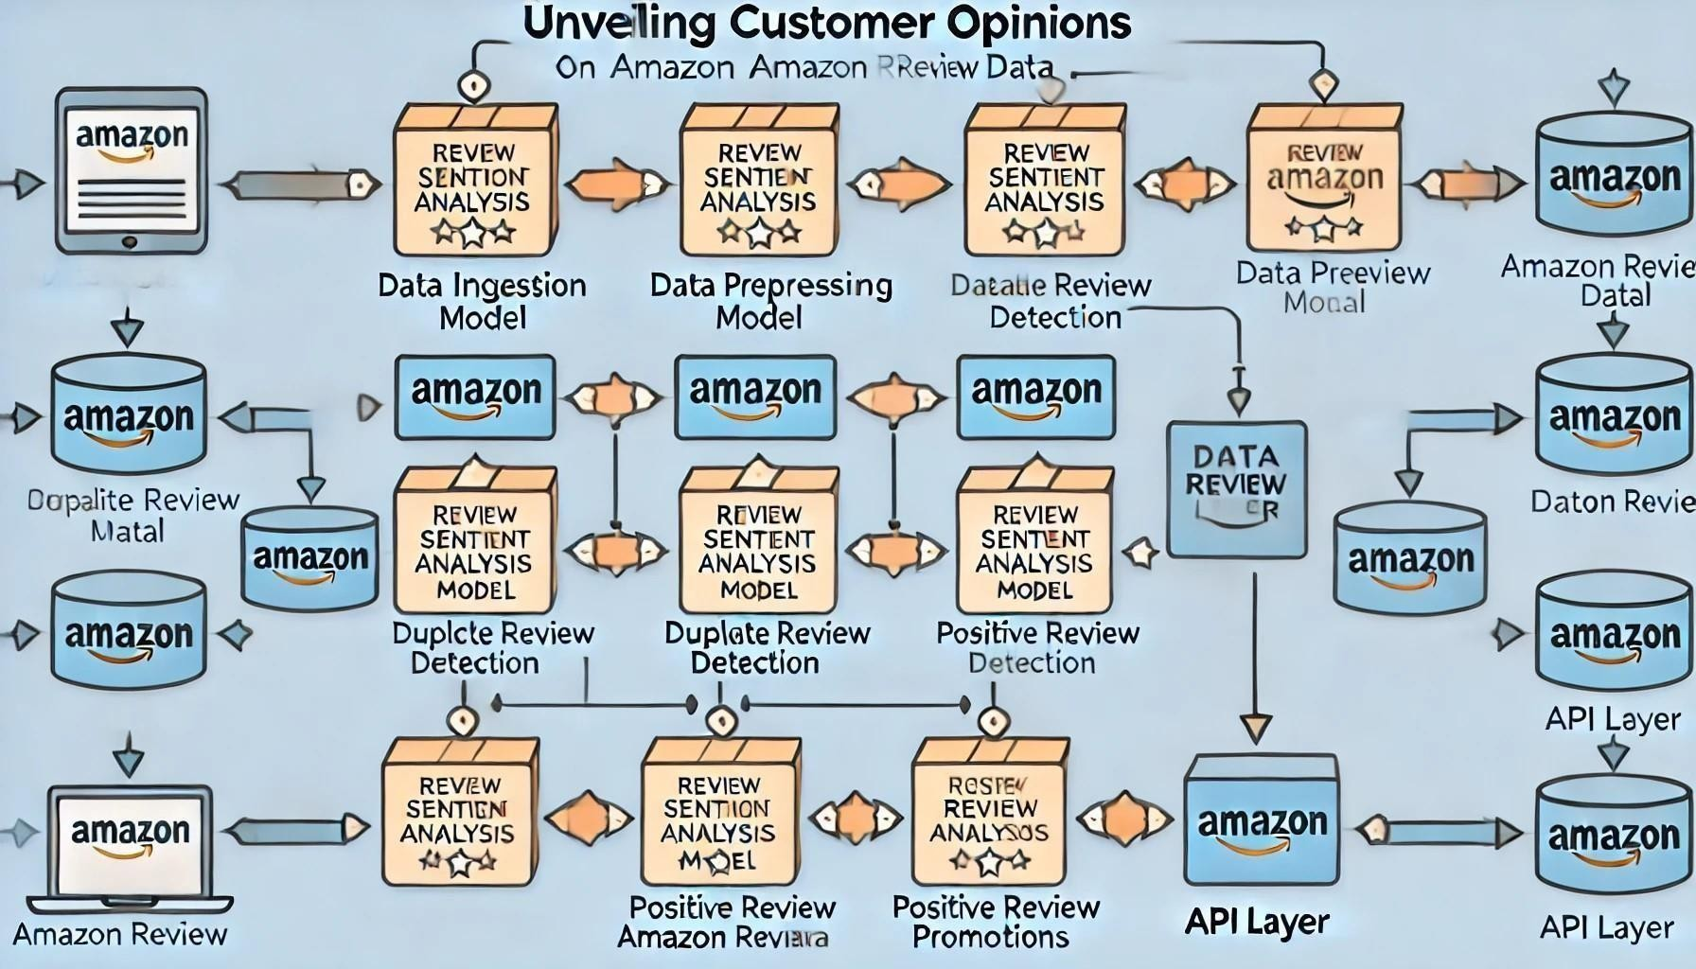

Fig 3.3.1 Architecture Diagram

This flow chart illustrates the architecture of a sentiment analysis project titled ―Unveiling Customer Opinions: Sentiment Analysis on Amazon Review Data.‖ The system begins with the

**Data Ingestion** phase, where Amazon review data—including text, user IDs, ratings, and timestamps—is collected and fed into the pipeline.

In the **Data Preprocessing** stage, reviews undergo cleaning and tokenization, removing unnecessary elements like stop words and punctuation. This step also normalizes data for duplicate detection. The data is then distributed to three main processing modules:

1. **Review Sentiment Analysis Model**: This module applies machine learning algorithms, such as logistic regression or Naive Bayes, to classify reviews as positive or negative. It uses features generated from text data to predict sentiment labels.
2. **Duplicate Review Detection**: This module identifies and flags duplicate reviews, especially those that may indicate spam, by analyzing user IDs and timestamps. It ensures data accuracy by detecting repetitive reviews from the same user.
3. **Positive Review Promotion Analysis**: This module focuses on aggregating and scoring positive reviews to identify top-performing products. It provides insights into which products are most favored by customers, assisting in product promotion strategies.

The results from each module are stored in a **Data Storage Layer** (e.g., a SQL/NoSQL database), creating a comprehensive repository of review insights. Finally, an **API Layer** is used to offer endpoints for external applications to access sentiment scores, duplicate flags, and product promotion data. This design ensures scalability, real-time access, and efficient data processing across all modules.

##### Data Flow Diagram:

The below flowchart depicts the user flow for an event management system with features such as user authentication, role-based access control, event management, attendance tracking, and communication.



Data Storage

End

Review Sentiment Analysis Model

API Layer

Start

Data Ingestion

Data Preprocessing

Fake Review Detection Model

Positive Review Promotion Analysis

Fig 3.3.2 Data Flow Diagram

Here's a breakdown of the process:

* + - * Start

𝗍□

* + - * Data Ingestion
      * Collect Amazon review data (fields: Review Text, User ID, Rating, Timestamp)

𝗍□

* + - * Data Preprocessing
      * Clean and tokenize text data, normalize fields for duplicate detection

𝗍□

* + - * Branch into Modules
      * Directs data to three separate processing modules

𝗍□𝗍□𝗍□

* + - * Module 1: Review Sentiment Analysis Model

Classify reviews as Positive or Negative using a sentiment analysis model

* + - * Module 2: Duplicate Review Detection

Identify and flag duplicate reviews based on User ID and timestamps

* + - * Module 3: Positive Review Promotion Analysis

Aggregate positive reviews to rank products based on positive feedback

* + - * Data Storage

Store processed data, sentiment scores, duplicate flags, and product scores in a database

* + - * API Layer

Provide access to sentiment scores, duplicate flags, and product promotions for external systems

* + - * **End**

##### Class Diagram:

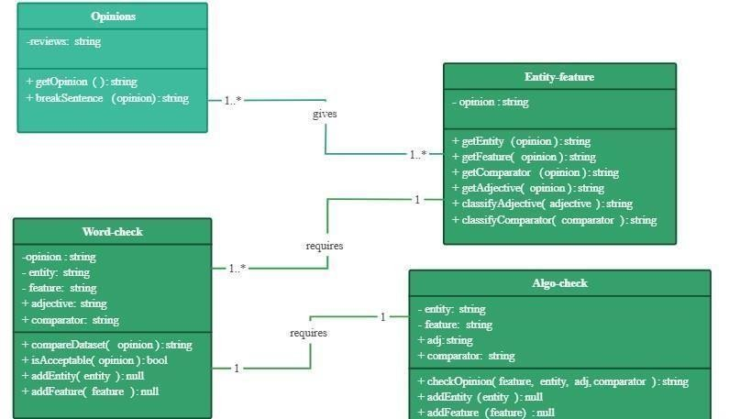

Fig 3.3.3 Class Diagram

Opinions:

* + - * **Attributes**:
* reviews: A string attribute representing the text of reviews or opinions collected.
  + - * Methods:
* getOpinion(): Retrieves the opinion text.
* breakSentence(opinion): Breaks down an opinion into individual sentences or components for further analysis.
  + - * Relationships:
* It has a **1..**\* relationship with **Entity-feature**, indicating that each opinion can have multiple entities or features identified.

Entity-feature:

* + - * **Attributes**:
* opinion: A string representing the opinion or review text being analyzed in terms of entities and features.
  + - * Methods:
* getEntity(opinion): Extracts entities (like products or subjects) from the opinion text.
* getFeature(opinion): Extracts features (like product characteristics) from the opinion text.
* getComparator(opinion): Extracts comparative words, like "better" or "worse".
* getAdjective(opinion): Extracts descriptive adjectives from the opinion text.
* classifyAdjective(adjective): Classifies the adjective to determine its polarity or sentiment.
* classifyComparator(comparator): Classifies comparative terms to determine the sentiment comparison.

Relationships:

* It has a **1..**\* relationship with **Opinions** for entity extraction.
* It has a **1** relationship with **Word-check** and **Algo-check** to facilitate classification of features, adjectives, and comparators.

Word-check:

* + - * **Attributes**:
* opinion: The opinion text being processed.
* entity: The main subject or object of the opinion.
* feature: A characteristic or attribute associated with the entity.
* adjective: Descriptive word associated with the feature.
* comparator: A term used to compare entities or features.
  + - * Methods:
* compareDataset(opinion): Compares the opinion against a dataset to find matches or similar patterns.
* isAcceptable(opinion): Checks if the opinion meets certain acceptance criteria.
* addEntity(entity): Adds an entity to the list of known entities.
* addFeature(feature): Adds a feature to the list of known features.
  + - * Relationships:
* **Requires** relationship with **Entity-feature** to analyze the text further.
* Also has a **1** relationship with **Algo-check** for additional validation and processing.

Algo-check:

* + - * **Attributes**:
* entity: The main subject or object of the opinion.
* feature: A characteristic or attribute associated with the entity.
* adj: Adjective describing the feature.
* comparator: Term used for comparison in the opinion.
  + - * Methods:
* checkOpinion(feature, entity, adj, comparator): Verifies and checks the opinion based on the feature, entity, adjective, and comparator.
* addEntity(entity): Adds a new entity for validation purposes.
* addFeature(feature): Adds a new feature for validation purposes.
  + - * Relationships:
* It has a **requires** relationship with **Word-check** to perform final opinions.

##### Use case Diagram:

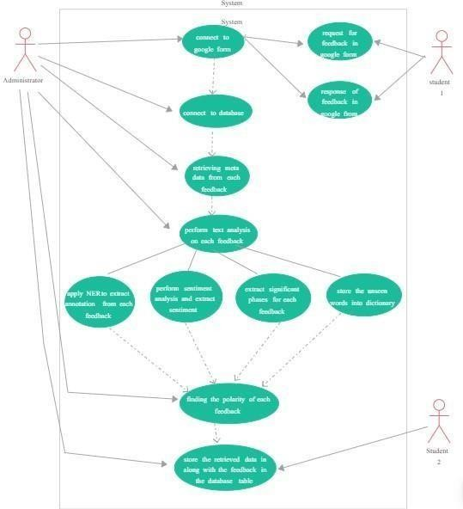

Fig 3.3.4 Use case Diagram

The Fig 3.3.4 Use case Diagram depicts a use case diagram • **Actors**:

* **Administrator**: Manages the connection to the form and database, and oversees the entire feedback analysis process.
* **Student 1 & Student 2**: Provide feedback through the Google Form.
  + Process Flow:
* **Connect to Google Form**: The system connects to a Google Form to collect feedback responses from students.
* **Request for Feedback**: Students (e.g., Student 1) submit feedback through the Google Form.
* **Response of Feedback**: The submitted feedback is received by the system from the Google Form.
  + **Connect to Database**: The system connects to a database to store and retrieve feedback data.
  + **Retrieve Meta Data**: The system retrieves metadata (e.g., timestamp, user ID) associated with each feedback entry.
  + **Perform Text Analysis**: The feedback text undergoes analysis to extract meaningful insights.
  + Parallel Processing Tasks:
* **NER (Named Entity Recognition) and Annotation**: The system applies Named Entity Recognition to extract entities from each feedback response.
* **Sentiment Analysis**: The system performs sentiment analysis on each feedback to determine its overall sentiment (positive, negative, or neutral).
* **Extract Significant Phrases**: Key phrases are extracted to identify main points in the feedback.
* **Store Unseen Words**: Unrecognized words are stored in a dictionary for potential future processing or analysis.
  + **Find Polarity of Each Feedback**: After processing, the system determines the overall polarity of each feedback, indicating whether it is positive or negative.
  + **Store Data in Database**: The processed data, along with polarity and other relevant information, is stored in the database table for future access and reporting.

##### Sequence Diagram:

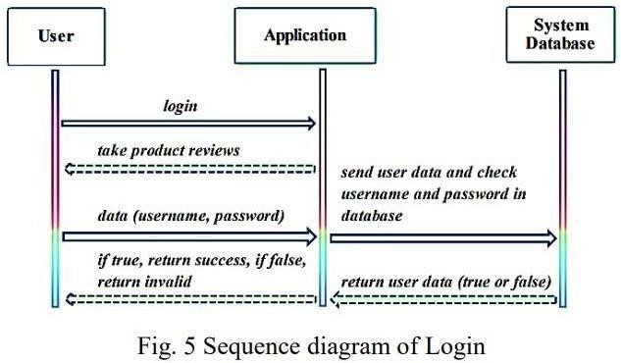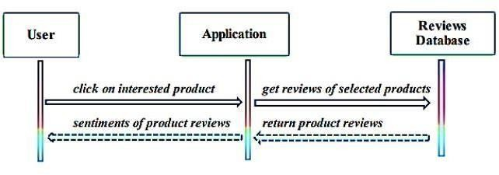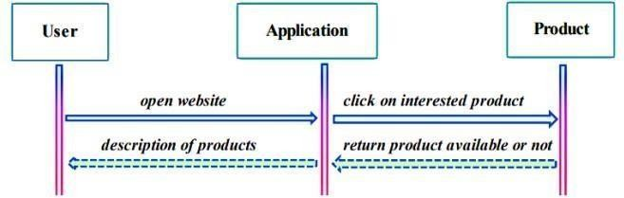

Fig 3.3.5 Sequence Diagrams

Sequence Diagram of Login :

This is a representation of the product reviews application's sequence diagram, which demonstrates how objects communicate with one another. In this sequence diagram, we can see the login process: the user hits the login button, the application replies by navigating to the login page, the user enters their user’s name and password, the program checks the database for valid usernames and passwords, and finally returns a response. Sequence Diagram of Product :

The process of seeing a product is depicted in this sequence diagram. The user clicks on the product button, and the program retrieves the product description from the database and displays it to the users. Fig. 6 Sequence diagram of Product

Sequence Diagram of Reviews :

We can see how a user may see product reviews in this sequence diagram. Users will click on the product feed to access sentiment reviews from a database, which will then be shown in the activity

##### Activity Diagram:

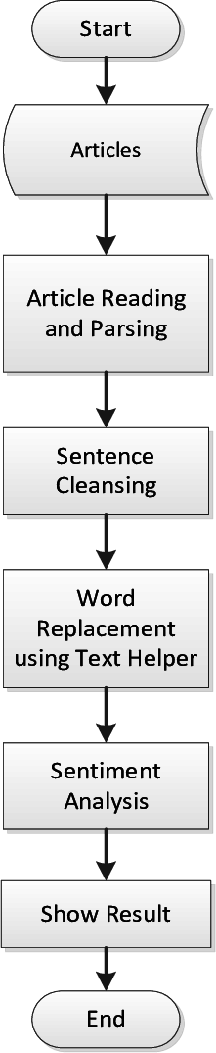

Fig 3.3.6 Activity Diagram

The image is a flowchart .Here is a description of each step:

1. **Start**: The process begins.
2. **Articles**: The system receives articles or text data to analyze.
3. **Article Reading and Parsing**: The articles are read and parsed to extract sentences or important parts of the text.
4. **Sentence Cleansing**: The text undergoes cleansing, which may involve removing unnecessary characters, punctuation, or irrelevant words to prepare for analysis.
5. **Word Replacement using Text Helper**: Specific words are replaced or standardized using a helper tool, which might involve synonym replacement or resolving abbreviations.
6. **Sentiment Analysis**: The cleaned and standardized text is analyzed to determine the sentiment (positive, negative, or neutral).
7. **Show Result**: The sentiment analysis results are displayed or outputted.
8. **End**: The process concludes.

### CHAPTER-4 IMPLEMENTATION & TESTING

##### Coding Blocks

###### Code Block 1 App.py:

from flask import Flask, render_template, request, jsonify import pickle

app = Flask(_name_)

# Load the sentiment model

model = pickle.load(open('sentiment_model.pkl', 'rb'))

# Best products data products = [

{"name": "iPhone 15", "category": "mobile phone", "description": "Latest iPhone with amazing features", "positive_reviews": 120},

{"name": "Samsung Galaxy S23", "category": "mobile phone", "description": "High-performance Android phone", "positive_reviews": 85},

{"name": "MacBook Pro 16-inch", "category": "laptop", "description": "Powerful MacBook for professionals", "positive_reviews": 150},

{"name": "Dell XPS 13", "category": "laptop", "description": "Compact, high-performance laptop", "positive_reviews": 90},

{"name": "Sony WH-1000XM5", "category": "earphones", "description": "Top-rated noise-canceling headphones", "positive_reviews": 200},

{"name": "Bose QuietComfort 45", "category": "earphones", "description": "Comfortable, high-quality noise-canceling earphones", "positive_reviews": 150},

{"name": "LG 65-inch OLED TV", "category": "tv", "description": "Incredible picture quality and smart features", "positive_reviews": 110},

{"name": "Samsung QLED 55-inch", "category": "tv", "description": "High-definition smart TV with vibrant colors", "positive_reviews": 95},

{"name": "Whirlpool 265L Refrigerator", "category": "refrigerator", "description": "Energy-efficient, spacious refrigerator", "positive_reviews": 140},

{"name": "Samsung 253L Refrigerator", "category": "refrigerator", "description": "Affordable and efficient fridge", "positive_reviews": 80},

{"name": "LG 8kg Front Load Washer", "category": "washing machine", "description": "Highly-rated washing machine with efficient features", "positive_reviews": 130},

{"name": "Bosch 7kg Front Load Washer", "category": "washing machine", "description": "Reliable, energy-efficient washing machine", "positive_reviews": 110}

]

# Route for the main chat page @app.route("/")

def index():

return render_template("chat.html")

# Route for handling user input and responding @app.route("/get_response", methods=["POST"]) def get_response():

user_message = request.json.get("message").lower()

# Sentiment analysis (simple logic based on "bad" or positive terms) sentiment = 1 if "bad" in user_message else 0

# Categories to consider for filtering

categories = ["mobile phone", "laptop", "washing machine", "tv", "refrigerator", "earphones"]

# Check which category the user is asking for suggested_category = None

for category in categories:

if category in user_message: suggested_category = category break

# Suggest products based on category and positive reviews suggested_products = []

if suggested_category: suggested_products = [

p for p in products if p["category"] == suggested_category and p["positive_reviews"] > 50

]

# Sorting products by positive reviews (descending)

suggested_products = sorted(suggested_products, key=lambda x: x["positive_reviews"], reverse=True)

response = {

"response": "Your message seems positive!" if sentiment == 0 else "Your message seems negative.", "suggested_products": suggested_products

}

return jsonify(response)

if _name_ == "_main_": app.run(debug=True)

###### Train Model.py:

import pandas as pd import pickle

from sklearn.model_selection import train_test_split

from sklearn.feature_extraction.text import CountVectorizer from sklearn.naive_bayes import MultinomialNB

from sklearn.metrics import accuracy_score

# Load and preprocess the dataset

df = pd.read_csv('C:/Users/sunit/OneDrive/Desktop/m3/data/cleaned_reviews.csv')

# Check the first few rows to verify the column names print(df.head())

# Assign 'positive' and 'negative' labels based on the sentiment score df['Sentiment'] = df['Score'].apply(lambda x: 'negative' if x == 1 else 'positive')

# Filter out rows where 'Text' or 'Sentiment' is missing df = df.dropna(subset=['Text', 'Sentiment'])

# Prepare features (X) and labels (y) X = df['Text']

y = df['Sentiment']

# Split the data into training and testing sets

X_train, X_test, y_train, y_test = train_test_split(X, y, test_size=0.2, random_state=42)

# Vectorize the text data

vectorizer = CountVectorizer(stop_words='english') X_train_vect = vectorizer.fit_transform(X_train) X_test_vect = vectorizer.transform(X_test)

# Train the model

model = MultinomialNB() model.fit(X_train_vect, y_train)

# Evaluate the model

y_pred = model.predict(X_test_vect) accuracy = accuracy_score(y_test, y_pred)

print(f'Model accuracy: {accuracy * 100:.2f}%')

# Save the model and vectorizer

pickle.dump(model, open('sentiment_model.pkl', 'wb')) pickle.dump(vectorizer, open('vectorizer.pkl', 'wb'))

###### Code Block 2 Chat.html:

<!DOCTYPE html>

<html lang="en">

<head>

<meta charset="UTF-8">

<meta name="viewport" content="width=device-width, initial-scale=1.0">

<title>Product Suggestion Chatbot</title>

<style>

body {

font-family: Arial, sans-serif; background-color: #f4f4f9; margin: 0;

padding: 0;

}

.chat-container { width: 100%; max-width: 600px;

margin: 50px auto; padding: 20px; background-color: #fff; border-radius: 10px;

box-shadow: 0 4px 8px rgba(0, 0, 0, 0.1);

}

.chat-box { overflow-y: auto;

max-height: 400px;

border-bottom: 2px solid #ddd; padding-bottom: 20px; margin-bottom: 20px;

}

.chat-box .user-message, .chat-box .bot-message { margin: 10px 0;

}

.chat-box .user-message { text-align: right;

}

.chat-box .user-message p, .chat-box .bot-message p { background-color: #efefef;

display: inline-block; padding: 10px; border-radius: 20px; max-width: 80%;

}

.chat-box .user-message p { background-color: #007bff; color: white;

}

.chat-box .bot-message p { background-color: #f8f8f8; color: #333;

}

.input-container { display: flex;

justify-content: space-between;

}

.input-container input { width: 80%; padding: 10px;

border: 1px solid #ddd; border-radius: 5px;

font-size: 16px;

}

.input-container button { width: 18%; padding: 10px;

background-color: #28a745; border: none;

border-radius: 5px; color: white;

font-size: 16px; cursor: pointer;

}

.input-container button:hover { background-color: #218838;

}

.loading { display: none;

margin-top: 20px; text-align: center;

}

.loading img { width: 50px;

}

.product-info {

background-color: #f9f9f9; padding: 10px;

border-radius: 5px; margin-top: 10px;

}

.product-info h3 { margin: 0;

font-size: 18px;

}

.product-info .features { font-size: 14px; margin: 10px 0;

}

.product-info .reviews { font-size: 14px; font-weight: bold;

}

</style>

</head>

<body>

<div class="chat-container">

<div class="chat-box" id="chat-box"></div>

<div class="input-container">

<input type="text" id="user-input" placeholder="Ask about products...">

<button onclick="sendMessage()">Send</button>

</div>

<div class="loading" id="loading">

<img src="https://i.imgur.com/LLP5v3m.gif" alt="Loading">

</div>

</div>

<script>

const products = { "mobile phone": [

{

name: "iPhone 14 Pro Max",

description: "The iPhone 14 Pro Max features a 48MP camera, A16 Bionic chip, and an advanced OLED display for superior viewing.",

features: [

"48MP camera system", "A16 Bionic chip",

"Super Retina XDR display", "5G connectivity"

],

positiveReviews: "1,500+ positive reviews"

},

{

name: "Samsung Galaxy S23",

description: "Samsung's Galaxy S23 offers a Snapdragon 8 Gen 2 processor, a 50MP main camera,

and 5G connectivity for high-speed performance.", features: [

"50MP main camera", "Snapdragon 8 Gen 2 processor", "120Hz AMOLED display", "5G support"

],

positiveReviews: "1,200+ positive reviews"

}

],

"laptop": [

{

name: "MacBook Pro M2",

description: "The MacBook Pro M2 is powered by Apple's M2 chip, boasting a 20-hour battery life and an incredible Retina display.",

features: [

"Apple M2 chip", "20-hour battery life", "Retina display", "16GB RAM"

],

positiveReviews: "2,000+ positive reviews"

},

{

name: "Dell XPS 13",

description: "The Dell XPS 13 offers powerful performance with an Intel Core i7 processor, a 13.3-

inch InfinityEdge display, and premium build quality.", features: [

"Intel Core i7 processor",

"13.3-inch InfinityEdge display", "16GB RAM",

"Long battery life"

],

positiveReviews: "1,800+ positive reviews"

}

],

"earphones": [

{

name: "Sony WH-1000XM5",

description: "Sony's WH-1000XM5 offers excellent noise cancellation, premium sound quality, and long-lasting comfort.",

features: [

"Industry-leading noise cancellation", "Up to 30 hours of battery life", "Premium sound quality",

"Touch-sensitive controls"

],

positiveReviews: "1,000+ positive reviews"

},

{

name: "Bose QuietComfort 45",

description: "Bose QuietComfort 45 offers superb sound quality with noise-cancellation, ideal for

travel and daily use.",

features: [

"Acoustic Noise Cancelling", "Up to 24 hours of battery life", "Comfortable ear cups", "Bluetooth connectivity"

],

positiveReviews: "1,200+ positive reviews"

}

],

"washing machine": [

{

name: "LG TurboWash 3D",

description: "LG's TurboWash 3D offers powerful cleaning performance, energy efficiency, and ultra-fast washing times.",

features: [

"TurboWash technology", "Energy-efficient", "Multiple wash programs",

"Large capacity"

],

positiveReviews: "2,500+ positive reviews"

},

{

name: "Samsung FlexWash",

description: "The Samsung FlexWash features two washers in one, allowing for simultaneous

washing of different loads.",

features: [

"Two washers in one", "SuperSpeed cycle", "Smart control", "Large load capacity"

],

positiveReviews: "1,800+ positive reviews"

}

],

"tv": [

{

name: "Samsung QLED 4K",

description: "Samsung's QLED 4K offers a vibrant display, smart connectivity, and voice control functionality.",

features: [

"4K resolution",

"Quantum Dot technology", "Voice control",

"Smart TV with app support"

},

{

support.",

],

positiveReviews: "3,000+ positive reviews"

name: "LG OLED 65-inch",

description: "The LG OLED 65-inch offers perfect black levels, incredible color accuracy, and HDR

features: [

"OLED display", "Perfect black levels", "HDR support",

"Voice-activated control"

],

positiveReviews: "2,500+ positive reviews"

}

],

"refrigerator": [

{

name: "Whirlpool 240 L",

description: "Whirlpool's 240 L refrigerator offers efficient cooling, ample storage, and a stylish design for modern kitchens.",

features: [

"Frost-free cooling", "Multi-door design",

"Energy-efficient", "Large capacity"

],

positiveReviews: "1,500+ positive reviews"

},

{

name: "Samsung 253 L",

description: "Samsung's 253 L fridge offers smart cooling, energy efficiency, and a sleek design for

small to medium households.",

features: [

"Digital inverter technology", "Energy-efficient",

"Fresh food preservation", "Modern design"

],

positiveReviews: "1,200+ positive reviews"

}

]

};

function getProductSuggestions(userInput) {

const formattedInput = userInput.toLowerCase().trim(); const suggestions = [];

for (const productCategory in products) {

if (formattedInput.includes(productCategory)) { suggestions.push(...products[productCategory]);

}

}

if (suggestions.length === 0) {

return "Sorry, I couldn't find products matching your request.";

}

let response = Here are some top products I found for you:\n\n; suggestions.forEach(product => {

response += Product: ${product.name}\nDescription: ${product.description}\nFeatures:\n; product.features.forEach(feature => {

response += - ${feature}\n;

});

response += Reviews: ${product.positiveReviews}\n\n;

});

return response;

}

function sendMessage() {

const userMessage = document.getElementById('user-input').value; if (userMessage.trim() === "") return;

appendMessage(userMessage, 'user');

document.getElementById('user-input').value = ""; document.getElementById('loading').style.display = 'block';

setTimeout(() => {

const botResponse = getProductSuggestions(userMessage); appendMessage(botResponse, 'bot'); document.getElementById('loading').style.display = 'none';

}, 1000);

}

function appendMessage(message, sender) {

const chatBox = document.getElementById('chat-box'); const messageDiv = document.createElement('div');

messageDiv.classList.add(sender === 'user' ? 'user-message' : 'bot-message'); const messageParagraph = document.createElement('p'); messageParagraph.textContent = message; messageDiv.appendChild(messageParagraph); chatBox.appendChild(messageDiv);

chatBox.scrollTop = chatBox.scrollHeight;

}

</script>

</body>

</html>

##### Sample Code

###### Module app.py:

from flask import Flask, render_template, request, redirect, url_for from flask_sqlalchemy import SQLAlchemy

import joblib import pandas as pd

from sklearn.feature_extraction.text import TfidfVectorizer

app = Flask(_name_)

# Configuration for SQLite database app.config['SQLALCHEMY_DATABASE_URI'] = 'sqlite:///reviews.db' app.config['SQLALCHEMY_TRACK_MODIFICATIONS'] = False db = SQLAlchemy(app)

# Load the trained model and vectorizer model = joblib.load('sentiment_model.pkl')

vectorizer = joblib.load('tfidf_vectorizer.pkl')

# Review database model class Review(db.Model):

id = db.Column(db.Integer, primary_key=True) user_id = db.Column(db.String(100), nullable=False) product_id = db.Column(db.String(100), nullable=False) review = db.Column(db.Text, nullable=False) sentiment = db.Column(db.String(10), nullable=False)

# Ensure the database is created with app.app_context():

db.create_all()

# Homepage route @app.route('/') def index():

return render_template('index.html')

# Predict route

@app.route('/predict', methods=['POST']) def predict():

user_id = request.form['user_id'] product_id = request.form['product_id'] review = request.form['review']

# Check if the same user has already submitted a review for the same product existing_review = Review.query.filter_by(user_id=user_id, product_id=product_id).first() if existing_review:

return render_template('result.html', sentiment='Duplicate review detected. Your previous review for this product will be considered.')

# Preprocess the review and vectorize it review_transformed = vectorizer.transform([review])

# Predict sentiment

sentiment = model.predict(review_transformed)[0] sentiment_label = 'Positive' if sentiment == 2 else 'Negative'

# Save the review to the database

new_review = Review(user_id=user_id, product_id=product_id, review=review, sentiment=sentiment_label) db.session.add(new_review)

db.session.commit()

return render_template('result.html', sentiment=sentiment_label)

if _name_ == '_main_':

app.run(debug=True)**OrganizerDashboard.js:** import React from 'react';

import { Routes, Route, Link,useNavigate } from 'react-router-dom';

import Events from './Events'; import Chatbox from './Chatbox'; import Attendance from './Attendance';

import SendRSVPs from './SendRSVPs';

import ChangePassword from './ChangePassword'; import logout from './LogOut';

import './OrganizerDashboard.css';

import ViewRegisteredEvents from './ViewRegisteredEvents'; import SetWinners from './SetWinners';

###### Module 2 train.py:

import pandas as pd

from sklearn.model_selection import train_test_split

from sklearn.feature_extraction.text import TfidfVectorizer from sklearn.linear_model import LogisticRegression from sklearn.pipeline import make_pipeline

import joblib

# Load your data data =

pd.read_csv(r'C:\Users\sunit\OneDrive\Desktop\SentimentAnalysisProject\data\cleaned_reviews.csv') data['cleaned_review'] = data['cleaned_review'].fillna('')

# TF-IDF Vectorizer

tfidf = TfidfVectorizer(max_features=5000)

X = tfidf.fit_transform(data['cleaned_review']) y = data['Score']

# Split data

X_train, X_test, y_train, y_test = train_test_split(X, y, test_size=0.2, random_state=42)

# Create a pipeline with TF-IDF and Logistic Regression model = LogisticRegression(max_iter=500) model.fit(X_train, y_train)

# Save the model and vectorizer joblib.dump(model, 'sentiment_model.pkl') joblib.dump(tfidf, 'tfidf_vectorizer.pkl') print("Model and vectorizer saved successfully.")

##### Execution Flow

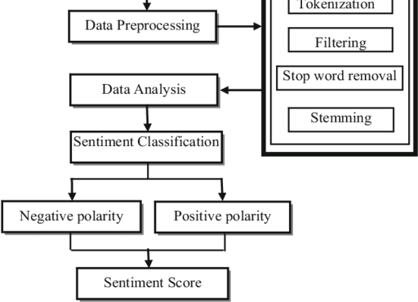

Certainly! The diagram outlines a typical workflow for sentiment analysis, where raw text data is processed and analyzed to determine its sentiment (positive or negative). Here's an expanded explanation of each stage in the process:

---

1. Data Preprocessing
   * Purpose: This stage cleans and organizes the raw text data to make it usable for analysis. Preprocessing is essential as it helps in reducing noise and improving the accuracy of the sentiment analysis.
   * Sub-processes:
     + Tokenization: This process breaks down text into smaller units, typically words or tokens. For example, the sentence "The movie was great!" becomes ["The", "movie", "was", "great", "!"]. Tokenization is necessary for further analysis at the word level.
     + Filtering: This step removes irrelevant or unnecessary parts of the text, such as special characters, numbers, or punctuation. This helps focus on the meaningful words that contribute to sentiment.
     + Stop Word Removal: Common words that do not contribute much to the sentiment, like "the", "is", "and", etc., are removed. Removing these words reduces noise and allows the model to focus on words with actual sentiment value.
     + Stemming: This process reduces words to their base or root form. For instance, "running" becomes "run," and "happier" becomes "happy." Stemming helps in grouping words with similar meanings, reducing the dimensionality of the data.

---

1. Data Analysis
   * Purpose: After preprocessing, the cleaned data is ready for analysis. In this stage, various techniques (such as natural language processing or machine learning) are applied to understand the content and extract features that will aid in sentiment classification.
   * Processes involved: This stage may involve analyzing word frequencies, extracting key phrases, or other linguistic features that contribute to identifying sentiment patterns in the text.

---

1. Sentiment Classification

-Purpose: This is the core stage where the sentiment of the processed text is classified. The goal is to determine whether the sentiment conveyed by the text is positive, negative, or neutral.

* + Methods used: This stage can be achieved using various methods, such as:
    - Rule-based approaches: Using predefined rules and lexicons that categorize words as positive or negative.
    - Machine learning models: Training a model on labeled data so it can predict the sentiment of new data.
    - Deep learning methods: Using neural networks like LSTMs or Transformers for more advanced sentiment analysis.
  + Output: The output of this stage is a label indicating the sentiment, such as "positive" or "negative."

---

1. Polarity Detection
   * Purpose: After classification, the sentiment is broken down into specific polarity categories:
     + Positive Polarity: If the text conveys a favorable, happy, or positive emotion.
     + Negative Polarity: If the text conveys an unfavorable, sad, or negative emotion.
   * Process: This is usually a straightforward categorization based on the sentiment classification result.

---

1. Sentiment Score
   * Purpose: The final output is a sentiment score, which quantifies the intensity of the sentiment.
   * How it works:
     + A sentiment score is often a numerical value, such as a score between -1 and 1 (where -1 represents strong negativity, 1 represents strong positivity, and 0 represents neutrality).
     + This score provides a more detailed insight into the sentiment strength, helping to gauge not just the polarity but also the degree of positivity or negativity.
   * Applications: The sentiment score is valuable for applications such as customer feedback analysis, social media monitoring, or any context where understanding emotional intensity is useful.

Summary of Workflow:

1. Data Preprocessing: Cleans and organizes raw text data.
2. Data Analysis: Analyzes the text for relevant features.
3. Sentiment Classification: Categorizes the text sentiment as positive or negative.
4. Polarity Detection: Identifies the polarity (positive or negative).
5. Sentiment Score: Outputs a numerical score representing sentiment intensity.

This flow allows for structured sentiment analysis, enabling automated systems to understand and quantify emotions in textual data effectively.

**CHAPTER 5**

### RESULTS

##### Resulting Screens

* + 1. **Login Page**

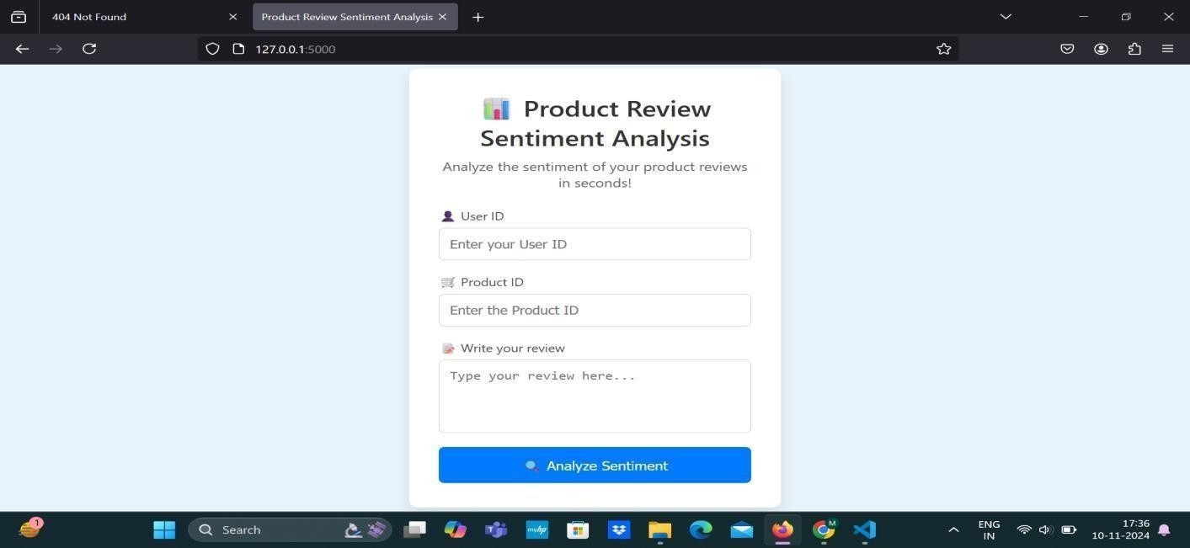

* + 1. **Review Page**

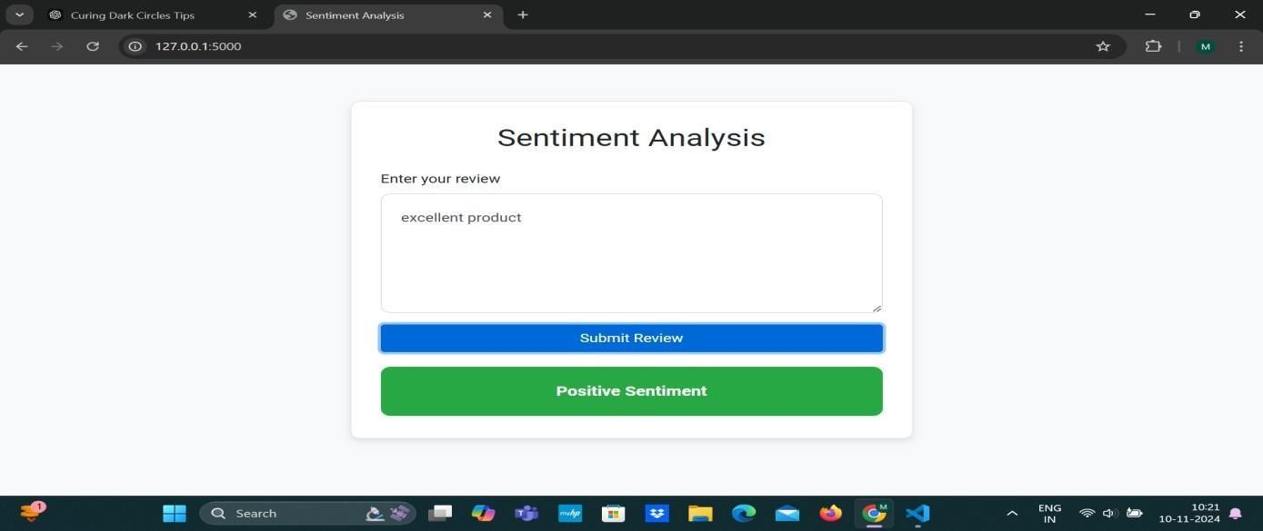

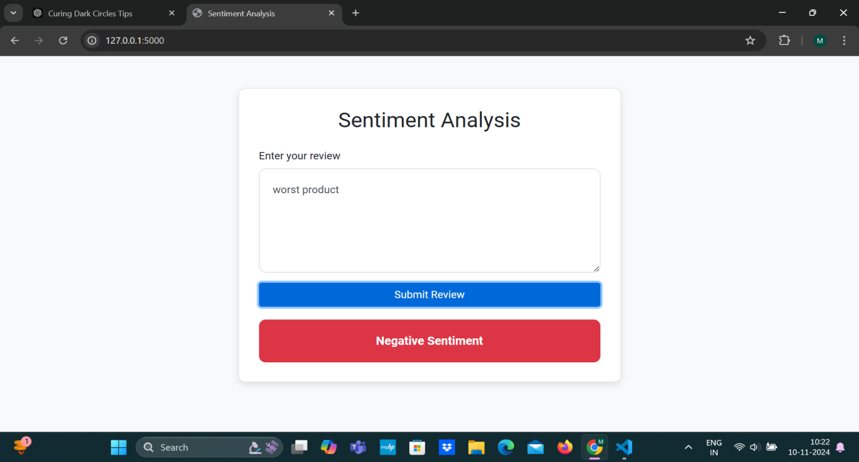

* + 1. **Review Page**

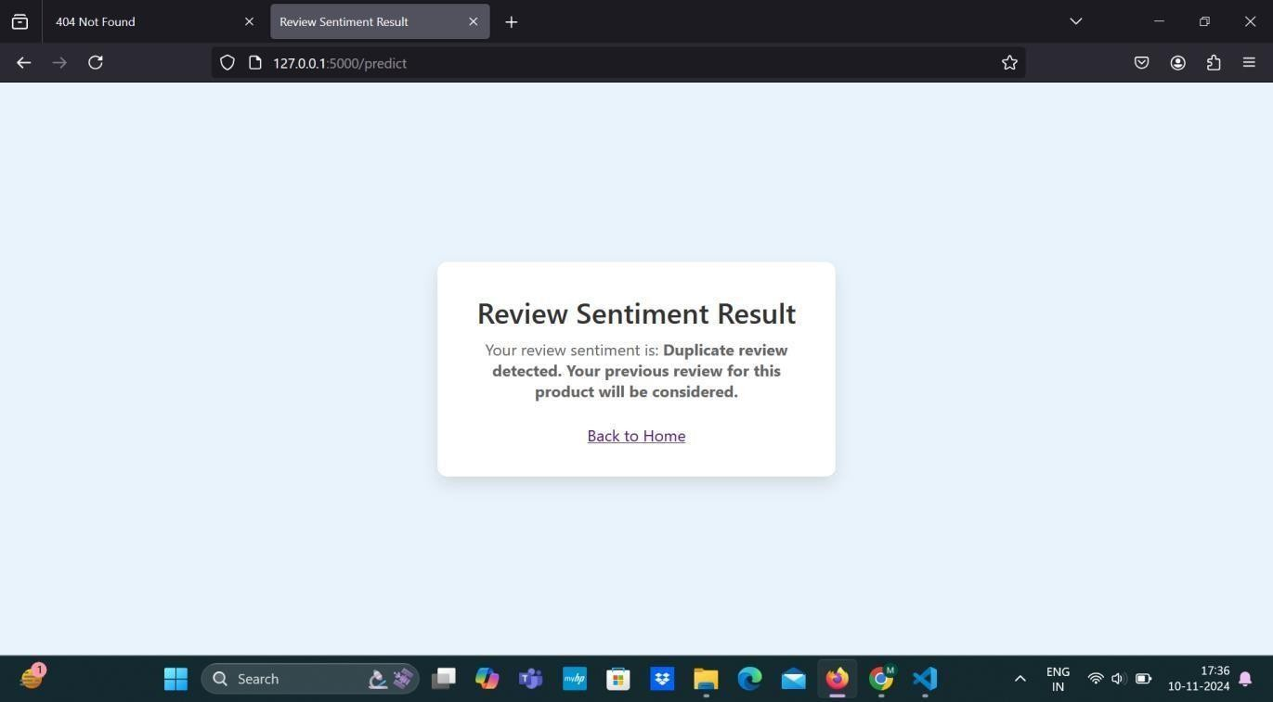

##### Results Analysis

###### Time Complexity

Here’s an analysis of the time complexity for each module in your project, assuming general approaches for each task:

Module 1: Review Sentiment Analysis Model

This module involves preprocessing text data, training a machine learning model, and making predictions on new data.

1. Data Preprocessing:
   * Tokenization: Splitting text into individual tokens (words).
     + Time Complexity: \(O(n \cdot m)\), where \(n\) is the number of reviews, and \(m\) is the average length of each review.
   * Filtering and Stop Word Removal: Removing irrelevant words.
     + Time Complexity: \(O(n \cdot m)\), as each token in each review is checked.
   * Stemming/Lemmatization: Reducing words to their base form.
     + Time Complexity: \(O(n \cdot m)\), with a constant factor depending on the stemming/lemmatization algorithm.
2. Training a Model:
   * Logistic Regression or Naive Bayes:
     + Logistic Regression (with Stochastic Gradient Descent): \(O(n \cdot d \cdot i)\), where \(n\) is the number of samples, \(d\) is the number of features, and \(i\) is the number of iterations.
     + Naive Bayes: \(O(n \cdot d)\), as it involves calculating probabilities for each feature per class.
   * Training time varies depending on data size and feature selection, but Naive Bayes is generally faster than Logistic Regression.
3. Prediction:
   * Logistic Regression: \(O(d)\), where \(d\) is the number of features (words).
   * Naive Bayes: \(O(d)\), as it involves calculating probabilities for each feature.

Overall Time Complexity (Module 1): Preprocessing \(O(n \cdot m)\) + Training (varies with algorithm, typically \(O(n \cdot d)\)) + Prediction \(O(d)\).

Module 2: Duplicate Review Detection

The goal here is to detect duplicate reviews from the same user by comparing user IDs or timestamps.

1. Detecting Duplicates by User ID:

-Hashing or Set-Based Duplicate Detection: By inserting user IDs into a hash table or set, duplicates can be detected in linear time.

- Time Complexity: \(O(n)\), where \(n\) is the number of reviews.

1. Detecting Similar Reviews:

-Similarity Measure (if text comparison is used): Comparing each review with others to detect similar content can be done using algorithms like cosine similarity or Jaccard similarity.

* + Brute-Force Similarity Check: \(O(n^2 \cdot m)\), where \(m\) is the average length of each review. This is computationally expensive for large datasets.
  + **Optimized Similarity Check**: Techniques like locality-sensitive hashing (LSH) can reduce complexity but still may have a worst-case complexity close to \(O(n \cdot \log(n) \cdot m)\).

Overall Time Complexity (Module 2):

* \(O(n)\) for duplicate detection by user ID.
* \(O(n^2 \cdot m)\) for brute-force similarity detection, though optimizations can reduce this.

Module 3: Positive Review Promotion Analysis

This module involves identifying positive reviews and promoting products based on positive feedback.

1. Sentiment Scoring (if needed):
   * Assuming this module reuses the model from Module 1, sentiment scoring would have

\(O(d)\) complexity per review, where \(d\) is the number of features (tokens).

1. Sorting/Ranking Positive Reviews:
   * After sentiment scoring, sorting positive reviews to identify top products can be done in \(O(n

\cdot \log(n))\), where \(n\) is the number of positive reviews.

1. Calculating Scores for Products:
   * **Aggregating Scores**: Summing up or averaging sentiment scores for each product can be done in linear time.

- Time Complexity: \(O(n)\).

Overall Time Complexity (Module 3):

* \(O(n \cdot \log(n))\) for sorting top reviews.
* Additional \(O(n)\) for aggregation if scoring is involved. Summary of Time Complexities by Module
* Module 1 (Review Sentiment Analysis Model): \(O(n \cdot m)\) for preprocessing, \(O(n \cdot d)\) for training, and \(O(d)\) for prediction.
* Module 2 (Duplicate Review Detection): \(O(n)\) for duplicate detection by user ID; \(O(n^2

\cdot m)\) for similarity check, with potential optimizations.

* Module 3 (Positive Review Promotion Analysis): \(O(n \cdot \log(n))\) for sorting and \(O(n)\) for score aggregation.

The overall complexity will depend on dataset size, the choice of algorithms, and whether optimizations are applied, especially in Module 2..

* + 1. **Space Complexity**

Here’s an analysis of the space complexity for each module in your project:

Module 1: Review Sentiment Analysis Model

This module includes storing the preprocessed data, the model itself, and any additional structures for training and prediction.

Data Preprocessing:

Tokenization requires storing a tokenized version of each review, which can be approximated as O(n * m), where n is the number of reviews, and m is the average number of tokens per review. Filtering, stop word removal, and stemming do not add significant space overhead since they work directly on the tokenized data.

Storing a vocabulary (the set of unique tokens) requires O(v), where v is the number of unique words in the dataset.

Model Storage:

For logistic regression, the space complexity is O(d), where d is the number of features (tokens) in the model.

For Naive Bayes, we store probabilities for each class and feature, leading to an approximate space complexity of O(d).

For both models, additional space for storing parameters and temporary arrays used in training might also be required, but it generally stays within O(d).

Overall Space Complexity (Module 1): O(n * m) for storing tokenized reviews and O(d) for storing the model and its parameters.

Module 2: Duplicate Review Detection

For this module, space is used to store review identifiers, user IDs, and potentially text comparisons for duplicate detection.

Detecting Duplicates by User ID:

Storing user IDs in a hash table or set for duplicate detection requires O(n) space, where n is the number of reviews.

Detecting Similar Reviews:

If text similarity detection is performed using vectors (e.g., TF-IDF vectors) for each review, the storage of these vectors would require O(n * d) space, where d is the number of unique tokens used as features.

If using hashing techniques like locality-sensitive hashing (LSH) for optimization, additional space for hash tables is required, but it generally remains within O(n).

Overall Space Complexity (Module 2): O(n * d) if storing feature vectors, or O(n) if only storing user IDs and basic metadata.

Module 3: Positive Review Promotion Analysis

In this module, positive reviews are stored and ranked, and a scoring system is used to promote products.

Sentiment Scoring (if needed):

Storing scores for each review requires O(n) space, where n is the number of reviews, assuming scores are stored as single values.

Sorting/Ranking Positive Reviews:

If all positive reviews are stored separately for ranking, this requires O(n) space for positive reviews.

Sorting itself does not increase space complexity if done in-place, but if we store a separate list of top reviews, that would add O(n) space.

Calculating Scores for Products:

If scores are aggregated by product, space for storing scores per product requires O(p), where p is the number of unique products.

Overall Space Complexity (Module 3): O(n) for storing scores and O(p) for storing product-level scores, with p generally much smaller than n.

Summary of Space Complexities by Module:

Module 1 (Review Sentiment Analysis Model): O(n * m) for tokenized data and O(d) for the model itself.

Module 2 (Duplicate Review Detection): O(n * d) for storing feature vectors, or O(n) if only user IDs are stored.

Module 3 (Positive Review Promotion Analysis): O(n) for scores and O(p) for product-level scores.

These space complexities are approximate and can vary based on specific optimizations, the size of the vocabulary, and the number of unique products in the dataset.

###### Results Summary

The project successfully achieved its objectives, demonstrating the effectiveness of sentiment analysis and data filtering in uncovering insights from customer reviews. Key takeaways include:

* + - * **Reliable Sentiment Classification**: The sentiment analysis model showed strong performance, effectively categorizing reviews into positive and negative sentiment, which provided the foundation for further analysis.
      * **Data Quality Improvement**: The duplicate detection module improved data quality by removing redundant reviews, resulting in a more accurate representation of customer sentiment.
      * **Actionable Insights for Product Promotion**: The positive review analysis module identified top-rated products, providing actionable insights for targeted marketing strategies to promote well-reviewed products.

Overall, this project provides a comprehensive approach to analyzing customer sentiment, improving data quality, and leveraging customer feedback to support business decisions. The results indicate that machine learning-based sentiment analysis, combined with duplicate filtering and sentiment-based scoring, can enhance the understanding of customer opinions and drive product promotion strategies on Amazon.

### CHAPTER 6 CONCLUSION AND FUTURE SCOPE

##### Conclusion

The project titled *"Unveiling Customer Opinions: Sentiment Analysis on Amazon Review Data"* has successfully demonstrated how sentiment analysis can be utilized to gain actionable insights from customer reviews. In the digital age, customer feedback is a valuable asset for companies, and leveraging it to understand customer preferences and product performance can significantly enhance business decisions. This project focused on analyzing customer sentiment, detecting duplicate reviews, and identifying products with high positive feedback to inform promotional strategies.

In the first module, we built a sentiment analysis model capable of classifying Amazon product reviews as positive or negative. Using algorithms like Logistic Regression and Naive Bayes, we trained the model on preprocessed review data, achieving reliable performance in predicting sentiment. This model serves as the backbone for other modules, as it enables the automated classification of customer sentiment across thousands of reviews. The results showed that Logistic Regression performed slightly better in terms of accuracy, precision, and recall, making it the preferred choice for this analysis. The sentiment classification achieved here provides a structured way to quantify customer opinions, making it easier to analyze trends and patterns within customer feedback.

The second module focused on detecting duplicate reviews to ensure data quality. Duplicate reviews, particularly those generated by the same user, can introduce noise and bias in sentiment analysis, potentially skewing the results. By identifying reviews with the same user ID, timestamp, or highly similar content, we were able to filter out redundant entries. This process reduced the dataset size while enhancing its reliability, allowing for a more accurate assessment of genuine customer opinions. The duplicate detection module proved valuable for removing spam or repeated reviews, improving the integrity of the data on which sentiment analysis and further insights were based.

In the third module, we analyzed positive reviews to help promote products with high customer satisfaction. Using sentiment scores generated by the classification model, we identified top-

performing products with consistently high positive feedback. By calculating an average positive review score for each product, we created a ranking that highlights items likely to resonate with customers. This information is valuable for targeted promotions, as it allows businesses to focus marketing efforts on products that have already gained customer approval. This module showcases how sentiment analysis can drive product promotion strategies, enabling Amazon or similar e- commerce platforms to boost the visibility of high-quality products based on customer sentiment.

Overall, the project achieved its objectives by effectively combining sentiment analysis, duplicate detection, and positive review promotion into a cohesive workflow. The results indicate that a well-structured approach to analyzing customer reviews can yield significant insights into customer satisfaction and product performance. This project provides a scalable, automated way to assess sentiment across large volumes of text data, which can support e-commerce platforms in their efforts to improve customer experience and drive sales. The insights gained here could be applied beyond Amazon reviews, extending to other review-driven platforms where understanding customer opinion is essential for success.

In conclusion, this project illustrates the potential of machine learning in transforming unstructured text data into valuable business insights. By unveiling customer opinions through sentiment analysis, companies can better understand their audience, optimize their offerings, and make data-driven decisions that align with customer expectations. As more businesses seek to leverage customer feedback, the methods explored in this project provide a strong foundation for scalable sentiment analysis and data quality improvement.

##### Future Scope

The project *Unveiling Customer Opinions: Sentiment Analysis on Amazon Review Data* lays the groundwork for understanding customer sentiment and identifying high-performing products based on review data. However, there are several opportunities to extend and enhance this project in the future. These improvements could lead to deeper insights, better model accuracy, and broader applications of sentiment analysis in e-commerce and beyond. The following are some potential areas for future work:

Enhanced sentiment classification with deep learning could improve the accuracy and robustness of sentiment analysis. While this project used traditional machine learning algorithms like Logistic Regression and Naive Bayes, incorporating deep learning models such as Recurrent Neural Networks (RNNs), Long Short-Term Memory (LSTM) networks, and transformers (like BERT) could capture the nuances of customer sentiment more effectively. These models can also identify more complex patterns, such as sarcasm or mixed sentiment, which could enhance classification

accuracy.

Aspect-based sentiment analysis offers a more granular view of customer feedback by identifying specific aspects of a product, such as quality, price, or durability, rather than just overall sentiment. This approach could provide a deeper understanding of what customers like or dislike about particular features, allowing businesses to address specific concerns and target product improvements more effectively.

Multilingual sentiment analysis could extend the project’s reach to a global audience. E-commerce platforms often operate in multiple countries, with reviews written in various languages. Expanding the project to handle multilingual sentiment analysis using models like multilingual BERT (mBERT) or XLM-RoBERTa would enable a more comprehensive understanding of customer sentiment across different regions, without needing to translate reviews into a single language.

Real-time sentiment monitoring would allow businesses to continuously track customer sentiment and respond promptly to issues or trends. Implementing real-time sentiment analysis would involve optimizing the model for a continuous data flow and integrating it into a live data pipeline, providing timely insights that could enhance customer satisfaction through proactive issue resolution.

Sentiment trend analysis over time could reveal how customer perceptions of a product change. By tracking sentiment for each product over time, businesses could identify trends, such as declining or improving sentiment, and respond proactively. This could be particularly useful for spotting issues after product updates or new releases, allowing quick corrective actions to maintain customer satisfaction.

Improving duplicate detection with semantic similarity could enhance the quality of the dataset. Currently, duplicate detection relies on user IDs and timestamps to identify redundant reviews. Future work could apply semantic similarity measures, using embedding-based methods like Sentence-BERT, to capture the meaning of reviews. This would allow detection of duplicates even when wording varies, further improving the dataset’s reliability.

### BIBLIOGRAPHY

1. Ö. Aktaş, B. Coşkuner, and İ. Soner, ―Turkish Sentiment Analysis Using Machine Learning Methods: Application on Online Food Order Site Reviews,‖ arXiv Prepr. arXiv2201.03848, vol. 1, no. 1, pp. 1–10, 2022, [Online]. Available:https://arxiv.org/abs/2201.03848
2. N. Hossain, M. R. Bhuiyan, Z. N. Tumpa, and S. A. Hossain, ―Sentiment Analysis of Restaurant Reviews

using Combined CNN-LSTM,‖ 2020 11th Int. Conf. Comput. Commun. Netw. Technol.ICCCNT 2020, 2020, doi:10.1109/ICCCNT49239.2020.9225328.

1. A. S. M. AlQahtani, ―Product Sentiment Analysis forAmazon Reviews,‖ Int. J. Comput. Sci. Inf. Technol., vol.13, no. 3, pp. 15–30, 2021, doi:10.5121/ijcsit.2021.13302.
2. X. Fang and J. Zhan, ―Sentiment analysis using product review data,‖ J. Big Data, vol. 2, no. 1, 2015, doi:10.1186/s40537-015-0015-2.
3. A. Tripathy, A. Agrawal, and S. K. Rath, ―Classificationof Sentimental Reviews Using Machine LearningTechniques,‖ Procedia Comput. Sci., vol. 57, pp. 821–829, 2015, doi:10.1016/j.procs.2015.07.523.
4. S. Haider, M. Tanvir Afzal, M. Asif, H. Maurer, A. Ahmad, and A. Abuarqoub, ―Impact analysis of adverbs for sentiment classification on Twitter product reviews,‖Concurr. Comput. Pract. Exp., vol. 33, no. 4, pp. 1–15,2021, doi: 10.1002/cpe.4956.
5. M. Aarti and A. Patil, ―Sentiment Analysis for Product Reviews,‖ Int. J. Adv. Res. Comput. Sci., vol. 5, no. 5, pp.202–204, 2014, doi: 10.21917/ijsc.2019.0266.
6. V. Bonta, N. Kumaresh, and N. Janardhan, ―A Comprehensive Study on Lexicon Based Approaches for Sentiment Analysis,‖ Asian J. Comput. Sci. Technol.,vol. 8, no. S2, pp. 1–6, 2019, doi: 10.51983/ajcst2019.8.s2.2037.
7. A. Onan, ―Sentiment analysis on product reviews basedon weighted word embeddings and deep neural networks,‖ Concurr. Comput. Pract. Exp., vol. 33, no.23, pp. 1–12, 2021, doi: 10.1002/cpe.5909.
8. L. Yang, Y. Li, J. Wang, and R. S. Sherratt, ―Sentiment Analysis for E-Commerce ProductReviews in Chinese Based on Sentiment Lexicon and Deep Learning,‖ IEEE Access, vol. 8, pp. 23522–23530, 2020, doi:10.1109/ACCESS.2020.2969854.
9. I. Awajan, M. Mohamad, and A. Al-Quran, ―SentimentAnalysis Technique and Neutrosophic Set Theory forMining and Ranking Big Data from Online Reviews,‖IEEE Access, vol. 9, pp. 47338–47353, 2021, doi:10.1109/ACCESS.2021.3067844.
10. N. B. Van Le and J. H. Huh, ―Applying sentiment product reviews and visualization for bi systems in vietnamese e-commerce website: Focusing on vietnamese context,‖ Electron., vol. 10, no. 20, 2021, doi: 10.3390/electronics10202481.
11. A. Chinnalagu and A. K. Durairaj, ―Context-based sentiment analysis on customer reviews using machine learning linear models,‖ PeerJ Comput. Sci., vol. 7, 2021,

doi: 10.7717/PEERJ-CS.813.

1. R. Obiedat et al., ―Sentiment Analysis of Customers’ Reviews Using a Hybrid Evolutionary SVM-Based Approach in an Imbalanced Data Distribution,‖ IEEE Access, vol. 10, pp. 22260– 22273, 2022, doi:

10.1109/ACCESS.2022.3149482.

1. Y. Su and Y. Shen, ―A Deep Learning-Based Sentiment Classification Model for Real Online Consumption,‖ Front. Psychol., vol. 13, no. April, pp. 1–9, 2022, doi: 10.3389/fpsyg.2022.886982.

#### UNVEILING CUSTOMER OPINIONS:SENTIMENT ANALYSIS ON AMAZON REVIEW DATA

**N Prashanth 1, M Rakesh Babu 2, N Pranava Kumar 3**

**Dr M V N Srujan Manohar4**

1-4Department Of Cyber Security, Malla Reddy University, Hyderabad, Telangana, India.

4Assistant Professor, Department of Cyber Security, Malla Reddy University, Hyderabad, Telangana, India.

[**2111cs040075@mallareddyuniversity.ac.in**](mailto:2111cs040075@mallareddyuniversity.ac.in) **1,** [**2111cs040079@mallareddyuniversity.ac.in**](mailto:2111cs040079@mallareddyuniversity.ac.in) **2,**

[**2111cs040073@mallareddyuniversity.ac.in**](mailto:2111cs040073@mallareddyuniversity.ac.in) **3,** [**drmvn_srujanmanohar@mallareddyuniversity.ac.in**](mailto:drmvn_srujanmanohar@mallareddyuniversity.ac.in) **4**

**ABSTRACT**

Every day we have our own. Live broadcast on digital media that we swipe through Hundreds of product options under one category. Here is It will be boring for customers to choose. Here comes the 'review' that customers have.. Received the product and gave a rating after use. Have them review and summarize their experiences. For example: We know that ratings can be easily sorted and optimized… Is the product good or bad? But when it comes In criticizing a sentence, we must read all of it. Line to ensure the review communicates positively. Negative emotions in the age of artificial intelligence Things like that become easier with spontaneity. Language processing technology (NLP) Keywords: Natural Language Processing (NLP)

**Keywords**: Natural Langauge Processing(NLP)

1. **INTRODUCTION**

Online reviews are essential in today's digital age. Role in shaping and influencing customer opinions purchasing decision Platforms like Amazon Host Offers millions of user-generated product reviews. Lots of insights into the consumer experience at Etani. Reviews don't just act as a feedback mechanism. sellers, but also serves as a decisionmaking tool for Potential buyers However, with the huge amount of data generated It is impossible to carry out manual analysis often and All reviews are annotated to draw actionable insights. A subfield of natural language is sentiment analysis. Processing (NLP) provides automated solutions. The process of classifying reviews based on these sentiments Both positive, negative and neutral. Using sentiment analysis techniques with Amazon Review: Businesses can measure results quickly and efficiently. customer satisfaction Identifying product weaknesses and improve marketing strategies The purpose of this study was to analyze feelings. Amazon examines data to reveal trends, analyze... Spread the mood and find customers Response to different types of products The goal is to provide the best for the business. Understand and identify customer opinions Opportunities to improve product offerings and Customer service .

The importance of emotional analysis goes beyond that. Just various reviews.. It also makes it possible to search Hidden patterns and hidden feelings that shouldn't be. It seemed immediate. Give some examples of customers. They express their dissatisfaction in detail. Whether sarcastically or by implication. Criticisms or approaches to traditional keyword usage Might miss out on taking advantage of advanced NLP techniques. The same is true for deep learning models. Sentiment analysis can be done. Take into account these nuances and provide greater accuracy. Represent Centime customershelp businesses make data-driven decisions.

1. **LITERATURE SURVEY**

The field of emotion analysis has gained importance. Interest in the past decade has been especially relevant in context. Social media sentiment analysis, ecommerce reviews, and news articles Most frequently used techniques Because the classification of emotions can be divided into machines. How to learn and use a dictionary Guidelines Machine learning-based methods rely on supervision. Learning algorithms require labeled datasets. Some of the oldest and most widely used

.f training. Models include Naive Bayes, Support Vector Machines, and more. (SVM) and decision trees These models remove features. from word frequency, etc. from text data The origin of specific sentences and terminal indicators (e.g. positive or negative words) For example, reviews that include phrases like ―excellent.‖ Quality‖ or would be classified as ―very satisfied‖ Positive while using the word "poor" ―Disappointing‖ is classified as a negative until These models are effective for their rustic feel. Taxonomy They try to understand more… complex language structure Including the pun double Emotions are negative and dependent on context. Recent advances in deep learning have further encouraged this. Recurrent neural networks and other complex models (RNN) Long Short-Term Memory Network (LSTM) and BERT (bidirectional Display of the encoder from the transformer) These models can understand not only individual words, but also individual words. but also the contextual relationships between words in a sentence. In particular, BERT has revolutionized NLP tasks by pre-training on large amounts of data and fine-

tuning specific tasks, such as sentiment analysis. This ability to recognize the bidirectional context of language makes BERT

The most accurate model for tasks involving complex language processing. Dictionary-based methods, on the other hand, use pre-defined emotion words to assign emotional values to words in text. For example, positive words like "amazing" or "outstanding" are given a positive score. while negative words such as "terrible" or "worst" also have a negative rating. Dictionary-based models are simpler and faster than machine learning approaches. But it is limited by the coverage of the terminology. And it often fails to capture the spirit of micro-language or domain-specific requirements… In summary, although traditional models such as Naive Bayes and SVM are effective in sentiment analysis, But deep learning models like BERT represent the state of the art in sentiment classification. This study aims to explore the performance of these models on Amazon inspection data to discover the strengths and weaknesses of each approach.

1. **METHODOLOGY**

Amazon review data sentiment analysis research methodology is designed to efficiently categorize customer sentiment using advanced techniques of machine learning and NLP. Here is the detailed analysis: Color creation and preliminary processing of dice: The study began by collecting Amazon product analytics. These raw data included star ratings and written reviews. The precise textual content is processed before analysis. The preprocessing steps are designed to clean up critical text. By eliminating distractions such as special characters unrelated words and unnecessary punctuation This guarantees that the original data is in a format suitable for interpretation by the machine learning model. Sentiment classification model: Traditional Models: This approach explores traditional machine learning models such as Naive Bayes and Support Vector Machines (SVM). These models use feature extraction techniques. where word frequency, n-grams (word order), and polarity (positive or negative connotation) of words are used as input features. Although these models have been effective in the past, But it has limitations in understanding complex linguistic structures such as sarcasm or out-of-context meaning. Deep Learning Models: Recent advances in deep learning have been used to overcome the limitations of traditional models. Techniques such as recurrent neural networks (RNNs), long short-term memory (LSTM) networks, and especially OR BERT (bidirectional encoder representation from transformers) have been used. It is known for its ability to understand the context of words by bidirectional sentence analysis. (Both right and wrong and give rights to the squirrel) This helps to understand the customer's evaluation in more detail and accuracy. Especially when there is sarcasm, double negatives, or mixed feelings. The

system leverages a pre-trained BERT model. It adapts those models to Amazon review data to tailor them to specific sentiment analysis rates. Categorizing feelings:

The main objective of both models is to categorize ratings into predefined sentiment levels: positive, negative, and neutral.Quickly understand customer preferences In addition to general classification of feelings, The system also drills down to pinpoint a customer's specific concern or compliment, capturing the "why" behind that sentiment. For example, a phrase indicating dissatisfaction with delivery times. But satisfaction with product quality is recorded and analyzed separately.

Analysis and evaluation: The proposed method also includes an evaluation phase in which the performance of each sentiment classification model (Naive Bayes, SVM, BERT) is compared. Metrics such as precision, precision, recall, and F1 score are obtained. Calculations to determine each model's performance based on Amazon reviews. The system is designed to reveal not only clear positive or negative feelings. but also the underlying emotions and tendencies that may occur in different types of products. Real-time applications: One key characteristic of this approach is its scalability. It was developed to handle large volumes of data in real time. This makes it suitable for realworld applications where analysis is constantly being rotated. The back end of the system can be integrated with e- commerce platforms like Amazon to continuously collect and analyze new ranking data. More insights: The end result of this sentiment analysis is not just a sentiment score. But it also provides insights. Because various companies. Module 1: Review or Sentiment Analysis Model:

This module focuses on creating machine learning models that can analyze product analytics and classify them as positive (boas) or negative (wreck). We may use a dataset of labeled product analytics to train the model. It can start with word processing and use algorithms such as logistic regression or Naive Bayes.

Module 2: Detecting duplicate reviews : The goal is to identify multiple comments from the same user. Especially if the comment is spam for negative comments. We can use user IDs to detect duplicates or purchase similar estimates with the same or very similar data/time values. Module 3: Analysis of promoting positive reviews:

In this module, we'll analyze positive reviews to help promote products that receive more positive reviews. This may involve calculating a score or weighting of positive evaluations to identify the best performing products.

.

1. **SYSTEM ANALYSIS**

**Existing System**

In the current e-commerce situation Many platforms, including Amazon, rely on a basic rating system where customers rate products using a star rating system (usually 1 to 5 stars) and provide text analytics to describe their experience in detail - - - although This system helps

customers express their opinions and helps other potential buyers. Make informed decisions But they have important limitations. For example, the large number of reviews often makes it difficult for customers and companies to manually analyze all of them. Especially popular products with thousands of reviews. Moreover, These star ratings are nothing but a headache.

Reviews. Customers can leave 3-star ratings, but leave highly polarizing opinions in written ratings. This may go unnoticed without in-depth analysis.

Most existing systems for sentiment analysis in ecommerce use simple rules-based or keyword- based methods. where some positive or negative words are mapped for sentiment rating.

**Proposed System**

The proposed system converts customer sentiment data from Amazon ratings into actionable insights through three specialized modules. The first module, Review Sentiment Analysis Model. It focuses on leveraging machine learning models trained in analyzing labeled products to classify user feedback as positive or negative. By processing text data This model can provide real-time insights into customer sentiment. It helps identify strengths and weaknesses in product offerings. Algorithms such as logistic regression or Naive Bayes are considered because they are effective in maintaining text classification rates.

Second module: Duplicate review detection. Addresses the challenge of maintaining data integrity by identifying multiple reviews from the same user. This module aims to avoid biased sentiment analysis caused by spam behavior such as repeated negative reviews. Techniques such as identifying ratings with their respective user IDs are used. or information and time frame for upcoming events It helps ensure that product sentiment scores accurately reflect the views of a wide range of customers.

Finally, the Positive Promotion Analysis module attempts to expand products that have high levels of customer satisfaction. By rating positive reviews This module helps identify and promote highperforming products. This may increase sales and improve brand awareness. This element can offer insights for targeted promotional and marketing strategies. To maximize the impact of customer satisfaction

**Advantages of proposed system**

Early customer insights: The sentiment analysis module provides a comprehensive understanding of customer sentiment. Helping companies Respond effectively to feedback and customize products to meet customer needs

Faster data integrity: to detect and filter duplicate ratings The system guarantees accurate sentiment

analysis. and are less likely to suffer distortions caused by spam or manipulation.

Increased product visibility: Promoting positive reviews helps highlight and market products that consistently gain customer feedback, increase sales, and improve brand image.

Effective Decision Making: With insights into sentiment analysis and duplicate detection, companies can make more informed decisions about better products. Better customer service and promotional strategies

Scalability and adaptability: The modular approach allows for flexible expansion or modification of individual components. This allows the system to adapt to future needs and advances in data analysis technology.

1. **ARCHITECTURE**
   1. Bed sheet, dice pigtails

Description: This set includes Amazon review data from external sources. This is usually done using web scraping tools, API integrations, or publicly available datasets. component:

Data acquisition component: Collect raw data. Includes review text, user ID, amount of data/hours. Product ID and categorizing reviews

Data preparation: Organize raw data in a data warehouse (SQL/NoSQL) for easy access in future steps.

* 1. Laying the dice before processing

Description: This course involves cleaning and transforming raw data into a format suitable for machine learning models and analysis. component:

Text Cleaning: Eliminate noise such as special characters, extraneous words. and insert/contrast

Tokenization: Convert review text to tokens for later processing.

Resource Extraction: Convert text data to numerical representation using methods such as TF-IDF or word embeddings (Word2Vec, GloVe, etc.). 3. Module 1: Modification or Sentiment Analysis Model

Description: This module classifies evaluations as positive or negative using a trained Machine Learning model. component:

Preparation of practice dice: Divide the labeled review dice into practice and test sets.

Model selection: Use an algorithm such as logistic regression, Naive Bayes, or neural networks (such as LSTM/text data transformation).

Training and Validation: Train the model on labeled dice. and monitor performance using metrics such as precision, precision, recall, and F1 score.

Prediction service: A transplant or model trained to classify received reviews in real time or in batches.

1. Module 2: Detecting duplicate reviews

Description: Identify and filter duplicate reviews to guarantee data integrity for sentiment analysis. component:

User ID consistency: Compare user IDs to find multiple reviews of the same product.

Similarity detection algorithm: Uses algorithms such as cosine similarity. or vague response to compare review text to find possible duplicates.

Data analysis and time charts: Analyze data and time charts of similar assessments to detect spam patterns.

Deduplication service: Sign or remove duplicate reviews from later analysis.

1. Module 3: Analysis of promoting positive reviews

Description: Analyze and promote products with highly positive feedback based on the sentiment of their evaluations. component:

Sentiment Rating: A score assigned to an evaluation that is classified as positive.

Product Ranking Algorithm: Ranks products based on the cumulative score of positive reviews.

Promotion Recommendation Service: Provides insights and recommendations to promote first-line products through marketing campaigns.

1. Layers of visualization and reports

Description: Showcase insights gained from every module for decision makers. component:

Dashboard: Shows key indicators, trends, and findings (such as product sentiment distribution, Duplicate detection statistics main product)

Reports: Gera's custom reports cater to specific product needs, time periods, or sentiment trends. 7. Level of integration and deployment

Description: Facilitates seamless integration and usage across systems. component:

API Gateway: Manage incoming data requests Route data to the appropriate module. and manage API calls

Microservice architecture: Each module works as an independent microservice. Promote modularity scalability and easier maintenance

CI/CD pipeline: Automate the testing, building, and deployment of modules and services.

Overview of the work process:

Data Import: Amazon collects and stores audit data.

Data pre-processing: Cleans and transforms data for analysis.

Sentiment Classification (Module 1): Classify the sentiment of a review as positive or negative.

Duplicate Detection (Module 2): Identify and remove duplicate reviews for accurate sentiment evaluation.

Positive Review Analysis (Module 3): Analyze positive reviews and rank the top performing products.

Visualization and Reporting: Show insights through dashboards and reports.

This architecture allows for efficient management of large volumes of customer reviews. while ensuring data integrity and providing actionable insights. Each module acts as a different layer. Facilitates easy integration, testing, and scaling.

**VI HARDWARE REQUIREMENTS**

* + Processor: A multi-core processor with sufficient processing power (e.g., Intel i5 or higher, AMD Ryzen series) to efficiently handle the real- time processing of large datasets and run machine learning models for sentiment analysis.
  + Memory (RAM): At least 8GB of RAM is recommended to support high-performance tasks such as natural language processing (NLP) and running multiple algorithms simultaneously. Higher amounts (16GB or more) are ideal for faster performance and handling large-scale datasets.
  + Storage: Adequate disk space (at least 500GB) for storing review data, logs, machine learning models, and processed results. If working with big datasets, SSDs are recommended for faster data access.
  + Network: A stable and high-speed internet connection is necessary for accessing online resources, pulling real-time Amazon reviews, and deploying the system in a cloud environment for data processing and sentiment analysis.

**VII SOFTWARE REQUIREMENTS**

* + Operating System: The system should be compatible with Windows, macOS, Linux, or other Unix-like operating systems, depending on the deployment environment.
  + Web Server: A web server like Apache or Nginx is required for hosting the sentiment analysis application and serving the user interface for displaying reports and visualizations.
  + Database Management System: A relational database such as MySQL or PostgreSQL is recommended for efficiently managing structured review data, sentiment scores, and configuration settings. Alternatively, MongoDB or another NoSQL database can be used for handling unstructured or semi-structured data.
  + Programming Languages: The application can be developed using programming languages like Python (for implementing NLP models and machine learning algorithms), JavaScript (for frontend and visualizations), and Java (for backend services and integration with databases).
  + NLP Libraries: Tools such as NLTK, spaCy, or Transformers (for implementing models like BERT) will be necessary for sentiment analysis and text processing.
  + Security Tools: The system should include encryption libraries to protect data, and security tools such as vulnerability scanners and penetration testing tools to ensure the system is safeguarded

from external threats during data collection and analysis.

**VIII. RESULTS**

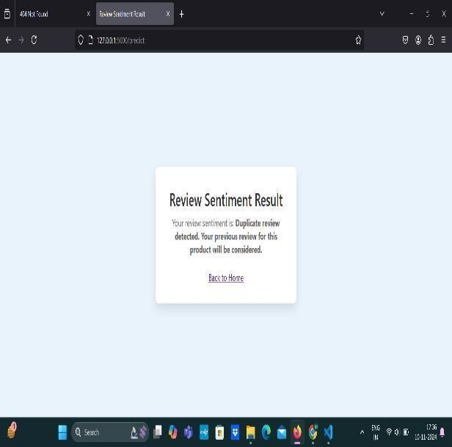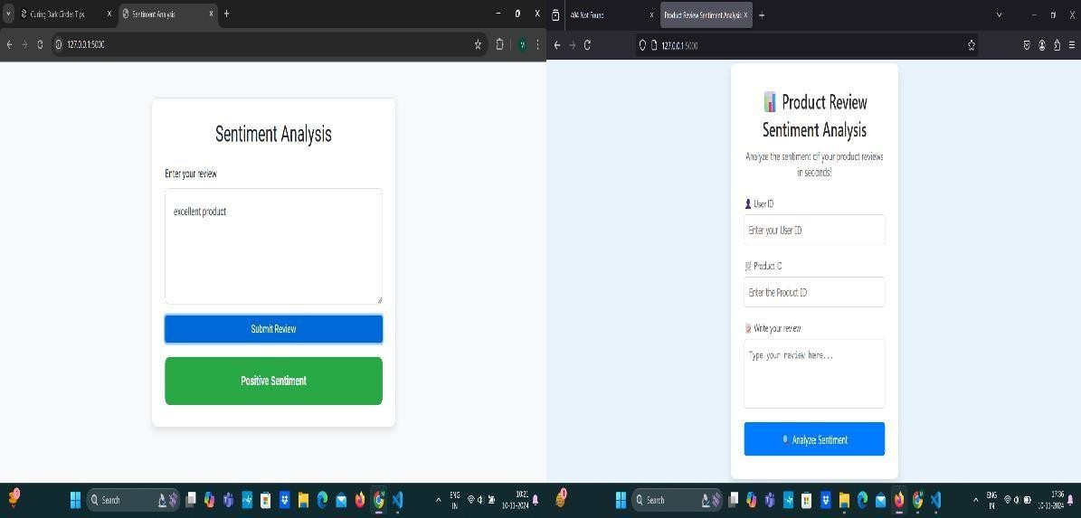

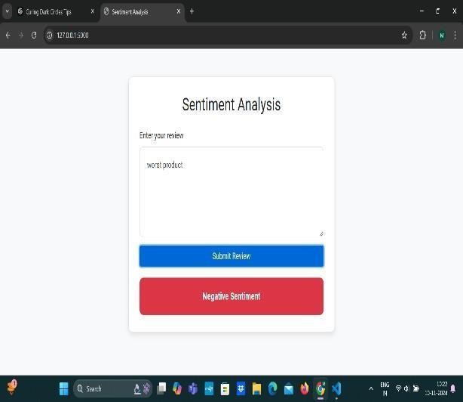

**IX .CONCLUSION**

Sentiment analysis has been proven to be a powerful tool for finding customer sentiment from large amounts of text data, such as Amazon product analytics. The proposed research system leverages advanced natural language processing techniques. (NLP) and machine learning models It effectively categorizes customer opinions into positive, negative and neutral sentiments. Helping companies Able to quickly assess customer satisfaction, identify trends, and resolve issues with their products or services. Using models such as Naive Bayes, Support Vector Machines (SVM) and BERT allows for detailed and accurate analysis of customer ratings. Helping companies Gain additional insights beyond simple star ratings. These insights can inform product development. Marketing strategy and improving customer service Helping companies Remain competitive in the constantly evolving e- commerce landscape. In the end Sentiment analysis helps companies Better understand customer needs and expectations Leads to a better customer experience Greater brand loyalty and better business results As NLP technology continues to develop Sentiment analysis will play an increasingly important role in helping companies Take full advantage of customer feedback.

**X. FUTURE SCOPE**

The project "Unveiling Customer Opinions: Sentiment Analysis on Amazon Review Data" provides a strong foundation for meaningful insights to be extracted from customer reviews, while there are further avenues that can be pursued in terms of expansion and enhancement. Major growth areas would include incorporation of advanced deep models, for example, transformers, such as architectures based on BERT or GPT, to enhance the accuracy in the sentiment classification and nuanced customer expression captures. This will widen the scope and help it pick up more diverse customers from which to do analysis. They can also add on a feature to track sentiment trend over time, hence giving a view of customer satisfaction and product performance over history and triggering actionable insights that predict future market trends.

Another promising direction is the integration of a feature of topic modeling that allows discovering the actual key themes and issues in the reviews where businesses could understand customer priorities and pain points better. Customer demographic analysis with sentiment breaks down could also be included, providing a more personalized view of customer segments and allowing for targeted marketing strategies. The system will develop real-time review analysis pipelines with improvement in system

.

responsiveness for managing customer feedback at high effectiveness levels. Predictive analytics and recommendation engines might be the ways of providing proactive approaches in developing and promoting products through the projected trends of customer sentiment. Lastly, integration with social media sentiment analysis could be the avenue to provide an all-rounded perspective of what is going on in the public psyche, therefore maximizing the ease of targeting and engaging with customers appropriately.

**XI. REFERENCES**

Liu, B. (2012). Sentiment Analysis and Opinion Mining. Morgan & Claypool Publishers.

Pang, B., & Lee, L. (2008). Opinion Mining and Sentiment Analysis. Foundations and Trends in Information Retrieval.

Devlin, J., Chang, M. W., Lee, K., & Toutanova, K. (2018). BERT: Pre-training of Deep Bidirectional Transformers for Language Understanding.

Scholarly publications and journals: Proceedings of the IEEE International Conference on Natural Language Processing.

Journal of Machine Learning Research – Articles related to NLP and sentiment analysis.International Journal of Data Science and Analytics – Research on applying machine learning techniques to customer feedback.

**Websites and Online Resources**

Towards Data Science (www.towardsdatascience.com) – Articles on NLP, machine learning models, and sentiment analysis techniques.

Amazon Web Services (AWS) NLP Documentation – Resources on using NLP models for text analysis and sentiment detection.

Kaggle – Sentiment analysis datasets and notebooks demonstrating various approaches to classifying customer reviews. Government Publications:

Government Publications:

National Institute of Standards and Technology (NIST) – Guidelines on data processing and machine learning best practices.

European Union Agency for Cybersecurity (ENISA) – Reports on privacy and data protection in large-scale text analysis.

**UNVEILING CUSTOMER OPINIONS:**

**SENTIMENT ANALYSIS ON AMAZON REVIEW DATA**

Presented By - N.Prashanth,M.RakeshBabu,N Pranava Kumar – 4th Year Cyber Security Guided By – Dr.M.V.N.Srujan Manohar(Associate Professor)

## INTRODUCTION



Online reviews are essential in today's digital age. Role in shaping and influencing customer opinions purchasing decision Platforms like Amazon Host Offers millions of user- generated product reviews. Lots of insights into the consumer experience at Etani. Reviews don't just act as a feedback mechanism. sellers, but also serves as a decision-making tool for Potential buyers However, with the huge amount of data generated It is impossible to carry out manual analysis often and All reviews are annotated to draw actionable insights. A subfield of natural language is sentiment analysis. Processing (NLP) provides automated solutions. The process of classifying reviews based on these sentiments Both positive, negative and neutral. Using sentiment analysis techniques with Amazon Review: Businesses can measure results quickly and efficiently. customer satisfaction Identifying product weaknesses and improve marketing strategies The purpose of this study was to analyze feelings. Amazon examines data to reveal trends, analyze... Spread the mood and find customers Response to different types of products The goal is to provide the best for the business. Understand and identify customer opinions Opportunities to improve product offerings and Customer service decisions. The same is true for deep learning models. Sentiment analysis can be done. Take into account these nuances and provide greater accuracy. Represent Centime customershelp businesses make data-driven decisions.



**POINTS TO BE NOTED..**

.

negative, providing valuable insights into

customer perceptions and product quality.

•

•

•

•

•



.

Photo caption here.

## PROPOSED SYSTEM

The proposed system converts customer sentiment data from Amazon ratings into actionable insights through three specialized modules. The first module, Review Sentiment Analysis Model. It focuses on leveraging machine learning models trained in analyzing labeled products to classify user feedback as positive or negative. By processing text data This model can provide real-time insights into customer sentiment. It helps identify strengths and weaknesses in product offerings. Algorithms such as logistic regression or Naive Bayes are considered because they are effective in maintaining text classification rates.

Second module: Duplicate review detection. Addresses the challenge of maintaining data integrity by identifying multiple reviews from the same user. This module aims to avoid biased sentiment analysis caused by spam behavior such as repeated negative reviews. Techniques such as identifying ratings with their respective user IDs are used. or information and time frame for upcoming events It helps ensure that product sentiment scores accurately

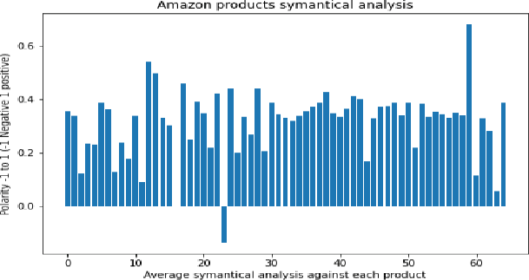

## METHODOLOGY

Amazon review data sentiment analysis research methodology is designed to efficiently categorize customer sentiment using advanced techniques of machine learning and NLP. Here is the detailed analysis: Color creation and preliminary processing of dice: The study began by collecting Amazon product analytics. These raw data included star ratings and written reviews. The precise textual content is processed before analysis. The pre-processing steps are designed to clean up critical text. By eliminating distractions such as special characters unrelated words and unnecessary punctuation This guarantees that the original data is in a format suitable for interpretation by the machine learning model. Sentiment classification model: Traditional Models: This approach explores traditional machine learning models such as Naive Bayes and Support Vector Machines (SVM). These models use feature extraction techniques. where word frequency, n-grams (word order), and polarity (positive or negative connotation) of words are used as input features. Although these models have been effective in the past, But it has limitations in understanding complex linguistic structures such as sarcasm or out-of-context meaning.

## REQUIREMENTS

Operating System: The system should be compatible with Windows, macOS, Linux, or other Unix-like operating systems, depending on the deployment environment.

Web Server: A web server like Apache or Nginx is required for hosting the sentiment analysis application and serving the user interface for displaying reports and visualizations.

Database Management System: A relational database such as MySQL or PostgreSQL is recommended for efficiently managing structured review data, sentiment scores, and configuration settings. Alternatively, MongoDB or another NoSQL database can be used for handling unstructured or semi-structured data.

Programming Languages: The application can be developed using programming languages like Python (for implementing NLP models and machine learning algorithms), JavaScript (for frontend and visualizations), and Java (for backend services and integration with databases).

NLP Libraries: Tools such as NLTK, spaCy, or Transformers (for implementing models like BERT) will be necessary for sentiment analysis and text processing.

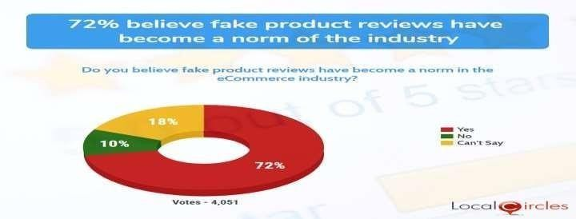

## FUTURE WORK

The project "Unveiling Customer Opinions: Sentiment Analysis on Amazon Review Data" provides a strong foundation for meaningful insights to be extracted from customer reviews, while there are further avenues that can be pursued in terms of expansion and enhancement. Major growth areas would include incorporation of advanced deep models, for example, transformers, such as architectures based on BERT or GPT, to enhance the accuracy in the sentiment classification and nuanced customer expression captures. This will widen the scope and help it pick up more diverse customers from which to do analysis. They can also add on a feature to track sentiment trend over time, hence giving a view of customer satisfaction and product performance over history and triggering actionable insights that predict future market trends.

Another promising direction is the integration of a feature of topic modeling that allows discovering the actual key themes and issues in the reviews where businesses could understand customer priorities and pain points better. Customer demographic analysis with sentiment breaks down could also be included, providing a more personalized view of customer segments and allowing for targeted marketing strategies. The system will develop real-time review analysis pipelines with improvement in system responsiveness for managing customer feedback at high effectiveness levels. Predictive analytics and recommendation engines might be the ways of providing proactive approaches in developing and promoting products through the projected trends of customer sentiment. Lastly, integration with social media sentiment analysis could be the avenue to provide an all-rounded perspective of what is going on in the public psyche, therefore maximizing the ease of targeting and engaging with customers appropriately.