**BIG DATA AND DEEP LEARNING IN SPORTS**

**ANALYTICS: PERFORMANCE OPTIMIZATION**

***Ms. Meenu *1***

*Assistant* *Professor*

[Kodnya.meenu@gmail.com](mailto:Kodnya.meenu@gmail.com)

*(AI & DS)*

***Dhruv Singh*2***

[tomardhruv679@gmail.com](mailto:tomardhruv679@gmail.com)

Department of Artificial Intelligence and Data Science,

Dr. Akhilesh Das Gupta Institute of Professional Studies, New Delhi

**Abstract**

The advent of big data analytics in sports has fundamentally changed how teams, coaches, and athletes approach performance enhancement. This paper explains how big data impacts athlete development, strategic planning, and decision-making in a variety of sports and examines how it is transforming sports performance analytics. Big data analytics in sports refers to the collection, processing, and analysis of massive amounts of data generated by numerous sources, including wearables, sensors, video, and statistical records.

Using advanced algorithms and machine learning techniques, this data is transformed into insightful knowledge that

can be used to enhance tactical plans, maximize training schedules, and lower the

risk of injury. The main way that big data contributes to sports performance analytics is by provide a comprehensive understanding of the dynamics of player performance and behaviour. Coaches and sports scientists can analyse complicated performance data, such as movement patterns, biomechanics, and physiological markers, to identify strengths, weaknesses, and areas for improvement with unprecedented detail.

In conclusion, the integration of big data into sports performance analytics has resulted in a paradigm shift in the way

sports are played, coached, and enjoyed. By leveraging data-driven insights, athletes and teams may reach their maximum potential, perform at their peak, and keep a competitive edge in the highly competitive sports industry.

**Keywords-** Performance Tracking, Big Data in Sports, Video-analysis, Deep Learning For Pattern Recognition, Real Time Analytics and Edge Computing.

**Abbreviations**

**GPS -**Global Positioning System

**RNNs -**Recurrent neural Network

**NLP**-Natural Language Processing

**CNNs**-Convolution neural Network

**EEG –** Electro encephalogram

**AUC-**Area under the curve

**VR-** Virtual Reality

**AI-** Artificial intelligence

1. **Introduction**

The way organizations, coaches, and athletes approach performance improvement has undergone a significant transformation since the introduction of big data analytics in sports. This study explores how big data is changing sports performance analytics and describes how it affects athlete development, strategic planning, and decision-making across a range of sports. In the context of sports, big data analytics is the gathering, processing, and examination of vast volumes of data produced by many sources, such as wearables, sensors, video, and statistical records.

**IMPORTANT POINTS**

**1. Big Data in Sports:** Big data technologies compile and oversee large datasets produced by athlete monitoring systems, historical game data, and real-time tracking. This covers specifics like ambient factors, biometrics, and movement patterns.

**2. Deep Learning for Pattern Recognition:** Neural networks, in particular, are excellent at seeing intricate patterns in data that conventional statistical approaches would miss. For instance, recurrent neural networks (RNNs) are helpful for temporal data, such as player performance over time, while convolutional neural networks (CNNs) can evaluate video data to identify crucial motions.   
These technologies allow teams to make accurate, data-driven adjustments by utilizing real-time data from wearables, video analysis, and sensor technology

**1.1 Applications**

1. **Performance Tracking**

* **Wearable Technology**: Devices such as GPS trackers, heart rate monitors, and accelerometers collect continuous data on player movements, speed, heart rate, and physical exertion. This data enables personalized training programs that maximize individual performance.
* **Video Analysis**: Big Data enables the analysis of video footage, where every play and player movement can be quantified. For example, tracking software records data points, allowing teams to analyze players’ decision-making and optimize their skills.

1. **Game Strategy and Tactics:**

* **Predictive Modeling:** Teams can model game situations and forecast results by using historical data. Predictive models, for instance, might suggest the best plays or tactics based on the patterns of opponents.
* **Pattern Recognition:** Coaches can make tactical adjustments in real time by using advanced analytics to identify trends in their opponents' play styles. Developing better gaming strategy is aided by information on shot placements, success rates, and defensive configurations.

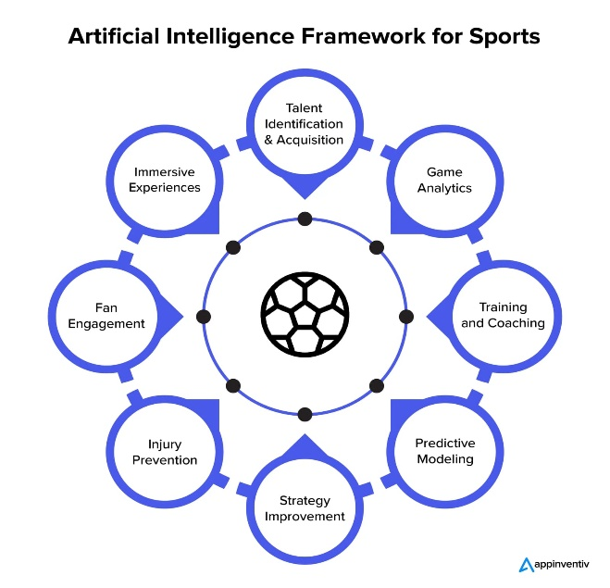

**Proposed Figure 1: Predictive Analytics [4] in Sports**

A data-driven future for sports analytics is being shaped by the use of Big Data [5] and Deep Learning. Sports teams may make well-informed decisions that optimize performance, enhance spectator experiences, and improve athlete health by utilizing large amounts of data and sophisticated algorithms.

**1.2 Role of different fields**

**1.** **Data Science and Statistics :**

Data scientists' role is to create and use statistical models to analyze big data sets and produce insights that can be put to use. They support the development of sports prediction models, the measurement of correlations between performance metrics, and the monitoring of changes over time.

**2**. **Artificial Intelligence and Machine Learning:**

Experts in AI and ML create models to automatically analyze enormous amounts of sports data by gleaning intricate patterns and insights from unprocessed data. Deep learning models recognize and classify player movements, evaluate form, and instantly improve technique.  
Reinforcement Learning: Teams can try different approaches and improve decision-making through AI-based simulations. Analyzing team sentiment and communication through natural language processing can aid in determining player morale and team cohesiveness.

**3**. **Sports Medicine and Physiotherapy**:

By utilizing data to create individualized strategies that maximize healing and long-term health, this profession aids in injury prevention, treatment, and rehabilitation. Injury Prediction Models: These models use biomechanical analysis and player health data to determine injury risk variables and recommend preventative actions. Monitoring recovery indicators to make sure athletes are getting back to their best after suffering an injury.

**1.3 Recent advancement**

**1. Real-Time Analytics with Edge Computing**:

By processing data closer to the source (such as wearables or cameras) rather than depending on cloud-based servers, edge computing has made real-time analytics possible. For in-game modifications, this technology's rapid feedback and reduced latency are essential.

**2. Computer Vision and Pose Estimation [6] for Technique Improvement**:

More precise pose estimation and action recognition in video footage are now possible because to the substantial improvements made to deep learning models in computer vision. AI systems can now analyze player motions frame-by-frame thanks to these developments.

**3. Predictive Injury Prevention Models Using Biomechanics Data**:

**Development**: AI can already identify trends that predate injuries thanks to the inclusion of granular biomechanical and physiological data in big data. These models monitor a variety of parameters, such as muscle activation, load, and joint movement, and compare them to past injury cases.

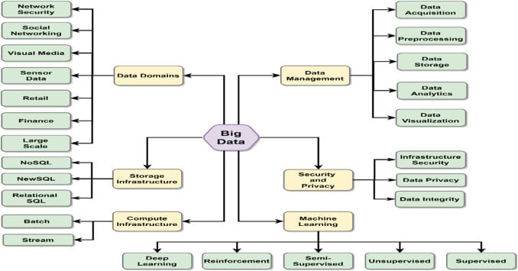

**Proposed Figure2:** **Features of Big Data and Deep Learning in Sports Analytics**

**1.4 Challenges**

**1. Data Privacy and Security Concerns**:

There are privacy and security issues when collecting data from athletes, particularly physiological and health data. Strict security protocols and compliance with privacy rules are necessary for sensitive data, such as biometric and injury data. To guarantee that athlete data is safeguarded, teams need to make investments in safe data processing and storage solutions. Failing to do so may result in violations of laws like the GDPR and damage sporting organizations' reputations.

**2. Data Quality and Standardization**:

It can be challenging to guarantee consistent data quality and standards in sports because data comes from a variety of sources, including wearables, video analysis, player statistics, and social media. Inaccurate insights might result from inconsistent or poor-quality data, which reduces the efficacy of analytics models. Although standardization across teams, leagues, and regions is difficult and time-consuming, it is essential for accurate analysis.

**3. Resource Limitations for Smaller Organizations**:

Smaller groups or non-profits frequently lack the funds and resources necessary to purchase wearable technology, AI platforms, and sophisticated analytics tools. Because larger teams with more funds have access to more sophisticated insights and optimization tools, this leads to an imbalance in the competition. The cost barrier prevents data-driven performance optimization from being widely used.

**4. Change Management and User Adoption:**

Smaller groups or non-profits frequently lack the funds and resources necessary to purchase wearable technology, AI platforms, and sophisticated analytics tools.  
Because larger teams with more funds have access to more sophisticated insights and optimization tools, this leads to an imbalance in the competition. The cost barrier prevents data-driven performance optimization from being widely used.

1. **Literature Review**

The application of big data analytics to sports performance has drawn a lot of attention from academics, practitioners, and business professionals in recent years. This phenomenon has been the subject of numerous literary works that range from technical methods to practical consequences for teamwork and athlete development. In sports, big data analytics is basically the collection, processing, and analysis of massive amounts of data from a variety of sources, including video recordings, wearable technologies, statistical databases, and tracking devices. Researchers have looked into the technical challenges of managing such large datasets, including data storage, processing speed, and algorithm scalability.

In addition to its influence on player performance and strategic planning, big data analytics in sports has also been examined in connection to fan interaction and business operations. Researchers have looked into how data-driven insights could enhance the overall fan experience by influencing marketing plans, ticket prices, sponsored activations, and the revenue generated by sports organizations. Despite the potential benefits, integrating big data analytics into sports is not without challenges. Data security, privacy, and moral risks are now hot subjects for debate and analysis. In order to uphold moral standards and protect people's right to privacy, academics have underlined the need for specific regulations and laws to regulate the collection, use, and distribution of athlete data.

Research on big data analytics in sports performance is extensive and varied, encompassing practical applications, ethical considerations, and technical methodologies. By applying big data analytics, sports companies may enhance performance, get valuable insights, and sustain a competitive edge in an increasingly competitive industry. However, the ethical and privacy consequences of data-driven activities must be carefully considered in order to preserve the sport's integrity and athletes' rights.

**3.Methodology**

When using big data analytics to sports performance analysis, a robust and systematic approach is required to guarantee that the data collection, processing, and analysis are in accordance with research objectives and practical applications. Data gathering, model deployment, and evaluation are all steps in the process of using Big Data and Deep Learning in sports analytics for performance optimization.

The recommended strategy outlined below provides a systematic framework for integrating big data analytics into performance analysis in sports:

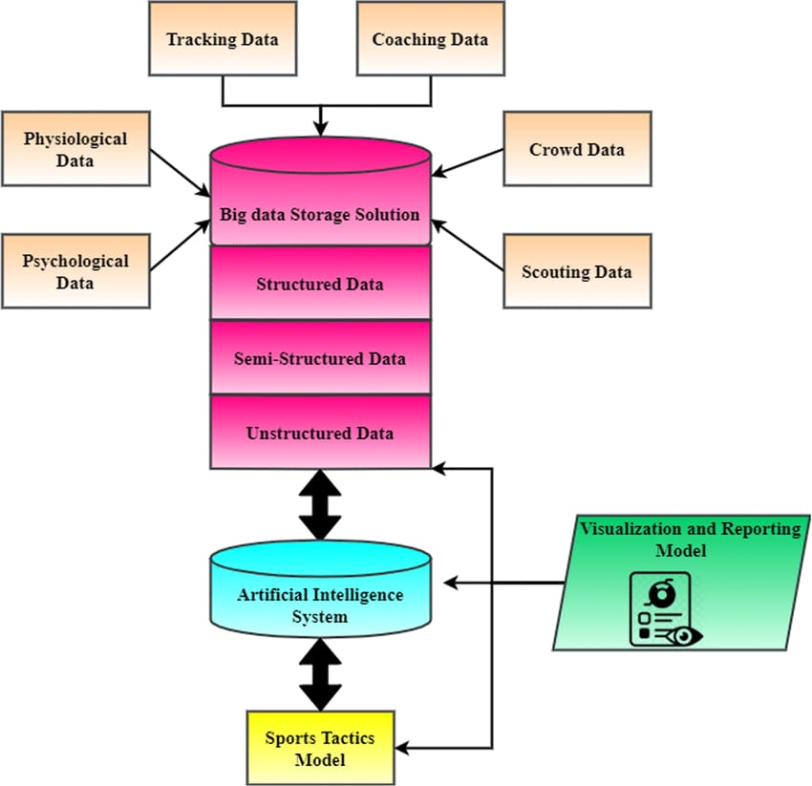

**Proposed Figure3: Architecture for Smart Health Monitoring System**

**Phase 1: Data Collection**

Gathering vast amounts of varied data is essential. Game performance data, biometric data, wearable physiological data, video footage, GPS monitoring, and even sentiment from social media are all included.   
Techniques: Wearable technology: Monitor vital signs in real time, such as heart rate, speed, acceleration, and weariness. Computer Vision: Record footage for action identification, pose estimation, and motion tracking. IoT sensors: Gather physical measurements (e.g., force, jump height) and environmental data (e.g., temperature, altitude).Outside Sources of Information: Make use of other resources like fan sentiment research, performance history, and weather information.

**Phase 2: Data Preprocessing and Integration**

Raw data is frequently available in a variety of formats and configurations. In order to guarantee consistency, dependability, and analytical applicability, the data is cleaned and transformed in this step.  
Data cleaning includes handling missing values, eliminating outliers, and fixing any errors.

Data should be standardized for compatibility with different models and analytic tools through normalization. Use applications to give players and coaches immediate access to model insights and actionable feedback while they're on the go.

Feature engineering is the process of identifying or developing new features that draw attention to crucial elements of player performance, such as biomechanical data, stress indications, or acceleration variations.

**Phase 3: Model Evaluation [2] and Validation**

Use evaluation metrics that are specific to the objectives of the sports analytics project to evaluate the model's success.  
**Methods:** F1 Score, Accuracy, Precision, and Recall are standard metrics for classification tasks, particularly in injury risk prediction or player action recognition.

**Mean Squared Error (MSE):** Applies to regression tasks like forecasting game results or player weariness.  
Confusion Matrix: Helps comprehend categorization errors by comparing true and expected values to assess model performance.  
**AUC (Area Under Curve) and ROC Curve**: Evaluate the model's capacity for discrimination; these metrics are particularly helpful in injury risk models to see how well the model distinguishes between players who pose a high and low risk.

**4.Conclusion**

Team competitiveness, coach strategy, and athlete training are all changing as a result of the use of big data analytics to sports performance analysis. In this paper, we've explored the various aspects of big data analytics' significance in sports, highlighting how it could transform player development, tactical innovation, injury prevention, fan interaction, and ethical considerations. By enabling them to glean valuable insights from vast quantities of data, big data analytics provides sports organizations with a comprehensive understanding of the dynamics of player performance, tactical planning, and audience behaviour.

By applying advanced analytics techniques like machine learning and predictive modelling, coaches and sports scientists can enhance strategic decision-making, boost performance outcomes, and lower injury risks.

The fan experience has also been totally transformed by big data analytics, which offers immersive experiences, tailored content, and interactive interactions that increase fan loyalty and generate revenue for sports organizations. To ensure that data-driven practices respect athletes' rights to privacy and consent while also adhering to ethical standards, it is imperative that privacy and ethical concerns be addressed as big data analytics advances. The future of big data analytics in sports is extremely bright, as new innovations like wearable technology, artificial intelligence, and real-time analytics are poised to further change sports performance analysis.

**5. Future scope**

Big Data and Deep Learning have a bright future in sports analytics, with developments anticipated to enhance performance optimization capabilities. These technologies will keep developing, offering information beyond the scope of present analysis and influencing how teams practice, plan, and interact with supporters.

**1. Real-Time Cognitive [1] and Emotional Analytics**:

 Real-time analysis of emotional, cognitive, and physical states will be feasible. Using information from biometric sensors, wearable EEG devices, and facial recognition, machine learning models may evaluate players' levels of motivation, stress, and attentiveness. By making in-game decisions based on an athlete's mental condition, coaches can provide specialized psychological assistance and mental resilience training, particularly in high-pressure situations.

**2. Advanced Injury Prediction and Prevention**:

 With greater accuracy and lead time, models will be able to anticipate injuries before they happen. Future models that incorporate information from biomechanics, player load, genetics, and past injuries will be better able to predict injury risks. Accurate injury prediction will enable improved rest guidelines, workload management, and customized recovery programs, thus extending athletes' careers and enhancing general health outcomes.

**3. AI-Powered Wearables with Embedded Deep Learning Models:**

Without depending on external devices or cloud resources, wearables with built-in AI models might process and evaluate data in real time. Wearables that offer real-time feedback on form, efficiency, and energy consumption fall under this category. Without relying on intricate data pipelines, these gadgets would provide previously unheard-of autonomy and real-time feedback, enabling high-tech analytics to be accessed even while practicing or on the go.

**6.References**

[1] What is Real time cognitive?

(<https://www.sciencedirect.com/science/article/abs/pii/S0364021384800026>)

[2] Model Evaluation?

(<https://domino.ai/data-science-dictionary/model-evaluation>)

[4] Predictive Analysis

([cloud.google.com/learn/what-is-predictive-analytics](https://cloud.google.com/learn/what-is-predictive-analytics))

[5] What is Big Data ?

(<https://cloud.google.com/learn/what-is-big-data>)

[6] Computer Vision and Pose Estimation

([https://paperswithcode.com/task/pose-estimation#:~:text=Pose%20Estimation%20is%20a%20computer,case%20of%20Human%20Pose%20Estimation.)](https://paperswithcode.com/task/pose-estimation%23:~:text=Pose%20Estimation%20is%20a%20computer,case%20of%20Human%20Pose%20Estimation.))

[7] Predictive Injury

([https://jeoesska.springeropen.com/articles/10.1186/s40634-021-00346-x)](https://jeoesska.springeropen.com/articles/10.1186/s40634-021-00346-x)%20%20%20%20%20%20%20%20%20%20%20%20%20%20%20%20%20%20%20%20%20%20%20%20%20%20%20%20%20%20%20%20%20%20%20%20)

[8] Albert, M. V., Han, J., & Cook, D. (2019). Modeling interactional contexts in sport using network theory: A review and an application. IEEE Transactions on Pattern Analysis and Machine Intelligence, 41(7), 1605-1619.

[9] Pappalardo, L., Cintia, P., Ferragina, P., Massucco, E., Pedreschi, D., & Giannotti, F. (2019). PlayeRank: Datadriven performance evaluation and player ranking in soccer via a machine learning approach. ACM Transactions on Intelligent Systems and Technology (TIST), 10(5), 27.

[10] Liu, H., Hopkins, W. G., Gómez, M. A., & Molinuevo, J. S. (2013). Inter-operator reliability of live football match statistics from OPTA Sportsdata. International Journal of Performance Analysis in Sport, 13(3), 803-821.

[11] Redwood-Brown, A. J., O'Donoghue, P. G., & Nevill, A. M. (2012). Influence of pitch dimensions on heart rate responses and technical demands of small-sided soccer games in elite players. Journal of Sports Sciences, 30(15), 1573-1580.

[12] Lago-Peñas, C., & Dellal, A. (2010). Ball possession strategies in elite soccer according to the evolution of the match-score: The influence of situational variables. Journal of Human Kinetics, 25(1), 93-100.