A review paper on

**Military Surveillance Drone**

1Sneha Gulhane , 2Janhavi Abruk , 3Anjali Raut , 4Prachi Poharkar , 5Shravani Kale ,

6Shrejal Gawaner, 7Shri R.M.Gharat

123456Students, Electronics Engineering.

7HOD, Electronics Engineering.

Dr. Panjabrao Deshmukh Polytechnic, Amravati , Maharashtra ,India.

***Abstract :-***

*This research presents the design and development of a mobile-operated unmanned aerial vehicle (UAV) tailored for military surveillance and reconnaissance missions. The UAV integrates a high-resolution camera system optimized for real-time intelligence gathering. Controlled via a secure mobile interface, the drone offers portability and ease of operation, enabling rapid deployment in field scenarios. Key features include a lightweight design, extended battery life, low acoustic signature, and robust communication systems to ensure mission continuity under challenging conditions.[6]*

Keyword :- Mobile-operated UAV, Surveillance , Cost effective , Real-Time Intelligence , Lightweighted.

**Introduction**

Unmanned Aerial Vehicles (UAVs), often referred to as military drones, are pilotless aircraft remotely controlled by operators or programmed to fly autonomously. These drones have revolutionized military operations, enabling the execution of tasks that were once perilous or impractical for humans . Initially employed primarily for surveillance and reconnaissance, UAVs have evolved significantly. Today, they are utilized for a diverse range of missions, including precision strikes, supply delivery, communication disruption, and real-time intelligence gathering.

The primary advantage of UAVs lies in their ability to operate in hazardous environments without endangering human lives. Equipped with advanced cameras, sensors, and communication systems, these drones are highly effective in various operational contexts. Notable examples such as the MQ-9 Reaper and Bayraktar TB2 have demonstrated the transformative impact of drones on modern warfare, where speed, accuracy, and safety are paramount.

This research paper delves into the historical development of military drones, their cutting-edge capabilities, and their contemporary applications. It further explores the benefits and challenges associated with drone technology, including ethical considerations and future prospects. As technology continues to advance rapidly, drones are poised to become an increasingly indispensable component of military strategies, shaping the future of defence and security.

The history of military drones, also known as unmanned aerial vehicles (UAVs), can be traced back to the early 20th century and includes the following notable events:

In 1964 is the 1st time in world the drone is used for surveillance:The First Wave of Military Drones the Vietnam War marked a significant turning point in military history with the widespread deployment of unmanned aerial vehicles (UAVs). The U.S. military introduced the Ryan Model 147, nicknamed the "Lightning Bug," as its primary reconnaissance drone. Over 3,400 of these drones were deployed, each averaging three missions before being lost.

The Indian Army first used a military surveillance drone in 1999 to fight guerrilla forces in the Kashmir Valley. The drone, called the Nishant, was developed by the Defence Research and Development Organization (DRDO) to meet the Army's operational needs.

Despite their widespread use and advanced capabilities, military UAVs (drones) still face several unresolved challenges and limitations. These problems hinder their full potential and raise concerns about their effectiveness, reliability, and ethical use. Some of the key unresolved problems include:

1. Vulnerability to Cyberattacks
2. Autonomy and Decision-Making
3. Weather and Environmental Limitations
4. Detection and Countermeasures
5. Cost and Maintenance

By incorporating affordable materials such as pencils, wires, and rubber tubes, we have demonstrated that cost is no longer a limiting factor in UAV development. This innovative approach allows for the creation of reliable, functional, and scalable military drones without the financial burden of traditional manufacturing methods. These cost-saving measures pave the way for broader adoption and greater accessibility of UAVs in diverse operational scenarios.

Weight Distribution and Drone Stability Weight distribution significantly impacts a drone's flight stability and performance. By optimizing the placement of heavier components, drones can achieve a lower centre of gravity, enhancing their manoeuvrability and overall flight characteristics.

Lightweight Design for Enhanced Performance UAVs achieve weight reduction through innovative materials, optimized design, efficient batteries, and miniaturized components. This enables improved performance, longer flight times, and increased efficiency. [6]

**Literature Review :**

In 1964 is the 1st time in world the drone is used for surveillance:The First Wave of Military Drones The Vietnam War marked a significant turning point in military history with the widespread deployment of unmanned aerial vehicles (UAVs). The U.S. military introduced the Ryan Model 147, nicknamed the "Lightning Bug," as its primary reconnaissance drone. Over 3,400 of these drones were deployed, each averaging three missions before being lost.

The Indian Army first used a military surveillance drone in 1999 to fight guerrilla forces in the Kashmir Valley. The drone, called the Nishant, was developed by the Defence Research and Development Organization (DRDO) to meet the Army's operational needs.

Drone technology has evolved significantly over the decades, with its origins dating back to the early 20th century. Here's a brief history of drone technology, from its beginnings to modern developments:

1. Early Developments (Pre-World War II)

1916-1917: The concept of using drones (then called "aerial targets") began to emerge during World War I. The idea was to create a target for anti-aircraft training, but it wasn’t developed into a functional technology at this stage.

1930s: The U.S. Army developed the first radio-controlled aircraft, primarily used as targets for training anti-aircraft gunners. These were early versions of UAVs, but still very basic.

2. World War II (1939-1945)

Radio plane: One of the first successful military drones was the Radio plane, developed by actor and inventor Dr . Jack Northrop and later improved by Clarence "Kelly" Johnson. The Radio plane was used for target practice by the military during the war.

U.S. and British Use: The development of UAV technology accelerated as both the United States and the United Kingdom began to explore its potential for training and reconnaissance missions. These early drones were primarily used for target practice rather than active combat.

3. Cold War Era (1947-1991)

1950s-1960s: The Cold War spurred further technological advancements. The RQ-2 Pioneer, developed in the 1980s, was one of the first UAVs to be used for tactical surveillance and reconnaissance. These UAVs were primarily employed for gathering intelligence without risking human lives.

1950s-1970s: The U.S. developed early reconnaissance drones, such as the Ryan Firebee , which were used for intelligence gathering and reconnaissance missions. These drones were used primarily for military reconnaissance over hostile territories.

4. The Gulf War and Precision Strike (1990-1991)

The use of drones in military operations was significantly highlighted during the Gulf War. The Pioneer UAV provided real-time surveillance to military commanders, helping in the targeting of enemy forces. Drones began to prove their potential for both reconnaissance and tactical operations.

Global Hawk (1995): Developed by Northrop Grumman, the RQ-4 Global Hawk became one of the most advanced surveillance UAVs in the world. It provided high-altitude, long-duration reconnaissance and could cover vast areas with its powerful sensors.[6]

5. Post-9/11 and the Rise of Armed Drones (2000s)

2001-2002: The War on Terror marked a turning point for drone technology, with armed drones like the MQ-1 Predator being used extensively for targeted strikes in Afghanistan, Iraq, and other regions. The MQ-1 Predator was equipped with Hellfire missiles and used for both surveillance and precision strike missions.

2004: The MQ-9 Reaper, an upgraded version of the Predator, was introduced and became a key player in military operations. With more powerful engines and the ability to carry heavier payloads, the Reaper proved to be a major asset in precision bombing and surveillance.

6. Modern-Day Drones (2010-Present)

Technological Advancements: Modern military drones are equipped with advanced sensors, cameras, GPS, and weaponry. Drones like the MQ-9 Reaper, MQ-1C Gray Eagle, and RQ-4 Global Hawk are regularly used for intelligence, surveillance, reconnaissance, and strike missions in conflict zones .Autonomous and Swarming Technology: In recent years, there has been significant progress in the development of autonomous drones and "swarming" technology. Drones can now operate with minimal human input, communicate with each other, and carry out coordinated operations. This has expanded the role of drones in both military and civilian applications.

7. Drone Warfare and Ethical Concerns

Remote Warfare: Drones have become a symbol of modern "remote warfare," where military forces can engage enemies without putting their personnel in harm’s way. This has led to significant ethical debates about the use of drones in warfare, particularly with regard to targeted killings, civilian casualties, and the psychological impact on drone operators.

Proliferation and Global Use: Today, drones are used by many countries for surveillance, reconnaissance, and combat operations. The proliferation of drone technology has led to concerns about arms races, terrorism, and the potential use of drones in asymmetric warfare.[4]

One of the stories exposed the employment of a Skystar aerostat surveillance device in Jerusalem to track confrontations between Palestinians and Israeli military sources. Jerusalem has benefited from drone-delivered communication in protecting its national security. Drones are no longer only employed by the military; citizens are now using them as well. Figure 5 shows the positive inclination on the usage of drone among public projected by US Department of Transportation. The extension on the use of drone among public has led towards the national issues pertaining to safety. However, study conducted indicated that drone has also aided communication as key enabler of 5G and act as resilient to public safety network . In other report found, the use of drones has also been used in assisting firefighters during emergency situations. The situation shows a continuous climb on the use of drone until the year 2035. Future of drone use is bright and expected to be much advanced.[8],[9].

**Proposed Methodology:**

Drones, or unmanned aerial vehicles (UAVs), consist of several basic components that work together to ensure flight, control, and communication. Below are the primary components typically used to build the drone:

* 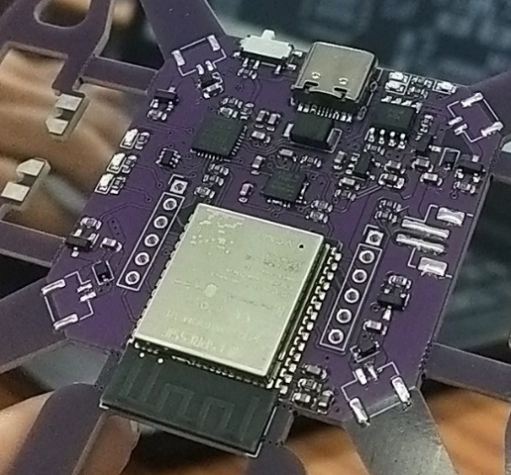**Frame**

Fig 1 Drone Frame

The drone frame serves as the backbone, supporting all essential components. Its design significantly influences flight characteristics. A well-designed frame must be lightweight yet robust, ensuring even weight distribution for optimal balance and performance . The frame is the structure of the drone that allows all the components to be assembled. The parts of the drone are attached to the frame in a configuration that allows the drone to have excellent aerodynamic performance. The drone must be light enough to take off, but strong enough to support the whole structure. The frame protects the sensitive electrical components of the drone.

Carbon Fiber is a preferred material for drone frames because of its strength-to-weight ratio. Almost all drone structures are made from carbon Fiber composites.

The size of a drone is often measured by the diagonal distance between the motor center, which is called the "wheelbase". The wheelbase determines the size of the drone and can impact its flight characteristics.

There are different types of drone frames, including racing frames, freestyle frames, and long-range frames. Racing frames are typically small and lightweight and are designed for high-speed, agile flying.

* **ESP32:**

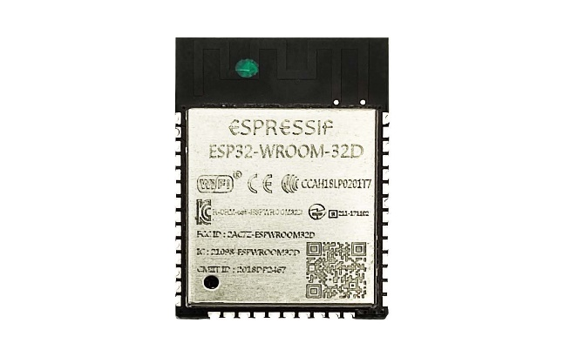

Fig 2 ESP 32

The ESP32 is a smart chip that's great for simple drones. It can connect to Wi-Fi, Bluetooth, and other wireless things, and it can work with sensors. But for more advanced drones that need to flysmoothly, process videos in real-time, and navigateautonomously, stronger chips like those based on ARM Cortex are usually better.

Drone Bridge for ESP32 supports ESP-NOW LR, enabling ranges of more than 1km with external receiving antennas. The number of drones is only limited by the channel capacity and the ESP32s processing power. All data is encrypted using AES256-GCM.This low-power programming circuit uses less power and it offers support to low-power mode states. Another nice feature of ESP32 is that it can be easily connected to a Wi-Fi network to link to the station mode. Also, you can create a Wi-Fi wireless network for ESP32 to enables the connection of other devices.

* **ESP CAM**

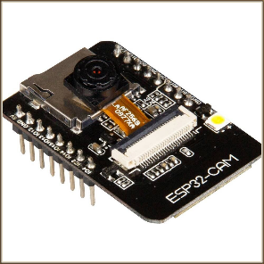

Fig 3 ESP CAM

The ESP CAM typically refers to a series of camera modules based on the ESP32 microcontroller, specifically designed for integrating Wi-Fi and Bluetooth functionalities with a camera system. The most common of these modules is the ESP32-CAM, which is an affordable and compact development board that combines a camera with wireless communication capabilities, making it suitable for various IoT (Internet of Things) projects. The ESP32-CAM is a small size, low power consumption camera module based on ESP32. It comes with an OV2640 camera and provides onboard TF card slot. The ESP32-CAM can be widely used in intelligent IoT applications such as wireless video monitoring, Wi-Fi image upload, QR identification, and so on[10].

* **SI2303**

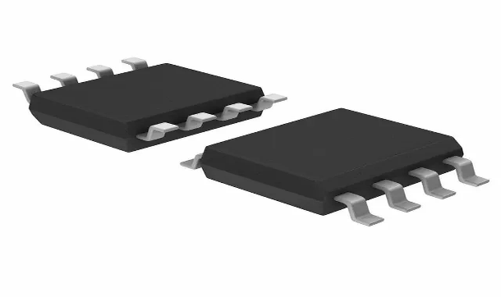

Fig 4 SI2303

The SI2303 is a P-channel MOSFET commonly used in electronic circuits for power management and switching applications. In the context of UAV (unmanned aerial vehicle) drones, the SI2303 is often integrated into power distribution, motor controllers, or other subsystems where efficient control of power is essential.

* 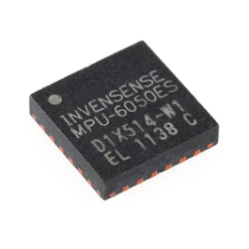**MPU6050**

Fig 5 MPU6050

The MPU6050 is a 6-axis motion tracking device that combines a 3-axis gyroscopeand a 3-axis accelerometer in a single package. In UAV (unmanned aerial vehicle) drones, it is a critical component for attitude and orientation sensing, allowing the drone to maintain stability, control, and perform precise manoeuvres. The MPU6050 can be used to control the roll, pitch, and yaw of a quadcopter. It can also be used to build an electronic level that displays the level of a surface on an LCD and with LEDs.

* 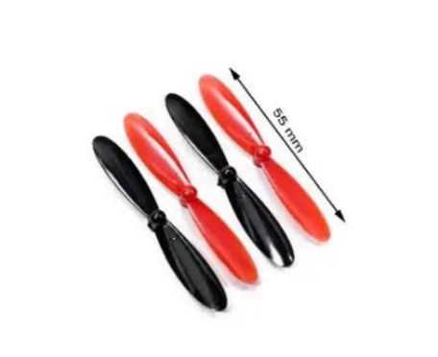**Propellers**

Fig 6 Propellers

Propellers for Drones and UAVs. Propellers are devices that transform rotary motion into linear thrust. Drone propellers provide lift for the aircraft by spinning and creating an airflow, which results in a pressure difference between the top and bottom surfaces of the propeller. Propellers are avital part of a drone's flight system, and they are responsible for:

Propellers spin to create lift by generating a pressure difference between the top and bottom of the propeller. This difference in pressure accelerates air in one direction, which counteracts gravity. Propellers help maintain stability and control of the drone. Propellers allow the drone to travel in different directions. The size, pitch, number of blades, and materials of a drone's propellers all affect its performance

* **Motors**

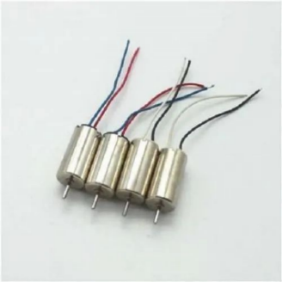

Fig 7 Motors

The motors used in UAV drones are typically electric motors chosen based on the type of drone, its purpose, and the required performance characteristics. These motors can be broadly categorized into brushless DC motors (BLDC) and brushed DC motors, with brushless motors being the industry standard for most UAVs due to their efficiency and reliability. A [drone motor](https://mechtex.com/products/drone-motors) is a type of electrical motor specifically designed for use in drones. These motors are crucial components and provide the necessary thrust to the drone to propel it into the sky. Drone motors come in various sizes and configurations, and power rating depends on the requirements of Unmanned aerial vehicles (UAVs).These motors are lightweight and compact to ensure optimal performance and efficiency by minimizing the overall weight of the drone. They are made to deliver a high level of power output while minimizing energy consumption, thereby increasing flight time and endurance.

* **Pencils**

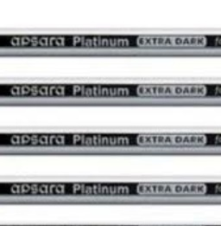

Fig 8 Pencils

To maintain the weight so the drone will not lost its balance while flying

* **Black heat shrinkable tube**

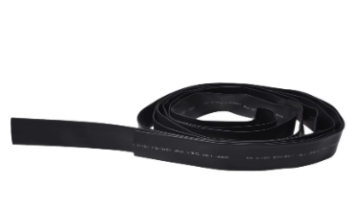

Fig 9 Shrinkable tube

It is use to hold the pencil at its place so the pencil will not move from its place and its diameter is 18mm

* 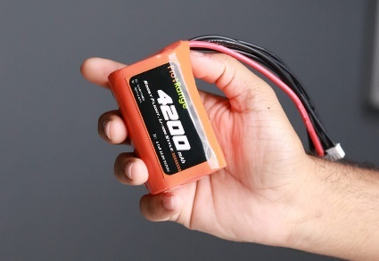**Battery**

Fig 10 Battery

Lithium Polymer (LiPo) batteries are the most widely used batteries in UAV drones due to their lightweight, high energy density, and ability to deliver high current (discharge rates). These characteristics make them ideal for providing the necessary power for stable and efficient drone flight. Each LiPo cell has a nominal voltage of 3.7V and a fully charged voltage of 4.2V.[4]

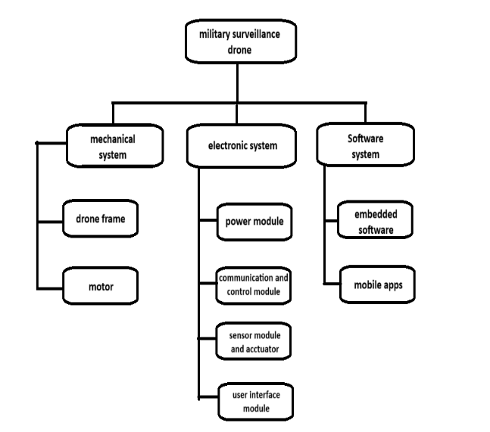**Block Diagram**

Fig 11 Block diagram of military surveillance drone

Mechanical system :In mechanical system there is drone frame and motors along with propellers on the drone frame there are the components mounted which are mentioned above

Electronic system : In this there are power module, communication module and control module connected through which the communication will be done .there is sensor module , actuator and user interference module. The Sensor modules are critical components in UAV (Unmanned Aerial Vehicle) drones. They enable drones to sense and respond to their environment, ensuring safe, efficient, and autonomous operation. The User Interface (UI) module in a UAV (Unmanned Aerial Vehicle) drone provides a bridge between the drone's operational systems and the human operator. It allows users to interact with, monitor, and control the drone effectively

Software system: In the software system there is Embedded systems in drones are responsible for a drone's flight, data collection, and communication. They are designed to perform these tasks efficiently and reliably and mobile apps through which we will fly the drone and will see the real time image during the operation.

**Steps to build a drone**:-

Step 1: Choose a Frame

Step 2: Select the Motors and Propellers

Step 3: Choose a Flight Controller

Step 4: Select a Radio Transmitter and Receiver

Step 5: Choose a Battery and Power Distribution System

Step 6: Assemble the Components

Step 7: Configure the Flight Controller

Step 8: Test and Fly

At first we will connect the battery to the drone after giving the supply the motors will start to rotate and the sensors will sense the condition the drone will be connected through an mobile application as we will fly the drone by the help of mobile app and will control it as the drone is small in size and light weighted the drone will not face much problem as there is camera connected to the drone through which we will get the real time image on the mobile phone through the application the range of the drone can be vary by making modifications in the circuit it is a cost effective product and easy to handle and the size of drone is small so we can fly the drone in small areas as it will need less space that other drones .[5]

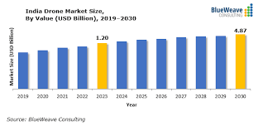**Conclusion :**

Fig 12 Graph of India’s drone market [11]

The Indian drone market is experiencing rapid growth, driven by increased adoption across industries such as agriculture, logistics, surveillance, and defence. As of 2024, the market size is estimated at $1.3 billion and is expected to grow at a compound annual growth rate (CAGR) of approximately 20-25% during the next decade. By 2030, the market is projected to reach $4.87 billion.

Key factors contributing to this growth include government initiatives like the Production Linked Incentive (PLI) scheme to encourage domestic manufacturing and reduced dependency on imports, particularly from China. Applications like precision agriculture, mapping, surveying, and delivery services are also driving demand.

The military drone market is expected to grow to USD 47.16 billion by 2032, with a compound annual growth rate (CAGR) of 13.15%. The United States is the world's leader in military drone capabilities, with over 13,000 unmanned aerial vehicles (UAVs).

Using UAV drones for military surveillance is a smart way to monitor areas without putting people at risk. To make these drones cheaper, we can focus on simpler designs with only the most important parts for tasks like capturing images or videos and sending data. Building the drones locally and using lightweight, efficient materials can also save money.

The key is to cut costs without losing reliability. Even with fewer components, the drone must still do its job well in tough conditions. This approach ensures that the drones are affordable and effective for military surveillance.

**Reference:**

1. Matyas Palik, Máté Nagy BRIEF HISTORY OF UAV DEVELOPMENT DOI: 10.32560/rk.2019.1.13
2. Journal of Physics: Conference Series PAPER • OPEN ACCESS Development of surveillance drone based internet of things (IoT) for industrial security applications To cite this article: H Ali et al 2021 J. Phys.: Conf. Ser. 2107 012018
3. Brig (Dr) Navjot Singh Bedi (Retd) DRONES AS FORCE-MULTIPLIER IN FUTURE WARS SYNERGY – Volume 2 Issue 2 • September 2023
4. Robert Callum (2001) War as a Continuation of Policy by Other Means: Clausewitzian Theory in the Persian Gulf War, Defense Analysis, 17:1, 59-72,
5. H Ali, L Y Hang, T Y Suan, V R Polaiah, M I F Aluwi, A A Mohd Zabidi, M Elshaikh1
6. OpenAI. (2023). ChatGPT (Feb 13 version) [Large language model].
7. Army War College, “Principles of Warfare on the Network-Centric Battlefield
8. He, D., Chan, S., & Guizani, M. (2017). Drone-assisted public safety networks: The security aspect. IEEE Communications Magazine, 55(8), 218-223.
9. Yanmaz, E., Quaritsch, M., Yahyanejad, S., Rinner, B., Hellwagner, H., & Bettstetter, C. (2017). Communication and coordination for drone networks. In Ad hoc networks (pp. 79-91). Springer, Cham.
10. Akgüç B. FPV Camera Selection for RC/FPV planes and Drones. 2023.Availablefrom:https://avdesodrone.com/rc-fpv-ucaklar-ve-dronlar-icin-fpv-kamera-secimi.
11. The Bureau Investigative Journalism. History of Drone Warfare. Retrieved from https://www.thebureauinvestigates.com/explainers/history-of-drone-warfare.