CONSTRUCTION OF SECANT PILE WALL FOR UNDERGROUND STRUCTURE
Dharmendra Vishwakarma¹

** ¹M.Tech. Scholar, School of Civil Engineering, Faculty of Engineering and Technology
Madhyanchal Professional University Bhopal, M.P**

Dr. Ashish Kant Ahirwar²
** ²Assistant Professor, School of Civil Engineering, Faculty of Engineering and Technology
Madhyanchal Professional University Bhopal, M.P **

Abstract
The construction of underground structures or building works is very challenging for engineers, both in the field of design and on-site execution, as they must address various site problems occurred during the design phase of the region. As the soil strata differs from region to region the problem also differs, and hence separate detail design need to be carried out followed by Geotechnical Investigation to find out the solutions and innovations in the Engineering design. This project synopsis report aims to understand the challenging aspects and the various in situ issues during the construction phase for the design. Based on the geotechnical investigation data and results the GTI (Geotechnical Investigations Report) and the GRF (Geo-factual reports) are to be prepared which shows the approximate profile of the soil strata with respect to depth generally called as “lithological profile”, design of secant pile is carried out taking into all the factors and parameters as obtained in the GFR/GIR. In this study to design the retaining wall as a secant pile wall method, we have examined the soil profile, rock strata, and their properties, which are dynamically changes with increasing depth. Additionally, we have explored the effects of pore water pressure on the side face of the soil and, most importantly, the uplift pressure acting upon the base slab of the structure. The study also includes an analysis of earth retaining techniques, such as secant pile construction and shot Crete concrete.

Keywords: Underground structures, Geo-factual reports, Dynamically changes, GFR/GIR, Crete concrete.

Introduction
The project is located at BKC (Bandra Kurla Complex) area of Mumbai city in the Maharashtra a financial state of India.
Mumbai HSR station is the originating station for the high-speed line of Mumbai - Ahmedabad high speed rail (MAHSR). The work under this package shall be suitable for maximum design train speed of 350 km/hr. and operating speed of 320 km/hr.

Meteorological Information: -

Temperature: The mean average temperature of Mumbai is 27.2°C. The mean maximum average temperature of Mumbai is about 32°C in summer and 30°C in winter, while the average minimums are 25°C in summer and 18°C in the winter.

Rainfall: Rainy season is from June to September. Most of the annual rainfall is concentrated in this period. The normal annual rainfall varies from about 1800mm to about 2400 mm. The BKC area is prone to flooding as happened in July 2005.

Wind: Like mainly from southern and southwestern direction blow during summer in Twitter light winds blow from Northwest and Northeast during monsoon however, moderate to heavy build prevails from south and south-western direction mean wind speed ranges from 4.5 km/hr. during winter 2 more than 9.2 km/hr. during summer and monsoon.

Humidity: The climate of Mumbai is a tropical wet and dry climate. Mumbai’s climate can be best described as moderately hot with level of humidity. The relative humidity varies in the pre-monsoon and monsoon months from about 80% to 86%, reducing to about 67% in the dry season.

Literature Review

V. Silva et al. (2023) focuses on the finite element analysis (FEA) of deep excavation supports using a secant pile wall, providing valuable insights into the modeling and parameter selection for such systems. To develop accurate modeling strategies for deep excavations using field data and two-dimensional finite element analysis. The study emphasizes the elastic modulus (E50) of the soil, which can be adjusted to reflect the unloading-reloading stiffness (Eur). This adjustment is crucial as Eur typically exceeds E50 by several times during. Proper calibration of these parameters ensures a realistic simulation of soil behavior under stress changes. Recommendations are made for selecting appropriate soil parameters and improving the modeling process to capture the complex interactions between the secant pile wall and surrounding soil. Accurate selection of soil stiffness parameters is critical for predicting wall deformation and soil displacement during excavation. The study highlights the importance of using field data for calibration and suggests increasing E50 values to approximate unloading-reloading stiffness for more precise predictions. This study underscores the significance of realistic parameter selection and field validation in designing effective deep excavation support systems. It is particularly useful for engineers and researchers working with secant pile walls in challenging geotechnical conditions.

Jigar Shah et al. (2020) focuses on a comparative analysis of diaphragm walls supported by anchors versus tube shoring systems, with a case study involving a mix of diaphragm walls and secant pile walls as earth-retaining structures for deep excavations. Structure: A deep shoring wall designed for a 26m excavation to accommodate four basements and a multi-story building. The study offers insights into the stability, deformation, and efficiency of these retaining structures. By comparing the structural behavior under the excavation loads.

Method and analysis
The study deals into the behavior of soil and rock strata, meticulously observing how their properties and stability change with increasing depth towards the center of the earth, which is particularly crucial in the construction of underground buildings of multiple stories. This comprehensive research involves collecting extensive data about the region's geological conditions, including detailed soil profiles, chemical, physical properties and their mechanical and hydraulic behaviors. The study also encompasses a thorough analysis of earth-retaining schemes, examining various methods to prevent soil collapse and ensure stability during excavation. It scrutinizes the impacts of uplift thrust and water pressure at greater depths, vital factors that influence the safety and feasibility of underground construction. Additionally, the research addresses the selection of appropriate foundation types tailored to the specific soil and rock conditions encountered. Finally, it culminates in the design of the building structure, ensuring that it can withstand the unique challenges posed by subterranean environments. The earth excavation will be meticulously planned and executed in steps or layers, with each phase designed to concurrently support the surrounding earth profile from the side face, maintaining stability and minimizing the risk of collapse or shifting during the construction process. This step-by-step approach ensures that the excavation progresses safely and efficiently, laying a robust foundation for the development of underground structures.
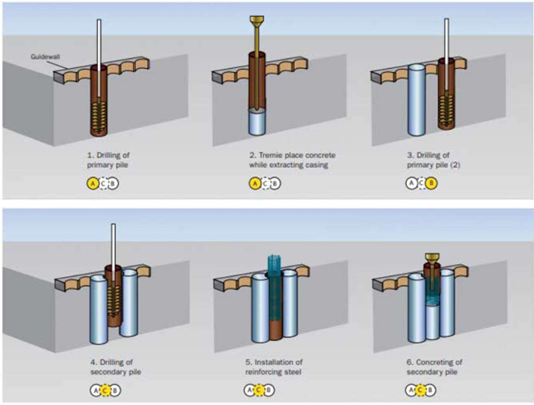
Figure 1 – Typical sequencing for PCC and RCC secant pile casting

Result and Discussion
Design of Secant pile
The results from the numerical analyses are presented in the Appendix B. Results are included to highlight the Factor of safety, forces in secant pile & anchors/ bolts, contours for shear strain, horizontal & vertical displacements, seepage volume, pore water pressure, total water head, for critical stages.
Secant piles are classified into three types based on the depth as per tender geotechnical data.
Type of Secant piles

Table1– Designed Depth of Secant Pile

Type | Depth range (in m BGL)
Type-1 | 13 to 16 m
Type-2 | 17 to 19 m
Type-3 | 19 to 21 m

The factor of safety estimated at the end of excavation is shown in table below.
Table2– Designed Factor of Safety for Secant Pile
Type | Factor of Safety (FoS)
Type-1 | 1.708
Type-2 | 1.727
Type-3 | 1.736

Shows the summary drawn from the results of 15.5 m, 19m and 21m deep secant pile analyses.
Table 3 – Result of Designed Pile
Analysis | Max Horizontal Displacement of Secant Pile  (mm) | Max Bending Moment in the pile (kN-m) | Ma Axial Force in pile  (kN) | Max Shear Force in pile  (kN)
Type-1 | 18 | 227 | 419 | 355
Type-2 | 23 | 291 | 412 | 471
Type-3 | 27 | 335 | 687 | 551

The surface settlement as evaluated in numerical model are shown in table below
Settlement Analysis | Max Vertical displacement at Ground level  (mm)
Type-1 | 13
Type-2 | 17
Type-3 | 23

Conclusion
The design of a Secant pile wall presents significant challenges due to the complex ground conditions encountered during construction. However, with comprehensive testing and the derivation of accurate results, the design and execution process can be made more manageable on-site. Several crucial factors must be considered during this phase, such as construction safety, landslide risks, shifts in rock strata, and potential failures in execution methods. As infrastructure development continues to expand, Secant pile construction offers a promising solution for facilitating underground works and structures. This method holds immense potential for both designers and construction agencies, as it provides a viable option for stabilizing and reinforcing below-ground structures. Furthermore, advancements in underground structure design could increasingly adopt the Secant pile wall construction technique, allowing for additional modifications and improvements based on its foundational principles.
References
[1] J. E. Bowels, Foundation Analysis and Design – Fifth Edition.
[2] Foundation Design Manual by M V Nayak, Pg. No 29-32.
[3] Proceedings from Workshop on Rock Mechanics & Tunnelling Techniques, ISRM (India) and CBIP, 24-26 April,2008, Manali, HP (India).
[4] Practical Rock Engineering by Dr. Evert Hoek, 2007 ed (Updated paper 2023).
[5] Embedded retaining walls - Guidance for Economic Design - CIRIA C580,2003.
[6] BS 8002 - 1994, Code of practice for Earth retaining structures.
[7] IS:14448-1997: Code of Practice for Reinforcement of Rock Slopes with Plane Wedge Failure. [8] IS:3025 (Part 24) (1986, Reaffirmed 2009): Method of Sampling and Test (Phys- ical and Chemical) for Water and Wastewater, Part 11,24,32,51.
[9] FHWA-NHI-14-007 (2015): Soil Nail Walls Reference Manual
10] LITTLEJOHN G.S. (1980), “Design Estimation of Ultimate Load-Holding Capacity of Ground Anchors”.
[11] JB Burland, JR Standing, “Building response to tunneling Case studies from construction of the Jubilee Line Extension, London VOLUME 1”.
[12] IS:10270-1982: Guidelines for Design and Construction of Prestressed Rock Anchors.
[13] Building response to tunneling Case studies from construction of the Jubilee Line Extension, London VOLUME 1; JB Burland, JR Standing. Page-62

