Artificial Intelligence in Human Brain Research

*Ms. Garima Saraswat Student*

*B. Tech, Student*

*Dept. Of Artificial Intelligence and Data Science,*

*Poornima Institute of Engineering and Technology, Jaipur, Rajasthan, India*

*Email* [garimasaraswat85@gmail.com](mailto:garimasaraswat85@gmail.com)

*Ms. Alka Rani Assistant Professor*

*Dept. Of Artificial Intelligence and Data Science,*

*Poornima Institute*

*of Engineering and Technology, Jaipur, Rajasthan, India*

*Email* [*alka.rani@poornima.org*](mailto:alka.rani@poornima.org)

# Abstract-

### Artificial intelligence (AI) has emerged as a transformative force in human brain research in to decode neural structures, analyze complex neuroimaging datasets and predict neural states Deep learning, theory unambiguous, graph neural networks enabling images Using such sophisticated techniques, AI improves the accuracy of diagnostic tools, facilitates real-time neural decoding between brain and computer communications (BCIs), and automotive innovation in aerotherapeutics This technology enables researchers to model complex cognitive processes, identify biomarkers of neurodegenerative diseases and they are empowered to develop treatment plans Integrating AI into brain research also extends to multimodal data fusion, combining neuroimaging with genomics and proteomics to provide a comprehensive view of brain health Recent advances in interpretable AI (XAI). addresses interpretive challenges, enabling clinicians to make informed decisions that improve insights into neurological manifestations data processing Activated- neuromodulation. The technologies are optimizing medical applications for conditions such as epilepsy and depression by personalizing stimulation protocols based on real-time feedback. Despite its transformative potential, the adoption of AI in human brain research is not without challenges. Concerns over data privacy, algorithmic bias, ethical implications, and the high cost of infrastructure highlight the need for robust frameworks to ensure equitable and responsible deployment. Addressing these issues will be critical to unlocking AI's full potential in neuroscience.

**Keywords— Artificial intelligence, Neuroscience, Brain- computer interfaces, AI-driven neuroimaging, Personalized mental health treatment, Ethical challenges in AI.**

1. Introduction

The integration of artificial intelligence (AI) into human brain research heralds a transformative shift in neuroscience, enabling deeper insights into brain challenges AI has revolutionized traditional approaches studies the brain, and provides advanced tools and systems for analyzing large data

sets, identifying patterns and mapping them for neural processes, expanding our understanding of neurodegeneration and brain-machine interfaces, and opens the way to amazing discoveries. AI applications in brain research include areas such as neuroimaging, disease diagnosis and neuroplasticity research. Using machine learning, deep learning and natural language processing techniques, researchers can analyze complex neural models and gain insights previously unattainable. This ushers in a new era of neuroscience, with methods types that use data to design.

1. Technological foundations of AI in brain research
2. Neuroimaging Analysis

Artificial intelligence (AI) has revolutionized neuroimaging by automating the analysis of complex data and enabling detailed understanding of brain structure and function in models that AI leverages applications from magnetic resonance imaging (MRI), positron emission tomography (PET), and functional MRI (fMRI). Features are extracted and processed from neuroimaging datasets to facilitate abnormal detection and generate neurodynamic insights

Key Techniques and Applications

* 1. Deep Learning Models:

Convolutional Neural Networks (CNNs): CNNs are used to analyze high-resolution MRI and PET images, and identify patterns indicative of neurological conditions such as Alzheimer's disease or brain tumors these systems excel at transforming difficulty in system detection compared to traditional statistical tools.

Recurrent neural networks (RNNs): applied to dynamic fMRI and other time series data to capture the time dependence of brain activity.

* 1. Graph-neural networks (GNNs):

GNNs are needed to model brain connectivity by representing neural data as graph structures, where nodes denote brain regions and edge connections or networks denote their locations functional brain networks in conditions such as epilepsy or schizophrenia. This approach is also particularly useful in the study of dissociation.

* 1. Multimodal integration:

AI combines different imaging modalities (e.g., structural MRI, functional MRI, and PET) with non-image data (e.g., genetics or behavior) to provide comprehensive insights into brain function and pathology.

1. Brain-computer interfaces (BCIs):

AI has greatly improved brain-computer interfaces (BCIs), allowing the brain to communicate seamlessly with external devices. BCIs translate neural signals into usable outputs, enhancing mobility, communication, and rehabilitation for individuals with neurological impairments.

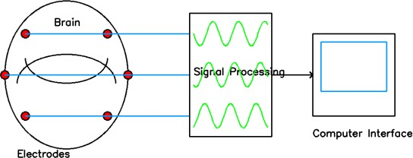

**Figure 1: BCI**

Key Techniques and Applications

1. Neuroprocessing: AI-enhanced BCIs interpret neural signals to control robotic limbs or prosthetic limbs, allowing paralyzed patients to walk again These systems though deep learning algorithms serve to accurately interpret the pattern of brain activity and adapt to the specific neural responses of the user.
2. Neural Artificial Intelligence: AI-powered BCIs provide real-time feedback on patients recovering from stroke or traumatic brain injury. Adaptive learning systems optimize therapeutic exercises based on the patient’s muscle function, speeding recovery and improving outcomes.

I. APPLICATIONS OF AI IN BRAIN RESEARCH

1. Neurological Disorder Diagnosis:

Deep learning techniques succeed in coping with complex mathematics and detecting subtle coincidences Artificial intelligence (AI) has brought unprecedented accuracy and efficiency to neurons diagnosis of complex diseases by analyzing neuroimaging data, biomarkers and electrophysiological signals.

Key Innovations

1. Alzheimer’s Disease Diagnosis:

Fuzzy logic-based deep learning systems:

These systems analyze brain scans and molecular biomarkers to identify early signs of Alzheimer's disease, even when data are incomplete or inaccurate Such methods clarify the diagnostic accuracy is greatly increased and early intervention procedures are supported.

AI tools combine structural MRI with brain and spinal cord biomarker analysis for earlier detection, reducing the risk of disease progression.



**Figure 2: FIS**

1. Epilepsy prediction: EEG-based machine learning models: AI systems process complete EEG data to identify seizure precursors, enabling real- time intervention Predictive models are trained on neural activity patterns to provide actionable insights for patients and caregivers.
2. Parkinson’s Disease Monitoring: AI analyzes motor activity data and dopamine imaging to optimize treatment plans by tracking disease progression, resulting in appropriate care.
3. Cognitive Neuroscience :

AI enables researchers to identify neural networks associated with attention, memory and decision- making, providing insights into the patterns of brain activity.

Key Innovations

1. Modeling Neural Mechanisms: AI systems describe brain activity during tasks such as problem solving or memory recall, providing a deeper understanding of cognitive processes.
2. Example: Recurrent neural networks (RNNs) model sequential data from fMRI studies to track how mental states evolve over time.
3. Multimodal Data Integration: AI combines neuroimaging, behavior, and genetic data to better study emotions. These multiple perspectives reveal complex networks underpinning cognitive processes.

.3. Advances in blood list management

In the past few years Innovative approaches have transformed red list management by addressing the shortcomings of traditional systems: Category and Screen (T&S) process: This technique does not require initial entries to ensure compatibility electronically or by rapid serology test It increases flexibility and reduces danger in blood bank management. Prediction models: Data-driven methods such as machine learning and statistical algorithms. This improves the accuracy of demand forecasts. These models help optimize inventory. Reduce shortages and overstock of products Decentralized system: by transferring inventory control from a central location to a regional network. These systems can perform real-time integration and evenly distribute resources. It also increases the ability to respond to fluctuations in domestic demand.

1. Epilepsy prediction: EEG-based machine learning models: AI systems process complete EEG data to identify seizure precursors, enabling real-time intervention Predictive models are trained on neural activity patterns to provide actionable insights for patients and caregivers.
2. Parkinson’s Disease Monitoring: AI analyzes motor activity data and dopamine imaging to optimize treatment plans by tracking disease progression, resulting in appropriate care.
3. Cognitive Neuroscience :

AI enables researchers to identify neural networks associated with attention, memory and decision-making, providing insights into the patterns of brain activity.

Key Innovations

* 1. Modeling Neural Mechanisms: AI systems describe brain activity during tasks such as problem solving or memory recall, providing a deeper understanding of cognitive processes.
  2. Example: Recurrent neural networks (RNNs) model sequential data from fMRI studies to track how mental states evolve over time.
  3. Multimodal Data Integration: AI combines neuroimaging, behavior, and genetic data to better study emotions. These multiple perspectives reveal complex networks underpinning cognitive processes.
  4. Applications include the study of neuroplasticity and its role in learning and adaptation.
  5. Virtual Simulations for Cognitive: Training: AI- powered virtual environments simulate real-world scenarios to learn and train cognitive skills, such as space navigation and decision-making.

1. Neurotherapeutics and Rehabilitation:

AI-powered technologies are revolutionizing treatment strategies for neurological conditions and enhancing rehabilitation outcomes.

Key Innovations

1. Individual Configuration: AI programs are rehabilitation programs for stroke patients, focusing on physical and mental rehabilitation. These systems monitor progress and adjust practices in real time to improve outcomes
2. Robotic systems integrated with AI provide tactile feedback, enabling precise recovery of motor control.
3. Neurostimulation changes: AI customizes deep brain stimulation (DBS) protocols for conditions like Parkinson’s and depression, improving therapeutic efficacy while minimizing side effects
4. Cognitive Behavioral Therapy (CBT Development): AI chatbots and virtual assistants are delivering CBT-based products to help patients with anxiety, PTSD, and other psychological conditions by personalizing treatments based on real-time data.

### 3. CASE STUDIES:

1. Early diagnosis of Alzheimer's disease:

Intelligence (AI) is redefining the early diagnosis of Alzheimer’s disease by combining advanced imaging technology with sophisticated computer algorithms.

Implementation:

1. Shallow deep learning systems combine structural imaging (e.g. MRI) and biomarkers (e.g. brain proteins) to detect early stage Alzheimer's disease This system overcomes the limitations of traditional

diagnostic methods and deals with ambiguous and noisy data.

1. 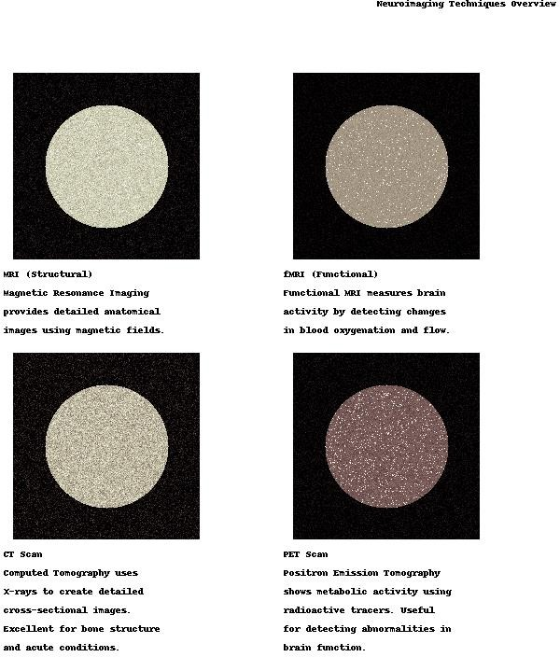Neuroimaging analysis: AI shows small changes in the hippocampus and cortex, the areas most affected by Alzheimer’s disease.
   1. Adaptive learning:

AI adapts to individual neural systems over time, improving accuracy and usability.

Influence:

* + 1. Paraplegic patients have regained the ability to perform basic tasks such as grasping objects and using a wheelchair.
    2. Improved quality of life and psychological well-being by restoring a degree of independence.

**Figure 3: Neuroimaging**

Biomarker integration: The algorithm analyzes amyloid- beta and tau protein levels along with neuroimaging results to increase diagnostic accuracy.

Influence:

1. It achieved an impressive screening rate of 87%, which exceeded traditional clinical screening.
2. Enable early intervention, which is critical to slow disease progression and improve patient outcomes.

Challenges:

Data sets are limited, with most data coming from Western populations. Addressing this issue is important to ensure uniform research applications around the world.

1. Brain-Computer Interfaces (BCIs) for Restoring Available Traffic:

AI-enhanced BCIs have emerged as a beacon of hope for individuals with extreme limb weakness and motor impairment.

* 1. Implementation:

BCIs use AI to interpret motor cortex signals, translating neural activity into action commands for robotic limbs or assistive devices.

* 1. Signal processing:

Machine learning models analyze electrical signals from the brain to determine desired movement patterns.

Challenges:

The high cost of BCI systems limits access, especially in resource-limited settings.

Ethical concerns regarding the direct use and potential for misuse of neural data must be addressed.

*B.* Predictive Models for Epilepsy:

AI-driven predictive analytics are transforming stroke management by providing real-time stroke prediction systems.

Implementation:

AI models analyze EEG data to identify patterns of seizures. These policies include the following:

Feature extraction: Deep learning models extract relevant temporal and spectral features from EEGrecordings.

Predictive analytics: Algorithms analyze historical seizure data to predict future events.

Influence:

Improved patient safety through timely warnings, enabling individuals to take preventative measures such as medication or support.

Giving patients more predictability and control overtheir condition has reduced anxiety and improved quality of life.

Challenges:

The high variability in epilepsy patients poses achallenge to develop universally effective models.

Addressing ethical concerns about maintaining neurological function is important to ensure patient trust and confidentiality.

### Methodology

* 1. Data acquisition and preprocessing:

Data are obtained from multiple neuroimaging sources such as MRI, PET, and fMRI datasets. Electrical data such as EEG signals have also been fused.

The preprocessing includes noise reduction, normalization of the imaging data, and artifact removal for the EEG.

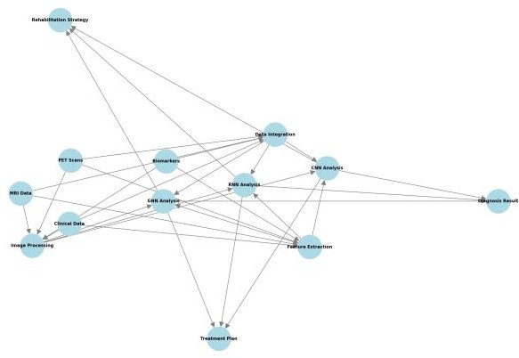

**Figure 4 Neuroimaging and Data Integration Framework**

* 1. Model development and training

Convolutional neural networks (CNNs) are used to analyze spatial information, while graph neural networks (GNNs) analyze neural networks.

This hybrid model incorporates advanced preprocessing and feature extraction techniques to optimize learning.

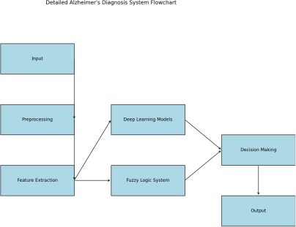

**Figure 5: Workflow of Alzheimer's diagnosis system**

### Challenges in AI for Brain Research:

The use of artificial intelligence (AI) in human brain research has opened up new frontiers, but it is not without significant challenges. From ethical considerations to technical limitations, these obstacles must be addressed to maximize the potential of AI while protecting individual rights and scientific integrity.

* 1. Privacy of data:

Neural data, being inherently personal and sensitive, requires strict privacy measures to prevent improper use.

Key issues

1. Encrypted data storage and transfer protocols will be adopted.
2. Use de-identification techniques to anonymize datasets.
3. Establish clear consent processes, to ensure participants understand how their data will be used.

The proposed solution:

1. Verbal perception: Neural recordings, such as EEG or fMRI scans, contain information that can reveal mental state, emotional response, and even psychiatric status.
2. Risk of breaches: Potential use of unauthorized tissue data may lead to abuse, including discrimination by insurance companies or employers.
3. Global regulations: While regulations such as the GDPR address data protection in general, brain scans often lack a specific regime, creating gaps in data processing policies.
   1. Algorithmic bias:

AI systems are as unbiased as the data they train alone. When datasets lack diversity, the resulting models can perpetuate or exacerbate biases.

Key issues

1. Population underrepresentation in datasets: Underperforming populations in training datasets, such as individuals in specific ethnic or age groups.
2. Skewed results: Biased algorithms can inappropriately flag certain population groups as false positives or negatives, resulting in inequitable health care.

The proposed solution

1. Expanding diversity in training datasets to include individuals from different populations.
2. Use Explanatory AI (XAI) tools to regularly review AI systems for bias.
3. Partner with communities to ensure inclusive data collection practices.
   1. Interpretability:

AI models often act as a "black box," delivering results without explaining the underlying decision- making processes. This lack of insight undermines their clinical and research confidence.

Key issues

1. Lack of confidence: Clinicians and researchers are reluctant to trust AI systems without a clear understanding behind the predictions.
2. Complex models: Detailed models, like deep roots, involve millions of objects, making them inherently difficult to interpret.
3. The proposed solution: Adding an XAI framework to visualize how models arrive at specific conclusions.
4. Simplify examples wherever possible to ensure accuracy and scalable interpretation.

Educating researchers and clinicians about the inner workings of AI systems to build confidence and understanding.

* 1. Material Costs:

AI research requires considerable computing and financial resources, making it difficult for low- income organizations to adopt cutting-edge technology.

Key issues

1. Hardware cost: Complex training models require high- performance GPU and specialized hardware.
2. Data storage and management: Processing large amounts of neuroimaging and neural data requires complex infrastructure.
3. Skilled workforce: Using AI, neuroscience and data science experts increases operating costs.

The proposed solution:

1. Implementing cloud-based platforms for cost- effective access to scalable computing resources.
2. Encourage collaborative research initiatives to share data, models and projects.
3. To secure funding from public and private organizations dedicated to advancing neuroscience research.

### Comparative Analysis of AI Applications in Brain Research:

The combination of artificial intelligence (AI) with brain scans has led to remarkable advances in a variety of fields including neuroimaging, neurodegenerative disease diagnosis, brain computer interfaces (BCIs), and predictive model , and the focused outcome is . These comparisons highlight the diversity and depth of AI applications in understanding and treating complex neurological conditions.

1. Objectives and scope of the study:

The papers reviewed reflect different areas of focus, from the early diagnosis of neurodegenerative diseases to the development of therapeutic BCIs:

1. Deep learning in neuroimaging: Explores the use of CNN and other advanced models to improve the analysis of MRI and PET data for structural and functional connectivity of the brain.
2. Fuzzy Logic for diagnosing Alzheimer's disease: Focus on incorporating biomarkers into imaging to achieve high diagnostic accuracy despite noise or incomplete data.
3. Electrode interfaces for BCIs: Investigates materials and designs that enhance the performance and flexibility of neural Interfaces.
4. Predictive modeling of neurological diseases: Develops time series models using EEG data for early detection of seizure-like conditions.
5. Technology and Methods:

The following technologies and techniques are widely used in the studies:

Deep Learning Models:

1. CNNs for spatial image analysis.
2. RNNs provide dynamic data, such as aggregate dynamic activity.
3. Fuzzy Logic Systems: Effective in addressing uncertainty in biomarker data for Alzheimer’s diagnosis.
4. Graph Neural Networks (GNNs): Brain networks are represented as graph structures, which contribute to the understanding of network chaos.
5. Signal decoding for BCIs: AI models analyze signals in the motor cortex to interpret the intended movement.
6. Challenges Identified:

Despite the progress, many challenges remain in studies:

* 1. Data privacy and ethics: The sensitive nature of neural data requires strong privacy protections.
  2. Algorithmic biases: Training datasets often lack diverse populations, leading to biased results.
  3. Increased technical costs: Advanced models require critical resources, making them inaccessible in areas where resources are scarce.
  4. Interpretability: The complexity of deep learning models limits their transparency and acceptance among clinicians.

1. Result and Findings:

The results of these studies demonstrate the transformative power of AI:

1. Improved assessment accuracy: The combination of images and biomarkers in an Alzheimer’s disease diagnosis model achieved an accuracy of up to 87%.

## Improved patient outcomes*:* AI-powered BCI restored mobility and functional cognition to patients with paraplegia to manage seizures.

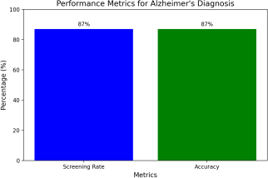

**Fig:6: Bar Chart**

1. Comparative Table

|  |  |  |  |  |  |
| --- | --- | --- | --- | --- | --- |
| Criteria | Paper 1 | Paper 2 | Paper 3 | Paper 4 | Paper 5 |
| Objective | Enhance neuroimaging analysis using DL. | Improve Alzheimer’s detection with fuzzy logic. | Develop robust  neural electrode interfaces. | Evaluate AI’s role in improving BCIs. | Build predictive models for early epilepsy detection. |
| Technologies | Deep Learning, CNNs, MRI, PET | Fuzzy Logic, Biomarker Integration | AI-Driven Material | sNeural Signal Decoding | Machine Learning,EEG, Time-Series Data |
| Methodology | Multimodal data  integration with DL. | Combine imaging and biomarkers with fuzzy DL. | Experimental analysis of  electrode performance. | Adaptive learning for neural  responses | Time-series analysis for seizure prediction. |
| Challenges | High computation demands, data diversity | Sensitivity to noisy data, low  generalizabilit | Material durability in neural  applications. | High cost, signal decoding accuracy | Variability in  patient data patterns. |
| Results | Improved imaging analysis and connectivity mapping. | Achieved 87% accuracy in early diagnosis. | Enhanced electrode efficiency for BCIs. | Restored motor functions in paralyzed patients. | Timely seizure predictions for better safety. |

# Recent Advancements:

## Artificial intelligence (AI) continues to drive transformative advances in brain research, pushing the limits of what’s possible in neuroscience. Recent innovations focus on improving explicit AI models, integrating data sets for comprehensive analysis, and optimizing neuromodulation techniques for targeted therapies are These advances are changing the accuracy of diagnosis, therapeutic interventions, and our understanding of brain function.

* + 1. *Specification AI (XAI):*

## Explainable AI (XAI) has emerged as an important advance, addressing one of the most important challenges in AI applications: the "blackbox" nature of complex algorithms Information AI systems often deliver results come into play without providing insight into the reasoning behind their predictions. XAI focuses on making these models interpretable and transparent, which is important for clinical and research applications in neuroscience.

*The main features*

## *Good obviousness:* XAI techniques, such as SHAP (Shapley Additive explanations) and LIME (Local Interpretable Model-agnostic Explanations), help visualize how AI models process data and make predictions.

1. *Physician-friendly definitions*: It enables physicians to understand AI-driven diagnostic decisions, ensuring that these recommendations can be trusted and acted upon*.*

## It improves decision-making by highlighting important biomarkers or neurological patterns that affect prognosis.

1. *Useful Resources:*

## In the diagnosis of Alzheimer’s disease, XAI identifies specific regions of interest in an MRI image, such as those in the hippocampus, aiding early diagnosis.

In BCIs, it teaches how neural signals are mapped to body functions, improving the performance of specific devices.

*Influence:*

## By bridging the gap between AI and human interpretation, XAI promotes wider acceptance of AI in

neuroscience and ensures ethical application in clinical settings*.*

* + 1. *Multimodal Data Fusion:*

## AI-driven multimodal data fusion combines disparate data sets for a comprehensive understanding of brain diseases. By integrating neuroimaging data (e.g., MRI, PET) with genomics, proteomics, and behavioral data, this approach enables comprehensive insight into complex neurological conditions.

*The main features*

## *Comprehensive Analysis:* Neuroimaging provides structural and functional information. Genomics and proteomics combine molecular- level insights, revealing genetic traits and protein interactions.

1. *Integration Techniques: Deep learning model:* Neural networks in particular process multiple inputs to identify relationships among datasets.

## *Graph-based analysis:* Models represent relationships between data sets, such as muscle activity and genetic variation.

1. *Applications in neuroscience:* Multimodal fusion in schizophrenia research links disruption of brain connectivity to genetic markers, improving personalized medicine.

## Integration of MRI data and rehabilitation progress metrics in stroke recovery improves optimal treatment.

*Influence:*

## This approach accelerates the discovery process by identifying biomarkers of neurological diseases, enabling targeted interventions, and accurately diagnosing the disease through a multivariate approach.

* + 1. *AI-induced neurotransformation:*

## Neuromodulation, manipulating neural activity using electrical or magnetic stimuli, has been enhanced by AI. These systems use machine learning algorithms to optimize stimulation parameters for individual patients, improving clinical outcomes.

*The main features:*

## *Personalized Protocols:* The AI optimizes stimulation based on real-time neural feedback, adapting to the patient’s changing environment.

1. Optimal stimulus intensities and frequencies are determined for strategies such as reinforcement learning (RL).
2. *Therapeutic applications:*

## *Seizures:* AI detects pre-seizure activity in real- time and optimizes active neurotransmitter mechanisms to prevent seizures from being blocked*.*

1. *Depression:* AI-tuned repetitive transcranial magnetic stimulation (rTMS) improves performance by targeting specific cortical areas.
2. *The next generation of devices:* AI-powered wearable neuromodulation systems for continuous monitoring and engagement.

## Combining BCIs enables closed systems, where stimulation adjusts dynamically based on neural activity.

*Influence:*

AI-powered neuromodulation is reshaping the treatment landscape for neurological and psychiatric disorders, offering customized solutions with fewer side effects and greater treatment effectiveness.

# Future Directions in AI for Human Brain Research:

## The future of artificial intelligence (AI) in human brain research is filled with incredible possibilities, pushing the boundaries of neuroscience and its applications. As the field evolves, three major directions are emerging in transition: real-time brain-machine interfaces, personalized neurotherapy, and ethics management and these future approaches have the potential to redefine our understanding that we have in the brain and its relationship with AI.

* + 1. *Real-time brain-machine interfaces (BCIs) :*

## Next-generation BCIs promise to advance human capabilities by seamlessly connecting external devices to the brain. This initiative will use AI for real-time interpretation and feedback, improving efficiency.

*Major products:*

## ***Closed systems****:* In the future, BCIs will operate as closed systems, where neural signals are constantly monitored and devices actively respond.

For example, AI can decode motor intentions in real time, allowing paralyzed individuals to effortlessly control robotic limbs or wheelchairs.

## Cognitive Augmentation:

In addition to motor function, BCIs can improve cognitive behaviors such as recall and decision-making.

## AI algorithms can process and refine neural models, provide assistance to individuals with intellectual disabilities or even improve normal cognitive functions

1. *Things used in everyday life:*

## BCIs integrated into wearable devices can enable easy control of smartphones, home appliances, and virtual reality environments.

Advanced AI models will ensure faster and more accurate interpretation of neural signals, making this technology more accessible and user-friendly.

1. *challenges and considerations:*

## In order to be accessible, the cost of hardware and computing requirements must be substantially reduced.

Ethical issues surrounding cognitive enhancement and the privacy of neural data must be addressed.

* + 1. *Individual Neurotherapy:*

## AI-powered personalized neurotherapy aims to adapt interventions based on an individual’s unique neurogenetic and behavioral characteristics. This approach recognizes the wide spectrum of how neurological conditions manifest and respond to treatments.

*The main features*

## *Customized treatment plans:* AI systems analyze a patient’s neurological function, genetic traits, and medical history to develop targeted therapies.

For example, fracture rehabilitation programs can be adjusted in real time based on progress, to ensure optimal recovery.

1. *Prediction models for treatment outcome:* AI- powered neurofeedback systems can provide real-time adjustments to treatment sessions to improve outcomes.
2. *Integration of Emerging Technologies:*

## Personalized neurotherapy will seamlessly

integrate with wearable devices to allow for continuous monitoring and engagement.

## Through AI-powered neurotherapy, virtual reality environments can mimic real-world conditions, speeding up recovery.

1. *challenges and considerations*

## There is a need to develop datasets for training AI models to ensure that treatments are effective in different populations.

Building trust and ensuring patient consent and protecting sensitive information will be paramount.

* + 1. *Ethical AI-Policy:*

## As AI becomes increasingly involved in brain research, there is a need for stronger ethical frameworks to ensure fairness, transparency and equality

*Basic principles:*

## *Data Privacy and Security:* Protecting the privacy of neural data will be a cornerstone of ethical AI design. Methods of encryption and anonymization must evolve to keep pace with data collection technologies.

1. *Algorithmic internal justice:*

## Reducing bias in AI models is important to ensure similar results for all populations. Ethical frameworks should mandate diverse and inclusive data to prevent systematic loopholes. Biases in the diagnosis and treatment of rheumatoid arthritis.

1. *Obvious and interpretable explanation:*

## To gain the trust of researchers, clinicians, and patients, AI must be transparent in its decision- making processes.

Explicable AI (XAI) will be key to ensuring that the rationale behind AI-driven predictions and interventions is meaningful.

e) *Terms and Conditions*:

## Governments and international organizations need to establish clear regulations for AI in neuroscience to prevent abuse and ensure ethical use.

Surveillance mechanisms need to be put in place to about duplicate use technologies such as brain disposal or unauthorized use of neural data.

# Conclusion:

## Artificial intelligence (AI) ushered in a revolutionary era in human brain research, providing tools and techniques that were once the realm of speculation from describing complex neural systems to providing breakthroughs in research and therapeutically.

At the heart of this transformation is the ability of AI to process large and heterogeneous data sets, reveal hidden patterns, and deliver predictive capabilities that enhance early diagnosis and personalization e.g. The potential of AI extends beyond clinical applications, providing new methods for enhancing cognition, enhancing brain- machine interfaces and analyzing consciousness itself

## But integrating AI into brain research is not without its challenges. Data privacy concerns become more apparent, especially as the number and complexity of neural datasets increases. The fragility of the brain requires strong safeguards to prevent misuse or unauthorized use. Algorithmic bias from undiversified or skewed data sets threatens the accuracy of AI technology applications, potentially marginalizing populations Furthermore, the unobservable nature of many AI models convince, especially in critical medical situations where interpretation is critical.

REFERENCES

1. *Avberšek LK and Repovš G. "Deep learning in neuroimaging data analysis: applications, challenges, and solutions." face. Neuroimaging 1 (2022): 981642. DOI: 10.3389/fnimg.2022.981642.*
2. *Xiao Y, Lei M, Zhu J, Chang R, and Qu X. "Advances in electrode interface materials and switching technologies for brain-computer interfaces." Biometer Definition. 4, no. 4 (2023): 213–2 DOI: 10.12336/biomatertransl.2023.04.003.*
3. *Tanvir M. , Sajid M. , Akhtar M. , et al. "Fuzzy deep learning for Alzheimer's disease diagnosis: approaches and challenges." IEEE Transactions on Fuzzy Systems (2024). DOI: 10.1109/TFUZZ.2024.3409412.*
4. *Yan W, Qi G, Hu W, et al. "Deep learning in neuroimaging: promises and challenges." IEEE Signaling Bulletin (2022). DOI: 10.1109/MSP.2021.3128348.*