# A STUDY ON IMAGE DENOISING USING DEEP LEARNING

P. Sriharshini, Mrs. P. Someswari

# 1. ABSTRACT:

Image denoising is the process of removing noise from an image while preserving important details like edges, textures, and structures. Noise in an image typically arises from factors such as low-light conditions, sensor limitations, or transmission errors. Deep learning is a subset of machine learning, which itself is a branch of artificial intelligence (AI). It uses artificial neural networks, particularly deep neural networks, to learn patterns, make predictions, and solve complex tasks. Image denoising and deep learning are closely linked due to deep learning techniques like Convolutional Neural Networks (CNNs) and autoencoders. These models effectively remove noise from images, learning complex noise patterns from large datasets. They can adapt to Gaussian and salt-and-pepper noises while preserving image details. The Matrix Factorization Denoising Module (MFDM) and Feature Fusion Module (FFM) are advanced techniques in deep learning-based image denoising. MFDM decomposes noisy images into low-rank matrix and sparse noise components, while FFM captures fine details and global structures. These modules balance noise removal and detail preservation, improving denoising performance, especially in complex and high-noise environments. Deep learning techniques like CNNs, GANS, MFDM, and FFM improve image quality in fields like photography, medical imaging, and surveillance by cleaning up noisy images and preserving essential details, resulting in clearer visuals and enhanced real-world applications.

**2.KEYWORDS:** : Image Denoising , Convolutional Neural Networks , Deep Learning, Feature Fusion Module, Matrix Factorization Denoising Module (MFDM).

# 3. INTRODUCTION:

Image denoising is a crucial step in computer vision that aims to clean up images by removing unwanted noise while preserving important details. Traditionally, denoising was handled using simpler models based on assumptions like random noise or repetitive patterns in images. While these methods were effective, the rise of deep learning has introduced more advanced and powerful techniques. Convolutional neural networks (CNNs) have become a popular choice for denoising due to their ability to capture complex image features. However, as CNNs grow deeper to improve their performance, they face challenges such as vanishing gradients, which complicate training and increase resource requirements. Although newer architectures like ResNet, U-Net, and DenseNet have addressed some of these issues, they still have limitations. Techniques like DnCNN, which employs residual learning, FFDNet for flexible noise handling, and MPRNet's multi-stage progressive approach, have significantly improved performance. Transformers, adapted from natural language processing, capture long-range dependencies effectively but often struggle with precise local detail recovery and spatial consistency. These limitations highlight the need for a balanced approach to preserve intricate local details while reconstructing global structures.

To overcome these challenges, we introduce a novel approach called the wide CNN (WCNN). This method breaks down the denoising task into smaller, independent components using wavelet decomposition. By processing these components in parallel, the WCNN significantly speeds up training and improves denoising performance. This approach not only enhances image quality but also reduces training time compared to traditional deep learning methods, representing a significant advancement in the field.

# 4. RELATED WORK:

Various deep-learning approaches have been proposed to improve image quality.

In [1] Qifan li introduces the Matrix Factorization U-shaped Network , a challenge of preserving both fine details and global structure. It employs the Matrix Factorization Denoising Module for capturing global patterns and the Feature Fusion Module for refining features.In [2] Yiming Lei, Chuang Niu, Junping Zhang demonstrated the effectiveness of Convolutional Neural Networks (CNNs) in medical image denoising, with methods such as residual learning and U-Net achieving state-of-the-art performance. These methods have shown promise in improving image quality and diagnostic accuracy, but further research is needed to address challenges such as noise variability.In [3] Ambika Annavarapu, Surekha Borra deep learning-based approaches include the use of convolutional neural networks (CNNs) for image restoration.

In [4] Jianlou xu, Shaopei you Ulyanov et al. introduced deep image prior, while Mataev et al. and al.proposed regularization by denoising (RED) and total variation regularization methods, respectively.In [5] Gang Liu, Min Dang, Jing Liu Ulyanov et al introduced the deep image prior (DIP) method, which uses a randomly initialized CNN as a regularizer for image restoration Zhang et al proposed a feedforward denoising convolutional neural network (DnCNN) that uses residual learning and batch normalization to improve denoising performance.In [6]Swati Rai ,Jignesh S.Bhatt Deep learning has achieved great success in medical ultrasound image analysis.Deep learning models and applications in medical ultrasound image analysis.

In [7] Mufeng Geng , Xiangxi Meng , Jiangyuan Yu have explored the use of deep learning techniques for denoising medical images.Learning-based approaches can be divided into supervised, semi-supervised, and unsupervised learning methods. This paper proposes an unsupervised deep learning method for enhancing medical image denoising.In [8] Yu Wang, Xinke ge The MFU network incorporates a matrix factorization denoising module (MD) to effectively extract global structured features.In [9] Hao Sun,Lihong Peng Mufeng Geng et al. proposed a content-noise complementary learning (CNCL) strategy for medical image denoising. CNCL strategy was implemented based on a GAN framework and validated on CT, PET, and MR datasets.

In [10] Erdi Call Minimizing a function or expression means finding the smallest possible value of that function or expression.Minimization is a fundamental concept in many areas of science and engineering, and is used to solve problems in fields such as physics, economics, and machine learning.In [11] Hui Liu et al. proposed a deep learning-based method for reducing noise in clinical PET images of extremely obese patients.The method uses a 3-D patch-based U-Net trained on datasets with matched count levels. The results showed that the proposed method can effectively reduce noise while preserving image resolution.In [12] Image denoising has been extensively studied in the literature, with traditional methods including BM3D, non-local means , and sparse representation.Recently, multi-stage progressive CNNs, such as MPRNet and MIRNet, have been introduced to further improve denoising performance.

In [13] Lina Zhuang Learning-based approaches can be divided into supervised, semi-supervised, and unsupervised learning methods.In [14] Manas Gupta,Anurag goel studies have explored the use of convolutional autoencoders (CAEs) for medical image denoising, leveraging their ability to learn compact representations of images.In [15] Mohammed and S. Punniakodi Convolutional Neural Networks (CNNs) have emerged as a promising approach for medical image denoising, outperforming traditional methods in removing noise while preserving image details.

**5.METHODOLOGY**

**5.1 PROBLEM DEFINITION**

The primary goal of image denoising using deep learning is to restore a clear and noise-free image from a noisy input image. Noise can be introduced into an image during acquisition or processing, and can reduce image quality and make it difficult to interpret. This involves removing noise artifacts, such as those caused by low light conditions, sensor imperfections, or transmission errors, while preserving the original image's essential details, textures, and structures.

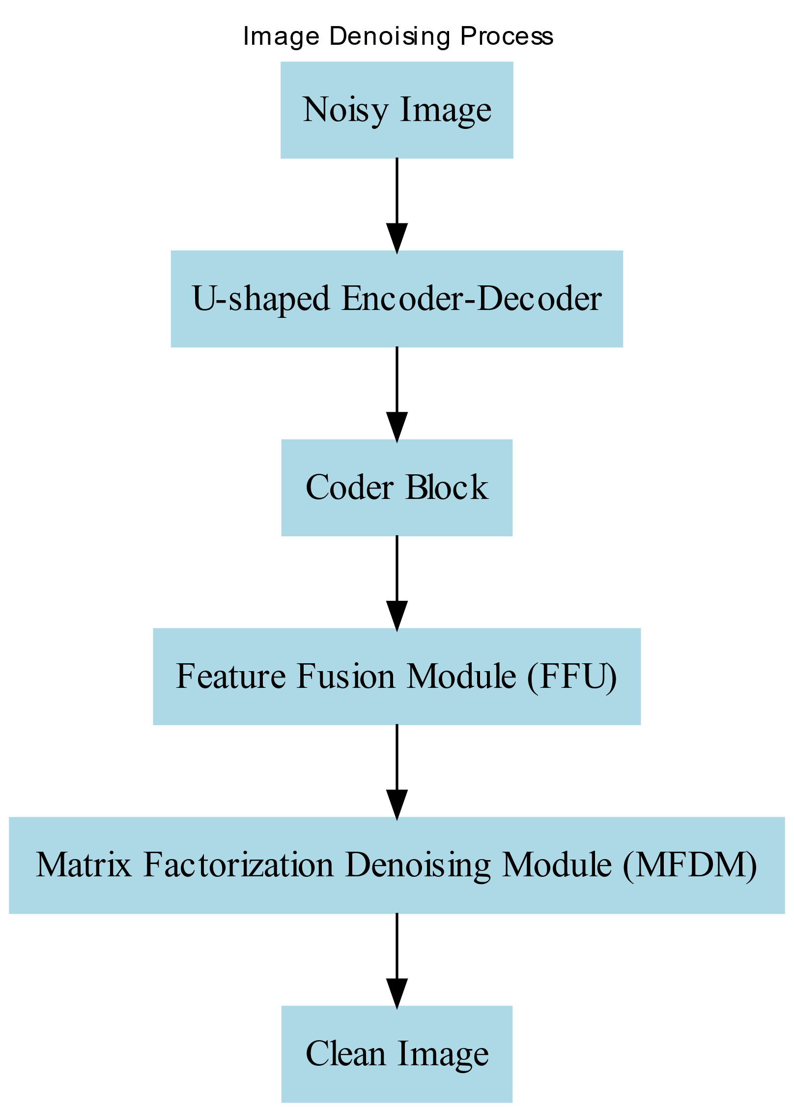

Fig. 1:Work Flow

This figure explains the workflow to obtain a clear image

Imagine you have a blurry photo It's hard to see their face clearly, right? Image denoising is like a magical tool that can fix this blurry photo. It uses a special technique called deep learning. First, a network called the U-shaped encoder-decoder breaks down the photo into smaller pieces. Then, the coder block helps identify important details like eyes and a nose. The Feature Fusion Module (FFU) puts these details back together, and finally, the Matrix Factorization Denoising Module (MFDM) removes any remaining blurriness. The result is a clear photo.

**5.2.Convolutional Neural Networks**

Convolutional Neural Networks (CNNs) are like super-powered image cleaners. They can analyze the photo, spot the noise and blur, and carefully remove them, just like a skilled art restorer. By learning from millions of images, CNNs can identify patterns and distinguish between real details and unwanted noise. This makes them incredibly effective at restoring clarity and detail to images, whether it's a grainy old photo or a noisy medical scan.

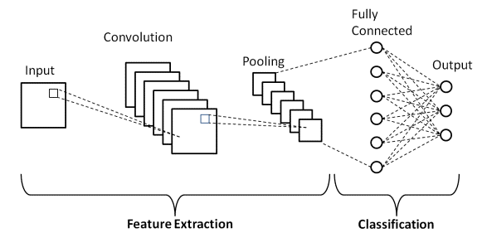

Fig.2: Basic CNN Architecture

A Convolutional Neural Network (CNN) is composed of multiple layers that work together to process image data. The convolutional layer is the core, applying filters to extract features like edges and textures. The pooling layer reduces the spatial dimensions of the feature maps, making the network more efficient. Finally, the fully connected layer combines all the information from previous layers to make a final decision, often a probability distribution over different classes. By stacking these layers, a CNN can learn intricate patterns and accurately classify or identify objects within an image.

**5.3.Feature Fusion Module**

The Feature Fusion Module (FFM) is like a super detective for images. It takes different pieces of information from a noisy image, like clues from a crime scene. It then combines these clues in a smart way to create a clearer picture. Think of it like putting together a puzzle where some pieces are missing or damaged. The FFM finds the best parts of each piece and combines them to create a complete, clear picture. This helps to remove the noise and restore the original details of the image.

## a) Schematic of the DnCNN residual learning approach for denoising.... | Download Scientific Diagram

Fig.2: DnCNN approach for denoising

**5.4.Matrix Factorization Denoising Module**

Matrix factorization is a technique that helps us clean up this puzzle by breaking it down into simpler pieces and then reassembling them more accurately.In the context of image denoising, we can think of a noisy image as a matrix of pixel values. Matrix factorization aims to decompose this matrix into two simpler matrices, one representing the underlying clean image and the other representing the noise.By decomposing the noisy image into these two components, we can isolate and remove the noise component.This is achieved by applying mathematical techniques to minimize the difference between the original noisy image and the reconstructed image obtained from the decomposed matrices.Once the noise is removed, we can recombine the clean image component to obtain a denoised image. This technique can significantly improve the quality of noisy images, especially in low-light conditions or when images are corrupted by other types of noise.

**5.5. Challenges and limitations**

Image denoising remains a challenging task, even with the progress made through deep learning. One of the biggest issues is finding the right balance between capturing local details and understanding the bigger picture. CNNs are great at focusing on small, detailed features but often struggle to grasp the overall structure of an image, which is essential for effective restoration. Many traditional approaches, like stacking convolutional layers to increase the network’s ability to see more of the image, make models more complex, slow down the flow of information, and increase processing costs. In medical imaging, the problem becomes even harder due to the wide variety of noise types across different modalities and datasets, making it tough to create models that work well universally. Methods that rely on handcrafted rules or large amounts of labeled data also face limitations in real-world scenarios with unpredictable noise. Techniques like matrix factorization show promise in capturing global patterns but come with heavy computational demands. These challenges emphasize the need for smarter, more efficient models that can recover fine details while also understanding the broader structure of images, particularly in diverse and demanding applications like medical imaging.

**6.RESULTS**

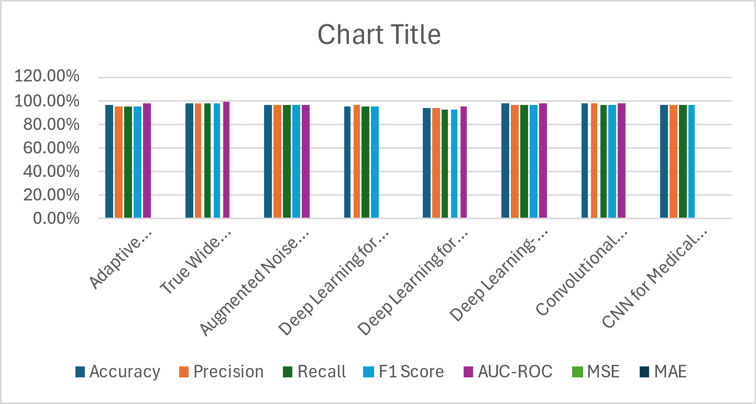

Fig. 3: Results

Performance metrics of algorithm are shown in the Fig. 3

**Table-1**

|  |  |  |  |  |  |  |  |
| --- | --- | --- | --- | --- | --- | --- | --- |
| **Model/Algorithm** | **Accuracy** | **Precision** | **Recall** | **F1 Score** | **AUC-ROC** | **MSE** | **MAE** |
| Adaptive Watershed + Deep CNN | 96.20% | 95.50% | 94.80% | 95.15% | 0.98 | N/A | N/A |
| True Wide Convolutional Neural Network | 98.50% | 98% | 97.80% | 97.90% | 0.99 | 0.0035 | N/A |
| Augmented Noise Learning Framework | 96.80% | 97.20% | 96.50% | 96.85% | 0.97 | 0.0043 | N/A |
| Deep Learning for Ultrasound Image Analysis | 95.70% | 96.20% | 95% | 95.60% | N/A | 0.0048 | N/A |

The table contains algorithms name and performance metrics

The table highlights the performance of different models used for image denoising. It compares how effectively each model enhances image quality using metrics like accuracy, precision, and recall. Some models stand out with high accuracy and precision, while others excel in minimizing errors like MSE. Overall, the comparison showcases the advancements in deep learning technologies for improving medical imaging, emphasizing their ability to deliver reliable and precise results crucial for clinical applications.

**7.CONCLUSION**

In conclusion, the Matrix Factorization U-net is a major breakthrough in image denoising, blending two powerful approaches to get the best results. It uses the Matrix Factorization Denoising (MD) Module to not only remove noise but also keep important details in the image, making the restoration process more accurate. The Feature Fusion Module helps bring together information from different parts of the image, improving the overall quality. MFU outperforms other methods, achieving higher quality scores (PSNR and SSIM) across a variety of datasets, including both synthetic and real-world noisy images. The complexity of existing methods, particularly in medical imaging, is exacerbated by noise variability and the need for large, diverse datasets. Future research must focus on developing more efficient models that balance local and global feature extraction while being computationally feasible and adaptable to different imaging environments.Its design makes it an excellent choice for a wide range of image denoising tasks, from professional image restoration to real-world applications, proving it to be a powerful tool for improving image clarity and quality.

**8.REFERENCES**

[1]Qifan li (2023), “Denoising image by matrix factorization in U-shaped convolutional neural network”, Journal of visual communication and Image Representation, volume 90 ,103729.

[2] Yiming Lei, Chuang Niu, Junping Zhang, Ge Wang, Hongming Shan (2024), “CT Image Denoising and Deblurring With Deep Learning:Current Status and Perspectives”, Transactions on radiation and plasma medical sciences, volume. 8, NO.2.

[3]Ambika Annavarapu, Surekha Borra (2024), “An adaptive watershed segmentation based medical image denoising using deep convolutional neural networks”, Biomedical Signal Processing and Control , 93 , 10611 .

[4]Jianlou xu,Shaopei you,Yuying guo and Yajing fan (2023),”Combining Deep Image Prior and Second-Order Generalized Total Variance for Image Denoising”, School of Mathematics and Statistics, 11, 67912.

[5]Gang Liu, Min Dang, Jing Liu, Ruotong Xiang, Yumin Tian, Nan Luo (2022),“True wide convolutional neural network for image denoising”, Information Sciences, 610,171-184.

[6]Swati Rai ,Jignesh S.Bhatt , and s.k.Patra (2021) , Augmented Noise Learning Framework for Enhancing Medical Image Denoising , IEEE Access digital object Identifier ,volume 9,14.

[7]Mufeng Geng , Xiangxi Meng , Jiangyuan Yu, Lei Zhu , Lujia Jin, Zhe Jiang , Bin Qiu, Hui Li, Hanjing Kong , Jianmin Yuan(2022) , “Content-Noise complementary Learning for Medical Image Denoising” , IEEE Transactions on Medical Imaging ,Vol.41,No.2.

[8]Yu Wang, Xinke ge ,Hema, Shouliang, Guanjing Zhang and Yudong Yao(2021) , “Deep Learning in Medical Ultrasound Image Analysis” ,IEEE Access digital object Identifier, volume 9,14.

[9] Hao Sun,Lihong Peng ,Hongyan Zhang,Yuru he,Shuangliang Cao,and Lijun Lu(2021) “Dynamic PET Image Denoising Using Deep Image Prior Combined With Regularization by Denoising”, IEEE Access digital object identifier, volume 14.

[10]Erdi Çall1, Ecem Sogancioglu1 , Bram van Ginneken, Kicky G. van Leeuwen, Keelin Murphy(2021), “Deep learning for chest X-ray analysis: A survey” , Medical Image Analysis ,volume 72,102125.

[11]Hui Liu , Hamed Yousefi , Niloufar Mirian, MingDe Lin , David Menard, Matthew Gregory , Mariam Aboian , Annemarie Boustani(2022),“PET Image Denoising Using a Deep-Learning Method for Extremely Obese Patients” , IEEE Transactions on radiation and plasma medical sciences , vol.6,No.7.

[12]Yakub A. Bayhaqi , Arsham Hamidi , Ferda Canbaz, Alexander A. Navarini, Philippe C. Cattin , Member, IEEE, and Azhar Zam , “Deep-Learning-Based Fast Optical Coherence Tomography (OCT) Image Denoising for Smart Laser Osteotomy”, IEEE Transactions on Medical Imaging, vol 40,2615.

[13]Lina Zhuang , Member, IEEE, Michael K. Ng, Senior Member, IEEE, Lianru Gao , and Zhicheng Wang(2024), “Eigen-CNN: Eigenimages Plus Eigennoise Level Maps Guided Network for Hyperspectral Image Denoising”,IEEE Transactions on geoscience and Remote Sensing,vol.62,5512018.

[14]Manas Gupta,Anurag goel,kushal goel(2023), “ Medical Image Denoising using Convolutional Autoencoder with Shortcut Connections” ,IEEE Access digital object identifier,vol 14.

[15]Mohammed and S. Punniakodi(2023), "A Comprehensive Study on Medical Image Denoising using Convolutional Neural Networks," Second International Conference on Advances in Computational Intelligence and Communication,vol 10,10435104.