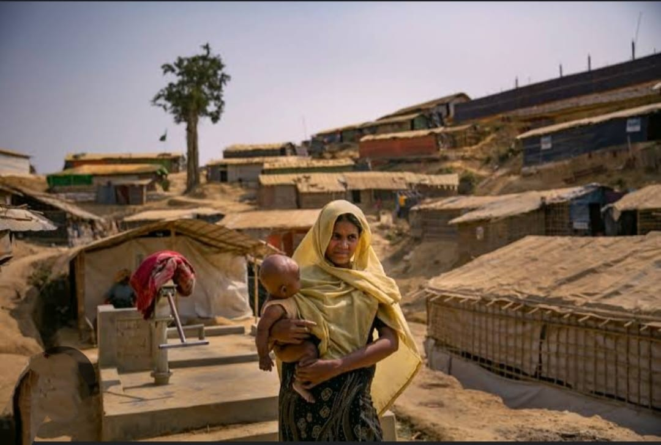

**Gendered Dimensions of Displacement: Addressing Women’s Rights and Security in the Rohingya Crisis at Cox's Bazar, Bangladesh**

**Abstract**

Over 1.2 million Rohingya have been forcibly drove from Myanmar as a result of violence, persecution, and prejudice, making the Rohingya crisis in Cox's Bazar, Bangladesh, one of the biggest and most complicated humanitarian crises [1]. Both the host towns and the refugees have faced tremendous difficulties as a result of this surge, and the humanitarian response has found it difficult to satisfy the huge requirements. Particularly, women and girls deal with distinct gendered issues that jeopardize their safety, rights, and general wellbeing. Inadequate infrastructure, resources, and ingrained gender stereotypes that restrict access to opportunities and necessary services further compound these difficulties. The gendered aspects of relocation in Cox's Bazar are examined in this paper, with particular attention paid to the obstacles women encounter when trying to get necessities including, food, water, shelter, and sanitary facilities. It also discusses how the camps' inadequate security, medical treatment, and protection systems make women and girls more susceptible to abuse, exploitation, and violence. Notwithstanding the UNHCR's, local governments', and non-governmental organizations' efforts, cultural, economic, and systemic hurdles that prevent women and girls from accessing protection and assistance exacerbate their vulnerabilities. These difficulties stem from social, political, and economic disparities that existed before relocation. Women's involvement in decision-making processes inside the camps and the larger refugee response is severely constrained, and gender-based violence—including sexual abuse, trafficking, and early marriage—remains pervasive. Women and girls find it challenging to rebuild their lives and achieve safety and dignity as a result of this lack of empowerment. The causes of these vulnerabilities are examined in this article, with a focus on the necessity of a gender-responsive strategy that integrates the Women, Peace, and Security (WPS) framework. The article emphasizes how addressing women's needs is essential for stability, peace, and long-term rehabilitation in the host and refugee communities by promoting policies that address gender imbalances, enhance access to resources, and fortify safety measures.

**Keywords**

Rohingya refugees, women’s rights, gender-based violence, displacement, WPS framework, security, Cox’s Bazar, humanitarian aid, women empowerment, peacebuilding.

**______________________________________________________________________________**

**Introduction**

Over 1.2 million Rohingya refugees have been forcibly relocated since August 2017, making the continuing Rohingya refugee crisis in Cox's Bazar, Bangladesh, one of the worst humanitarian catastrophes of the twenty-first century. The Rohingya population has migrated in large numbers into Bangladesh as a result of this crisis, which was brought on by a brutal military campaign in Myanmar. The situation has presented enormous difficulties for both the host communities and the refugees. Bangladesh's infrastructure and resources have been overburdened by the scope and complexity of the crisis, necessitating a multifaceted response from governments, humanitarian actors, and international organizations. All refugees experience severe challenges, but because of the exacerbated vulnerabilities brought on by long-standing gender inequality, women and girls are disproportionately impacted by the catastrophe. Widespread gender-based violence (GBV), which has become a major problem in the refugee camps, is one way how these vulnerabilities show up. The extremely vulnerable status of women and girls is made worse by their heightened vulnerability to sexual abuse, exploitation, trafficking, and early marriage. Women and girls are especially at risk of being taken advantage of by opportunistic individuals in the camps because to the disintegration of social institutions and protective family systems. In addition to GBV, displaced women have a very difficult time getting access to reproductive health services, which are crucial for their overall health. maternity mortality rates have increased as a result of many women not having access to the essential maternity and child health treatments. Additionally, young girls' prospects for the future are severely limited by the dearth of educational possibilities available to them, which feeds the cycle of poverty and marginalization. Economic hardship brought on by displacement has also made women more vulnerable and dependent on charity, as they face obstacles in obtaining employment. The lack of proper legal protections and support networks exacerbates these gendered issues, making women and girls particularly susceptible to exploitation and abuse. The living conditions for displaced women and girls in the camps have only grown worse as a result of the systemic failure to address these issues in a timely and sufficient manner.

From a Women, Peace, and Security (WPS) perspective [2]—which emphasizes the protection, rights, and empowerment of women and girls in conflict and post-conflict contexts—this article explores the gendered aspects of displacement in the context of the Rohingya refugee crisis. In order to ensure that women are not only shielded from exploitation and violence but are also actively involved in decision-making, the WPS framework highlights the significance of addressing gender-specific needs and obstacles in humanitarian interventions. It emphasizes that empowering women in refugee situations is crucial to promoting long-term peace and stability in addition to being a human rights problem. This strategy is essential for enhancing the lives of displaced women and girls in Cox's Bazar, guaranteeing the protection of their rights, and creating an atmosphere that allows them to become more resilient and empowered. The WPS framework attempts to offer a complete solution that goes beyond immediate survival and strives towards restoring dignity, autonomy, and long-term prospects by addressing the particular needs of women and girls. In addition to providing insights into how humanitarian interventions might be better tailored to meet the needs of women and girls in displacement, this paper seeks to advance a more thorough understanding of the crisis by concentrating on the gendered components of the refugee experience. Additionally, it promotes more responsive and inclusive policies that tackle the unique obstacles women encounter when trying to access resources and vital services in the context of refugees.

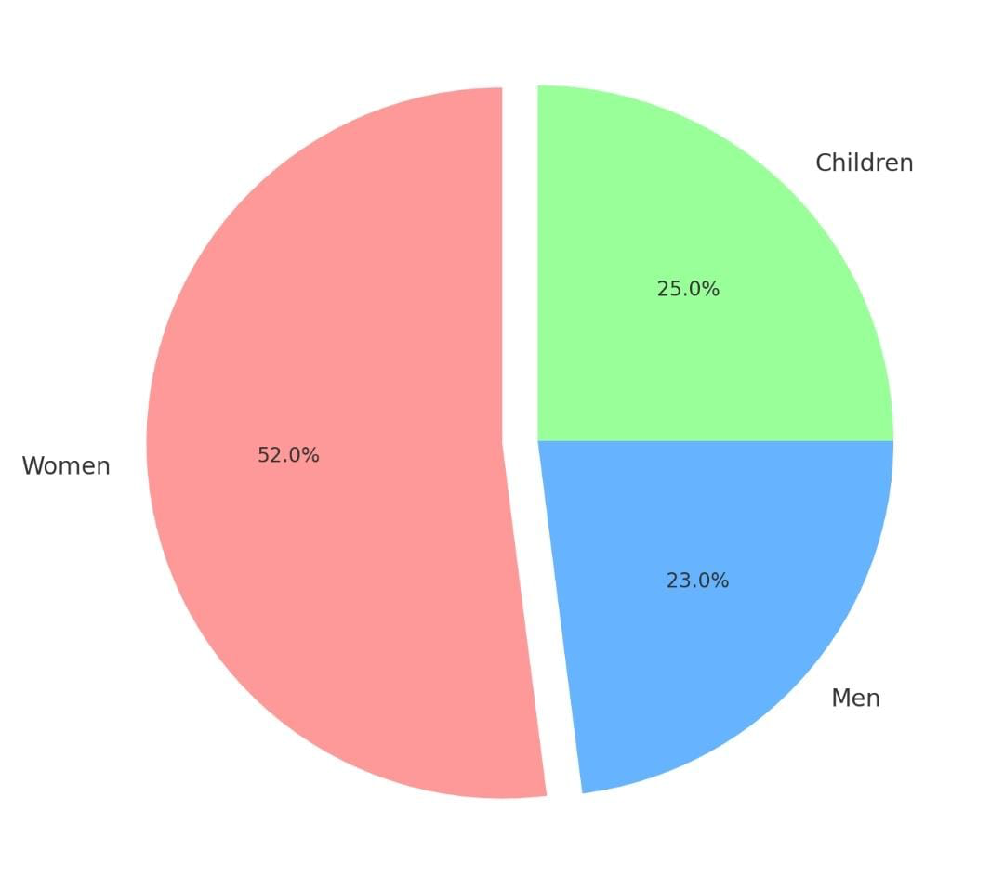

Figure 1: Demographics of Rohingya Refugees in Cox's Bazar (by Gender and Age) [3]

**Literature Review**

Over 1.2 million Rohingya refugees have fled Myanmar because of violence and persecution, making the Rohingya refugee crisis in Cox's Bazar, Bangladesh, one of the biggest humanitarian crises of the twenty-first century. The literature has extensively highlighted the gendered vulnerabilities that disproportionately affect women and girls. Gender-based violence (GBV), which includes exploitation, domestic abuse, and sexual assault, is one of the most urgent problems. The overcrowding, lack of protection, and disintegration of social institutions in the camps put women and girls at greater risk. According to the United Nations High Commissioner for Refugees (UNHCR), more than half of the women in the camps have been victims of gender-based violence, with sexual violence being the most common type [4]. Despite the existence of initiatives to prevent and address GBV, their scope and efficacy are restricted, frequently as a result of resource and cultural restrictions. Enhancing protective mechanisms requires more research, especially when it comes to community-based solutions and women's participation in their creation.

Challenges related to reproductive health are equally crucial. High maternal mortality and problems during childbirth are caused by a lack of healthcare infrastructure and crowded environments. The World Health Organization (WHO) emphasizes how mothers and babies are put in danger due to the lack of prenatal, birth, and postnatal care services. More study is required to determine the best ways to incorporate reproductive healthcare into larger humanitarian operations, especially through expanding community-based health programs and mobile clinics.

Women have very limited access to economic and educational opportunities, and girls experience more inequalities than boys. Just 23% of refugee girls have access to formal education, according to the Global Partnership for Education (GPE) [5]. Due to their lack of education, women are less able to find work and make financial contributions. Expanding educational programs and vocational training for displaced women and girls need further investigation.

Gender-based vulnerabilities are further exacerbated by the Rohingya's legal status. They do not have recourse to inheritance, property ownership, or justice for crimes like GBV because they are stateless. It is necessary to conduct research on how legislative frameworks might handle these issues, especially with relation to women's rights. Finally, greater research is needed to determine how community-led initiatives to address women's security and rights can be scaled up and included into official humanitarian responses. In summary, greater study on the gendered aspects of displacement is essential for more gender-responsive interventions and long-term healing for both host communities and the Rohingya.

**______________________________________________________________________________**

**Research Methodology**

This research applies a qualitative approach to explore the gendered dimensions of displacement in the Rohingya refugee crisis in Cox’s Bazar, Bangladesh, with a specific focus on the rights, protection, and empowerment of women and girls from a Women, Peace, and Security (WPS) viewpoint. In order to give a thorough grasp of the difficulties experienced by displaced women and to assess the efficacy of ongoing humanitarian initiatives, the technique combines primary and secondary data sources.

* **Data Collection**
* **Primary Data:** Focus group discussions (FGDs), participant observation, and in-depth interviews are some of the qualitative research techniques used to collect primary data for this study. These techniques shed light on the perspectives of community leaders, local stakeholders, and humanitarian workers as well as the lived experiences of displaced women and girls in the refugee camps.

- **In-depth Interviews:** To learn more about the experiences of displaced Rohingya women and girls with regard to gender-based violence (GBV), their general security in the camps, and their access to healthcare, education, and employment prospects, semi-structured interviews are performed with them. The role of women in the camps' peacebuilding and decision-making processes is also covered in the interviews. Purposive sampling is used to choose the interviews, guaranteeing a varied representation of women in terms of age, marital status, and position in the home.

**- Focus Group Discussions (FGDs):** To encourage group conversations about common issues, the efficacy of existing aid, and suggestions for enhancing women's security and empowerment, focus groups (FGDs) are arranged with groups of women from all sectors, including mothers, community leaders, and young people. The FGDs facilitate group discussion of gender-specific topics and assist in placing personal accounts in the larger context of community dynamics.

**- Participant Observation:** Through participant observation, the researcher observes women's areas in the camps, including safe spaces for women, medical facilities, and educational initiatives. This approach aids in comprehending how women interact with humanitarian interventions and their lived experiences in these settings. The main focus of observation is on the obstacles that women face when trying to obtain and use services.

* **Secondary Data:** In order to comprehend the larger context of the Rohingya refugee crisis and gender-based vulnerabilities, secondary data is obtained by conducting a thorough analysis of the body of current literature, reports, and policy papers.

**-**  Reports by international organizations (such as the UNHCR, WHO, and FAO) that address GBV, women's rights, health, and education in refugee environments are among them.  
**-** Research papers, books, and journal articles about women, peace, and security (WPS) frameworks, gendered refugee experiences, and displacement.  
**-** Government and non-governmental organization policy documents that address interventions, obstacles, and tactics to meet the needs of displaced women in Cox's Bazar.

* **Data Analysis**

A content analysis approach is used to thematically examine the qualitative data collected from participant observation, focus group discussions, and interviews. Finding recurrent themes and patterns in the data through the use of thematic analysis enables them to be grouped into important areas of concern, including:

**-** Gender-based violence and its different manifestations (sexual assault, domestic abuse, trafficking, and early marriage).

**-** Obstacles to obtaining reproductive health and medical care.

The difficulties girls in the camps encounter in their education.

**-** Economic empowerment and livelihoods for women.

**-** The involvement of women in peacebuilding and decision-making processes.

To guarantee that the information is arranged in a methodical manner, the data is either manually coded. A more complex understanding of the relationships between gender, displacement, and women's lived reality in the context of refugees is made possible by this process.

* **Ethical Considerations**

When conducting research with vulnerable populations, like refugees, ethical considerations are crucial. The following moral principles are followed:

**- Consent:** Every participant receives comprehensive information about the study's goals, procedures, and possible dangers. In order to guarantee that participants are fully informed of their right to engage voluntarily and to withdraw at any moment without facing any repercussions, consent is acquired prior to any data collection.

**- Confidentiality:** All information is anonymized and participant identities are kept private to safeguard respondents' safety, especially those who may be in danger as a result of taking part in the study.

**- Sensitivity to Trauma:** The study is carried out with consideration for the emotional and psychological health of refugees, especially women and girls, due to the high levels of trauma they have endured. In addition to offering recommendations to support resources in the event that participants experience distress, interviewers and facilitators are trained to provide a safe environment for participants.

* **Limitations**

This methodology has several limitations even though it offers a thorough approach to comprehending the gendered aspects of relocation. First, logistical difficulties and cultural constraints may limit the accessibility of women and girls in the camps, which could lead to bias in participant selection or a small sample size. Second, a large portion of the study's data comes from self-reports, which could be skewed by social desirability bias or a reluctance to talk about delicate subjects like GBV. Finally, it might be difficult to fully depict the scope of the problem at any one time due to the dynamic and ever-changing character of the refugee camps.

The approach is intended to give a comprehensive grasp of the gendered difficulties that women and girls encounter in the Cox's Bazar Rohingya refugee camps. The study intends to provide a thorough analysis of the present gaps in humanitarian responses and propose suggestions for enhancing women's rights, protection, and empowerment within the refugee environment by fusing qualitative data collection techniques with secondary literature. By using a WPS framework, the study will draw attention to how critical it is to meet the particular needs of women and girls who are displaced and help create gender-sensitive, more successful responses for future humanitarian emergencies.

**______________________________________________________________________________**

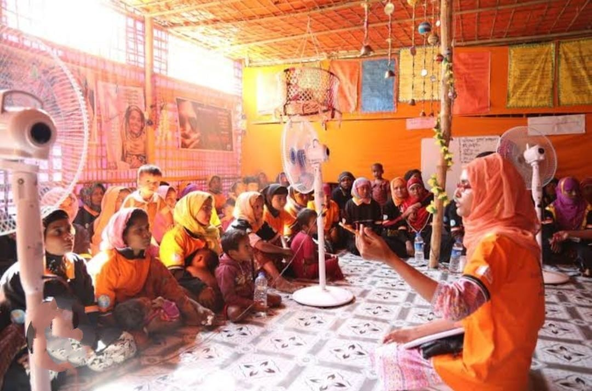

Photo: A photo of women gathering in a women friendly space in Rohingya camp of Cox’s Bazar

**Gendered Vulnerabilities in the Rohingya Refugee Crisis**

* **Gender-Based Violence (GBV)**

For women and girls living in the Rohingya refugee camps, gender-based violence (GBV) is one of the most serious issues they face. This includes exploitation, trafficking, domestic abuse, and sexual assault, all of which exacerbate living conditions in the camps while also violating human rights. The danger of GBV is increased by overcrowding, a lack of protection, and the disintegration of social systems. Over 1.2 million refugees live in overcrowded camps, making it difficult for women and girls to locate safe places. Inadequate shelter, dim lighting, and little privacy also foster an atmosphere that is conducive to GBV.

Ineffective law enforcement, a lack of legal frameworks, and the absence of male family members all make women even more vulnerable. Due to cultural stigma and fear of reprisals, many people are unwilling to complain. Over 50% of women have suffered GBV, with sexual violence being the most common type, according to UNHCR [5]. In order to stop additional bloodshed and assist survivors in this ongoing humanitarian disaster, immediate action is essential.

|  |  |  |
| --- | --- | --- |
| **Type of GBV** | **Cases (2023)** | **Age Group (Most Affected)** |
| Sexual Violence | 3,500 | 18-35 years |
| Domestic Violence | 7,200 | 25-40 years |
| Exploitation/Trafficking | 2,100 | 12-25 years |

Table 1: Types of GBV Reported in Cox's Bazar Camps [6]

* **Reproductive Health Challenges**

Women's vulnerability is increased by the significant obstacles they experience in obtaining reproductive healthcare in the Rohingya refugee camps in Cox's Bazar. The quality of medical care is compromised by inadequate sanitation, congested environments, and a lack of healthcare infrastructure. Inadequate treatment throughout pregnancy, labor, and the postpartum period leads to high rates of maternal death. According to the World Health Organization (WHO), many women have problems as a result of inadequate medical facilities, medical equipment, and trained personnel, which can result in avoidable injuries and fatalities [7].

Lack of postpartum care also increases the risk for both moms and babies. Infant mortality is raised by inadequate follow-up care, such as immunizations and assistance with nursing. Infectious disease propagation is further aided by overcrowding and inadequate sanitation. These disparities in healthcare hinder the women's capacity to heal and start afresh, adding to the larger cycle of vulnerability in the camps. To fulfill the growing need for reproductive healthcare and guarantee the welfare of displaced women and girls, immediate action is required.

­­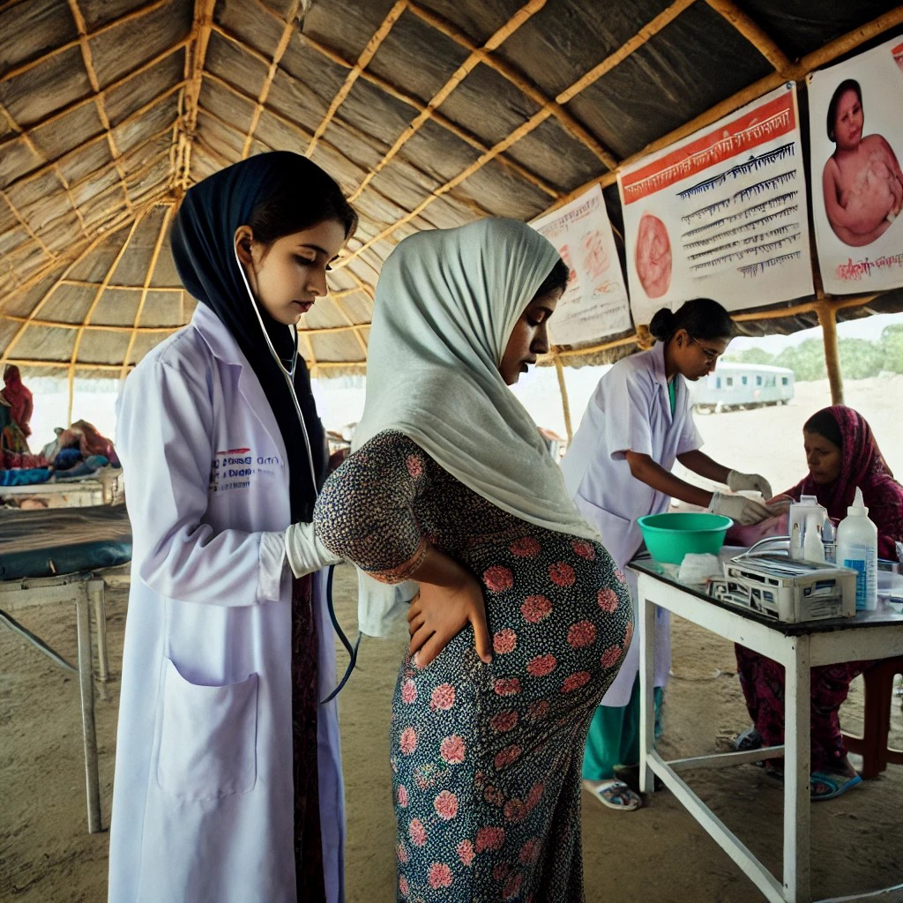

Photo: A healthcare worker assists a pregnant woman in a maternal health center in a Rohingya camp in Cox's Bazar, underscoring the need for maternal healthcare

* **Limited Educational and Economic Opportunities**

Women's empowerment depends on having access to economic and educational opportunities, yet Cox's Bazar refugee women encounter numerous obstacles that make them more vulnerable. Just 23% of refugee girls have access to formal education, which limits their long-term opportunities and prolongs poverty, according to the Global Partnership for Education (GPE) [8]. This restriction limits women's ability to participate in the workforce and make decisions, which perpetuates gender inequity. Women must receive education in order to comprehend their rights, which include protection against gender-based violence and sexual and reproductive health. Women are still susceptible to abuse and exploitation if they are not educated.

Additionally, livelihood initiatives that frequently give preference to men or neglect to meet the unique requirements of women, such childcare and mobility, exclude refugee women. Women continue to rely on humanitarian assistance as a result, which impedes both their independence and the healing of the larger society. In the context of refugees, removing these obstacles is crucial to advancing gender equality, women's empowerment, and sustainable development.

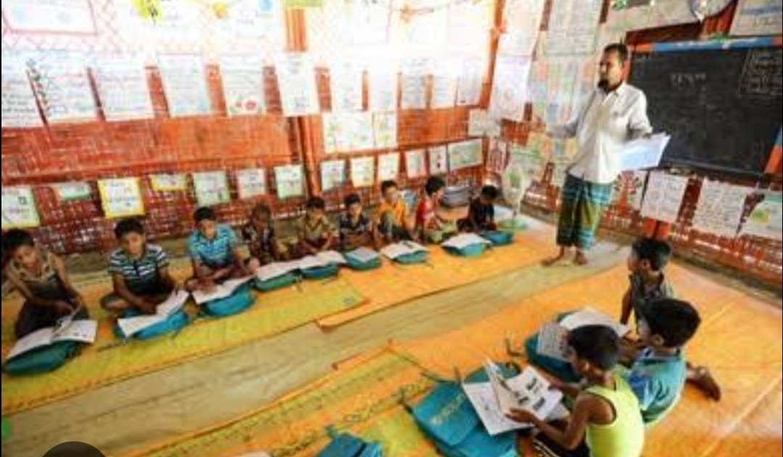

Photo: Rohingya children attending class in a makeshift classroom at a Rohingya camp in Cox’s Bazar. Limited access to education remains a significant challenge, particularly for girls

|  |  |
| --- | --- |
| **Group** | **Access to Formal Education (%)** |
| Boys | 42% |
| Girls | 23% |

Table 2: Education Enrollment Rates for Refugee Girls vs. Boys [9]

**______________________________________________________________________________**

**Social and Economic Impacts of Displacement on Women**

* **Economic Disempowerment and Food Insecurity**

Both host communities and refugee populations in Cox's Bazar have experienced increased food insecurity as a result of displacement, with women and girls in particular suffering greater difficulties as the primary caretakers. Both groups struggle to obtain enough food due to a lack of resources, inadequate food distribution, and unstable conditions. Women are more susceptible to food insecurity, especially in homes headed by women. According to the FAO, women-headed households are more likely to suffer from malnutrition because they have less options for earning a living, unequal access to resources like capital or land, and a lack of resources to buy food [10].

Women's ability to increase food security is further hindered by social and cultural restrictions. Gender norms restrict mobility and aid negotiation skills, frequently keeping women out of food distribution decision-making processes. Poor nutrition has serious repercussions, including higher rates of maternal and infant mortality as well as long-term health problems. Equal access to food, resources, and decision-making for women and girls requires a gender-responsive strategy.

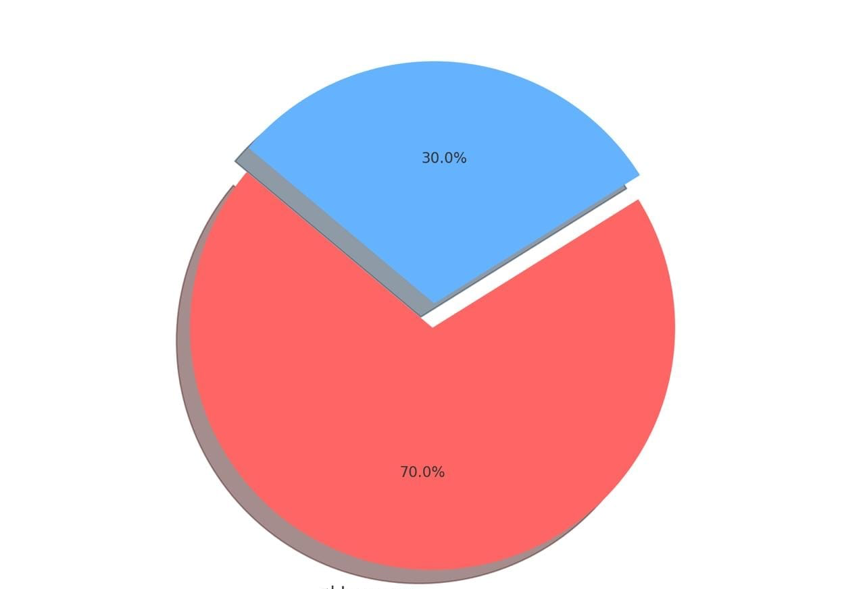

Figure 2: Prevalence of Food Insecurity Among Female-Headed Households [11]

* **The Strain on Social Structures and Relationships**

Social systems in both the host and refugee groups have been severely stretched by the displacement, leading to changes in customs and responsibilities. In the absence of male family members, women are frequently unprepared to assume new roles, such as taking on the role of principal breadwinner or head of the household. Women are under tremendous stress as a result of this change, which is made worse by their restricted access to social support systems. Women and girls are separated due to unfamiliar community systems, which raises their risk of mental health problems. Their vulnerability might be exacerbated by mental health issues like anxiety and depression brought on by elevated stress and a lack of support.

**______________________________________________________________________________**

**Protection Gaps and Legal Rights**

* **Legal Status and Statelessness**

The fact that Rohingya women are legally stateless presents several difficulties for them. Being refused citizenship leaves individuals open to exploitation and abuse since they are not granted the legal safeguards that come with having their rights recognized. Their marginalization is made worse by their lack of legal status, which restricts their access to opportunities, resources, and justice. Additionally, it hinders women's ability to claim their rights in areas like property ownership, inheritance, and assault protection. Governments and humanitarian groups must push for the legal status of the Rohingya to be recognized and establish mechanisms for the effective protection of women's rights.

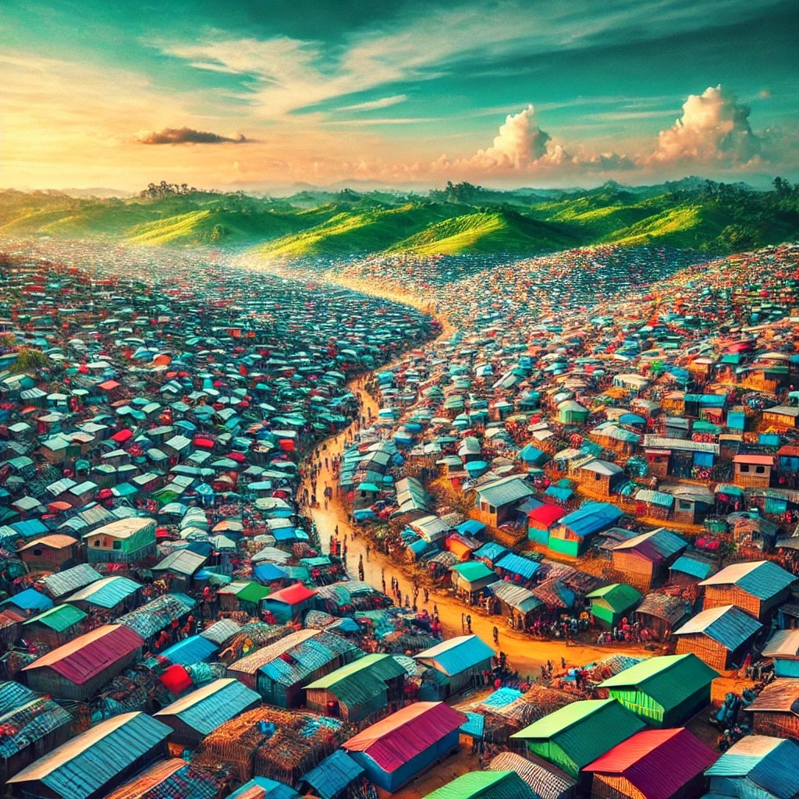

Photo: An aerial view of Rohingya camps in Cox’s Bazar, highlighting the scale of the crisis

* **Inadequate Protection Mechanisms**

Many women and girls in the refugee camps are forced to rely on male family members for safety due to the lack of efficient protection systems, making them more susceptible to exploitation and domestic abuse. Furthermore, there are gaps in protection because camp security forces are sometimes ill-equipped to handle the particular needs of female refugees. Enhancing legal assistance for women, guaranteeing protection from gender-based violence (GBV), and giving women the chance to take part in security-related decision-making are all essential to addressing these problems. This will contribute to improving women's access to justice and safety in the camps.

**Women’s Participation in Peacebuilding and Decision-making**

* **Empowering Women as Leaders**

It is imperative that women participate in the decision-making processes that impact their lives. In order to ensure that their needs are satisfied and their views are heard, the WPS agenda places a strong emphasis on women's involvement in peacebuilding and conflict resolution. Although there has been some improvement in the inclusion of women in camp management and decision-making in Cox's Bazar, their involvement is still quite low. Building resilience and guaranteeing a more sustainable future for both refugees and host communities requires empowering women to assume leadership positions within the refugee community.

|  |  |  |  |
| --- | --- | --- | --- |
| **Category** | **Cox’s Bazar (Rohingya)** | **Uganda (South Sudanese Refugees)** | **Jordan (Syrian Refugees)** |
| Women-Friendly Spaces | 12 | 15 | 20 |
| Maternal Healthcare Access | 65% | 78% | 85% |
| Female Participation in Leadership Roles | 5% | 12% | 20% |

Table 3: Comparison of Women’s Leadership Participation in Refugee Contexts [12]

* **Community-Led Initiatives and Gender Equality**

Enhancing women's rights and security requires community-led programs that advance gender equality. Local women's organizations have formed in Cox's Bazar to fight gender-based violence (GBV), support women's education and health, and promote their involvement in peacebuilding. Through direct participation in their own rehabilitation and community reconstruction, these grassroots initiatives empower women. Support and resources that enable them to grow are crucial for bolstering these programs and enabling women to actively participate in determining their own futures and bringing about long-lasting change in their communities.

**______________________________________________________________________________**

**Recommendations**

**Strengthening Gender-Based Violence Prevention and Response Mechanisms:** Community-led initiatives that promote gender equality are necessary to improve women's rights and security. In Cox's Bazar, local women's organizations have emerged to combat gender-based violence (GBV), assist women's health and education, and encourage their participation in peacebuilding. These grassroots efforts empower women by allowing them to directly participate in their own recovery and community regeneration. Strengthening these programs and empowering women to take an active role in shaping their own futures and enacting real change in their communities requires resources and support that allow them to develop.

**Enhancing Access to Healthcare and Reproductive Services:** Reducing maternal mortality rates in refugee contexts requires expanding reproductive healthcare and maternal health services. In high-density refugee communities, setting up mobile clinics and growing medical facilities would assist guarantee that women have prompt access to care they need. These services ought to provide family planning information as well as prenatal, postpartum, and delivery care. In order to meet the special needs of displaced women, enhance their health, and lower the dangers of pregnancy and childbirth in crowded, resource-constrained settings, it is imperative that these healthcare systems be strengthened.

**Increasing Educational and Economic Opportunities for Women:** There must be a concentrated effort to give women in refugee camps access to vocational training and enhance educational options for girls. Programs for livelihoods should be customized to meet the unique requirements of women and provide skill development in line with market expectations. By giving them the means to generate revenue, sustain their families, and end the cycle of poverty, this will empower women. In addition to improving women's financial independence, increasing access to economic and educational possibilities also strengthens the general resilience of displaced populations, promoting gender equality and long-term development.

**Advocating for Legal Protection and Status Recognition:** The legal rights of Rohingya women must be recognized, and this requires advocacy on a national and international level. Securing legal status for the Rohingya community should be the main goal in order to provide women with access to healthcare, education, legal safeguards, and other necessities. In order to protect women's rights, stop exploitation, and guarantee their involvement in decision-making processes, this acknowledgment is essential. Legal frameworks that prioritize the protection and empowerment of Rohingya women and guarantee the upholding of their fundamental human rights can be established with the assistance of humanitarian organizations and international pressure.

**Promoting Women’s Leadership and Participation:** Encouraging women to actively participate in decision-making is crucial to ensure that their demands are met. Women's perspectives are heard in the planning and execution of humanitarian responses when female leadership is promoted in both the host and refugee communities. This is especially crucial in fields where women's viewpoints are frequently disregarded, such security, healthcare, and education. Women may more effectively and inclusively advocate for their rights, influence policies that affect their lives, and aid in the general healing and well-being of their communities when they are given the opportunity to assume leadership roles.

**______________________________________________________________________________**

**Conclusion**

The gendered aspects of the Rohingya refugee crisis in Cox's Bazar need to be addressed right away because women and girls are particularly affected by the larger social structures that sustain inequality as well as their marginalization inside refugee contexts. These women are frequently disproportionately impacted by problems that increase their vulnerability and instability, such as economic prospects, inadequate education, lack of access to reproductive healthcare, and gender-based violence (GBV). Addressing the full needs of displaced women requires a Women, Peace, and Security (WPS) approach, which places a high priority on women's protection, empowerment, and active involvement. In addition to protecting women from abuse, the WPS framework advocates for a rights-based approach that allows them to fully participate in all decision-making processes, from organizing humanitarian responses to post-crisis rehabilitation initiatives.  
  
To make sure that women's needs are satisfied and their opinions are heard, humanitarian actions must incorporate WPS principles. The creation of policies and interventions becomes more inclusive and successful when women are positioned at the center of decision-making processes. This will support a more equitable and durable recovery for both host communities and refugees, in addition to empowering women. Women's active participation in fields including education, healthcare, and security helps guarantee that the solutions proposed represent their goals and reality.

Furthermore, fostering long-term peace and security in Cox's Bazar and elsewhere requires addressing the gendered vulnerabilities of women and girls in the context of refugees. It is crucial to implement policies that lessen gender disparities and increase women's resilience as the region recovers in order to promote a more secure, equitable, and peaceful future for everybody. The execution of these actions will support the more general objective of attaining human rights and gender equality in the aftermath of the crisis.

**______________________________________________________________________________**

**Author’s Contribution**

The author's work, "Gendered Dimensions of Displacement: Addressing Women’s Rights and Security in the Rohingya Crisis at Cox's Bazar, Bangladesh," is exclusively her own. The idea, research design, data collection, analysis, and writing were all completed without any additional assistance. Throughout the procedure, the author made sure that all sources were appropriately cited and that ethical research guidelines were followed. The article emphasizes the gendered challenges faced by women and girls in the Rohingya refugee camps in Cox's Bazar, highlighting their increased vulnerability to violence, exploitation, and limited access to essential services. It advocates for a gender-responsive approach that integrates the Women, Peace, and Security (WPS) framework to address these vulnerabilities and promote long-term stability and rehabilitation by adhering to the values of integrity, transparency, and accountability.

**______________________________________________________________________________**

**References**

1. United Nations High Commissioner for Refugees (UNHCR). (2017). Rohingya emergency. Retrieved from [UNHCR](https://www.unhcr.org)

Médecins Sans Frontières (MSF). (2023). "Rohingya refugee crisis." Retrieved from [MSF Australia] (https://www.msf.org.au)

UNHCR. (2017). "Donors pledge over US$344 million in response to Rohingya refugee crisis." Retrieved from [UNHCR](<https://www.unhcr.org>)

2. United Nations Security Council. (2000). Resolution 1325 (2000) on Women, Peace, and Security. United Nations. Retrieved from [https://www.un.org/womenwatch/osagi/wps/] (https://www.un.org/womenwatch/osagi/wps/).

3. UNHCR and REACH Joint Assessment (2019). Demographics of Rohingya Refugees in Cox's Bazar, Bangladesh. Available at: [UNHCR Data] (<https://data.unhcr.org/en/country/bgd>)

4. United Nations High Commissioner for Refugees (UNHCR), "Rohingya Refugee Response in Bangladesh: Gender-Based Violence (GBV) Factsheet," March 31, 2022.

5. Global Partnership for Education (GPE). (2020). Displacement, girls' education, and COVID-19. Retrieved from [https://www.globalpartnership.org] (https://www.globalpartnership.org).

6. UNHCR. (2022). Global Report 2022: Gender-Based Violence Chapter. UNHCR. Retrieved from [https://reporting.unhcr.org] (https://reporting.unhcr.org).

7. World Health Organization (WHO). (2021). Women's health. Retrieved from [https://www.who.int/health-topics/women-s-health] (https://www.who.int/health-topics/women-s-health).

8. Global Partnership for Education (GPE). "Results Report 2021." Global Partnership for Education, 2021.

9. United Nations High Commissioner for Refugees (UNHCR). (2023). Education Report 2023: Refugee Education Statistics. UNHCR.

10. FAO. (2023). Gender and food insecurity: Women's vulnerability in rural economies. Food and Agriculture Organization of the United Nations. Retrieved from [FAO Website] (https://www.fao.org/gender/en/).

11. Quisumbing, A., & Meinzen-Dick, R. (2001). Gender and food security: A framework for analysis. [FSIN 2023 Global Report on Food Crises] (https://www.fsinplatform.org/global-report-food-crises-2023).

PLOS ONE (2023). "Revisiting food insecurity gender disparity," [PLOS ONE] (https://journals.plos.org/plosone/article?id=10.1371/journal.pone.0253152).

12. UNHCR. (2023). Gender equality and the empowerment of women and girls. UNHCR. Retrieved from [https://www.unhcr.org/gender-equality] (<https://www.unhcr.org/gender-equality>).