Review Article:

**THE SYNERGISTIC EFFECT OF NATURAL ANTIFUNGALS IN TREATING ONYCHOMYCOSIS**

**Mr. Sahil N. Patel1, Mr. Ganesh Gophane2**

**Author 1, Guide 2**

* **Abstract :-**

Onychomycosis, or fungal nail disease, affects a large segment of the population worldwide and is associated with significant morbidity, including nail deformities, discomfort, and psychosocial impacts. Conventional treatments, though effective, are often accompanied by undesirable side effects and limitations in efficacy. In recent years, interest has surged in natural and alternative treatments due to their potential for fewer side effects, accessibility, and cost-effectiveness. This review synthesizes findings on various natural therapies, including essential oils, plant extracts, and other naturally derived substances, which have demonstrated antifungal activity in laboratory and clinical studies. The mechanisms of action, efficacy, and safety profile of these treatments are critically examined, with an emphasis on understanding their role in integrative and complementary medicine.

* **Keywords :-** Onychomycosis, Dermatophyte, Natural-Antifungal, Treatment, Nigella Sativa, Clove, Neem, Oregano Oil.
* **Introduction :-**

Onychomycosis, commonly known as fungal nail disease, is caused primarily by dermatophytes such as Trichophyton rubrum and Trichophyton mentagrophytes, although non-dermatophyte molds and yeasts (notably Candida species) can also contribute to infections [1]. The condition often manifests as discolored, thickened, brittle, and distorted nails, and in severe cases, may lead to pain and secondary bacterial infections. Traditional treatment options, including systemic antifungal agents (such as terbinafine and itraconazole) and topical formulations (e.g., amorolfine and ciclopirox), come with challenges such as limited penetration, potential hepatotoxicity, and drug resistance [2].

Natural therapies offer alternative approaches to managing onychomycosis. These therapies utilize plant-derived oils, extracts, and compounds that possess inherent antifungal properties. The appeal of natural treatments lies in their favorable safety profile, ease of access, and historical use in folk medicine. This review provides a comprehensive assessment of the efficacy, mechanisms of action, and potential application of various natural therapies for fungal nail disease.

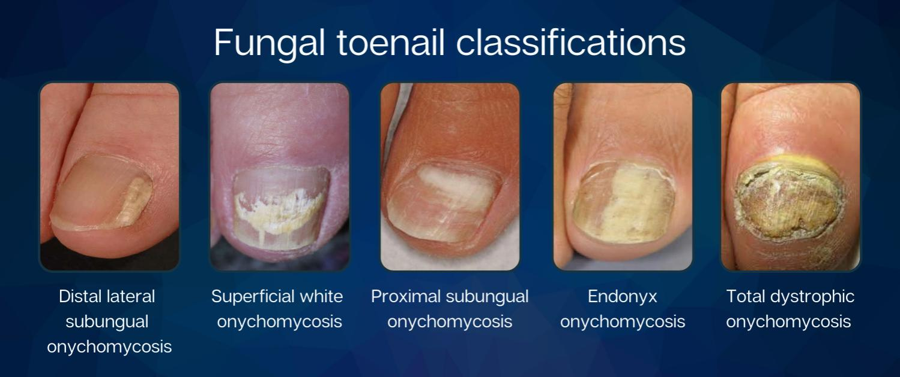**Fig. 1:** Various types of Onychomycosis

* **Recent Approaches Of Transungual Drug Delivery :-**

The development of nail patches for the treatment of onychomycosis in order to accomplish targeted drug delivery is the study’s primary focus. Therefore, the goal of the research is to choose a more effective drug delivery method in order to stop the illness. There are several therapy limitations with conventional dose formulations. The study employed a variety of therapy options, including in-situ hydrogels, nail lacquers, nanoemulsions, microemulsions, and nail patches. Drug distribution, penetration, therapeutic efficacy, treatment strategies, patient compliance, and treatment procedures are the criteria's primary concerns.

**• Nanoparticles**

Nanoparticles in topical/transungual drug delivery have received a lot of attention in recent years. Nanoparticles in the form of a topical treatment can be readily administered to nails while avoiding the side effects associated with oral drugs. The inclusion of nanoparticles improves therapeutic targeting while also improving drug profile and permeability [3].

a) Nano-emulsion.

b) Nanocapsules.

**• Liposomes**

Liposomes are phospholipid bilayered vesicles with an aqueous centre and a phospholipid outer membrane. The structure is similar to that of a natural membrane, providing a distinct feature for medication administration. Liposomes are suitable for both hydrophilic as well as hydrophobic drug delivery.Liposomes are frequently used in topical drug delivery applications due to their advantages such as biocompatibility, improved skin penetration, stability, low toxicity, and prolonged release [3]

**• Microemulsion**

Microemulsion is a thermodynamically stable carrier with low surface tension and droplet sizes ranging from 10 to 100 nanometres. It has exceptional properties such as increased bioavailability, absorption, and permeability. It improves the bioavailability of all medicines, both hydrophilic and lipophilic. They have become a preferred mode of delivery for topical and transdermal formulations due to their ability to store high amounts of medication and improve diffusion across skin membranes [3].

**• Hydrogel**

Hydrogels are water-soluble polymeric networks capable of absorbing large amounts of water or physiological fluids. Hydrogels are often created via natural and synthetic polymers. They exhibit good viscosity and bioadhesion without generating irritation or sensitisation. They are easily washable and adhere well. Self assembling hydrogels are created in response to external stimuli such as temperature, pH, as well as concentration. Such systems are known as in situ gelling systems [3].

**• Nail lacquer**

Nail lacquers (enamel or varnish) have long been used as a cosmetic to protect and embellish nails. Drug-containing nail lacquers are a relatively new type of preparation known as transungual delivery techniques [4].

* **Natural Treatments and Their Efficacies**
* **Black Cumin (Nigella Sativa)**

Nigella sativa, commonly known as black seed or black cumin, has a long history in traditional medicine due to its broad antimicrobial and anti-inflammatory properties.The essential oil of a N.sativa targets cell wall, plasma membrane, Membraneous oraganell mainly in nuclei and mitochondria of fungi.

The various extract of black cumin containing Thymoquinone, thymol, thymohydroquinone reveled potent antifungal effect against several fungal strains including dermatophytes, molds and yeasts [5]. Its ether extract and thymohydroquinone show inhibitory activity against T. Rubrum, T. Interdigitale, T. Mentagrophytes, Epidermophyton floccosum and microsporum canis [6]. Its Methanolic extract followed by chloroform extract shows strong antifungal effect against candida albicans [7].

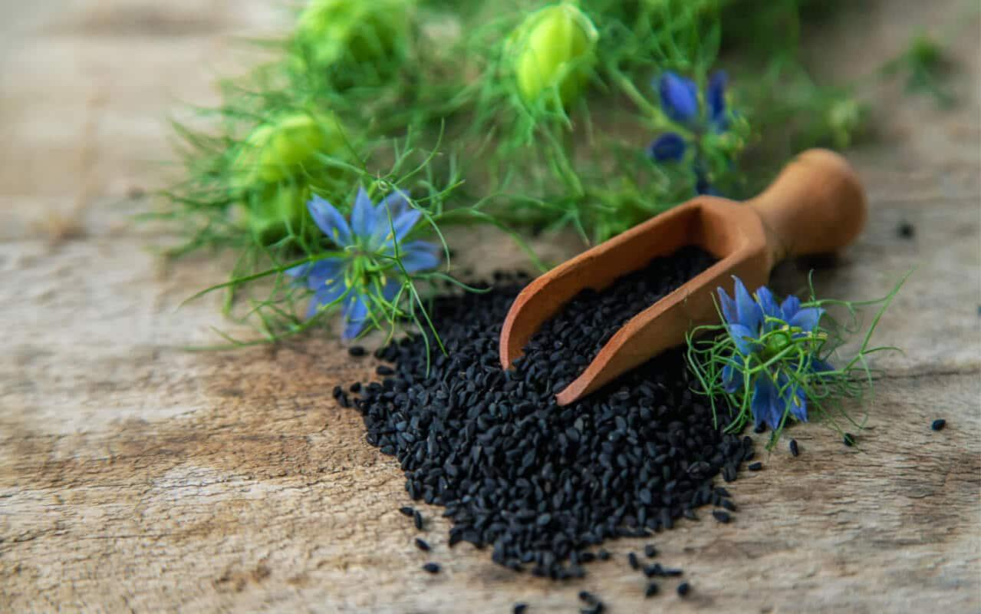**Fig. 2:** Nigella Sativa

* **Clove (Eugenia cariophylata)**

Eugenol has high antifungal activity against T.rubrum, as well as yeast and filamentous fungal species. [8]eugenol additionally induced significant morphological defects in T. Rubrum, prohibiting its growth, viability, and virulence. Eugenol is lipophilic in the sense that it increases the fluidity and permeability of the microbe’s cell membrane. Eugenol inhibits ergosterol manufacturing, resulting in an antifungal impact on T. Rubrum’s cell wall and membrane. Clove oil has been shown in studies to dramatically limit the growth of dermatophytes and can be administered topically to nail infections, making it a promising natural alternative or additional treatment for onychomycosis [9].

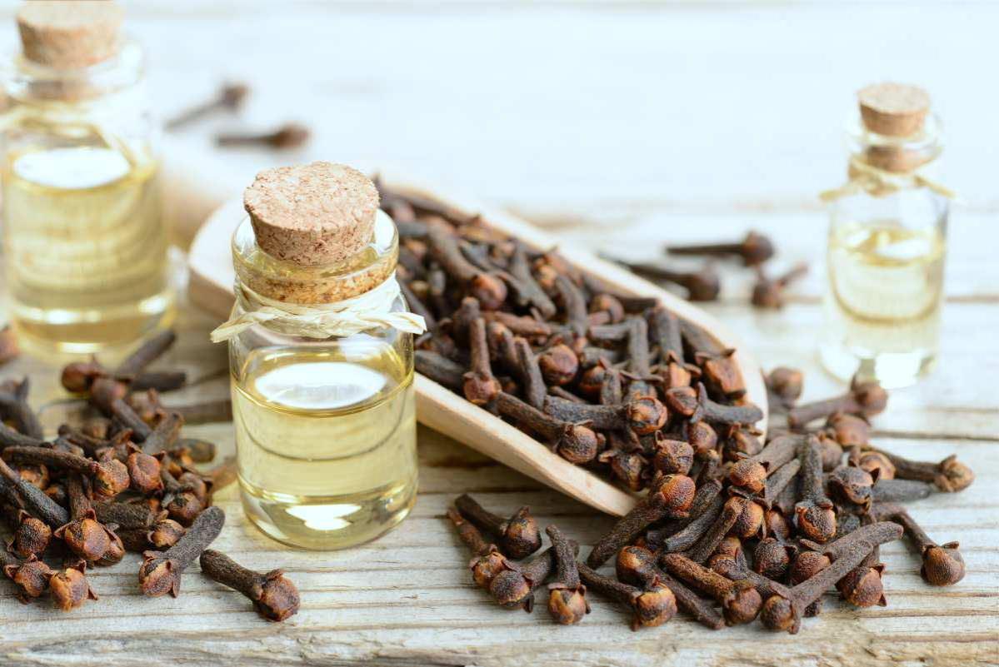**Fig. 3:** Eugenia cariophylata

* **Neem (Azadirachta indica)**

Neem oil is rich in compounds such as azadirachtin, nimbidin, nimbin, and gedunin, which contribute to its antifungal efficacy [10] . Neem oil and neem-based extracts have demonstrated significant antifungal activity against dermatophytes, including Trichophyton rubrum, one of the most common causative agents of onychomycosis [11]. In clinical observations and anecdotal evidence, patients applying neem oil topically to the affected nails report improvements in nail color, reduction in thickness, and overall healthier nail appearance within 3–6 months of consistent application [12].

Some formulations combine neem oil with other carrier oils (such as coconut oil) or include neem extract in nail lacquers to improve retention and penetration, enhancing neem’s transungual activity [13].

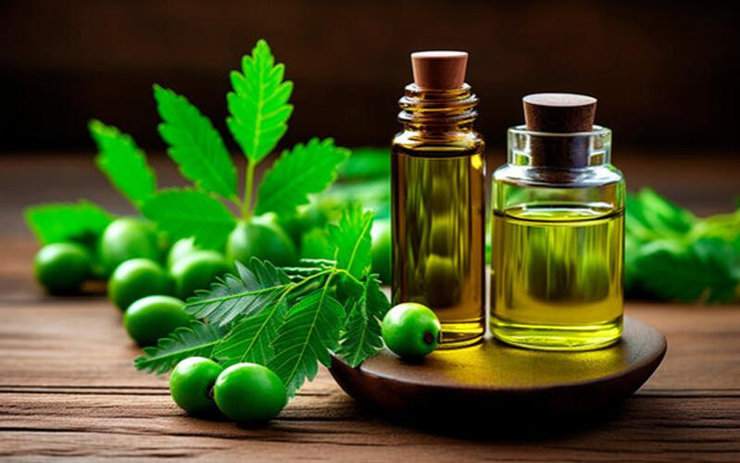**Fig. 4:** Azadirachta indica

* **Senna (Cassia alata Linn.)**

Cassia alata Linn (Fabaceae) is a tropical tree that can thrive in a variety of temperatures. C. alata functions as both an attractive and therapeutic plant. C. alata contains bioactive compounds such as flavonoids, tannins, saponins, alkaloids, phenols, steroids, alatinon, alanonal, and β-sitosterol-β-D-glucoside (Fatmawati et al., 2020). These constituents were reported to have anti-inflammatory, anti-allergic, antioxidant, antidiabetic, anticancer, and antifungal properties in various studies [14].

The methanol leaf extract of Cassia alata displayed the strongest antimycotic activity, as evidenced by both the least inhibitory and minimum fungicidal concentrations. Finally, the study found that Cassia alata (Linn.) had in vitro antimycotic action against field strain dermatophytes, indicating that the plants are a good vegetal drug candidate and a feasible alternative to conventional medications [14],[15].

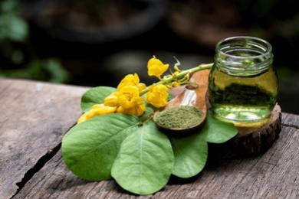**Fig. 5:** Cassia alata Linn.

* **Garlic (Allium sativum)**

Garlic, known for its antibacterial, antiviral, and antifungal properties, contains allicin, an organosulfur compound that disrupts lipid synthesis in fungal cell membranes, thereby inhibiting fungal growth [16]. A clinical trial showed that garlic extract applied as a gel was effective in reducing fungal growth on infected nails within a month [17]. Additionally, its anti-inflammatory effects make garlic a valuable option for reducing discomfort and inflammation associated with onychomycosis.

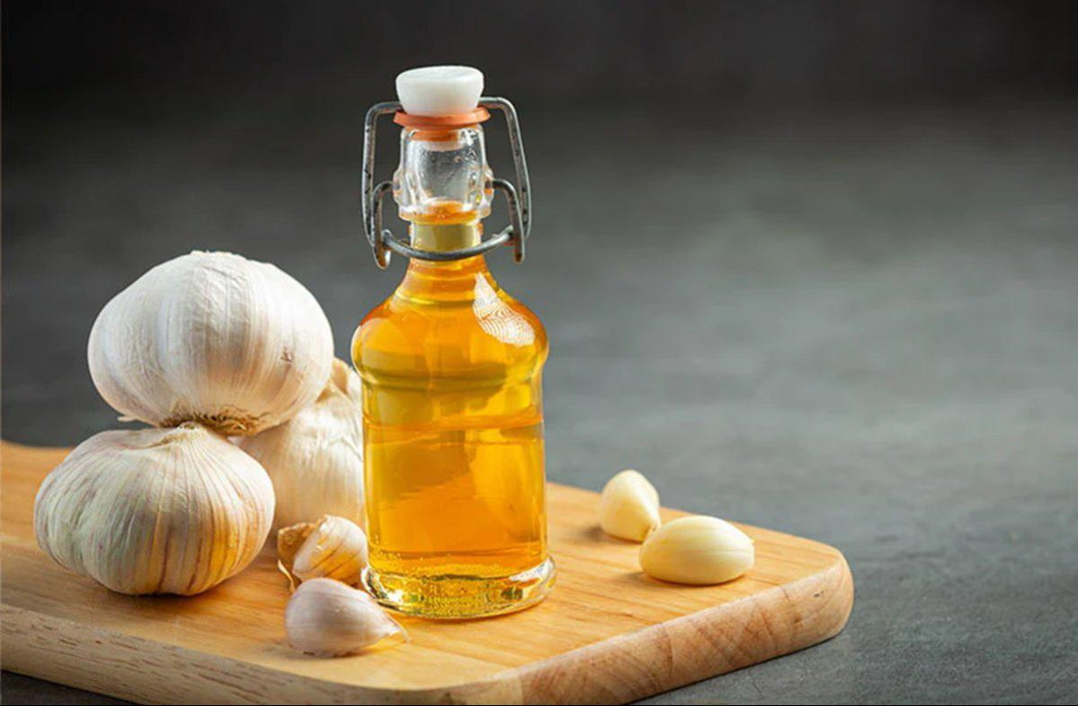**Fig. 6:** Allium sativum

* **Vinegar (Acetic Acid)**

Vinegar is widely used as a natural antifungal due to its acetic acid content, which lowers the pH of the infected area, creating a hostile environment for fungi [18]. Although robust clinical evidence is sparse, case reports and small observational studies support the use of vinegar soaks (typically a 1:1 dilution with water) to control mild fungal infections. Users often report reduced discoloration and improved nail texture after 2-3 months of regular use.

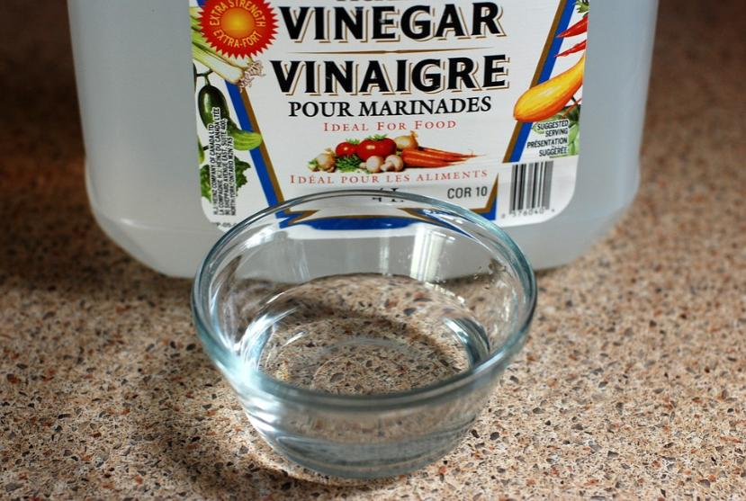

**Fig. 7:** Acetic Acid

* **Oregano Oil (Origanum vulgare)**

Oregano oil contains high concentrations of phenolic compounds, such as carvacrol and thymol, which have demonstrated robust antifungal activity against a range of pathogenic fungi, including Candida and dermatophyte species [19]. Carvacrol in particular disrupts the structural integrity of fungal cells by interacting with cell membrane phospholipids, leading to increased permeability and cell death [20]. Clinical evidence suggests that a 10% oregano oil solution applied daily can lead to visible improvement in nail appearance within 2–3 months [21].

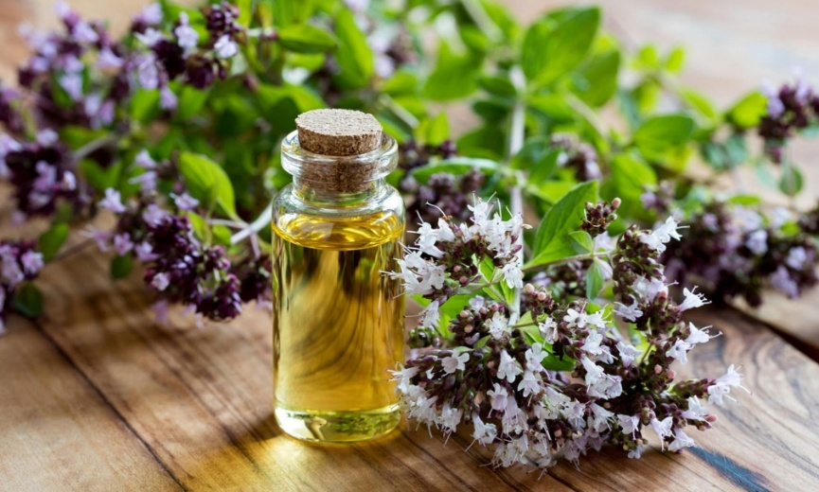**Fig. 8:** Origanum vulgare

* **Tea Tree Oil (Melaleuca alternifolia)**

Tea tree oil has gained widespread recognition due to its potent antifungal, antibacterial, and anti-inflammatory properties. Studies attribute its effectiveness primarily to the presence of terpinen-4-ol, a monoterpene that disrupts fungal cell membranes, resulting in cellular leakage and cell death [22]. In a comparative study, Syed et al. demonstrated that 100% tea tree oil was comparable in efficacy to 1% clotrimazole solution, with approximately 60% improvement observed after 6 months of daily application [23]. Notably, tea tree oil may also exhibit anti-inflammatory effects that can reduce irritation and redness around the infected nail.

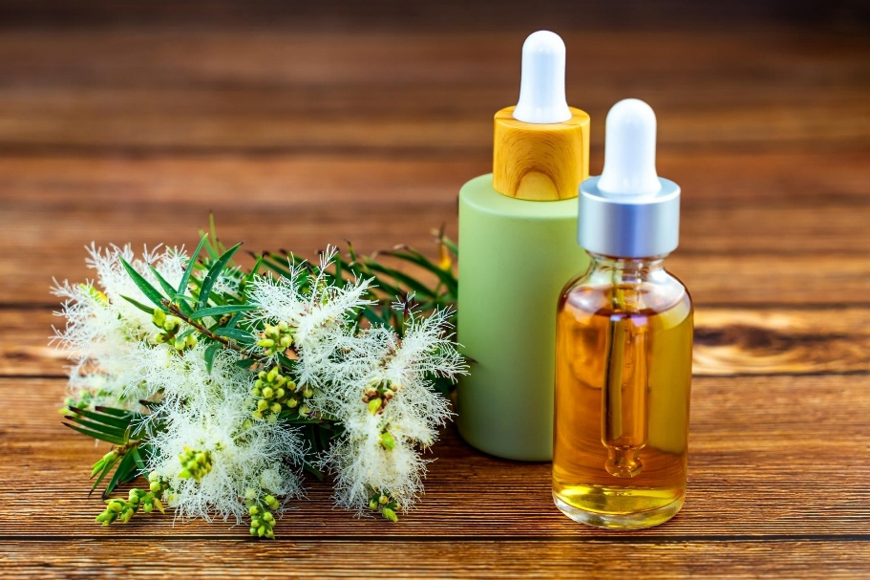

**Fig. 9:** Melaleuca alternifolia

* **Coconut Oil (Cocos nucifera)**

Coconut oil is rich in medium-chain fatty acids, particularly lauric acid, which has been studied for its antifungal activity. Lauric acid integrates into the fungal cell membrane, causing structural damage that inhibits fungal replication [24]. While limited clinical studies exist on coconut oil’s efficacy for onychomycosis, anecdotal evidence and laboratory studies on dermatophytes suggest potential benefits as a supportive treatment. Coconut oil’s emollient properties may also provide additional benefits for nail health, reducing brittleness and dryness.

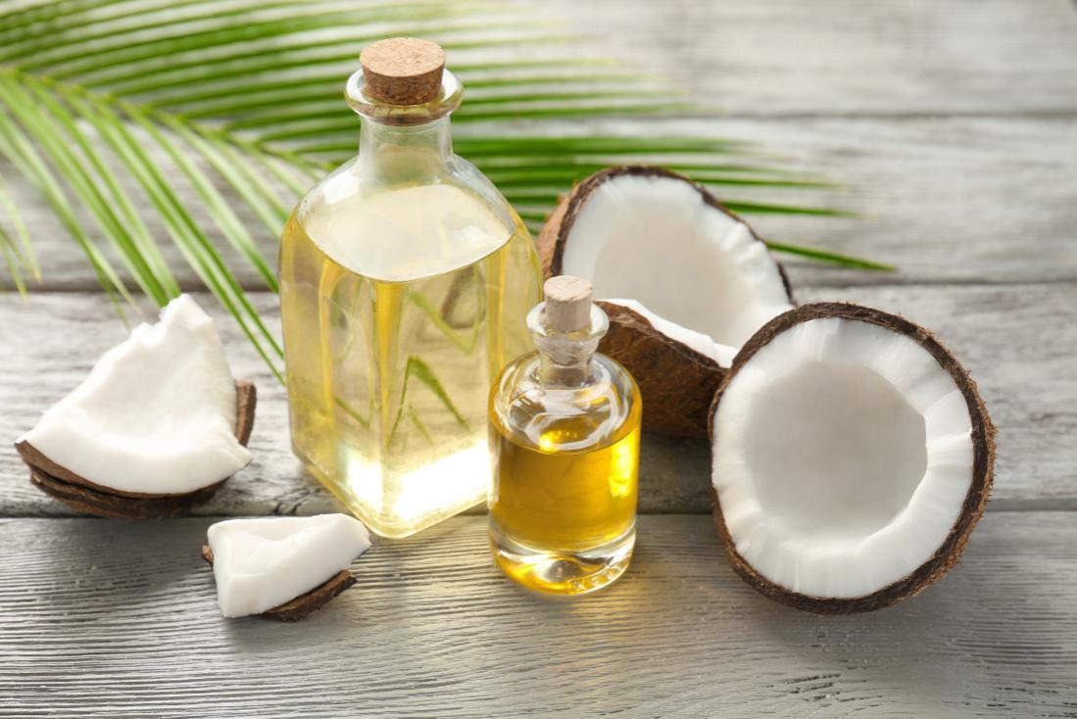**Fig. 10:** Cocos nucifera

* **Turmeric (Curcuma longa)**

Turmeric contains curcumin, a polyphenol with strong antifungal, antibacterial, and anti-Inflammatory properties. Curcumin inhibits fungal growth by disrupting fungal cell membranes and metabolic pathways [25]. In animal and laboratory studies, oral curcumin has demonstrated broad antifungal activity against Candida, dermatophytes, and molds. Although clinical trials on turmeric for onychomycosis are limited, curcumin supplements have shown safety in high doses, making it a promising candidate for oral antifungal therapy [26].

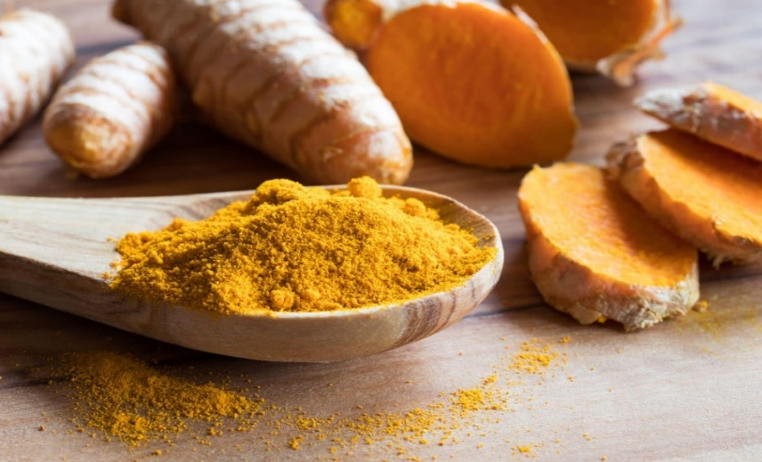**Fig. 11:** Curcuma longa

* **Nutritional healthcare of Nails :-**

Lack of vitamin A, Vitamin D and calcium causes dryness and brittlness of nail. Sources of these micronutrients include fortified milk ,cereal, juices, salt water fish, fish liver oil and some vegetables. Lack of vit B12 causes excessive dryness, darkened nail, rough and rounded nail ends [27].

Low dietary protein results in white nail bed. Protection is essential building material for nail. Dietary source of these nutrients are egg, milk, cheese, meat, beans and legumes. Essential fatty acids play a large role in healthy nail. Fatty acids are obtained from fish, flaxseed, canola oil, seeds, leafy vegetables and nuts. Iron deficiency may cause pale, flat and concave nails. Iron found in meat, fish and poultry, fruit, vegetables, dried beans, nuts and grain products [27].

* **Mechanisms of Action :-**

Natural antifungal agents primarily exert their effects by compromising the structural integrity of fungal cells or inhibiting critical biochemical pathways necessary for fungal survival and replication.

* **Membrane Disruption:**

Compounds such as terpinen-4-ol in tea tree oil and carvacrol in oregano oil disrupt fungal cell membranes, resulting in cellular leakage and death.

* **Inhibition of Lipid Synthesis:**

Allicin, found in garlic, interferes with lipid biosynthesis pathways, preventing the formation of essential cell membrane components.

* **Environmental Modification:**

Acetic acid from vinegar reduces the pH of the affected area, which hampers fungal metabolism and growth.

* These actions, combined with potential anti-inflammatory effects (notably from compounds like menthol and camphor), underscore the multifaceted benefits of natural therapies in managing onychomycosis [28].
* **Safety Profile and Potential Side Effects :-**

Natural treatments are generally associated with a favorable safety profile; however, some adverse effects have been reported. Essential oils, such as tea tree oil and oregano oil, may cause skin irritation or allergic reactions in sensitive individuals. To minimize such risks, these oils should be diluted before application. Vinegar may cause mild burning or irritation when used in high concentrations, especially on broken or sensitive skin. Vicks VapoRub, though widely used, contains camphor, which should be used cautiously, particularly in young children [29].

* Compared to systemic antifungal medications, which can cause gastrointestinal and liver toxicity, natural treatments offer a safer alternative for individuals seeking non-pharmacological approaches.
* **Limitations and Future Research Directions :-**

Despite promising findings, limitations exist in the current body of research on natural therapies for onychomycosis. Most studies are small-scale, and there is significant variability in the concentration and purity of natural products used across studies, which complicates standardization and replication. Larger randomized controlled trials are needed to determine the optimal formulations, application frequencies, and long-term efficacy of these therapies. Standardization in the preparation and application of natural antifungal agents will enhance their clinical applicability and acceptance in mainstream medicine.

* **Conclusion :-**

Natural therapies offer a valuable addition to the management of onychomycosis, particularly for patients seeking alternatives to conventional antifungal agents. Essential oils such as tea tree and oregano oil, as well as garlic, coconut oil, vinegar, and Vicks VapoRub, exhibit promising antifungal properties supported by both laboratory studies and clinical evidence. While these treatments may not be as potent as systemic antifungal medications, their safety profile, accessibility, and cultural acceptance make them appealing options for integrative and complementary treatment of fungal nail disease. Further research is essential to standardize these therapies and establish clear guidelines for their use, enabling clinicians to provide evidence-based recommendations to patients.

* **References :-**

1. Elewski, B. E., et al. (2009). “Onychomycosis: pathogenesis, diagnosis, and management.” Clinical Microbiology Reviews, 22(3), 409-433. Doi:10.1128/CMR.00059-08
2. Gupta, A. K., and Simpson, F. C. (2012). “New therapeutic options for onychomycosis.” Expert Opinion on Pharmacotherapy, 13(8), 1131-1142. Doi:10.1517/14656566.2012.678841
3. Bhattacharjee Bedanta, Dey Nikita, Barman Dhunusmita, Karmakar Arka, Ahmed Nasima. Understanding the drug delivery through nails: a comprehensive review. Journal of Drug Delivery & Therapeutics. 2021; 11(4):116-131
4. Aggarwal R, Targhotra M, Kumar B, Sahoo P, Chauhan MK. Novel Polypseudorotaxanes Hydrogel based Nail Lacquer of Efinaconazole for Transungual Drug Delivery. Drug Delivery Letters. 2021; 11(1):52-61.
5. Yimer, E. M., Tuem, K. B., Karim, A., Ur-Rehman, N., & Anwar, F. (2019). Nigella sativa L. (Black Cumin): A Promising Natural Remedy for Wide Range of Illnesses. Evidence-based complementary and alternative medicine : eCAM, 2019, 1528635. https://doi.org/10.1155/2019/1528635
6. Majid, A. (2018). The Chemical Constituents and Pharmacological Effects of Nigella sativa. Journal of Bioscience and Applied Research, 4(4), 389-400. Doi: 10.21608/jbaar.2018.151793
7. Prashant Tiwari, Susmita Jena, Swaroop Satpathy, Pratap Kumar Sahu. Nigella sativa: Phytochemistry, Pharmacology and its Therapeutic Potential. Research J. Pharm. And Tech. 2019; 12(7):3111-3116. Doi: 10.5958/0974-360X.2019.00526.2
8. De Oliveira Pereira F, Mendes JM, de Oliveira Lima E. Investigation on mechanism of antifungal activity of eugenol against Trichophyton rubrum. Med Mycol. 2013 Jul;51(5):507-13. Doi: 10.3109/13693786.2012.742966. Epub 2012 Nov 27. PMID: 23181601.
9. Park, M. J., et al. (2007). “Antifungal activity of the essential oils from Thymus vulgaris and clove against dermatophytes.” Journal of Microbiology, 45(5), 460-465.
10. Biswas, K., et al. (2002). “Biological activities and medicinal properties of neem (Azadirachta indica).” Current Science, 82(11), 1336-1345.
11. Pandey, S., et al. (2014). “Antifungal potential of Azadirachta indica and its components in skin fungal infections.” Journal of Clinical and Diagnostic Research, 8(7), DC01-DC04. Doi:10.7860/JCDR/2014/8417.4554
12. Martinez, M., et al. (2010). “The use of neem oil for dermatophytosis and onychomycosis: a case study.” Journal of Alternative and Complementary Medicine, 16(4), 395-398
13. Singh, R., and Kumar, P. (2017). “Neem-based nail lacquer for fungal infections: a formulation study.” International Journal of Pharmaceutical Sciences Review and Research, 46(2), 123-128.
14. Fatmawati S, Yuliana, Purnomo AS, Bakar MFA (2020). Chemical constituents, usage and pharmacological activity of Cassia alata. Heliyon 6:e04396.
15. Emmanuel Edegbo, Martin-Luther Oseni Okolo, Adetunji Sunday Adegoke, Cornelius Arome Omatola, Benjamin Mudi Idache, Joseph Oyiguh Abraham, Monday Eneojo Akor, David Adeiza Zakari, Adebayo Zainab Alaba, Sunday Omale, Abdulrazaq Yahaya, Qasim Musa and Danjuma Muhammed. “Phytochemical screening and antifungal activity of Cassia alata (Linn.) crude leaf extracts.” African Journal of Microbiology Research 17, no. 8 (2023): 176-183.
16. Arora, D. S., and Kaur, J. (2009). “Antimicrobial activity of spices.” International Journal of Antimicrobial Agents, 34(5), 416-420. Doi:10.1016/j.ijantimicag.2009.07.012
17. Ghannoum, M. A., and Isham, N. (2009). “Antifungal activity of garlic extract and its potential for oral use.” Mycoses, 52(5), 447-453. Doi:10.1111/j.1439-0507.2008.01624.x
18. Fernandes, T., et al. (2014). “In vitro antifungal activity of acetic acid in comparison with other agents.” Journal of Antimicrobial Chemotherapy, 69(12), 3296-3299. Doi:10.1093/jac/dku284
19. Ramos, M., Carneiro, C., and Silva, L. (2011). “Antifungal activity of thymol and carvacrol: mechanisms of action.” Journal of Applied Microbiology, 110(3), 785-792. Doi:10.1111/j.1365-2672.2011.04907.
20. Park, M., Bae, J., and Lee, D. S. (2017). “Antifungal activity of carvacrol against Candida albicans: involvement of mitochondrial and Ca2+ homeostasis-mediated apoptosis.” Journal of Applied Microbiology, 122(3), 689-698. Doi:10.1111/jam.13356
21. Sookto, T., and Juntachai, W. (2020). “Evaluation of the antifungal activity of oregano essential oil against Trichophyton rubrum and Candida albicans.” Journal of Essential Oil Research, 32(4), 349-354. Doi:10.1080/10412905.2020.1743751
22. Hammer, K. A., Carson, C. F., and Riley, T. V. (2003). “Antimicrobial activity of essential oils and other plant extracts.” Journal of Applied Microbiology, 95(4), 853-860. Doi:10.1046/j.1365-2672.2003.02059.x
23. Syed, T. A., Qureshi, Z. A., Ali, S. M., Ahmad, S., and Ahmad, S. A. (1999). “Treatment of toenail onychomycosis with 2% butenafine and 5% Melaleuca alternifolia (tea tree) oil in cream.” Tropical Medicine & International Health, 4(4), 284-287. Doi:10.1046/j.1365-3156.1999.00396.x
24. Tosti, A., Hay, R., Arenas-Guzman, R. (2005). “Patients at risk of onychomycosis—risk factor identification and active prevention.” Journal of the European Academy of Dermatology and Venereology, 19(2), 3-6. Doi:10.1111/j.1468-3083.2005.01247.x
25. Araújo, C. C., and Leon, L. L. (2001). “Biological activities of Curcuma longa L.”Memórias do Instituto Oswaldo Cruz, 96(5), 723-728. Doi:10.1590/S0074-02762001000500026
26. Kunnumakkara, A. B., et al. (2017). “Curcumin, the golden nutraceutical: multitargeting for multiple chronic diseases.”British Journal of Pharmacology, 174(11), 1325-1348. Doi:10.1111/bph.13621
27. Bharat parashar, Virendra yadav, Brajesh maurya, Love sharma. Natural Therapy of Fungal Nail Disease: Review. Pharma Innovation 2012;1(4):31-47.
28. Fitzpatrick, D., and Donnelly, R. (2007). “Mechanisms of action of antifungal agents.” Irish Journal of Medical Science, 176(1), 25-31. Doi:10.1007/s11845-007-0010-1
29. Carson, C. F., Hammer, K. A., and Riley, T. V. (2006). “Melaleuca alternifolia (Tea Tree) oil: a review of antimicrobial and other medicinal properties.” Clinical Microbiology Reviews, 19(1), 50-62. Doi:10.1128/CMR.19.1.50-62.2006

**APPENDIX**

* **Appendix:-**

**NATURAL THERAPIES FOR FUNGAL NAIL DISEASE (ONYCHOMYCOSIS)**

* **Abstract :-**

Onychomycosis, or fungal nail disease, affects a large segment of the population worldwide and is associated with significant morbidity, including nail deformities, discomfort, and psychosocial impacts. Conventional treatments, though effective, are often accompanied by undesirable side effects and limitations in efficacy. In recent years, interest has surged in natural and alternative treatments due to their potential for fewer side effects, accessibility, and cost-effectiveness. This review synthesizes findings on various natural therapies, including essential oils, plant extracts, and other naturally derived substances, which have demonstrated antifungal activity in laboratory and clinical studies. The mechanisms of action, efficacy, and safety profile of these treatments are critically examined, with an emphasis on understanding their role in integrative and complementary medicine.

* **Keywords :-** Onychomycosis, Dermatophyte, Natural-Antifungal, Treatment, Nigella Sativa, Clove, Neem, Oregano Oil.

**ERATTA**