**Analyzing and Identifying Data Breaches**

Ganapathi kinjarapu1  
Computer Science and Engineering *GMR Institute of Technology*  
Rajam,India

kinjarapuganapathi9493@gmail.com

Ms.K.Kiranmai2

Computer Science and Engineering *GMR Institute of Technology*  
Rajam,India

Kiranmai.k@gmrit.edu.in

*Abstract*—In an era where data has become a critical asset for organizations and individuals alike, the prevalence of data breaches poses significant risks to both security and privacy. This term paper explores the multifaceted nature of data breaches, focusing on the methodologies for analyzing and identifying these security incidents. It begins with a definition of data breaches and an overview of their importance, followed by a detailed examination of various types of breaches including cyber attacks, insider threats, physical theft, accidental disclosure, and system vulnerabilities. The paper then delves into the techniques used for breach detection and analysis, highlighting the role of intrusion detection systems, security information management, and forensic investigations. Case studies of notable breaches, such as those involving Equifax, Target, and Sony PlayStation Network, provide insights into the causes, impacts, and lessons learned from these incidents. The paper also addresses legal and regulatory considerations, including compliance with data protection laws like GDPR, CCPA and DPDP. Finally, it offers recommendations for preventive measures and best practices to mitigate the risk of data breaches, emphasizing the importance of robust security policies, incident response planning, and technological advancements. Through this comprehensive analysis, the paper aims to enhance understanding of data breach dynamics and contribute to more effective strategies for safeguarding sensitive information

Keywords—*Data Breaches, Potential Impacts, Detection Methods, Prevention Strategies, Cybersecurity.*

# Introduction

In today’s increasingly digital world, data has become a critical asset. Data is essential for decision-making, service enhancement, and various other activities for both businesses and individuals. However, as the amount of collected and stored data increases, so does the risk of data breaches -unauthorized access to sensitive information. Such breaches can result in severe consequences, including financial losses, reputational harm, and legal ramifications for the affected organizations. Personal information, intellectual property, and confidential business data can be compromised, putting privacy, security, and trust at risk.

Data breaches can occur in various ways, from cyberattacks by external hackers to human errors, such as employees inadvertently exposing information. Some breaches result from malicious insiders who misuse their access, while others arise from vulnerabilities in software. High-profile incidents, like the breaches at Equifax, Target, and the Sony PlayStation Network, have highlighted how vulnerable organizations can be and the serious impact breaches can have on both companies and their customers. These situations highlight the importance of strong data protection measures to safeguard against unauthorized access.

This paper aims to explore and analyze data breaches by examining different detection and analysis techniques. Crucial technologies, including Intrusion Detection Systems (IDS) for tracking suspicious activities, Security Information and Event Management (SIEM) systems for identifying patterns and irregularities, and machine learning algorithms for spotting patterns and anomalies, are essential in detecting breaches. Additionally, blockchain technology has emerged as a valuable tool in enhancing data security by creating tamper-proof records and tracking data activity in an immutable manner. These technologies, when used together, are essential for early breach detection and preventing further damage.

In addition to technical measures, the legal aspects of data protection must also be considered. Around the globe, governments have enacted regulations to protect data and hold organizations accountable. Laws such as the European General Data Protection Regulation (GDPR), the California Consumer Privacy Act (CCPA), and India’s Digital Personal Data Protection (DPDP) Act set guidelines for how data should be handled and mandate companies to report breaches. Compliance with these regulations ensures transparency, protects user privacy, and helps organizations avoid significant fines.

By examining current technologies, detection methods, and real-world breach examples, this paper provides insight into how data breaches occur and how they can be effectively identified and managed. Through a comparison of various approaches and an emphasis on best practices, this study offers recommendations for organizations aiming to strengthen their data security strategies. Ultimately, the goal is to help organizations safeguard sensitive data, respond swiftly to emerging threats, and maintain trust in a data-driven world.

# LITERATURE REVIEW

Pranay et al. (2021) and Xu et al. (2018) examine how predictive models can be used to forecast cyber breaches. Their research looks at historical breach data to identify patterns and potential risk factors, allowing organizations to anticipate and strengthen weak points before an attack occurs. Pranay et al. use machine learning techniques to create models that can predict when and where breaches are likely to happen. Xu et al. extend this by integrating forensic data into their predictive models, improving the accuracy of breach detection. These models help organizations stay one step ahead of hackers and minimize the damage caused by breaches [1]. Ansar et al. (2023) explore how blockchain can be used to detect and prevent data breaches. Blockchain is known for its transparency and immutability, making it a powerful tool for ensuring data integrity. By using blockchain, organizations can maintain tamper-proof logs of system activities, which can be crucial in identifying unauthorized access or breaches. While blockchain offers significant benefits, Ansar et al. also acknowledge challenges, such as the scalability of blockchain networks and the computational overhead required for maintaining them. They suggest hybrid models that combine blockchain with other technologies to improve performance while keeping data secure [2]. Al-Shehari and Alsowail (2021) focus on insider threats, which are often the most difficult to detect because insiders have authorized access to systems. They propose using machine learning techniques, such as one-hot encoding and anomaly detection, to monitor employee behavior and identify potential threats. Their approach aims to detect unusual patterns that could indicate an insider is misusing their access to data. By leveraging advanced algorithms, organizations can flag suspicious activities early, preventing the damage caused by insiders before it escalates. The research emphasizes the need for continuous monitoring and the use of adaptive systems that can learn and adjust to new patterns of behaviour [3]. Song and Ananth (2020) explore the issue of information leakage in AI models, particularly in embedding models, where sensitive information can inadvertently be exposed during training or inference. They explain how these models can unintentionally reveal private data, such as passwords or personal information, and suggest methods to prevent such leakage. Lukas et al. (2023) also discuss the risks of personally identifiable information (PII) leakage in language models, a growing concern as these models become more widely used. Both studies highlight the need for privacy-preserving techniques, such as differential privacy, to ensure that sensitive information remains secure. By incorporating these methods, researchers aim to protect user data while still benefiting from advanced AI technologies [4]. Roumani (2021) highlights the importance of quickly detecting data breaches, as delays in detection can lead to larger-scale compromises. The research emphasizes that the faster a breach is identified, the quicker an organization can respond and mitigate the damage. Roumani’s study suggests using automated systems and machine learning-driven monitoring to accelerate detection times, helping organizations stay ahead of attackers. Fang et al. (2019) take this a step further by analyzing how breaches are discussed in underground forums, uncovering trends that can be used to predict where breaches might occur next. By understanding how stolen data is shared and sold in these forums, organizations can better anticipate future threats [5]. Shankar and Mohammed (2020) provide a case study analysis of how organizations respond to data breaches. Their research shows that the ability of an organization to recover from a breach largely depends on its level of preparedness, the strength of its communication strategies, and its ability to maintain stakeholder trust. Dileep (2020) examines the financial and reputational impact of breaches across various industries, noting that the consequences can be severe, especially for companies that fail to act quickly. Joseph (2017) offers insights from the public sector, where data breaches often face additional challenges like limited budgets and public accountability. All these studies reinforce the need for organizations to have strong recovery plans in place to minimize the long-term effects of a breach [6]. Arshney et al. (2020) propose several strategies for preventing data breaches in the first place. These include implementing strong encryption methods, conducting regular system audits, and setting up strict user access controls. By safeguarding sensitive data effectively, organizations can greatly minimize the risk of a breach. Hassanzadeh et al. (2021) build on this by focusing on the human element, suggesting that user trust is critical in breach prevention. Their study emphasizes that transparency and clear communication with users can help mitigate reputational damage after a breach. Both studies stress the importance of creating a comprehensive security framework that addresses both technical and organizational aspects [7]. Saleem and Naveed (2020) provide a detailed analysis of the technical mechanisms behind data breaches. Their work highlights common attack techniques, including phishing, malware, and social engineering, often used by cybercriminals to gain unauthorized access to systems. Understanding these attack methods is crucial for developing effective defense strategies. The authors suggest a multi-layered approach to security that combines prevention, detection, and response mechanisms. This approach helps organizations to not only stop breaches from happening but also to quickly identify and contain them if they do occur. By adopting this comprehensive strategy, organizations can strengthen their defenses against a wide range of threats [8]. Akinola (2024a, 2024b) presents a two-part framework for developing a comprehensive cybersecurity strategy. His work focuses on proactive risk management, emphasizing the importance of identifying vulnerabilities before they can be exploited. He also highlights the need for ongoing employee training, this strategy ensures that staff are prepared to detect and address potential security threats. Additionally, incident response planning is vital, enabling organizations to respond promptly and effectively in the event of a breach. Akinola’s strategy is designed to help organizations not only prevent breaches but also recover from them with minimal damage. His approach aligns with industry best practices and offers a roadmap for organizations seeking to strengthen their cybersecurity posture [9]. Trabelsi (2019) stresses the importance of real-time monitoring to detect data leaks as soon as they occur. In an environment where data is constantly being generated and shared, it is crucial for organizations to have automated systems in place that can flag unauthorized access or leaks. Trabelsi advocates for the use of advanced tools that can identify leaks quickly and trigger an immediate response. By acting fast, organizations can prevent further exposure and minimize the impact of the breach. This proactive strategy is crucial in today’s rapidly evolving digital environment, where every second counts when it comes to data security [10]. Shah (2022) and Varma et al. (2020) explore the role of machine learning in enhancing cybersecurity. Their research highlights how AI-powered algorithms can detect abnormal behavior, predict potential threats, and adapt to new attack methods. Machine learning allows systems to continuously learn from new data, improving their ability to detect threats over time. However, they also address the challenges of training models, including the need for large, high-quality datasets and the risk of adversarial attacks. Both studies advocate for improving the accuracy and robustness of machine learning systems to enhance their effectiveness in real-world cybersecurity applications [11].

# EXISTING MODELS

## A. Text Mining and Topic Modeling using Latent Dirichlet Allocation (LDA)

This model applies Latent Dirichlet Allocation (LDA), a commonly used algorithm for topic modeling in natural language processing, to analyze text from underground forums where breaches are often discussed or disclosed. The main goal is to detect trends, breach types, and specific breach details by identifying and categorizing prevalent topics. Here’s how it works:

* Data Collection - Data is gathered from online forums and platforms associated with the dark web or cybersecurity discussions. This data often includes forum posts, comments, or messages.
* Preprocessing - Text data is processed through steps like tokenization, stopword removal, stemming, and lemmatization to prepare it for analysis.
* Topic Modeling with LDA - LDA groups words into topics, identifying patterns in the words used across posts. Each topic might represent different types of breaches (e.g., phishing attacks, ransomware).
* Results Interpretation - By examining topics and their associated words, researchers can interpret and classify breach types, and determine characteristics and frequency. This helps identify how breaches are discussed, reported, or exposed in underground forums, offering valuable insights into the types of breaches and their sources

System architecture of identifying data breach threads:

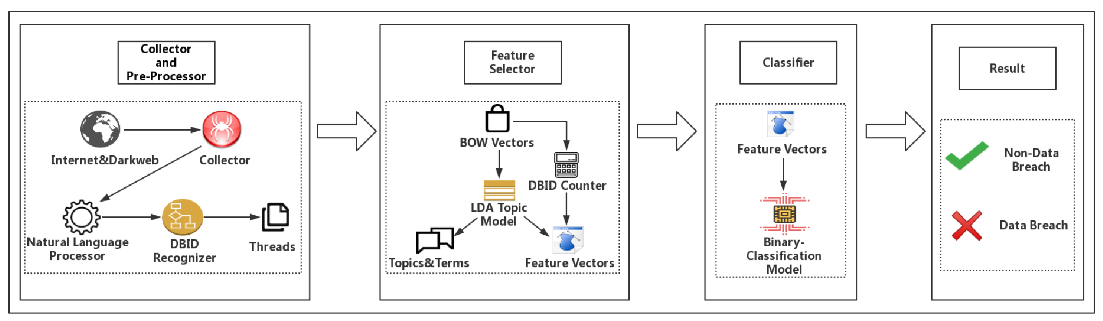

*B. Model: Data Breach Analysis Model (DBAM)*

The Data Breach Analysis Model (DBAM) deconstructs data breaches into several identifiable stages, providing a structured approach to understanding the lifecycle of breaches. By analyzing the process flow, DBAM helps organizations pinpoint vulnerabilities and track breach events from inception to resolution. The model includes:

* Initiation - This stage involves unauthorized access attempts, often involving the exploitation of system vulnerabilities or social engineering tactics like phishing.
* Exploitation - After gaining access, attackers typically exploit the system, often through malware installation or privilege escalation, to access sensitive data.
* Data Exfiltration - In this phase, the attacker extracts sensitive data from the system, often through encrypted channels or exfiltration techniques that evade detection.
* Post-Breach Activity - After data exfiltration, attackers may cover their tracks by modifying logs, using data-sharing forums, or leveraging data for blackmail.
* Analysis and Prevention - By mapping specific breaches to these stages, organizations can conduct forensic analysis and strengthen defenses against identified vulnerabilities in each phase. The DBAM model emphasizes the importance of tracking breach stages for more effective incident response and prevention planning.

*C. Rule-Based Detection and Machine Learning Classification Models*

This survey covers various detection models for data leakage, including rule-based and machine learning-based classification methods. These methods are essential for identifying abnormal access patterns and potential breaches. The main components include:

* Rule-Based Detection - In this approach, predefined rules, such as frequency of access, time of access, and user permissions, are used to monitor data access patterns. If the behavior deviates from set rules (e.g., accessing files outside normal working hours), the system triggers an alert.
* Machine Learning Classification - Classification algorithms like Support Vector Machines (SVM) and Naïve Bayes are used to analyze labeled datasets of normal and abnormal access patterns. The steps in this process include:

a. Data Collection and Labeling - Data access logs and user behavior data are labeled as either normal or suspicious. This labeled data is used to train the classifiers.

b. Training and Testing - The classifier is trained on a subset of data, learning to differentiate between normal and abnormal behavior patterns.

* Deployment - Once trained, the model can monitor data access in real-time, flagging suspicious activities based on learned patterns.
* Results and Analysis - This approach provides a strong baseline for identifying breaches by combining rule-based methods for quick detection and machine learning for deeper pattern recognition, improving detection accuracy and reducing false positives.

Process of data leakage detection:

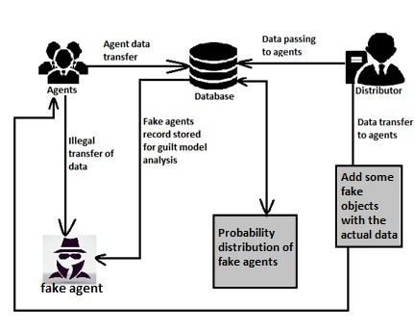

*D. Model - SMOTE-Enhanced Machine Learning Classification Model*

This model focuses on detecting insider threats, a significant factor in data breaches, and addresses the common issue of imbalanced datasets using Synthetic Minority Oversampling Technique (SMOTE) to enhance detection accuracy. Key elements include:

* One-Hot Encoding for Feature Representation - One-hot encoding transforms categorical variables into binary vectors, providing a clear representation of user roles, permissions, and actions in the dataset.
* Synthetic Minority Oversampling Technique (SMOTE) - SMOTE addresses imbalanced datasets by generating synthetic samples for the minority class (suspicious behavior), ensuring that the model is not biased towards the majority class (normal behavior).
* Machine Learning Classification Algorithms - Common algorithms used include Decision Trees and SVMs. These classifiers learn to distinguish between normal and suspicious activities based on user behavior patterns.

a. Training and Validation: The model is trained with balanced data and validated to ensure accuracy in predicting suspicious behavior, even with previously unseen data.

b. Deployment: The model monitors real-time data access activities, flagging potential insider threats based on patterns learned from synthetic and real training data.

* Outcome: This SMOTE-enhanced model effectively addresses insider threats, especially those that do not follow typical breach patterns, and reduces false negatives by accurately identifying malicious activity in minority classes.

An overview of the system:

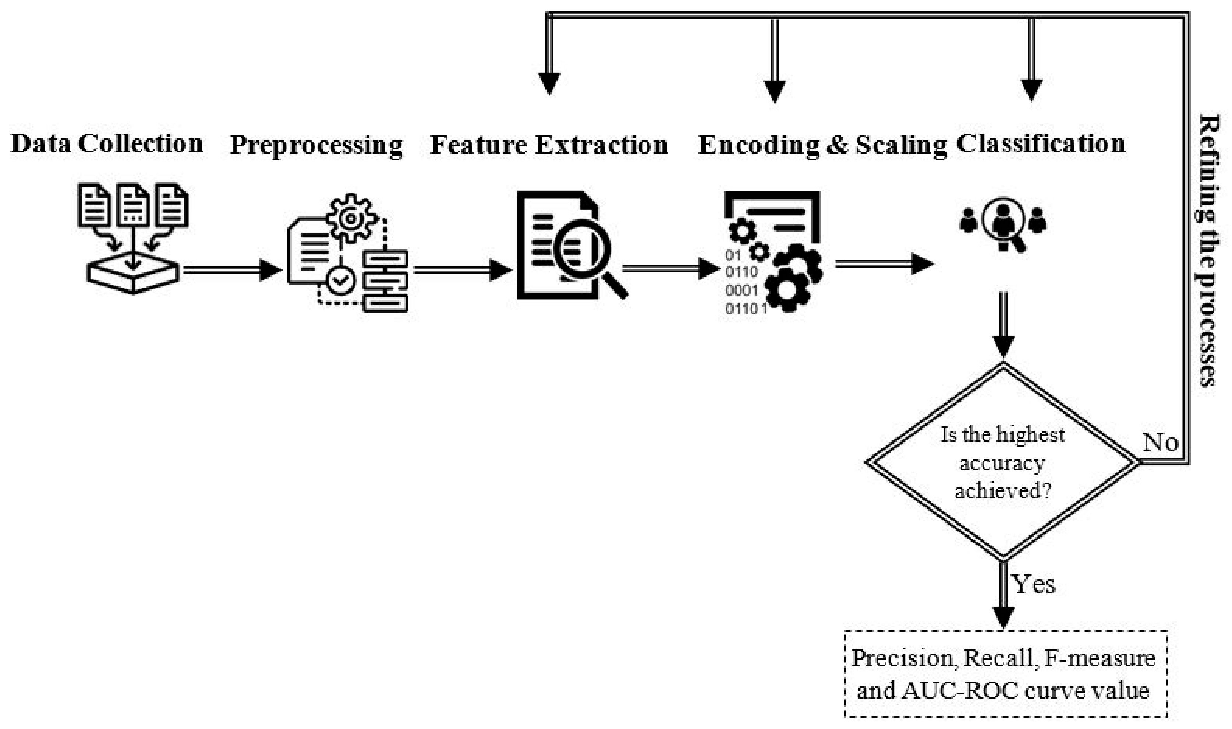

# DESIGN

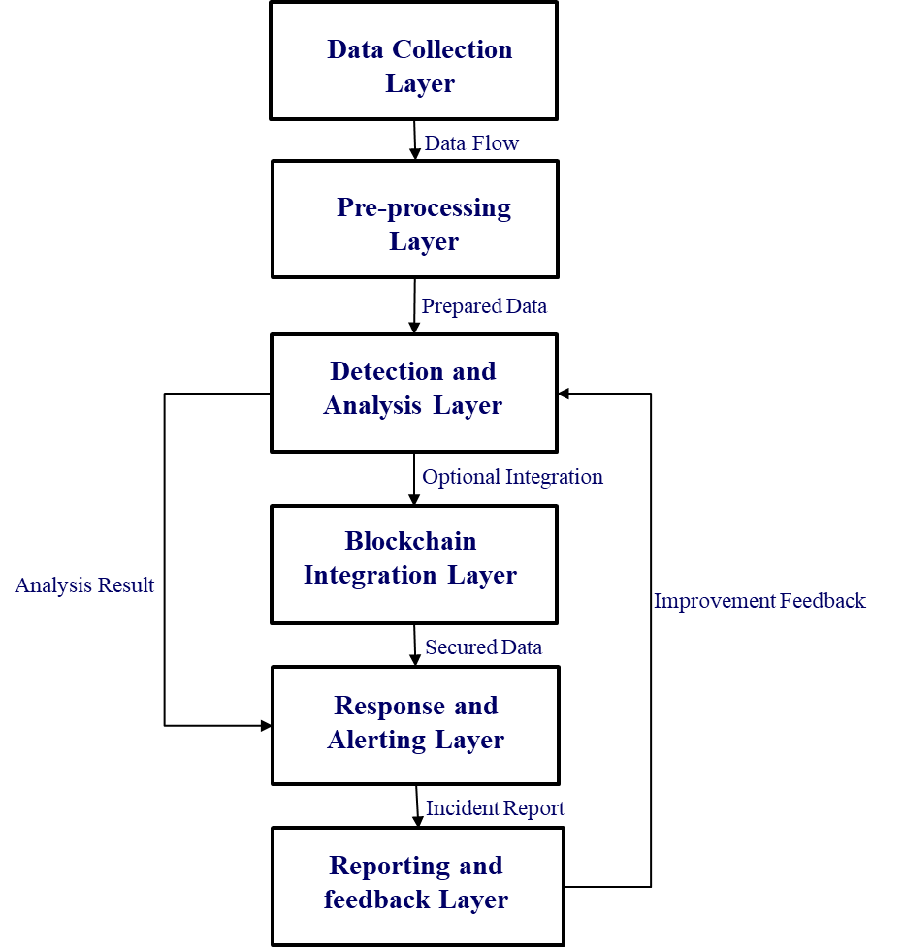

*A. Data Collection Layer*

* Purpose - This layer is responsible for gathering raw data from multiple sources within an organization’s IT infrastructure.
* Components

Network Logs - Records of network activity that track data traffic patterns, connections, and anomalies.

Application Logs - Logs from software applications, which capture usage, errors, and access patterns within applications.

User Activity - Information on user actions, including login attempts, file access, and account modifications.

Access Patterns - Monitors patterns in accessing sensitive data and resources, which can signal potential breaches.

* Output: This layer provides a continuous data flow of raw, unprocessed information to the next layer for further analysis.

*B. Pre-Processing Layer*

* Purpose - Prepares collected data for analysis by cleaning, organizing, and structuring it.
* Processes

Data Cleaning - Removes irrelevant or redundant data, which reduces noise and improves the accuracy of analysis.

Feature Extraction: Identifies key characteristics or "features" of the data, such as login frequency or unusual data transfers, that are relevant to breach detection.

Data Labeling - Assigns labels to data instances (e.g., "normal" or "anomalous") to assist in training machine learning models and improve detection accuracy.

* Output - Generates "prepared data" that is clean, structured, and ready for advanced analysis in the next layer.

*C. Detection and Analysis Layer*

* Purpose - Detects potential breaches using sophisticated algorithms and intrusion detection systems (IDS).
* Components

Machine Learning Algorithms - These algorithms detect patterns and irregularities that may indicate a breach. Common algorithms include clustering, classification, and anomaly detection models.

Behavioral Analysis - Examines user behavior and compares it to normal usage patterns. Deviations can indicate suspicious activity.

Intrusion Detection System (IDS) - Monitors network or system activities for malicious actions or policy violations.

* Output - Produces "analysis results" indicating whether a potential breach has been detected. This layer may also provide feedback to refine the pre-processing steps based on analysis results.

*D. Blockchain Integration Layer (Optional)*

* Purpose - Enhances data security by integrating blockchain technology for immutable logging and securing records of detected breaches.
* Components

Immutable Logging - Ensures that once a log entry is made, it cannot be altered, providing a tamper-proof record for auditing and forensic purposes.

Contracts - Automates security processes, such as triggering alerts or restricting access if specific conditions are met.

Output - Provides "secured data" that is recorded in a way that ensures transparency and immutability, adding an additional layer of protection and accountability.

*E. Response and Alerting Layer*

* Purpose - Responds to detected breaches in real-time, minimizing damage and alerting relevant personnel.
* Processes:

Real Time Alerting - Sends immediate alerts to security teams when a breach is detected, enabling swift action.

Incident Response - Takes predefined steps to contain and mitigate the effects of a breach, such as isolating affected systems or blocking malicious users.

* Output - Generates an "incident report" that details the detected breach and the actions taken to mitigate it.

*F. Reporting and Feedback Layer:*

* Purpose - Provides documentation of breach incidents and uses feedback to improve the system over time.
* Processes

Report Generation - Creates detailed reports on detected breaches, including analysis, response actions, and impact assessment.

Feedback Loop - Uses insights gained from each incident to refine detection algorithms, update rules, and improve future breach responses.

* Output - Produces comprehensive reports and continually enhances the system based on feedback, making it more resilient to new types of breaches

# CASE STUDIES

* 1. *Equifax data breach*

In 2017, Equifax, a major U.S. credit bureau, suffered one of the biggest data breaches ever, exposing personal information of 147.9 million Americans, 15.2 million British citizens, and around 19,000 Canadians. The breach happened because Equifax didn’t update its website software, which hackers took advantage of. The hackers stole employee login details, accessed sensitive data, and used encryption to hide what they were doing. Over two months, they retrieved the data and transferred it before removing it. The breach wasn’t noticed until July 29, 2017, but was only made public in September. The stolen information included names, Social Security numbers, birthdates, and addresses. As part of a settlement with the U.S. Federal Trade Commission, Equifax offered compensation and free credit monitoring to those affected. In 2020, the U.S. government charged members of China’s People’s Liberation Army for the attack, but China denied the accusations.

*5.2. Target data breach*

The 2013 data breach at Target became one of the most notorious retail cybersecurity incidents. The breach occurred during the crucial holiday shopping period, from November 27 to December 15, 2013, and affected millions of customers. The hackers gained access to both personal information and payment card details. Target detected the breach on December 12, 2013, and within a few days, confirmed the intrusion. On December 19, the company publicly disclosed that around 40 million credit and debit card accounts were compromised. In January 2014, it was revealed that personal information such as names, addresses, phone numbers, and email addresses of an additional 70 million customers had also been stolen. The breach stemmed from a phishing attack on a third-party contractor, Fazio Mechanical Services, which had access to Target’s network for billing purposes. Once inside Target’s systems, the attackers deployed malware on the company’s point-of-sale (POS) terminals, enabling them to capture payment card details during transactions. The breach resulted in major financial losses for Target, with the total cost, including legal fees, fines, settlements, and security improvements, reaching up to $290 million. Although insurance helped cover some of the costs, the company’s reputation suffered, and its sales during the holiday season were negatively impacted.

*5.3. Sony PlayStation data breach*

The Sony PlayStation data breach of 2011 was one of the most notable cybersecurity incidents in gaming history, affecting millions of users globally. This breach involved a massive attack on Sony’s PlayStation Network (PSN), exposing sensitive customer data and leading to significant financial and reputational impacts for Sony. Sony's network was compromised between April 17 and April 19, 2011. The breach targeted the PlayStation Network and Sony Online Entertainment (SOE) servers, which housed personal and financial information for tens of millions of users. Sony discovered the breach on April 19, and on April 20, they took PSN and Qriocity (a Sony music streaming service) offline to investigate the extent of the intrusion. The network remained down for nearly a month, severely disrupting online gaming for PlayStation users worldwide. Sony informed the public about the breach on April 26, confirming that customer data, including potentially sensitive information, had been compromised. Sony reported that personal information from approximately 77 million PSN accounts was accessed. This data included names, addresses, birth dates, email addresses, usernames, and passwords. For some users, security question answers and PSN purchase history were also accessed. Sony estimated losses from the breach and network downtime to be around $171 million, which covered IT repairs, customer compensations, and upgrades to security. However, total long-term costs, including lawsuits and settlements, reached into the hundreds of millions. Sony took the network offline for nearly a month to strengthen its security. This included implementing improved firewalls, additional encryption, and enhanced security measures to prevent future breaches.

# DATA PROTECTION REGULATIONS

*6.1 GDPR (General Data Protection Regulation)*

The GDPR, effective since May 2018, governs data protection across the EU and applies globally to businesses handling data of EU residents. It emphasizes principles like transparency, purpose limitation, data minimization, and integrity. Individuals have rights such as accessing, rectifying, erasing (right to be forgotten), and porting their data. Non-compliance can lead to hefty fines of up to €20 million or 4% of global turnover.

*6.2 CCPA (California Consumer Privacy Act)*

Introduced in California in January 2020, the CCPA provides residents rights like knowing how their data is used, requesting its deletion, and opting out of its sale. It applies to businesses meeting specific thresholds, such as earning over $25 million annually or processing data from over 50,000 consumers. Fines for violations can reach $7,500 per incident.

*6.3 DPDP (Digital Personal Data Protection Act)*

India’s DPDP Act, enacted in August 2023, regulates the processing of digital personal data with a focus on lawful use and consent. It grants individuals the right to access, correct, and withdraw consent for their data, while requiring organizations to ensure data protection. Penalties for non-compliance can go up to ₹250 crores.

# RESULT & DISCUSSION

*7.1 Comparison*

|  |  |  |  |
| --- | --- | --- | --- |
| Approach/Technology | Description | Strengths | Weaknesses |
| Intrusion Detection Systems (IDS) | Monitors network and system activities for suspicious patterns. | Real-time monitoring; detects known patterns of attacks. | Limited to known threats; may produce false positives. |
| Security Information and Event Management (SIEM) | Centralized collection and analysis of security events from various sources. | Correlates data from multiple sources; provides centralized monitoring. | Can be complex and costly to implement; requires skilled personnel to manage. |
| Machine Learning Algorithms | Uses algorithms to analyze large datasets and detect anomalies and patterns indicative of breaches. | Can detect new and evolving threats; learns from data to improve over time. | Requires extensive data for training; risk of false positives in complex environment |
| Behavioral Analysis | Analyzes user behavior patterns to detect deviations that may indicate insider threats or breaches. | Effective in identifying insider threats; can detect subtle and sophisticated attacks. | May raise privacy concerns; high implementation cost and complexity. |
| Forensic Investigation | Post-breach investigation to identify root cause, impact, and threat actor. | Provides detailed insight into the breach; essential for compliance and legal follow-up. | Reactive approach; does not prevent breaches but helps in understanding future threats. |

*7.2 Discussion*

Each model contributes unique strengths to the overall goal of breach analysis and detection. Their performance and results highlight that the choice of model largely depends on the specific needs of an organization, such as the type of data being monitored, the threat landscape, and whether real-time detection or post-breach analysis is prioritized.

Effectiveness in Different Contexts:

* The LDA model excels in analyzing unstructured text data from underground forums, revealing breach trends and providing insight into potential attack methods. However, it may not be ideal for real-time detection due to the post-analysis nature of forum data.
* DBAM serves more as a comprehensive breach analysis framework, mapping the lifecycle stages of a breach. It’s not suitable for active detection but is invaluable for post-breach investigations and understanding how breaches unfold over time.

Real-Time Detection and Monitoring:

* The Rule-Based and ML Classification model is designed for environments that require continuous, real-time monitoring. By combining rules and ML, it provides a dual-layer approach, enhancing detection precision while keeping alert rates manageable.
* The SMOTE-Enhanced ML model specifically addresses insider threats, achieving high accuracy in identifying rare and suspicious insider activities. Its application of SMOTE to balance imbalanced datasets allows it to detect threats that traditional models might overlook, making it ideal for environments with high insider threat risks.

Limitations:

* While effective in identifying trends, the LDA model depends on the availability and reliability of forum data, which may not always reflect current, verified breach incidents.
* DBAM does not detect breaches independently, which limits its application to reactive rather than proactive cybersecurity.
* The Rule-Based and ML Classification model requires regular updates to rules and ML models to remain effective as new breach methods evolve, posing maintenance challenges.
* The SMOTE-Enhanced ML model relies on synthetic data, which might not capture every nuance of real-world insider activities, leading to potential misclassifications.

Application Suitability:

* For organizations focused on understanding breach trends and threat intelligence, the LDA model is ideal for identifying new breach patterns.
* DBAM is best suited for forensic teams conducting root cause analysis post-breach, while the Rule-Based and ML Classification model provides robust support for real-time breach monitoring in data-sensitive organizations.
* The SMOTE-Enhanced ML model is particularly effective in highly regulated industries where insider threats pose significant risks and where balancing data sets improves detection reliability.

*7.3 Result*

After evaluating various techniques for detecting and preventing data breaches, it becomes evident that a multi-layered and proactive security strategy is crucial for safeguarding sensitive data. A well-rounded approach that integrates advanced solutions such as Intrusion Detection Systems (IDS), Security Information and Event Management (SIEM) systems, machine learning models, and blockchain technology offers a thorough framework for identifying threats and reducing the risk of breaches. Studies show that machine learning algorithms and behavioral analysis can significantly enhance detection accuracy by identifying patterns and anomalies that traditional methods might overlook. Additionally, utilizing blockchain for secure, tamper-proof logging strengthens data integrity, making it more difficult for malicious actors to alter records. By combining these technologies, organizations can enhance response times and more effectively manage breaches, minimizing their potential damage. Furthermore, adhering to data protection regulations like GDPR, CCPA, and DPDP not only ensures compliance with legal requirements but also sets a standard for responsible data management practices. Following these regulations improves data governance and ensures that organizations remain accountable to their stakeholders.

# CONCLUSION

In conclusion, safeguarding sensitive information in today’s digital age demands a strategy that combines cutting-edge technological solutions with a solid regulatory framework. The most effective approach to breach detection and prevention involves integrating machine learning for detecting anomalies, SIEM systems for centralized analysis, IDS for real-time monitoring, and blockchain technology for secure, tamper-resistant logging. This multi-layered security approach allows organizations to identify breaches more quickly, respond to threats more efficiently, and protect critical data from unauthorized access. Real-world incidents have demonstrated the significant financial and reputational damage caused by data breaches. As a result, organizations must invest in both advanced technologies and comprehensive policies to safeguard their assets. Adhering to global data protection regulations is not only a legal requirement but also essential for building user trust and maintaining a secure digital environment. Ultimately, this analysis emphasizes that no single solution or technology can entirely prevent data breaches. The most robust defense lies in an integrated, multi-faceted strategy that combines advanced detection tools with strong governance practices. By remaining proactive and adjusting to the constantly evolving cyber threat landscape, organizations can better safeguard sensitive data, maintaining security and trust in an increasingly data-driven world.

# REFERENCES

1. B.Pranay, P.Sree Surya, Rithvik .A, R.Raja Subramanian.(2021). Modeling and Predicting Cyber Hacking Breaches. *Proceedings of the ICICCS. IEEE Xplore Part Number: CFP21K74-ART; ISBN:978-0-7381-1327-2.* pp. 288-293
2. K.Ansar, M.Ahmed, M.Helfert & J.kim.(2023). Blockchain-Based Data Breach Detection: Approaches, Challenges, and Future Directions. *Mathematics 2024,12,107. https://doi.org/ 10.3390/math12010107.* pp. 1-21.
3. Congzheng Song and Ananth, S. (2020). Information Leakage in Embedding Models. *Proceedings of the 2020 ACM SIGSAC conference on computer and communications security.* pp. 377-390.
4. Yaman Roumani. (2021). Detection time of data breaches. [*Computers & Security*](https://www.sciencedirect.com/journal/computers-and-security)[*Volume 112*](https://www.sciencedirect.com/journal/computers-and-security/vol/112/suppl/C)*,102508*, pp. 1-14.
5. Shankar, N. & Mohammed, Z. (2020). Surviving Data Breaches: A Multiple Case Study Analysis. *Journal of Comparative International Management, 23(1)*. pp. 35–54.
6. Yong Fang, Yusong Guo, Cheng Huang and Liang Liu.(2019). Analyzing and Identifying Data Breaches in Underground Forums*. Digital Object Identifier 10.1109/IEEE ACCESS.* pp. 48770-48777.
7. Maochao Xu, Kristin M. Schweitzer, Raymond M. Bateman, and Shouhuai Xu.(2018). Modeling and Predicting Cyber Hacking Breaches. *IEEE transactions on information forensics and security, vol. 13.* pp. 2856-2870.
8. Slim Trabelsi.(2019). Monitoring Leaked Confidential Data. Global Security Research, SAP, Mougins, France*.* pp. 1-5.
9. Shipra Varshney, Dheeraj Munjal, Orijit Bhattacharya, Shagun Saboo, and Nikunj Aggarwal. (2020). Big Data Privacy Breach Prevention Strategies. Dr. Akhilesh Das Gupta Institute of Technology and Management, New Delhi, India. IEEE. pp. 1-6.
10. Samuel Akinola.(2024). Cybersecurity Strategic Plan Part 1. International Journal of Latest Technology in Engineering Management & Applied Science. DOI: 10.51583/IJLTEMAS. 2024.130719. pp. 163-169.
11. Samuel Akinola.(2024). Cybersecurity Strategic Plan Part 2. International Journal of Latest Technology in Engineering Management & Applied Science. DOI: 10.51583/IJLTEMAS. 2024.130724. pp. 197-207.
12. Rhoda C. Joseph.(2017). Data Breaches: Public Sector Perspectives. Digital Object Identifier 10.1109/MITP.2017. 265105441 1520-9202/$26.00 2017 IEEE. pp. 1-16.
13. Varun shah.(2022). Machine Learning Algorithms for Cybersecurity: Detecting and Preventing Threats. Revista Española de Documentación Científica eISSN: 1988-4621 pISSN: 0210-0614 Volume No: 15 Issue No: 04 (2021). pp. 42-66.
14. Hamza Saleem and Muhammad Naveed.(2020). Anatomy of Data Breaches. *Proceedings on Privacy Enhancing Technologies. DOI 10.2478/popets-2020-0067*. pp. 153-174.
15. Zahra Hassanzadeh , Robert Biddle and Sky Marsen.(2021). User Perception of Data Breaches. *IEEE Transactions On Professional Communication, Vol. 64*. pp. 374-389.
16. Rajat Verma, Vipin Gautam, Chandra Prakash Yadav, Ishu Gupta and Ashutosh Kumar Singh.(2020). A Survey On Data Leakage Detection and Prevention. *International Conference on Data Analytics and Management (ICDAM 2020).*
17. Taher Al-Shehari and Rakan A. Alsowail. (2021). An Insider Data Leakage Detection Using One-Hot Encoding, Synthetic Minority Oversampling and Machine Learning Techniques. *Entropy 2021, 23, 1258.* [*https://doi.org/10.3390/e23101258.* pp. 1-24](https://doi.org/10.3390/e23101258.%20pp.%201-24).
18. Nils Lukas, Ahmed Salem, Robert Sim, Shruti Tople, Lukas Wutschitz and Santiago Zanella-B´eguelin.(2023). Analyzing Leakage of Personally Identifiable Information in Language Models. *IEEE Symposium on Security and Privacy (S&P). Available:* [*https://github.com/microsoft/analysing*](https://github.com/microsoft/analysing) *pii leakage.* pp. 1-16.
19. K. Dileep. (2020). Analysis of Data Breaches and Its impact on Organizations. Computing Trendz - The Journal of Emerging Trends in Information Technology, 8(10), 6989-6994. DOI: 10.30534/ijeter/2020/588102020. pp. 6989-6994.