**Identify Strategies to Revive the Craft Culture of Braj Region: A Modern Perspective**

Neha Agarwal1, Madhulika Gautam2

Research scholar1, Professor2, Department of Home Science,

1,2Dayalbagh Educational Institute (Deemed to be University), Agra (U.P), India. 282005

**Abstract:**

Brajbhoomi, the land of Radha Krishna, is rich in traditional crafts. While skilled artisans continue to preserve these practices, many crafts face challenges due to their outdated designs. This paper examines the issues surrounding rug-making and agriculture-based crafts, seeking solutions for future generations. The research involved 40 artisans (20 from Naujheel in Mathura for rug-making and 20 from Poiya in Agra for agriculture-based crafts) using both primary and secondary data. A checklist was employed to gather information about design usage and artisan interest. Observations and secondary sources provided additional insights. Findings indicate that most artisans rely on traditional methods and rarely use their skills for economic benefit. The study shows that blending old techniques with innovative approaches can create more appealing products. Despite the potential for tourism and economic growth, artisans face difficulties earning fair wages due to a lack of awareness, technological knowledge, and raw materials. While initiatives like The Indian Habitat Centre and USTTAD work to revive traditional crafts, further efforts are needed. Raising awareness about the arts and crafts is essential, and integrating modern techniques with traditional designs can enhance innovation and help preserve the rich craft culture of Braj.

**Keywords:** Agriculture-based Craft, Braj region, Innovative designs, Problems of artisans, Rug-making craft, Strategies, Traditional designs.

1. **INTRODUCTION**

The Braj region of India, known for its rich cultural heritage and vibrant craft traditions, faces significant challenges in sustaining its artisanal practices. Addressing these challenges requires a holistic approach that considers the economic, social, and cultural dimensions of the craft ecosystem (Dash & Bidhu, 2021). Craftsmanship is a skill that can be taught and utilized by others, encompassing an artist's unique ideas (Perry, 2009). While an artisan’s work can inspire others, it is inherently distinct to each individual. The identity of a nation relies on the achievement of its human and cultural values. India boasts a rich variety of crafts on a large scale. Villagers in Braj have engaged in various traditional arts and crafts for generations, including Sanjhi art, rug making, agriculture-based handicrafts, metalwork, and Kundan work. Braj Mandal holds significant importance in Hindu mythology and culture. The term "Braj" is derived from the Sanskrit word "vraja," meaning "an enclosure of herdsmen," and it references the region associated with Krishna's early years when he grazed cattle (Antwistle, 1987). Many scholars believe that Braj was designated as a territorial nomenclature by Chaitanya and his followers (Habib, 2009). The extent of Braj, or Braj Mandal, is defined by various religious texts such as the Garga Samhita. According to the district gazetteer of Mathura, the eastern boundary of Braj is marked by Bara in the Aligarh district. The northwestern corner is formed by Sonhada in the Gurugram district, and the southern boundary is marked by Jajaugaon in the Dhaulpur district (Gulati et al., 2024). In the current context, Braj can be divided into two distinct areas: the eastern part of the Yamuna, which includes Gokul, Baldeo, Mant, and Naujhil, and the western part of the Yamuna, covering areas in the Mathura district (including Vrindavan, Mathura, Govardhan, Chhata, Kosi, Nandgaon, and Barsana), Bharatpur (specifically Kaman and Deeg tehsil), and Hodal tehsil of Palwal district. The nature of the Braj region and its culture have historically coexisted in harmonious balance. However, in modern times, the culture and traditions of this region are in danger. Radhika Bharat Ram has emphasized the importance of promoting folk art. Additionally, it is disappointing that no work by Indian craftsmen was displayed at the Indian Art Fair (PTI, Aug. 2017). Several factors contribute to the decline of traditional arts and crafts, including a lack of market knowledge, low education levels, insufficient skilled labor, limited financial support, a lack of interest among the youth, and adherence to outdated techniques, designs, and methods (Vidyarthi, 2019). A significant reason for this decline is the lack of innovation and technological advancement in the handicrafts sector, leading to stagnation and increased manufacturing costs. Furthermore, many states in India face a shortage of raw materials needed for handicrafts. According to Sharma and Nagendra (2016), only 2.3% of the workforce in India has undergone formal skill training, compared to 68% in the UK, 75% in Germany, 52% in the USA, 80% in Japan, and 96% in South Korea. This lack of training has rendered much of the workforce in India largely unemployable. India has provided minimal training services in the field of skill development. Vidyarthi (2019) noted that the handicraft sector contributes 5% of India’s total GDP. It is crucial to raise societal awareness about the importance of art and craft culture, addressing the problems associated with this sector to ensure its revival on a global scale. India is renowned for its rich ethnic diversity and is famous for its handicrafts and highly skilled artisans. However, very few artisans are actively working to restore their traditions in Braj. Since the 16th century, with the establishment of the concept of Braj and Chaurasi Kos Yatra, the region has welcomed numerous devotees, pilgrims, saints, and scholars. This number has gradually increased, particularly in recent decades, resulting in haphazard growth of settlements. The economic impact of tourism-oriented development on local communities is among the major causes of changes in the region's economic structure. Pilgrimage and tourism are major drivers of economic development in Braj, with roughly 40% of the workforce engaged in tourism-related jobs. There is a pressing need for design interventions that cater to evolving market demands while preserving the authenticity of crafts. Initiatives, such as those implemented in the Ektaal cluster, have shown promising results in revitalizing the craft industry by incorporating technological and design-based solutions (Jagatramka & Prasad, 2021). This study aims to assess the current condition of craft culture, particularly regarding rug making and agriculture-based handicrafts in Braj, and to understand the various problems faced by artisans that are hindering their craft. Some strategies to revive this culture of crafts were also mentioned in present study.

**Objectives**

* To assess the present condition of art and craft culture in Braj region.
* To study the solution to revive the culture of art and craft in Braj region.

1. **MATERIALS AND METHODS**

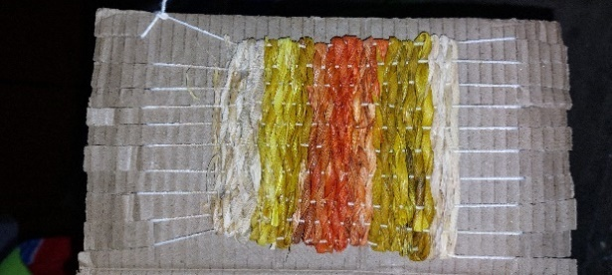This study utilizes a qualitative approach to explore practical solutions for reviving the handicraft culture of Braj, with a particular focus on rug weaving and agriculture-based craft products. Primary data were collected from 40 artisans purposively selected from Agra and Mathura district. Naujheel from Mathura and Poiya from Agra, two villages were selected from Braj region. 20 artisans of Naujheel were involved in rug making craft and 20 from Poiya were involved in agriculture based craft. The researcher focused on two types of crafts because the weaving methods used for rugs can also be applied to agriculture-based crafts. As part of the study, a trial was conducted, and an image of the product-making process was presented as an example. Primary data were collected through field observations and an analysis of the weaving patterns, materials, and techniques employed by artisans, highlighting their craftsmanship and innovation in the rural areas of the Braj region. During these observations, a variety of weaving patterns were identified, showcasing the creativity and versatility of the artisans. These patterns were meticulously documented to evaluate their potential for innovation and marketability. The researcher developed a self-prepared checklist that included a total of 10 items to assess the condition of both rug-making and agriculture-based crafts. Scoring was performed using higher marks (1) for positive responses and lower marks (0) for negative responses. Percentages were then used to analyse the collected data. Additionally, secondary data analysis was performed to supplement the findings, drawing on academic articles, government reports, case studies, and market trends related to traditional crafts. This data provided context regarding the historical significance of Braj's handicrafts, the challenges faced by artisans, and successful initiatives for cultural revival in other regions. Special attention was given to reports on sustainable practices and market-driven approaches to handicraft development. The integration of field observations and secondary data allowed for a comprehensive analysis. The observed patterns served as a foundation for proposing innovative designs and diversifying product offerings, while the secondary data offered insights into aligning these crafts with modern consumer preferences and sustainability standards. This dual approach not only identified gaps in current practices but also proposed actionable strategies to enhance the economic viability and cultural preservation of Braj's handicrafts.

Image 1. Weaving maize husk for tea coaster

1. **RESULTS AND DISCUSSION**

**Table 1: Assessment of rug making craft skills of selected artisans**

|  |  |  |  |
| --- | --- | --- | --- |
| S. No. | Statements | Yes | No |
| 1 | Use old designs and methods in weaving rugs. | 80% (16) | 20% (04) |
| 2 | Use always new designs in weaving rugs. | 15% (03) | 85% (17) |
| 3 | Rugs are used for economic benefits. | 15% (03) | 85% (17) |
| 4 | Interested to learn new rug making designs and methods. | 70% (14) | 30% (06) |
| 5 | Interested in selling handmade rugs. | 25% (05) | 75% (15) |

Table 1 provides insights into the rug-making skills of artisans from selected areas of Braj. Notably, approximately 80% of these artisans rely on traditional designs and methods in their rug weaving, while only about 15% incorporate new designs. Most artisans do not leverage their rug-making skills to sell their products for economic gain. This is largely due to a lack of awareness and knowledge about market opportunities and services. As a result, the villagers primarily create these rugs for personal use, producing fewer items utilizing only a limited range of designs. However, it is encouraging to note that 70% of the artisans expressed interest in learning new designs and rug-making techniques. On the other hand, only 25% of artisans showed their interest in selling their handmade crafts.

**Table 2: Agriculture based craft skills of selected artisans**

|  |  |  |  |
| --- | --- | --- | --- |
| S. No. | Statements | Yes | No |
| 1 | Use old designs and methods in weaving agriculture based craft. | 90% (18) | 10% (02) |
| 2 | Use always new designs in weaving agriculture based craft. | 00% (00) | 100% (100) |
| 3 | Agriculture based craft are used for economic benefits. | 00% (00) | 100% (100) |
| 4 | Interested to learn new agriculture based craft designs and methods. | 85% (17) | 15% (03) |
| 5 | Interested in selling handmade agriculture based craft. | 75% (15) | 25% (05) |

Table 2 presents the agricultural skills and interests of selected artisans. It was found that 90% of the women used traditional designs and methods in weaving products, and none of them employed new designs or techniques. Notably, no participants utilized their skills in this craft for economic benefits. However, it is encouraging to see that 85% of the women expressed interest in learning new skills for creating these types of handicraft products, and 75% of the artisans showed an interest in selling these handmade crafts.

* **Identified problems in handicrafts of the Braj region**

Various studies were reviewed, and some major problems that affect the culture were found. From various research papers, Soundarapandian (2002) sheds light on textile production and concludes that poor raw material supplies, lack of awareness, and a lack of knowledge about technologies and methods are major issues for artisans. Seth and Singh (2017) state that the craft of Braj is in danger and the reason behind this endangered craft is the lack of commercialization and the time-consuming process. More issues were also found in previous research as-

1. **Old designs, methods, techniques**

Crafts are embedded as culture and tradition in rural areas. Much of the rural population depends on handicrafts. The reasons for the failure of village crafts such as poor designs, low quality materials, and inefficient market approaches. Some types of crafts were observed in the surrounding villages of Braj. The traditional motifs and designs in rugs’ work and in agriculture-based craft were observed in this study. It was observed that most of the designs and methods were the same, with only the colour concept being different.Artisans in the Braj region often lack access to modern technologies and resources that could improve the efficiency and quality of their crafts.

1. **Globalization**

Studies reflected that globalization affects handicraft market because of creates competition in market. There are many options available for products at cheaper rates. So artisans face lot of competition in this market and do not get beneficial avenues for their crafts.

1. **Lack of education**

The level of education among artisans is often low, and illiterate artisans are susceptible to exploitation by middlemen, which contributes to their low earnings. The lack of education hampers their ability to manage inventory, access government schemes, stay informed about market conditions, and negotiate effectively with traders and middlemen.

1. **Lack of interest in learning skills**

Skill development relies heavily on personal interest; however, recent studies suggest a diminishing interest among the youth, leading to a lack of skilled labor. Consequently, experienced artisans who wish to pass on their skills to the next generation struggle to find motivated candidates to continue their crafts.

1. **Lack of financial support**

The handicraft sector suffers from inadequate funding, limiting accessibility in various aspects. Many individuals involved in this industry are laborers who lack capital and, therefore, struggle to establish their own platforms. Furthermore, financial support is often insufficient, which makes it challenging for them to access government schemes designed to assist them.

1. **Unaware of new information**

Due to low levels of education, information channels are often weak. Artisans may be unaware of developments in their field, advancements in tools and techniques introduced by the government, and other benefits that could enhance their practices. This lack of awareness further isolates them from potential improvements in their craft.

* **Old vs. New: A Visual Journey of Handicraft Patterns**

**Fig. 1 Weaving designs used in rugs making by artisans of selected area**

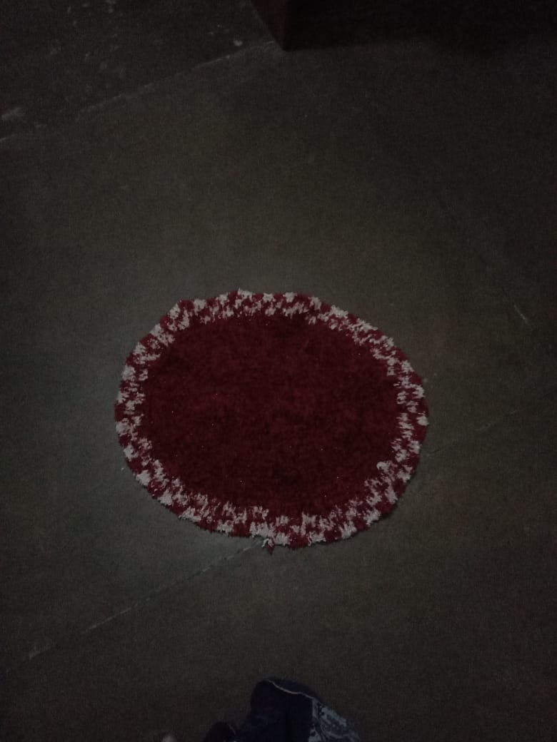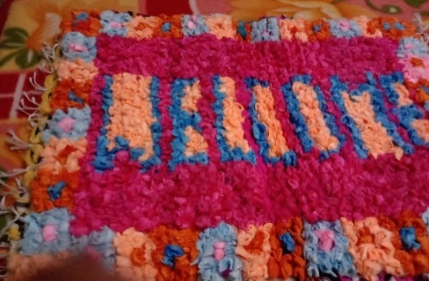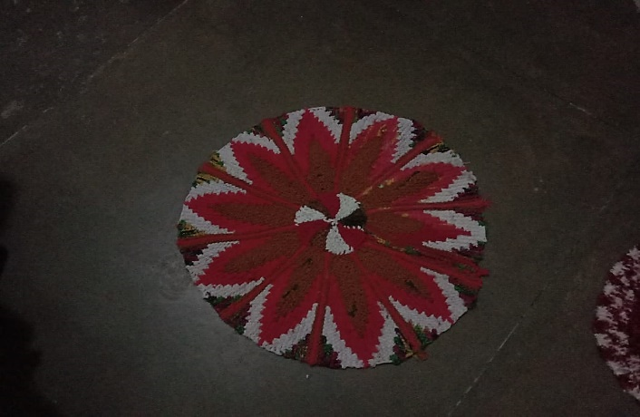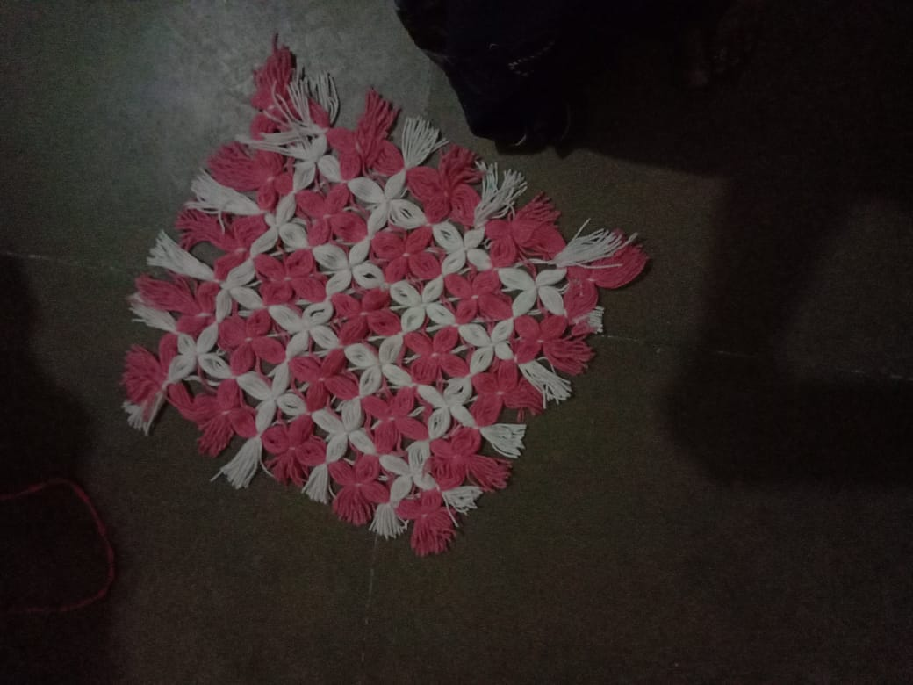

Source: By researcher

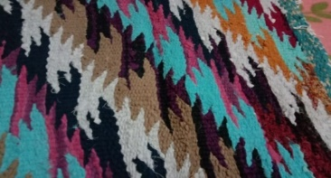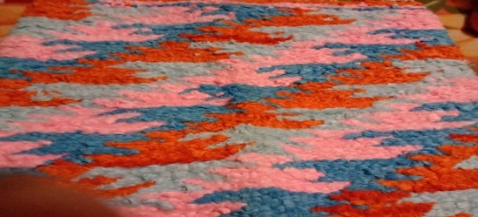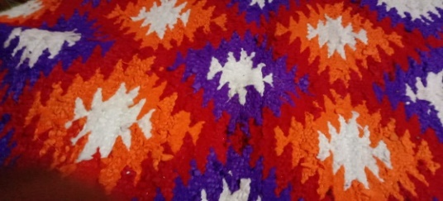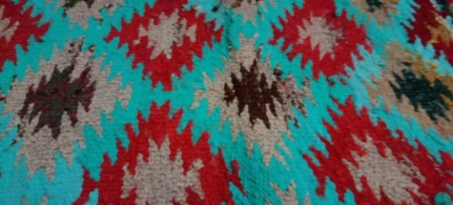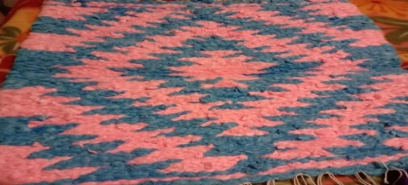

Source: By researcher

Fig. 1.1. Similar and old designs of rugs

Fig. 1.2. Innovative methods and design used rugs

The attached images in Fig. 1.1 illustrate the weaving designs used in rug making from the selected villages of the Braj region are available. It can be understood that the same patterns, techniques, and methods were used in this craft.

The images in Fig. 1.2 showcase various innovative designs and methods used in rug-making that are visually appealing. These designs can serve a marketing purpose. The rugs incorporate different raw materials such as wool, fabric, and macrame. Old clothes can also be utilized in this craft for waste management (Agarwal & Awasthi, 2022).

**Fig. 2: Weaving designs used in agriculture based craft by artisans**

There are some images attached in Fig. 2.1 depicting the weaving designs and methods used in preparing agriculture based crafts from the selected villages of the Braj region. The artisans also used their skills in this field. It can be seen that different kinds of designs are used but a variety of products is lesser. These designs were used from the old time. This is also a traditional craft that of Braj and is also in danger. It is important to save the arts and crafts which are connected to Braj culture. Mainly women were focused in making baskets with wheat straws and Moonj grass. Maize husk was also used in making this handicraft.

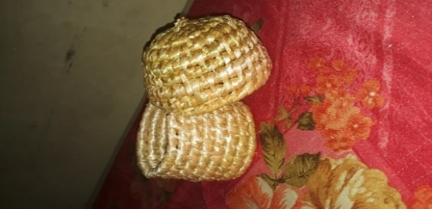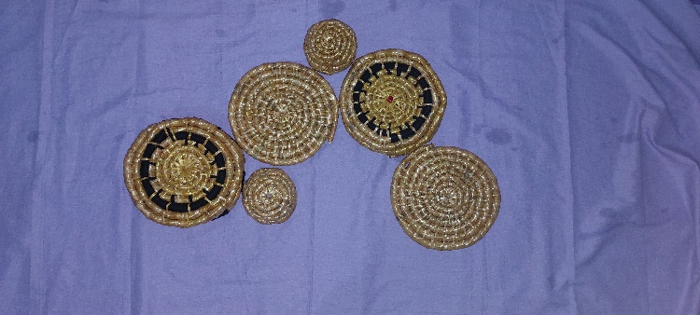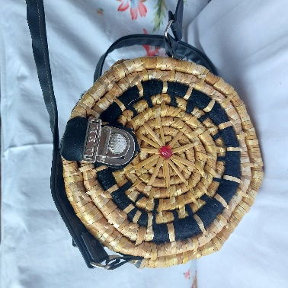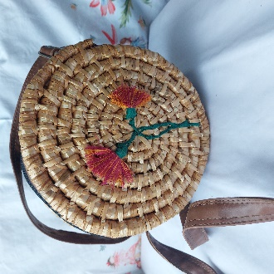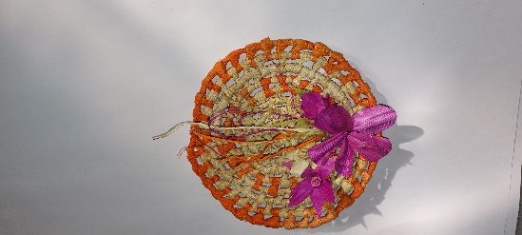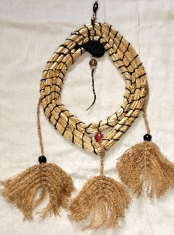

Source: By researcher

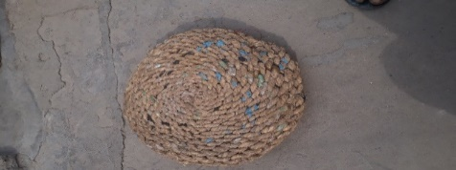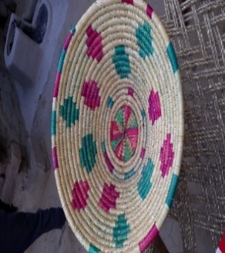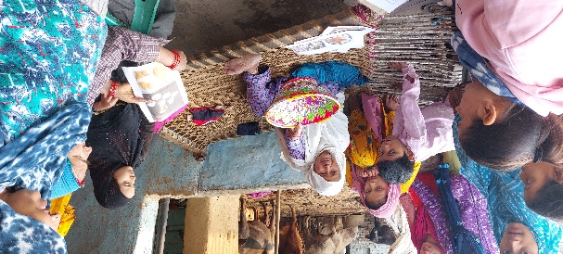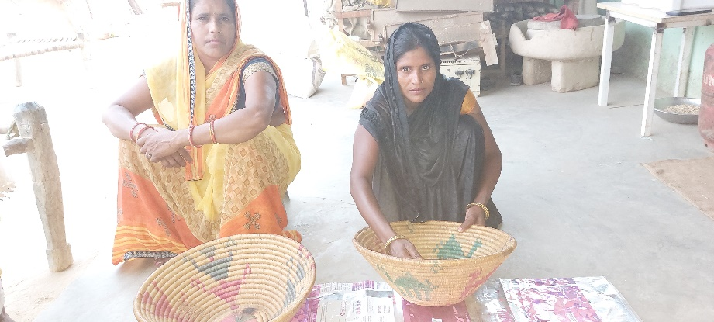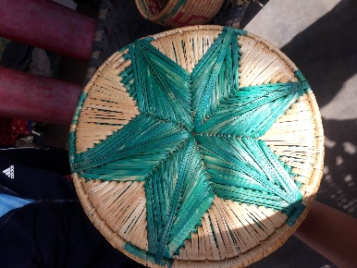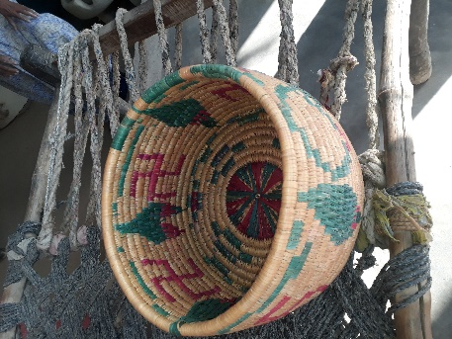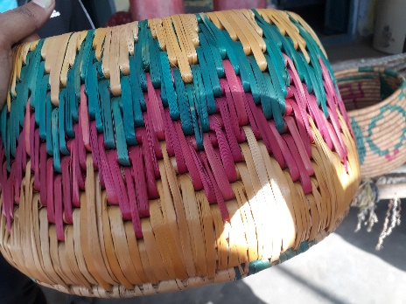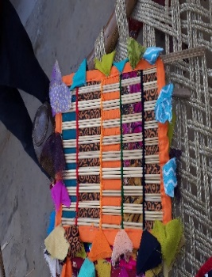

Fig. 2.1. Similar and old designs used by artisans of selected area

Fig. 2.2. Innovative methods and design used by researcher

Source: By researcher

The products shown in Fig. 2.2, which are made from wheat straw and maize husks using various techniques, are visually appealing, innovative, and unique. It is essential to sustain this tradition, and one way to do so is by increasing the usage of these products. Providing artisans with marketing knowledge could lead to a rise in production. Previous studies offered solutions to help revive the culture of this craft.

* **Suggestions for Reviving the Rug-Making and Agriculture-Based Crafts of the Braj Region**

Most forms of art and craft in Braj are tied to the themes of Krishna and Radha, and maintaining this cultural connection is essential. Various organizations, including the government, are working to restore this rich heritage. Notable groups like the Braj Foundation, the Indian Habitat Centre, and the Delhi Craft Council are actively involved in reviving endangered crafts (Seth and Singh, 2017). To attract more interest and enhance skills, it is crucial to make these products more appealing. Currently, very few villagers in Braj are engaged in rug-making or developing diverse designs. Previous studies have proposed several solutions to address the challenges faced by this industry:

1. The lack of a well-organized market has led to exploitation of both consumers and producers. Therefore, the government should establish a structured handicraft marketing system to ensure that both parties benefit.
2. Price uniformity is essential for industry growth. Customers feel exploited and frustrated when they find the same handicraft product priced differently at various shops.
3. Mohiuddin, Mir, and Bhushan (2014) suggested that promoting exhibitions, printing brochures, and participating in national and international fairs would contribute to the sustainable growth of the handicraft industry.
4. The government should consider exempting or at least lowering the sales tax on handicrafts, which would make these products more affordable and boost sales.
5. Inviting foreign master designers to design centers could provide valuable guidance to local craftsmen.
6. Existing government schemes for arts and crafts have had limited reach and should be expanded to benefit a larger audience. Additionally, these programs should include skills-based training for artisans, allowing them to incorporate new techniques and styles into their traditional crafts. This would facilitate the creation of innovative products that blend old traditions with modern designs.
7. Public-Private Partnerships can play a significant role in developing and enhancing artisan skills.
8. To promote interest and sustain tradition, initiatives such as the Make in India campaign can effectively contribute to skill development, aligning with the mission of “Koushal Bharat, Kushal Bharat.”
9. Seth and Singh (2017) emphasized the importance of integrating design elements to improve the marketability of handicrafts.
10. Furthermore, Sharma and Nagendra (2016) highlighted that skill development is crucial for the country’s advancement. Achieving success in this area requires coordinated efforts from all stakeholders, including agencies and students. With India’s demographic dividend, it is essential to capitalize on this opportunity for the nation’s benefit.

**CONCLUSION**

Braj is renowned for its rich culture and various crafts, many of which are associated with Krishna. The villagers in Braj have traditionally used their skills to produce rugs and agricultural products. However, artisans today are not passing these skills on to the next generation, primarily due to inadequate benefits and a lack of knowledge on how to improve their craftsmanship and create new designs. Previous studies have indicated that factors such as lack of education, globalization, and insufficient access to new skills have limited opportunities for artisans. Observations show that most artisans are eager to learn new techniques and eager to sell their handmade products. However, many of their techniques and designs are outdated, and there is a pressing need for new methods that align with current market demands. Implementing training programs focused on skill development would enable artisans to create more appealing products, thereby providing them with beneficial knowledge. Introducing vocational training at the school level would be particularly effective. Various organizations and government policies are actively working to preserve these traditions and should provide maximum assistance at minimal cost. Such efforts will not only promote sustainable growth in the long term but will also enhance contributions to employment generation, foreign exchange, and the overall socio-economic development of the Indian economy. By doing so, these initiatives will add value to the country’s economy and help integrate Braj's traditions into the global market.

**REFERENCES**

* Agarwal, N., & Awasthi, A. (2022). Sustainable domestic solid waste management in making creative crafts by women as social responsibility during COVID-19 lockdown. *International Entrepreneurship Summit on Beyond Sustainability-Trends in Regenerative, Socially Responsible, Community Ventures. EUREKA PUBLICATION,* ISBN: 978-93-91260-26-2,501-507. *https://www.researchgate.net/publication/383871670_Sustainable_Domestic_Solid_Waste_Management_in_Making_Creative_Crafts_by_Women_as_Social_Responsibility_During_COVID-19_Lockdown*
* Agarwal, N. (2021). Strengthening the basketry making entrepreneurship of rural women*. 3rd International Conference on Recent Advances in Management & Technology (ICRAMT-2020),* 262-266.
* Agarwal, N., & Gautam, M. (2021). Possibility assessment of utilization of crop residues to uplift economic condition of the rural women. *GAU Research Journal 46*(4), 3-8.
* Chaturvedi, S. K. A. (n. d.). Brief History and Sanskriti (Culture?) of Braj-Bhoomi (the Land of Braj-Vrindavan/the Land of Radha-Krishna). Retrieved on 24/03/2024 from file:///Chaturvedi-A-Brief-History-and-Culture-of-Braj-2-s47htt.pdf
* Dak, T. M. (1989). Rural Industrialisation: Challenges and Responses, North Book, Delhi, pp-23-24.
* Dash, M., & Mishra. B. B. (2021). Problems of handicraft artisans: An overview. *International Journal of Managerial Studies and Research (IJMSR)*. 9(5), 29-38. <https://doi.org/10.20431/2349-0349.0905004>
* Entwistle, A. W. (1987). Braj, Centre of Krishna Pilgrimage, Groningen: *Egbert Forsten*.
* Gulati, R., Sehgal, V., & Sanyal, A. (2024). Revitalization of cultural landscape: Barsana in Braj. *World Journal of Innovative Research (WJIR)*. *16*(6), 01-10. <https://doi.org/10.31871/WJIR.16.6.6>
* Gupta, T., Mistry, B., & Gupta, B. S. (2017). A treatise on recent trends and sustainability in crafts & design. Published by: excel India publishers, New Delhi. ISBN: 978-93-86724-21-2. Nov. 2017. Indian Institute of Crafts & Design, Jaipur
* Harshma, K. (2010). Crossing the divide between art and craft. *Journal of Undergraduate Research at Minnesota State University, Mankato:* 10(4). DOI: <https://doi.org/10.56816/2378-6949.1039>
* Jagatramkaa, R., & Prasad, R. (2021). Design interventions in bell metal at Ektaal cluster. Community Based Research and Innovations in Civil Engineering IOP Conf. Series: Earth and Environmental Science, IOP Publishing, 796. <https://doi:10.1088/1755-1315/796/1/012041>
* Khan, W. A., & Amir, Z. (2013). Study of handicraft marketing strategies of artisans in Uttar Pradesh and its implications. *Research Journal of Management Sciences*, 2(2), 23-26.
* Mohi-ud-din, T., Mir, L. A., & Bhushan, S. (2014). An analysis of current scenario and contribution of handicrafts in Indian economy. *Journal of Economics and Sustainable Development.* 5(9).
* Seth, J., & Singh, S. (2017). Sanjhi the Braj craft. International Conference on Recent Trends and Sustainability in Crafts and Design. IICD, Jaipur, November 17-18th, 2017. https://www.academia.edu/35697675/SANJHI_THE_BRAJ_CRAFT
* Sharma, L., & Nagendra, A. (2016). Skill Development in India: Challenges and Opportunities. *Indian Journal of Science and Technology*, 9(48). DOI: 10.17485/ijst/2016/v9i48/107324
* Soundarapandian, D. M. (2002). Growth and prospects of handloom sector in India. *National Bank for Agriculture and Rural Development*. <https://www.nabard.org/demo/auth/writereaddata/File/OC%2022.pdf>
* Vidyarthi, A. (2019). An analysis of problems faced by handicraft sector in Uttar Pradesh. *International Journal of Research in Engineering, IT and Social Sciences, 09*(4), 123-126.

REPORTS:

* Habib, I. (2010). "Braj Bhum in Mughal Times," *Proceedings of the Indian History Congress, 2009-10.*
* Government of Uttar Pradesh. (1968). *District Gazeteer of Mathura*. Department of District Gazeteers.
* Design Associates Inc., Ecourbs Consultants. (2019). *Braj development plan for Braj region of Uttar Pradesh - Inception report*.