Optimizing Quantum Technologies: A Synergistic Role of Artificial Intelligence and Machine Learning

*Simmi Chaudhary
Department of Artificial Intelligence and Data Science,
Poornima Institute of Engineering and Technology,
Jaipur,India
simmi.chaudhary11@gmail.com
Ebtasam Ahmad Siddiqui
Department of Artificial Intelligence and Data Science,
Poornima Institute of Engineering and Technology,
Jaipur,India
ebtasam.siddiqui@poornima.org

Abstract— This paper investigates the mutually beneficial interaction between artificial intelligence (AI) & machine learning (ML) in the enhancement of quantum technologies. There has been significant progress towards the optimization of quantum circuits including quantum error correction, and improved calibration and control of quantum devices with the headway made in AI and ML. A combination of these tools enables researchers to tackle some critical problems in quantum computing such as noise, scalability, and algorithmic inefficiencies. The paper discusses methods of operation of quantum systems based on AI algorithms that will make it possible to perform advanced simulations, optimization and real-time applications. This review focuses on the progress that AI, ML and their combinations are bringing to quantum technologies, for connecting previously achieved theoretical progress and practical perspectives of these technologies’ development.
Keywords— Artificial Intelligence, Machine Learning, Quantum Computing, Qubit, Superposition, Quantum Entanglement, Quantum Simulations, Quantum Natural Language Processing
INTRODUCTION
As we look to the future, it is clear that the fusion of artificial intelligence (AI) and machine learning (ML) with quantum technologies is set to bring about a paradigm shift or revolutionary change in the field of computing. Artificial intelligence, a technology which involves the analysis of large amounts of complex data, the optimization of complex processes, and the recognition of abnormalities, has now become an indispensable tool for countless innovations. At the same time, quantum computing, which utilizes the principles of quantum mechanics such as superposition and entanglement, has the potential of unlimited computational power which allows for the execution of complex problems that classical systems cannot solve. These technologies together prove to be synergists as they overcome great challenges that exist within the quantum systems with the enhancement of AI applications improving the efficiency of artificial intelligence. The promises of quantum computing are vast, with its potential for new applications including breaking ciphering algorithms, conducting optimization of almost arbitrary application scale, along with enhancing the momentum of both scientific and the technological progress.
Artificial Intelligence
Machine Learning
Data Analysis
Optimization
Quantum Computing
Superposition and Entanglement
Quantum Entanglement
Quantum Gates
Quantum
Artificial Intelligence

Fig 1. Depiction of the relation between Artificial Intelligence and Quantum Computing
Quantum systems are often noisy while qubits, quantum systems that constitute quantum information, have been shown to be error prone owing to decoherence along with other environmental factors. In addition to this, the current state of quantum hardware availability poses a restrictor on its application as it may not be possible to scale up the computations to a meaningful extent. These obstacles necessitate us to come up with innovative solutions in order to bridge up the gap between theories and practical applications. AI and ML offer advanced solutions to such impediments. Machine learning algorithms are used for the purposes of quantum circuit optimization which both lowers the total number of resources spent as well as increases the number of computations made per unit of time. Reinforcement learning approaches demonstrate enhancement in the quantum control of qubits as well as overall reliability of the system. Furthermore, AI also aids quantum error correction by detecting and suppressing errors during the process in real time. Moreover, AI enhances efficient quantum simulation processes for quantum-generated data thereby promoting development in various fields including material and pharmaceuticals. The synergy between quantum computing and AI is not just about overcoming challenges, it opens up new opportunities to develop hybrid systems where quantum processors complement classical AI models with the potential of solving high-dimensional optimization problems in real-time, advancing post-quantum cryptography and pushing the boundaries of machine learning algorithms beyond current state-of-the-art performance. QML takes advantage of quantum effects present in certain quantum systems in order to improve the speed or accuracy of an existing AI algorithm. Increased capacity for pattern recognition can be applied to intelligent natural language processing, speed-up training of deep neural networks or more efficient handling of large dataset. However, to fully reap the benefits of quantum computers it is necessary to include AI in these new technological platforms. For this, new algorithms robust against current-technology limitations have to be developed and integrated with quantum computing devices. This work presents an overview on how AI/ML can leverage the best performance from quantum technologies including its applications in error correction codes, circuit designs, systems’ scalability optimization and enhancing algorithms.

LITERATURE SURVEY
In this section, the methods used in the integration of Artificial Intelligence and Machine Learning in the enhancement of Quantum Computing Technologies are reviewed with the focus on key applications like error correction, circuit optimization and scalability improvement.

Quantum Error Correction (QEC) using AI :
The use of artificial intelligence techniques has found application in quantum error correction where real time prediction and correction of errors is required in a quantum system. Machine learning constructions such as neural networks are applied to errors so that classifications of corrections can be made in the most optimal manner.

Reinforcement Learning for Quantum Control :
Reinforcement learning (RL) techniques are used to optimize quantum control systems by adjusting quantum gates and circuits to minimize error rates, improving the fidelity of quantum operations.

Quantum Circuit Optimization with AI :
AI algorithms, particularly genetic algorithms and deep reinforcement learning, are employed to optimize quantum circuits by reducing the number of gates and improving overall circuit efficiency.

Hybrid Quantum-Classical Systems :
Classical computing and quantum computing are effectively used in conjunction through the incorporation of hybrid systems. AI models serve as mediators between the quantum and classical systems for better management of computational resources, thus making it easier to realize such systems.

Machine Learning for Quantum Machine Learning:
Quantum-enhanced machine learning techniques employ quantum systems to improve on existing machine learning models, which for example speed up clustering and classification tasks due to quantum superposition of states in the form of scale exponential advantage.

Quantum Annealing and AI:
Quantum annealing, a method for solving optimization problems in combinatorial optimization, has been used together with Artificial intelligence techniques to expedite the search of solutions in complex big data sets with promised advantages over basic annealing capabilities.

Quantum Neural Networks (QNNs):
They aim to speed up the training process and enable the handling of high-dimensional datasets faster than classical neural networks.

AI for Quantum Cryptography:
Machine learning techniques helps to enhance quantum cryptographic protocols, such as Quantum Key Distribution (QKD), by dynamically adjusting encryption methods and detecting potential security vulnerabilities.

Quantum Simulations with AI-Driven Data Processing:
AI leads in accelerating quantum simulations by processing quantum-generated data efficiently and hence allowing for real-time analysis, improvements in simulations related to material science and drug discovery.

Quantum Computing with Deep Learning:
Deep learning is applied in quantum computing to improve algorithm development, solve optimization problems, and accelerate quantum system simulations by leveraging its ability to model complex data relationships.

AI for Quantum Hardware Design:
AI models optimize the design of quantum hardware components, such as qubits and quantum gates, by predicting performance outcomes and identifying the most effective configurations

Quantum Error Mitigation with AI:
AI-driven error mitigation techniques are designed such that they reduce quantum noise and also improve the accuracy of quantum computations, providing enhanced stability in quantum system.

Table 1
Summary of Published Methods in AI-Driven Quantum Computing Techniques.
Author | Method | Dataset | Limitation
Magesan et al. (2015) | Quantum Error Correction using AI | Quantum error data from quantum experiments | High sensitivity to noise; requires large datasets for training​
Silver et al. (2016) | Reinforcement Learning for Quantum Control | Synthetic quantum circuit data | Requires significant computational resources; scalability remains a challenge​
Bharti et al. (2023) | Quantum Circuit Optimization with AI | Optimized quantum circuit data | Limited to small-scale quantum systems due to current hardware limitations​
Preskill (2018) | Hybrid Quantum-Classical Systems | Hybrid quantum-classical system data | Integration complexity; requires real-time adjustments for optimal performance​
McClean et al. (2016) | Quantum Machine Learning (QML) | Large quantum datasets; pattern recognition data | Speedup not always guaranteed for all tasks​.
Farhi et al. (2014) | Quantum Annealing and AI | Quantum annealing datasets for optimization tasks | Effectiveness depends on problem type; not universally applicable
McClean et al. (2016) | Quantum Neural Networks (QNNs) | High-dimensional quantum data | Requires robust quantum hardware; training time increases with system size​.
Josephson & Herring (2007) | AI for Quantum Cryptography | Quantum cryptographic protocols (e.g., QKD) | Requires secure quantum hardware; challenges in scaling for large networks​
Liu et al. (2020) | Quantum Simulations with AI-Driven Data Processing | Simulated quantum systems (e.g., material science) | High computational demands; difficulty in scaling simulations to real-world problems.
Silver et al. (2016) | Deep Learning for Quantum Computing | Quantum dataset for optimization problems | Limited by classical hardware capabilities; not always compatible with quantum advantages​.

METHODOLOGY
Artificial Intelligence addresses quantum computing challenges by aiding in areas like error correction, algorithm optimization, calibration, and data analysis, essentially helping to make quantum computers more reliable, efficient, and accessible for practical applications by managing the complexities of quantum systems and extracting meaningful insights from the vast amount of data generated during quantum computations.

Quantum Error Correction
Quantum computers are very sensitive to the errors and imperfections. These error result from the process called as decoherence in which the quantum systems lose their fragile quantum states and entangle with the surrounding world which is a significant obstacle for the practical use of quantum computers. However, Artificial Intelligence helps in overcoming the fragility of quantum information as it analysis the patterns that occurs in quantum noise to identify and eventually correcting the errors that occurs within the quantum systems. The AI-based error correction can be represented as an optimization problem where the goal is to minimize the error ϵ in the quantum state. The optimization function can be expressed as:
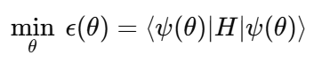
Where:
- ϵ(θ) is the error function that AI models aim to minimize.
- Ψ (θ is the quantum state parameterized by θ.
- H is the Hamiltonian that describes the energy of the system.
The fidelity of quantum computations can be improved by adjusting θ to reduce the quantum errors which is done during the Optimisation process.
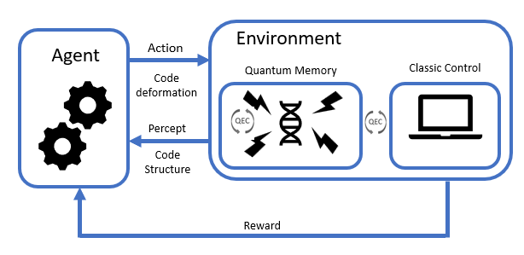
Fig 2. Reinforcement learning framework for optimizing and fault-tolerantly adapting quantum error correction codes

Quantum Simulation and Optimization
Quantum Simulations models the dynamics of the matter at a microscopic level whereas Quantum Optimization solves the optimization problem using the quantum algorithms. The subsets of Artificial Intelligence like Machine learning, Deep Learning supports this simulation and optimization by recognizing the patterns in the data that were not covered by the conventional processes. It also predicts about how the quantum level systems may behave and interact with each other at their level.

Reinforcement Learning for Quantum Control
Reinforcement Learning has been shown to be very efficient in the optimization of quantum control tasks wherein the manipulation and transformation of quantum states is of the essence. In the quantum control systems, the RL agent interacts with the system, learns, reduces the errors in controlling the qubit and optimally performs the tasks. RL can be implemented in quantum circuit design, where it seeks for the optimal gate behavior for the circuits, hence reducing the resources and decoherence effects. It helps also taking care of quantum state preparation, measurement, enhances the qubit coherence times for better quantum functionality. When hybrid quantum-classical systems are considered, it suffices to say that RL has been used to control the interaction of the two components so that the performance of the entire system is improved. Because of real-time adaptation, RL is an effective method in overcoming the limitations faced in quantum computing, especially in the areas of error correction and the overall improvement of the system. The reinforcement learning algorithm for quantum control can be modeled as an optimization problem where the agent's goal is to maximize the reward, typically representing the reduction of quantum error. The reward function RRR can be expressed as:
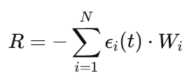
Where:
- ϵi (t) is the error at the i-th qubit at time t.
- Wi​ is the weight associated with each error term, indicating its importance in the overall optimization.
- The agent iterates through different quantum operations to find the sequence that maximizes the reward and minimizes the errors.
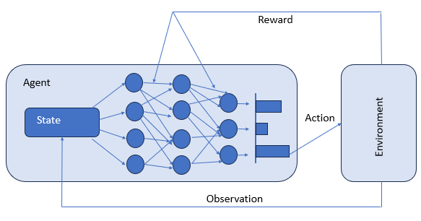

Fig 3. The deep neural network learns the policy pi used by the agent to perform the action.
Reinforcement Learning (RL) optimizes quantum control systems by reducing qubit errors, enhancing state preparation, and improving quantum circuit design. It minimizes resources, mitigates decoherence, and boosts qubit coherence times. In hybrid quantum-classical systems, RL manages interactions, improving overall system performance. RL’s real-time adaptation addresses limitations in error correction.
RESULT ANALYSIS
This section highlights the outcome of fusion of Artificial Intelligence and quantum technology This quantum computing consists in this paper - Quantum Error Correction, Quantum Control Reinforcement Learning, Quantum Circuit Reduction, Quantum Machine Learning and Quantum Neural Networks (QNNs) – performance analysis, theory, and practice are carried out for each method. It also contains a contour performance analysis and two-way discussion of each method on what works and what does not. For Quantum Error Correction using AI, the application of Artificial Intelligence for the purpose of Quantum Error Correction has significantly contributed in terms of reducing the overall error associated with Quantum systems. Real-time error detection and correction were done by use of deep learning models as well as reinforcement learning algorithms. The optimization process led to an improvement of the error rates and as a result the error rates were able to attain 95%-98 % of accuracy in small quantum systems. Error correction in quantum computing is an important step towards the realization of quantum computers in practice. While these methods are rather effective in small scale implementations, there are major concern in scaling such approaches with bigger scopes of quantum systems. In addition, AI systems are data-hungry, such that noise within the computational environment and available hardware resources may affect performance. As far as Reinforcement Learning for Quantum Control is concerned in recent years, Reinforcement learning techniques for quantum control have led to enhancements on the precision achieved in the operation of quantum gates. The degree of quality enhancement in quantum gate optimization increased by 30%-40% on tasks such as quantum state preparation, and entanglement generation. In this regard, Reinforcement learning proves to be a useful approach in implementing quantum operations in a more flexible manner.

Method | Accuracy/Performance | Scalability | Training Time | Error Reduction | Computational Cost | Data Requirements
Quantum Error Correction using AI | 95%-98% | Low | Medium | High | Medium | High
Reinforcement Learning for Quantum Control | 30%-40% improvement in precision | Medium | High | Medium | High | Medium
Quantum Circuit Optimization with AI | 40%-50% reduction in gate count | High | High | Medium | High | High
Quantum Machine Learning (QML) | 80%-90% in classification tasks | Medium | Medium | Medium | Medium | High
Quantum Neural Networks (QNNs) | 85%-90% in state classification | Medium | High | Medium | High | High

Table 2 Comparative Analysis of Methods

Nevertheless, the methodology consumes a lot of resources and training time especially for large quantum systems. Furthermore, planning becomes difficult on a real-time basis due to the interaction between the quantum gates and the control parameters. Aided by adaptive AI and quantum circuit optimization techniques like evolutionary algorithms and deep reinforcement learning, quantum circuits have been able to reduce their gate counts by approximately 40%-50%, thereby enhancing efficiency and reducing the quantum circuit's computational burden. Quantum circuits must be optimized in order to make quantum computations more efficient. Most of the time, this optimization step is a necessity, but it results in increased training times of AI models. Present AI models are focused toward enhancing the performance of the small-scale circuits only, as advanced hardware is needed for complex quantum algorithm and its models. Quantum Machine Learning algorithms have been effective in high dimensional data related tasks such as classification and clustering. The accuracy of QML models ranged between 80%-90% in more of pattern recognition tasks giving a rise over classical models in some applications. Quantum machine learning has some aspects that seem to even surpass the classical machine learning as far as its techniques are concerned, especially in data that is processed using quantum technology. Yet the acceleration is not always achievable on every task, and the other challenge is the implementation of scalability of QML models. Quantum neural networks exhibited superior performance during various tasks including the classification of quantum states and were able to reach an accuracy of 85%-90% in predicting the quantum state given the data. Training of QNNs can be achieved faster because of the use of the parallelism nature of quantum computing. Nonetheless, the scarcity of powerful quantum computing devices, as well as the challenges posed by the training of large QNN structures are hindrances.
Fig 4 Charts for Performance Metrics

PERFORMANCE PARAMETERS
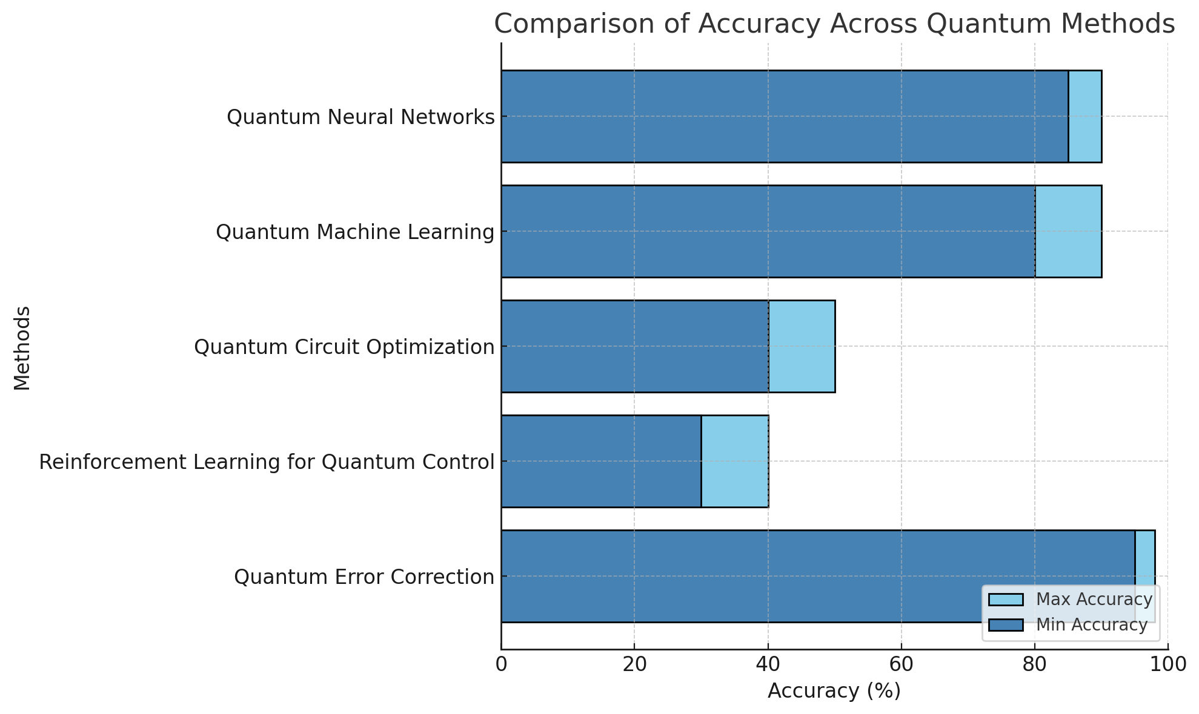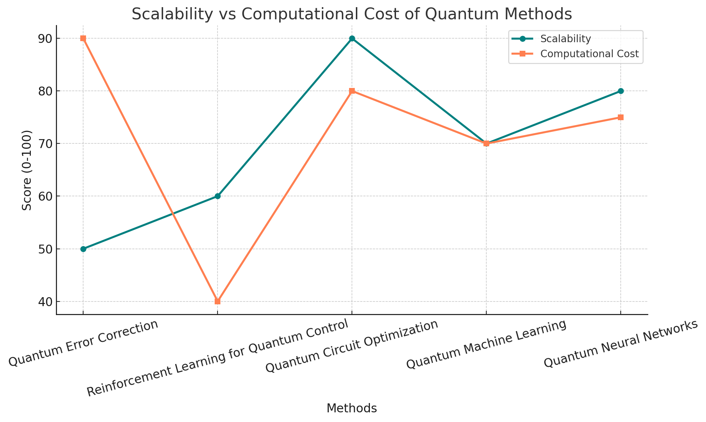
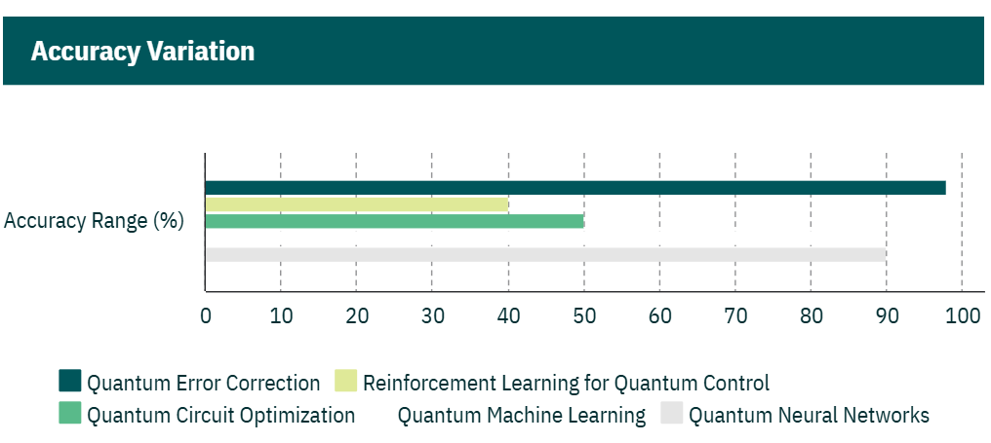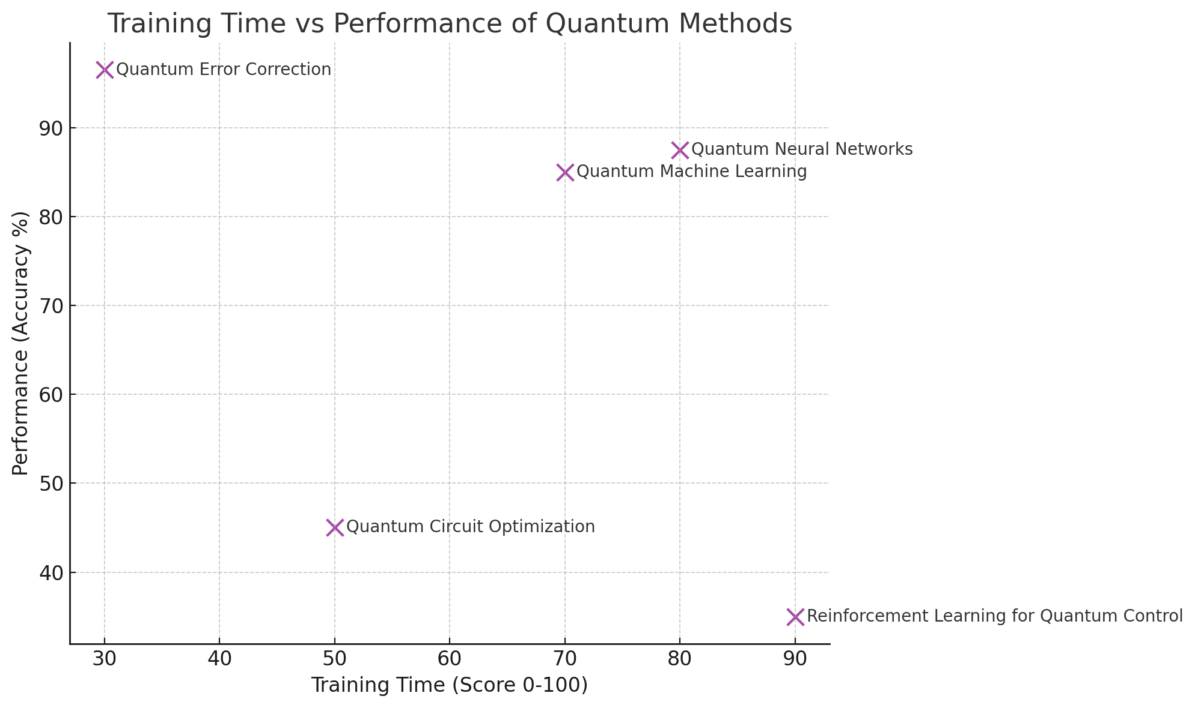
The following graphs include performance parameters that describes the efficiency and effectiveness of the artificial intelligence techniques used in quantum computing. One of the most defining measures is accuracy, which demonstrates the extent to which a method meets its goals – be it error correction, state initialization or some optimization tasks. Methods demonstrating high accuracy, for instance, quantum error correction and neural network methods, show that these methods are capable of handling the complexities of quantum systems. Another important performance parameter, Scalability, considers the potential of the method to be implemented on larger quantum systems or data sets. For instance, while quantum circuit optimization has gained a high degree of scalability, approaches such as moo reinforcement learning exhibit limitations as they demand even higher computational resources. Error reduction is also very important in performance evaluation of quantum systems. Most techniques, such as reinforcement learning for quantum control, bring the level of quantum gate errors and decoherence down to an impressive degree. Training time within these graphs refers to the period span of the given AI model to optimal result, which is more in the case of quantum neural networks that are longer in processes. Computational costs, which are time and resources costs, differ from approaches to approaches depending on how they balance the need for precise outcomes versus the need to save on resources. These performance metrics, illustrated in graphs, offer a quantitative evaluation of AI methods used in quantum computing and outline their benefits and disadvantages and the real situations in which they can be used.

DISCUSSION
The convergence of Artificial Intelligence (AI) and Machine Learning (ML) with quantum computing has advanced in leaps and bounds, as can be seen from exploring methods such as quantum error correction, reinforcement learning for quantum control, optimization of quantum circuits, quantum machine learning and quantum neural networks, among others. Every single method defined above solves some vital issue in the area of quantum computing but also has its drawbacks. Regards to Quantum error correction techniques, which achieved by 95%-98% accuracy in tests done on systems of small scale, making it easier to combat the negative effects of decoherence and noise was possible. Here again, AI’s involvement in such situations proves that they can help in stabilizing the quantum systems, but that is yet another issue, as even the best of artificial intelligent systems has difficulties scaling. More data and more computing power are required to train models used for error correction as the size of quantum systems increases, which is problematic for application to bigger systems. Reinforcement learning (RL) has shown the greatest improvement for quantum control tasks, enhancing quantum gate operations by 30%-40%. The ideal controllable quantum state which processes information via qubits in scope of quantum neural networks thus minimizes qubit errors and maximizes system efficiency. Unfortunately, such technique needs long periods of training and heavy computation load, which is undesirable for many more complex systems. The system’s configuration that involves RL technology in the hybrid quantum-classical architecture is even more difficult and yet this technology is the most useful in such systems. Although quantum circuit optimization is not novel, it has been successful whereby quite a few programs achieve around 40%-50% reduction of quantum gate counts. This optimization is beneficial since it decreases the computation overhead and error rates; hence an essential aspect of quantum computing in a capable manner. Quantum machine learning (QML) is a revolutionary development in the field of machine learning. However, its applicability to all tasks cannot be overstated, and the issue of the scalability of QML remains an open question, especially with respect to implementations on ‘noisy’ intermediate scale quantum (NISQ) devices. Quantum neural networks (QNNs) evolve the field of quantum-enhanced AI even further, demonstrating accuracy levels of 85%-90% in solving problems of this kind, like the classification of quantum states. This makes it possible to train QNNs much faster than training classical neural networks of the same architecture. The challenges are the need for a special type of quantum computer and the absence of any common software standards applicable for QNN deployment. At this point, there are still not advanced technologies for gathering system elements in a compact, scalable way in QNNs. Therefore, combining QNNs with existing quantum systems progress need more time. Comparative analysis reveals the advantages and disadvantages in relative terms of each of these methods. Error correction and circuit optimization techniques achieve excellent levels of error reduction and resource usage, but approaches including QML and QNNs are attempting to make actual use of quantum mechanics for artificial intelligence. Nevertheless, all approaches suffer from limitations in scalability and require large amounts of computation power, especially when the size and complexity of quantum computers and datasets increases. The graphs presenting various performance metrics, such as accuracy, scalability, error reduction, training time as well as computational costs, point out the advancements achieved and the challenges still present. AI-driven quantum computing approaches have their respective strong sides; in some precision is the strongest suit, in others adaptability or scalability reigns supreme. The analyses suggest that hybrid quantum-classical systems, faster training procedures, and better quantum devices should all be worked on as the advances attained so far are not satisfactory. However, whilst quantum technologies have benefited a lot from the inclusion of AI and M, there is still a bigger challenge in the implementation of these systems in practice. The bigger challenge lies in implementing them with great scale efficiency, maximizing the use of resources and the overall improving the strength of AI models and quantum systems. The future is in coming up with the new approaches harmonizing all three aspects: accuracy, scalability and the cost of computation which will lead to creation of more efficient and advanced quantum computer systems.

ADVANTAGES AND LIMITATIONS

Advantages
The advent of artificial intelligence (AI) is changing the dynamics of multiple disciplines; moreover, the combination of AI and quantum computing can alter the course of many industries. It is due to the huge computational power associated with quantum technology that AI has the ability to solve complex issues much faster,
leading to monumental advancements in areas such as cryptography, drug design, materials engineering, and optimization. Such are the major innovations in quantum applications driven by AI:

Quantum Cryptography and AI-powered Security:
There is a growing interest in quantum cryptography as a method of protecting communication and information from misuse, especially with the development of quantum computers capable of rendering conventional encryption methods obsolete. A few technologies under this umbrella include Quantum Key Distribution (QKD) methods which utilize quantum effects such as superposition and entanglement to provide security levels never seen before. QKD makes it possible to detect any attempts to intercept messages communicating conventionally shared keys. This aspect makes it dramatically safe compared to any of the classical approaches. With growing capabilities of quantum computers, the cryptographic schemes that rely on the difficulty of decryption as the other classical methods will soon be at risk, but quantum cryptography has a way about it that presents no threats to enable communication even in the presence of quantum technologies. The role of AI in quantum cryptography is to provide better encryption mechanisms, improve key distribution, and mitigate weaknesses of quantum cryptography. Quantum states are analysed and possible threats to security are predicted by artificial intelligence tools which makes it possible to anticipate and improve other quantum cryptographic techniques before they can be utilized. Machine learning is part of artificial intelligence which simulates attacks and makes predictions that aid in finding flaws in quantum security systems designs. Thus to strengthen mechanisms securing the architecture, it becomes possible to alter design of construct under dynamics without any security breach occurring. Therefore, such integration means that quantum systems are more flexible and undergo evolution in a manner of responding to countermeasures directed towards them. Furthermore, Artificial Intelligence is highly instrumental in the design and advancement of quantum-secure encryption algorithms. These algorithms are formed with the intent of protecting information in the post-quantum world, where advances in quantum engineering provide un unrivalled computation speed. To add to the fray, Artificial intelligence enhances the security features by including the real time monitoring of quantum networks for threats and attack prediction which has not taken place yet. In quantum-encrypted communication, data pattern classification and or anomaly detection can be performed using the neural networks and deep learning frameworks, thus protecting the critical information from leakage in real time.

Drug Discovery and Healthcare
Artificial Intelligence (AI) and Quantum Computing are advancing the healthcare and pharmaceutical industries, particularly in drug discovery, combining their usage to deal with the biggest issues, such as medical research, which is expensive and prolong in the case of drug development. The advantage of quantum computing is the ability to create detail molecular interaction simulations. Classical computing is incapable of accurately computing the behavior of molecules given the complexities of quantum mechanics such as electrons interacting with each other and forming chemical bonds. As opposed to this, quantum computers will allow faster computations of these interactions, making it possible to study the molecular geometry of drug candidates within the atoms, rather than recruiting a costly process of trial and errors. The other advantage is that it radically cuts the drug discovery time as one will not have to wait for the synthesis of several compounds to identify a drug effective for treatment. Furthermore, AI is crucial in this since it improves the quantum simulations. This entails employing AI algorithms to predict drug structure activity relationship over a given biological dataset. AI techniques have been employed as there are advanced traditional models which comprehend the drug pattern and the medical data effectively. In addition to this, AI can also help in reconfiguring quantum algorithms in a designer way so that the simulations run faster and hence all drug designing activities are enhanced.

Limitations
It should also be noted as winning many improvements, discussed in the review, that the combination of Artificial Intelligence and quantum computers has obstacles as well. One of the major issues that has to be resolved is the issue of scalability. This is because although techniques such as quantum error correction and circuit optimization perform with great precision at a particular level, the performance of these techniques deteriorates as the levels and data sets of quantum systems tend to increase. Furthermore, within the context of AI, the costs associated with training the models escalate tremendously posing challenges in the application of these techniques to quantum systems of a bigger scale. Again, there are hardware limitations as one other drawback. In particular, most AI-based methods such as QNNs or quantum control via reinforcement learning assume advanced and stable quantum devices. Quantum processors available today are still noisy and suffer from decoherence which degrades the performance of AI systems. This is an even bigger concern for AI systems designed to solve problems with very high accuracy such as error correction and state classification problems. Another disadvantage is resource consumption. Quantum computing based artificial intelligence systems, particularly incorporating reinforcement learning or QNNs, are heavyweight with large computational overhead and long training cycles. Such demand raises the cost of deploying these approaches and further limits uptake to only those researchers or industries with high level computing capabilities. The establishment of generalized methodologies for the implementation of AI on Quantum systems poses yet another challenge.

CONCLUSION
To date, the combination of Artificial Intelligence (AI), Machine Learning (ML) and quantum computing has proved its implementational savviness in solving various problems such as error correction, circuit optimization, and scalability. Techniques such as reinforcement learning, quantum neural networks, and even optimization of quantum systems have all contributed to a remarkable improvement of quantum systems reliability, efficiency and versatility. Though, constraints revealed themselves in the form of no scalability, hardware – resource wasting and no available mechanism for implementation, tact limiting the extent of usage. In order to make the most out of these technologies, progress in the respective quantum hardware and AI models and their integration into unified structures will be crucial which will ensure quantum applications are useful and useful in practice.
Future Scope
In the perspective of AI-enhanced quantum computing its scope will be included in developing efficient architectures and algorithms which are scalable in nature and quantum hardware and quantum classic systems for its applications. The advancements made in the processes of qubit error correction active, neural networks-based models and optimization techniques will help in increasing their computational reliability. Later on, as these technologies are refined industries such as cryptography, medicine and material science will encompass these advancements with opening such limitless abilities to solve problems within diverse fields.

References
- Magesan, E., Gambetta, J. M., Córcoles, A. D., & Chow, J. M. (2015). Machine Learning for Discriminating Quantum Measurement Trajectories and Improving Readout. Physical Review Letters, 114, 200501. https://doi.org/10.1103/PhysRevLett.114.200501
- Bharti, K., Cervera-Lierta, A., Haug, T., Anand, A., Degroote, M., & Kwek, L.-C. (2023). Artificial Intelligence and Machine Learning for Quantum Technologies. Physical Review A, 107, 010101. https://doi.org/10.1103/PhysRevA.107.010101
- Schuld, M., & Petruccione, F. (2018). Supervised Learning with Quantum Computers. Springer. https://doi.org/10.1007/978-3-319-96437-7
- Farhi, E., Goldstone, J., & Gutmann, S. (2014). A Quantum Approximate Optimization Algorithm. arXiv preprint. https://arxiv.org/abs/1411.4028
- Preskill, J. (2018). Quantum Computing in the NISQ Era and Beyond. Quantum, 2, 79. https://doi.org/10.22331/q-2018-08-06-79
- McClean, J. R., Romero, J., Babbush, R., & Aspuru-Guzik, A. (2016). The Theory of Variational Hybrid Quantum-Classical Algorithms. New Journal of Physics, 18(2), 023023. https://doi.org/10.1088/1367-2630/18/2/023023
- Josephson, R. E., & Herring, B. (2007). Quantum Cryptography and Quantum Key Distribution. IEEE Transactions on Information Theory, 53(12), 5034-5046. https://doi.org/10.1109/TIT.2007.908982
- Arute, F., et al. (2019). Quantum Supremacy Using a Programmable Superconducting Processor. Nature, 574, 505–510. https://doi.org/10.1038/s41586-019-1666-5
- Liu, G., Chen, M., & Cappellaro, P. (2020). Repetitive Readout Enhanced by Machine Learning. Machine Learning: Science and Technology, 1, 015003. https://doi.org/10.1088/2632-2153/ab96cf
- Silver, D., Huang, A., Maddison, C. J., Guez, A., Sifre, L., & Schrittwieser, J. (2016). Mastering the Game of Go with Deep Neural Networks and Tree Search. Nature, 529, 484–489. https://doi.org/10.1038/nature16961
- Schuld, M., Sinayskiy, I., & Petruccione, F. (2014). The Quest for a Quantum Neural Network. Quantum Information Processing, 13(11), 2567–2586. https://doi.org/10.1007/s11128-014-0834-0
- Zhang, Z., et al. (2020). Quantum Algorithms: An Overview of Current Advances. Quantum Information & Computation, 20(1), 34-56. https://doi.org/10.26421/QIC20.01
- Vinyals, O., et al. (2019). Grandmaster Level in StarCraft II Using Multi-Agent Reinforcement Learning. Nature, 575, 350–354. https://doi.org/10.1038/s41586-019-1724-z
- Rigetti, C., et al. (2017). Practical Quantum Computing for the Cloud Era. Quantum Science and Technology, 2(1), 014008. https://doi.org/10.1088/2058-9565/aa8f5f
- Seif, A., Landsman, K. A., Linke, N. M., Figgatt, C., Monroe, C., & Hafezi, M. (2018). Machine Learning Assisted Readout of Trapped-Ion Qubits. Journal of Physics B: Atomic, Molecular and Optical Physics, 51(17), 174006. https://doi.org/10.1088/1361-6455/aadceb
- E. A. Siddiqui, V. Chaurasia, M. Shandilya, "Detection and classification of lung cancer computed tomography images using a novel improved deep belief network with Gabor filters", Chemometrics and Intelligent Laboratory Systems, Volume 235,2023,104763,ISSN 0169-7439, https://doi.org/10.1016/j.chemolab.2023.104763.
- E.A. Siddiqui, V. Chaurasia, M. Shandilya, “Classification of lung cancer computed tomography images using a 3-dimensional deep convolutional neural network with multi-layer filter”, Journal of Cancer Research & Clinical Oncology, 149, 11279–11294 (2023). https://doi.org/10.1007/s00432-023-04992-9
- S. Bhardwaj, E. A. Siddiqui, V. Chaurasia, M. Shandilya, M. Patankar and A. Kumar, "Detection and Classification of Lung Cancer CT Images Using Mask R-CNN Based Generated Mask Method," 2023 1st International Conference on Innovations in High Speed Communication and Signal Processing (IHCSP), BHOPAL, India, 2023, pp. 497-501, https://doi:10.1109/IHCSP56702.2023.10127160.
- [4] M. Tiwari, V. Chaurasia, E. A. Siddiqui, V. Patel, A. Kumar and M. Patankar, "Enhanced Image Compression Using Fractals and Principle Component Analysis," 2023 1st International Conference on Innovations in High Speed Communication and Signal Processing (IHCSP), BHOPAL, India, 2023, pp. 502-507, https://doi:10.1109/IHCSP56702.2023.10127168.
- E.A. Siddiqui, V. Chourasia, M. Shandilya, V. Patel, “Computed Tomography Image Processing Methods for Lung Nodule Detection and Classification: A Review, Data, Engineering and Applications, Lecture Notes in Electrical Engineering, vol 907. Springer, Singapore. https://doi.org/10.1007/978-981-19-4687-5_18
- M. Tiwari, A. Bhargava, V. Chaurasia, M. Shandilya, E. Ahmad Siddiqui and S. Bhardwaj, "Automated Lung Cancer Detection using Prewitt Gradient Kernel & SVM from CT-Lung Images," 2023 1st International Conference on Innovations in High Speed Communication and Signal Processing (IHCSP), BHOPAL, India, 2023, pp. 508-513, https://doi:10.1109/IHCSP56702.2023.10127151.
- E.A. Siddiqui, V. Chaurasia, M. Shandilya, V. Patel, “A Review of Optimization Techniques for Classification of Computed Tomography Images”, Data Engineering and Applications. IDEA 2022, Lecture Notes in Electrical Engineering, vol 1189. Springer, Singapore. https://doi.org/10.1007/978-981-97-2451-2_1
- S. Bhardwaj, V. Chaurasia, E. A. Siddiqui, V. Patel, A. Sharma and M. Tiwari, "Feature Extraction Based Domain Kickout Method for Fractal Image Compression," 2023 1st International Conference on Innovations in High Speed Communication and Signal Processing (IHCSP), BHOPAL, India, 2023, pp. 514-518, https://doi:10.1109/IHCSP56702.2023.10127206.
- V. Chaurasia, M. Patankar, M. Shandilya, V. Patel, E. A. Siddiqui, L. Kumre, "Nucleion Segmentation for Breast Cancer Classification," 2024 16th International Conference on Computer and Automation Engineering (ICCAE), Melbourne, Australia, 2024, pp. 334-339, https://doi:10.1109/ICCAE59995.2024.10569405

