**Advanced Techniques in Sentiment Analysis:**

**Leveraging Pre-trained Transformers and Hybrid Models**

Muccharla. Praveen | Dr. K. Kavitha (Sr. Assistant Prof) | GMRIT

**Abstract:**

Sentiment analysis is an essential method for understanding and evaluating the enormous amounts of text data generated across multiple platforms. Rapid advancements in Natural Language Processing (NLP), particularly the introduction of pre-trained language models such as BERT, RoBERTa, and hybrid architectures, sentiment analysis has become much more extensive and accurate. Applications of these advanced models in sentiment analysis, highlighting their ability to improve classification accuracy and capture contextual nuances. Combining different models—ResNeXt for feature extraction, BiLSTM with self-attention for context representation, and RoBERTa for language interpretation—develops a robust framework for sentiment analysis. Comparative studies across multiple datasets demonstrate that hybrid models perform better at handling complex phrase patterns and a variety of expressions of sentiment. The power of pre-trained models in sentiment analysis is a Turning point, unlocking new possibilities for understanding the emotions and opinions of people on social media and in customer feedback. Additional issues including sarcasm detection, domain-specific adaptations, and context generation are tackled, Paving the way for future innovations in this field.

**Keywords:** *Sentiment Analysis, Pre-trained Transformers, BERT, Hybrid Models,*

*Aspect-Based Sentiment Analysis (ABSA).*

**Introduction:**

Today, in the world where all the texts are generated daily from social media, customer reviews, and so on, to extract insights is more and more important for companies as well as researchers. Sentiment analysis, or the process of determining the emotional tone of text, became a key methodology for analyzing this emerging data stream. Recent breakthroughs in NLP, especially pre-trained transformer models like BERT, RoBERTa, and DistilBERT, have positively impacted the precision and depth of sentiment analysis. Hybrid architectures employing LSTM, self-attention, and ResNeXt have paved the way for machines to understand text in much more sophisticated manners than traditional methods. The models can handle hard-to-parse language patterns of very complex phrases of semantics: that includes sarcasm and multi-domain sentiment, which previously was hard to analyze. Research papers explain the application of the advanced models in handling more advanced sentiment analysis, most notably Aspect-Based Sentiment Analysis. This means that sentiments related to aspects of products or services can be available in more detail. Hybrid models of varied architectures, such as for language interpretation. Like RoBERTa, and context representation via BiLSTM with self-attention, help to give a stronger framework to deal with complex datasets and enhance the accuracy of classification. Researchers of this study conducted comparative studies across different datasets in order to explicate how hybrid models outperform the basic sentiment analysis approaches in all possible ways. Generation of context, detection of sarcasm, and adaptation-specific domain are some of the difficulties that are explored here. Pre-trained models have gradually become the trend in sentiment analysis, and as the field is continuously evolving, further opportunities have been opened up to understand emotions and opinions; hence, new possibilities are set open in improved, more insightful analyses across different fields of application.

**Literature Survey:**

Chuanjun Zhao et al. Introduces the topic **Aspect Base Sentimental analysis (ABSA)** and explains that it focuses on the importance of analyzing the feelings/emotions associated with particular entities or characteristics in a text. **BERT + Filtering**: Highlight the new hybrid of high advanced BERT for text generation as well as a filtering algorithm in order to potentially bring new improvements in data quality [1].

Yang et al. KEPLMs: Summary of recent developments occurring within NLP research, particularly in the area of **Knowledge Enhanced Pre-Trained Language Models (KEPLMs).** What is recent news about **Pre-trained Language Models (PLMs)** and **Knowledge Representation Learning (KRL)** that push the limits of symbolic knowledge into neural networks to advance PLMs? Classifies the existing KEPLMs that categorize them into 3 ways they are granularity of knowledge, which are entity-fused, syntax-tree-fused, KG-fused, and rule-fused categories. It also discusses retrieval-based KEPLMs [2].

L. Mathew et al.Highlights the evolution from traditional word embedding techniques to advanced Pre-trained models, emphasizing their effectiveness in sentiment classification. Includes various pre-trained models such as **ULMFiT, Transformer, OpenAI's GPT-2,** and **XLNet**. Emphasing the role of transfer learning in NLP, where models trained on one task can be adapted for others, enhancing their utility [3].

Amit Chauhan et al. Focuses on **Aspect-Based Sentiment Analysis (ABSA)**, essential for identifying emotions related to specific elements in text. It highlights the challenges posed by the informal nature of social media content, which is a rich source for ABSA. Techniques like the **Dependency Tree Graph Convolutional Network (DTGCN)** and **Mutual Distillation Structure Knowledge Injection (MDSKI)** to improve sentiment classification accuracy [4].

Pedro Colon-Hernandez et al. Integration of structured knowledge, particularly from knowledge graphs, into transformer-based language models. It highlights the challenges and opportunities in leveraging both structured and unstructured information sources. **Knowledge Injection**: Input-focused injections, Architecture-focused injections, Output-focused injections [5].

T. Liang et al. Various models used in aspect-based sentiment analysis, including **Convolutional Neural Networks (CNNs)** and **Long Short-Term Memory (LSTM) Networks.** Propose a model that combines pre-trained language representations (like BERT) with TextCNN [6].

Amir Jabbary Lat et al. Methodologies in sentiment analysis, including character-level, ensemble-based, transformer-based, and hybrid models. Hybrid feature extraction method structured into three steps: Pre-Processing, Review-Related Features, And Aspect-Related Features. Integrates various models to enhance sentiment classification, utilizing an LSTM classifier to categorize reviews into positive, negative, or neutral sentiments [7].

Tucudean G et al. Identifies and extracts relevant articles to summarize the current state of NLP, focusing on applications, language models, and data sets used in the field. Structured selection algorithm, methodology includes identifying recent studies, applying filters, and assessing the proposed strategies [8].

The evolution of Sentiment Analysis (SA) techniques, highlighting early machine learning approaches like **Naive Bayes and SVM**, which struggled with sentiment classification due to their reliance on the Bag-Of-Words (BoW) model that ignores grammatical structures and semantic relations. Various deep learning models, including **CNN**, Talaat et al. **LSTM**, and hybrid approaches, which have shown improved performance in sentiment classification tasks. Proposes a combination of BERT with BiLSTM and BiGRU architectures, utilizing pre-trained word embeddings for model fine-tuning [9].

S. Kumawat et al. Evolution from traditional methods like Naïve Bayes classifiers and rule-based systems to advanced techniques using deep neural networks, such as LSTM and Transformer architectures. Utilize State-Of-The-Art transformer models, including BERT, Roberta to perform sentiment analysis on a dataset of tweets. Adaptions of these models using the Simple Transformers framework [10].

Qurat Tul Ain et al. Integrating of deep learning with machine learning concepts to enhance sentiment classification accuracy. Multiple models such as **Convolutional Neural Network (CNN)**, **Recurrent Neural Network (RNN)**, and **Deep Belief Network (DBN).** Use of hybrid neural networks that combine multiple models for improved sentiment analysis, discuss specific model like **Hierarchical Bidirectional Recurrent Neural Networks (HBRNN)** [11].

Mahdi Rezapour et al. Aims to explore how these models can effectively capture the nuances of human emotions expressed in text, which is a complex task due to the limitations of language itself. Different methods of fine-tuning transformer models for emotion classification, addressing challenges such as data scarcity, class imbalance, and domain adaptation [12].

Da Yin, Li Dong et al. A knowledge fusion module that integrates this knowledge with representations learned from pre-trained language models. Various categories of knowledge fusion methods and discusses their implementations in enhancing the performance of **Pre-Trained Language Model-Based Knowledge-Enhanced Models (PLMKEs)** [13].

Latha Narayanan Valli et al. Aims to enhance data analysis, improve decision-making, and facilitate knowledge discovery. Quantitative analysis is used to measure performance metrics across various data science tasks. Qualitative analysis focuses on gaining insights into the interpretability and explainability of the model's decisions [14].

Singla **e**t al. Various transformer-based pre-trained models, including **BERT, RoBERTa**, and **ALBERT**, and their applications in sentiment analysis tasks. It highlights the advancements in transfer learning and the significance of self-supervised models in **Natural Language Processing (NLP)**. Fine-tuning the selected transformer models on a sentiment analysis task [15].

K. L. Tan et al.Highlights comparisons among methods like Naïve Bayes, Support Vector Machine (SVM), and **K-Nearest Neighbour (KNN)** using datasets from platforms like Twitter and IMDb. The results indicate varying accuracies, with Naïve Bayes achieving 75.58% and CNN reaching 99.33% on different datasets. Hybrid approach combining RoBERTa for feature extraction and LSTM for capturing long-distance dependencies [16].

**Methodology:**

* **Datasets:**

The datasets used in the paper **“Enhancing Aspect-Based Sentiment Analysis With BERT-Driven Context Generation and Quality Filtering”** is the SemEval-2014 laptop and restaurant. Models used is **Convolutional Neural Network (CNN), Recurrent Neural Network (RNN), Unified Generation Framework (UGF)**. Integration of advanced Text Generation and Filtering Techniques to create a robust framework for Sentimental Analysis.

* **Convolutional Neural Networks (CNNs):**

Convolutional Neural Networks (CNNs) are deep learning models designed for the processing of grid-like structured data, particularly in the case of images. A CNN model uses convolutional layers, where filters or kernels kept over input data, performing element wise multiplication to extract features such as edges, textures and patterns. This feature extraction process makes effective for image classification tasks.

CNNs consists of several layers like:

1. **Convolutional layers** – For Feature
2. **Extraction Pooling Layers** – For Down-Sampling
3. **Fully Connected Layers** – For Decision making

In CNN’s Activation function like ReLU (Non-Linearity) to learn complex patterns. CNNs has a vast applications like facial recognition, medical imaging and so on.

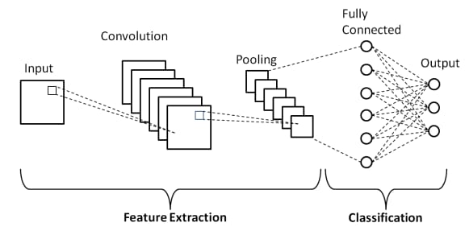

* **Recurrent Neural Networks (RNNs):**

Recurrent Neural Networks (RNNs) is a class of neural networks designed for sequential data. In RNNs Order of information is crucial, the connections forms cycles, allowing information to maintain continue. By this way we can say RNNs are well suited for time series tasks, NLP sequential data tasks.

RNNs is widely used in Language Modelling, Sentiment Analysis, Machine Translation and Speech Recognition.

* **Unified Generation Framework (UGF):**

Unified Generation Framework (UGF) is a integration tool for integrating AI generations techniques under a single cohesive architecture. The framework promotes an efficiency by using a unified pipeline for preprocessing, training and output generation. UGF also facilitates transfer learning, where knowledge from one generative task can be applied to another.

* **Bert-Based Text Generation:**

BERT is a pre-trained language model that is capable of understanding the context of words and sentences. It is used to identify the relationship between the sentences for further making of sentences. The model integrates sentence relationships with their respective labels, creating an initial corpus for data augmentation.

**Text Filtering Algorithm:**

A Function is introduced named “augment_text” which is used in the base paper[1] for data generation and for evaluating the the generated text we used a metrics named **“bleu_score”** which is used to check grammerly score, fluency score, relevance score available in python’s NLTK library and the **“language_tool_python”** library.

score = $\frac{grammerly score + fluency score + relevance score}{3}$

The main is to eliminate the low-quality generated text, ensuring that only high-quality data is retained for further analysis.

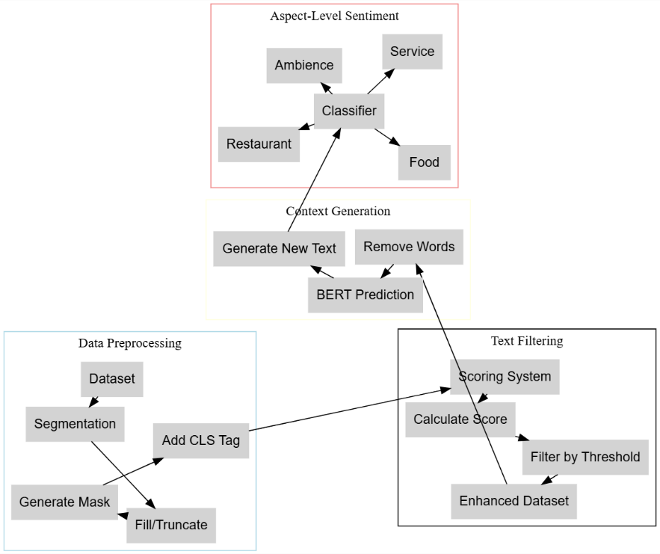

* **Data Augmentation:**

Data Augmentation refers to expanding of datasets when there is a limited dataset for training a model. In this paper the researcher tries to expand the dataset with relevant to the data for sentimental analysis classification.

strategies like:

1. **Synonym Replacement:** Substituting of words with exact synonyms
2. **Basic Bert Text Generation:** Generate text without specific conditioning related to labels.
3. **Conditional Bert Approach:** Also known as Con-Bert, Enhance the quality of generated text.

**Results:**

The paper’s mainly focuses on combining a BERT – based contextual text generation model and a text filtering algorithm. Then the effectiveness of sentimental analysis on the combined approaches is tested by various methods like CNN, RNN, UGF as a baseline models.

|  |  |  |  |  |
| --- | --- | --- | --- | --- |
| **Model** | **Laptop Dataset**  **F1-score** | **Laptop Dataset Accuracy** | **Restaurant Dataset F1-score** | **Restaurant Dataset Accuracy** |
| CNN +  CON – BERT | 62.9% | 63.3% | 64.2% | 64.0% |
| RNN +  CON – BERT | 63.2% | 63.8% | 70.1% | 69.2% |
| UGF +  CON – BERT | 73.1% | 73.9% | 79.8% | 80.1% |

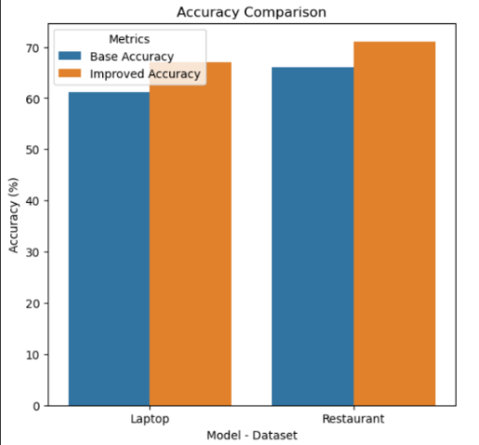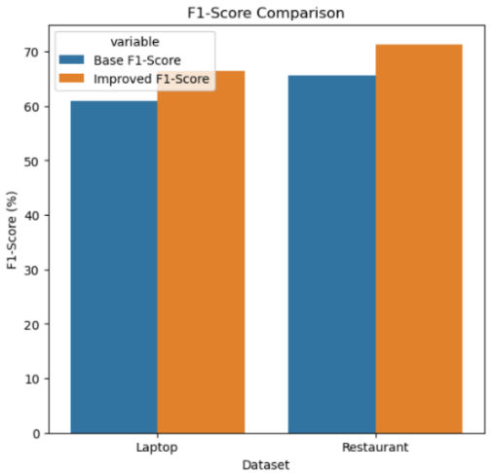

**Conclusion:**

The paper results show that combining the Conditional BERT context text generation language model with filtering methods lead a significant improvements in Aspect Based Sentiment Classification tasks. On comparing with the basic BERT text generation approach, the conditional BERT model, along with the filtering algorithm, can be observed relationship between aspect terms and their context more effectively. This allows the model to expand datasets for sentence classification tasks without compromising label compatibility.

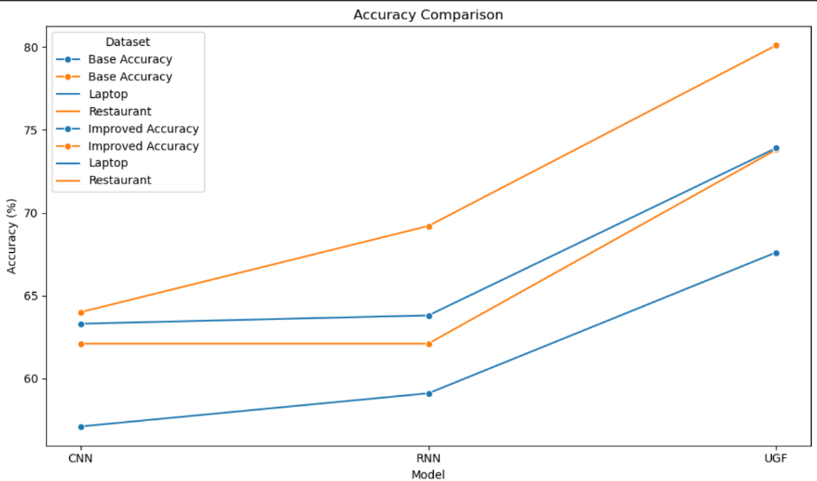

**Future Prospect:**

Advanced models structures and Techniques: Approaches like Integration of Knowledge Graphs, Alternative transformers variants has improve text augmentation quality and effectiveness.

Transfer-Learning and Meta-Learning: Of these methods have the potential to offer a robust and diverse technical support for fine-grained sentiment analysis.

**References:**

1. **Chuanjun Zhao, Rong Feng, Xuzhuang Sun, Lihua Shen, Jing Gao, Yanjie Wang,** "Enhancing aspect-based sentiment analysis with BERT-driven context generation and quality filtering", Natural Language Processing Journal, Volume 7, 2024, 100077, ISSN 2949-7191, <https://doi.org/10.1016/j.nlp.2024.100077>
2. **Yang, Jian and Hu, Xinyu and Xiao, Gang and Shen, Yulong,** “A Survey of Knowledge Enhanced Pre-trained Language Models”, 2024, Association for Computing Machinery, New York, NY, USA, 2375-4699, <https://doi.org/10.1145/3631392>, 10.1145/3631392.
3. **L. Mathew and V. R. Bindu,** "A Review of Natural Language Processing Techniques for Sentiment Analysis using Pre-trained Models," 2020 Fourth International Conference on Computing Methodologies and Communication (ICCMC), Erode, India, 2020, pp. 340-345, doi: 10.1109/ICCMC48092.2020.ICCMC-00064.
4. **Amit Chauhan, Aman Sharma, Rajni Mohana,** "A Pre-Trained Model for Aspect-based Sentiment Analysis Task: using Online Social Networking", Procedia Computer Science, Volume233,2024,Pages35-44,ISSN 877-0509, <https://doi.org/10.1016/j.procs.2024.03.193>.
5. **Pedro Colon-Hernandez, Catherine Havasi, Jason Alonso, Matthew Huggins, Cynthia Breazeal,** "Combining pre-trained language models and structured knowledge", 2021, <https://doi.org/10.48550/arXiv.2101.12294>
6. **T. Liang, X. Yang, X. Zhou and B. Wang,** "Aspect Based Sentiment Analysis by Pre-Trained Language Representations," 2019 IEEE Intl Conf on Parallel & Distributed Processing with Applications, Big Data & Cloud Computing, Sustainable Computing &Communications,SocialComputing&Networking(ISPA/BDCloud/SocialCom/SustainCom), Xiamen, China, 2019, pp. 1262-1265, doi: 10.1109/ISPA-BDCloud-SustainCom-SocialCom48970.2019.00180.
7. **Amir Jabbary Lak, Reza Boostani, Farhan A. Alenizi, Amin Salih Mohammed, Seyed Mostafa Fakhrahmad,** "RoBERTa, ResNeXt and BiLSTM with self-attention: The ultimate trio for customer sentiment analysis", Applied Soft Computing, Volume 164,2024, 112018,ISSN 1568-4946, <https://doi.org/10.1016/j.asoc.2024.112018>.
8. **Tucudean G, Bucos M, Dragulescu B, Caleanu CD. 2024.** "Natural language processing with transformers: A Review". PeerJ Computer Science 10:e2222 <https://doi.org/10.7717/peerj-cs.2222>
9. **Talaat, A.S.** "Sentiment analysis classification system using hybrid BERT models ". J Big Data 10, 110 (2023). <https://doi.org/10.1186/s40537-023-00781-w>
10. **S. Kumawat, I. Yadav, N. Pahal and D. Goel,** "Sentiment Analysis Using Language Models: A Study",2021,11th International Conference on Cloud Computing, Data Science & Engineering (Confluence), Noida, India, 2021, pp. 984-988, doi: 10.1109/Confluence51648.2021.9377043.
11. **Qurat Tul Ain, Mubashir Ali, Amna Riaz, Amna Noureen, Muhammad Kamran, Babar Hayat and A. Rehman,** "Sentiment Analysis Using Deep LearningTechniques: A Review", International Journal of Advanced Computer Science and Applications(IJACSA), Volume 8 Issue 6, 2017.
12. **Mahdi Rezapour,** "Emotion Detection with Transformers: A Comparative Study", 2024 <https://doi.org/10.48550/arXiv.2403.15454>
13. **Da Yin, Li Dong, Hao Cheng, Xiaodong Liu, Kai-Wei Chang, Furu Wei, Jianfeng Gao,** "A Survey of Knowledge-Intensive NLP with Pre-Trained Language Model", 2022, <https://doi.org/10.48550/arXiv.2202.08772>.
14. **Latha Narayanan Valli, N. Sujatha, Mukul Mech and Lokesh V.S,** "Exploring the roles of AI-Assisted ChatGPT in the field of data science", International Conference on Environmental Development Using Computer Science (ICECS’24), Article Number 01026,page(s)-14,Volume 491, 2024, DOI: <https://doi.org/10.1051/e3sconf/202449101026>
15. **Singla, Saurav. (2020).** "Comparative Analysis of Transformer Based Pre-Trained NLP Models". INTERNATIONAL JOURNAL OF COMPUTER SCIENCES AND ENGINEERING. 8. 40-44. 10.26438/ijcse/v8i11.4044.
16. **K. L. Tan, C. P. Lee, K. S. M. Anbananthen and K. M. Lim,** "RoBERTa-LSTM: A Hybrid Model for Sentiment Analysis With Transformer and Recurrent Neural Network," in IEEE Access, vol. 10, pp. 21517-21525, 2022, doi: 10.1109/ACCESS.2022.3152828.