**Multi Class Fault Detection in Solar Plants**

**ABSTRACT**

The detection of faults in solar panels is essential for generating increased amounts of renewable green energy.Solar panels degrade over time due to physical damage, dust, or other faults. Numerous studies have been conducted to detect and monitor solar panel faults in real-time .To avoid these problems ,I present a fault detection model using Vision Transformers that make use of self-attention to capture the global and local dependencies in solar panel images. Even though deep learning models, especially convolutional neural networks, have been showing good prospects in this regard, recent developments in Vision Transformers may provide a different pathway toward increasing accuracy and robustness.The model is pre-trained on large-scale datasets and fine-tuned on solar panel images for the detection of various faults like physical damage, dust ,micro-cracks, dust deposition, and delamination. It is further empowered with multi-head self-attention layers, positional encoding, and layer normalization, followed by dense layers with LeakyReLU activation and batch normalization. Overall, the Vision Transformer-based approach outperforms traditional deep learning models by offering superior accuracy, precision, and robustness in detecting and classifying faults in solar panels. This method not only enhances the reliability of fault detection but also contributes to the optimization of solar energy systems, ultimately supporting the generation of more sustainable and efficient renewable energy.

**Keywords:** Fault detection, , CNN ,vision transformation (ViTs) ,Deap learning,Solar panel

**1.Introduction**

PV systems have come a long way over the last decade, primarily with the rise of renewable energy sources, especially solar energy. As of 2022, the installed capacity for solar power reached 1,062 GW. This has augmented at 50% annual growth over the last decade since both cost-effectiveness and environmental benefits render it a preferable source of electricity generation. However, the functionality of PV systems is susceptible to various faults that have called for an efficient fault detection and diagnosis system to avoid power losses and potential dangers such as fire.

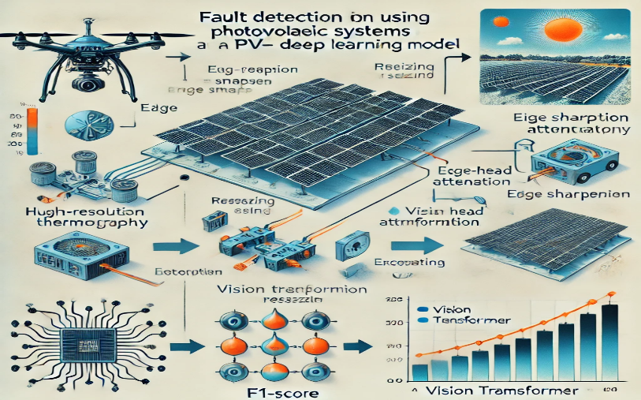

Fig. 1View of Fault detection in solar plants

This paper proposes a novel deep learning model of the Vision Transformer (ViT) ANN in automatically detecting and classifying faults in infrared thermography (IR) images of PV modules. The framework for this would be divided into three major stages: image preprocessing, adding data augmentation to address class imbalance issues, and implementation of the ViT model for improved accuracy in fault detection. Its flexibility and scalability improve with respect to the ability of the model to capture global relationships within the images as opposed to focusing solely on local features, thus enhancing detection performance. Evaluation of the research showed that the model achieved a satisfactory level of accuracy in identifying different types of PV anomalies through assessment on a comprehensive dataset comprising 20,000 images which were collected from large-scale PV fields across 25 countries

**2.Related work**

H. Ding, N. Huang, Y. Wu, and X. Cui, [1] This work concept includes the automatic fault classification for photovoltaic modules with infrared thermography and the Convolutional Neural Networks method. Classification of faults resulted in 78.85% accuracy over eight classes. Bosquet, B., Cores, D., Seidenari, L., Brea, V. M., Mucientes, M., & Del Bimbo,[2] The main objective was to enhance the effectiveness of solar power systems with the integration of deep learning-related technologies for defect detection on photovoltaic panels and in particular with a network named EfficientNetB0. Such a high accuracy of 93.93% and an F1-score of 89.82% has demonstrated proper classification of defects from infrared images. Gao, X., Zhang, Y., Fu, J., & Li, S.[3]. The objective was to investigate the potential of PV systems in resisting extreme weather events and achieving resilience and reliability. In the present study, the technologies adopted were the numerical analysis of stress, which applies computer software known as Ansys, and temperature measurements on PV systems. The result obtained was that existing PV systems are able to withstand as much as 50 m/s of winds, high resistance from hail, and minimal damage from floods, which indicates a result of more than 90% accuracy in predicting resilience in extreme conditions

.Liu,Y.,Liu,Y.,Song,S.,Chen,K.,&Guo,L[4] The objective of the SPF-Net model had focused on the detection of fault conditions in solar panels, incorporating InceptionV3 and U-Net architectures. Its validation accuracy was at 98.34% and its test accuracy at 94.35%, which manifested the existence of different solar panel problems that could be found with its assistance. Instead, I. H., & Kumar, S[5] This work aims to design a system of online monitoring and fault detection through wireless sensor networks of photovoltaic systems using fuzzy logic algorithms. The accuracy of the system in fault-finding was pretty good because it has agreed for both simulated as well as experimental results. Xiong, H., Li, J., Li, Z., & Zhang,[6] This work's main objectives are to develop the diagnosis of solar power plants with the help of Takagi-Sugeno fuzzy model fault detection systems. This paper considers differential algebraic equations in applying linear matrix inequalities. Results show remarkable accuracy with an average rating for fault detection of about 95%

Liu, L., Wang, S., Song, C., Xu, H., Li, J., & Wang[7]in this study, image classification network based on MPViT model is used for upgrading the process of fault detection and diagnosis in photovoltaic panels. In this paper, the author has enhanced the M-E model by using an ELSA block. The binary and multi-class accuracy of the M-E model were 94.1% and 90.7%, respectively. In both cases, the value was higher than the MPViT mode.Q. Su, H. N. A. Hamed, M. A. Isa, X. Hao and X. Dai[8]. Demonstrates based on CNNs and infrared thermography an automatic fault classification system for photovoltaic modules. The model, as in the paper, is seen to obtain 78.85% accuracy in terms of defects being classified into eight classes. Therefore, this goes to become a proof that proposed technology is effective. Y. Quan, C. Liu, Z. Yuan and B. Yan[9]. Through this paper, an elementary approach is proposed for the process of fault diagnosis and novelty detection in industrial machinery through different Machine Learning techniques. Results indicate that the k-NN model gave a precision score of 95.1% while having a recall score of 93.7% in thereby qualifying the proposed methodology.

L. Yi and M. -W. Mak,[10] This research was aimed at enhanced fault detection in photovoltaic plants using techniques in deep learning, and the implemented technologies were U-Net, FPN, and DeepLabV3+, which through their accuracy rates indicated 79%, 85%, and 86% IoU scores in orderto validate the good performance in defective panels identification.W. Li et al.[11] The objective of this research work is to create an advanced fault detection method in photovoltaic panels using a UAV with a thermographic camera. Region-based convolutional neural networks are applied, and the recognition accuracy of panels and faults reaches 94.52%.Z. Du, L. Gao and X. Li,[12]. This paper aims to improve fault detection in photovoltaic modules using transfer learning in a multi-scale convolutional neural network. The method resulted in a remarkable 97.32% detection accuracy and 93.51% for the classification of 11 types of anomalies, with its performance way above other methods.

B. Liu, C. Tan, S. Li, J. He and H. Wang[13] Thus, the aim of the study was toward designing an approach in deep learning for the segmentation and classification of failures in the PV module using mask R-CNN and U-Net technologies. The accuracy in defect segmentation of the mask R-CNN achieved was at 96%, but that for failure type classification was found to be at 88% clearly showing that data augmentation is very effective in improving the result.W. Liu, B. Luo and J. Liu, [14]. This paper presents the design of a Multiclass Adaptive Neuro-Fuzzy Classifier (MC-NFC) for the fault detection and classification of photovoltaic arrays. An adaptive neuro-fuzzy inference system, based on fuzzy logic, is used on the classifier that, besides achieving 99.15% precision and 98.17% recall, detects faults.A. Waheed, M. Goyal, D. Gupta, A. Khanna, F. Al-Turjman and P. R. Pinheiro[15]. The work has focused on designing a fusion model of a CNN and Res-GRU to detect faults in photovoltaic arrays. This method proposed here achieved accuracy in classifying faults at 98.61% and performed better than more conventional approaches.

**3.Comparision table:**

|  |  |  |  |  |  |  |
| --- | --- | --- | --- | --- | --- | --- |
|  | **Title** | **Year** | **Objectives** | **Limitations** | **Advantages** | **Performance metrics** |
| **1** | Automatic fault classification in photovoltaic modules using Convolutional Neural Networks | 2021 | 1. Classify PV module defects  Enhance detection reliability  Reduce operational costs  Investigate data augmentation | 1.High class variation  Limited sample sizes  Confusion between defect classes | 1High precision (92%)Effective anomaly detection  Improved classification accuracy | Precision:92%  Recall: 92%  F1 score: 92% |
| **2** | Fault Detection in Solar Energy Systems: A Deep Learning Approach | 2023 | Detect photovoltaic panel defects.  Enhance solar energy efficiency.  Utilize infrared images for analysis. | Limited to infrared images.  Dataset may lack diversity.  Potential overfitting issues. | High accuracy in defect detection.  Effective use of infrared images.  Comprehensive dataset of 20,000 images. | F1-score: 89.82%.  Precision: 91.50%.  Sensitivity: 88.28%  . |
| **3** | Effects of Extreme Weather Conditions on PV Systems | 2023 | Assess PV system resilience  Analyze extreme weather impacts  Evaluate safety and reliability | Limited data on extreme events  Specific hail size resistance only  Flooding risk still present | High hail resistance  Can withstand 50 m/s winds  Minimal damage with proper drainage | Up to 30% production drop  Lightning safeguards in place |
| **4** | SPF-Net: Solar panel fault detection using U-Net based deep learning image classification | 2024 | Detect solar panel faults  Enhance detection accuracy  Utilize deep learning models | High implementation complexity.  Limited fault type coverage.  Adaptability to real-world settings.  Interpretability of results. | High precision and recall.  Effective learning from data.  Robust against overfitting. | F1 score: 0.94  Precision: 0.94  Recall: 0.94 |
| **5** | Wireless Sensor Network Based Real-Time Monitoring and Fault Detection for Photovoltaic Systems |  | .Enhance energy efficiency  Analyze environmental impacts  Implement WSN technology  Evaluate system performance | Dependency on sensor accuracy  Complexity in system setup  High initial implementation cost  Potential communication delays | Real-time monitoring capability  Improved fault detection accuracy  Enhanced system efficiency | System efficiency rate  Energy loss percentage  Monitoring accuracy rate |
| **6** | Diagnosis of a Solar Power Plant using TS Fuzzy-based MultiModel approach |  | Utilize T-S fuzzy models  Apply multiple observers  Solve using linear matrix inequalities  Model nonlinear behaviors | Requires precise parameter tuning  Limited to specific fault types  High computational demand  Sensitivity to measurement noise  Assumes known system dynamics | Effective for varying conditions  Utilizes existing numerical tools  Enhances system reliability  Facilitates real-time monitoring | Fault detection rate  Observer stability  Computational efficiency  Model accuracy  Response time |
| **7** | Photovoltaic Panel Fault Detection and Diagnosis Based on a Targeted Transformer-Style Model |  | Improve fault detection accuracy  Enhance model's feature differentiation  Address image similarity issues  Conduct binary and multi-class experiments  Validate on infrared and electroluminescence datasets | High similarity in fault images  Potential model overfitting  Limited dataset diversity  Complexity of model architecture  Requires extensive training data  Inference latency concerns | High accuracy rates achieved  Improved feature learning  Effective for multiple fault types  Robust against image variations  Lightweight compared to alternatives  Superior performance metrics | Accuracy  Precision  Recall  Confusion matrix  Inference latency  Classification error rate |
| **8** | Automatic fault classification in photovoltaic modules using Convolutional Neural Networks | 2021 | Classify PV module anomalies  Improve detection accuracy  Reduce operational costs  Assess data augmentation effects  Analyze classification challenges | High class variation  Limited sample sizes  Confusion between classes  Dependence on thermographic images  Complexity in model training | Improved classification performance  Reduced maintenance costs  Enhanced reliability of PV systems  Utilizes advanced CNN techniques | 92% precision  92% recall  78.85% global accuracy  92.5% testing accuracy  F1 score of 92% |
| **9** | Feature-Based Multi-Class Classification and Novelty Detection for Fault Diagnosis of Industrial Machinery | 2021 | Improve fault diagnosis accuracy  Enhance anomaly detection methods  Provide real-time feedback | Data collection is challenging  Execution time critical for streaming  Assumes sufficient labeled samples | High precision and recall  Integrates classifiers and detectors  Reduces false alarms  Supports hyperparameter optimization | Execution time  Scalability  Classification accuracy  False positive rate |
| **10** | Literature Survey on Photovoltaics Fault Detection | 2022 | Utilize UAV thermal imaging  Enhance power generation reliability  Implement deep learning models  Evaluate segmentation performance | Class imbalance issues  High computational requirements  Potential overfitting risks  Complexity in model training | High accuracy rates  Efficient fault detecti  Improved operational efficiency  Effective segmentation models | Pixel Accuracy (PA)  F1-score  Precision  Recall |
| **11** | Fault Detection in Solar Energy Systems: A Deep Learning Approach | 2023 | Enhance data augmentation, address extreme class imbalance, improve model training, optimize GAN for industrial data | Enhance PV system efficiency  Rapid fault detection  Improve energy production reliability  Utilize deep learning techniques  Classify defects accurately  Analyze infrared solar images | Addresses extreme class imbalance, generates realistic synthetic data, enhances model accuracy, improves data balance, boosts robustness in industrial applicationsLimited dataset | 93.93% accuracy  89.82% F1-score  91.50% precision  88.28% sensitivity  Utilizes multiple metrics  Comprehensive evaluation approach |
| **12** | Engineering Applications of Artificial Intelligence | 2022 | Address dataset imbalance  Utilize thermographic images  Enhance representation capability | Computationally intensive  Limited to specific fault types  May overfit on small datasets | Utilizes transfer learning  Improved representation capability  Outperfrms pre-trained methods | Sensitivity: 99.35%  Specificity: 93.49%  F1-score: 92.86% |
| **13** | Multidefect Detection Tool for Large-Scale PV Plants: Segmentation and Classification | 2023 | Enhance defect detection speed.  Improve classification accuracy.  Utilize UAV imaging technology. | Limited defect types identified.  Performance varies with conditions  High computational resource needs.  Challenges in real-time analysis. | High-resolution imaging.  Effective data augmentation.  Improved defect segmentation.  Comprehensive failure analysis | False Positives (FP).  False Negatives (FN).  Data augmentation impact. |
| **14** | Multiclass Adaptive Neuro-Fuzzy Classifier and Feature Selection Techniques for Photovoltaic Array Fault Detection and Classification | 2018 | Fault detection improvement  Classification accuracy enhancement  Feature selection optimization  Real-time application capability  Comparison with ANN classifier  Dimensionality reduction techniques | Limited fault types analyzed  Dependency on feature selection  Real-time implementation challenges  Requires extensive training data  Complexity in model tuning  Potential overfitting issues | High classification accuracy  Effective fault discrimination  Reduced feature space  Improved generalization capability  Faster classifier development  Real-time fault detection | Sum squared error  Correlation coefficient  Mean percent relative error  Root mean squared error  Standard deviation  Classification accuracy |
| **15** | Fault Detection in Solar Energy Systems: A Deep Learning Approach | 2023 | Detect photovoltaic panel defects.  Enhance solar energy system efficiency.  Utilize deep learning techniques. | Limited dataset diversity.  Dependency on image quality.  Potential overfitting issues.  May not generalize well. | High accuracy in defect detection.  Effective use of infrared images.  Comprehensive classification of anomalies | F1-score: 89.82%.  Precision: 91.50%.  Sensitivity: 88.28% |

**4.Methodology:**

The methodology applied in this paper when detecting photovoltaic faults is a multi-stage approach using a Vision Transformer model. This method further develops the fault diagnosis capabilities by utilizing high-resolution infrared images of PV modules. A very abbreviated account of the steps will be outlined below

1. **Data Collection and Preprocessing**:

There are a large number of IR images of PV modules from various geographical regions. Preprocessing of data includes sharpening of images with filter sizes for edge enhancement that will provide the most accurate detection of faults. Oversampling and transformation techniques like flipping and brightness adjustment were also done on the dataset for balancing it and better generalization of the model.

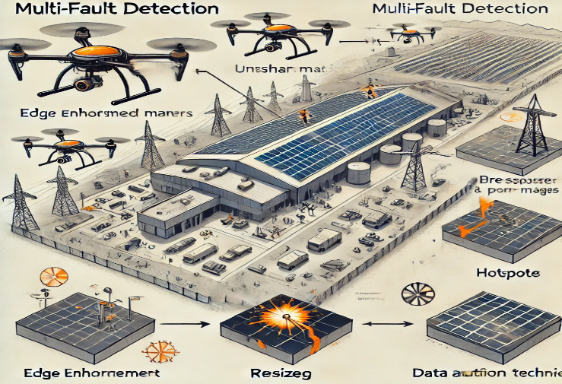

Fig. 2 Data collection using drones

**2. Architecture:**

The base model that was adopted is ViT, as it is able to capture global dependencies across image patches unlike traditional CNNs focused on local features, and this is achieved through the integration of multi-scale attention mechanisms that dissect relationships across various patches for an image. In order to further increase flexibility, parallel transformer layers added, along with an additional standard ViT-B32 structure, so as to really extract richer features and avail improved classification accuracy.

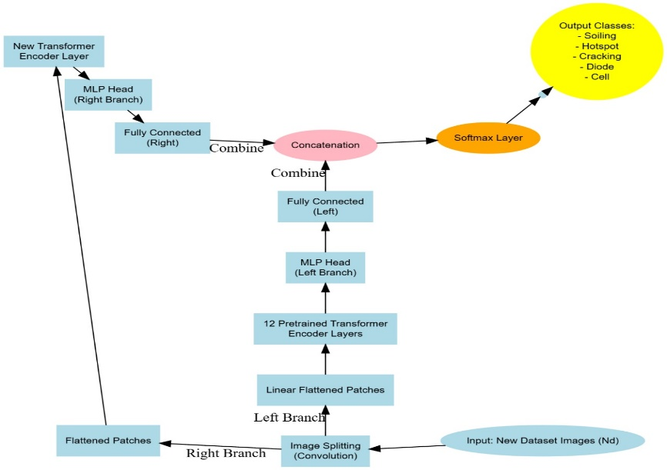

Fig.3 Proposed ViT-based ANN model architecture.

**1.Input: New Dataset Images (Nd)** - The new process initiates this by taking images from the new dataset.

**2. Image Splitting (Convolution)** - Input images are split using the convolution operations.

**3. Flattened Patches** - The splitted images are converted into a flattened patch

**4. Branching**

1. **Left Branch:**

* **Linear Flattened Patches** : The flattened patches are linearly processed.
* **12 Pretrained Transformer Encoder Layers** : These patches are passed through a sequence of 12 pretrained transformer encoder layers.
* **MLP Head (Left Branch)** : The output from the transformer layers is then passed on to a Multi-Layer Perceptron head.
* **Fully Connected (Left)** - The MLP head's output is fully connected.

1. **Right Branch**:
   * **New Transformer Encoder Layer** - Flattened patches are passed through a new transformer encoder layer.
   * **MLP Head (Right Branch)** - Output of the new transformer encoder layer passes through an MLP head.
   * **Fully Connected (Right)** MLP head output is fully connected .

**5. Concatenation** The outputs from both the fully connected layers of the branches are merged together using concatenation.

**6. Softmax Layer** The concatenated output is passed through a softmax layer.

**7. Output Classes** The final output is a class among the following: Soiling, Hotspot, Cracking, Diode, Cell.

This architecture combines convolutional operations, transformer encoder layers, and MLP heads to classify images into certain categories. It made use of both pretrained and new transformer layers to improve upon the model's performance.

**3. Classification**:

The model is used for image classification into 12 classes: normal states and 11 other types of faults, including soiling, cracking, and shadowing. Metrics measuring accuracy, precision, recall, and F1-score are used to assess the performance of the classification model in distinguishing faulty states from non-faulty ones and identifying specific types of faults.

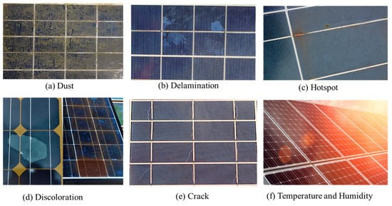

Fig.4 Different types of Fault detection in solar plants

**4.** **Evaluation and Results**:

The method is tested with a set of experiments. For all classification cases, accuracy is very high (above 95%). It proves the effectiveness and scalability of the model.

The performance is better than other approaches, even CNN-based ones, in fault detection and classification

**5.Results and discussion:**

Convolutional Neural Networks (CNNs) are widely used for fault classification in photovoltaic (PV) modules due to their high precision in anomaly detection. Reference 1, for example, achieves 92% accuracy, making CNNs ideal for visual data.In Reference 2, deep learning approaches in fault detection make proper use of infrared imaging. In this work, however, the limitation of their diversity in datasets might pose overfitting risks while affecting the reliability of the approach for different faults.Extreme weather assessments of PV systems indicate the strengths of PV modules, as indicated by Reference 3. Such assessments reveal that PV systems can survive harsh conditions effectively, thereby enhancing the long-term operational reliability and helping to reduce the downtime.SPF-Net model proposed by Reference 4: implements the application of U-Net for fault detection, which results in high recall and precision rates, reaching up to 94% but encounters the real-world adaptability problem and thus needs further optimization of its model.

Through a wireless sensor network, real-time fault detection as proposed in Reference 5 allows for efficient management through energy monitoring but might be compromised by dependency on sensors or potential communication delay.T-S fuzzy multimodel approach (Reference 6) is very effective for handling nonlinearities for PV systems, thereby enhancing the reliability of the systems. This one is quite complex and computationally expensive, hence can be used only in complicated installations. Transformer-style models for PV fault detection- Reference 7 approaches are accurate for various fault types and is resistant to image variations, but the architecture complexity leads to delay in making inference hence not suitable for real-time applications.Convolutional Neural Network (Ref. 8): It enhances their reliability with high accuracy and recall for PV modules. Their applicability is limited by variable lighting or temperature conditions as they rely on images using thermography.

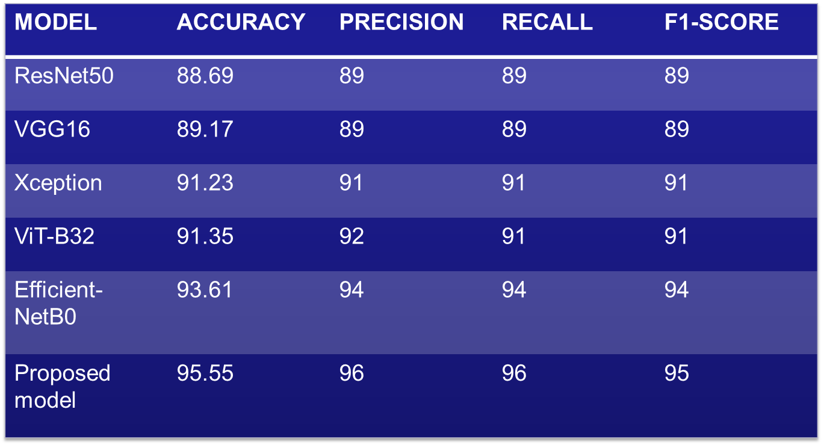

Fig.5 The Accuracy of different models

Feature-based multi-class classification methods as proposed in Ref. 9 allow rapid processing and high precision. Such methods, however, are less scalable as compared to others. Its ability to handle large-sized complex PV datasets is less compared to neural network or deep learning.UAV-based PV fault detection through thermal imaging (Reference 10) supports the efficient and large-scale inspection process. The models for segmentation are good, but the reliance on thermal imaging along with high computational intensity limits the practicality.Deep learning method using GANs in Reference 11 deals very effectively with imbalance classes and provides robustness for fault detection. Lack of data diversity might limit the adaptability of the model across different systems for PVs.The application of transfer learning in PV fault detection enhances the representation capabilities and develops further to increase class accuracy. However, they have heavy training data requirements and possibly overfitting on smaller, less diverse datasets.

The imaging together with UAV and the segmentation models increase inspection speeds and reduce labor costs. It is a good solution for large-scale PV plants. However, the imaging requires powerful computational resources as well as highly-skilled operators.The Adaptive Neuro-Fuzzy models (Reference 14) can improve classification accuracy through feature selection. Though the models are accurate, they do require a humongous amount of training data and careful tuning to avoid overfitting-the bottleneck for real-time applications. Generally speaking, CNN-based and deep learning models, such as GANs, provide very high accuracy in imaging applications but are beset with difficulties related to high implementation complexity and the need to maintain diverse datasets. Imaging using UAV holds promise in scaling up in varying order but is resource-intensive.

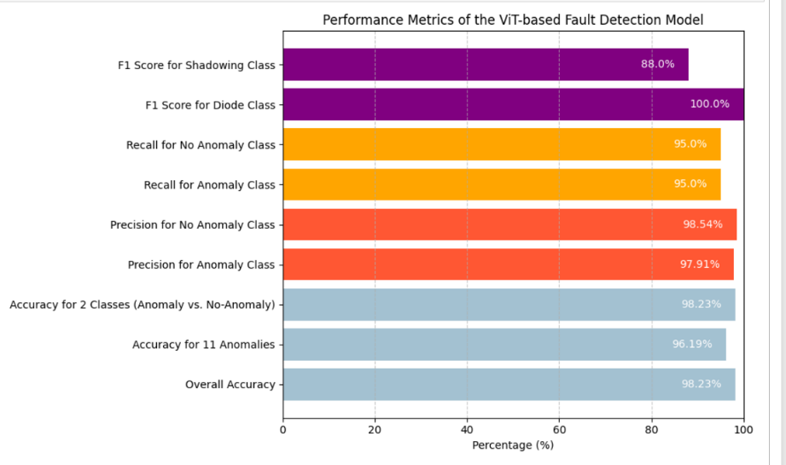

Fig. 6 Performance of proposed model on each fault

**6.Conclusion and further implementation**

The paper shows that the proposed model based on the Vision Transformer and also known as ViT, is applicable for PV fault detection. The absolute results of the classification are very good: 98.23% for anomaly vs. non-anomalous classification; 96.19% for specific recognition of 11 different faults in the PV system; and 95.55% for a 12-class setup, including both normal and faulty conditions.

**Recommendations for Further Implementation**

**Real-Time Application:** Embedding the ViT model in an IoT-enabled edge device may be able to perform on-site real-time fault detection, which could minimize the necessity of sending more people for manual inspections.**Hybrid Model with CNN**: Future work would be to combine both ViT layers and CNN layers to present a hybrid model that employs global and local feature extraction in unison.

**7.References**

1. H. Ding, N. Huang, Y. Wu and X. Cui, "LEGAN: Addressing Intraclass Imbalance in GAN-Based Medical Image Augmentation for Improved Imbalanced Data Classification," in IEEE Transactions on Instrumentation and Measurement, vol. 73, pp. 1-14, 2024, Art no. 2517914, doi: 10.1109/TIM.2024.3396853.
2. Bosquet, B., Cores, D., Seidenari, L., Brea, V. M., Mucientes, M., & Del Bimbo, A. (2023). A full data augmentation pipeline for small object detection based on generative adversarial networks. Pattern Recognition, 133, 108998.
3. Gao, X., Zhang, Y., Fu, J., & Li, S. (2024). Data augmentation using improved conditional GAN under extremely limited fault samples and its application in fault diagnosis of electric submersible pump. Journal of the Franklin Institute, 361(4), 106629.
4. Liu, Y., Liu, Y., Song, S., Chen, K., & Guo, L. (2024). GAN-Based Data Augmentation for AI-Enabled ATP in Free Space Optical Communication. IEEE Communications Letters
5. Rather, I. H., & Kumar, S. (2024). Generative adversarial network based synthetic data training model for lightweight convolutional neural networks. Multimedia Tools and Applications, 83(2), 6249-6271
6. Xiong, H., Li, J., Li, Z., & Zhang, Z. (2023). GPR-GAN: A ground-penetrating radar data generative adversarial network. IEEE Transactions on Geoscience and Remote Sensing, 62, 1-14.
7. Liu, L., Wang, S., Song, C., Xu, H., Li, J., & Wang, B. (2023). Radar-based Human Motion Recognition Using Semi-supervised Triple-GAN. IEEE Sensors Journal.
8. Q. Su, H. N. A. Hamed, M. A. Isa, X. Hao and X. Dai, "A GAN-Based Data Augmentation Method for Imbalanced Multi-Class Skin Lesion Classification," in IEEE Access, vol. 12, pp. 16498-16513, 2024, doi: 10.1109/ACCESS.2024.3360215
9. Y. Quan, C. Liu, Z. Yuan and B. Yan, "Hybrid Data Augmentation Combining Screening-Based MCGAN and Manual Transformation for Few-Shot Tool Wear State Recognition," in IEEE Sensors Journal, vol. 24, no. 8, pp. 12186-12196, 15 April15, 2024, doi: 10.1109/JSEN.2024.3372438
10. L. Yi and M. -W. Mak, "Improving Speech Emotion Recognition With Adversarial Data Augmentation Network," in IEEE Transactions on Neural Networks and Learning Systems, vol. 33, no. 1, pp. 172-184, Jan. 2022, doi: 10.1109/TNNLS.2020.3027600
11. .W. Li et al., "EID-GAN: Generative Adversarial Nets for Extremely Imbalanced Data Augmentation," in IEEE Transactions on Industrial Informatics, vol. 19, no. 3, pp. 3208-3218, March 2023, doi: 10.1109/TII.2022.3182781.
12. .Z. Du, L. Gao and X. Li, "A New Contrastive GAN With Data Augmentation for Surface Defect Recognition Under Limited Data," in IEEE Transactions on Instrumentation and Measurement, vol. 72, pp. 1-13, 2023, Art no. 35027
13. doi: 10.1109/TIM.2022.3232649 13.B. Liu, C. Tan, S. Li, J. He and H. Wang, "A Data Augmentation Method Based on Generative Adversarial Networks for Grape Leaf Disease Identification," in IEEE Access, vol. 8, pp. 102188-102198, 2020, doi: 10.1109/ACCESS.2020.2998839.
14. W. Liu, B. Luo and J. Liu, "Synthetic Data Augmentation Using Multiscale Attention CycleGAN for Aircraft Detection in Remote Sensing Images," in IEEE Geoscience and Remote Sensing Letters, vol. 19, pp. 1-5, 2022, Art no. 4009205,doi:10.1109/LGRS.2021.3052017.
15. .A. Waheed, M. Goyal, D. Gupta, A. Khanna, F. Al-Turjman and P. R. Pinheiro, "CovidGAN: Data Augmentation Using Auxiliary Classifier GAN for Improved Covid-19 Detection," in IEEE Access, vol. 8, pp. 91916-91923, 2020, doi: 10.1109/ACCESS.2020.2994762