**Review paper on sign language to text into speech conversion using**

**Arduino**

1Shravani Alaspure,2Payal Kapile, 3SrushtiMahalle, 4Mayuri Thakare, 5Shivani Khadtalkar, 6Kritika Aherwar

7R.M.Gharat

1,2,3,4,5,6Students,ElectronicsEngineering.

7HOD,ElectronicsEngineering,

Dr .Panjabrao Deshmukh Polytechnic ,Amravati, Maharashtra, India.

***Abstract: -***

***Sign language is a communication way for the deaf and mute peoples who are not able to speak.***

***There are institution for them to teach sign language and hand gestures those people are usually use sign language or hand gestures for communication but the normal people who can able to speak and hear have n difficulty to understand them thus to solve this issue there is a system that convert their hand gestures to text and then to voice with the help of speaker there is an hand glove to sense their hand gestures with the help of flex sensors and then it will convert into text and speech with the help of display and speaker this system is known as sign to speech converter.***

***Keywords— Flex sensor; Sign language; Hand glove ; Gesture recognition ; Text***

**INTRODUCTION**

Communication is an essential part of life and a fundamental skill that shapes how we interact with others. In a world where communication is key to social inclusion, individuals who rely on sign language often face barriers when interacting with those who do not understand it. Sign language is a

non-verbal system that uses visual signs and gestures to convey meaning, serving as a crucial bridge for those with speaking and/or hearing disabilities. This gap in communication can lead to social isolation, limited opportunities, and a lack of independence for non-verbal individuals. Therefore, there is a growing need for an innovative solution that provides real-time, accessible, and convenient translation of sign language into a form that everyone can understand. To address this issue, our project offers a practical solution, translating sign language gestures into text and speech to facilitate seamless communication for those unfamiliar with sign language. This project, the “Sign Launguage Coverter To Text Into Speech Converter”, aims to address this challenge by offering a portable and user-friendly device that converts hand gestures into both text and audio outputs. By using a glove fitted with flex sensors that detect finger movements, an Arduino Nano microcontroller processes each gesture and converts it into corresponding text, which is displayed on 16x2 LCD screen. Additionally, the system uses a voice module and speaker to output the text as speech, allowing non-verbal individuals to communicate directly with others. Through this device, we aim to empower individuals who rely on sign language, enhancing their ability to interact, participate, and be included in diverse social, educational, and professional setting.

**LITERATUREREVIEW**

[1] Ahmed, Syed Faiz, et. describe an electronic speaking glove, designed to facilitate easy communication through synthesized speech for the benefit of speechless patients. This project is designed to solve this problem. Gestures of fingers of a user of this glove will be converted into synthesized speech to convey an audible message to others, for example in a critical communication with doctors. The glove is internally equipped with multiple flex sensors that are made up of “bend sensitive resistance elements”. For each specific gesture, internal flex sensors produce a proportional change in resistance of various elements

[2]. Chandra, Malli Mahesh, et al. claims that a prototype is proposed to give speech output for the Sign Language gestures to bridge the communication gap between the people with speech impairment and normal people. This prototype consists of a glove which has flex sensors, gyroscopes and accelerometers embedded on it. These sensors capture the real time gestures made by the user. An Arduino Nano microcontroller is used to collect data from these sensors and send it to the PC via Bluetooth. The PC processes the data sent by the Arduino and runs a Machine Learning Algorithm to classify the Sign Language gestures and predicts the word associated with each gesture. Support Vector Machine (SVM) is used for classification.

1. Murillo , Shawn Clifford M., et. al, aims to develop a web-based real-time application which recognizes Filipino Sign Language (FSL) and converts it into text. Purposive sampling was used to determine a total of 30 respondents: 9 Special Education Students, 7 Special Education Teachers, and 14 Non-Disabled People. The study focused on the following variables: the independent variable, the level of acceptability in terms of content, design, and functionality; and the dependent variable, SPEAK THE SIGN: A Real-Time Sign Language to Text

Converter Application for Basic Filipino Words and Phrases. A researcher-made questionnaire was used to gather data on both variables. The statistical tools used in the study were frequency count, sum, percentage, and mean.

1. Yash Jhunjhunwala, et al. introduce a basic system consisting of two parts; sign language recognition and conversion to text and further to speech. The sign language glove consists of simple hand gloves fitted with flex sensors which are being used for monitoring the amount of bend on the fingers. Flex means bend, this is the sensors that change the resistance depending on the amount of bend on the sensor. Data from the sensors is sent to the Control unit which is the Arduino Nano the analog signals from the sensors are digitally converted and compared with the stored value for the recognition of sign and then displayed as a text on the 16x2 LCD. Further the text output is wirelessly transmitted to a cellular phone or a PC which consist of a test to speech conversion software.

1. Poornima, N.,Abhijna Yaji,et. al, proposed here is to develop a system which can assist them in converting gestures to text and/or speech. Creating a robust communication system for the deaf and dumb community will help them be more independent and confident. In this article, an extensive review is made on the various approaches available for gesture recognition.

6] K. Prasanna Mery, et al. introduces a glove-based device, integrating flex sensors and an Arduino Nano control unit, facilitates the recognition of intricate sign language gestures. The system's ability to convert these gestures into text, displayed on an LCD, demonstrates a tangible bridge between sign language and written communication. The wireless transmission of information to a PC or cellular phone for subsequent text-to-speech conversion underscores the adaptability and potential widespread use of the technology. Moreover, the ongoing prototype development indicates a commitment to expanding the system'scapabilities beyond basic alphabets and numeric characters

7] Sparsha, U., M. Priyanka, et. proposed to develop a system that is capable of converting sign language to speech, with an objective to assist the specially abled people communicate with the world seamlessly. Because for the masses with speech impairments, it is extremely challenging to communicate with everyone else. These people make use of sign language for communication with normal people, but the sign language is not known by many people. Whenever a speech- impaired person communicates with normal person, a communication gap is created which happens to be hard to fill.

8] Vijayalakshmi, P., et. al, have conducted research behind this work is to develop a system for recognizing sign language, which provides communication between people with speech impairment and normal people, thereby reducing the communication gap between them. In the current work flex sensor-based gesture recognition module is developed to recognize English alphabets and few words and a Text-to-Speech synthesizer based on HMM is built to convert the corresponding text.

9] E. Karthiga, et. al, presented a sign language to speech conversion which is obtained by folding of flex sensors. In this flex sensor based gesture recognition system, according to the resistance of the flex sensor the input is provided to the Arduino which in turn responds by giving voice output. This system has faster response and efficiency for communication is improved.

10] Heera, S. Yarisha, et. al, approach that gives a technique for improving Sign Language Recognition systems. In the proposed method; they will be using sensors which are incorporated on a glove to detect the gestures and convert it to speech with the help of a Bluetooth module and an Android Smartphone. The gloves will help in producing artificial speech which provides an environment similar to daily communication

**METHODOLOGY**

The proposed system aims to bridge the communication gap for individuals who rely on sign language by converting their hand gestures into spoken text. This system will use a glove equipped with three flex sensors that detect the bending of fingers to interpret different gestures. These flex sensors are connected to an Arduino Nano microcontroller, which will analyze the data and map each gesture to a specific text output. The processed text will then be displayed on a 16x2 LCD screen for visual confirmation. Simultaneously, an 8-channel voice module will convert the text into audio, which is played through a connected speaker, allowing the message to be heard by others. The glove's flexibility and lightweight design allow for ease of use, enabling sign language users to communicate seamlessly with individuals who may not understand sign language. This system is particularly useful in enhancing accessibility, promoting inclusivity, and facilitating interaction in diverse settings.

# BLOCK DIAGRAM:-

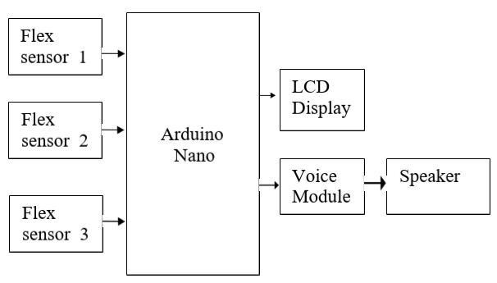

Fig(a) Block diagram

**DESCRIPTION**

In this Block diagram, we have used the Arduino Nano as a microcontroller. And three Flex Sensors and a Voice module (8 channel) and a Speaker as input devices. A 16x2 LCD Display is connected as an output device to the microcontroller.

# SYSTEM REQUIREMENT

HARDWARE REQUIREMENT

1. Arduino Nano
2. Flex sensor *3
3. 16x2 LCD Display
4. Voice module (8 channel)
5. Speaker
6. Gloves

SOFTWARE REQUIREMENT

1. Arduino IDE
2. Proteus

**Arduino Nano :**

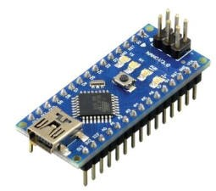

Fig. (b) Arduino Nano

Arduino Nano is a small, complete, flexible and breadboard-friendly Microcontroller board, based on ATmega328p. Arduino Nano Pinout contains 14 digital pins, 8 analog Pins, 2 Reset Pins & 6 Power Pins.

**Flex Sensor :**

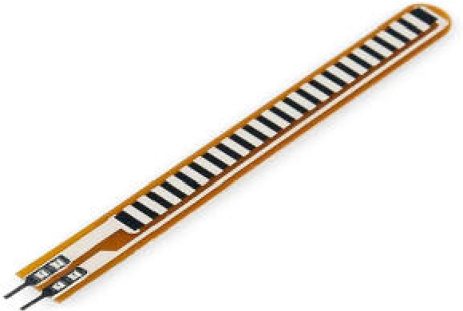

Fig. (c) Flex sensor

A flex sensor is a kind of sensor which is used to measure the amount of bending. It consist of carbon material with thin substrate .Depending upon the bending of flex sensor the resistance changes. The change in resistance given as input to Arduino Nano.

**LCD Display :**

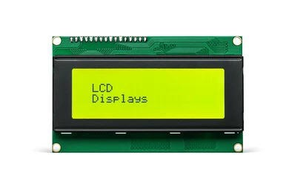

Fig. (d) LCD Display

16x2 LCD displays are a compact type of liquid crystal display that can show 16 characters on 2 lines. They can be used as small electronic devices like calculators, clocks, and measurement instruments. These displays work by using a backlight to illuminate the screen, while liquid crystals control the passage of light to form the desired characters. The characters are stored in a character generator, and a controller sends signals to the liquid crystals to create the correct patterns.

# CONCLUSIONS

The “Sign Launguage Coverter To Text Into Speech Converter” project offers an innovative and practical solution to bridge the communication gap for individuals who rely on sign language, providing a means for real-time, accessible, and inclusive interaction. By translating hand gestures into both visual and auditory outputs, this device enhances the independence of non-verbal individuals and fosters a greater sense of inclusion in various social educational, and professional settings. The system’s affordability, portability, and user-friendly design make it a viable tool for widespread use, offering significant benefits in improving communication and understanding between sign language users and non sign language speakers. This project underscores the potential of technology to break down barriers and promote accessibility, creating a more inclusive society for all.

# REFERENCES

[1], Syed Faiz, Syed Muhammad Baber Ali, and Sh Saqib Munawwar Qureshi. "Electronic speaking glove for speechless patients, a tongue to a dumb." In 2020 IEEE conference on sustainable Ahmed utilization and development in engineering and technology, pp. 56-60. IEEE, 2020..

[2] Chandra, Malli Mahesh, S. Rajkumar, and Lakshmi Sutha Kumar. "Sign languages to speech

conversion prototype using the SVM classifier." In

TENCON 2019-2019 IEEERegion 10 Conference

(TENCON), pp. 1803-1807. IEEE, 2020.

[3] Murillo, Shawn Clifford M., Maria Cherry Ann

E. Villanueva, Khloe IssabellaM.Tamayo, Mary Joy

V. Apolinario, and Mikko Jan D. Lopez. "Speak the

Sign: A Real-Time Sign Language to Text Converter Application for Basic Filipino Words and

Phrases. “Central Asian journal of mathematical theory and computer sciences 2, no. 8 (2021): 1-8.

[4] Yash Jhunjhunwala, Pooja Shah, Pradnya Patil

and Jyoti Waykule, “sign language to speech conversion using Arduino”, IJRIER, 2022..

[5] Poornima, N., AbhijnaYaji, M. Achuth, Anisha

Maria Dsilva, and S. R. Chethana. "Review on text

and speech conversion techniques based on hand

gesture." In 2021 5th international conference on

intelligent computing and control systems (ICICCS),pp.1682-1689. IEEE, 2021.

[6] K. Prasanna Mery, G. Annamalai, R. Ashmeerhaan, “Sign Language to Speech Conversion Using Arduino”, IJCRT | Volume 12, Issue 2 February 2024 .

[7] Sparsha, U., M. Priyanka, S. Mukthashree, and

K. N. Kiran. "System for Sign Language to Speech

Conversion." In 2024 International Conference on

Intelligent and Innovative Technologies in Computing, Electrical and Electronics (IITCEE), pp.1-4. IEEE, 2024.

[8] Vijayalakshmi, P., and M. Aarthi. "Sign language to speech conversion." In 2016 international conference on recent trends in information technology (ICRTIT), pp. 1-6. IEEE, 2020

[9] E. Karthiga, M. Sameera Fathimal, N. Gowthami, P. Madura, “Sign Language to Speech Using Arduino Uno”, International journal of scientific progress and Research (IJSPR), 2024

[10] Heera, S. Yarisha, Madhuri K. Murthy, V. S.

Sravanti, and Sanket Salvi. "Talking hands—An

Indian sign language to speech translating gloves." In 2017 International conference on innovative

mechanisms for industry applications (ICIMIA), pp.

746-751. IEEE, 2021.