Brain Tumour Detection, Classification, and Segmentation

# Gayatri, Shreya Rathi, Mansha Khattar

Department of Computer Science and Engineering, Maharaja Agrasen Institute of Technology, Delhi-110086, India

# Abstract

Brain tumours are serious medical conditions that can significantly impact an individual's health and well-being. These abnormalities can lead to various debilitating effects, including neurological issues, cognitive impairment, motor and sensory deficits, and emotional and behavioural changes. Early diagnosis and timely treatment are crucial to prevent further deterioration and improve the patient's quality of life.

Traditionally, radiologists have performed brain tumour detection and segmentation manually, which can be a time-consuming and error-prone process. To address this challenge, researchers have been exploring automated techniques, particularly those leveraging machine learning and deep learning algorithms, to enhance the accuracy and efficiency of brain tumour detection and segmentation. To address this problem, we proposed a deep [Convolutional Neural Network](https://www.sciencedirect.com/topics/engineering/convolutional-neural-network) (CNN)-based architecture for automatic brain [image classification](https://www.sciencedirect.com/topics/computer-science/image-classification) into four classes and a U-Net-based [segmentation model](https://www.sciencedirect.com/topics/computer-science/segmentation-model). The results demonstrate that our classification and segmentation model both achieved the highest accuracy of 99%.

# Introduction

A brain tumour is an abnormal proliferation of brain cells. It can be non-cancerous (benign) or cancerous (malignant), with symptoms differing based on the tumour's size and its position in the brain. Cancerous tumours can originate in the brain or metastasize from other areas of the body. Various kinds of brain tumours can lead to symptoms that vary depending on the specific area of the brain that is impacted. These symptoms can consist of headaches, seizures, vision issues, nausea, and cognitive disturbances. A brain tumour ranks among the most lethal conditions that can impact individuals of all ages and genders.

The brain consists of billions of neurons and a trillion glial cells, and tumours develop when these cells grow uncontrollably, creating a mass. These irregularities in the brain cells are recognized as a neoplasm or a brain tumour. Brain tumours are classified into primary or secondary types. Primary brain tumours develop within the brain, originating from areas like the membranes, cranial nerves, pituitary glands, or even the pineal gland. On the other hand, secondary brain tumours, which are more common, occur when cancer cells spread from another part of the body and metastasize to the brain.

Metastatic brain tumours are the most common type of brain tumours and are always cancerous. The leading sources of these secondary brain tumours are lung and breast cancers. The appearance of symptoms in brain tumour cases depends on the size, type, and precise location of the tumour. Common symptoms include morning headaches that improve over the day, nausea, vomiting, poor coordination, trouble walking, seizures, and changes in speech, vision, or hearing. It's crucial to point out, however, that these symptoms can also arise from other health problems. There are more than 120 unique varieties of primary brain tumours, with gliomas being the most prevalent type of brain tumours.

Timely identification of brain tumours is essential for choosing the best treatment options and prolonging the patient’s life. Glioma and meningioma, both deadly if not detected promptly, are significant forms of brain tumours. Pituitary tumours, arising from hormone-producing adenohypophysis cells, are another type. The most precise diagnostic technique is a biopsy, yet its invasive characteristics carry risks of haemorrhage or functional impairment. As a result, healthcare providers are progressively depending on medical imaging methods for faster and more precise outcomes.

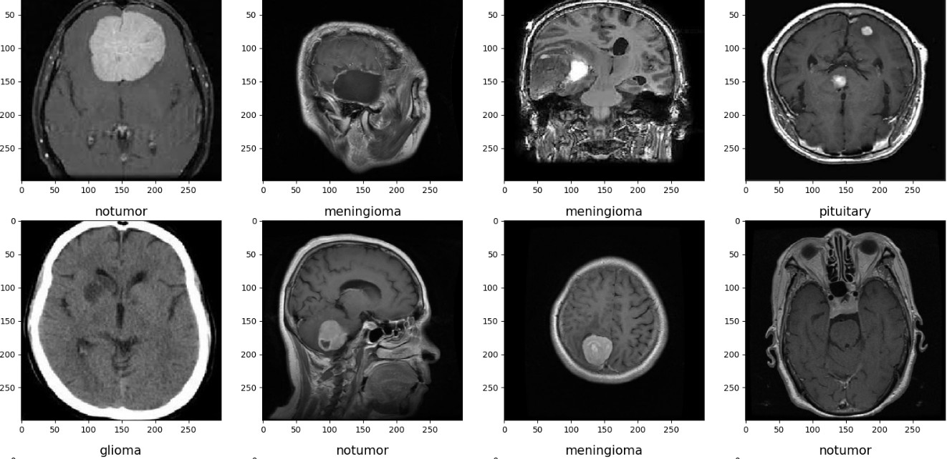

**Figure 1.** Examples of results of the proposed method for three slices corresponding to meningioma, glioma, and pituitary

Different medical imaging techniques, especially MRI and CT scans, are utilised to identify irregularities in the brain's structure, dimensions, or position. MRI is favoured for its comprehensive details on brain structure. Nonetheless, the manual classification of brain tumours from MRI images is a lengthy process. Automatic classification provides a solution that needs little input from radiologists.

Machine learning (ML) has greatly progressed the healthcare sector, but traditional ML techniques have drawbacks, such as reduced accuracy, extended computation times, vulnerability to errors, and the necessity for manual algorithm choices. Recent research shows that deep learning (DL) methods, which automate feature extraction and classification, address these shortcomings.

Deep learning, a subset of artificial intelligence, utilises artificial neural networks (ANNs) to replicate the human brain and gain insights from large volumes of data. DL architectures are favoured over conventional ML algorithms because they can autonomously learn and recognize intricate image characteristics. Ongoing advancement of novel models improves feature extraction in deep learning methods, utilised in multiple medical fields. The benefits of DL encompass managing extensive datasets, enhancing time efficiency, sophisticated analytics, adeptness with unstructured data, and being cost-efficient. These methods are widely applied in image processing, classification, and segmentation activities.

The procedure for correctly identifying a brain tumour consists of multiple stages carried out by radiologists, neurologists, and doctors, such as physical assessments, analysis of medical history, utilisation of contrast agents, and biopsy examinations. The objective is to accurately identify the abnormal tissues along with their precise location, area, and orientation. The assessment of the imaging scans and their interpretation comes after the physical examination and historical analysis to produce digital brain images. The imaging method of choice is Magnetic Resonance Imaging (MRI) due to its excellent contrast and resolution. Although Computed Tomography (CT) scans are utilised, they are not as efficient as MRIs. Diagnosing brain tumours manually is a complicated, lengthy, and pressure-filled process that carries the risk of human mistakes due to elements like exhaustion and excessive information, making early and precise diagnosis of brain tumours crucial and driving extensive research efforts. Furthermore, precise evaluation of the tumour's area is essential for effective targeted treatment. Methods in Machine Learning (ML) are greatly progressing the domain of medical image analysis. Recent advancements in ML have resulted in the development of automated systems for diagnosing brain tumours. These systems offer essential assistance.

# Materials & Methods

* 1. **Dataset**

# Dataset used for classification

The dataset used is a combination of the following three datasets: figshare, SARTAJ dataset, Br35H. ● It contains 7023 images of human brain MRI images which are classified into 4 classes: glioma - meningioma - no tumour and pituitary.

# Dataset used for segmentation

The Brain Tumour Segmentation (BraTS) dataset is a widely used benchmark for brain tumour segmentation tasks. It includes multimodal MRI scans (T1, T1-Gd, T2, and FLAIR) of glioma patients, with manual annotations for different tumour sub-regions, including the enhancing tumour, tumour core, and whole tumour. The dataset is designed to evaluate and advance the performance of models in automatic tumour segmentation, making it ideal for training and validating deep learning algorithms in medical imaging.

# Data Preprocessing

In this research, MRI images were presented utilising the IPython.display and IPython.Image libraries, facilitating easy visualisation and analysis of the dataset. To improve the appropriateness of the images for model training, pixel values were scaled to a range of [0, 1]. The dataset was subsequently split into training, validation, and test sets, guaranteeing an organised method for model assessment.

To satisfy the model's input specifications, every image was adjusted to a consistent size of 299 x 299 pixels in case of classification and 128 x 128 in case of segmentation. These enhancements boosted the accuracy of the model, which could enhance the model’s effectiveness and adaptability on new data.

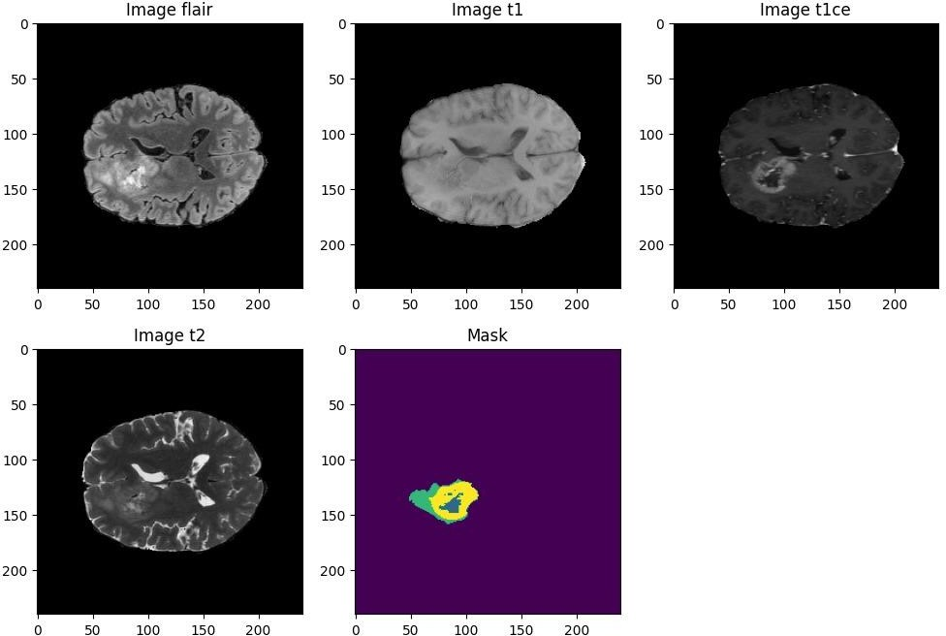

**Figure 2.** The four imaging modalities **T2-FLAIR (T2 - Fluid Attenuated Inversion Recovery), Native (T1),**

**Post-contrast T1-weighted (T1ce, also known as T1Gd), T2-weighted (T2)** providing distinct perspectives on the same brain image, each highlighting different features and the **Ground Truth** image**.**

# Comprehensive Explanation of Each Modality:

Native (T1): This modality exposes the arrangement and makeup of different tissue types in the brain. It plays a crucial role in detecting tumours, cysts, and various other irregularities.

Post-contrast T1-weighted (T1ce, or T1Gd): Like T1 images, but augmented with a contrast agent (Gadolinium), enhancing the detection of irregularities.

T2-weighted (T2): This technique emphasises the presence of fluid in brain tissues.

T2-FLAIR (T2 - Fluid Attenuated Inversion Recovery): This method reduces fluid signals, facilitating the detection of lesions that might not be seen on T1 or T2 scans. It is especially effective for identifying lesions in the brain's white matter, which can be difficult to detect with other imaging techniques.

For medical professionals, these four modalities together offer an extensive perspective, assisting in accurate tumour assessment and validation. In our artificial intelligence method, we seek to simplify the process by lowering computational and memory requirements. By employing just two modalities, this can be accomplished, resulting in a quicker and more efficient segmentation task.

To improve our model, we will omit the T1 modality because its superior version, T1ce, offers greater clarity. Likewise, we will exclude the T2 modality since the fluids it emphasises might adversely affect our forecasts. Conversely, the T2-FLAIR modality, which efficiently emphasises impacted areas by diminishing fluid signals, will be more advantageous for our training.

# Proposed Convolutional Neural Network and Implementation Details for Classification

For classification tasks, we propose a convolutional neural network (CNN) based on transfer learning, using the Xception model as a feature extractor. The Xception architecture, known for its depth wise separable convolutions, is initialised with pre-trained weights from ImageNet, providing a robust foundation by leveraging the model’s learned features across millions of natural images.

**Base Model (Xception)**: Xception is a deep convolutional neural network architecture that involves Depthwise Separable Convolutions. It was developed by Google researchers. Google presented an interpretation of Inception modules in convolutional neural networks as being an intermediate step in-between regular convolution and the depthwise separable convolution operation (a depthwise convolution followed by a pointwise convolution).

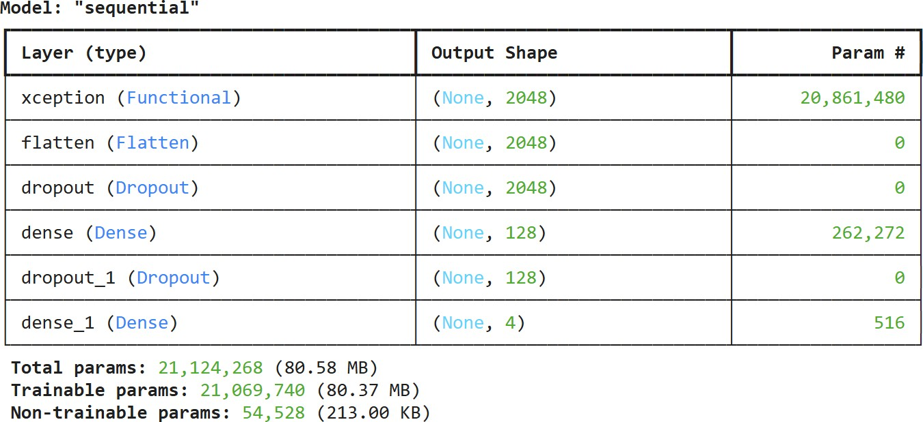**Table 1.** Summary of the model architecture used for classification

# Proposed UNet and Implementation Details for Segmentation

U-Net is a deep learning model uniquely created for the segmentation of biomedical images. It utilises an encoder-decoder architecture, with the encoder gathering contextual information and the decoder recreating accurate spatial details, making it very efficient for segmenting intricate structures such as tumours in medical imaging. The skip connections linking corresponding layers of the encoder and decoder aid in maintaining intricate details, thereby improving segmentation precision.

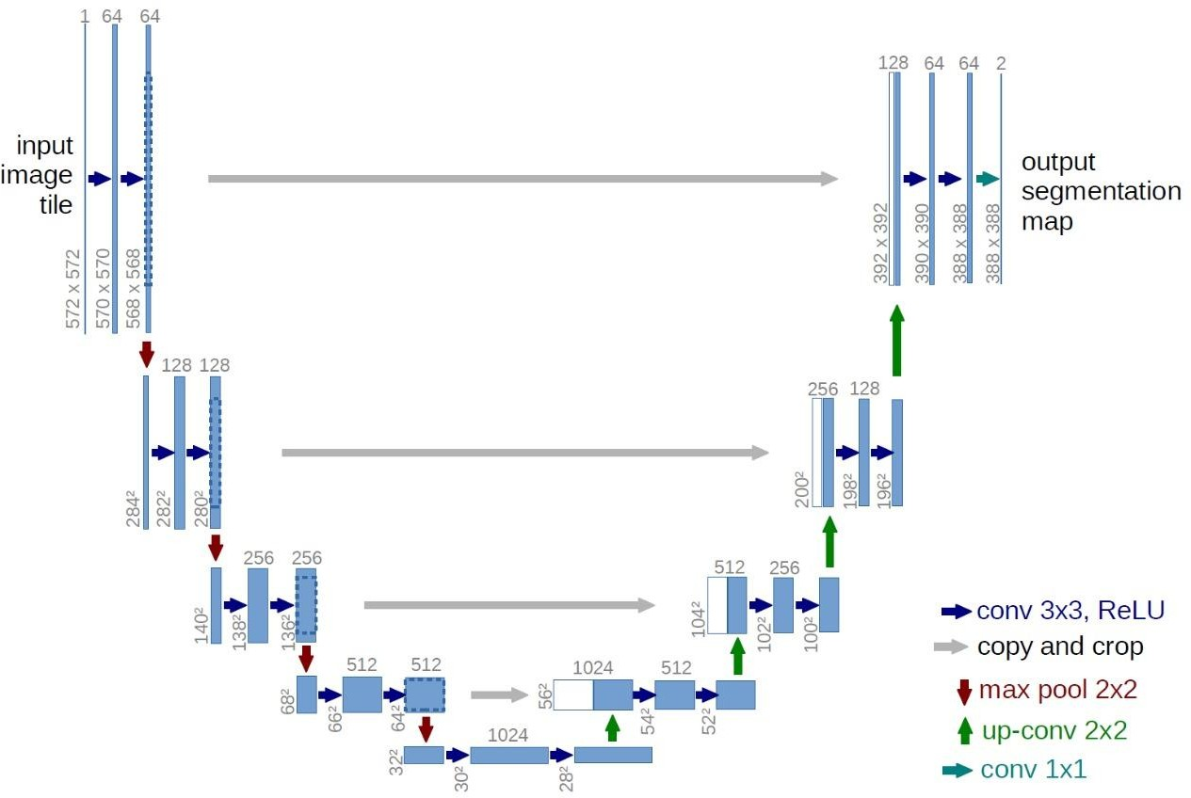

**Figure 3.** U-Net Model Architecture

The dataset consists of 3D images, with each image comprising multiple 2D slices of three orthogonal planes, we have two options: using a 2D U-Net or a 3D U-Net.

**3D U-Net:** More suitable for leveraging the 3D spatial context of the images, reducing the risk of false positives and false negatives from partial information in individual slices. However, it requires more computational resources and memory.

**2D U-Net:** Faster and requires less memory, advantageous when working with large datasets or limited computational resources.

In practice, it’s useful to try both architectures and compare their performance. We will opt for a 2D U-Net implementation due to its efficiency and lower resource requirements.

# Loss Functions

For both classification and segmentation problems, we have used **categorical cross-entropy**. This function measures the difference between the predicted probability distribution of each pixel and the one-hot encoded ground truth values. Additionally, in the segmentation model we have used the **Dice loss function**, which focuses on the overlap between the predicted and actual segments, further refining the accuracy of the segmentation.

# Evaluation Metrics

To effectively monitor the model's performance, we use various evaluation metrics:

**Accuracy:** Measures the overall proportion of correctly classified pixels. However, it can be misleading with imbalanced datasets like BraTS2020, where the background class is overrepresented.

**Intersection over Union (IoU):** Measures the overlap between the predicted and ground truth segmentations.

**Dice Coefficient:** Evaluates the similarity between predicted and ground truth segmentations. Sensitivity (Recall or True Positive Rate): Measures the proportion of positive ground truth pixels correctly predicted as positive.



**Precision (Positive Predictive Value):** Measures the proportion of predicted positive pixels that are actually positive.



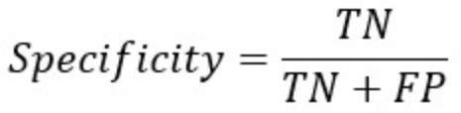**Specificity (True Negative Rate):** Measures the proportion of negative ground truth pixels correctly predicted as negative.

# Results

The model achieved a high dice similarity coefficient and IoU, indicating effective segmentation performance. Below are the mean values for each metric across the test dataset:

# Table 2. Evaluation Metrics Table for both segmentation and classification model

|  |  |  |
| --- | --- | --- |
| **Metric** | **Segmentation** | **Classification** |
| Accuracy | 0.99 | 0.99 |
| Precision | 0.994 | 0.99 |
| Recall | - | 0.99 |
| Dice Similarity Coefficient (DSC) | 0.53 | - |
| Intersection over Union (IoU) | 0.5 | - |

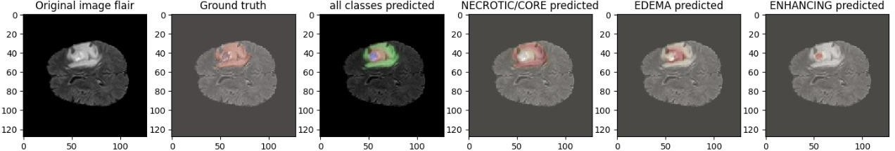

**Figure 4.** Result of Segmentation

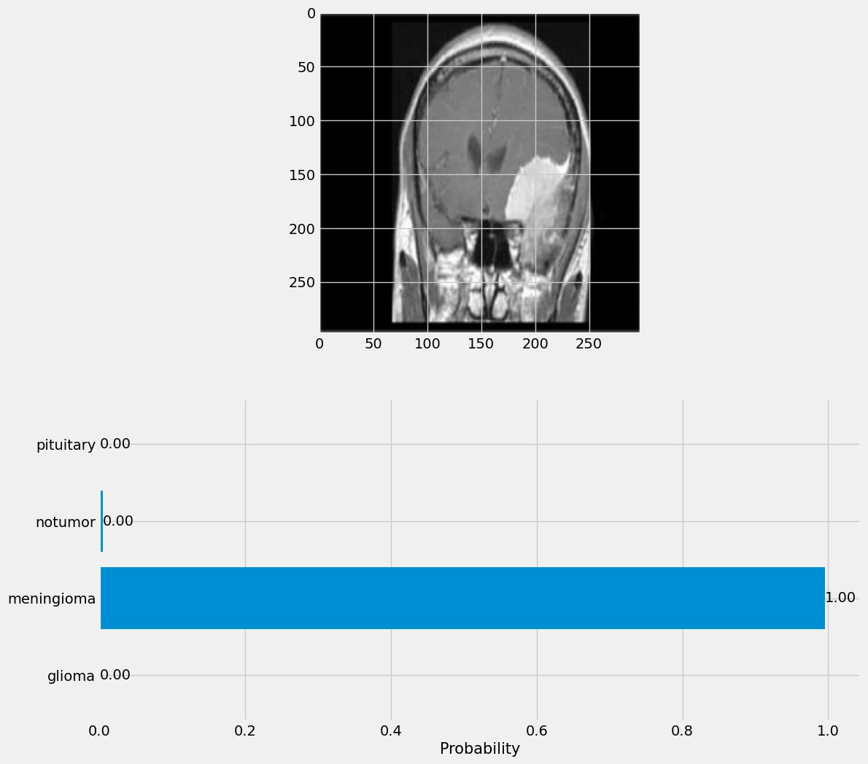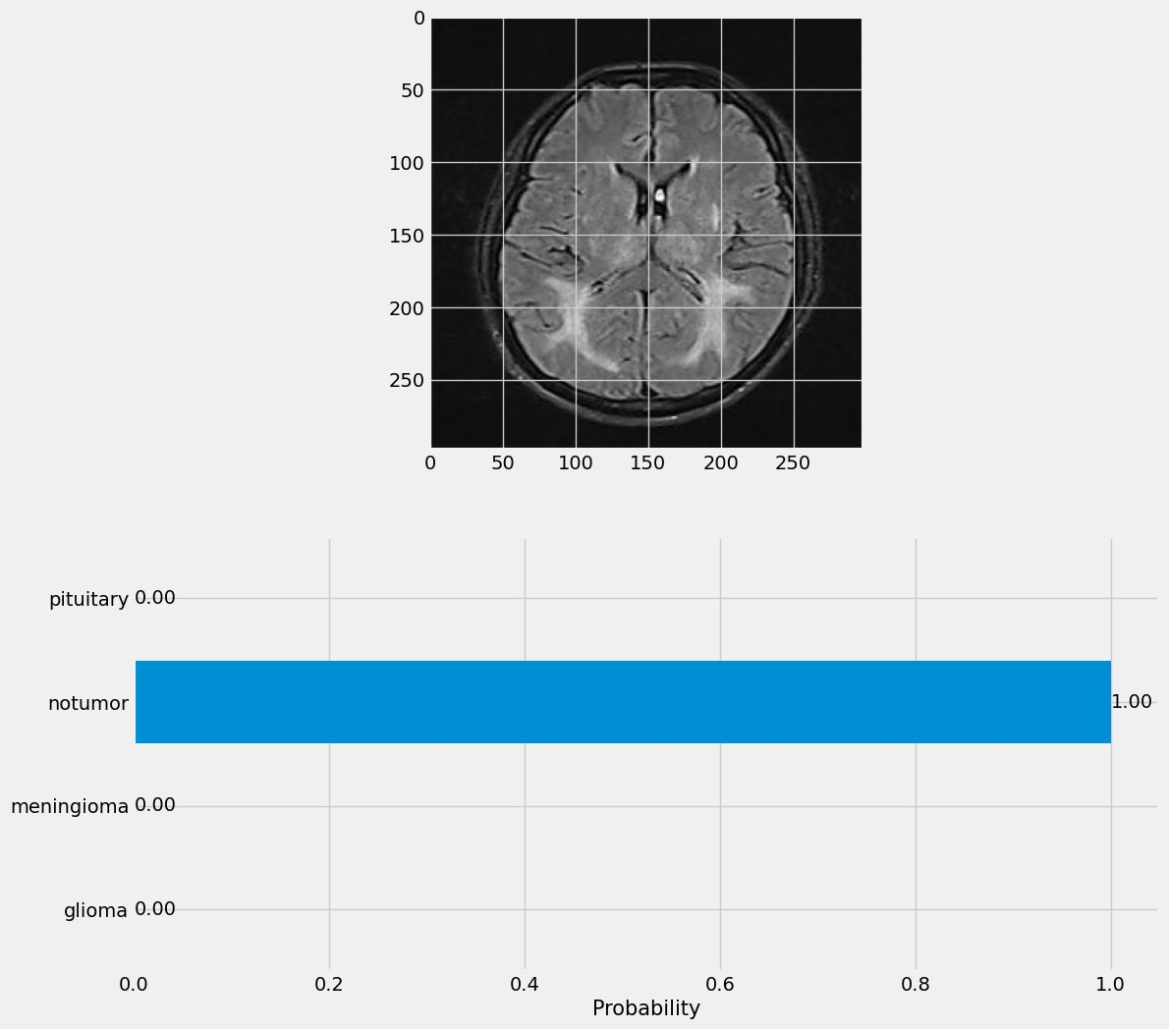

**Figure 5:** Classification result correctly predicting meningioma and no tumour image.

# Conclusion

Early identification of brain tumours can be crucial in saving lives as they can be extremely harmful and even deadly. This study proposes an automated classification strategy for a rapid, early, and accurate diagnosis to prevent disastrous consequences. A deep CNN model was used to classify brain MRIs into four groups: glioma, meningioma, no tumour, and pituitary. An accurate and automatic segmentation model was applied to segment brain MRIs from the original input MRIs. Effective automated tumour segmentation can be challenging due to the wide variety of tumour locations, shapes, and structures. For segmenting the tumour sections, a U-Net architecture-based model was developed.

Our approach obtained the highest tumour classification accuracy with a value of 0.99. Our classification model is able to successfully detect and classify the brain MRI images into four labels in the dataset: meningioma, glioma, pituitary and no tumour. Our U-Net based segmentation model also achieved high accuracy of 0.99, Mean IoU of 0.5 and Dice Coefficient of 0.53.

This proposed model has the potential to be developed into standalone software for use in hospitals and clinics, serving as a valuable tool for radiologists in identifying tumour locations for further diagnosis. It can aid resident radiologists by improving their skills in locating tumours and minimising mistakes in recognizing questionable areas.

# References

* 1. Erena Siyoum Biratu; Friedhelm Schwenker; Yehualashet Megersa Ayano; Taye Girma Debelee**,** A Survey of Brain Tumour Segmentation and Classification Algorithms (2021) [[Link](https://www.mdpi.com/2313-433X/7/9/179)]
  2. André Ferreira, Naida Solak, Jianning Li, Philipp Dammann, Jens Kleesiek, Victor Alves, Jan Egger, Enhanced Synthetic Data Augmentation and Model Ensemble for brain tumour segmentation, (2024), [[Link](https://arxiv.org/html/2402.17317v1)]
  3. Muhammad Faheem Khan, Arslan Iftikhar,Huzaifa Anwar, Sadaqat Ali Ramay, Brain Tumour Segmentation and Classification using Optimised Deep Learning (2024) [[Link](https://www.jcbi.org/index.php/Main/article/view/528/439)]
  4. Francisco Javier Díaz-Pernas, Mario Martínez-Zarzuela , Míriam Antón-Rodríguez and David González-Ortega, A DeepLearning Approach for Brain Tumour Classification and Segmentation Using a Multiscale Convolutional Neural Network (2021), [[Link](https://arxiv.org/pdf/2402.05975)]
  5. Atika Akter, Nazeela Nosheen, Sabbir Ahmed, Mariom Hossain, Mohammad Abu Yousuf, Mohammad Ali Abdullah Almoyad, Khondokar Fida Hasan, Mohammad Ali Moni, Robust

clinical applicable CNN and U-Net based algorithm for MRI classification and segmentation for brain tumour (2024) [[Link](https://www.sciencedirect.com/science/article/pii/S095741742302849X)]

* 1. Milica M. Badža, Marko Č. Barjaktarović, Classification of Brain Tumours from MRI Images Using a Convolutional Neural Network (2020), [[Link](https://www.mdpi.com/2076-3417/10/6/1999)]
  2. Neelum Noreen, Sellapan Palaniappan, Abdul Qayyum, Iftikhar Ahmad, Madini O. Alassafi, Brain Tumour Classification Based on Fine-Tuned Models and the Ensemble Method (2021), [[Link](https://www.sciencedirect.com/org/science/article/pii/S1526149220002015)]
  3. Jason Walsh a, Alice Othmani b, Mayank Jain a c, Soumyabrata Dev, Using U-Net network for efficient brain tumour segmentation in MRI images (2022), [[Link](https://www.sciencedirect.com/science/article/pii/S2772442522000429)]
  4. Reham Kaifi, A Review of Recent Advances in Brain Tumour Diagnosis Based on AI-Based Classification (2023), [[Link](https://pmc.ncbi.nlm.nih.gov/articles/PMC10527911/)]