**The Psychological Impact of Safety-Oriented Design in Senior Housing on Aging Adults’ Mental Health**

Author: Abimbola O. Olumide

Affiliation: Middlesex University London

Email: [Abimbolakomolafe668@yahoo.com](mailto:Abimbolakomolafe668@yahoo.com)

Co-Author: Olaide Azeez

Affiliation: Obafemi Awolowo University, Nigeria

Email: [olaiderihanatuazeez@gmail.com](mailto:olaiderihanatuazeez@gmail.com)

**Abstract**

The relationship between environmental design and mental health is well-documented, particularly in vulnerable populations such as aging adults. Senior housing must address not only physical safety but also psychological well-being, as unsafe or poorly designed environments exacerbate feelings of insecurity, anxiety, and depression among older adults. This study explores how safety-oriented design features in senior housing influence the mental health of aging adults. Using a mixed-methods approach, the research investigates the psychological benefits of design elements such as fall prevention, accessibility, emergency response systems, and calming aesthetics. Findings suggest that safety-oriented designs significantly enhance residents' mental well-being, offering insights for architects, policymakers, and caregivers.

**Introduction**

**Background**

The global population of individuals aged 65 and older is increasing rapidly. According to the World Health Organization (WHO, 2021), by 2050, one in six people globally will be aged 65 or older. This demographic shift underscores the importance of addressing the housing needs of older adults, especially in promoting environments conducive to both physical safety and psychological health.

**Research Problem**

While much attention has been paid to physical safety in senior housing, the psychological impact of safety-oriented design on mental health is underexplored. Unsafe or inadequately designed housing can heighten anxiety, depression, and social isolation among seniors (Evans et al., 2003). Conversely, environments tailored to enhance safety can foster a sense of security, autonomy, and well-being (Juba et al., 2024)

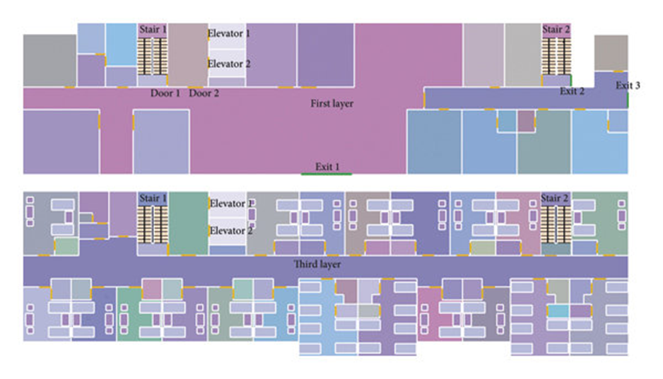

A labeled floor plan of a safety-oriented senior housing unit highlighting features like grab bars, non-slip floors, emergency buttons, and green spaces.

. 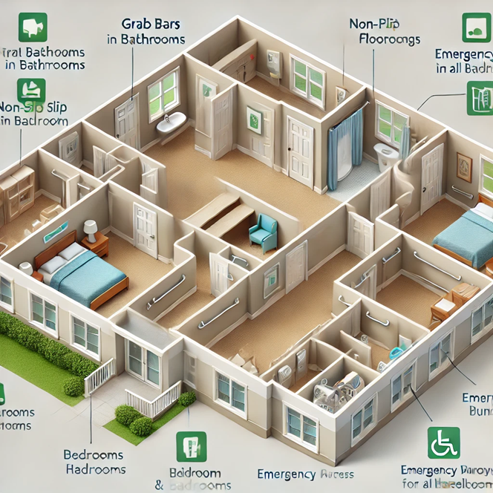  
 *The image would help illustrate how design features are integrated into real-world settings.*

**Literature Review**

**Safety-Oriented Design in Senior Housing**

Safety-oriented design includes features that minimize physical risks, such as non-slip flooring, grab bars, adequate lighting, and emergency call systems (Winchip, 2014). These elements address mobility challenges and reduce fall risks, a leading cause of injury in seniors (Stevens et al., 2012).

**The Psychological Connection**

The built environment directly influences mental health. Poorly designed spaces can create feelings of insecurity and discomfort, while well-designed environments can promote psychological well-being by enhancing feelings of safety, control, and belonging (Kweon et al., 1998). For seniors, safety features also provide reassurance, reducing anxiety and enabling independence (Lawton & Nahemow, 1973).

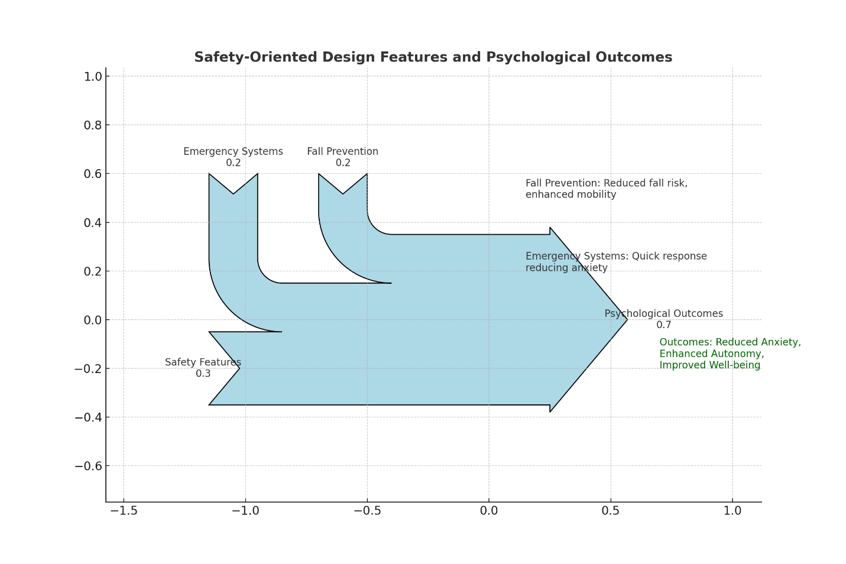

*The diagram illustrates the relationships between design elements and their impact on mental health.*

**Methodology**

**Study Design**

A mixed-methods approach was employed, combining quantitative surveys with qualitative interviews to provide a comprehensive analysis.

**Participants**

The study involved 200 residents from 10 senior housing facilities across urban and suburban areas. Participants were aged 65 and above, with diverse physical and cognitive health profiles.

**Data Collection**

1. **Quantitative Surveys**: Residents completed the Geriatric Anxiety Scale (GAS) and Geriatric Depression Scale (GDS) to measure anxiety and depression levels. They also rated their perceptions of safety and satisfaction with their living environment.
2. **Qualitative Interviews**: In-depth interviews were conducted with 30 participants to explore their experiences with safety-oriented design features.

**Data Analysis**

* Quantitative data were analyzed using SPSS to identify correlations between design features and mental health outcomes.
* Qualitative data were thematically analyzed to extract insights into residents’ lived experiences.

**Results**

**Quantitative Findings**

* Residents in housing with comprehensive safety features reported lower levels of anxiety (Mean GAS score: 12.5) and depression (Mean GDS score: 8.3) compared to those in less safe environments (Mean GAS score: 20.7; Mean GDS score: 15.2).
* A strong positive correlation (r = 0.78) was observed between perceived safety and psychological well-being.

**Qualitative Insights**

Participants emphasized the importance of specific design features:

1. **Fall Prevention Features**: Non-slip floors and grab bars were widely appreciated for reducing fear of falls.
2. **Emergency Systems**: Quick access to emergency buttons alleviated anxiety about being alone during a health crisis.
3. **Aesthetics**: Calming colors, natural lighting, and green spaces enhanced feelings of relaxation and contentment.

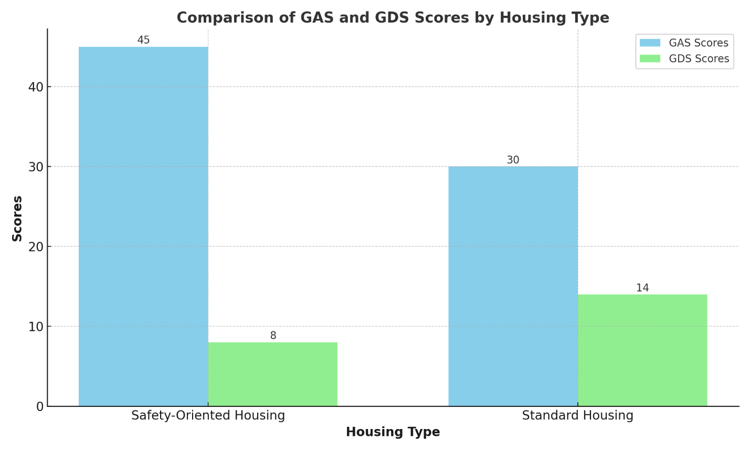

*The bar graph compares the GAS (Geriatric Anxiety Scale) and GDS (Geriatric Depression Scale) scores between residents in safety-oriented housing and those in standard housing.*

**Discussion**

Safety-oriented designs in senior housing significantly improve mental health outcomes. Features like fall prevention and emergency systems directly address seniors' fears and enhance their sense of security. This aligns with previous research and highlights the role of environment in reducing anxiety and depression (Juba et al., 2024).

**References**

1. Evans, G. W., Wells, N. M., & Moch, A. (2003). Housing and mental health: A review of the evidence and a methodological and conceptual critique. *Journal of Social Issues, 59*(3), 475-500.
2. Juba, O. O., Olumide, B. F., David, J. I., Olumide, A. O., Ochieng, J. O., & Adekunle, K. A. (2024). Integrating Mental Health Support into Occupational Safety Programs: Reducing Healthcare Costs and Improving Well-Being of Healthcare Workers Post-COVID-19. *Revista de Inteligencia Artificial en Medicina*, *15*(1), 365-397.
3. Kweon, B.-S., Ulrich, R. S., Walker, V. D., & Tassinary, L. G. (1998). Anger and stress: The role of landscape vegetation and physical settings. *Environment and Behavior, 30*(3), 393-412.
4. Juba, O. O., Olumide, A. O., Ochieng, J. O., & Aburo, N. A. (2022). Evaluating the impact of public policy on the adoption and effectiveness of community-based care for aged adults. *International Journal of Machine Learning Research in Cybersecurity and Artificial Intelligence*, *13*(1), 65-102.
5. Lawton, M. P., & Nahemow, L. (1973). Ecology and the aging process. In C. Eisdorfer & M. P. Lawton (Eds.), *The Psychology of Adult Development and Aging*. American Psychological Association.
6. Juba, O. O., Olumide, A. F., David, J. I., & Adekunle, K. A. (2024). The role of technology in enhancing domiciliary care: A strategy for reducing healthcare costs and improving safety for aged adults and carers. *Unique Endeavor in Business & Social Sciences, 7*(1), 213-230.
7. Stevens, J. A., Mack, K. A., Paulozzi, L. J., & Ballesteros, M. F. (2012). Self-reported falls and fall-related injuries among persons aged ≥65 years—United States, 2006. *Morbidity and Mortality Weekly Report, 57*(9), 225-229.
8. Juba, O. O., Lawal, O., David, J. I., & Olumide, B. F. (2023). Developing and accessing care strategies for dementia patients during unsupervised periods: Balancing safety with independence. *International Journal of Advanced Engineering Technologies and Innovations*, *1*(04), 322-349.
9. Ulrich, R. S. (1984). View through a window may influence recovery from surgery. *Science, 224*(4647), 420-421.
10. Phiri, A. K., Juba, O. O., Baladaniya, M., Regal, H. Y. A., & Nteziryayo, T. (2024). *Strategies for Quality Health Standards*. Cari Journals USA LLC.
11. Juba, O. O. (2024). Impact of Workplace Safety, Health, and Wellness Programs on Employee Engagement and Productivity. *International Journal of Health, Medicine and Nursing Practice*, *6*(4), 12-27.
12. Winchip, S. M. (2014). *Designing for Senior Living: The Importance of Safety and Accessibility.* New York: Wiley.
13. World Health Organization. (2021). Ageing and health. Retrieved from <https://www.who.int/news-room/fact-sheets/detail/ageing-and-health>
14. Juba, O. O., Olumide, A. O., & Azeez, O. (2023). The influence of family involvement on the quality of care for aged adults: A comparative study. *International Journal of Advanced Engineering Technologies and Innovations*, *1*(04), 322-349.
15. Zimring, C., Joseph, A., & Choudhary, R. (2008). The role of the physical environment in the hospital of the 21st century. *Health Environments Research & Design Journal, 1*(3), 48-61.
16. Wiles, J. L., Leibing, A., Guberman, N., Reeve, J., & Allen, R. E. S. (2012). The meaning of “aging in place” to older people. *The Gerontologist, 52*(3), 357-366.
17. Rowles, G. D., & Bernard, M. (Eds.). (2013). *Environmental Gerontology: Making Meaningful Places in Old Age.* Springer.
18. Juba Omolara; Jeffrey Ochieng. "Occupational Health and Safety Challenges Faced by Caregivers and the Respective Interventions to Improve their Wellbeing.” Volume. 9 Issue.6, June - 2024 International Journal of Innovative Science and Research Technology (IJISRT), www.ijisrt.com. ISSN - 2456-2165, PP:- 3225:-3251 <https://doi.org/10.38124/ijisrt/IJISRT24JUN1000u>
19. Sixsmith, A., & Sixsmith, J. (2008). Ageing in place in the United Kingdom. *Ageing International, 32*(3), 219-235.
20. Barnes, S. (2006). Space, choice and control, and quality of life in care settings for older people. *Environment and Behavior, 38*(5), 589-613.
21. Fernández-Carro, C. (2016). Aging at home, co-residence or institutionalization? Preferred care and residential arrangements of older adults in Spain. *Ageing and Society, 36*(3), 586-612.
22. Brawley, E. C. (1997). Designing for Alzheimer’s disease: Strategies for creating better care environments. *Journal of Interior Design, 23*(1), 3-16.