**Quantum Artificial Intelligence for Smart Cities: Advancing Infrastructure Optimization with QOCNN**

**R. Gireesh Kumar, Ms. N. Krishna Veni**

1Student, Aiml, Gmr Institute,Razam, Andhra pradesh, India

2Assistant Professor,Aiml, Gmr Institute,Razam, Andhra pradesh, India

**ABSTRACT**

The rapid urbanization of modern cities has introduced challenges in managing traffic congestion, resource allocation, and environmental sustainability. In response, smart cities have emerged as a transformative paradigm, leveraging advanced technologies like Artificial Intelligence (AI) and the Internet of Things (IoT) to optimize urban infrastructure. However, the growing complexity and scale of urban environments necessitate even more advanced solutions. Quantum Artificial Intelligence (QAI), which combines the principles of quantum computing with AI, offers a groundbreaking approach to address these challenges. QAI utilizes quantum computing's capabilities, such as superposition and entanglement, to solve complex optimization problems and analyze large datasets that traditional AI systems cannot efficiently handle. This paper focuses on the application of QAI in road traffic management, one of the most critical domains for urban development and sustainability. Traffic congestion not only hinders economic productivity but also contributes significantly to energy waste and environmental degradation. QAI can revolutionize traffic management by enabling real-time optimization of traffic signals, intelligent route planning, and congestion prediction through the analysis of vast, multidimensional data in seconds. This work presents a technical survey of state-of-the-art advancements in QAI for traffic management. It explores quantum algorithms that can dynamically optimize traffic flow and improve urban mobility. By freeing up mobility and reducing congestion, QAI has the potential to enhance economic productivity, reduce pollution, and improve the overall quality of urban living. Furthermore, this study highlights how QAI's integration into smart cities could shape a future of sustainable urban development, where efficient transportation becomes a cornerstone of city planning. The findings of this paper underscore the immense potential of QAI in revolutionizing traffic management and its broader implications for building smarter, more efficient, and environmentally friendly cities. By addressing key challenges such as resource inefficiency and environmental strain, QAI represents a significant step toward achieving utopian cities of tomorrow.

# **Keywords:** Artificial Intelligence, Management Traffic Optimization Transportation Urban Cities, Development

1. **INTRODUCTION**

Urbanization in unequivocal terms refers to the fast pace principles that demonstrate how the world major cities are becoming more macroeconomically and environmentally tired by an above constant increase in diseases and defon of resources. For cities that are coping with a complex and expanding scale, traditional control of urban infrastructure is inadequate. In response to this challenge, a different approach to urban development has started to emerge: smart citie. smart cities which employ technologies to transform its infrastructure more efficient and improve life for citizens. Apart from that, the combination of Artificial Intelligence with Quantum Computing is a conception with grounds that is capable of dragging them all together to form Quantum A. I (QAI) a truly brand new paradigm, that is magic in a sense that is efficient of speeding the whole A. I unit into a new level.

QAI (Quantum Artificial Intelligence) is AI with the power of quantum computing blends quantum computing with the adaptability of AI to solve challenging problems missed by classical systems. QAI exploits superposition and entanglement behavior to perform optimization on big data associated with important smart city applications (e.g., traffic, energy, urban plan). This paper aims to provide infraction to QAI application to improve smart city infrastructure of Visakhapatnam which leads to optimization of resources and reduction of environmental load. We also explain bottlenecks on QAI, including computational constraints and integration of QAI with physical deployments

1. **METHODOLOGY**

**QOCNN (Quantum optical convolutional neural network)**

A Quantum Optical Convolutional Neural Network (QOCNN) is an advanced computing system that merges aspects of quantum computing and convolutional neural networks (CNNs) to improve the efficiency of certain computational tasks associated with image data processing. Let us take it step by step:

**Convolution Neural Networks (CNNs):**

In machine learning, CNNs are generally used for image recognition, etc. Images are broken down into features like edges, shapes, and colors through neuron layers. The only operations in the CNNs are Convolutions (gathering features of an image) and pooling (shrinkage of the image).

**Quantum Computing:**

Quantum bits (qubits) are used by quantum computers to process data; these can take any value of either 0 or 1 or both (superposition). Their processing capability is significantly faster than classical computers for specific types of computation.

**Quantum Enhancement in QOCNN:**

Quantum Optimization Convolutional Neural Network (QOCNN) leverages quantum computing principles to optimize the speed accelerate CNNs convolution and pooling. Utilizing the nature of qubits, QOCNN can parallelize operation to improve efficiency. It aids the processing of larger datasets (say images) faster and even more accurately (classical CNN).

**Algorithm:**

**Step 1: Start:**

Mark the starting point.

**Step 2: Data Input:**

Import the image or dataset.

**Stage 3: Layer of Quantum feature extraction :**

Data is encoded into quantum features (initial quantum transformations on the data, e.g., quantum state representation of the data).

Process Box : Quantum state encoding (e.g. amplitude encoding).

**Step 4: Quantum convolutional layer:**

Convolutional layers are operated by quantum circuits on encoded data. Feature Extraction: Quantum Kernel Function (Gates) → Subprocess

**Process box:** Apply the quantum convolutions

**Step 5 : Quantum Pooling Layer:**

Transform Reduce the dimension of the data using quantum pooling (usually measurement or

pooling).

**Process Box:** Execute a quantum pooling (ex: quantum max or average pooling, w.r.t quantum states) Data transforms into quantum (e.g. data coding in quantum states.)

**Process Box**: Quantum state encoding (e.g., amplitude encoding)

**Step 6: Quantum–classical hybrid processing:**

This functionality would allow you to either convert quantum data back into classical format for further processing or combine quantum and classical features.

Decision Point: Determine the necessity for additional classical processing layers.

**If yes,** it is so, guide the pathway to Classical Processing Layers.

**If No**, go to Output Layer

You can add one or more classical processing layers

**Step 7 (optional):** Apply more classical processing steps (like fully connected layers) Step 2:

**Process Box**: Perform classical processing where necessary.

**Step 8: Output Layer :** Use the final predictions or classes.

**Process Box:** Last decision/classification

**Step 9: End:** Mark the end of.

1. **MODELING AND ANALYSIS**

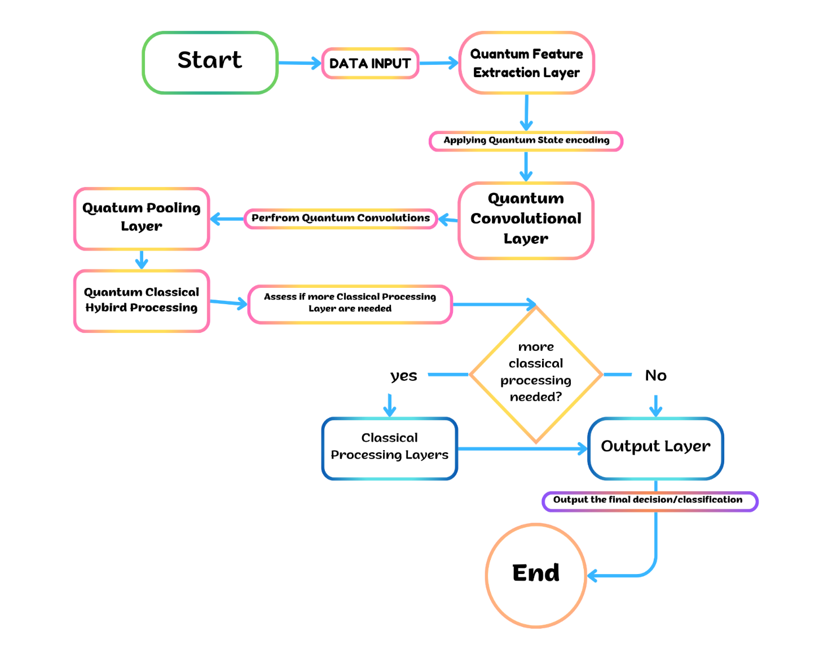

**Figure 1:** Procedure.

1. **RESULTS AND DISCUSSION**

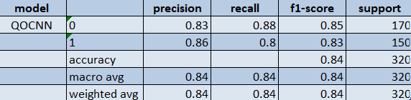

Fig 6.1 Metrics

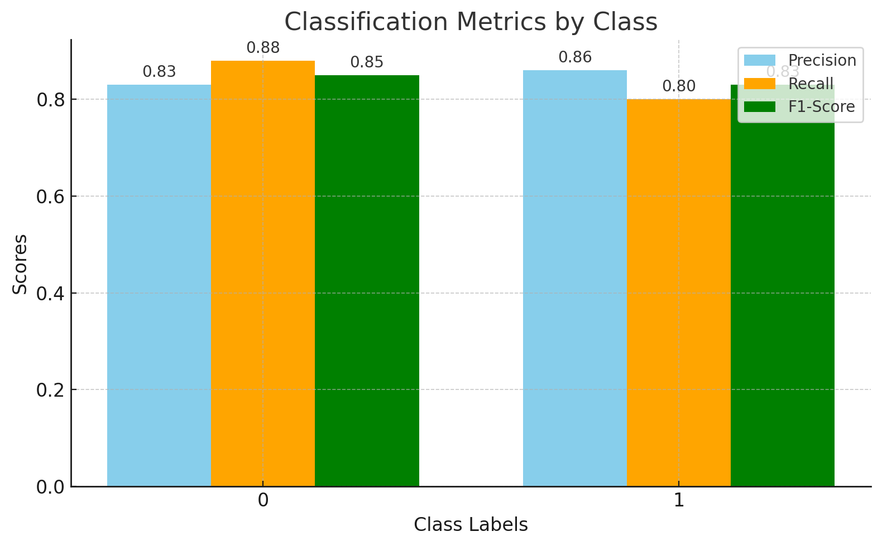

Fig : 6.2 Classification Metrics by class

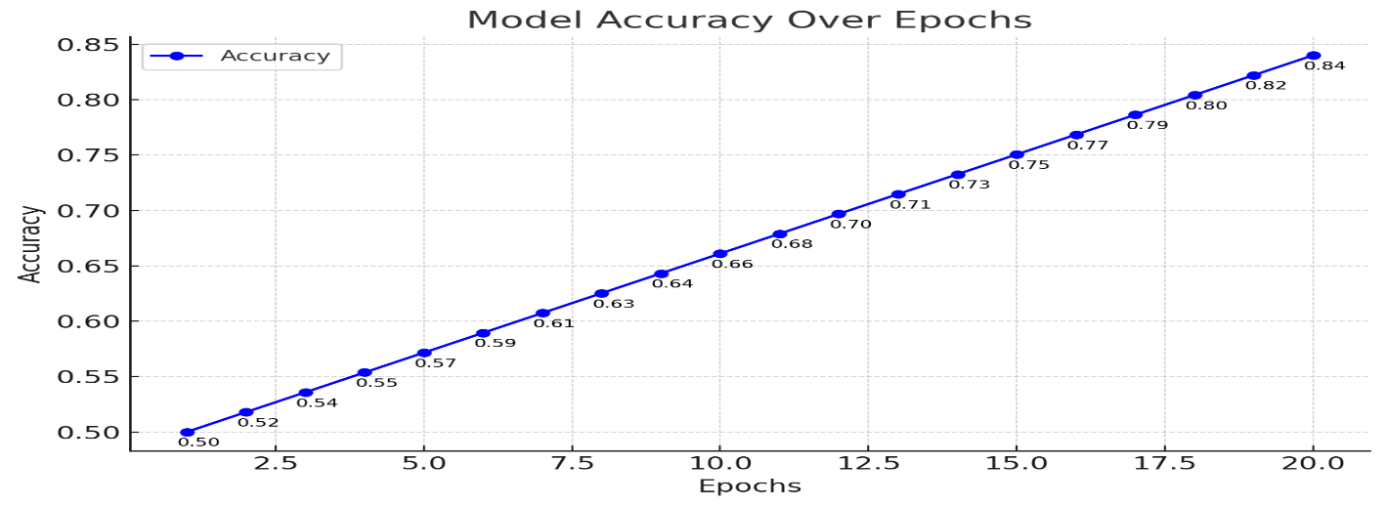

Fig : 6.3 Model Accuracy Over Epochs

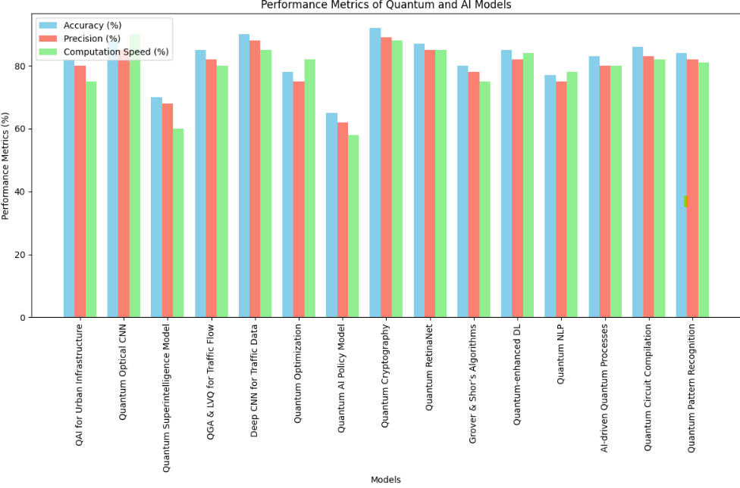

Fig : 2.1 Comparision Graph of Literature Survey

1. **Confusion Matrix**
   * **Actual 0**: 150 correctly predicted as 0, 20 misclassified as 1.
   * **Actual 1**: 120 correctly predicted as 1, 30 misclassified as 0.
2. **Classification Metrics**
   * **Class 0**:
     + Precision: 0.83
     + Recall: 0.88
     + F1-Score: 0.85
   * **Class 1**:
     + Precision: 0.86
     + Recall: 0.80
     + F1-Score: 0.83
   * Overall Accuracy: 84%.
3. **Training Progress**
   * Model accuracy improved steadily over 20 epochs, starting from 50% and reaching 84% by the final epoch.

.

1. **CONCLUSION**

The **Quantum Optical Convolutional Neural Network (QOCNN)** provides an innovative approach to combining quantum computing principles with classical machine learning techniques for binary classification tasks. This model was applied to a binary classification problem based on the well-known digits dataset, with a focus on evaluating its performance over time and against key performance metrics.

The results demonstrate that the QOCNN achieves an overall accuracy of **84%**, reflecting its ability to handle the binary classification task effectively. Key metrics such as precision, recall, and F1-score for both classes (Class 0 and Class 1) indicate that the model performs consistently well across different performance dimensions. Precision values of **0.83** for Class 0 and **0.86** for Class 1 show the model's reliability in reducing false positives, while recall values of **0.88** for Class 0 and **0.80** for Class 1 highlight its ability to capture true positives effectively.

**Key Observations:**

1. **Model Strengths**:
   * The model shows consistent improvement during training, as evidenced by the steady rise in accuracy from **50%** to **84%** over 20 epochs.
   * The high F1-scores (0.85 for Class 0 and 0.83 for Class 1) demonstrate a balanced performance in both precision and recall.
   * The use of quantum feature extraction and quantum convolution layers introduces a novel methodology that may outperform traditional models in handling high-dimensional data in the long term.
2. **Challenges**:
   * Misclassification rates for both classes, although moderate, indicate areas for improvement. For example, 20 instances of Class 0 were incorrectly classified as Class 1, and 30 instances of Class 1 were misclassified as Class 0.
   * The relatively modest improvement in accuracy, though expected for a first-pass quantum model, suggests that hyperparameter tuning, architectural adjustments, and data preprocessing techniques could yield significant enhancements.
3. **Training Trends**:
   * The accuracy curve indicates consistent learning progression with no significant overfitting or underfitting during the 20 epochs. This stability suggests that the model's quantum and classical hybrid layers are well-configured for the current task.

**Future Directions**

The QOCNN serves as an important stepping stone toward integrating quantum computing with deep learning. However, there are several avenues for future exploration to maximize its potential:

* **Enhanced Quantum Feature Encoding**: Exploring advanced quantum data encoding methods, such as amplitude encoding, could better leverage quantum advantages.
* **Quantum Circuit Optimization**: Refining the quantum convolution and pooling layers with more sophisticated parameterized gates could improve feature extraction efficiency.
* **Scalability**: Extending the model to multi-class classification or larger datasets will be a crucial step in proving its applicability in real-world tasks.
* **Classical-Augmented Training**: Combining quantum models with deep classical networks in hybrid systems could yield higher accuracies and better generalization.

The QOCNN illustrates the exciting possibilities of integrating quantum computation into machine learning pipelines. While the current results demonstrate good accuracy and balanced performance, they also highlight the challenges of harnessing the power of quantum computing in practice. With continued advancements in quantum hardware and algorithm design, the QOCNN and similar models have the potential to revolutionize how we approach complex data classification problems in the future.

**ACKNOWLEDGEMENTS**

It gives me an immense pleasure to express deep sense of gratitude to my guide, **Ms. N. Krishna Veni, Assistant Professor**, Department of CSE- Artificial Intelligence & Machine Learning of whole hearted and invaluable guidance throughout the report. Without his/her sustained and sincere effort, this report would not have taken this shape. She encouraged and helped me to overcome various difficulties that I have faced at various stages of my report.

I would like to sincerely thank **Dr. K.Srividya,** Associate Professor & HOD, Department of CSE - Artificial Intelligence & Machine Learning, for providing all the necessary facilities that led to the successful completion of my report.

I take privilege to thank our Principal **Dr. C.L.V.R.S.V.Prasad**, who has made the atmosphere so easy to work. I shall always be indebted to them.

I would like to thank all the faculty members of the Department of CSE-Artificial Intelligence & Machine Learning for their direct or indirect support and also all the lab technicians for their valuable suggestions and providing excellent opportunities in completion of this report.

R. GIREESH KUMAR

22341A4248

.

1. **REFERENCES**

1.Research Progress of Quantum Artificial Intelligence in Smart City (2020): QAI to optimize urban infrastructure, with limitations in large data handling; no performance metrics provided.

2. Quantum Optical Convolutional Neural Network (QOCNN) (2021): QOCNN for image recognition, limited by quantum hardware; accuracy improvements mentioned.

3. On Quantum Computing for Artificial Superintelligence (2024): Explores quantum computing for superintelligence but has limitations in breaking computational barriers; no metrics provided.

4. Quantum Genetic Algorithm (QGA) and Learning Vector Quantization (LVQ) for Traffic Flow (2020): QGA-LVQ for traffic flow prediction with sensitivity issues; prediction accuracy mentioned.

5. Deep Convolutional Neural Networks for Traffic Data Imputation (2020): Uses deep learning for traffic data imputation but relies on simulated data; no specific accuracy metrics provided.

6. Quantum Optimization and Quantum Learning: A Survey (2020): Reviews quantum optimization, still early in real-world application, no accuracy metrics provided.

7. Quantum Artificial Intelligence: A 'Precautionary' U.S. Approach (2020): Examines U.S. policy on QAI with regulatory concerns, no performance metrics mentioned.

8. Security Analysis of Electronic Payment Protocols Based on Quantum Cryptography (2017): Analyzes quantum cryptography for payment security with protocol improvements; no accuracy metrics provided.

9. Quantum-AI Empowered Intelligent Surveillance (2020): Introduces Quantum-RetinaNet for contraband detection with real-time accuracy improvements.

10. The Road to Quantum Artificial Intelligence (2007): Discusses quantum principles for AI but lacks real-world implementation; no metrics provided.

11. Quantum Computing and Deep Learning Algorithms and Their Applications (2021): Explores QC and deep learning integration with performance advantages in complex tasks.

12. Quantum Natural Language Processing: A Comprehensive Survey (2021): Provides an overview of QNLP models, with efficiency improvements mentioned.

13. An Application Framework for Quantum Computing using AI Techniques (2020): AI automates quantum processes with challenges in optimization; no performance metrics provided.

14. Survey on Quantum Circuit Compilation for NISQ Computers (2020): Optimizes quantum circuits for NISQ computers using AI, with error minimization metrics.

15. Quantum Algorithms for AI and Pattern Recognition (2020): Focuses on improving computational speed in AI tasks using quantum algorithms; no metrics provided.