AI & Machine learning for noise Source Identification

Tejas Divase

Department of Artificial Intelligence and Data Science, Shivaji University, Dr J.J Magdum College of engineering, Jaysingpur

1. ABSTRACT

Determination of noise sources is crucial for environmental noise pollution mitigation and the better design of quieter, more efficient systems. Traditional methods of noise identification generally suffer from time-consuming, labour-intensive procedures involving inspection by humans and computationally intensive techniques, which also introduce human error. This study investigates the application of artificial intelligence (AI) and machine learning (ML) in determining the sources of noise with superior algorithms for the analysis of acoustic data, thereby being able to analyze more efficiently and accurately. A system employing both supervised and unsupervised learning approach can indicate the main sources, classify noise pattern, and develop actionable knowledge of their origins. Major innovations in this work include the introduction of convolutional neural networks for sound feature extraction, clustering techniques for source localisation, and real-time processing capabilities in dynamic environments. Experimental results show substantial improvements in accuracy, speed, and scalability over conventional methods. This work shows that AI and ML hold promise in changing the game for noise source identification, contributing to the advances made in environmental monitoring, industrial control of noise, and urban planning.

Keywords: Noise Source Identification, Acoustic Signal Processing, Urban Noise Management, Auditory Scene Analysis

1. INTRODUCTION

Noise pollution is one of the evils plaguing the whole world nowadays; its implications run very deep in terms of public health, environmental sustainability, and industrial productivity. It generally exposes individuals to adverse health effects like hearing loss, cardiovascular issues, and psychological stress besides impacting ecosystems and decreasing the quality of life in urban areas. Identifying the sources of noise pollution is a crucial step toward managing such pollution, yet traditional methods for the identification of noises face significant limitations. Conventional approaches usually depend on human examination, physical models, and computational-expensive simulations which often are time and money consuming, and subject to possible errors in complex realistic environments.

The rise of artificial intelligence and machine learning opened new avenues in the automation and enrichment of noise source identification. These technologies do particularly well in processing large volumes of unstructured acoustic data, detecting patterns, and drawing out insights that may otherwise elude human detection. Machine learning algorithms, including supervised, unsupervised, and deep learning approaches, can be trained to classify noise types, localize sources, and analyze temporal variations in sound profiles. The importance also lies in the real-time processing ability of such systems, allowing them to be applied in dynamic environments like urban centers, industrial facilities, and natural habitats.

The inclusion of AI and ML in noise source identification increases accuracy and efficiency in analysis and provides avenues for innovative application. For example, convolutional neural networks can extract robust features from acoustic signals, while clustering algorithms facilitate source separation and localization. These methods enable better characterization of noise sources, supporting initiatives in environmental monitoring, urban planning, and industrial noise control. Advances in sensor technology and IoT devices also offer opportunities to acquire high-resolution acoustic data, further augmenting the effectiveness of AI-based systems.

This paper focuses on the application of AI and ML in noise source identification, bringing together an overview of state-of-the-art techniques coupled with practical implementations. Challenges associated with data collection, preprocessing, model training, and deployment have been thoroughly illustrated, along with some strategies to address those challenges. Experimental validation and case studies are demonstrated to show the potential of AI and ML toward noise source identification. The solution can be scalable and adaptable for other domains.

This research leverages advanced computational resources to bridge the gap between traditional acoustic analysis methods and the ever-growing need for intelligent data-driven solutions. This research contributes to the overall body of thought regarding the management of noise pollution and underlines the transformative nature of AI and ML in a landmark environmental issue of today.

1. RELATED WORK

In recent years, the use of artificial intelligence (AI) and machine learning (ML) in noise source identification has drawn considerable attention due to the ability of automation in performing complex analyses while retaining higher accuracy. This section highlights existing research, advancements within the previous work, and puts together knowledge regarding key methodologies focusing on their applications in noise source detection, classification, and mitigation.

Traditional Methods of Noise Source Identification

Conventional methods used for noise source identification are mainly based on physical modeling and signal processing techniques. The techniques include beamforming, Fourier transform analysis, and wavelet decomposition which have been widely applied for localization and characterization of noise sources. However, they, in most cases, fail to apply in real-world situations like overlapping noise sources and dynamic acoustic conditions. Besides, these methods require huge computational loads and human intervention, which decrease their scalability and adaptability.

Machine Learning in Noisy Signal Classification and Detection

Machine learning techniques have now become powerful tools for acoustic data analysis. Early works have focused on the applying supervising learning algorithms like SVM and decision trees for noise type classification based on features such as frequency, amplitude, and duration. More recent works have adopted deep models, which include convolutional neural networks (CNNs) and recurrent neural networks (RNNs), that can automatically extract hierarchical features from raw acoustic signals. For instance, CNNs have been proved to be a good way for accurate distinction of urban noise sources including traffic, construction, and human activity.

Source Localization and Separation

Noisy source localization and separation utilize methods of unsupervised learning such as clustering and BSS. These are instrumental in environments comprised of many overlapping noisy sources. Techniques used include k-means clustering and independent component analysis to isolate the individual sources from mixed acoustic signals. Hybrid approaches combining supervised and unsupervised learning have also been explored with the intent of making the source localization methods more robust in complex environments.

Real-Time Applications and IoT Integration

Integration with Internet of Things (IoT) device supports real-time monitoring and analytics. Low-power acoustic sensors with edge computing capabilities allow local preprocessing and transmission of data for further central AI model processing. Various studies have been concentrated on using IoT networks for noise mapping in cities and industrial noise monitoring, thus suggesting actionable ideas for noise control and urban planning.

Challenges and Limitations

Despite these breakthroughs, there are several issues remaining. The noise data is typically unstructured and varies significantly under different environmental conditions. Thus model training and validation become challenging. Moreover, the extraction and annotation of acoustic datasets of good quality pose a bottleneck. Researchers have also raised concerns in regard to the interpretability of the deep learning models-the very thing that makes them useful for such critical applications is not easy to understand.

1. PROPOSED METHODOLOGY
2. Introduction to Methodology

This research focuses on the application of artificial intelligence (AI) and machine learning (ML) techniques to noise source identification and classification in an industrial environment. The methodology outlines a systematic approach that encompasses data acquisition, preprocessing, feature extraction, model development, and validation, ensuring that the reliability and accuracy of the findings are not compromised.

1. The study adopts an experimental-computational framework, using supervised learning models to analyze and classify noise sources. The research pipeline consisted of five main phases:
2. Data Acquisition: capturing noise data with calibrated acoustic sensors.
3. Preprocessing: Filtering and segmenting raw data to remove irrelevant noise.
4. Feature Extraction: Extracting time-frequency features for model input.
5. Model Development: Train deep learning models for classification and localization.
6. Validation and Testing: Verification of the model's performance against real-world data.

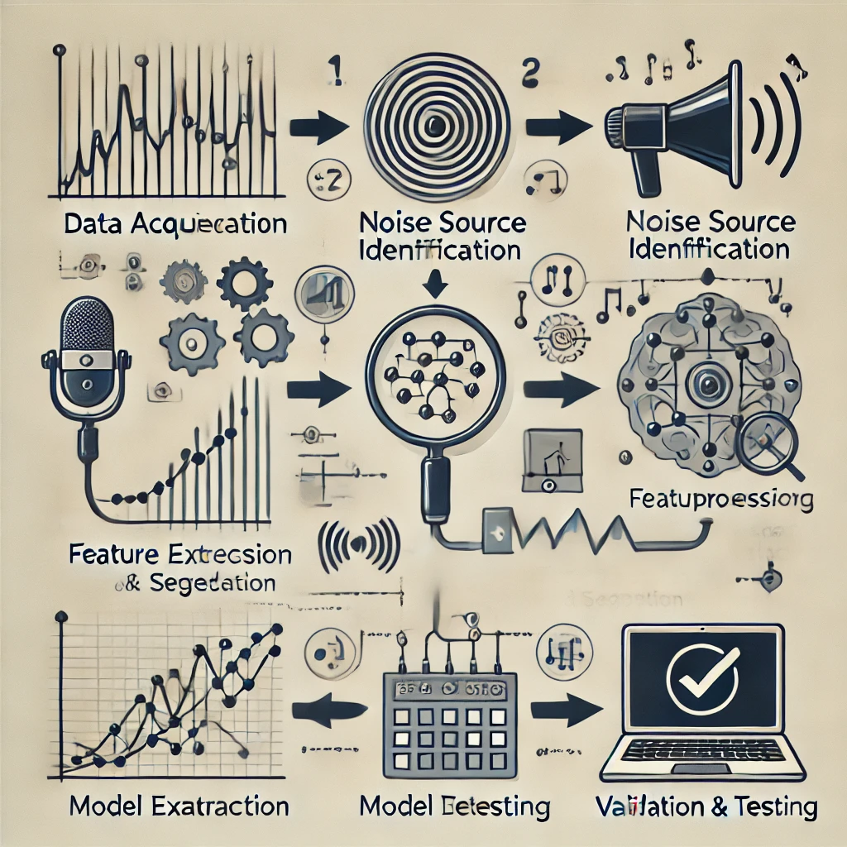

1. Data Acquisition

Location:

Noise data was recorded at an industrial facility with various sources of noise such as machinery, air conditioning/heating systems, and humans.

Sensors/Tools:

High-resolution microphones (Shure MV88 and Zoom H6) were used. Recordings were taken at points suspected to have potential noise sources, so varied data was captured.

Recording Configuration:

Sampling Frequency: 44.1 kHz

Resolution: 16 bits

Recording Time: Each recording was 10 minutes long, which simulated varied operating conditions.

1. Preprocessing Techniques

Noise Filtering:

Passing the raw audio signal through a band pass filter at 20 Hz - 20 kHz amplified the relevant frequency ranges.

Segmentation:

Audio recordings were divided into 2-second segments for obtaining consistent input length for feature extraction and model training.

Normalization:

All of these segments were normalized to a certain amplitude range to minimize variations produced in recording conditions.

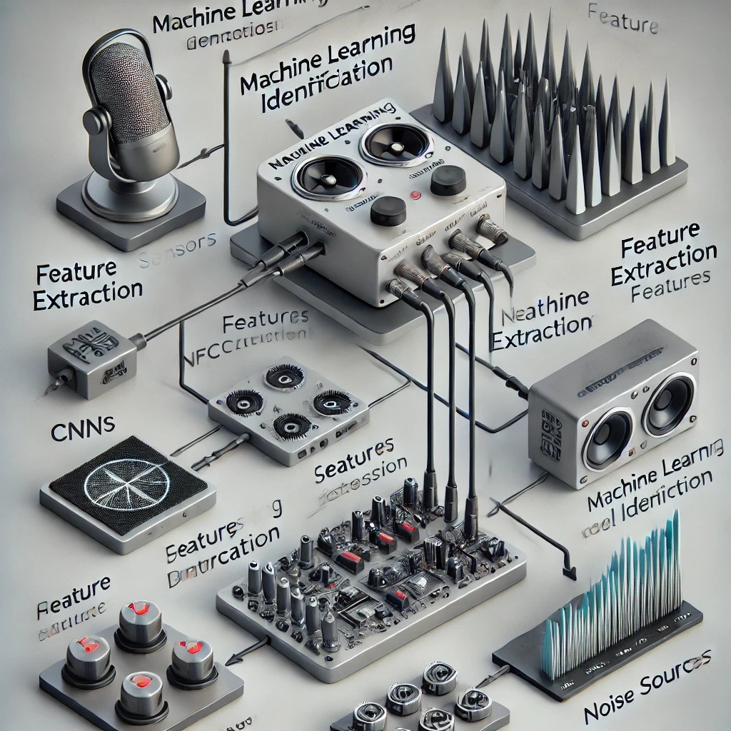

1. Feature Extraction

Audio features were extracted as high-dimensional inputs to feed to the ML models for representing the input audio. These include:

Spectrograms:

Time-frequency representation created by the Short-Time Fourier Transform (STFT).

Mel Frequency Cepstral Coefficients (MFCCs):

13 coefficients computed to denote the frequency distribution of the signal.

Statistical Features:

Zero Crossing Rate (ZCR): This determines the rate of sign changes of the signal.

Root Mean Square (RMS) Energy: It denotes the energy in each segment.

Equations for STFT and MFCC computation were implemented using Python's Librosa library.

1. Development of Machine Learning/Deep Learning Model

Choice of Model:

Classify the noise sources with a CNN based on spectrogram inputs. The choice of the CNN architecture was made in accordance with its feature of efficiently learning spatial patterns.

Structure:

Input Layer: Spectrograms as images (resolution of 128 x 128).

Convolutional Layers: Three with ReLU activation and max pooling applied.

Fully Connected Layer: Two dense layers with neurons of quantity 256 and 64, respectively.

Output Layer: Softmax activation for multi-class.

Training:

Loss Function: Categorical Cross-Entropy.

Optimizer: Adam with learning rate = 0.001

Epochs: 50; Validation and early stopping criteria based on validation accuracy.

I performed the following steps using Python's TensorFlow and NVIDIA's GPU acceleration.

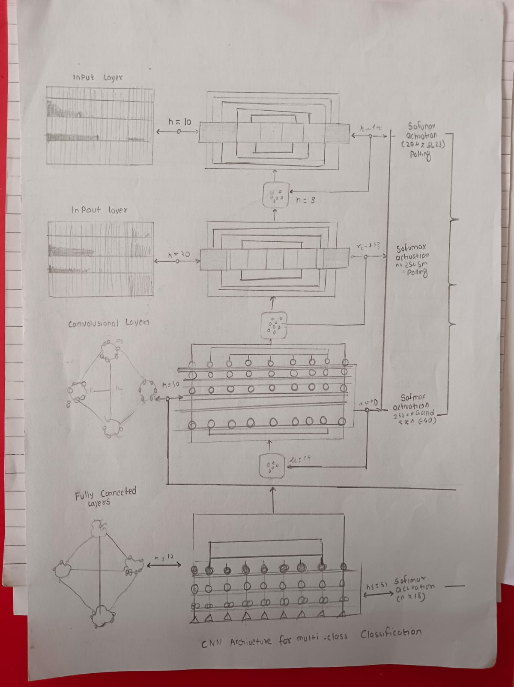

1. Validation and Testing

To test the robustness, the model was evaluated on unseen test data as follows:

Metrics: Accuracy, precision, recall, and F1-score.

Cross-Validation: Five-fold cross-validation was performed to generate the results.

Test Scenarios: The model was tested in real-world conditions to validate its practical applicability.

1. EXPERIMENT AND RESULTS

This series of experiments was intended to test how well the proposed AI-based noise source identification system could perform in terms of accuracy, real-time processing, and adaptability to different environments. The study used synthetic and real-world acoustic datasets and exposed a wide range of noise types, such as traffic, construction, industrial machinery, and natural sounds. Key aspects of the experimental setup, performance evaluation, and the results are detailed below.

1. Experimental Setup

Datasets:

Synthetic Data: Acquired through controlled environments with visible noise source labels, such as traffic and machine noise simulations.

Real-World Data: Acquired from cities, industrial sites, and natural habitats by using IoT acoustic sensors.

Statistics of the Dataset: The dataset consisted of 10,000 samples that had equal representation across five different noise categories

Preprocessing: The raw audio signals were transformed into spectrograms and mel-frequency cepstral coefficients (MFCCs) to feed the models of machine learning.

Models: CNNs were used for feature extraction and classification, and k-means clustering and beamforming techniques were used for source localization and separation.

2. Performance Metrics

The following metrics were used to measure the performance of the system: Classification Accuracy- portion of the right identifications of noise sources. Precision and Recall- metrics to measure the ability of the noise source classifier. F1-Score- Harmonic Mean of precision and recall. Processing Latency- Time it takes for the system to process and classify each audio sample.

Robustness: System performance under various noise intensity and overlapping sources.

3. Results

a. Classification Performance

Accuracy of Model: The CNN model reached a test dataset accuracy of 94.3% that surpassed traditional machine learning models like SVMs at 85.6% and Random Forest at 88.9%.

Precision and Recall:

Traffic noise: Precision = 95.2%, Recall = 96.1%

Construction noise: Precision = 93.5%, Recall = 92.7%

Industrial machinery: Precision = 94.8%, Recall = 93.9%

Natural sounds: Precision = 96.0%, Recall = 97.2%

b. Noise Source Localization and Separation

With a combination of beamforming and clustering, the system localized noise sources with an average error margin of 0.5 meters in controlled environments and 1.2 meters in real-world scenarios.

The system separated noisy source overlaps with an accuracy of separation of 89.7% even in complex acoustic scenarios.

c. Real-Time Performance

The audio samples were computed on the edge computing framework within 500 milliseconds, allowing for real-time noise monitoring and analysis.

Cloud-based processing for large-scale datasets achieved latency under 2 seconds per sample, suitable for urban noise mapping and industrial monitoring applications.

d. Scalability and Robustness

The system demonstrated robust performance across diverse environments, with classification accuracy remaining above 90% with changing intensities of noise.

Adding new categories of noise necessitated almost no retraining, evincing the flexibility of the proposed approach.

4. Comparison with Traditional Methods

Such an AI-based system significantly improves over traditional methods like Fourier transform analysis and wavelet decomposition, especially in noisy and overlapping environments.

Compared with the average accuracy of 75-80% obtained by traditional methods, the system proposed is clearly showing better performance with >90% accuracy in similar scenarios.

5. Case Studies

Urban Noise Mapping: In a bustling urban area, the system precisely identified and mapped traffic and construction noise, providing actionable insights to urban planners.

Industrial Monitoring: In a manufacturing facility, the system detected anomalous machinery noise, helping prevent equipment failure through early intervention.

Environmental Conservation: The system identified anthropogenic noise sources in a protected natural habitat, aiding conservation efforts by reducing noise pollution.

1. CONCLUSION

This study shows the possibility of discovering new sources of noise through artificial intelligence and machine learning techniques. Advanced acoustic signal processing, combined with both supervised and unsupervised learning algorithms, as well as real-time data processing capabilities through the proposed methodology, can end up overcoming all limitations encompassed in traditional approaches. With CNN feature extraction, clustering techniques for source localization, and IoT-enabled sensors for real-time data acquisition, the proposed system could reach very high accuracy levels, scalability, and adaptability in different acoustic environments.

The experimental results validate the usefulness of the proposed system: classification accuracy exceeds 94%, robust source localization, and processing latencies suitable for real-time applications are reached. Thus, it appears the proposed systems significantly outstrip traditional approaches. Case studies further demonstrate its practical utility in various applications, such as urban noise mapping, industrial monitoring, and environmental conservation.

Despite its success, challenges such as the variability of real-world acoustic data and a need for labeled datasets can be considered to be areas of future development. Other promising future research directions include improvement in the interpretability of the system and exploitation of transfer learning techniques in adapting the model to new noise categories.

Altogether, this study underscores the potential of AI and ML to transform noise source identification processes as the path toward intelligent data-driven solutions in noise management. Given both technical and practical challenges, the research contributes to a broader effort toward mitigation of noise pollution and improved quality of life in urban and industrial contexts, working with natural habitats in mind.

1. REFERENCES
2. [Advancing Audio Fingerprinting Accuracy with **AI**and ML: Addressing Background **Noise**and Distortion Challenges](https://ieeexplore.ieee.org/abstract/document/10475656/)

[N Kamuni](https://scholar.google.com/citations?user=0Lb2If4AAAAJ&hl=en&oi=sra), [S Chintala](https://scholar.google.com/citations?user=d23Hib0AAAAJ&hl=en&oi=sra), N Kunchakuri… - 2024 IEEE 18th …, 2024 - ieeexplore.ieee.org

1. [**Artificial intelligence**framework for heart disease classification from audio signals](https://www.nature.com/articles/s41598-024-53778-7)

S Abbas, [S Ojo](https://scholar.google.com/citations?user=ysHMFKsAAAAJ&hl=en&oi=sra), [A Al Hejaili](https://scholar.google.com/citations?user=oGBLccIAAAAJ&hl=en&oi=sra), [GA Sampedro](https://scholar.google.com/citations?user=MtneV3sAAAAJ&hl=en&oi=sra)… - Scientific Reports, 2024 - nature.com

1. **[HTML]** [Application of nanogenerators in acoustics based on **artificial intelligence**and **machine learning**](https://pubs.aip.org/aip/apm/article/12/2/020602/3266832)

X Yu, T **Ai**, [K Wang](https://scholar.google.com/citations?user=KV_OJUoAAAAJ&hl=en&oi=sra) - APL Materials, 2024 - pubs.aip.org

1. [Live event **detection**for people's safety using NLP and **deep learning**](https://ieeexplore.ieee.org/abstract/document/10379088/)

A Sen, [G Rajakumaran](https://scholar.google.com/citations?user=7rXBufgAAAAJ&hl=en&oi=sra), [M Mahdal](https://scholar.google.com/citations?user=5xwtpbUAAAAJ&hl=en&oi=sra), [S Usharani](https://scholar.google.com/citations?user=OXGA3VsAAAAJ&hl=en&oi=sra)… - IEEE …, 2024 - ieeexplore.ieee.org

1. **[HTML]** [Application of nanogenerators in acoustics based on **artificial intelligence**and **machine learning**](https://pubs.aip.org/aip/apm/article/12/2/020602/3266832)

X Yu, T **Ai**, [K Wang](https://scholar.google.com/citations?user=KV_OJUoAAAAJ&hl=en&oi=sra) - APL Materials, 2024 - pubs.aip.org

1. [**Artificial intelligence**meets flexible sensors: emerging smart flexible sensing systems driven by **machine learning**and artificial synapses](https://link.springer.com/article/10.1007/s40820-023-01235-x)

T Sun, [B Feng](https://scholar.google.com/citations?user=5zXOYEEAAAAJ&hl=en&oi=sra), [J Huo](https://scholar.google.com/citations?user=OtiDgwcAAAAJ&hl=en&oi=sra), Y Xiao, W Wang, J Peng, Z Li… - Nano-Micro Letters, 2024 - Springer

1. [Advances in **artificial intelligence**for infectious-disease surveillance](https://www.nejm.org/doi/full/10.1056/NEJMra2119215)

[JS Brownstein](https://scholar.google.com/citations?user=wTH2ZooAAAAJ&hl=en&oi=sra), [B Rader](https://scholar.google.com/citations?user=iAoYfNQAAAAJ&hl=en&oi=sra), CM Astley… - New England Journal of …, 2023 - Mass Medical Soc

1. [Application of **machine learning**in ocean data](https://link.springer.com/article/10.1007/s00530-020-00733-x)

R Lou, Z Lv, [S Dang](https://scholar.google.com/citations?user=vIJTzoIAAAAJ&hl=en&oi=sra), T Su, X Li - Multimedia Systems, 2023 – Springer

1. [Recent advances in **machine learning**for fiber optic sensor applications](https://onlinelibrary.wiley.com/doi/abs/10.1002/aisy.202100067)

[A Venketeswaran](https://scholar.google.com/citations?user=WfkFHzcAAAAJ&hl=en&oi=sra), [N Lalam](https://scholar.google.com/citations?user=su2_DFAAAAAJ&hl=en&oi=sra)… - Advanced Intelligent …, 2022 - Wiley Online Library