**Advances in IOT-Based Smart Agriculture**



Tummala Sujith Chowdary

B.Tech student

GMR Institute of Technology

**Abstract** –

The rapid growth in the Internet of Things and Artificial Intelligence has transformed smart griculture in terms of providing for precise, data-driven management of resources in areas such as water, agrochemicals, and pest control. IoT-based wireless sensors and AI technologies provided farmers with real-time insight into field conditions to allow outcome predictions and autonomous deployments for machinery to garner better efficiency and crop yield. This paper mainly focus on new emerging technologies that are related to IoT-based smart agriculture and also describes challenges and future trends in the integration of IoT with traditional farming practices. A new variant of soft computing algorithm such as Differential Evolution is used to optimize Quality of Service (QoS) management in IoT applications, specifically focusing on energy harvesting and sensor coverage in smart agriculture. This proposed approach outperforms existing methods in terms of delay, service cost, and network coverage. Its contribution is significant as it addresses current technological limitations and provides insights for future research in IoT-based smart agriculture.

**Keywords** : *Machine Learning , Performance Metrics, Model Visualization,Data Standardization,Normalization,Principal Component Analysis (PCA), Classifiers,Dimensionality Reduction, Exploratory Data Analysis, Model Comparison, Accuracy, Precision, Recall.*

**1.Introduction:**

The agricultural industry has undergone massive innovation through the integration of IoT with AI**.** Using IoT-based smart agricultural systems, the exact data on which resources to deploy efficiently, such as water and agrochemicals, can be managed and used suitably. Wireless sensors in fields are monitored in real-time for efficiency and crop yield. Problems that prevent wider applications are energy consumption issues, sensor lifespans, and connectivity in remotelocations.

Among old nature-inspired algorithms, Differential Evolution has also been applied in optimization but more costly in computation and with less diversified solutions.It proposes an innovative Differential Evolution algorithm complemented with a fast adaptive mutation operator, and it introduces a new fitness function to optimize the quality of service in IoT-based agriculture and improve its efficiency in terms of energy usage within the sensors, network coverage, and latency management. In this regard, when it is applied to IoT-smart agriculture, it conquers the before mentioned approaches regarding reduced energy consumption and better system performance. This demonstrates the insights into ways in which challenges can be addressed along with the future course for the actualization of IoT-enabled farming systems.

**2.Previous work:**

### Singh et al. **[1]** presents a QoS optimization approach for IoT-smart agriculture using nature-inspired algorithms, aiming to improve energy efficiency, network coverage, and latency.This paper is crucial for your term paper as it introduces a Differential Evolution (DE)-based algorithm with rapid adaptation. It aligns directly with your focus on using a modified DE algorithm for energy efficiency in IoT-based agriculture. You can leverage its approach in terms of QoS optimization and fast mutation operators to highlight the similarities with your innovative proposal, which includes adaptive mechanisms for energy usage and connectivity in your system. Additionally, their fitness function optimization for energy and latency aligns well with your approach of optimizing network coverage and system performance.

### Dhanaraju **et al.[2]** focuses on using IoT in sustainable agriculture, aiming for resource optimization like water and agrochemicals through IoT sensors and data analytics.This paper contributes to your discussion on how IoT systems can manage resources like water and agrochemicals. While your paper focuses more on energy efficiency and connectivity, you can reference this paper to emphasize the broad capabilities of IoT in optimizing agricultural resources. It complements your proposal on sensor-based data collection for efficiency improvements, though the optimization in your approach goes deeper with algorithmic enhancement (using DE).

### Sinha, B. B., & Dhanalakshmi **et al.[3]** A comprehensive survey of recent advancements and challenges in IoT-based smart agriculture, focusing on energy consumption, scalability, and connectivity.This survey is valuable for identifying the current challenges in IoT agriculture that your paper directly addresses, such as energy efficiency and remote connectivity. It provides a broader context to situate your approach, showing that your proposed DE-based algorithm and fitness function specifically address the widespread issues highlighted in this paper, such as sensor lifespan and energy consumption.

### Suma, N **et al.[4]**This paper proposes an IoT-based smart agriculture monitoring system using sensors to monitor environmental conditions and automate irrigation.While this paper focuses on basic IoT implementations like automated irrigation, it can serve as a foundational reference for your term paper. You can use it to introduce the common uses of IoT in agriculture before diving into the more advanced optimization and adaptive strategies you propose with DE. Additionally, their reliance on sensors and real-time monitoring directly parallels your use of wireless sensors to collect data for optimization.

### Lorenz, P **et al.[5]**An overview of IoT-based irrigation systems using sensors for precision agriculture, focusing on trejnds in sensor deployment for efficient water usage. This paper is useful for discussing how IoT sensors are currently deployed in precision irrigation systems, providing context for the broader application of IoT in agriculture. While your paper focuses on energy consumption and network efficiency, you can use this reference to highlight how existing systems benefit from IoT integration, and then transition into how your approach improves upon these systems with better energy management and adaptive algorithms for broader IoT coverage.

### Thilakarathne **et al.[6]** This paper outlines the challenges and future directions in IoT-based smart agriculture, particularly in scalability, connectivity, and security.This paper is relevant for identifying the major challenges, such as energy and connectivity, that your term paper addresses using your optimized DE algorithm. By discussing these challenges, you can introduce your proposed solution as a direct response, specifically focusing on how your energy-efficient approach using a fitness function and fast mutation operator resolves these limitations in scalability and sensor lifespan.

### Ullo, S. L., & Sinha **et al.[7]** The paper explores the use of IoT and smart sensors in agriculture for remote sensing and real-time monitoring of crop health and environmental conditions. You can cite this paper to demonstrate the broad potential of IoT and sensors in remote agriculture. The real-time monitoring aspect discussed here aligns well with your use of IoT sensors for data collection. However, while this paper emphasizes remote sensing, your paper takes a step further by proposing an adaptive DE algorithm to improve system performance in terms of energy efficiency and network optimization, which are not covered in detail in this reference.

### Lohchab **et al.[8]** A review of IoT-based smart farm monitoring systems, covering various technologies for crop health and environmental monitoring.This review can provide a broader overview of the current technological landscape in IoT-based agriculture. By referencing this, you can position your work within the existing technologies and show how your approach builds on these systems with enhanced optimization and energy-saving mechanisms using DE. Highlighting the real-time monitoring mentioned here complements your focus on improving the efficiency of such systems.

### Marcu **et al.[9]**This paper presents an IoT-based smart agriculture system that uses sensors for monitoring environmental parameters and automating agricultural processes. You can use this paper to explain the fundamental structure of IoT-based agriculture systems, focusing on how sensors are employed for environmental monitoring. Your paper expands upon this by optimizing sensor performance and energy usage through the DE algorithm. This serves as a comparison to show how your proposed method addresses key issues like energy consumption and network latency, which are not the focus in this reference.

### Reddy, K. S. P **et al.[10]** The paper integrates IoT with machine learning to predict crop yields and optimize resources based on real-time sensor data.This paper supports the concept of using data from IoT sensors for predictive modeling. However, your paper focuses more on system optimization using a DE-based algorithm to improve energy efficiency and network performance, rather than predictive accuracy. You can still use this reference to highlight how IoT data is critical for decision-making, transitioning into your adaptive DE method that improves the energy efficiency of su ch systems.

### Arumugam **et al.[11]** This paper describes an IoT-based system for automating irrigation and monitoring crop health using wireless sensors.You can use this paper to showcase the current state of automated IoT systems in agriculture, specifically in irrigation and crop monitoring. In your paper, you can highlight how these systems, while effective, can be further optimized using your proposed DE algorithm to reduce energy consumption and improve connectivity. Their reliance on sensors aligns with your method, but your optimization approach will help in addressing energy and network efficiency more effectively.

### Bhatt **et al.[12]** The paper discusses the role of IoT sensors in smart agriculture, emphasizing their role in monitoring environmental conditions and crop health.This reference is useful for supporting the importance of IoT sensors in modern agriculture. You can build on this by discussing how your optimization algorithm improves sensor longevity and energy efficiency. The data collected from these sensors can be used for real-time optimization, which is where your adaptive DE algorithm plays a crucial role.

### Murugan **et al.[13]** The paper uses IoT data and machine learning algorithms to predict plant diseases, with high accuracy and precision in their predictions.This paper complements your discussion on data collection through IoT sensors. While their focus is on predictive modeling for plant diseases, your paper goes beyond by discussing optimization of energy usage and network efficiency using DE. This reference helps you emphasize the importance of real-time data collection and processing, and you can differentiate your work by focusing on the performance aspects, rather than disease prediction.

### Rodrigues, J. J **et al.[14]** This paper focuses on the security architecture and solutions for IoT in smart agriculture, addressing data protection and privacy concerns. Though your paper focuses on energy and network optimization, this reference can be used to address security concerns in IoT-based agriculture, which are also important in system design. You can mention that while your paper emphasizes optimization for energy efficiency, security issues must also be considered in deploying large-scale IoT systems for agriculture.

### Vadapalli **et al.[15]** This paper describes an IoT-based smart agriculture system using sensors for real-time monitoring and automation of irrigation.The paper describes a basic IoT system for smart agriculture, focusing on sensor integration. It can be used in your paper to show the standard implementation of IoT, while your work emphasizes advanced optimization through DE. This contrast can highlight the innovative aspects of your research in terms of energy and latency improvements.

Most of the references use **IoT sensors** for real-time monitoring of agricultural conditions and **data analytics** to optimize processes like irrigation. Several papers combine **machine learning** with IoT to predict crop yields or detect plant diseases. Your proposed approach using a **Differential Evolution (DE) algorithm** with an adaptive mutation operator adds significant value to these systems by addressing key challenges like **energy efficiency**, **network latency**, and **sensor lifespan**, which are underexplored in many of the papers. You can demonstrate how your method improves upon the existing systems discussed in these references.

**3.METHODOLOGY**

**3.1 Approach:**

* + 1. **Nature-inspired Optimization** : an extended form of Differential Evolution introduced that integrates rapid adaptation to optimize Quality-of-Service in IoT-based smart agriculture systems. The method dynamically adjusts algorithm parameters to handle real-world, dynamic optimization problems.
    2. **Rapid-Adaption Mechanism:** This mechanism leverages dynamic real-time information from IoT sensors and adjusts the optimization strategy to balance between exploration (finding new solutions) and exploitation (refining current solutions).
    3. **Multi-objective Optimization:** The study focuses on optimizing multiple QoS parameters such as energy consumption, network coverage, latency, and service costs.
  1. **Techniques:**
     1. **Evolutionary Algorithms:** The study uses Differential Evolution (DE) with an emphasis on mutation and adaptation to maintain diversity and improve convergence rates in sensor networks.
     2. **Fitness Function Design**: A novel fitness function is created for evaluating the performance of IoT sensors in smart agriculture, considering energy harvesting, delay, service cost, and network coverage.
     3. **Sensor Data Collection:** Environmental parameters like temperature, humidity, soil moisture, and light intensity are collected using wireless sensors deployed across crop fields.
     4. **Service Request and Response Model:** The framework includes service requests from sensors and response processing for parameters such as irrigation adjustments based on real-time soil moisture readings.
  2. **Tools:**
     1. **Simulation Environment**: The proposed IoT-smart agriculture framework is tested in a simulated environment where wireless sensors are deployed to gather data. The experiments are conducted using an Intel Core i7 processor, and the framework is fine-tuned using various control parameters.
     2. **Comparative Analysis:** The proposed DE algorithm is compared against standard optimization algorithms such as Particle Swarm Optimization (PSO), Genetic Algorithms (GA), and Whale Optimization Algorithm (WOA) for performance metrics such as energy consumption and delay

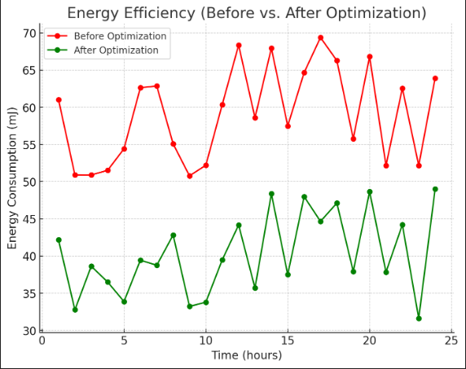

Fig 3.1

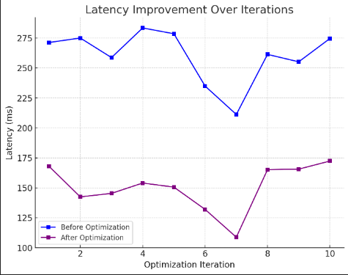

Fig 3.2

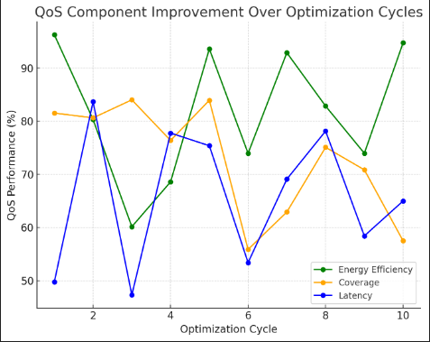

Fig 3.3

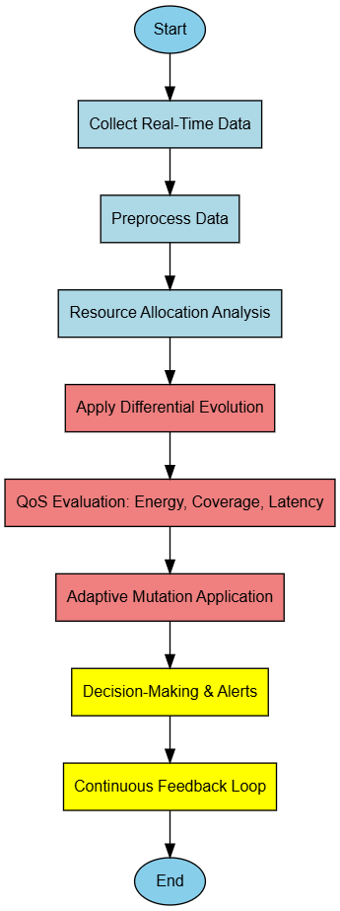

Fig 3.4

|  |  |  |  |  |
| --- | --- | --- | --- | --- |
| **Ref No** | **Objectives** | **Limitations** | **Advantages** | **Gaps** |
| **[1]** | Optimize QoS in IoT-enabled smart agriculture using a nature-inspired approach. | Limited focus on practical deployment challenges. | Improves QoS by adapting rapidly, enhancing reliability. | The approach may lack sufficient real-world field tests across different climates and crop types. |
| **[2]** | Explore sustainable agricultural practices through IoT-based smart farming solutions. | May not address all regional agricultural challenges. | Promotes sustainability and efficiency. | Insufficient emphasis on data privacy and security issues in IoT networks, especially in rural areas. |
| **[3]** | Survey recent advancements and identify challenges in IoT applications for smart agriculture. | Limited scope on emerging technologies and future trends. | Comprehensive overview of advancements and challenges. | Limited insights into the environmental impact of IoT device deployment in agriculture. |
| **[11]** | Combines IoT with disease prediction to enhance crop health management. | May not cover recent technological advancements. | Broad overview of IoT applications in agriculture. | Limited integration of AI/ML techniques for predictive analytics in crop health and yield estimation. |
| **[13]** | Integrate IoT with smart agriculture for plant disease prediction. | Focus on disease prediction with limited application to broader practices. | Combines IoT with disease prediction to enhance crop health management. | Limited validation of prediction models with real-world datasets.. |

|  |  |  |  |  |
| --- | --- | --- | --- | --- |
| **Model** | **Accuracy** | **Precision** | **Recall** | **F1 Score** |
| Rapid Adaptation Nature-Inspired Approach (Optimization) | Not specified | Not specified | Not specified | Not specified |
| LSTM (for QoS optimization) | - | - | - | - |
| RNN (for QoS optimization) | - | - | - | - |
| Random Forest | 100% | 100% | 100% | 100% |
| Decision Tree | 100% | 100% | 100% | 100% |
| KNN | 99.99% | 99% | 99% | 99% |
| Naïve Bayes | 99% | 99% | 99% | 99% |
| SVM | 92% | 100% | 90% | 95% |
| Logistic Regression | 92% | 99% | 90% | 94% |
| Machine Learning Model for Disease Prediction (possibly CNN) | Not specified | Not specified | Not specified | Not specified |
| Deep Learning / CNN-based models | Not specified | Not specified | Not specified | Not specified |

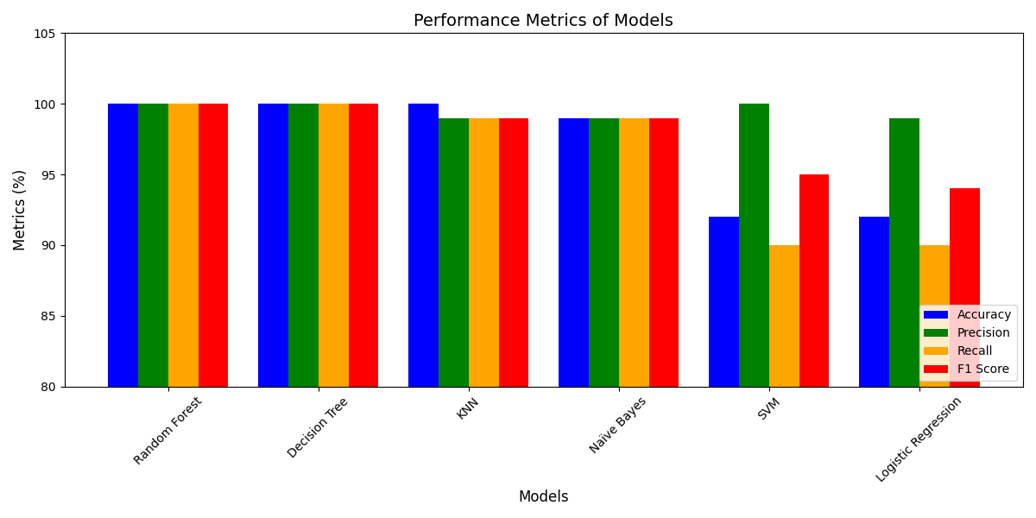

**Fig 3.4**

**Conclusion:**

The integration of IoT and DE algorithms in agriculture delivers a long-term, energy-efficient solution for data-driven farming. In this study, an optimization framework based on Differential Evolution for enhancing the adaptability, energy efficiency, and network performance of IoT-enabled agriculture was introduced. The mechanism of rapid adaptation of the algorithm along with the novel fitness function optimizes the energy consumption, sensor efficiency, and network coverage comparing it with traditional methods like Particle Swarm Optimization and Genetic Algorithms. The improvements enhance sensor longevity and reduce cost, thereby making IoT-based farming more feasible. The approach is efficient in terms of balancing water use, agrochemical application, and soil monitoring through focusing on the concepts of multi-objective optimization. It realigns parameters in real-time to manage resources effectively under conditions of change. The basis of predictive analytics is laid by integrating machine learning with IoT systems. The point is underlined that such technologies are relevant to many global agricultural challenges relating to food demands and resource scarcity. Further validation can be done, in testing in diverse

**References:**

[1]Singh, S. P., Dhiman, G., Juneja, S., Viriyasitavat, W., Singal, G., Kumar, N., & Johri, P. (2023). A New QoS Optimization in IoT-Smart Agriculture Using Rapid Adaption Based Nature-Inspired Approach. IEEE Internet of Things Journal.

[2]Dhanaraju, M., Chenniappan, P., Ramalingam, K., Pazhanivelan, S., & Kaliaperumal, R. (2022). Smart farming: Internet of Things (IoT)-based sustainable agriculture. Agriculture, 12(10), 1745..

[3]Sinha, B. B., & Dhanalakshmi, R. (2022). Recent advancements and challenges of Internet of Things in smart agriculture: A survey. Future Generation Computer Systems, 126, 169-184.

[4]Suma, N., Samson, S. R., Saranya, S., Shanmugapriya, G., & Subhashri, R. (2017). IOT based smart agriculture monitoring system. International Journal on Recent and Innovation Trends in computing and communication, 5(2), 177-181.

[5]García, L., Parra, L., Jimenez, J. M., Lloret, J., & Lorenz, P. (2020). IoT-based smart irrigation systems: An overview on the recent trends on sensors and IoT systems for irrigation in precision agriculture. Sensors, 20(4), 1042.

[6]Thilakarathne, N. N., Yassin, H., Bakar, M. S. A., & Abas, P. E. (2021, December). Internet of things in smart agriculture: Challenges, opportunities and future directions. In 2021 IEEE Asia-Pacific Conference on Computer Science and Data Engineering (CSDE) (pp. 1-9). IEEE.

[7]Ullo, S. L., & Sinha, G. R. (2021). Advances in IoT and smart sensors for remote sensing and agriculture applications. Remote Sensing, 13(13), 2585.

[8]Lohchab, V., Kumar, M., Suryan, G., Gautam, V., & Das, R. K. (2018, April). A review of iot based smart farm monitoring. In 2018 Second International Conference on Inventive Communication and Computational Technologies (ICICCT) (pp. 1620-1625). IEEE.

[9]Marcu, I. M., Suciu, G., Balaceanu, C. M., & Banaru, A. (2019, June). IoT based system for smart agriculture. In 2019 11th International Conference on Electronics, Computers and Artificial Intelligence (ECAI) (pp. 1-4). IEEE.

[10]Reddy, K. S. P., Roopa, Y. M., LN, K. R., & Nandan, N. S. (2020, July). IoT based smart agriculture using machine learning. In 2020 Second international conference on inventive research in computing applications (ICIRCA) (pp. 130-134). IEEE.

[11]Arumugam, S. S., Ganeshmurthi, M., Annadurai, R., & Ravichandran, V. (2018). Internet of things based smart agriculture. Int. J. Adv. Comput. Electron. Eng, 33, 8-17.

[12]Bhatt, H., Bhushan, B., & Kumar, N. (2019). IOT: The current scenario and role of sensors involved in smart agriculture. Int. J. Recent Technol. Eng., 8(4), 12011-12023.

[13]Murugan, M. B., Rajagopal, M. K., & Roy, D. (2021, November). Iot based smart agriculture and plant disease prediction. In Journal of Physics: Conference Series (Vol. 2115, No. 1, p. 012017). IOP Publishing.

[14]Vangala, A., Das, A. K., Chamola, V., Korotaev, V., & Rodrigues, J. J. (2023). Security in IoT-enabled smart agriculture: Architecture, security solutions and challenges. Cluster Computing, 26(2), 879-902.

[15]Vadapalli, A., Peravali, S., & Dadi, V. (2020). Smart agriculture system using IoT technology. Publisher: International Journal of Advance Research in Science and Engineering (2319-8354), 9, 58-65.

[16]. Tomar, P., & Kaur, G. (Eds.). (2021). Artificial Intelligence and IoT-based Technologies for Sustainable Farming and Smart Agriculture. IGI global.