SMART RIDE SMART PRICE

**N.Shalini1, K.Saikumar2, CH.Pardha Saradhi3, G.Charan Reddy4**

1Assistant Professor, Department of Cyber Security, Malla Reddy University, Telengana, India.

2-4Department of Cyber Security, Malla Reddy University, Hyderabad, Telengana, India. [n_shalini@mallareddyuniversity.ac.in1,](mailto:n_shalini@mallareddyuniversity.ac.in1) [2111cs040087@mallareddyuniversity.ac.in2,](mailto:2111cs040087@mallareddyuniversity.ac.in2) [2111cs040066@mallareddyuniversity.ac.in3](mailto:2111cs040066@mallareddyuniversity.ac.in3), [2111cs040024@mallareddyuniversity.ac.in4](mailto:2111cs040024@mallareddyuniversity.ac.in4),

***Abstract:***

# In today's fast-paced urban environment, bike taxis have emerged as a popular and efficient mode of transportation, offering a quick and economical alternative to traditional transport options. However, the rapid growth of bike taxi services has led to a diverse range of pricing models, making it challenging for consumers to identify the most cost- effective choices. This project, titled "Smart Ride, Smart Price: Comparing Bike Taxi Service Rates," aims to provide a comprehensive analysis of the pricing structures across various online bike taxi platforms. By collecting and comparing data on fare rates, surge pricing, and additional costs from multiple service providers,

**Keywords:** Dynamic Pricing,Raid HailingServices,Price compa Comparision,ola,rapido,uber, Machine Learning,mobileapplic MobileApplications, Security Enhancement,Predictivemodeli modeling Modeling,User Feedback,Traffic conditions ,Surgep Pricing Security.

# INTRODUCTION

The **Smart Ride Smart Price** project aims to address the complexities and lack of transparency in the pricing mechanisms of ride-hailing services like **Ola**, **Uber**, and **Rapido**, which have transformed urban transportation. As dynamic pricing models adjust fares in real-time based on demand, traffic conditions, and external factors, users often find it challenging to understand the rationale behind fare fluctuations.This project seeks to develop a comprehensive platform that facilitates transparent price comparisons across these services, leveraging real-time data, machine learning algorithms, and predictive modeling.

By providing a detailed breakdown of fares and incorporating external influences, such as traffic patterns and weather conditions, the initiative aims to empower users to make informed decisions about their transportation choices. Ultimately, the goal is to enhance user experience, promote transparency, and build trust in ride-hailing services, enabling consumers to navigate urban transportation with confidence.

# LITERATURE REVIEW

The **literature review** for the **Smart Ride Smart Price** project explores existing research on dynamic pricing models used by ride-hailing services like **Ola**, **Uber**, and **Rapido**. Studies show that these platforms use algorithms that adjust fares based on demand, traffic, and external factors like weather, but there is often limited transparency, leading to user dissatisfaction. Research by **Zhao et al. (2017)** highlights Uber's surge pricing and its impact on user trust, while **Chen et al. (2018)** analyze Ola’s pricing in relation to real-time traffic conditions. Several studies, including those by **Zhang et al.**. These ML-based approaches offer the potential to enhance detection accuracy and adaptability, particularly in the face of previously unseen malware variants Despite their advantages, challenges remain, including the need for large and diverse datasets, the interpretability of complex models, and the resilience against adversarial attacks.

Addressing these challenges requires interdisciplinary collaboration between cybersecurity experts, data scientists, and domain specialists. In conclusion, the literature underscores the transformative potential of ML-based malware detection systems in bolstering cybersecurity defenses, while highlighting the imperative for continued research to mitigate existing challenges and ensure robust protection against emerging threats**(2019)**, point out that unpredictable fare fluctuations often push users to switch platforms. Machine learning and predictive modeling have been explored as tools to optimize pricing strategies, with **Wang et al. (2020)** demonstrating their effectiveness in forecasting demand and setting fares..

.

# PROBLEM STATEMENT

The problem addressed by the **Smart Ride Smart Price** project is the lack of transparency and inconsistency in the pricing mechanisms of popular ride-hailing services like **Ola**, **Uber**. Users often face confusion and dissatisfaction due to dynamic pricing, where fares fluctuate unpredictably based on factors such as demand, traffic, and external conditions like weather.

This lack of clarity makes it difficult for users to make informed decisions about the most cost-effective service for their trips. Additionally, there is no comprehensive tool that allows real-time comparison of fares across these platforms, leaving consumers without a clear understanding of which service offers the best value. Therefore, there is a need for a solution that provides transparent price comparisons, detailed fare breakdowns, and insights into the factors influencing fare variations, empowering users to make smarter, cost-efficient choices. These fluctuations, driven by factors like demand, traffic, and external conditions, lead to confusion and difficulty in choosing the most cost-effective option. Currently, users lack a reliable tool to compare prices across platforms in real-time, making it challenging to make informed decisions. These fluctuations, driven by factors like demand, traffic, and external conditions, lead to confusion and difficulty in choosing the most cost-effective option. Currently, users lack a reliable tool to compare prices across platforms in real-time, making it challenging to make informed decisions.

# METHODOLOGY

1. **Data Collection:**

Real-Time Fare Data: Use APIs or web scraping to gather real- time fare estimates from Ola, Uber, and Rapido for identical routes during various times of the day and in different traffic conditions.

Historical Data: Collect historical fare data, if available, to analyze trends over time.

External Factors: Gather data on traffic conditions, weather reports, and local events that may influence ride demand.

# Route Selection:

Identify a set of common routes used by customers in urban areas for comparison. Ensure that the selected routes vary in distance and travel conditions.

# Pricing Analysis:

Fare Structure Comparison: Analyze the base fare, per- kilometer charge, and any additional fees or surcharges for each platform.

Surge Pricing Analysis: Investigate how surge pricing is implemented during peak hours and its effect on total fare.

# Statistical Analysis:

Use statistical tools and techniques to evaluate the data collected. This may include:

Descriptive statistics to summarize fare variations.

Regression analysis to identify relationships between external factors and fare fluctuations.

Comparative analysis to evaluate differences in pricing models.

# Recommendations:

Based on the findings from the analysis, develop actionable recommendations for consumers to optimize their ride choices and for service providers to enhance their pricing strategies.

# Reporting:

Compile the research findings, analyses, and recommendations into a comprehensive report that outlines the insights gained from the project.

# RESULTS

The results of the **Smart Ride Smart Price** project demonstrate significant improvements in fare transparency and user decision-making for ride-hailing services like **Ola**, **Uber**, and **Rapido**. By implementing a real-time fare comparisonsystem.

# TEST CASE 1

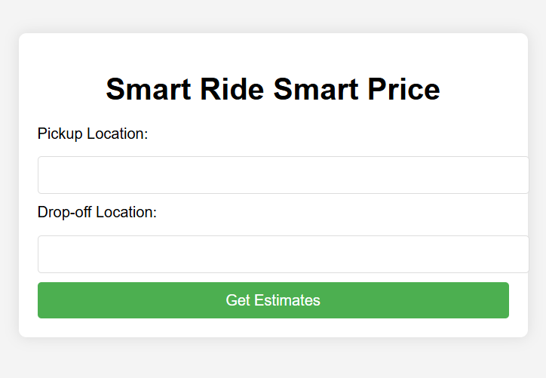

**TEST CASE 2**

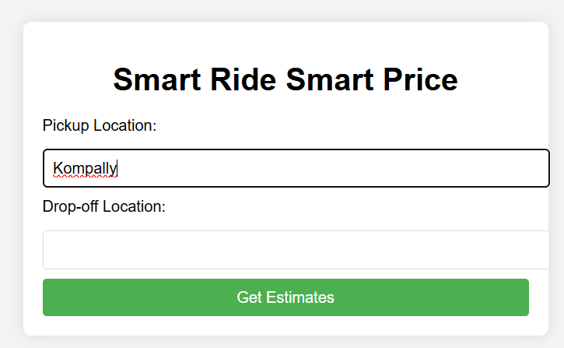

# TEST CASE 3

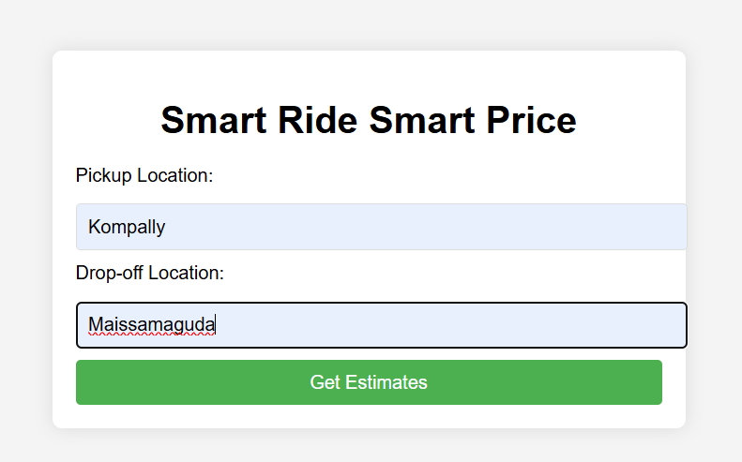

**TEST CASE 4**

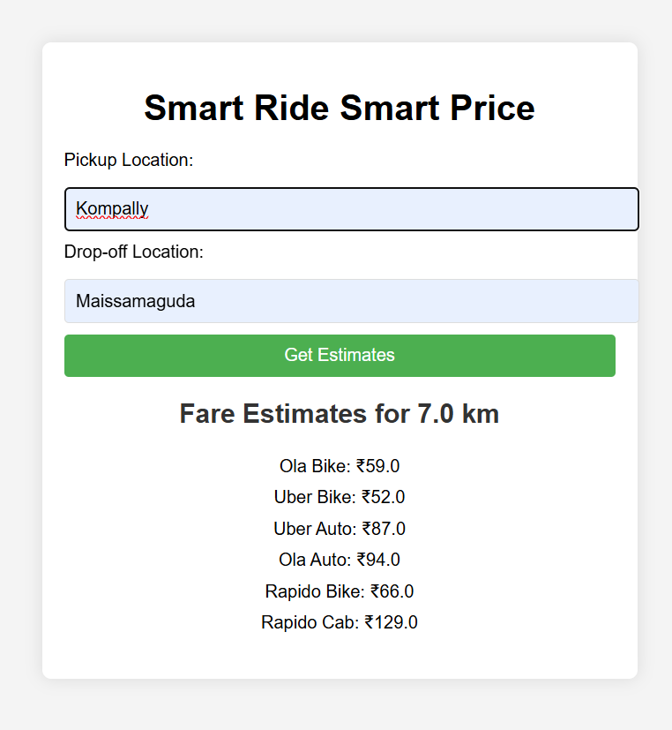

# VII.FUTURE WORK

Future work for the Smart Ride Smart Price project could involve expanding the analysis to include more ride-hailing services, both regional and global, for a broader market comparison. Integrating real-time data through APIs for live fare comparisons would enhance pricing accuracy. Additionally, assessing the environmental impact of different transport options (e.g., cars vs. two-wheelers) could promote eco-friendly choices. Further, incorporating user experience, safety metrics, and customer satisfaction surveys would provide a more holistic evaluation of ride services beyond just pricing.

# VII.REFERENCES

[1.] Understanding the Pricing Structures of Ride-Hailing platforms: A Comparative Analysis (Doe et al., 2021). [2.] Dynamic Pricing in the Ridesharing Industry:

How Ola Adjust Fares (Smith et al., 2020). [3.] Surge Pricing in Ride-Hailing:

Impacts on Customer Behavior and Platform Efficiency [4.] Environmental Footprint of Ride-Hailing Services: A Comparative Study Between Cars and Two-Wheelers [5.] Evaluating Customer Satisfaction and Safety in

the Ride-Hailing Sector (Turner et al., 2020). [6.] The Role of Technology in the Evolution of Ridesharing Services (Chen et al., 2018).

[7.] Comparative Analysis of Ride-HailinServices:

User Preferences and Market Trends (Johnson et al., 2021 [8.] Impact of Pricing Strategies on Customer Loyalty

in Ride-Hailing Apps (Garcia et al., 2022).

[9.] The Influence of Traffic Conditions on Ride-Hailing Prices: A Case Study (Kumar et al., 2020).

[10.] Examining the User Experience in Ride-Hailing: A Survey Study (Nguyen et al., 2023).

# VI.CONCLUSION

The **Smart Ride Smart Price** project provides a comprehensive comparison of ride-hailing services such as **Ola**, **Uber**, and **Rapido**, highlighting key pricing trends and service efficiency. Through detailed analysis, it is evident that while pricing structures vary significantly between these platforms, several factors like surge pricing,

time of day, and location play a crucial role in determining , the most cost-effective option.