**A STUDY ON IMPACT OF SELF SERVICE ON PERFORMANCE IN SUPERMARKET**

**Dr. M. Robinson,** Assistant Professor, Department of Management Studies. Anna University BIT Campus, Trichy, Tamilnadu, India.

**R. ASHOK,** Final MBA Student, Department of Management Studies. Anna University, BIT Campus, Trichy, Tamilnadu, India.

**ABSTRACT**

The conception of self-service technology in supermarkets has greatly changed the retail industry, affecting not only operational performance but also customer experience. This study explores the impact of a self-service system, such as kiosks at checkout and online ordering platforms, on supermarket performance. The study analyzes these technologies in the light of efficiency as well as cost management and customer satisfaction, thus offering valuable insights into the basic forces that shape self-service innovations to remake the forms through which supermarkets do business and respond to present-day consumers. One thing that is often associated with self-service technology is a reduction in wait times, an improvement in operational efficiency, and better conveniences for customers. It thus enables supermarkets to vary their personnel according to the demand that helps reduce operating costs. On the downside, self-service shift comes with a good number of challenges that include increased customer irritation with the technology used, security issues, and continuous training of staff and adaptation. This paper analyzes both positive and negative self-service adoption outcomes for supermarkets, offering insights to balance technological innovation with customer satisfaction and operational needs. Results indicate that self-service can result in significant performance improvements, but it must be implemented and managed carefully to maximize the benefits and minimize disadvantages.

**Keywords:**

SSTs (Self Service Technologies), Reduced Staff Needs, Performance Metrics

**INTRODUCTION**

There have been a lot of changes in supermarkets with regard to the retail industry, especially in the recent years, mainly due to scientific inventions and people's evolving preferences. Among the most significant innovations introduced are the self-service systems, such as from self-checkout kiosks to mobile apps that make orders in stores or online purchases.Developed to make customer experience easy and efficient in terms of shopping, and effective in bringing down the overhead cost for retailers, these technologies hence draw a need for a better understanding of their influence on supermarket business performances.This paper studies the impact of self-service technology on operational efficiency through cost management, customer satisfaction, and business performance in supermarkets. Analyzing both positive and negative aspects of self-service, the study offers valuable insights into how supermarkets can take advantage of these technologies to meet the new expectations of modern consumers, while improving internal processes and optimum performance.

**LITERATURE REVIEW**

**According to Meuter et al. (2000)**, customers expect convenience, control, and expediency from self-service options, but satisfaction varies with issues of ease of use and reliability of the systems.

**Dabholkar et al. 2003**. There are three types of SSTs: interactive kiosks, mobile apps, and internet based. All of which are assigned to improve convenience and reduce operational costs.

**Jones and Clark (2018),** the self-service systems reduce operational dependencies on cashiers, making transactions faster. Self-checkout supermarkets haveexperienced lower labor costs and increased throughput, thus empowering supermarkets during peak hours..

**Davis and Johnson (2019) reveals,** an older customer often becomes frustrated and dissatisfied upon dealing with SSTs. Besides, job displacement and loss of personal contact have also been depicted.

**According** **to Smith et al. (2020),** supermarkets implemented with self-checkout kiosks have observed an increase of 10-15% compared to total profitability.

**OBJECTIVES**

**•**  To determine the impact of self-service on efficiency and cost-cutting of supermarkets.

• To analyzing Self-Service and Employee Role/ Productivity in Supermarkets.

• To challenges that supermarkets face while carrying out and maintaining self-service systems.

• To Recommendations for the optimization of self-service systems to provide better performances for supermarkets.

**DATA ANALYSIS AND INTERPRETATION:**

**1.PERCENTAGE ANALYSIS:**

**1.AGE**

| **S.no** | **Variables** | **Respondents** | **% of Respondents** |
| --- | --- | --- | --- |
| 1 | 18-25 | 49 | 59 |
| 2 | 25-35 | 17 | 20.5 |
| 3 | 35-45 | 10 | 12 |
| 4 | 45-55 | 6 | 7.2 |
| 5 | 55 above | 1 | 1.2 |
|  | Total | 83 | 100 |

**Figure No:**1.1

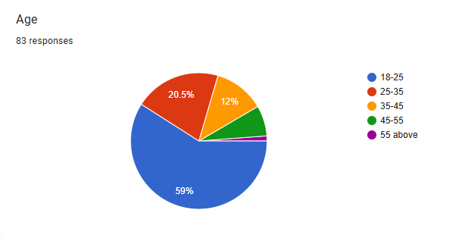**Interpretation:**

The frequency distribution table reveals the age of respondents. The majority 59% are between 18-25 years, and so it suggests that younger respondents are the main participants who are more interested or concerned with self-service in a supermarket. It is followed by 25-35 age group at 20.5%, followed by 35-45(12%), 45-55(7.2%), and the last one is aged 55 above, which only takes the smallest segment at 1.2%. This trend means younger respondents are more concerned about self-service in supermarket.

**2.GENDER**

| **S.no** | **Variables** | **Respondents** | **% of Respondents** |
| --- | --- | --- | --- |
| 1 | Male | 40 | 48.2 |
| 2 | Female | 40 | 48.2 |
| 3 | Prefer not to say | 3 | 3.6 |
|  | Total | 83 | 100 |

**Figure No:** 1.2

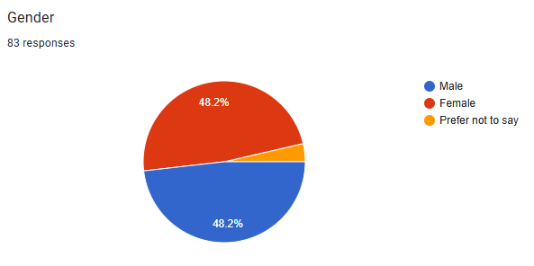

**Interpretation:**

The gender distribution is almost even in this sample, as males and females each make up almost half of the respondents (48.2% each). A small minority chose the "Prefer not to say" option, at 3.6%, implying a very low level of non-disclosure on gender.

**3.MARTIAL STATUS**

| **S.no** | **Variables** | **Respondents** | **% of Respondents** |
| --- | --- | --- | --- |
| 1 | Married | 29 | 35.4 |
| 2 | Unmarried | 53 | 64.6 |
| 3 | Widow | 0 | 0 |
|  | Total | 83 | 100 |

**Figure No:**1.3 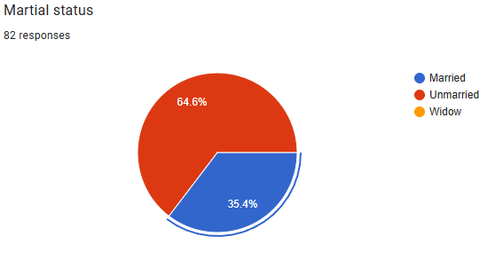

**Interpretation:**

A big percentage of respondents are not married; the percentage was 64.6 percent and 35.4 percent were married, while the widowed was zero since none of them fall in that category.

**4.QUALIFICATION**

| **S.no** | **Variables** | **Respondents** | **% of Respondents** |
| --- | --- | --- | --- |
| 1 | 10th | 3 | 3.6 |
| 2 | 12th | 4 | 4.8 |
| 3 | Diploma | 11 | 13.3 |
| 4 | Graduate | 33 | 39.8 |
| 5 | Post graduate | 32 | 38.6 |
|  | Total | 83 | 100 |

**Figure** :1.4

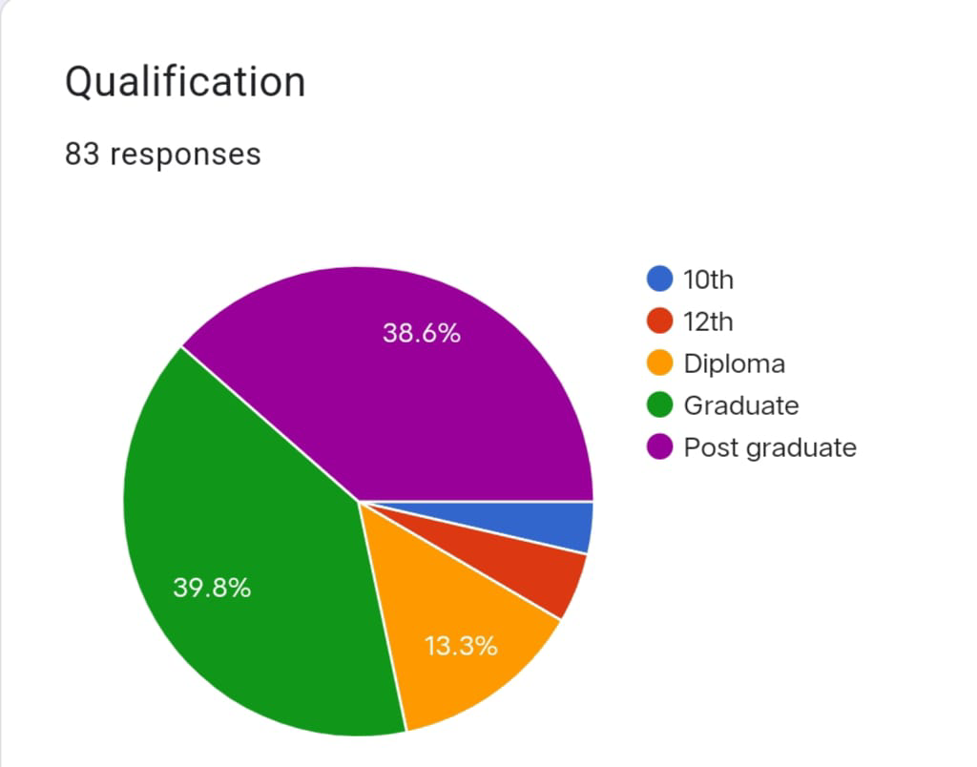

**Interpretation:**

A large proportion of the respondents (78.4% combined) have higher educational qualifications, with the largest groups being graduates (39.8%) and postgraduates (38.6%).The remaining 21.6% of the sample consists of individuals with lower levels of education, such as 10th grade (3.6%), 12th grade (4.8%), and diploma holders (13.3%).This would suggest a fairly well-educated sample overall, with the majority having completed graduate or post-graduate education.

**1.5: OCCUPATION**

| **S.no** | **Variables** | **Respondents** | **% of Respondents** |
| --- | --- | --- | --- |
| 1 | Employed | 30 | 36.1 |
| 2 | Unemployed | 11 | 13.3 |
| 3 | Student | 37 | 44.6 |
| 4 | Self Employed | 5 | 6 |
|  | Total | 83 | 100 |

**Figure No:**1.5

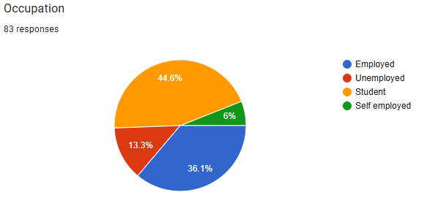

**Interpretation:**

A majority of the respondents, 44.6%, are students, which means the sample is highly representative of people who are currently in school. The majority of the respondents, 36.1%, are working, and 13.3% are unemployed. Only 6% reported being self-employed, which would indicate that entrepreneurship or self-employment is not as prevalent within this population.

**1.6: INCOME**

| **S.no** | **Variables** | **Respondents** | **% of Respondents** |
| --- | --- | --- | --- |
| 1 | Below 10000 | 24 | 32 |
| 2 | 10000-20000 | 12 | 16 |
| 3 | 20000-30000 | 15 | 20 |
| 4 | 30000-40000 | 14 | 18.7 |
| 5 | 40000-50000 | 4 | 5.3 |
| 6 | 50000 Above | 6 | 8 |
|  | Total | 75 | 100 |

**Figure No:**1.6

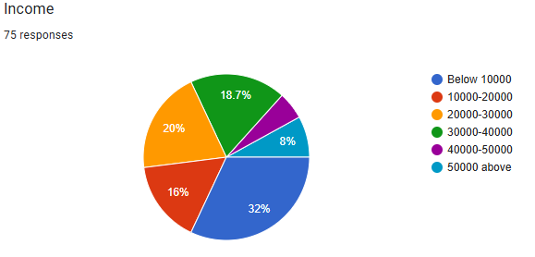

**Interpretation:**

The largest percentage of the respondents (32%) earn below 10,000 meaning that most of the sample has relatively low income. The income distribution is relatively wide, with the largest share (32%) earning below 10,000, followed by 20% earning between 20,000 and 30,000. The higher income ranges of 40,000-50,000 and above 50,000 have a much smaller share of the sample at 5.3% and 8%, respectively. Overall, this suggests that most respondents are in the lower to middle-income brackets, with fewer individuals in the higher-income ranges.

**2.CHI-SQUARE TEST ANALYSIS:**

**1.Age and Frequency use**

H0:There is no significant difference between age and frequency use of self service in supermarket

H1: There is a significant difference between age and frequency use of self service in supermarket

**Table No:** 2.1

**Table Name:** Age and frequency use

|  |  |  | | | | |  |
| --- | --- | --- | --- | --- | --- | --- | --- |
|  |  | always | often | sometimes | rarely | never | Total |
| 18-25 | Observed | **12** | **9** | **19** | **6** | **3** | 49 |
|  | Expected | 8.37 | 11.35 | 22.71 | 4.78 | 1.79 | 49.00 |
|  | % of chisq | 9.2% | 2.8% | 3.5% | 1.8% | 4.7% | 22.1% |
| 25-35 | Observed | **1** | **4** | **12** | **0** | **0** | 17 |
|  | Expected | 2.90 | 3.94 | 7.88 | 1.66 | 0.62 | 17.00 |
|  | % of chisq | 7.3% | 0.0% | 12.6% | 9.7% | 3.6% | 33.1% |
| 35-45 | Observed | **1** | **3** | **4** | **2** | **0** | 10 |
|  | Expected | 1.71 | 2.32 | 4.63 | 0.98 | 0.37 | 10.00 |
|  | % of chisq | 1.7% | 1.2% | 0.5% | 6.3% | 2.1% | 11.8% |
| 45-55 | Observed | **0** | **2** | **3** | **0** | **0** | 5 |
|  | Expected | 0.85 | 1.16 | 2.32 | 0.49 | 0.18 | 5.00 |
|  | % of chisq | 5.0% | 3.6% | 1.2% | 2.8% | 1.1% | 13.6% |
| above 55 | Observed | **0** | **1** | **0** | **0** | **0** | 1 |
|  | Expected | 0.17 | 0.23 | 0.46 | 0.10 | 0.04 | 1.00 |
|  | % of chisq | 1.0% | 14.8% | 2.7% | 0.6% | 0.2% | 19.3% |
| Total | Observed | 14 | 19 | 38 | 8 | 3 | 82 |
|  | Expected | 14.00 | 19.00 | 38.00 | 8.00 | 3.00 | 82.00 |
|  | % of chisq | 24.1% | 22.4% | 20.5% | 21.2% | 11.8% | 100.0% |
|  |  |  |  |  |  |  |  |
|  |  | 17.16 | chi-square |  |  |  |  |
|  |  | 16 | df |  |  |  |  |
|  |  | .3755 | p-value |  |  |  |  |

**Interpretation:**

Thus the χ2 value is less than table value we accept the hypothesis. Therefore there is no relationship between age and frequency use among consumer.

**2. Gender and Customer Satisfaction**

H0:There is no significant difference between gender and customer satisfaction of self service in supermarket

H1:There is a significant difference between gender and customer satisfaction of self service in supermarket

**Table No:**2.2

**Table Name:** Gender and Customer satisfaction

|  |  |  | | | | |  |
| --- | --- | --- | --- | --- | --- | --- | --- |
|  |  | vs | s | n | ds | vs | Total |
| male | Observed | **8** | **10** | **21** | **1** | **0** | 40 |
|  | Expected | 4.44 | 11.36 | 23.21 | 0.49 | 0.49 | 40.00 |
|  | % of chisq | 34.0% | 1.9% | 2.5% | 6.2% | 5.9% | 50.6% |
| female | Observed | **1** | **13** | **26** | **0** | **1** | 41 |
|  | Expected | 4.56 | 11.64 | 23.79 | 0.51 | 0.51 | 41.00 |
|  | % of chisq | 33.2% | 1.9% | 2.5% | 6.1% | 5.8% | 49.4% |
| Total | Observed | 9 | 23 | 47 | 1 | 1 | 81 |
|  | Expected | 9.00 | 23.00 | 47.00 | 1.00 | 1.00 | 81.00 |
|  | % of chisq | 67.2% | 3.8% | 5.0% | 12.3% | 11.7% | 100.0% |
|  |  |  |  |  |  |  |  |
|  |  | 8.36 | chi-square |  |  |  |  |
|  |  | 4 | df |  |  |  |  |
|  |  | .0794 | p-value |  |  |  |  |

**Interpretation**

Thus the χ2 value is less than table value we accept the hypothesis. Therefore there is no relationship between Gender and Customer among consumer.

**FINDINGS**

1. The proportion of male to female respondents is almost the same at 48.2%, with 3.6% not wanting to specify gender.

2. Respondents are primarily unmarried (64.6%), with the remaining respondents (35.4%) having a spouse. No participants are reported as being widowed.

3. The majority of respondents have either graduated (39.8%) or have pursued postgraduate education (38.6%). Others hold diplomas (13.3%) or have completed higher secondary education (4.8%).

4. Students form the largest group in the sample (44.6%), followed by employed individuals (36.1%). A smaller percentage are unemployed (13.3%) or self-employed (6%).

5. Most respondents earn between ₹10,000 and ₹30,000 monthly (68.6% combined). A significant portion earns less than ₹10,000 (32%), while fewer earn above ₹30,000.

6. Online services are used occasionally by the largest share of respondents (45.8%), with a notable number using them often (24.1%). A minority rarely (9.6%) or never (3.6%) utilize these services.

7. Most of the respondents were neutral (59%) or satisfied (28.9%) with their experience. Very few were dissatisfied (1.2%), and no one was very dissatisfied.

8. Ease of use: Most of the respondents feel that it is neutral (57.8%), while others find it easy (31.3%). Very few think it is difficult (2.4%), and no one finds it very difficult.

9. More than two-thirds of respondents perceive the influence as neither positive nor negative (66.3%). Others are somewhat positive (24.1%) or significantly positive (9.6%). None are negative. 10. Most respondents also perceive the product or service as neutral in influence to them (68.7%). Some view it as very influential (13.3%), or somewhat influential (14.5%).

11. A big portion of the respondents were neutral at 41%, or even willing to endorse the product/service at 45.8%. Fewer were highly recommending it at 13.3% with no one advising against.

12. Areas for improvement are desired on better customer service (34.9%) and faster machines (22.9%). Other requests included easier payment methods at 19.3%, fewer errors at 12%.

13. Most respondents agree to the behavior "sometimes" (61.4%), with fewer saying it is done "often" (20.5%) or "very often" (6%).

14. Most respondents are neutral regarding a statement (61.4%), while 24.1% agreed and 10.8% strongly agreed. A small minority (3.6%) did not fully agree or disagree.

**SUGGESTIONS**

1. With the sample almost equally distributed between males and females, ensure that the design of the product or service and features and marketing strategies are as appealing to both genders. Provide options for those who do not want to reveal their gender.

2. With 64.6% of the participants being unmarried, create something that caters to younger, unmarried people's lifestyle choice. This could be in flexible subscription plans or something that could support social interaction and networking.

3. A large percentage of respondents are graduates and postgraduates. Provide features and content relevant to their educational levels. For those with lesser formal education, simplify the product or service by using visuals or easy-to-understand language.

4. Students comprise the largest segment (44.6%), so student-centric initiatives such as lower price points, loyalty programs, and features that address students' needs, like study aids or job opportunities should be given priority.

5. Design products or services in the range of ₹10,000 to ₹30,000. That would appeal to most incomes. To ensure that even people making below ₹10,000 could afford to pay for a plan, develop inexpensive basic plans or tiered price plans.

6. Ease of use and reliability of access to online services should be promoted to enhance usage frequency. A simple video tutorial or step-by-step guide should be designed for the less frequent user to get comfortable with using the site.

7. Although the majority of users are neutral or satisfied, efforts need to be done to mitigate dissatisfaction by improving customer service and responding to issues more quickly and efficiently.

8. Since most of the respondents have found the ease of use as neutral, make it simple and reduce the steps to complete a task while including features like FAQs, live chat support, as well as mobile-friendly design to enhance usability.  
  
9.Narrate the success stories to emphasize the positive effects and show the product's or service's value to their target clients.  
  
10. This value can be presented during market targeting by campaigns specifically created to highlight how this will serve users in a functional or practical way with benefits within real life.

11. Engage neutral users as brand advocates by rewarding them, for example, through a referral program. Maintain high product or service quality to create more frequent and stronger word-of-mouth recommendations.  
  
12. Focus on areas of improvement in key areas identified through responses: customer service (34.9%), speed optimization (22.9%), ease of payment processes (19.3%), and reduction of errors (12%) through quality control efforts.

13. Encourage user interaction by allowing personalized notifications, unique content, or gamification for the "sometimes" or "often" user of the product or service.  
  
14. Build communication and transparency so more users can agree with the product/service values. Apply clear messaging, workable demos, and experience the tangible benefits to clarify neutral and uncertain perceptions.

**CONCLUSION**

The results were that the customers give a good impression of the product or service offered. However, improvements are needed in areas like customer support, performance of machines, options available for payments, and reducing error rates. Though the impact created by this product received a neutral response, it does offer an opportunity to enhance the value this product provides to its target audience based on user-specific needs and improving the experiences of users overall. The product/service, therefore, shall be more aligned with streamlining procedures, fortifying the support structures, and coming up with features that appeal to the various user groups, such as students, low-income earners, among others. The good feeling already allocated by users with the product can help to bring about positive word-of-mouth, which is bound to lead to high involvement.

**REFERENCES**

1. Meuter, M. L., Ostrom, A. L., Roundtree, R. I., & Bitner, M. J. (2000). Self-service technologies: Understanding customer satisfaction with technology-based service innovations. Journal of Marketing, 64(3), 50-64.
2. Liao, C., Palvia, P., & Chen, J. (2006). Information technology adoption in the retail industry: A case study of self-service technology in supermarkets. International Journal of Retail & Distribution Management, 34(9), 663-681.
3. Pantano,E.,&Timmermans,H.2014.What is smart for retailing? Customers' and retailers' perspective on smart retailing. International Journal of Retail & Distribution Management, 42(4), 284-293.
4. Bitner, M.J., Ostrom, A.L.,& Meuter, M.L.(2002).Implementing successful self-service technologies. Academy of Management Perspectives, 16(4), 96-108.