**A STUDY ON CUSTOMER RELATIONSHIP MANAGEMENT IN SUPERMARKET**

**Dr. M. Robinson,** Assistant Professor, Department of Management Studies. Anna University BIT Campus, Trichy.

**M. Roobini,** Final MBA Student, Department of Management Studies. Anna University, BIT Campus, Trichy.

**ABSTRACT**

The purpose of this paper is to explore the role of CRM in supermarkets, indicating its influence on customer satisfaction and retention as well as business performance. Analyzing CRM strategies, which include data analysis, loyalty card programs, and personal marketing, contributes to customers' improved experiences. Therefore, through a review of existing literature this research would identify best practice and challenges facing the implementation of CRM systems in the retail sector. The results emphasized the importance of CRM in fostering customer loyalty, improving operating efficiencies, and profitability for a supermarket in a highly competitive market.

**Keywords:**

CRM (Customer Relationship Management), Supermarkets, Customer satisfaction

**INRODUCTION**

Customer Relationship Management, in short is the strategic approach to managing customer interaction for the purpose of building customer relationship in order to increase customer satisfaction and loyalty. CRM is highly important in the supermarket business with a competitive edge since it allows businesses to understand their customers' needs, personalize shopping, and build long-term relationships. Through data-driven insights, supermarkets can optimize their efforts in marketing, become more efficient in operations, and eventually retain customers. CRM systems provide methods for customer segmentation, tailored promotions, and proper feedback systems-which all come together to deliver much better services.

**LITERATURE REVIEW**

**According to Kotler and Keller (2016),** CRM is integral to building strong customer relationships, key drivers of brand loyalty and profitability.

**Research by Smith in 2019,** among others, entail that CRM tools involve loyalty programs and mobile applications among other things to enhance the engagement of customers and ultimately the basket size. In supermarkets, CRM facilitates personalization of offers and prediction of a customer's preferences, which subsequently leads to targeted marketing.

**Brown & Lee, 2020**,Technology advancement has transformed CRM practice. Supermarkets have the ability to analyze customer behavior, predict trends, and provide customized recommendations using big data analytics, artificial intelligence, and machine learning.

**Gronroos (2020),** demonstrate that successful CRM strategies have greatly improved customer satisfaction and loyalty. Mass communication, quality service, and rewarding schemes create value perceptions for customers, resulting in repeat business.

**According to research by Johnson et al. (2021),** effective CRM implementation highly depends on employee training and organizational alignment.

**OBJECTIVE**

* To Understand the concept of CRM and its significance in the retail industry.
* To Analyzing the way CRM strategies enhance customer satisfaction and loyalty in supermarkets.
* To Identify key CRM tools and techniques utilized by supermarkets to manage customer relationships.
* To Evaluate the challenges supermarkets face in implementing CRM systems and suggest effective solutions.
* To Investigate CRM's Effectiveness in Revenue Growth and Competitive Advantage for Supermarkets.

**DATA ANALYSIS AND INTERPRETATION:**

**1.PERCENTAGE TEST ANALYSIS:**

**1.AGE**

| **S.no** | **Variables** | **Respondents** | **% of Respondents** |
| --- | --- | --- | --- |
| 1 | 18-25 | 68 | 82.9 |
| 2 | 25-35 | 9 | 11 |
| 3 | 35-45 | 1 | 1.2 |
| 4 | 45-55 | 3 | 3.7 |
| 5 | 55 above | 1 | 1.2 |
|  | Total | 83 | 100 |

**Figure No:** 1.1

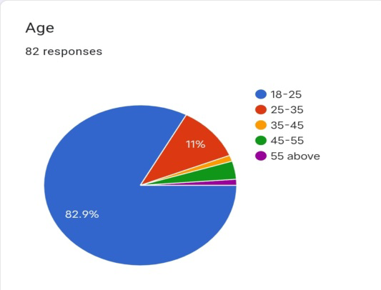

**Interpretation:**

The survey highly represents younger persons aged between 18-25, making up 82.9% of the respondents, and a minimum representation on the older groups aged 35 and above; this may likely be due to the resonance of the target audience with the nature of the survey with younger persons. The number of participants stands at 83 and this sample skews more heavily toward the younger age ranges so that these data will have more utility in the preference, behaviors, or attitudes among younger adults but much less utility among the elderly.

**2. GENDER**

| **S.no** | **Variables** | **Respondents** | **% of Respondents** |
| --- | --- | --- | --- |
| 1 | Male | 52 | 63.4 |
| 2 | Female | 30 | 36.6 |
| 3 | Prefer not to say | 0 | 0 |
| 4 | Total | 83 | 100 |

**Figure No:** 1.2

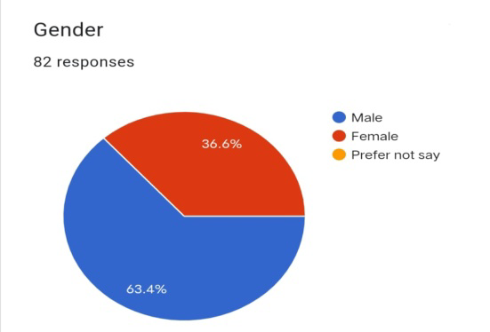

**Interpretation:**

The sample of survey participants indicates a gender imbalance, given that there are more male participants than female participants: 63.4% of the surveyed population is male, and 36.6% of the surveyed population is female. No respondents selected the answer choice of "Prefer not to say" related to their gender. The number of respondents is 83; gender distribution exhibits a predominance of the male group.

**3.MARTIAL STATUS**

| **S.no** | **Variables** | **Respondents** | **% of Respondents** |
| --- | --- | --- | --- |
| 1 | Married | 23 | 28 |
| 2 | Unmarried | 58 | 70.7 |
| 3 | Widow | 1 | 1.2 |
|  | Total | 83 | 100 |

**Figure No:** 1.3

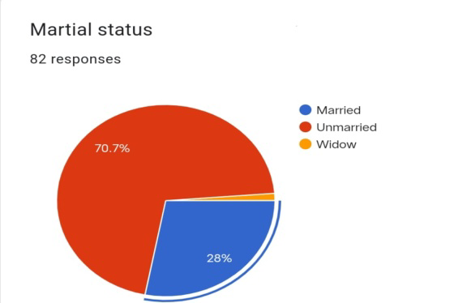

**Interpretation:**

The sample is mainly unmarried people, with 70.7% of the sample; a much smaller proportion is married, 28%; and a very small proportion is widowed, 1.2%. The total number of respondents is 83, and the data seems to indicate that the sample skews toward younger people or stages of life where marriage is less prevalent.

**4.QUALIFICATION**

| **S.no** | **Variables** | **Respondents** | **% of Respondents** |
| --- | --- | --- | --- |
| 1 | 10th | 0 | 0 |
| 2 | 12th | 2 | 2.5 |
| 3 | Diploma | 18 | 22.2 |
| 4 | Graduate | 30 | 37 |
| 5 | Post Graduate | 31 | 38.3 |
|  | Total | 81 | 100 |

**Figure** 1.4

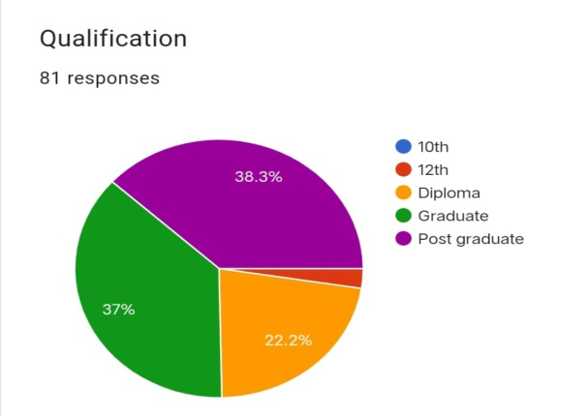

**Interpretation:**

The educational profile of the sample is highly skewed toward individuals with higher education, with a combined 75.3% of respondents holding at least a graduate or post-graduate degree. Only 2.5% have completed only up to the 12th grade, and no one has just completed the 10th grade. Total respondents totaled 81, and available data seem to indicate that the sample may have an orientation towards more educated people-focusing on graduates and post-graduates.

**5.OCCUPATION**

| **S.no** | **Variables** | **Respondents** | **% of Respondents** |
| --- | --- | --- | --- |
| 1 | Employed | 31 | 37.8 |
| 2 | Unemployed | 6 | 7.3 |
| 3 | Student | 44 | 53.7 |
| 4 | Self employed | 1 | 1.2 |
|  | Total | 82 | 100 |

**Figure No:** 1.5

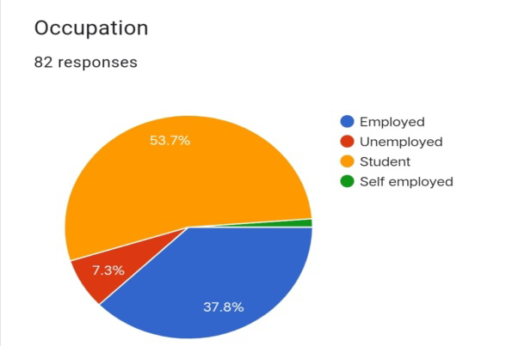

**Interpretation:**

Majority are students 53.7% and employed 37.8%, while small parts are unemployed 7.3% and self-employed 1.2%. Respondents total are 82 and the sample probably constitutes a younger segment of population since many respondents are in educational institutions.

**6.INCOME**

| **S.no** | **Variables** | **Respondents** | **% of Respondents** |
| --- | --- | --- | --- |
| 1 | Below 10000 | 35 | 49.3 |
| 2 | 10000-20000 | 23 | 32.4 |
| 3 | 20000-30000 | 5 | 7 |
| 4 | 30000-40000 | 3 | 4.2 |
| 5 | 40000-50000 | 2 | 2.8 |
| 6 | 50000 Above | 3 | 4.2 |
|  | Total | 71 | 100 |

**Figure No:** 1.6

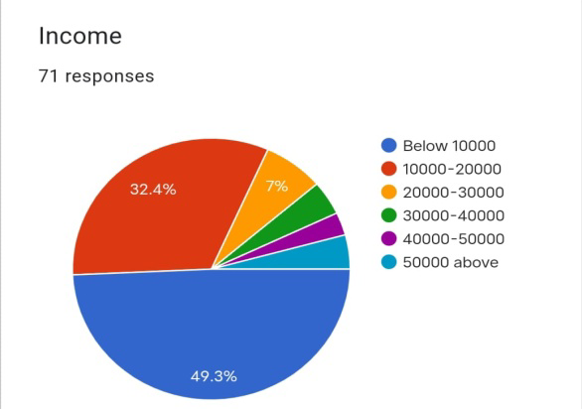

**Interpretation:**

The majority of respondents (49.3%) earn less than 10,000 per month, followed by those earning between 10,000 and 20,000 (32.4%). There are fewer respondents in the higher income brackets, with only 7% earning between 20,000 and 30,000, and even smaller proportions in the higher income ranges (30,000 and above). There are 71 total respondents. Data indicate that the sample consists mostly of those with lower to lower-middle income levels, with very few from higher income brackets.

**7.LIVING AREA**

| **S.no** | **Variables** | **Respondents** | **% of Respondents** |
| --- | --- | --- | --- |
| 1 | Urban | 64 | 78 |
| 2 | Rural | 18 | 22 |
|  | Total | 82 | 100 |

**Figure No:** 1.7

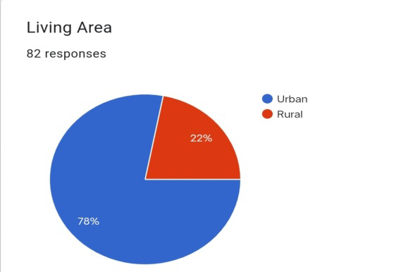

**Interpretation:**

The sample is predominantly urban, with 78% of respondents coming from urban areas and 22% from rural areas. The total number of respondents is 82, and the data indicates a strong urban skew in the sample, which may reflect the survey's reach or the focus of the study being more relevant to urban populations.

**2.CHI-SQUARE TEST ANALYSIS:**

**1. Age and Customer Satisfaction**

H0: There is no significant difference between age and customer satisfaction in CRM

H1: There is a significant difference between age and customer satisfaction in CRM

**Table No:** 2.1

**Table Name:** Age and customer satisfaction

|  |  |  | | |  |
| --- | --- | --- | --- | --- | --- |
|  |  | ve | se | ne | Total |
| 18-25 | Observed | **26** | **39** | **2** | 67 |
|  | Expected | 21.54 | 40.68 | 4.79 | 67.00 |
|  | % of chisq | 3.2% | 0.2% | 5.6% | 9.0% |
| 25-35 | Observed | **0** | **8** | **1** | 9 |
|  | Expected | 2.89 | 5.46 | 0.64 | 9.00 |
|  | % of chisq | 9.9% | 4.0% | 0.7% | 14.6% |
| 35-45 | Observed | **0** | **1** | **1** | 2 |
|  | Expected | 0.64 | 1.21 | 0.14 | 2.00 |
|  | % of chisq | 2.2% | 0.1% | 17.6% | 20.0% |
| 45-55 | Observed | **1** | **2** | **0** | 3 |
|  | Expected | 0.96 | 1.82 | 0.21 | 3.00 |
|  | % of chisq | 0.0% | 0.1% | 0.7% | 0.8% |
| above 55 | Observed | **0** | **1** | **2** | 3 |
|  | Expected | 0.96 | 1.82 | 0.21 | 3.00 |
|  | % of chisq | 3.3% | 1.3% | 51.0% | 55.6% |
| Total | Observed | 27 | 51 | 6 | 84 |
|  | Expected | 27.00 | 51.00 | 6.00 | 84.00 |
|  | % of chisq | 18.6% | 5.7% | 75.7% | 100.0% |
|  |  |  |  |  |  |
|  |  | 29.16 | chi-square |  |  |
|  |  | 8 | df |  |  |
|  |  | .0003 | p-value |  |  |

**Interpretation**

Thus the χ2 value is less than table value we accept the hypothesis. Therefore there is no relationship between Age and customer among consumer.

**2. Gender and Customer loyalty**

H0:There is no significant difference between gender and customer loyalty of CRM

H1: There is a significant difference between gender and customer loyalty in CRM

**Table No:** 2.2

**Table Name:** Gender and customer Loyalty

|  |  |  |  |  |  |  |
| --- | --- | --- | --- | --- | --- | --- |
|  |  |  |  | | |  |
|  |  |  | ve | se | ne | Total |
|  | male | Observed | **14** | **35** | **2** | 51 |
|  |  | Expected | 15.11 | 33.37 | 2.52 | 51.00 |
|  |  | % of chisq | 11.3% | 11.0% | 14.8% | 37.0% |
|  | female | Observed | **10** | **18** | **2** | 30 |
|  |  | Expected | 8.89 | 19.63 | 1.48 | 30.00 |
|  |  | % of chisq | 19.2% | 18.7% | 25.1% | 63.0% |
|  | Total | Observed | 24 | 53 | 4 | 81 |
|  |  | Expected | 24.00 | 53.00 | 4.00 | 81.00 |
|  |  | % of chisq | 30.5% | 29.7% | 39.8% | 100.0% |
|  |  |  |  |  |  |  |
|  |  |  | .72 | chi-square |  |  |
|  |  |  | 2 | Df |  |  |
|  |  |  | .6964 | p-value |  |  |

**Interpretation**

Thus the χ2 value is less than table value we accept the hypothesis. Therefore there is no relationship between Gender and customer Loyalty among consumer.

**FINDINGS**

1. The age group 18-25 constitutes the majority of the respondents (82.9%), and very few respondents are from the older age groups, thus a very young population for the survey.

2. The percentage of male respondents is higher than female respondents (63.4% and 36.6% respectively), indicating a predominantly male sample.

3. Most of the respondents are unmarried (70.7%), followed by married (28%), which indicates a relatively young, single respondent group.

4. Most of the respondents are graduates (37%) or have post-graduate (38.3%) qualifications, which shows that a very educated sample has participated in the survey.

5. The majority of the respondents are students (53.7%), and employed ones make up a relatively minor part of the sample (37.8%), that indicates an equal mix of academically and professionally orientated participants.

6. Most of the respondents lie in the range of 10,000-20,000 (32.4%). There is a substantial chunk of respondents who fall in the range of below 10,000 (49.3%).

7.Most stay in cities (78%), leaving only a few coming from cities (22%), which is an urban-bias sample.

8.63.4% of participants said they are fairly knowledgeable with regard to the topic discussed, but again, as above, there's a component who is very familiar with 25.6%.

9.Again, and again, most regard the issue to be fairly significant (64.2%), and again not least, a proportion of considerable magnitude regards the issue with considerable significance (30.9%).

10. A considerable amount feels it is somewhat effective (63%), though fewer respondents view it as very effective (33.3%).

11. Most consider the impact to be moderate (67.6%), although a smaller percentage thinks it to have a high impact (29.6%).

12. Most respondents report sometimes relating to the topic (72.8%), whereas a smaller percentage reports often (18.5%) or never/rarely (8.6%).

13.A majority of respondents indicate it would increase their spending modestly (75.3%), and very few indicated that it would have no impact at all (6.2%).

14. 59.3% say the topic is somewhat important, and 38.3% say it's very important, indicating a broad sense of its worth.

15. The most preferred loyalty rewards (66.7%), followed by personal promotions (22.2%), and fewer respondents chose customer service improvement (11.1%).

16. Most respondents sometimes receive promotional content (66.7%), while a smaller group receives it often (25.9%), and a very small group infrequently/never (7.4%).

17. Very large majority, 72.8%, are likely to act on offers; smaller group is uncertain 19.8%, and nearly none said they are not likely 3.7%.

18. Large proportion finds subject somewhat valuable 65.4%, extremely valuable 28.4%, while only 6.2% finds it not valuable.

19.The respondents preferred SMS alerts; this stood at 56.8%, followed by 18.5% preference for social media and 13.6% in-store signages. The least number of preference for communication was held by the respondents for email news letters with 11.1%.

20.The respondents were somewhat likely to act or make that decision at 70.4%. A significant chunk was very likely to act (25.9%).

21.Most believe the factor is handled well at 71.6%; 22.2% think they handle it very well, whereas 6.2% thought that they handle it very badly.

22. A majority, 72.8%, are likely to take action on future offers or promotions, indicating strong potential for future engagement.

**SUGGESTIONS**

1. Most respondents are aged between 18 and 25 (82.9%), so tailor products, services, and marketing strategies according to the preferences, habits, and needs of that age group. Use popular platforms and trends among them, such as social media, influencer marketing, or gamified promotions.

2. Since the sample is predominantly male (63.4%), determine whether the topic or offering inadvertently favors men. Consider female-centric campaigns or initiatives to achieve a balance.

3. Since most respondents are unmarried (70.7%), design offerings and messaging that appeal to single people, focusing on flexibility, personal growth, or social opportunities that match their lifestyle.

4. The majority of the respondents are highly educated: graduates 37% and postgraduates 38.3%. They will appreciate information detailed, factual, and engaging. Reduce complexity only when it is necessary to appeal to less-educated subgroups.

5. Most are students (53.7%) and a smaller part of them are employed (37.8%), so pay attention to budget-friendly products or services, student discounts, and career-oriented offers like skill-building resources or entry-level job support.

6. Almost half earn less than ₹10,000 (49.3%) and many others earn between ₹10,000–₹20,000 (32.4%), affordability is essential. Offer low-cost or tiered products to service this price-sensitive customer segment.

7. Most respondents cities (78%), campaigns as well as services need to remain urban-centric. But keep in mind that there must be an extension of area coverage to suburban or villages for the sake of diversity.

8. 63.4% are fairly knowledgeable, leave room for further education through the content on the topic 25.6% highly knowledgeable, so they should be engaged with deep or expert-level content.

9. Most respondents find the matter significant (64.2%), very significant (30.9%); highlight the salience of the issue with stories, data, and testimonials to maintain and expand this perception.  
  
10.63% finds the approach to be somewhat effective and 33.3% feels that it is very effective; thereby showing some clear evidence of success for the product/service in terms of metrics, user stories, or case studies that can swing perception toward "very effective."

11. Amplify the 29.6% that believe the product or service has a high impact on success stories. Concurrently, show benefits for moving the majority (67.6%) from moderate impact toward a higher perceived value.

12. Mostly concerning the topic "sometimes" (72.8%), run campaigns, challenges, or content to promote frequent interactions. Apply gamification or loyalty programs to encourage the use "often."  
  
13. 75.3% which it would slightly raise spending, create campaigns highlighting that a small investment pays off to a significant return and rewards to motivate people into taking action.

14. 59.3% see it as somewhat important, while 38.3% consider it very important: clearly and consistently communicate relevance in actionable messages.

15. Since 66.7% like loyalty rewards, do focus on these in the strategy. Introduce tiered reward systems to retain users, engage them, and also encourage frequent usage.

16. 66.7% receive promotional content "sometimes," increase the rate of this group to "often" by sending pertinent, relevant messages that avoid being overly aggressive.

17. 72.8 percent likely to respond, therefore make sure your offers are compelling, time-sensitive, and easily redeemable. And have clear calls to action to lock in the 19.8 percent who are unsure.

18. More than two-thirds of respondents feel the subject is of moderate value (65.4%) or of high value (28.4%). Continue to build on this by creating good educational or promotional material that communicates benefits.

19. SMS alerts are the favorite choice (56.8%), so prioritize this channel or outreach. Use it with social media (18.5%) and in-store signage (13.6%). Only use email newsletters (11.1%) to not disengage.  
  
20. 70.4% are somewhat likely and 25.9% very likely to act; reduce barriers by providing clear information and making decisions easier through trial offers or limited-time deals.

21. 71.6% feel that the factor is being managed well, and they continue to have this confidence while working to improve perceptions of the 22.2% who believe it is being handled very well. Identify concerns for the small percentage who believe it is being poorly managed (6.2%).   
  
22. 72.8% will act on future offers, so keep the momentum going by consistently delivering value, building trust, and keeping them engaged through timely, relevant promotions.

**CONCLUSION**

The key insights in this survey would help tailor marketing strategies better to focus on customer preferences and behaviors. Since most respondents are young, aged between 18 and 25, and a large number of them are students, promotions targeted at this group that ensure affordability and first digital communication via SMS and social media would really resonate with them. Loyalty programs, as well as customization through promotions, are attractive and highly persuasive to those who regularly or occasionally use the brand.

More so, the data indicates that most customers see the product/service as being of some value, though engagement is driven by communications that are neither too frequent nor too few in number. This point here means that the value proposition needs to be very clear and communicated in a concise manner. For future success, businesses must personalize customer experiences, target specific demographics, and focus on customer retention through effective loyalty programs and exclusive offers. Adapting strategies to suit customer preferences especially of undecided and infrequent visitors can consequently result in stronger and longer-lasting relationships between the business and audience. In addition, digital and in-store engagement coupled with continuous loops of feedback will ensure ongoing alignment of customer needs and expectations. Bottom line, the way to elevate customer engagement and loyalty is through relevant, personal experiences, strong digital presence, and clearly communicated value to all customers.

**REFERENCES**

1. Peppers, D., & Rogers, M. (2016). Managing Customer Relationships: A Strategic Framework. Wiley.

2. Payne, A., & Frow, P. (2005). A Strategic Framework for Customer Relationship Management. Journal of Marketing, 69(4), 167-176.

3. Kumar, V., & Shah, D. (2004). Building and Sustaining Profitable Customer Loyalty for the 21st Century. Journal of Retailing, 80(4), 317-329.

4. Zablah, A. R., Bellenger, D. N., & Johnston, W. J. (2004). Customer Relationship Management: A Framework, Implications, and Research Directions. Journal of Marketing Theory and Practice, 12(3), 76-87.