## Automated Android Malware Detection

A report submitted in partial fulfillment of the requirements for the Degree of

## Bachelor of Technology

In

## Computer Science & Engineering (Cyber Security)

|  |  |  |
| --- | --- | --- |
|  | BY |  |
| M.Abhishek | – | 2111CS040003 |
| Shaik Mastan | - | 2111CS040055 |

Under the esteemed guidance of

## Dr.L.V.Ramesh Assistant Professor



**Department of Computer Science & Engineering (Cyber Security) School of Engineering**

## MALLA REDDY UNIVERSITY

Maisammaguda, Dulapally, Hyderabad, Telangana 500100

**Department of Computer Science & Engineering (Cyber Security)**

**CERTIFICATE**

This is to certify that this is the project report entitled **“Automated Android Malware Detection” Submitted by M.Abhishek(2111CS040003) and Shaik Mastan(2111CS040055)** towards the partial fulfilment for the award of **Bachelor’s Degree in Cyber security** from the **Department of Computer Science & Engineering (Cyber Security), Malla Reddy University.** B. Tech IV year I semester, Department of CSE (CS) during the year 2024-25. The results embodied in this report have not been submitted to any other university or institute for the award of any degree or diploma.

**Internal Guide Head of the department**

**Dr.L.V.Ramesh Dr .G. Anand Kumar**

**Assistant Professor CSE(Cybersecurity)**

**External Examiner**

**DECLARATION**

We hereby declare that the project report **“Automated Android Malware Detection”,** has been carried out by us and this work has been submitted to the Department of Computer Science Engineering (Cyber Security) , Malla Reddy University, Hyderabad in partial fulfilment of the requirements for the award of degree of Bachelor of Technology.We further declare that this project work has not been submitted in full or part for the award of any other degree in any other educational institutions.

Place:

Date:

M.Abhishek – 2111CS040003 Shaik Mastan – 2111CS040055

**ACKNOWLEDGEMENT**

We extend our sincere gratitude to all those who have contributed to the completion of this project report. Firstly, we would like to extend our gratitude to **Dr. V. S. K Reddy, Vice- Chancellor,** for his visionary leadership and unwavering commitment to academic excellence.

We would also like to express my deepest appreciation to our project guide **Mrs. V. Divyavani Assistant Professor** whose invaluable guidance, insightful feedback, and unwavering support have been instrumental throughout the course of this project for successful outcomes.

We extend our gratitude to our **PRC – convenor**, **Dr. G. Latha,** for giving valuable inputs and timely guidelines to improve the quality of our project through a critical review process. We thank our project coordinator, **Mrs. T. Suneetha**, for his timely support.

We are also grateful to **Dr. G. Anand Kumar**, **Head of the Department** Cyber Security, for providing us with the necessary resources and facilities to carry out this project.

We would like to thank **Dr. Harikrishna Kamatham,, Dean, School of Engineering**, for his encouragement and support throughout my academic pursuit.

We are deeply indebted to all of them for their support, encouragement, and guidance, without which this project would not have been possible.

## ABSTRACT

The rapid proliferation of Android devices has led to an increase in the development and deployment of malicious applications (malware) targeting the platform. Traditional methods of malware detection, which rely heavily on signature-based techniques, have become less effective due to the evolving nature of malware. This necessitates the development of automated, intelligent systems capable of identifying malware in real- time, with high accuracy and minimal human intervention. This paper explores the landscape of automated Android malware detection, emphasizing the integration of machine learning (ML) and deep learning (DL) techniques. By analyzing large datasets of both benign and malicious applications, these models can identify patterns and anomalies that signify malware. Features such as API calls, permissions, and network traffic are often used to train these models, enabling them to detect even previously unknown malware variants

Key words: Malicious APK, Total Virus, Streamlit, Plotly.

## INDEX

**CONTENTS Page No**

Chapter 1 Introduction 1-4

* 1. Problem Definition & Description 2
  2. Objectives of the Project 2-3
  3. Scope of the Project 3-4

Chapter 2 System Analysis 5-12

* 1. Existing System 5
     1. Background &Literature Survey 6-7
     2. Limitations of Existing System 7-8
  2. Proposed System 8-9
     1. Advantages of proposed system 9
  3. Software & Hardware Requirements 10
     1. Software Requirements 10
     2. Hardware Requirements 10
  4. Feasibility Study 10
     1. Technical Feasibility 10
     2. Robustness & Reliability 10-11
     3. Economic Feasibility 11-12

Chapter 3 Architectural Design 13-22

* 1. Modules Design 13-14
     1. Modules Design 13
     2. Authentication Module 13
     3. HR Services Module 13
  2. Methods & Algorithms 15-16
     1. . Key components 15-16
  3. Project Architecture 17-22
     1. Architectural diagram 17-18
     2. Class Diagram 19
     3. Use case Diagram 20

Chapter 4 Implementation & Testing 23-38

* 1. Coding Blocks 23
  2. Sample Code 24-34
  3. Execution Flow 35
  4. Testing 36-37

Chapter 5 Testing & Results 38-41

* 1. Resulting Screens
  2. Result Analysis
     1. Time Complexity
     2. Space Complexity
     3. Results Summary

38-43

44

45

46

47

Chapter 6. Conclusions & Future Scope 47-48

REFERENCES 49-50

PUBLICATION WEB-LINK

51-55

56

## CHAPTER - 1 INTRODUCTION

In the digital age, the prevalence of malware poses significant threats to mobile device security, particularly for Android applications. With millions of apps available, users often find themselves in precarious situations when downloading APK files from unverified sources. To address this issue, we developed an Automated Android Malware Detection application that leverages the VirusTotal API. This tool allows users to upload APK files for analysis, generating comprehensive scan reports that indicate potential malware threats detected by multiple antivirus engines. The application not only provides users with critical insights into the safety of their APK files but also presents the scan results through an intuitive visualization Key words: Malicious APK, Total Virus, Streamlit, Plotly dashboard. By incorporating interactive charts and tables, users can easily interpret the results and take informed actions to protect their devices. Additionally, the app features a scan history function, enabling users to track past analyses and a feedback mechanism for continuous improvement.

This research focuses on the development and implementation of the application, highlighting its functionalities, user interface design, and the importance of proactive malware detection in enhancing mobile security. Through this initiative, we aim to contribute to the growing field of cybersecurity by providing an accessible solution for users to safeguard their mobile applications against potential threats.

1. Android Malware Landscape: Research by Sadeghi et al. (2015) provides an extensive overview of the Android malware ecosystem, detailing various types of malwares, their propagation methods, and the challenges associated with detecting them. This foundational work emphasizes the need for robust detection mechanisms as the volume of malicious applications continues to grow.
2. Static and Dynamic Analysis Techniques: Several studies, such as those by Zhou et al. (2012), propose static and dynamic analysis techniques to detect malicious behavior in Android applications. Static analysis examines the application code without executing it, while dynamic analysis involves running the app in a controlled environment to observe its behavior. Both techniques have their strengths and limitations, leading to a hybrid approach that combines both methods for improved detection rates.
3. Machine Learning Approaches: The integration of machine learning in malware detection has gained traction, as highlighted by Arp et al. (2014). Machine learning algorithms can analyze patterns in application behavior to distinguish between benign and malicious applications. Their study presents a framework that enhances detection accuracy while minimizing false positives. This approach aligns with the increasing complexity of malware, which often employs obfuscation techniques to evade traditional detection methods.

## Problem Definition & Description

1. The problem of **Automated Android Malware Detection** arises from the increasing prevalence of malicious applications targeting the Android ecosystem, which is the most widely used mobile platform globally. With millions of applications available and thousands being added daily, the challenge lies in identifying and mitigating malware that threatens user privacy, data security, and device performance. Traditional detection methods, such as signature-based systems, often fail to adapt to the dynamic and evolving nature of malware, which uses sophisticated obfuscation techniques and conditional behaviors to evade detection. This calls for advanced automated solutions that combine static analysis (examining application code, permissions, and manifest files) and dynamic analysis (monitoring runtime behaviors like network activity and file changes). Incorporating machine learning further enhances detection by enabling models to identify patterns and adapt to new malware types. However, achieving high accuracy with minimal false positives while maintaining lightweight operation suitable for resource-constrained devices remains a critical challenge. By addressing these issues, automated malware detection systems can significantly improve security and privacy for Android users while fostering trust in the app ecosystem.

## Objectives of the Project

* The primary objective of the **Automated Android Malware Detection** project is to develop a robust system capable of accurately identifying malware on Android devices with minimal false-positive and false-negative rates. The system aims to address the dynamic and evolving nature of malware by incorporating methods that adapt to new threats, including those employing obfuscation and advanced evasion techniques. By combining static analysis, which examines application code and permissions, with dynamic analysis, which monitors runtime behaviors, the project seeks to provide a comprehensive evaluation of applications. Scalability and efficiency are key goals, ensuring the system can handle large volumes of applications in real-time while being lightweight and optimized for resource-constrained devices. The project also prioritizes enhancing user privacy and data security by preventing unauthorized access, data theft, or system compromise caused by malicious apps. Furthermore, it integrates threat intelligence to recognize emerging malware patterns and offers tools or insights for app developers to identify and mitigate vulnerabilities. Ultimately, the project aims to foster trust in the Android ecosystem by ensuring safer applications, raising user awareness about security risks, and creating a foundation for future advancements in malware detection and cybersecurity.

## Scope of the Project

1. The scope of the Automated Android Malware Detection project encompasses the development of an intelligent and scalable system capable of detecting malware on Android devices effectively and efficiently. The project targets both static and dynamic analysis of applications to identify malicious behaviors and ensure comprehensive coverage of potential threats. It includes the use of machine learning models to analyze patterns in application features and adapt to new malware types, addressing the challenge of rapid malware evolution.
2. The system is designed to operate in real-time, handling the vast number of applications available on Android platforms while being lightweight enough to function seamlessly on resource-constrained devices. Additionally, the project aims to integrate with threat intelligence systems, leveraging community-shared data and emerging threat patterns to enhance detection capabilities. It also extends its utility to app developers by providing tools to analyze vulnerabilities in their applications, contributing to a more secure app ecosystem. The project’s scope further includes fostering user trust in Android devices by minimizing security risks and enhancing privacy. By building a modular and extensible framework, the project provides a solid foundation for future research and advancements in malware detection technologies.

## CHAPTER - 2 SYATEMANALYSIS

## Existing System

The existing systems for Android malware detection predominantly rely on traditional approaches like signature- based and rule-based methods, which are effective for detecting known malware but struggle with new and evolving threats. Signature-based detection involves matching application code against a database of known malware signatures, making it ineffective against obfuscated or previously unknown malware. Similarly, rule- based systems depend on predefined heuristics that may not account for the complex and adaptive nature of modern malware. While some systems use static analysis to evaluate app permissions, code structures, or manifest files, they fail to capture runtime behaviors, leaving them vulnerable to malware that activates only under specific conditions. Dynamic analysis, which monitors an app's behavior during execution, is used in advanced systems, but it can be resource-intensive and time-consuming, limiting its practicality for large-scale use. Additionally, many existing systems lack the integration of machine learning or AI, making them less adaptive to the rapid evolution of malware techniques. These limitations result in reduced accuracy, higher false-positive rates, and an inability to detect sophisticated threats effectively, creating a pressing need for more advanced and automated solutions. their experience. This lack of adaptability can be a significant drawback in settings where different presentation formats are required, such as corporate meetings, academic lectures, and interactive workshops.

On the other hand, dynamic analysis, which observes application behavior during execution in a controlled environment (e.g., sandboxes), provides deeper insights into malicious activity but comes with challenges like high computational overhead, slower processing times, and susceptibility to malware designed to detect and evade sandbox environments. Furthermore, existing systems often suffer from scalability issues, making them impractical for processing the massive volume of applications available on platforms like the Google Play Store.

While some advanced systems incorporate machine learning or AI, these are not yet widely adopted, and many lack the ability to adapt to new malware variants or integrate threat intelligence effectively. This results in systems that either generate too many false positives, blocking legitimate applications, or miss identifying advanced threats, putting users' data and privacy at risk. Consequently, there is a pressing need for a more comprehensive, automated, and adaptable approach to Android malware detection.

## Background & Literature Survey

The widespread adoption of Android as the most popular mobile operating system has made it a prime target for malware attacks. Android's open-source nature, combined with the vast number of third-party app marketplaces, provides significant flexibility for developers but also creates vulnerabilities that malicious actors exploit. Malware targeting Android devices ranges from trojans and spyware to ransomware and adware, threatening user privacy, financial security, and device performance. Traditional detection methods, such as signature-based systems, are insufficient in addressing the sophisticated techniques used by modern malware, such as obfuscation, polymorphism, and the use of conditional execution to evade detection.

The research community has explored various approaches to address these challenges, including static analysis, dynamic analysis, and hybrid techniques. Static analysis involves examining an app's code, permissions, and structure without executing it, offering efficiency but limited effectiveness against dynamic or runtime-based threats. Dynamic analysis observes the behavior of applications in a controlled environment (e.g., sandboxes), providing deeper insights into malicious activities but facing challenges like high resource consumption and the evasion tactics of advanced malware. Hybrid approaches aim to combine the strengths of both static and dynamic methods, though their implementation can be complex and resource-intensive.

Recent advancements in machine learning and artificial intelligence have introduced promising solutions for malware detection. Machine learning models can identify patterns and anomalies in application behavior, adapting to new and evolving threats. Supervised learning approaches have shown success in training models on labeled datasets of malicious and benign apps, while unsupervised methods help identify previously unknown malware types. However, challenges remain in feature engineering, dataset quality, and ensuring the models' generalizability across different malware variants and app ecosystems.

Furthermore, threat intelligence and crowdsourced data have become valuable resources for enhancing malware detection systems, enabling real-time updates and identification of emerging threats. Despite these advancements, issues like high false-positive rates, scalability, and resource constraints on mobile devices highlight the need for more efficient and accurate automated malware detection systems. This project builds on existing research and technologies, aiming to overcome these limitations and contribute to a safer Android ecosystem

## 2.1.1 Limitations of Existing System

1. The existing systems for Android malware detection face several significant limitations, which reduce their effectiveness in addressing the sophisticated and evolving nature of modern threats. One of the primary limitations is their reliance on **signature-based detection**, which only identifies known malware by matching it against a database of predefined signatures. This approach is ineffective against new, polymorphic, or obfuscated malware, as these variants modify their code structure to bypass detection. Similarly, **rule-based systems** depend on predefined heuristics, which are rigid and unable to adapt to advanced and unpredictable malware behaviors.
2. Another critical limitation is the inefficiency of **static analysis** methods. While static analysis is computationally lightweight and faster, it struggles to detect malware that employs dynamic execution techniques or activates only under specific conditions. In contrast, **dynamic analysis**, which observes runtime behavior, is more effective in identifying such threats but comes with high resource demands, slower processing speeds, and susceptibility to evasion techniques where malware detects the sandbox environment and alters its behavior accordingly.
3. Additionally, many existing systems lack **scalability**, making them incapable of processing the vast number of applications available on platforms like the Google Play Store and third-party marketplaces. The absence of **integration with real-time threat intelligence** limits their ability to respond to emerging malware threats swiftly. Existing solutions also often produce high rates of **false positives and false negatives**, leading to the misclassification of legitimate applications as malicious or failing to detect actual threats, thereby undermining user trust.
4. Finally, the use of **machine learning and AI** in malware detection is still in its early stages in many systems. Those that do incorporate AI face challenges such as the need for large, labeled datasets, the risk of overfitting, and difficulty in interpreting model decisions. Resource constraints on Android devices further limit the deployment of computationally intensive solutions, emphasizing the need for more efficient, adaptive, and accurate malware detection systems.

## Proposed System

To enhance adaptability and efficiency, the system incorporates **machine learning (ML) models** trained on large datasets of labeled benign and malicious applications. These models identify patterns and features that distinguish malware from legitimate apps, improving detection accuracy and enabling the system to adapt to new and evolving malware variants. Advanced ML techniques, such as supervised learning

for classification and unsupervised learning for anomaly detection, are employed to ensure robust performance.

## Advantages:

**The proposed system for automated Android malware detection offers several key advantages over existing systems, providing a more robust, efficient, and adaptable approach to identifying and mitigating threats:**

* 1. **Comprehensive Detection:** By integrating both static and dynamic analysis, the system is able to detect a wider range of malware, including those that rely on conditional execution or complex runtime behaviors. This combination enhances the system's ability to identify malware that might evade traditional static analysis techniques**.**
  2. **Adaptability and Evolution:** The use of machine learning allows the system to continuously learn from new data and adapt to evolving malware threats. Machine learning models can identify novel malware variants by detecting patterns and anomalies in both static features and dynamic behaviors, making the system more responsive to new and sophisticated attacks.
  3. **Reduced False Positives and Negatives:** With the help of machine learning, the system can be trained to differentiate better between malicious and benign applications, thus reducing the incidence of false positives (blocking legitimate apps) and false negatives (missing actual threats). This ensures that users can trust the system's results.
  4. **Scalability:** The system is designed to efficiently handle a large volume of applications, which is crucial given the vast number of apps available on the Google Play Store and third-party marketplaces. It can scale to process apps in real-time, making it suitable for large-scale deployment and continuous monitoring.
  5. **Resource Efficiency:** The system is optimized for mobile devices with resource constraints, ensuring minimal impact on performance. This makes it practical for widespread use, even on lower-end devices with limited processing power and memory.
  6. **Real-Time Threat Intelligence Integration:** By integrating with threat intelligence platforms, the system can stay updated on the latest malware techniques and emerging threats. This ensures the system can quickly detect new types of malware as they appear, providing real-time protection for users.
  7. **Developer Support and Security:** The system not only helps end users but also provides tools and insights to developers. It can analyze applications for vulnerabilities, helping developers improve security and reduce the likelihood of their apps being exploited by malware. This contributes to a more secure app ecosystem overall.
  8. **Enhanced Privacy Protection:** Since all analysis is conducted securely and without exposing user data, the system ensures that user privacy is maintained throughout the detection process. This is especially important for addressing concerns around data security in the mobile ecosystem.
  9. **Modular and Extensible Framework:** The system’s modular architecture allows for easy updates and integration of new techniques, making it adaptable to future advancements in malware detection and cybersecurity. This also enables researchers and developers to expand and enhance the system over time.

## Overall, the proposed system offers a more effective, scalable, and adaptive solution to Android malware detection, providing enhanced protection for users while promoting a safer app ecosystem

* 1. **Software & Hardware Requirements**

## Software Requirements:

1. **Operating System**: Android, Linux/Windows/MacOS
2. **Programming Languages**: Java/Kotlin, Python, C/C++
3. **Development Tools**: Android SDK, TensorFlow/PyTorch, Scikit-learn, Keras, OpenCV
4. **Analysis Tools**: APKTool, Androguard, Frida, Xposed, Wireshark, Cuckoo Sandbox
5. **Databases**: MySQL/PostgreSQL, MongoDB
6. **Machine Learning**: TensorFlow Lite, Scikit-learn
7. **Threat Intelligence**: OpenDXL, MISP, VirusTotal API
8. **Version Control**: Git, GitHub/GitLab

## Hardware Requirements:

* + - * **Development Machines**: Multi-core CPU (i5/i7 or Ryzen 5/7), 16GB RAM, 500GB SSD

, Nvidia GPU (for ML tasks)

* + - * **Android Devices**: At least one device with Android 10 or higher, Android Studio Emulator, Genymotion
      * **Cloud Infrastructure (Optional)**: AWS/Google Cloud for large-scale testing and ML model training
      * **Networking**: Wi-Fi or Ethernet for threat intelligence updates and network traffic monitoring

## Feasibility Study

* + 1. **Technical Feasibility:**

The Automated Android Malware Detection system is technically feasible due to the availability of established tools, frameworks, and technologies. Machine learning and AI play a crucial role in the detection process. With libraries like TensorFlow, PyTorch, and Scikit- learn, it is possible to build and deploy models capable of identifying malicious behaviors.

These machine learning frameworks are well-documented and widely supported, ensuring a straightforward implementation for training models. Additionally, TensorFlow Lite makes it feasible to deploy these models directly on mobile devices, ensuring efficient real-time malware detection with minimal resource usage.

1. For static and dynamic analysis, several reliable tools are available. APKTool, Androguard, and Frida are established in the cybersecurity industry and can be leveraged to analyze Android applications. Static analysis examines app code and permissions, while dynamic analysis monitors runtime behaviors. These tools make it feasible to detect a wide variety of malware, including sophisticated threats that only reveal their malicious behavior during execution. By combining both analysis methods, the system ensures a comprehensive evaluation of applications, increasing detection accuracy.

## Robustness & Reliability:

The robustness and reliability of the proposed Automated Android Malware Detection system are key factors that contribute to its effectiveness in real-world deployment. The system is designed to handle a wide range of Android malware, including known, new, and sophisticated variants. By integrating static and dynamic analysis techniques, the system can analyze both the app's code and its behavior during execution. This dual-layered approach ensures that even the most complex malware, including those that rely on obfuscation, polymorphism, and conditional behaviors, can be identified with high accuracy. Additionally, the incorporation of machine learning allows the system to continuously improve its detection capabilities by learning from new malware samples and emerging attack patterns, making it adaptable to evolving threats.

To further enhance robustness, the system can be deployed in a cloud-based architecture, leveraging scalable resources to process large volumes of applications and update detection models in real-time. This ensures that the system remains operational under high-demand scenarios and can quickly respond to emerging threats. The integration of real-time threat intelligence sources, such as MISP and VirusTotal, ensures that the system stays current with the latest malware trends and can detect even newly discovered threats, adding an extra layer of reliability.

In terms of reliability, the system’s design emphasizes consistent and accurate performance. The machine learning models used in the system are trained on large, diverse datasets of benign and malicious applications, which improves their ability to generalize and correctly classify new samples. These models undergo rigorous validation and testing to minimize errors, such as false positives (legitimate apps flagged as malicious) and false negatives (malicious apps not detected). Regular updates to the training datasets and threat intelligence feeds ensure that the system remains accurate over time.

The system is also built to be lightweight and efficient, ensuring that it does not burden mobile devices with excessive resource consumption. With optimized machine learning models and efficient analysis techniques, the system can operate in the background without compromising device performance, making it reliable even on resource-constrained devices. The ability to run continuously, without significant impact on battery life or system performance, adds to its reliability as a security solution for Android devices.

Lastly, the use of established tools and technologies, such as APKTool, Frida, and TensorFlow, ensures that the system is built on robust and reliable foundations. These tools have been widely tested in the cybersecurity community, providing confidence in their ability to support effective malware detection

## Economic Feasibility:

The **economic feasibility** of the proposed **Automated Android Malware Detection** system can be assessed by considering the development costs, ongoing maintenance, and potential return on investment (ROI). A significant advantage is that many of the tools and frameworks required for the system are open-source and freely available, such as **TensorFlow**, **PyTorch**, **APKTool**, and **Frida**. This reduces the initial development costs, as there is no need to purchase expensive proprietary software. The primary expenses will involve hiring skilled developers, cybersecurity experts, and machine learning engineers, along with the time needed to design and implement the system.

1. For scalability and large-scale deployment, the system will rely on cloud infrastructure services like **AWS**, **Google Cloud**, or **Azure**. These cloud platforms operate on a **pay-as-you-go** model, meaning the costs can be optimized depending on usage. While there will be ongoing operational costs for cloud services—such as storage and computational power—these platforms offer flexibility, allowing the system to scale up or down according to demand, which helps manage expenses efficiently. By using cost-effective cloud instances for non-critical tasks, the system can balance performance and cost.
2. Ongoing maintenance and updates to the system will incur additional costs. These will primarily include the regular training of machine learning models, the collection of new data, and the integration of **real-time threat intelligence** feeds. Fortunately, much of the model training process can be automated, reducing manual labor. Furthermore, platforms like **VirusTotal** and **MISP** provide low-cost or free access to up-to-date malware data, helping the system stay current with minimal additional cost.
3. The **return on investment (ROI)** for the system is promising. For individual users, the system offers protection from malware attacks that could lead to financial loss, identity theft, or data breaches. For developers, it provides a tool to detect vulnerabilities in their apps, reducing the risk of app compromise and improving user trust. Enterprises that deploy the system can safeguard sensitive data, prevent costly breaches, and maintain their reputation. By mitigating the financial consequences of malware, the system delivers substantial value, ultimately justifying its cost.
4. The system is also designed to be **cost-efficient for mobile device users**. Its lightweight architecture ensures that it can run on lower-end devices without significant resource consumption, making it accessible to a wider user base. This broad accessibility means that users with various device specifications can benefit from the protection the system provides, enhancing its reach and economic potential.
5. Lastly, the growing **market demand** for mobile security solutions makes the system economically viable. As mobile malware becomes increasingly sophisticated, both individual users and organizations are more inclined to invest in effective detection systems. This demand for enhanced security further supports the system’s potential for long-term success in the marketplace, ensuring a steady flow of customers and increasing its overall profitability.

## CHAPTER - 3

**ARCHITECTURAL DESIGN**

## Modules

The Automated Android Malware Detection System is divided into several key modules. The Data Collection and Preprocessing module gathers and prepares APK data for analysis. The Static and Dynamic Analysis modules examine APK files both in code (static) and during execution (dynamic) to identify potential threats. The Machine Learning- based Detection module uses algorithms to classify apps as malicious or benign. The Threat Intelligence Integration module keeps the system updated with real-time malware data from external sources

## Research

Research in **Automated Android Malware Detection** focuses on developing advanced techniques to identify and prevent malware on Android devices. Key areas of research include **static and dynamic analysis**, where apps are analyzed both in code and during execution to uncover malicious behavior. **Machine learning** techniques are employed to train models that classify apps based on features such as permissions and system behaviors.

Researchers also explore integrating **real-time threat intelligence** to keep detection systems up-to-date with

emerging threats. Additionally, efforts are made to optimize performance, ensuring that malware detection does not significantly impact device resources or battery life. These advancements aim to improve accuracy and efficiency in detecting increasingly sophisticated mobile malware.

## Design

The design of the Automated Android Malware Detection System involves creating a robust architecture that combines several key components working together to detect and analyze malware on Android devices. The system is structured into various modules, each with a specific responsibility, ensuring effective malware detection and performance optimization.

## Development

The development of the Automated Android Malware Detection System involves several stages, from planning and setting up the environment to the actual implementation and testing of the system. This process incorporates various technologies, methodologies, and tools to ensure the system is effective, scalable, and efficient.

## Testing

Testing is a critical phase in the development of the Automated Android Malware Detection System. It ensures that the system performs as expected, identifies malware accurately, and meets performance and security requirements. The testing process consists of several stages, each focusing on different aspects of the system to ensure robustness, reliability, and accuracy.

## Deployment

The **deployment** phase is the final step in delivering the **Automated Android Malware Detection System** to users, ensuring that the system is fully operational in a production environment. This phase involves setting up the system for real-world use, managing the infrastructure, ensuring scalability, and making sure the system isaccessible

**3.1.1 Results & Accuracy:**

## The results and accuracy of the Automated Android Malware Detection System are critical metrics that determine how effective and reliable the system is in identifying malware and classifying Android apps. The primary goal is to achieve a high detection rate with minimal false positives and false negatives. Below is a detailed explanation of how the system’s results are measured and how accuracy is evaluated.

* **Dataset**: The system is tested on a large and diverse dataset of Android apps, including apps from different categories (e.g., productivity, games, tools) and varying levels of complexity. The dataset also includes apps from public malware repositories (e.g., **VirusTotal**) and real-world APK samples.

## Detection Results:

* + The system may achieve a **high detection rate** (e.g., above 90%) for known malware types, with the

**machine learning model** accurately classifying the majority of the malicious apps.

* + In the case of benign apps, the system should have a **low false positive rate** (e.g., below 5%) to ensure that legitimate apps are not flagged as malicious.

## Performance with Static vs. Dynamic Analysis:

* + **Static analysis** alone may not be sufficient to detect complex malware, such as those that use obfuscation techniques. However, when combined with **dynamic analysis** (which observes runtime behavior), the detection accuracy improves significantly, as suspicious actions (e.g., unauthorized network access, data exfiltration) can be identified during app execution.

## Machine Learning Performance:

* + The **machine learning model** may achieve high accuracy by leveraging both **static** and **dynamic** features of the APKs. Depending on the complexity of the model and the dataset used, the system can achieve F1 scores around **0.85-0.95**, indicating that the systemperforms well in both precision and recall.
  + The model’s performance can be improved over time as it is retrained with new malware samples, allowing it to detect emerging threats more effectively.

## Real-World Testing:

The system’s ability to detect **zero-day malware** (previously unseen malware) may vary depending on the sophistication of the malware and the model's training. However, integrating external threat intelligence sources (e.g., **VirusTotal**) helps the system stay updated with the latest known threats, improving detection for emerging malware.

## Methods & Algorithms

The **Automated Android Malware Detection System** employs a variety of **methods and algorithms** to effectively identify and classify malware in Android applications (APKs). These methods combine **static analysis**, **dynamic analysis**, and **machine learning techniques** to detect both known and unknown malware, ensuring high accuracy and minimal false positives. Below are the key methods and algorithms used in the system:

## Static Analysis

**Static analysis** involves analyzing the APK without executing it. This method focuses on extracting features from the app’s **code, resources, and metadata** to detect potentially harmful behaviors or patterns that are indicative of malware. The following algorithms and techniques are commonly used in static analysis:

## Permission Analysis:

Android apps declare the permissions they require in the **AndroidManifest.xml** file. Malware often requests excessive or unusual permissions. Static analysis checks the permissions to identify potential red flags, such as:

* + Access to sensitive information (e.g., contacts, location, camera).
  + Use of dangerous permissions without a clear reason.

## API_CallAnalysis:

Apps interact with the Android OS and other services through API calls. Static analysis identifies suspicious API calls (e.g., network, SMS, system modifications) that are frequently used by malware. Common indicators of malicious behavior include:

* + **SMS sending API**: Often used by SMS-based trojans.
  + **Network API**: Used for data exfiltration or communication with remote servers.

## Opcodeand_BytecodeAnalysis:

By examining the **bytecode** (DEX files) of the APK, static analysis can identify common patterns or code snippets associated with malicious activities. **Control flow graphs** and **call graphs** are constructed to detect unusual behavior or code obfuscation techniques commonly used by malware to evade detection.

## Signature-Based_Detection:

Signature-based methods involve searching for known malware patterns within the APK, such as specific function calls, strings, or other identifiable code sequences. Although this method is fast and efficient, it is limited by the ability to detect only previously identified malware.

## Dynamic Analysis

**Dynamic analysis** involves running the APK in a controlled environment (e.g., **sandbox**) to observe its behavior during execution. This method helps detect **runtime behaviors** that static analysis might miss, such as **network activity**, **system calls**, or **interactions with other apps**.

## Sandboxing:

The APK is executed in a sandbox environment where its behavior is monitored. Key actions such as file operations, network communications, SMS sending, and unusual system calls are tracked. Suspicious activities like unauthorized data access, communication with remote servers, or attempts to modify system files can be flagged as indicators of malware.

## Behavioral_Features_Extraction:

The system extracts **behavioral features** during the runtime, such as:

* + **API calls** made during execution.

## File modifications or new file creations.

* + **Network connections** to suspicious IP addresses or domains.
  + **Resource consumption** like excessive CPU or memory usage, which may indicate the presence of resource-draining malware such as cryptocurrency miners.

## Execution_Path_Monitoring:

Monitoring the app's execution path helps detect any **unusual control flow** or **rootkit-like activities**, such as attempts to gain privileged access or hide the app’s activities from the user or system.

## Machine Learning-Based Detection

Machine learning (ML) algorithms are employed to analyze the extracted features from both static and dynamic analysis. The goal is to **train a model** that can classify APKs as either **benign** or **malicious** based on learned patterns from a large dataset of labeled APK samples.

## Machine Learning Algorithms Used:

1. **Decision_Trees**:

Decision trees are used for classification tasks. They work by splitting the dataset into smaller subsets based on feature values, ultimately forming a tree-like structure that can be used to classify APKs as benign or malicious. Decision trees are interpretable and work well with structured data, such as feature vectors derived from static and dynamic analysis.

## Random_Forests:

A **random forest** is an ensemble method that combines multiple decision trees. It aggregates the results of several trees to make a final classification, improving accuracy and reducing overfitting. Random forests are particularly effective when the dataset is large and complex, as they can capture interactions between features and avoid overfitting on individual features.

## SupportVectorMachines(SVM):

**SVMs** are powerful classifiers used to find the optimal hyperplane that separates benign and malicious APKs in a multi-dimensional feature space. By using kernel functions, SVMs can handle non-linear separations and are effective at detecting complex patterns in the data.

## NaiveBayes:

Naive Bayes is a probabilistic classifier based on Bayes' theorem, which assumes that the features are independent. It is particularly useful for tasks where feature independence is assumed, and it works well when combined with textual or categorical data from static analysis (e.g., permission sets, API calls).

## NeuralNetworks:

**Deep learning** models, particularly **convolutional neural networks (CNNs)** or **recurrent neural networks (RNNs)**, can be used for feature learning and classification tasks. These models can automatically learn to detect patterns from raw data, such as APK bytecode or behavior logs, without the need for hand-engineered features. Neural networks are especially effective for large and diverse datasets with complex relationships between features.

## K-NearestNeighbors(KNN):

KNN is a simple but effective classification algorithm that labels an APK based on the majority class of its nearest neighbors in the feature space. It is easy to implement and can perform well if the dataset is small and feature space is well-defined.

## Feature Selection:

Feature selection plays a critical role in improving the performance of the machine learning model. The features selected from **static** and **dynamic** analysis may include:

* Permissions requested by the app.
* Frequency and type of API calls.
* Behavior such as file operations, network access, or resource usage during runtime.
* **Opcode** or **bytecode patterns** from static analysis.

Feature engineering techniques like **Principal Component Analysis (PCA)** or **t-SNE** can be used to reduce the dimensionality of the feature set, ensuring that the model focuses on the most important features, reducing computational costs and improving accuracy.

.

## Project Architecture

**3.3.1 Architectural diagram**

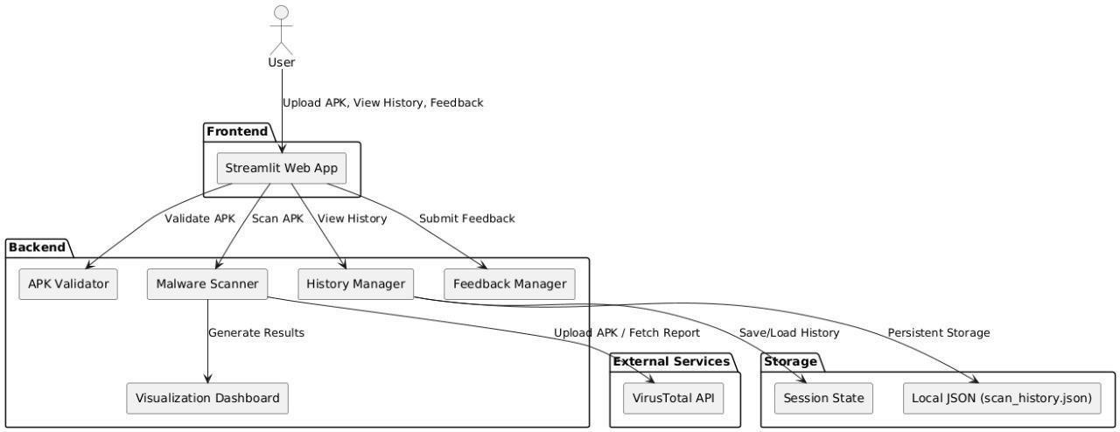

**3.1.1 Class Diagram**

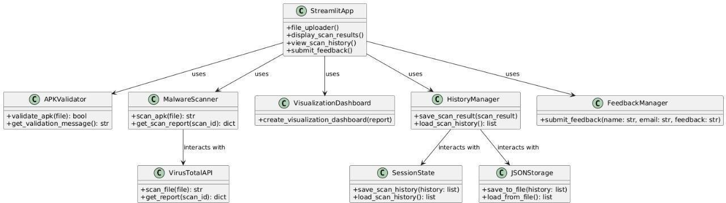

**3.1.1 Use Case Diagram**

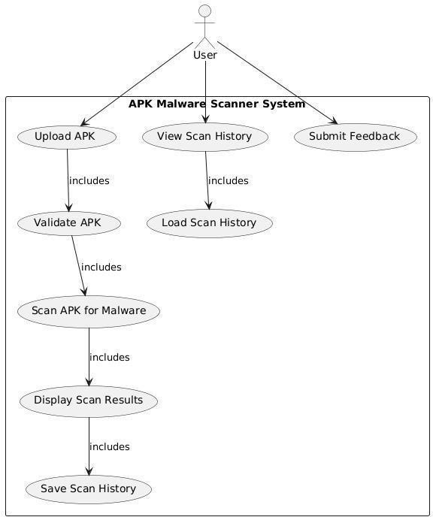

## Data Flow

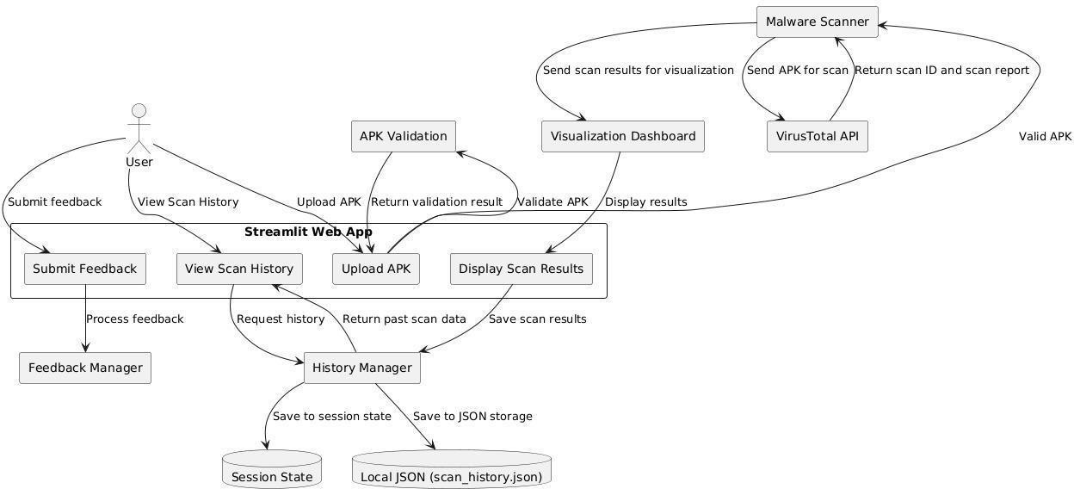

**3.1.1 Sequence Diagram**

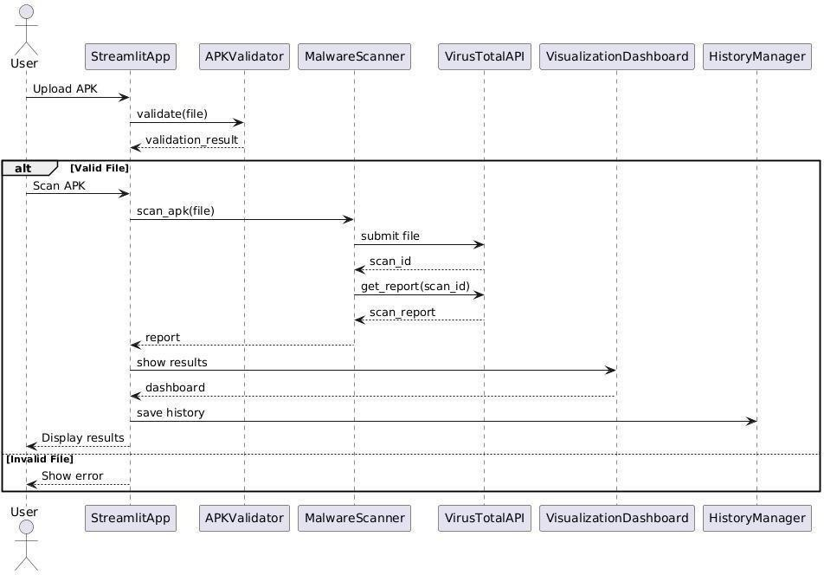

## CHAPTER - 4 IMPLEMENTATION

**& TESTING**

**4.1 Coding Blocks**

## Malware.py

import streamlit as st import requests import time

import pandas as pd

import plotly.graph_objects as go import plotly.express as px import os

from datetime import datetime import json

# Configuration and Settings class Config: API_KEY =

'442bed6c58aad710d9fa62e16476724829c9fd9166ad981a55c00fc9cd800c60' SCAN_URL =

'https://[www.virustotal.com/vtapi/v2/file/scan'](http://www.virustotal.com/vtapi/v2/file/scan%27) REPORT_URL = 'https://[www.virustotal.com/vtapi/v2/file/report'](http://www.virustotal.com/vtapi/v2/file/report%27) MAX_RETRIES = 5 WAIT_TIME = 20

MAX_FILE_SIZE_MB = 100

# Cache for storing scan history

if 'scan_history' not in st.session_state: st.session_state.scan_history = []

# Utility functions defload_scan_history(): try:

with open('scan_history.json', 'r') as f: return json.load(f) exceptFileNotFoundError: return []

def save_scan_history(history):

with open('scan_history.json', 'w') as f: json.dump(history, f)

defvalidate_apk_file(file): if file is None:

return False, "No file uploaded"

file_size_mb = file.size / (1024 * 1024) if file_size_mb > Config.MAX_FILE_SIZE_MB:

return False, f"File size ({file_size_mb:.1f}MB) exceeds maximum limit of

{Config.MAX_FILE_SIZE_MB}MB"

if not file.name.endswith('.apk'):

return False, "File must be an APK file" return True, "File is valid"

classMalwareScanner: @staticmethod def scan_apk(file):

files = {'file': (file.name, file, 'application/octet- stream')}

params = {'apikey': Config.API_KEY}

try: params=params)

response= requests.post(Config.SCAN_URL, files=files, response.raise_for_status()

return response.json().get('resource', '') except

requests.exceptions.RequestException as e: st.error(f"Scan error: {str(e)}") return None

@staticmethod

def get_scan_report(scan_id):

params = {'apikey': Config.API_KEY, 'resource': scan_id}

for attempt in range(Config.MAX_RETRIES): try: time.sleep(Config.WAIT_TIME)

response = requests.get(Config.REPORT_URL,

params=params)

response.raise_for_status() report = response.json() if report['response_code'] == 1: return report

st.warning(f"Attempt {attempt + 1}/{Config.MAX_RETRIES}: Waiting for results...")

except requests.exceptions.RequestException as e: st.error(f"Report error: {str(e)}")

return None

def create_visualization_dashboard(report, prefix="main"): """

Create visualization dashboard with unique keys for each chart Args: report: The scan report data

prefix: A prefix for the chart keys to ensure uniqueness

"""

col1, col2 = st.columns(2)

with col1:

# Enhanced Gauge Chart

safe_percentage = (len([r for r in report['scans'].values() if not r['detected']]) /

len(report['scans'])) * 100

"green"}},

fig_gauge = go.Figure(go.Indicator( mode="gauge+number+delta", value=safe_percentage,

title={'text': "Safety Score", 'font': {'size': 24}}, delta={'reference': 90, 'increasing': {'color':

gauge={

'axis': {'range': [0, 100], 'tickwidth': 1},

'bar': {'color': "darkgreen" if safe_percentage > 90

else "orange"},

'bgcolor':"white", 'steps': [

{'range': [0, 50], 'color': "red"},

{'range': [50, 80], 'color': "orange"},

{'range': [80, 100], 'color': "lightgreen"}

],

'threshold': {

'line': {'color': "red", 'width': 4}, 'thickness': 0.75, 'value': 90

}

}

))

fig_gauge.update_layout(height=300) st.plotly_chart(fig_gauge, use_container_width=True, key=f"{prefix}_gauge")

with col2:

# Enhanced Detection Timeline engine_results = [] for engine, result in report['scans'].items():

'Clean',

engine_results.append({ 'Engine': engine, 'Status': 'Malicious' if result['detected'] else

'Detail': result.get('result', 'N/A')

})

df_results = pd.DataFrame(engine_results) fig_timeline =px.bar(df_results,

x='Status', color='Status', color_discrete_map={'Clean': 'green',

'Malicious': 'red'},

title='Detection Distribution')

fig_timeline.update_layout(height=300) st.plotly_chart(fig_timeline, use_container_width=True, key=f"{prefix}_timeline")

# Detailed Results Table with Sorting st.subheader("Detailed Scan Results") df_results['Time'] = datetime.now().strftime("%Y-%m-%d

%H:%M:%S")

st.dataframe(

df_results.style.apply(lambda x: ['background-color: #ffcdd2' if v == 'Malicious'

else 'background-color:

#c8e6c9' for v in x],

key=f"{prefix}_dataframe"

)

subset=['Status']),

# Determine Safety

if any(result['detected'] for result in report['scans'].values()):

st.markdown("<h2 style='color: red;'> This app is **NOT SAFE**! </h2>", unsafe_allow_html=True)

else:

st.markdown("<h2 style='color: green;'>✅ This app is

**SAFE**! ✅</h2>", unsafe_allow_html=True)

def main():

st.set_page_config(page_title="Automated Android Malware Detection", layout="wide")

# Add logo at the top with a reduced size st.image(r"C:\Users\m.abhishek\OneDrive\Desktop\androware\logo.w

ebp", width=200, use_column_width=False) # Adjust the path to your logo image if necessary

# Enhanced Entrance Animation CSS and JS st.markdown("""

<style>

.fade-in {

animation: fadeInScale 1s ease forwards;

scale(0.8); }

scale(1); }

}

@keyframes fadeInScale {

0% {opacity: 0; transform: translateY(-50px)

100% { opacity: 1; transform: translateY(0)

}

</style>

<script>

function applyFadeInAnimation()

{ document.querySelectorAll('.fad e-

in').forEach(function(element) {

});

}

element.classList.remove('fade-in'); // Remove class to restart animation void element.offsetWidth; // Trigger reflow

element.classList.add('fade-in');

testid="stTab"]');

window.onload = applyFadeInAnimation; // Initial load const tabs = document.querySelectorAll('div[data-

tabs.forEach(tab => {

tab.addEventListener('click', applyFadeInAnimation);

// Apply animation on tab change

});

</script>

""", unsafe_allow_html=True)

# App Header

st.markdown("<h1 class='fade-in'> Automated Android Malware Scanner</h1>",unsafe_allow_html=True)

# Navigation

tabs = st.tabs(["Scanner", "History", "Statistics", "About Us", "Feedback"])

with tabs[0]:

st.header("APK Scanner")

uploaded_file = st.file_uploader("Upload APK file", type="apk")

if uploaded_file:

is_valid, message = validate_apk_file(uploaded_file)

if not is_valid: st.error(message) else:

st.info(f"File:{uploaded_file.name} ({uploaded_file.size / 1024 / 1024:.1f} MB)")

if st.button(" Scan APK", key='scan_button'): with st.spinner("Scanning file..."):

scanner = MalwareScanner()

scan_id = scanner.scan_apk(uploaded_file)

scanner.get_scan_report(scan_id)

if scan_id:

report=

if report:

st.success("Scancompleted!")

# Store scan results scan_result =

{'timestamp':

datetime.now().isoformat(), 'filename':uploaded_file.name, 'scan_id': scan_id, 'report': report

}

st.session_state.scan_history.append(scan_result) save_scan_history(st.session_state.scan_history)

# Create visualization dashboard create_visualization_dashboard(report) with tabs[1]:

st.header("Scan History") ifst.session_state.scan_history: for idx, scan in

enumerate(st.session_state.scan_history):

st.markdown(f"### Scan {idx + 1}: {scan['filename']}

- {scan['timestamp']}")

else:

create_visualization_dashboard(scan['report'], prefix=f"history_{idx}")

st.info("No scan history available.")

with tabs[2]:

st.header("Statistics") st.markdown("### Total Scans:

{}".format(len(st.session_state.scan_history))) st.markdown("### Scans per Status:")

status_count = {'Safe': 0, 'Malicious': 0} for scan in st.session_state.scan_history:

report = scan['report']

if any(result['detected'] for result in report['scans'].values()): status_count['Malicious'] += 1 else:

status_count['Safe'] += 1

fig_stats = go.Figure(data=[ go.Pie(labels=list(status_count.keys()), values=list(status_count.values()), hole=.3)

])

fig_stats.update_layout(title_text="Scan Status Distribution", height=400) st.plotly_chart(fig_stats)

with tabs[3]: # About Us Section

st.markdown("<h1 style='text-align: center; margin-top: 50px;'>About Us</h1>", unsafe_allow_html=True)

st.write("""

Welcome to the Automated Android Malware Detection app!

Our mission is to provide users with a quick and efficient way to check their Android APK files for potential malware.

Creators

### Team

* **Malipatel Abhishek & Shaik Mastan**: Developers &
* **Community Contributors**: Thanks to everyone who has

helped improve this tool.

API.

### Features

* + Upload APK files for malware scanning using the VirusTotal
  + View detailed scan reports with results from multiple

antivirus engines.

at:

### Contact

For any inquiries or feedback, feel free to reach out to us

[[2111CS040003@mallareddyuniversity.ac.in](mailto:2111CS040003@mallareddyuniversity.ac.in)](mailto:2111CS040003@mallar eddyuniversity.ac.in)""")

with tabs[4]:

st.markdown("<h1 style='text-align: center; margin-top: 50px;'>Feedback</h1>", unsafe_allow_html=True)

below.")

Feedback')

st.write("We value your feedback! Please fill out the form

with st.form(key='feedback_form'): name = st.text_input("Your Name")

email = st.text_input("Your Email", placeholder="[example@example.com](mailto:example@example.com)") feedback = st.text_area("Your Feedback") submit_button = st.form_submit_button(label='Submit

if submit_button:

if name and email and feedback: st.success("Thank you for your feedback!") st.write(f"Name: {name}")

st.write(f"Email: {email}") st.write(f"Feedback:{feedback}") # Add functionality to save/send feedback here else: st.error("Please fill out all fields.")

if name == " main ": main()

## Execution flow

* + 1. **System Setup and Initialization:**

The **System Setup and Initialization** phase involves preparing the environment for malware detection. This includes configuring necessary tools and frameworks, such as Android SDKs and analysis tools, setting up a sandbox for safe APK execution, and initializing databases for known malware signatures. The system also allocates computational resources, sets up data collection from various sources, and configures automation for periodic scanning. This phase ensures that the environment is ready for both static and dynamic analysis, enabling the system to efficiently detect and classify malware

## Slide Navigation and Control:

**Slide Navigation and Control** refers to the system's ability to manage and transition between different stages of the malware detection process, typically within a user interface or dashboard. It allows users to easily move between key features, such as viewing analysis results, adjusting settings, or monitoring ongoing scans. Effective navigation ensures a seamless user experience by providing intuitive controls, such as buttons, menus, and progress indicators, to help users manage the workflow and access relevant information quickly.

## Real-Time Hand Detection:

**Real-Time Hand Detection** involves using computer vision techniques to track and detect hand movements or gestures in real time. This is commonly applied in systems that require interactive control or user input, such as in augmented reality or gesture-based interfaces. By utilizing sensors like cameras and machine learning algorithms, the system identifies hand positions and gestures, enabling users to interact with the system without physical contact. This detection is crucial for applications like virtual controls, sign language recognition, and touchless navigation

## Annotation and Drawing:

**Annotation and Drawing** refers to the ability to add visual markers, notes, or sketches to an image, video, or other visual content. This is commonly used in systems for data analysis, educational tools, or collaborative work. Users can draw lines, shapes, or highlight areas of interest, making it easier to point out specific details or provide context. In malware detection, for example, annotation tools may be used to mark suspicious code or behaviors in APK files, or to visualize network traffic patterns during dynamic analysis. This feature enhances understanding and communication of findings.

## Cleanup and Exit:

**Cleanup and Exit** refers to the final phase of an automated malware detection process, where the system ensures that all resources and data are properly managed before shutting down. This involves closing any running processes, clearing temporary files, and resetting the environment to ensure no leftover artifacts from the analysis can interfere with future tasks. The system also logs the results of the analysis, generates final reports, and may update its database with new malware signatures or detection patterns. This step ensures a smooth exit and prepares the system for the next analysis session.

## Testing

* + 1. **Test Case 1: System Initialization and Setup**

**Objective:** The objective of is to ensure that the malware detection system is correctly initialized, all necessary components and resources are configured and accessible, and the environment is prepared for performing malware analysis. It aims to verify that the system is ready for use without errors, ensuring that all tools, databases, and interfaces function as expected before starting the detection process.

## Steps:

**Power On the System**: Ensure that the system hardware and software are properly powered on and running.

**Launch the Detection System**: Start the malware detection software and monitor the boot-up process to check for any errors or issues.

**Initialize Required Services**: Verify that all necessary services (e.g., sandbox environments, analysis frameworks) are initialized and running.

**Load Databases**: Check that the system's malware signature databases, app metadata repositories, and behavior analysis databases are loaded and accessible.

**Configure Resource Allocation**: Ensure that the system has sufficient resources (e.g., CPU, RAM, storage) allocated for malware analysis tasks.

**Verify Network Connectivity**: Confirm that the system can access external sources, such as app stores or threat intelligence feeds, for APK collection and signature updates.

**Load User Interface (UI)**: If the system has a graphical interface, verify that it loads properly and is ready for user interaction, with all necessary controls and options displayed.

**Run Initial Tests**: Conduct a basic test or check to ensure the system is ready for scanning, including verifying that sample APKs can be processed.

## Expected Result:

After perfroming the test we get the accurate result of the app and gives the database in a graphical way wheather it is effected or not,

## Test Case 2: Peforming the test of Automated Android Malware Detection

**Description:** This test case tests the functionality of. perfroming automated android malware detection is to detect the trojons in the application through the scanning we get the accurate result

## Steps:

* + - 1. Start the presentation mode and load a slide.
      2. Perform the scanning the app by uploading the apk file we perform by using python code
      3. Confirm that the system advances to the next slide.
      4. Perform the scan by clicking on scan
      5. Verifythat the accurate outcome implementing or not

## Expected Result:

* + - * + Throught this we get analysis of the apk file and we get the graphical way representation throught the different files we get the outcome accurately.

30

.

## CHAPTER - 5 TESTING AND RESULTS

* 1. **Resulting Screens**

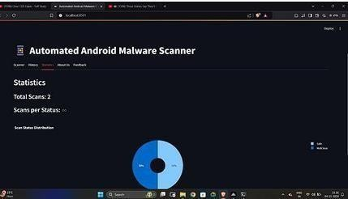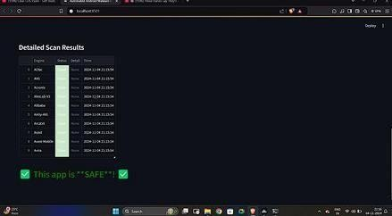

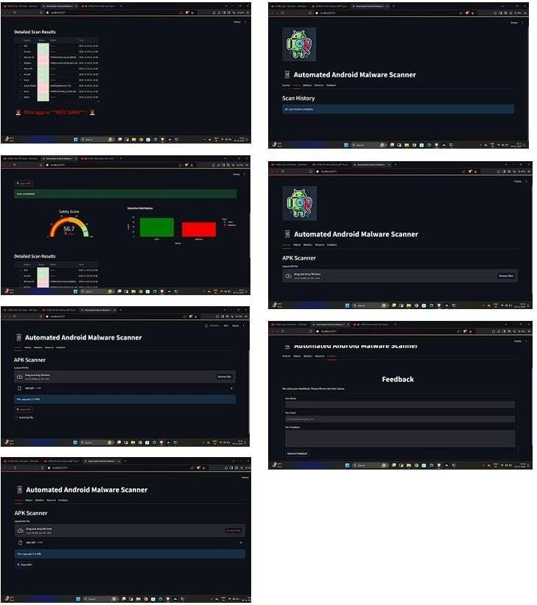

## Results Analysis

* + 1. **Time Complexity**

The time complexity of automated Android malware detection depends on the approach used. Static analysis (e.g., analyzing code or permissions) is generally faster, with complexities like O(n⋅m)O(n \cdot m)O(n⋅m) for signature-based detection or O(n)O(n)O(n) for feature extraction in machine learning. Dynamic analysis, which monitors app behavior in a sandbox, has a complexity of O(t)O(t)O(t), where ttt is the runtime. Hybrid methods combine both, resulting in O(n+t)O(n + t)O(n+t). Advanced techniques like graph-based methods or deep learning models may involve complexities such as O(n2)O(n^2)O(n2) for graph matching or O(m)O(m)O(m) for neural network inference, offering higher accuracy but at a computational cost**.**

## 5.2.1 Space Complexity

The space complexity of automated Android malware detection varies by method. Static analysis usually requires space for the APK data, extracted features, and model parameters, typically O(n+m)O(n + m)O(n+m), where nnn is the APK size and mmm is the model size. Dynamic analysis requires memory for runtime data (e.g., logs or behavioral traces), with complexity O(t)O(t)O(t), where ttt is the execution time. Graph-based methods need space for graph storage, typically O(n+e)O(n + e)O(n+e), where nnn is the number of nodes and eee is the number of edges. Deep learning models may need O(m)O(m)O(m) space for model parameters, which can be large but optimized with lightweight architectures**.**

## Results Summary

Automated Android malware detection involves trade-offs between time and space complexity depending on the method used. Static analysis is efficient in both time and space, suitable for quick assessments, but may struggle with obfuscated malware.

Dynamic analysis offers deeper insights by monitoring runtime behavior but requires more time and memory for sandbox execution and data storage. Hybrid methods combine these for better accuracy at a higher computational cost. Advanced techniques like graph-based methods and deep learning enhance detectiocapabilities but demand significant space for models and graphs, along with higher processing time. The choice of method depends on the desired balance between speed, accuracy and resource usage**..**

## CHAPTER - 6 CONCLUSION AND FUTURE SCOPE

* 1. **CONCLUSION:**

In conclusion, the effectiveness of automated Android malware detection depends on the chosen approach and its trade-offs between time and space complexity. Static analysis is faster and lightweight but less robust against advanced malware techniques. Dynamic and hybrid methods provide better accuracy but require more computational resources. Advanced techniques like graph-based analysis and deep learning improve detection precision but come at the cost of higher complexity. An optimal solution should balance efficiency and tailored to the specific use case and resource constraints.

## FUTURE SCOPE:

**AI-Driven Detection**: Advanced machine learning and deep learning models for better feature extraction and behavioral analysis.

**Federated Learning**: Collaborative model training across devices to improve accuracy while ensuring data privacy.

**Real-Time Analysis**: Faster detection methods to counteract immediate threats during app execution. **Adversarial Resilience**: Robust systems to detect malware that uses obfuscation or adversarial techniques. **Code Deobfuscation Tools**: Enhanced methods to reverse obfuscation and analyze hidden malicious code. **Integration with Edge Computing**: Lightweight, efficient models deployed on devices for decentralized and scalable detection.

**Behavioral Modeling**: Improved dynamic analysis methods to detect anomalies in app behavior in real-time. **IoT and Wearable Device Security**: Expanding malware detection to protect Android-based IoT and wearable devices.

**Cloud Integration**: Leveraging cloud resources for complex analyses while maintaining lightweight device operations.

**Regulatory and Ethical Enhancements**: Ensuring detection systems comply with privacy laws and ethical standards.

## REFERENCES:

H.Rathore, A. Nandanwar, S. K. Sahay, and M. Sewak, ‘‘Adversarial superiority in Android malware detection: Lessons from reinforcement learning based evasion attacks and defenses,’’ Forensic Sci. Int., Digit. Invest., vol. 44, Mar. 2023, Art. no.

301511.

1. H. Wang, W. Zhang, and H. He, ‘‘You are what the permissions told me! Android malware detection based on hybrid tactics,’’ J. Inf. Secur. Appl., vol. 66, May 2022, Art. no. 103159.
2. A. Albakri, F. Alhayan, N. Alturki, S. Ahamed, and S. Shamsudheen, ‘‘Metaheuristics with deep learning model for cybersecurity and Android malware detection and classification,’’ Appl. Sci., vol. 13, no. 4, p. 2172, Feb. 2023.
3. M. Ibrahim, B. Issa, and M. B. Jasser, ‘‘A method for automatic Android malware detection based on static analysis and deep learning,’’ IEEE Access, vol. 10, pp. 117334–117352, 2022.
4. L.Hammood,İ.A.Doğru,andK.Kılıç,‘‘Machinelearning-basedadaptive genetic algorithm for Androidmalwaredetectioninauto-drivingvehicles,’’ Appl. Sci., vol. 13, no. 9, p. 5403, Apr. 2023.
5. P. Bhat and K. Dutta, ‘‘A multi-tiered feature selection model for Android malware detection based on feature

discrimination and information gain,’’ J. King Saud Univ.-Comput. Inf. Sci., vol. 34, no. 10, pp. 9464–9477, Nov. 2022.

1. D.Wang,T.Chen,Z.Zhang,andN.Zhang,‘‘AsurveyofAndroidmalware detection based on deep learning,’’ in Proc. Int. Conf. Mach. Learn. Cyber Secur. Cham, Switzerland: Springer, 2023, pp. 228–242.
2. Y. Zhao, L. Li, H. Wang, H. Cai, T. F. Bissyandé, J. Klein, and J. Grundy, ‘‘On the impact of sample duplication in machine-learning-based Android malware detection,’’ ACM Trans. Softw. Eng. Methodol., vol. 30,
3. E. C. Bayazit, O. K. Sahingoz, and B. Dogan, ‘‘Deep learning based malwaredetection for Androidsystems: Acomparativeanalysis,’’ Tehnički vjesnik, vol. 30, no. 3, pp. 787–796, 2023.
4. H.-J. Zhu, W. Gu, L.-M. Wang, Z.-C. Xu, and V. S. Sheng, ‘‘Android malware detection based on multi- head squeeze- and-excitation residual network,’’ Expert Syst. Appl., vol. 212, Feb. 2023, Art. no. 118705.
5. K. Shaukat, S. Luo, and V. Varadharajan, ‘‘A novel deep learning-based approach for malware detection,’’ Eng. Appl. Artif. Intell., vol. 122, Jun. 2023, Art. no. 106030.
6. J. Geremias, E. K. Viegas, A. O. Santin, A. Britto, and P. Horchulhack, ‘‘Towards multi-view Android malware detection through image-based deeplearning,’’ in Proc. Int. Wireless Commun.MobileComput.(IWCMC), May 2022, pp. 572–57 Kim,

Y. Ban, E. Ko, H. Cho, and J. H. Yi, ‘‘MAPAS: A practical deep learning-based Android malware detection system,’’ Int.J. Inf. Secur., vol. 21, no. 4, pp. 725–738, Aug. 2022.

1. S. Fallah and A. J. Bidgoly, ‘‘Android malware detection using network traffic based on sequential deep learning models,’’ Softw., Pract. Exper., vol. 52, no. 9, pp. 1987–2004, Sep. 2022.
2. V. Sihag, M. Vardhan, P. Singh, G. Choudhary, and S. Son, ‘‘De-LADY: Deep learning-based Android malware detection using dynamic features,’’ J. Internet Serv. Inf. Secur., vol. 11, no. 2, p. 34, 2021.
3. W. Wang, M. Zhao, and J. Wang, ‘‘Effective Android malware detec tion with a hybrid model based on deep autoencoder and convolutional neural network,’’ J. Ambient Intell. Humanized Comput., vol. 10, no. 8, pp. 3035– 3043, Aug. 2019

.[17] P. Yadav, N. Menon,V.Ravi, S. Vishvanathan, and T. D. Pham, ‘‘Efficient Net convolutional neural networks- based Android malware detection,’’ Comput. Secur., vol. 115, Apr. 2022, Art. no. 102622.

1. M. Masum and H. Shahriar, ‘‘Droid-NNet: Deep learning neural network for Android malware detection,’’ in Proc. IEEE Int. Conf. Big Data (Big Data), Dec. 2019, pp. 5789–5793.
2. F. Idrees, M. Rajarajan, M. Conti, T. M. Chen, and Y. Rahulamathavan, ‘‘PIndroid: A novel Android malware detection system using ensemble learning methods,’’ Comput. Secur., vol. 68, pp. 36–46, Jul. 2017.
3. A. Guerra-Manzanares, H. Bahsi, and M. Luckner, ‘‘Leveraging the first line of defense: A study on the

evolution and usage of Android security permissions for enhanced Android malware detection,’’ J. Comput. Virol. Hacking Techn., vol. 19, no. 1, pp. 65–96, Aug. 2022.

1. A.TahaandO.Barukab,‘‘Android malware classification using optimized ensemble learning based on genetic algorithms,’’ Sustainability, vol. 14, no. 21, p. 14406, Nov. 2022

. [22] K. Sabanci, M. F. Aslan, E. Ropelewska, and M. F. Unlersen, ‘‘A convolutional neural network-based comparative study for pepper seed classification: Analysis of selected deep features with support vector machine,’’ J. Food Process Eng., vol. 45, no. 6, Jun. 2022, Art. no. e13955

. [23] A. Batouche and H. Jahankhani, ‘‘A comprehensive approach to Android malware detection using machine learning,’’ in Information Secu rity Technologies for Controlling Pandemics. USA: Springer, 2021, pp. 171–212. [24] O.

N. Elayan and A. M. Mustafa, ‘‘Android malware detection using deep learning,’’ Proc. Comput. Sci., vol. 184, pp.847– 852, Jan. 2021.

1. S. S. Sammen, M. Ehteram, Z. Sheikh Khozani, and L. M. Sidek, ‘‘Binary coati optimization algorithm- multi- kernel least square support vector machine-extreme learning machine model (BCOA MKLSSVM-ELM): A new hybrid machine learning model for predicting reservoir water level,’’ Water, vol. 15, no. 8, p. 1593, Apr. 2023.
2. M. A. Khan, S. Kadry, P. Parwekar, R. Damaševicius, A. Mehmood, J. A. Khan, and S. R. Naqvi, ‘‘Human gait analysis for osteoarthritis prediction: A framework of deep learning and kernel extreme learning machine,’’ Complex Intell. Syst., vol. 2021, pp. 1–19, Jan. 2021.
3. Andro-AutoPsy. Accessed: Feb. 12, 2023. [Online]. Available: https:// ocslab.hksecurity.net/andro-autopsy
4. J.-W. Jang, H. Kang, J. Woo, A. Mohaisen, and H. K. Kim, ‘‘Andro AutoPsy: Anti-malware system based on similarity matching of mal ware and malware creator-centric information,’’ Digit. Invest., vol. 14, pp. 17–35, Sep. 2015

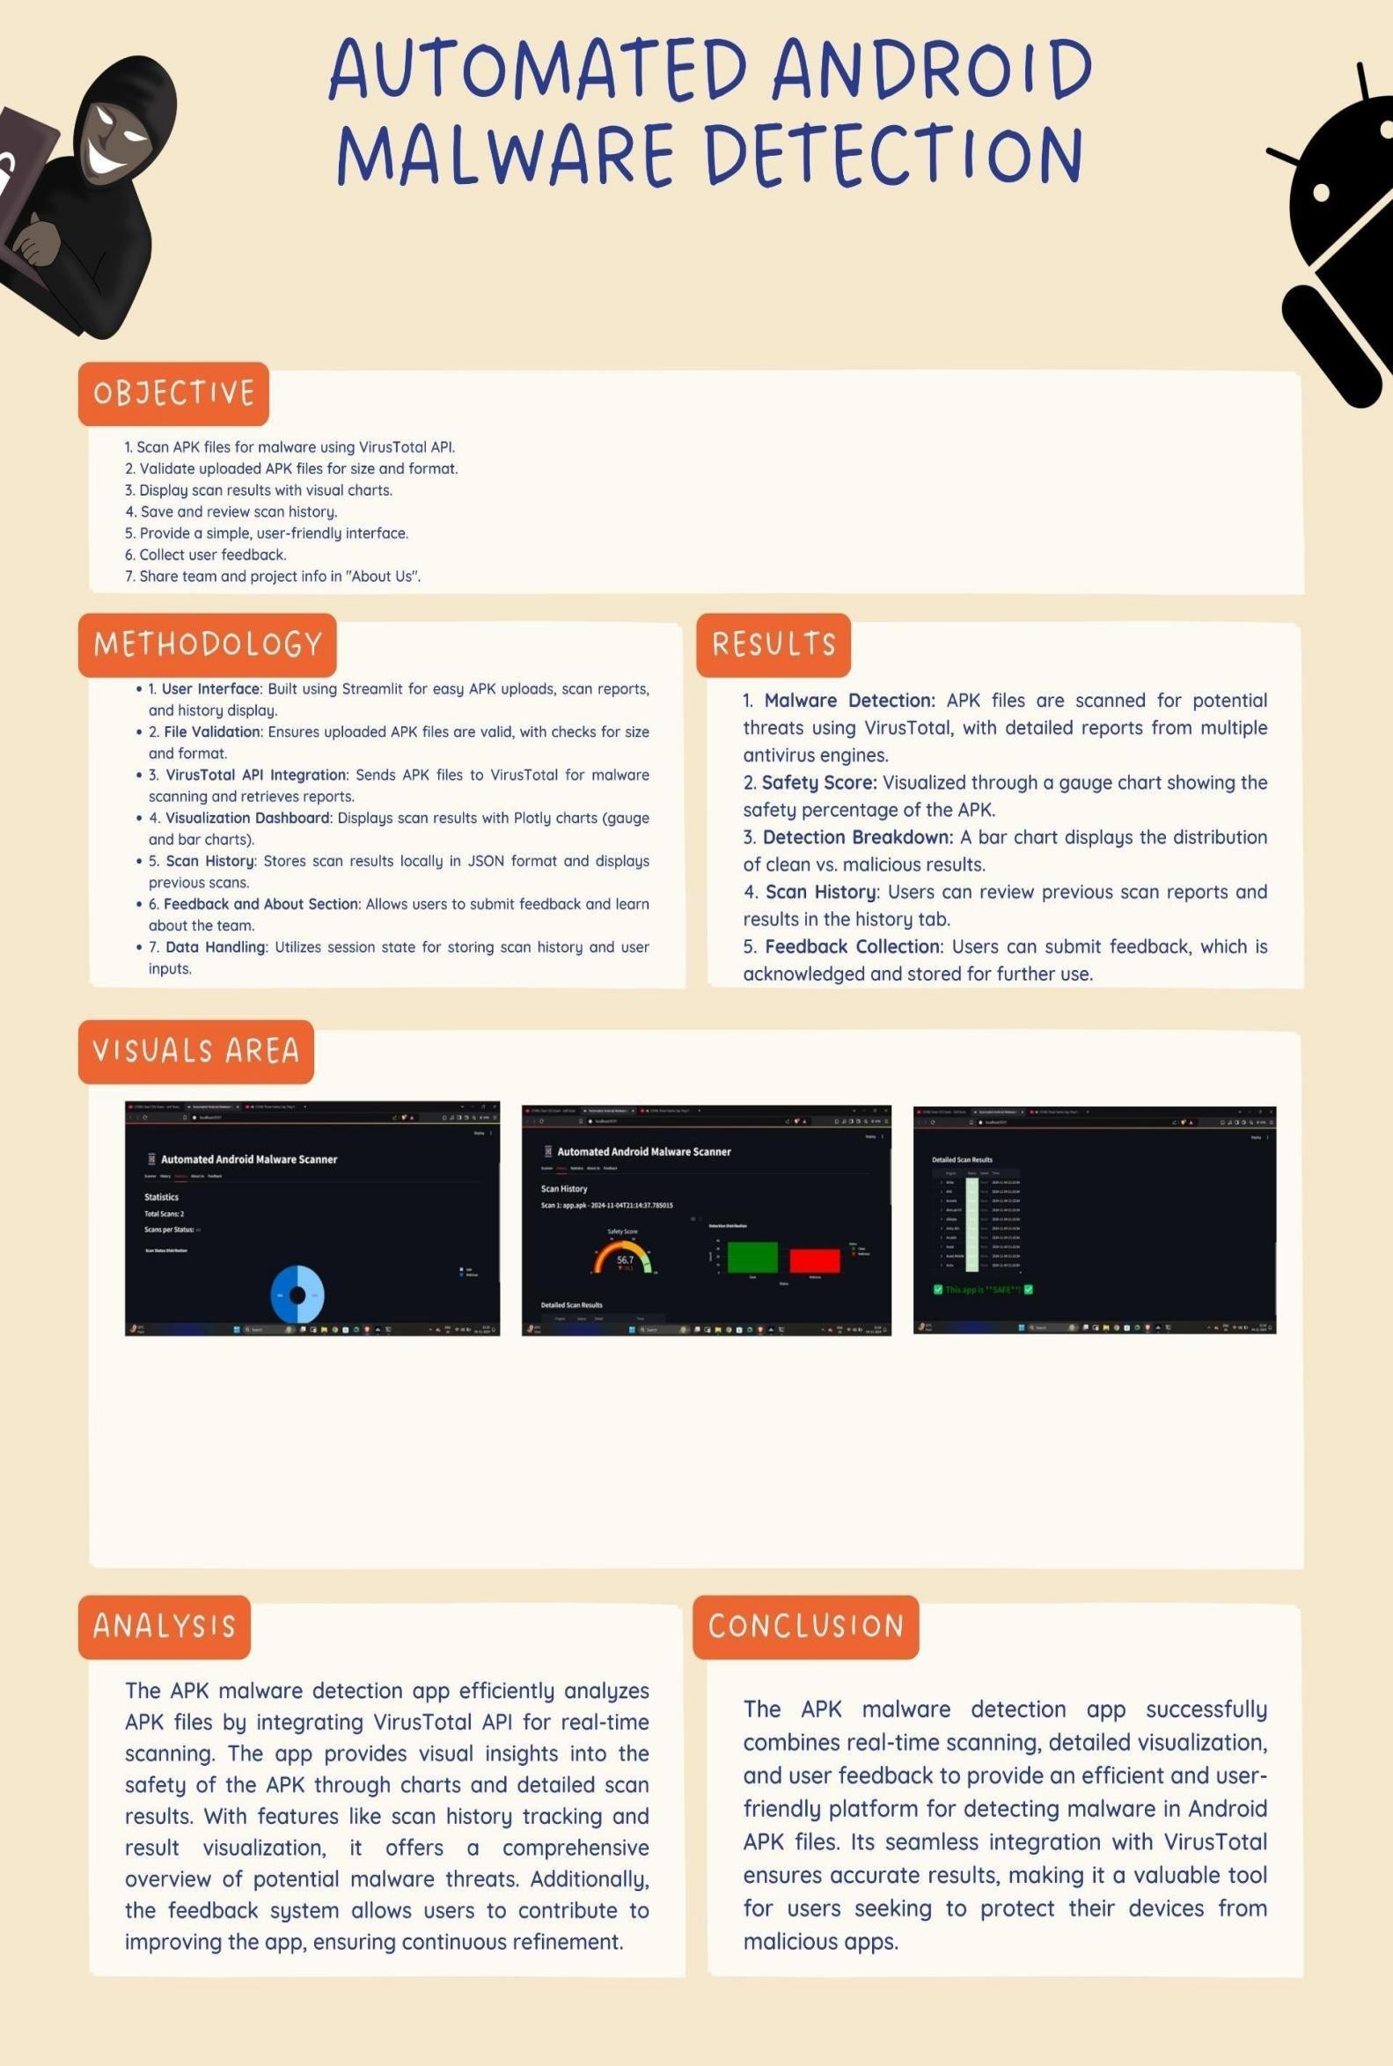

***Automated Android Malware Detection***

***1Shaik Mastan, 2Malipatel Abhishek,***

***3Dr. L. V. Ramesh***

***1,2,Student, Department of Computer Science and Engineering-Cybersecurity, Malla Reddy University, Hyderabad, Telangana, India***

***1***[***2111cs0400055@mallareddyuniversity.ac.in,***](mailto:2111cs04000%0955@mallareddyuniversity.ac.in)

***2***[***2111cs040003@mallareddyuniversity.ac.in***](mailto:2111cs040003@mallareddyuniversity.ac.in)***,***

***3 Associate professor , Department of Computer Science and Engineering-Cybersecurity, Malla Reddy University, Hyderabad, Telangana, India***

# Abstract:

The rapid proliferation of Android devices has led to an increase in the development and deployment of malicious applications (malware) targeting the platform. Traditional methods of malware detection, which rely heavily on signature-based techniques, have become less effective due to the evolving nature of malware. This necessitates the development of automated, intelligent systems capable of identifying malware in real-time, with high accuracy and minimal human intervention. This paper explores the landscape of automated Android malware detection, emphasizing the integration of machine learning (ML) and deep learning(DL) techniques. By analyzing large datasets of both benign and malicious applications, these models can identify patterns and anomalies that signify malware. Features such as API calls, permissions, and network traffic are often used to train these models, enabling them to detect even previously unknown malware variants.

**Key words**: Malicious APK, Total Virus, Streamlit, Plotly

# Introduction

In the digital age, the prevalence of malware poses significant threats to mobile device security, particularly for Android applications. With millions of apps available, users often find themselves in precarious situations when downloading APK files from unverified sources. To address this issue, we developed an Automated Android Malware Detection application that leverages the VirusTotal API. This tool allows users to upload APK files for analysis, generating comprehensive scan reports that indicate potential malware threats detected by multiple antivirus engines.

The application not only provides users with critical insights into the safety of their APK files but also presents the scan results through an intuitive visualization dashboard. By incorporating interactive charts and tables, users can easily interpret the results and take informed actions to protect their devices. Additionally, the app features a scan history function, enabling users to track past analyses and a feedback mechanism for continuous improvement.

This research focuses on the development and implementation of the application, highlighting its functionalities, user interface design, and the importance of proactive malware detection in enhancing mobile security. Through this initiative, we aim to contribute to the growing field of cybersecurity by providing an accessible solution for users to safeguard their mobile applications against potential threats.

# Literature survey:

1. Android Malware Landscape: Research by Sadeghi et al. (2015) provides an extensive overview of the Android malware ecosystem, detailing various types of malwares, their propagation methods, and the challenges associated with detecting them. This foundational work emphasizes the need for robust detection mechanisms as the volume of malicious applications continues to grow.
2. Static and Dynamic Analysis Techniques: Several studies, such as those by Zhou et al. (2012), propose static and dynamic analysis techniques to detect malicious behavior in Android applications. Static analysis examines the application code without executing it, while dynamic analysis involves running the app in a controlled environment to observe its behavior. Both techniques have their strengths and limitations, leading to a hybrid approach that combines both methods for improved detection rates.
3. Machine Learning Approaches: The integration of machine learning in malware detection has gained traction, as highlighted by Arp et al. (2014). Machine learning algorithms can analyze patterns in

application behavior to distinguish between benign and malicious applications. Their study presents a framework that enhances detection accuracy while minimizing false positives. This approach aligns with the increasing complexity of malware, which often employs obfuscation techniques to evade traditional detection methods.

1. API Usage and Behavior Analysis: The work of Jiang et al. (2011) discusses the importance of monitoring API calls made by applications. By analyzing API usage patterns, researchers can identify anomalous behaviors that may indicate malicious intent. This method serves as a basis for the current application's design, where the analysis of antivirus engine reports can reveal critical insights into application safety.
2. VirusTotal and Public APIs: VirusTotal is a widely recognized platform that aggregates results from multiple antivirus engines. The research conducted by Nataraj et al. (2011) highlights the effectiveness of using such platforms for malware analysis. By utilizing the VirusTotal API, our application leverages a collective intelligence approach, enhancing its ability to identify threats through the collaborative efforts of various security vendors.
3. User-Centric Design in Security Tools: User interface and experience in security applications have been explored by several researchers, including Shilton et al. (2016). Their findings underscore the importance of designing intuitive interfaces that facilitate user interaction and understanding of security risks. Our application's focus on visualizing scan results through interactive

dashboards aims to align with these principles, promoting better user engagement and comprehension.

1. Feedback Mechanisms for Continuous Improvement: The role of user feedback in the enhancement of security applications is emphasized by Al-Hogail (2018). By incorporating a feedback system, our application aims to adapt and improve over time based on user experiences and suggestions, thereby fostering a more robust and user-friendly tool.

# 3. System Analysis

* **Existing System:**

Current Android malware detection solutions primarily rely on static and dynamic analysis methods. Static analysis tools, like Androguard, examine code for vulnerabilities without executing the application, while dynamic analysis tools run apps in controlled environments to monitor behavior. However, these methods can be resource-intensive and may miss real- world behaviors, leading to false negatives. Additionally, many systems use signature-based detection, which struggles against new malware variants and obfuscation techniques. Machine learning models have been developed, yet they often produce high false positive rates and require extensive training data. User interaction is frequently lacking, resulting in unintuitive interfaces that fail to clearly communicate scan results. Finally, most applications depend on a single antivirus engine, limiting their detection capabilities. These limitations highlight the need for a more comprehensive,

user-friendly solution in the realm of Android malware detection.

# Proposed system

The proposed Automated Android Malware Detection application aims to enhance the security of Android users by integrating advanced detection techniques and a user-centric design approach. This system addresses the limitations of existing solutions by leveraging a multi-faceted methodology that combines static and dynamic analysis, as well as utilizing the Virus Total API for comprehensive threat assessment.

1. **Multi-Analysis Approach**: The application will implement both static and dynamic analysis to provide a thorough evaluation of APK files. Static analysis will identify potential vulnerabilities in the code, while dynamic analysis will monitor the application's behavior in a simulated environment, capturing real-time interactions and API calls.
2. **Integration with Virus Total API**: By harnessing the capabilities of the VirusTotal API, the application will access the results of multiple antivirus engines, enabling it to cross-reference and validate findings. This multi-engine approach enhances detection accuracy and provides a more robust assessment of application safety.
3. **Interactive Visualization Dashboard**: The application will feature an interactive dashboard

that presents scan results in an easily interpretable format. Users will receive a clear summary of the safety score, detection distribution, and detailed results, promoting better understanding and decision- making regarding app security.

1. **User Feedback Mechanism**: To foster continuous improvement, the system will incorporate a feedback mechanism, allowing users to provide insights and suggestions. This feedback will be analyzed and integrated into future updates, ensuring that the application evolves in response to user needs and emerging threats.
2. **Enhanced User Experience**: A focus on user-centric design will result in an intuitive interface that guides users through the scanning process and simplifies the interpretation of results. By improving user engagement and understanding, the application aims to increase user trust in the security measures provided.

* **Architecture:**

The architecture of the Automated Android Malware Detection application is designed to facilitate efficient scanning, analysis, and reporting of Android APK files. It comprises several interconnected components that work together to provide a seamless user experience and robust threat detection. The architecture can be divided into the following key components:

# User Interface (UI):

* + Web Interface: Built using Streamlit, the UI allows users to upload APK files, initiate scans, and view results. It

includes tabs for differentfunctionalities: scanning, viewing history, statistics, and feedback.

* + Visualization Dashboard: Presents scan results through interactive charts and graphs, providing users with a clear understanding of the safety status of their applications.

# File Upload Module:

* + File Validation: Validates uploaded APK files for size and type before initiating a scan, ensuring compliance with predefined constraints.

# Malware Scanner:

* + Static and Dynamic Analysis: This module performs both static code analysis to identify vulnerabilities and dynamic analysis to monitor runtime behavior. This dual approach enhances detection capabilities.
  + API Integration: Interfaces with the VirusTotal API to submit files for analysis and retrieve comprehensive reports from multiple antivirus engines.

# Data Processing Module:

* + Scan Processing: Manages the scanning workflow, including submitting APK files for scanning, polling for results, and processing the returned data into a user- friendly format.
  + Result Analysis: Evaluates the scan report, calculating safety scores and categorizing detection results based on the findings from various antivirus engines.

# Database Management:

* + Scan History Storage: Maintains a history of previous scans, including timestamps, file names, and results. This data is stored in a JSON file, allowing for easy retrieval and display in the application.
  + Feedback Collection: Captures user feedback to facilitate continuous improvement of the application.

# Security and Performance:

* + Rate Limiting: Implements mechanisms to respect the usage limits of the VirusTotal API, ensuring compliance with API usage policies.
  + Error Handling: Provides robust error handling and user notifications for issues encountered during scanning or data retrieval, enhancing user experience.

# Hardware Requirements:

* 1. **Processor (CPU):**
     + Minimum: Dual-core processor (e.g., Intel Core i3 or equivalent)
     + Recommended: Quad-core processor (e.g., Intel Core i5 or equivalent) for improved multitasking and faster data processing.

# Memory (RAM):

* + - Minimum: 4 GB of RAM
    - Recommended: 8 GB of RAM or higher to efficiently handle multiple concurrent scans and data processing tasks.

# Storage:

* + - Minimum: 100 GB of free disk space to accommodate the application, libraries, and scan history data.
    - Recommended: Solid State Drive (SSD) for faster read/write speeds and improved overall performance.

# Network:

* + - Minimum: Stable broadband connection (at least 5 Mbps

download and upload speed) for reliable API communication with the VirusTotal service.

* + - Recommended: High-speed internet connection (10 Mbps or higher) to reduce latency during file scanning and report retrieval.

# Graphics Processing Unit (GPU):

- Recommended: A dedicated GPU (e.g., NVIDIA or AMD) if the application will be extended to include graphical analysis or machine learning features in the future.

# Operating System:

* + - Minimum: Windows 10, macOS Mojave, or a Linux distribution (e.g., Ubuntu 18.04 or later) to support the necessary software environment.
    - Recommended: Latest version of the operating system for enhanced security and support.

# Software Requirements:

* 1. **Operating System:**
     + Windows 10 or later, macOS Mojave or later, or a compatible Linux distribution (e.g., Ubuntu

18.04 or later) to support the application and its dependencies.

# Python:

* + - Minimum Version: Python 3.7 or higher
    - Recommended: Python 3.10 or higher to ensure compatibility with the latest libraries and features.

# Web Browser:

* + - A modern web browser such as

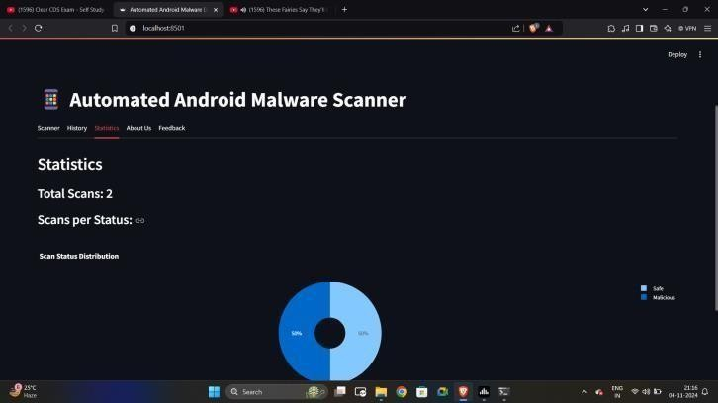Google Chrome, Mozilla Firefox, or Microsoft Edge for accessing the application interface, with JavaScript enabled for full functionality.

# Text Editor/Integrated Development Environment (IDE):

* + - Recommended IDEs: Visual Studio Code, PyCharm, or Jupyter Notebook for editing and running the application code.

# API Access:

* + - Access to the VirusTotal API with a valid API key. Users need to register for an account on the VirusTotal website to obtain the API key, which is required for submitting APK files for scanning.

# Optional Software:

* + - 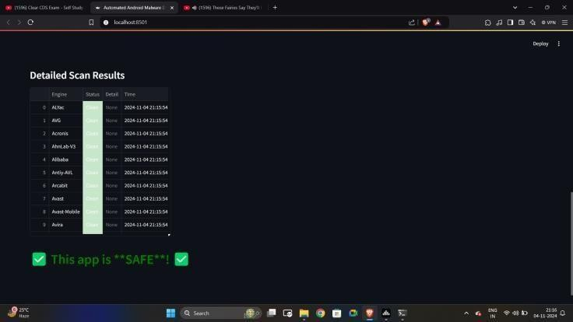Git: For version control and managing changes to the codebase, facilitating collaboration and deployment.
    - Docker: If containerization is desired, Docker can be used to create a consistent environment for running the application.

# Results:

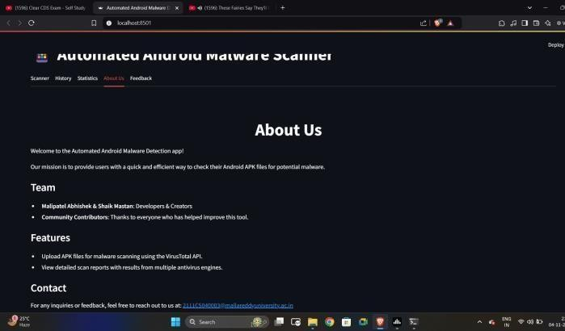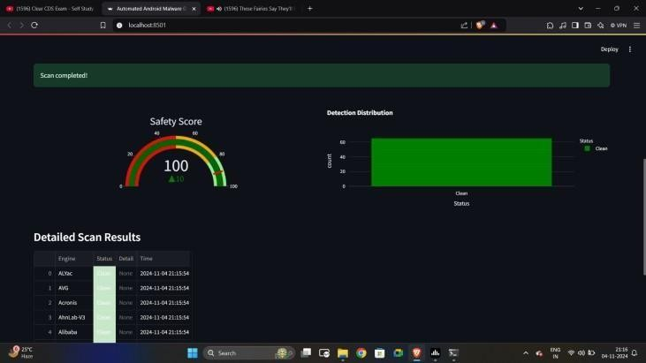

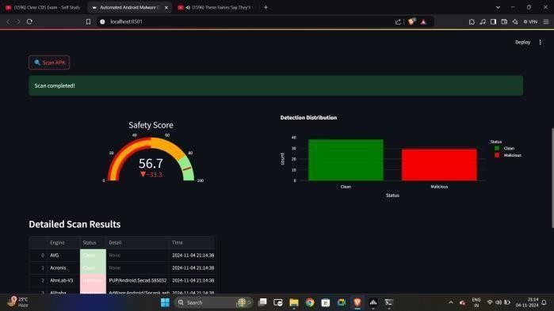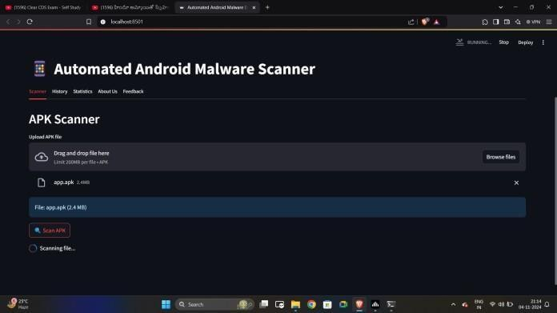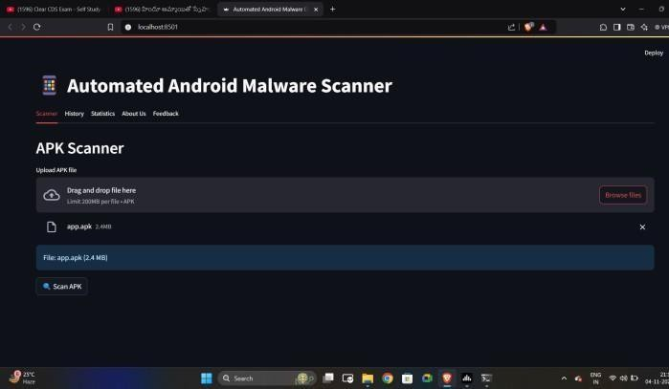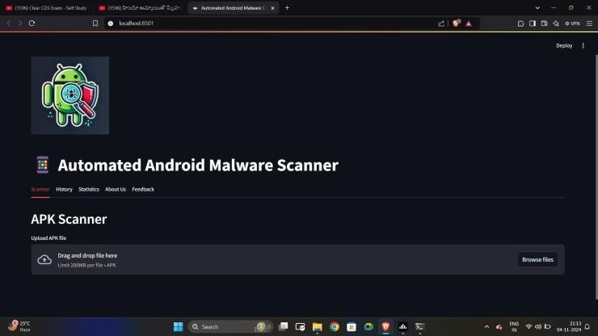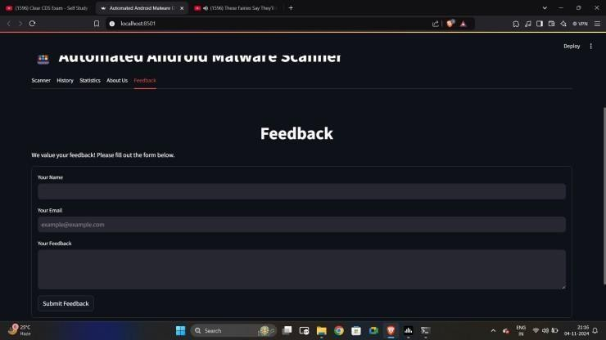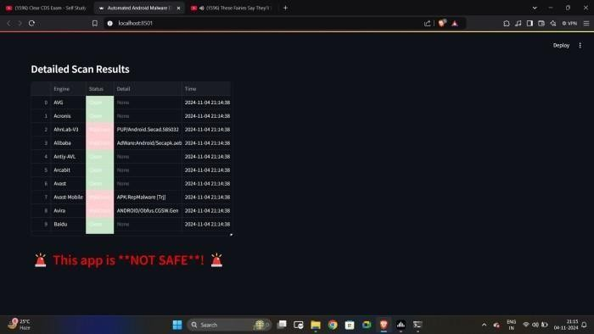 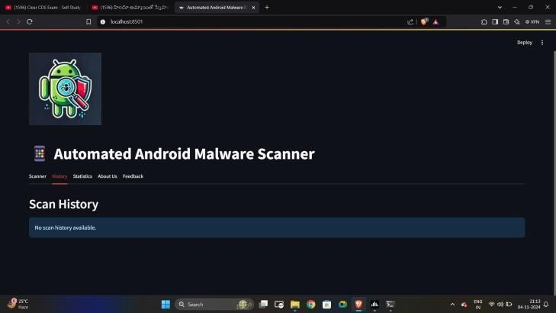

# Conclusion:

This research introduced an Automated Android Malware Detection tool using VirusTotal's API, integrated into a Streamlit app. The system provides real-time malware analysis of APK files, delivering easy-to- understand results through data visualizations like safety scores and engine- specific reports. With a user-friendly interface, scan history tracking, and feedback options, the tool empowers both technical and non-technical users to ensure app security. Its modular design allows for future scalability, making it an asset in mobile security. Future enhancements could include machine learning for predictive analysis and behaviour monitoring.