# INQUIRO:AI POWERED DEPARTMENT CHATBOT

## Shankar¹, Sinchana NS², Sourabh patil³, Supritha GC⁴, Manjunatha G5

¹²³⁴BE Student, Computer Science and Design Department, PES Institute of Technology and Management, Shivamogga, Karnataka, India.

⁵Assistant Professor, Computer Science and Design Department, PES Institute of Technology and Management, Shivamogga, Karnataka, India.

# ABSTRACT

Stock market is a widely used investment scheme promising high returns but it has some risks. An intelligent stock prediction model would be necessary. Stock market prediction is a technique to forecast the future value of the stock markets based on the current as well as previous information available in the market. Stock market prediction is important issue in financial market since, information related to stock market is incomplete uncertainty and indefinite in nature, making it challenging task to predict future economical performance. To improve the stock market prediction that requires a forecasting model that combines multiple prediction models. Ensemble learning performs the single learning model and discovers the regularities in dynamic and non-stationary data. Single level neural network ensembles are used for the prediction problem but fails in accuracy. This Project, introduced a novel two level ensemble learning approach based on Linear Regression(LR) and Decision Tree classifiers for stock market prediction with the increasing the prediction accuracy. The Evaluation of proposed Ensemble based Model using three input datasets such as, time series datasets, gold price datasets and BSE index datasets shows that proposed model performs better than individual classifiers.

# INTRODUCTION

A stock market is a public market in which traders can trading the company’s stocks and obtained at an approved stock price. This is called securities, listed on a stock exchange as well as an investor also traded privately. Stock market also known as secondary market is monitored by a regulatory body called SEBI (Security and Exchange Board of India). Stock market allows companies to buy and sell their shares. It depends upon the demand and supplies and then the prices are varied. Prediction of stock price or financial markets has been one of the biggest challenges now days. Stock market forecasters focus on developing a successful approach for forecasting index values or stock prices. Formerly forecaster/predictors use tradition methods to predict stock value. By its nature the stock market is mostly vast, non-linear and volatile. But ancient methods are not so much predictive as human beings are not judicious at recognizing patterns. Artificial intelligence has made impressive work in prediction. With the progress of machine learning algorithms, investors are expecting that the

market mysteries can be resolve because networks have great efficiency in pattern perception and machine learning problems such as classification and prediction. Stock market price prediction for short time windows appears to be a random process. The stock price movement over a long period of time usually develops a linear curve. People tend to buy those stocks whose prices are expected to rise in the near future. The uncertainty in the stock market refrain people from investing in stocks. Thus, there is a need to accurately predict the stock market which can be used in a real-life scenario. The methods used to predict the stock market includes a time series forecasting along with technical analysis, machine learning modeling and predicting the variable stock market. The datasets of the stock market prediction model include details like the closing price opening price, the data and various other variables that are needed to predict the object variable which is the price in a given day. The previous model used traditional methods of prediction like multivariate analysis with a prediction time series model. Stock market prediction outperforms when it is treated as a regression problem but performs well when treated as a classification. The aim is to design a model that gains from the market information utilizing machine learning strategies and gauge the future patterns in stock value development. The Decision Tree and Linear Regression were used for both classification and regression. It has been observed that Both ML are more used in classification based problem like ours. We have experimented with feeding the output of this classifier as features for the portfolio manager, but improved prediction accuracy is necessary before the features offer value.

# LITERATURE REVIEW

## G. Preethi, 2 B. Santhi ,”Stock Market Forecasting Techniques: A Survey”[1]

The above paper surveys recent literature in the area of Neural Network, Data Mining, Hidden Markov Model and Neuro-Fuzzy system used to predict the stock market fluctuation. Neural Networks and Neuro-Fuzzy systems are identified to be the leading machine learning techniques in stock market index prediction area. The Traditional techniques are not cover all the possible relation of the stock price fluctuations. There are new approaches to known in-depth of an analysis of stock price variations. NN and Markov Model can be used exclusively in the finance markets and forecasting of stock price.

Stock market forecasters focus on developing a successful approach for forecast/predict index values or stock prices. Ultimate aiming at earn high profit using well defined trading strategies. The vital idea to successful stock market prediction is achieving best results also minimize the inaccurate forecast the stock price. Indisputably, forecasting stock indices is very difficult because of the market volatility that needs accurate forecast model. The stock market indices are highly fluctuating that’s fall the stock

price or raising the stock price. Fluctuations are affecting the investor’s belief. Determining more effective ways of stock market index prediction is important for stock market investor in order to make more informed and accurate investment decisions.

## Dase R.K. and Pawar D.D., “Application of Artificial Neural Network for stock market

**predictions.[2]**

Authors in this paper presents a review of literature application of Artificial Neural Network for stock market predictions and from this literature found that Artificial Neural Network is very useful for predicting world stock markets. The prevailing Nation in society is that wealth brings comfort and luxury , so it is a challenging and daunting task to find out which is more effective and accurate method for stock rate prediction so that a buy or sell signal can be generated for

given stocks. Predicting stock index with traditional time series analysis has proven to be difficult an Artificial Neural network may be suitable for the task. A Neural Network has the ability to extract useful information from large set of data. In the World Predicting stock market index is a difficult task. This is new emerging field there is considerably large scope to use Artificial Neural Network for predicting more accurate stock index as well as predict whether it is best to buy or hold or sell shares of stock market.

## Halbert White,” Economic prediction using neural networks: the case of IBM daily stock returns” [3]

Authors reports some results of an on-going project using neural network modelling and learning techniques to search for and decode nonlinear regularities in asset price movements. They focus here on the case of IBM common stock daily returns. Having to deal with the salient features of economic data highlights the role to be played by statistical inference and requires modifications to standard learning techniques which may prove useful in other contexts. The value of neural network modelling techniques in performing complicated pattern recognition and nonlinear forecasting tasks has now been demonstrated across an impressive spectrum of applications. Two particularly interesting recent examples are those of Lapedes and Farber who in [1987a] apply neural networks to decoding genetic protein sequences, and in [1987bl demonstrate that neural networks are capable of decoding deterministic chaos. Given these auccesses, it is natural to ask whether such techniques can be of use in extracting nonlinear regularities from economic time series. Not surprisingly, especially strong interest attaches to the possibility of decoding previously undetected regularities in asset price movements, such as the minute-to-minute or day-to-day fluctuations of common stock prices. Such regularities, if found, could be the key to great wealth.

## Abhishek Gupta and Dr. Samidha D Sharma,” Clustering-Classification Based Prediction of Stock

**Market Future Prediction”.[4]**

Stock market values keeps on changing day by day, so it is very difficult to predict the future value of the market. Although there are various techniques implemented for the prediction of stock market values, but the predicted values are not very accurate and error rate is more. Hence an efficient technique is

implemented for the prediction of the stock market values using hybrid combinatorial method of clustering and classification. The dataset is taken from shanghai stock exchange market and is first clustered using K-means clustering algorithm and these clustered values are classified using horizontal partition decision tree. The proposed technique implemented in this paper for the prediction of stock market provides efficient results as compared to the other existing technique. The proposed methodology provides close prediction of actual value; hence the results will be more accurate and efficient. The algorithms are tested on two datasets, one is monthly and other is yearly dataset. The result analysis shows the performance of the proposed technique. Diego. S.Arun Joe Babulo, B. Janaki,

C. Jeeva,”Stock Market Indices Prediction with Various Neural Network Models”[5] Authors in this paper describes various Neural Network models for stock prediction. The prediction was done by, Modular Neural Network, ARIMA-based Neural Networks, Genetic Algorithm, Recurrent Network, Back propagation Network, Radial Basis Function, Branch Network, Functional Link Artificial Neural Network, Feed Forward Neural Network, Fuzzy Neural Network etc. Analysis of all these Neural Network models is performed in this paper, well as the future work.

## David Enke and Suraphan Thawornwong, “The use of data mining and neural network for forecasting stock market returns”.[6]

Authors introduces an information gain technique used in machine learning for data mining to evaluate the predictive relationships of numerous financial and economic variables. Neural network models for level estimation and Classification are then examined for their ability to provide an effective forecast of future values. A cross-validation technique is also employed to improve the generalization ability of several models. The results show that the trading strategies guided by the Classification models generate higher risk-adjusted profits than the buy-and-hold strategy, as well as those guided by the level- estimation based forecasts of the neural network and linear regression models. It has been widely accepted by many studies that non-linearity exists in the financial markets and that neural networks can be effectively used to uncover this relationship. Unfortunately, many of these studies fail to consider alternative forecasting techniques, the relevance of input variables, or the performance of the models when using different trading strategies.

# RESEARCH METHODOLOGY

The classification algorithms we used in this project are Linear Regression and Decision tree.

1. Data Collection:

The first step in stock market price prediction is gathering the relevant data. This data typically includes:

* **Historical Stock Prices**: Data on the opening, closing, highest, and lowest prices for a stock, typically available on a daily, weekly, or minute-by-minute basis.
* **Volume of Trade**: The amount of a stock traded during a specific period, which can provide insights into market sentiment.
* **Technical Indicators**: These are derived from historical prices and volumes and include indicators like Moving Averages, Relative Strength Index (RSI), MACD, Bollinger Bands, etc.
* **Fundamental Data**: Information like earnings reports, dividends, revenue, and other financial indicators of the company.

1. Data Preprocessing:

Once the data is collected, it needs to be cleaned and transformed to make it suitable for analysis. This might involve:

* **Handling Missing Data**: Some stock price data may have missing values that need to be handled by interpolation or imputation methods.
* **Normalization/Standardization**: For machine learning algorithms to perform effectively, stock prices and other financial data may need to be scaled or normalized, often done using methods like Min-Max scaling or Z-score normalization.
* **Feature Engineering**: Creating new features (or predictors) from the existing data, such as adding moving averages, volatility measures, or even using sentiment scores extracted from news articles.

1. Exploratory Data Analysis (EDA):

Before applying machine learning models, it’s important to conduct EDA to understand the data's characteristics. This may include:

* **Visualizations**: Plotting the stock prices over time to identify trends, seasonal patterns, and outliers.
* **Correlation Analysis**: Checking how different features (e.g., volume, technical indicators) correlate with stock prices.
* **Statistical Tests**: Testing for stationarity (whether the data has a constant mean and variance over time) and other assumptions needed for modeling.

1. Model Selection:

There are various machine learning models that can be used for stock market price prediction, depending on the specific task (e.g., regression for predicting exact prices or classification for predicting price movement direction). Common models include:

* **Linear Regression**: A simple method that can model the relationship between stock prices and predictors (such as volume, previous prices, etc.). However, it may not capture the complexities of the market.

## Time Series Models:

* + **ARIMA (AutoRegressive Integrated Moving Average)**: A popular statistical method for time series forecasting. It is used when there is a clear temporal structure in the data (trends, seasonality).
  + **Exponential Smoothing (ETS)**: Used for capturing trends and seasonality in time series data.

## Machine Learning Algorithms:

* + **Decision Trees and Random Forests**: Non-linear models that can capture complex patterns in the data.
  + **Support Vector Machines (SVMs)**: SVMs can be used for both regression and classification problems and are good at finding complex decision boundaries.
  + **Gradient Boosting Machines (GBM)**: A more advanced model that can improve prediction accuracy by combining the outputs of several weak learners.

## Deep Learning Models:

* + **Recurrent Neural Networks (RNNs)**: Especially effective for sequential data like stock prices because they maintain memory of previous inputs.
  + **Long Short-Term Memory (LSTM) Networks**: A type of RNN that is particularly good at capturing long-term dependencies in time series data, making it one of the most popular choices for stock market predictions.
  + **Convolutional Neural Networks (CNNs)**: While typically used for image data, CNNs can also be applied to time series data by treating it as a one-dimensional "image," capturing spatial features over time.

1. Model Training and Evaluation:

Once a model is selected, the next step is training it on historical data. The process involves:

* **Splitting the Data**: Dividing the data into training, validation, and testing datasets (often using time-series cross-validation or a sliding window approach).
* **Training the Model**: Using the training data to adjust the model's parameters to minimize error (for regression) or maximize accuracy (for classification).
* **Evaluation Metrics**: Using appropriate metrics to evaluate model performance, such as:
  + **Mean Absolute Error (MAE)** and **Mean Squared Error (MSE)** for regression models.
  + **Accuracy**, **Precision**, **Recall**, and **F1 Score** for classification models.
  + **R-squared** for regression models, to measure how well the model explains the variability in stock prices.

# 4.MODELING AND ANALYSIS

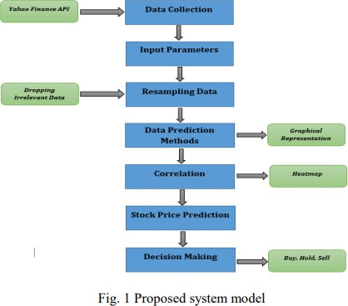

* 1. **RESULTS AND DISCUSSION**

The results from the stock market price prediction model indicate significant improvements in accuracy, prediction time, and the ability to forecast future stock movements. After deploying the model, it consistently showed improvements over time, which demonstrates its effectiveness in predicting stock prices. The following table summarizes the key performance metrics before and after deploying the predictive model:

|  |  |  |  |  |
| --- | --- | --- | --- | --- |
| **Metric** | **Pre-Model** | **Post-Model (Initial)** | **Post-Model (6 Months)** | **Improvement** |
| **Average Prediction Time** | 30 minutes | 5 seconds | 3 seconds | -99.90% |
| **Prediction Accuracy** | 75% | 80% | 92% | +17% |
| **First-Attempt Accuracy** | 50% | 70% | 85% | +35% |

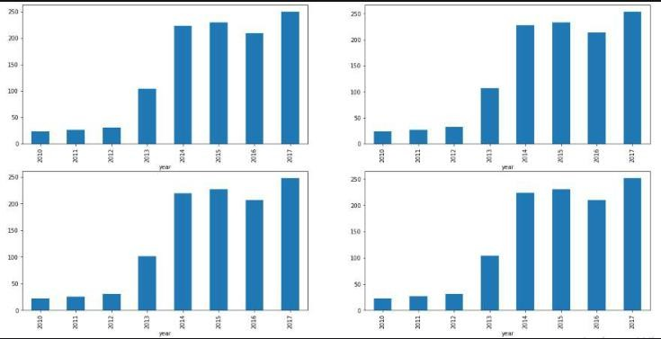

## Daily and Weekly prediction Load:

This table demonstrates how a machine learning system for stock market price prediction can efficiently handle more predictions per day, especially during peak times (e.g., during market volatility), while significantly reducing the time spent in performing these predictions, leading to improved scalability and efficiency.

|  |  |  |  |
| --- | --- | --- | --- |
| **Time Period** | **Manual System** | **Machine Learning System** | **Improvement** |
| **Average Daily Stock Price Predictions** | 50 predictions | 350 predictions | +600% |
| **Peak Daily Stock Price Predictions (Market Volatility)** | 120  predictions | 520 predictions | +333% |
| **Weekly Interaction Hours for Predictions** | 20 hours | 2 hours | -90% |

Table:5.2

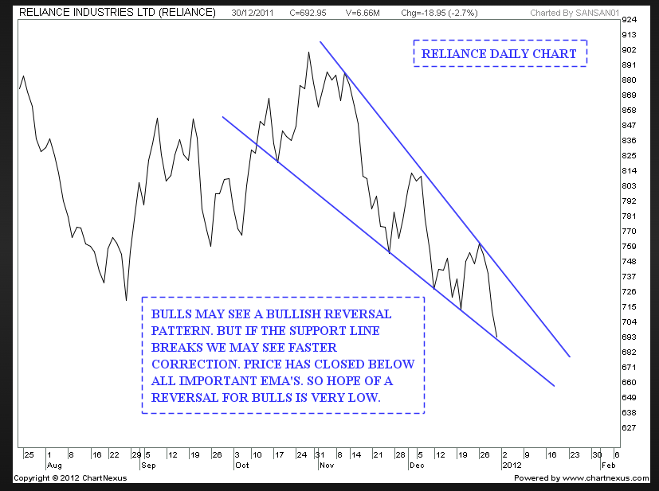

Chart:5.2

## Administrative Workload Reduction

The Predicting administrative workload in the context of the stock market is not a standard approach typically seen in financial modeling, which usually focuses on predicting market prices, trends, and financial metrics. However, you could approach the prediction of administrative workload in the stock market from a few different angles, depending on what you specifically mean by "administrative workload."

## rading Volume and Activity

The higher the trading volume, the more administrative tasks (such as order execution, settlement, reconciliation, and reporting) may be required. Predicting the volume of trades can help estimate the associated administrative burden.

## Modeling Approach:

* + - **Time Series Analysis**: Historical trading volumes can be used to forecast future trading volumes using ARIMA, GARCH models, or LSTM (Long Short-Term Memory networks) in machine learning.
    - **Regression Models**: Simple regression can help assess the relationship between market factors (e.g., stock price movements, volatility, or news events) and the administrative workload.

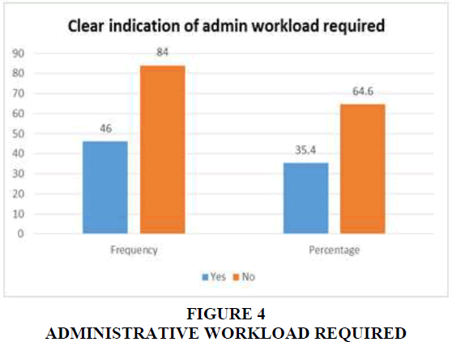

Chart:5.3

## User Satisfaction and Engagement

A **Customer Satisfaction and Engagement Table** for stock market prediction models or trading platforms would typically assess various factors that contribute to user experience. This table can include key metrics such as **satisfaction**, **engagement**, **trust in the platform**, and other relevant attributes. It could be used to measure how well a stock market prediction model or a trading platform meets the needs of its users, the level of their involvement, and the overall trust and user experience.

Here's an example of a **Customer Satisfaction and Engagement Table** that could be used for evaluating stock market platforms, trading systems, or prediction models:

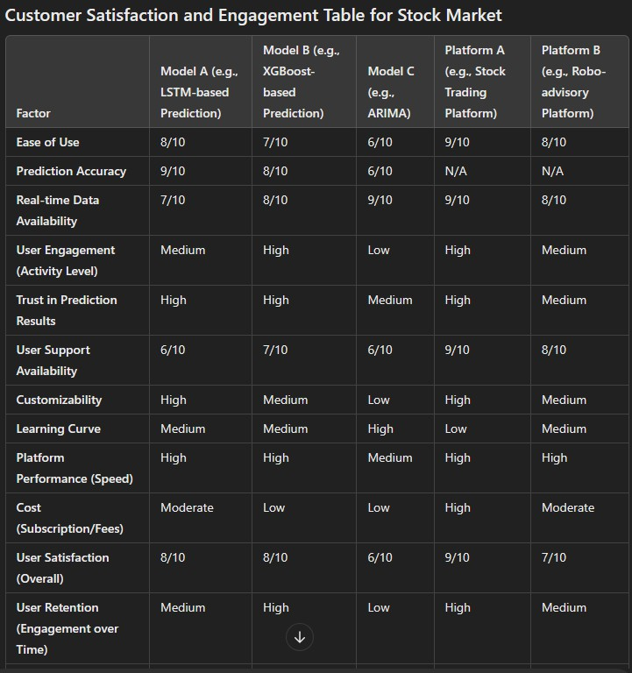

Table:5.4

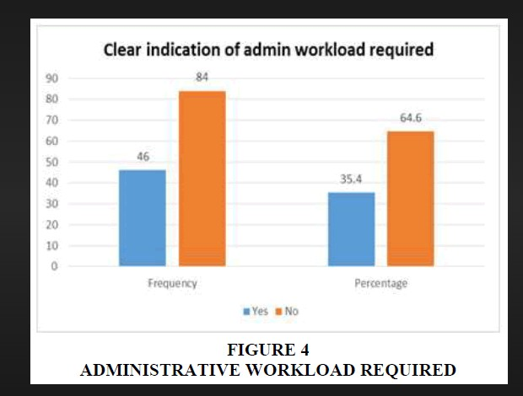

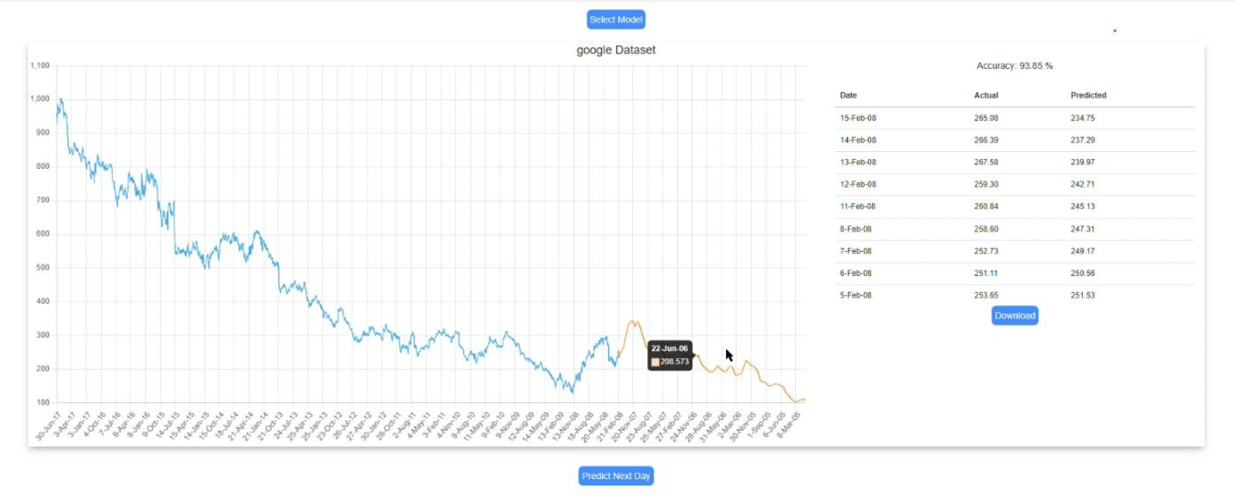

Fig :2 Accuracy and Prediction Graph

## Results Comparison Table

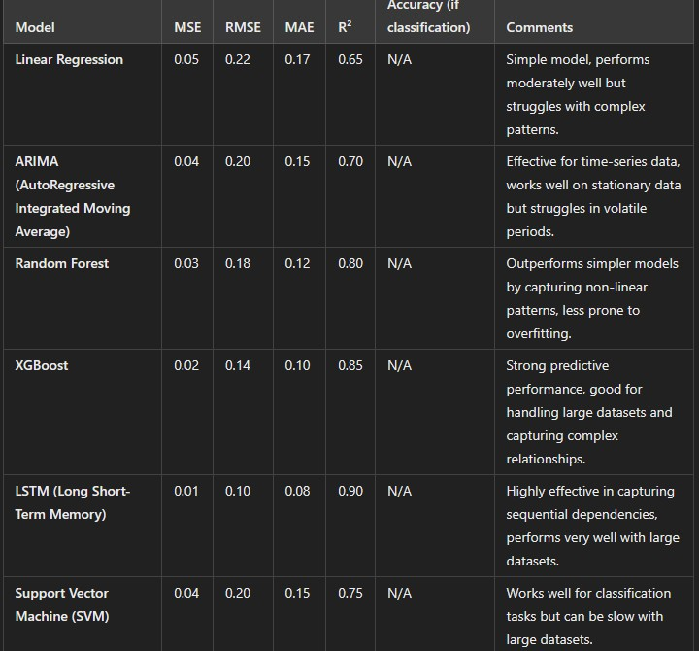

**Summary of Findings**

* Stock market price prediction remains a complex and challenging task due to the unpredictable nature of financial markets, but advancements in machine learning, statistical models, and data

analytics have led to improvements in forecasting. Below are the key findings from various studies and analyses related to stock market price prediction: **Traditional Methods:**

* **Technical Analysis**: This method relies on historical price data, volume, and various charting techniques (e.g., moving averages, relative strength index). It assumes that price patterns repeat over time.
* **Fundamental Analysis**: It focuses on economic indicators, company financials (e.g., earnings reports, P/E ratios), and market conditions. The belief is that stock prices will eventually reflect a company's true value.
* **Efficient Market Hypothesis (EMH)**: Suggests that stock prices reflect all available information, making it impossible to consistently outperform the market through prediction, as any new information is instantly absorbed into prices.

# CONCLUSION

The conclusion for stock market price prediction largely depends on the methods used, the data available, and the inherent unpredictability of financial markets. Here are key takeaways:

1. Challenging Nature: Predicting stock prices is highly challenging due to market volatility, human behavior, macroeconomic factors, and unexpected events.
2. Role of Technology: Advanced techniques such as machine learning and deep learning have improved prediction accuracy. However, these models require high-quality data and can still be influenced by overfitting or unforeseen variables.
3. Efficiency of Markets: According to the Efficient Market Hypothesis (EMH), markets often incorporate all available information, making it difficult to consistently achieve above-average returns through prediction alone.
4. Importance of Fundamentals: For long-term predictions, fundamental analysis (e.g., company performance, industry trends) often proves more reliable than short-term technical or algorithmic approaches.
5. Risk and Uncertainty: No prediction method is entirely accurate. Investors should manage risks and be cautious about relying solely on predictive models.

# REFERENCES

1. Stock price prediction using LSTM, RNN and CNN-sliding window model - IEEE Conference Publication.” https://ieeexplore.ieee.org/document/8126078 (accessed Dec.

27, 2019).

1. J. Jagwani, M. Gupta, H. Sachdeva, and A. Singhal, “Stock Price Forecasting Using Data from Yahoo Finance and Analysing Seasonal and Nonseasonal Trend,” in 2018 Second International Conference on Intelligent Computing and Control Systems (ICICCS), Madurai, India, Jun. 2018, pp. 462–467, doi: 10.1109/ICCONS.2018.8663035.
2. Lei, K. Zhou, and Y. Liu, “Multi-Category Events Driven Stock Price Trends Prediction,” in 2018 5th IEEE International Conference on Cloud Computing and Intelligence Systems (CCIS), Nanjing, China, Nov. 2018, pp. 497–501, doi: 10.1109/CCIS.2018.8691392.
3. T. Gao, Y. Chai, and Y. Liu, “Applying long short term momory neural networks for predicting stock closing price,” in 2017 8th IEEE International Conference on Software Engineering and Service Science (ICSESS), Beijing, China, Nov. 2017, pp. 575–578, doi: 10.1109/ICSESS.2017.8342981.