GASTRIC RESISTANT MULTI PARTICULATE SYSTEMS OF ACECLOFENAC FOR CONTROLLED RELEASE

Dr. alladi saritha, Akhila
SSJ College of pharmacy, VN Pally, Hyderabad

ABSTRACT
The present aim of the work was undertaken with one objective to develop gastroresistant drug delivery system for Aceclofenac. Aceclofenac is an Anti inflammatory drug, which causes gastric irritation in the stomach. Therefore, the drug should be targeted to intestine; to bypass the stomach the gastroresistant microspheric drug delivery system was adopted. The formulations were developed consisting of double wall. The primary wall composed of mucoadhesive polymer sodium alginate. The second wall coating the primary microspheres was composed of eudragit S-100.The effect of polymer concentration on the particle size, shape drug entrapment efficiency, mucoadhesive property, release study of core microspheres were evaluated.

CORRESPONDING AUTHOR

Dr. Alladi saritha

Head, dept of pharmaceutics,

SSJ College of Pharmacy

Hyderabad

Email-alladis1@gmail.com

INTRODUCTION

Oral delivery is the most widely utilized route of administration among all the routes that have been explored for systemic delivery of drugs via pharmaceutical products of different dosage form. Oral route is considered most natural, uncomplicated, convenient and safe due to its ease of administration, patient acceptance and cost effective manufacturing process (1).

Oral route of drug administration have wide acceptance up to 50-60% of total dosage forms. Solid dosage forms are popular because of ease of administration, accurate dosage, self-medication, pain avoidance and most importantly patient compliance. The most popular solid dosage forms are tablets and capsules. Oral dosage form is the most popular route for drug therapy. Over 80% of the drugs formulated to produce systemic effects in the United States are produced as oral dosage forms (2, 3).

Gastro-resistant tablet dosage form is intended to release a drug after some time that is delay or after the tablet has passed through one part of the GI tract in to another. “Delayed-release dosage forms are modified-release dosage forms showing a release of the active substance(s) that is delayed. Gastric resistant - coated dosage forms are designed to resist the acidic environment of the stomach and to disintegrate in the higher pH environment of the intestinal fluid. Proton pump inhibitors, H2 blockers, some NSAIDs, insulin delivery etc are suitable candidates for developing delayed release dosage forms (4,5).

The main objective of the work is to prepare gastric resistant micro particles of NSAIDS by using meth acrylic acid copolymer sodium alginate and further coating by using multi particulate technology method. Non-steroidal anti-inflammatory drugs are the most frequently prescribed medication as analgesics, anti-pyretic and anti-inflammatory agents. These are effectively used in treatment of rheumatoid arthritis, osteoarthritis.NSAIDS are associated with side effects of gastric irritation , haemorrhages and peptic ulcer such side effects can be overcome by formulating gastric resistant micro particles of aceclofenac. Formulating gastric resistant micro particle could increases the patient compliance by decreasing adverse effects associated with administration aceclofenac.

MATERIALS AND METHODS
Aceclofenac was received as a gift sample from Hetero drugs pvt ltd, Hyderabad. HPMC different grade, Eudragit s100, sodium alginate procured from SD fine chemiclas, E These all polymers are used in different ratios for different formulations. Isopropyl alcohol is used as solvent were obtained from sigma Aldrich pvt ltd.
EXPERIMENTAL

Sodium alginate micro particles of aceclofenac were prepared by congealing technique.The sodium alginate micro particles were characterized for the nanoparticle formation and the process was optimized. The sodium alginate micro particles were evaluated for dissolution studies, other in-vitro tests
preparation of sodium alginate gastro resistant micro particles
The microspheres were prepared by ionotropic external gelation technique using the formulations as shown in Table 1. The alginate solutions comprising different concentration sodium alginate were prepared by initially dissolving the polymer in deionized water using gentle heat and magnetic stirring. On complete solution, an accurately weighted quantity of aceclofenac was added to each solution to afford homogeneous dispersions. The dispersions were stirred for 30 min to remove any air bubbles that may have been formed during the stirring process. The sodium alginate-drug dispersions (25 mL) were added drop wise via a 20-gauge hypodermic needle fitted with a 10 mL syringe into 100 mL of 2 % w/v solution of cacl2. The formed alginate microspheres were further stirred in the solution of gelling agents for an additional 1 h. On expiration of this period the solutions of gelling agents were decanted and the microspheres were washed with of deionized water. The microspheres were thereafter dried at 60C for 2 h in a hot-air oven.
Coating of Calcium alginate bead
The gastric resistant solution was prepared by dissolving eudragit in acetone.This solvent makes complete dissolution of eudragit S 100 while maintaining integrity of the calcium alginate bead. The optimized batch of calcium alginate bead was dispersed in the enteric coated solution. Then the microspheres were stirred in 20ml given benzene .The obtained microspheres coated micro particulate system.

Morphology and particle size determination
The shape and surface morphology of the alginate microspheres were investigated using JEOL, JSM-6360, and microscope at 15 kV. Prior to examination the samples were gold coated under vacuum (Fine coat, Ion sputter, JFC-1100) to render them electrically conductive. The samples included various alginate microspheres prepared using different gelling agents before release study.
The particle size of coated gastric resistant micro particles is determined by microscopic method.The microspheres are placed on slide and measured by using eye piece micrometer.

Drug encapsulation efficiency
The microspheres equivalent to 50mg of aceclofenac from each batch was placed in 100 mL conical flask containing 100 mL of phosphate buffer of pH 7.4. The microspheres were magnetically stirred to promote swelling and breakup of the cross-linked structure. This afforded liberation and subsequent dissolution of aceclofenac. The solution was filtered through a 0.45 mm membrane filter. Then the drug was quantified spectrophotometrically at after appropriate dilution with phosphate buffer of pH 7.4. The incorporation efficiency was determined by the following empirical relationship: Drug incorporation efficiency (%) = (AQ/TQ) × 100 where AQ is the actual quantity of drug present in the microspheres and TQ is the 100 % theoretical quantity of drug present in the microspheres (i.e. actual initial loading dose).
Drug content in micro particles
The content of aceclofenac in micro particles was analyzed by UV spectroscopy.

Dissolution studies
The in-vitro dissolution study of samples was carried out by dispersed powder technique in a USP apparatus-I ( basket method), using 900 ml of dissolution medium at 37+0.5°C stirred at 100 rpm. Samples of 5 ml were withdrawn at different time intervals. An equal volume of fresh dissolution medium was immediately replaced. The samples were filtered and analyzed spectrophotometrically at 362 nm and 360 nm for aceclofenac respectively. The dissolution of each batch was performed in triplicate (n=3) and mean of all determinations was used to calculate the drug release profile.
Dissolution of aceclofenac samples
The weighing of drug sample was carried out by difference on calibrated digital balance (0.1 mg sensitivity). The sample was placed in the dissolution container and pre-warmed media (37+0.5°C) was poured over it. Dissolution studies of 100mg of plain drug and agglomerate samples equivalent to 15 mg of aceclofenac were conducted in 6.8, pH buffers and 0.1N HCl.

RESULTS AND DISCUSSION
Morphological Analysis Figure 3 shows the surface morphologies of polymer-coated and microspheres. While Eudragit S-100 -coated microsphere had rough surface, and smallerpores than those of plain alginate microspheres.
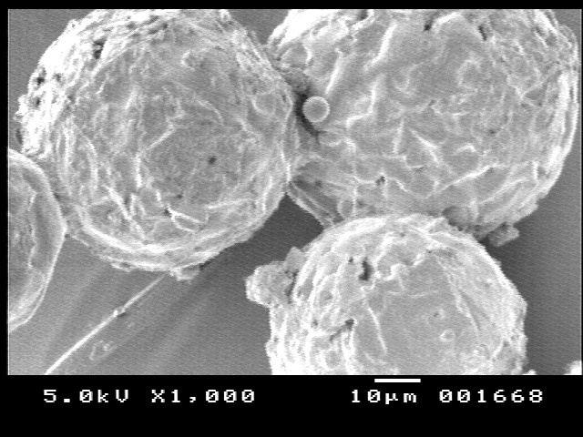
FIG:1 microspheres analysis of multi particulate system of aceclofenac
- Average diameter of alginate microspheres
The average diameter of polymer-coated and blended alginate microspheres shown Tables respectively. As the amount of polymer in the coating solution increased, the average diameter of coated alginate microspheres increased.
- This may be attributed to the increased amount of polymer on the microsphere surface. As seen in tables 3 and 4, the average diameters of Eudragit S-100 coated or blended alginate microspheres were longer than those of un coated formulations.
- FORMULATION OF ALGINATE MICROSPHERES TABLE:1
Formulation | Particle size | Drug content | Encapsulation efficiency
UNCOATED | 189.56 | 97 | 91
F1 | 234.67 | 98 | 86
F2 | 275.2 | 94 | 84
F3 | 313.9 | 97 | 80
F4 | 292.4 | 98 | 76
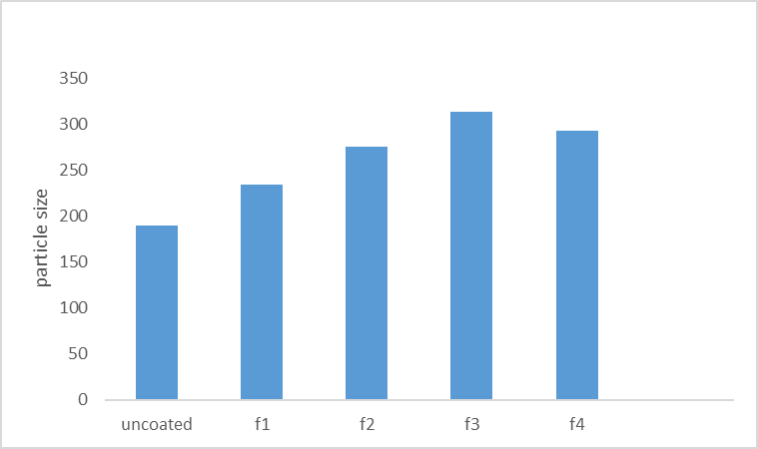
FIG-2 Particle size profile of aceclofenac multiparticulate system
- Encapsulation efficiency
The encapsulation efficiency of alginate microspheres prepared in this experiment was generally high, How ever, encapsulation efficiency of some formulations among coated microspheres was lower than other formulations. It can be explained that drug was diffused out slightly during coating process. The encapsulation efficiency of plain alginate microspheres was higher than that of coated polymer the encapsulation efficient of coated polymer increased with increase in sodium alginate .

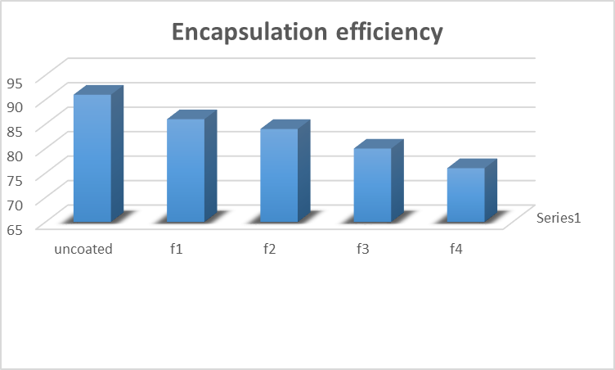

FIG-3 Encapsulation efficiency profile of coated multipurticulate

% CUMMULATIVE DRUG RELEASE PROFILE OF COATED MULTIPERTICULATE .TABLE:2

TIME | F1 | F2 | F3 | F4 | UNCOATED
0 | 0 | 0 | 0 | 0 | 0
1 | 1.4 | 1.1 | 1.1 | 1 | 23.7
2 | 1.1 | 1.2 | 2.7866 | 0.8 | 34.87
3 | 25.61 | 24.51 | 22.78 | 12.61 | 43.76
4 | 36.12 | 32.41 | 26.78 | 18.42 | 56.9
5 | 45.67 | 40.12 | 31.89 | 22.68 | 65.98
6 | 67.61 | 54.12 | 43.78 | 33.41 | 82.89
7 | 88.91 | 72.41 | 53.512 | 42.61 | 89.23
8 | 98.34 | 76.22 | 65.088 | 50.26 | 99.87
10 | 99.67 | 88.62 | 74.78 | 66.12 | 93.78
12 | 97.56 | 98.61 | 87.67 | 68.22 | 92.34
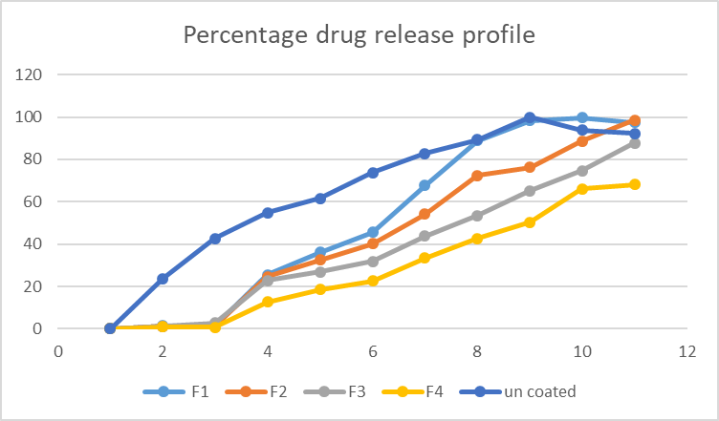
FIG-4 percentage drug release profile

- DRUG RELEASE FROM EUDRAGIT S100-COATED AND BLENDED ALGINATE MICROSPHERES
- The release profiles of EUDRAGIT S100-coated alginate microspheres are seen in figure 5. The formulation in 0.1N HCL produced no effect on the drug release. The drug release from all formulation was retarded , but slightly controlled after 40 min. As the amount of EUDRAGIT S100 increase in the coating solution, the release rate of drug from coated alginate microspheres was slightly reduced due to the increased amount of EUDRAGIT S100 on the microsphere surface. from the various gastric resistant formulations was carried out by using 6.8 pH phosphate buffer for 12 hr. the cumulative percentage release of aceclofenac was varied from 49.72% to 86.83% depends upon the drug polymer ratio for 12 hr (table 5.3).
- EUDRAGIT S100-coated alginate microspheres produced a slight effect on the release rate of drug. The release profiles of drug were determined for EUDRAGIT S100-blended alginate microspheres, as shown in figure 4. EUDRAGIT S100-blended alginate microspheres, showed an ideal linear release profile. Difference in release characteristics was not specifically determined, varying EUDRAGIT
- EUDRAGIT S100 was added to sodium alginate as an additive polymer to modify the drug release from the microspheres. It was reported that EUDRAGIT S100 polymers affected the drug release of alginate microspheres (Chan et al. 1997) and increasing the EUDRAGIT S100 amount in tablets decreased the release rate of drug. In this experiment, blending EUDRAGIT S100 with sodium alginate affected the release rate of drug from alginate microspheres as a result of protection from erosion and disintegration in stomach.
- EUDRAGIT S100 was found to be an effective additive polymer for controlling the release rates specifically in intestine. This may be attributed to the chemical nature of the EUDRAGIT S100 as well as its viscosity. Microspheres with tight polymer structures could be produced because the long, partially coiled EUDRAGIT S100 polymer chains could interpenetrate the sodium alginate polymer network (Chan et al. 1997). Therefore, EUDRAGIT S100-blended alginate microsphere is a good candidate for controlling the drug release.

CONCLUSION
The present research work was investigated on the design and evaluation of gastric resistant multi particulate systems of aceclofenac for controlled release. Microspheres are the sub microscopic particles with desired release properties. Aceclofenac is a potent NSAID with shorter half life. It requires multiple appliation for longer duration of period which is associated with GI bleeding and ulceration.

The microspheres of aceclofenac were developed using a bio comepatible polymer sodium alginate and further coated with pH dependent polymer eudragit s100. Microsphere evaluated with scanning electron microscopy showed spherical particls in a size range of 220-340 µm. All the formulation showed gastric resistance with controlled drug release in 6.8 phosphate buffer. The present concludes the application gastric resistant coating on the multi particulate systems of aceclofenaac.. This strategy can be a simple commercially feasible technique of formulation development of non-steroidal anti-inflammatory drugs

REFERENCES

1)Shargel L, Kanfer L. Introduction to Generic Drug Product Development, Generic Drug Product Development-Solid Oral Dosage Forms, Marcel Dekker, Inc., NY, 2005; PP 1-16.

2)US Department of Health and Human Services, Food and Drug Administration, Center for Drug Evaluation and Research (CDER): Guidance for Industry - Dissolution Testing of Immediate Release Solid Oral Dosage Forms [homepage on the Internet]. August 1997:1-11.

3) World Gastrointestinal Disorders Market 2008- 2023, (Updated 2008 Oct 30; cited 2008Dec01). Available from Review Paper Covered in Inde x Cope rnicus with IC Value 4.68 fo r 2010 Patel Harshna et al: Gastro Resistant Drug Delivery System: A Review Int. J. Drug Dev. & Res., October-December 2012, 4 (4).
4) Tripathi KD, Essentials of medical pharmacology, 6th ed, Delhi: Jaypee brothers medical publishers (p) Ltd, 2008; PP 628-638
5) Hoogerwerf HA, Pasricha PJ. Pharmacotherapy of gastric acidity, peptic ulcers and gastroesophageal reflux disease; Goodman & Gilman’s pharmacological basis of therapeutics Brunton LL, Lazo JS, Parker KL, editors. 11th ed, USA: McGraw- Hill Companies, Inc.:2006; PP 967-981
6) Hogan J. Modified release coatings, Pharmaceutical Coating Technology, Graham Cole, editor. UK: Taylor & Francis Ltd.; 1995; PP 428
7) Hogan J. Film-coating materials and their properties, Pharmaceutical Coating Technology, Graham Cole, editors. UK: Taylor & Francis Ltd.:1995; PP 15-20
8) Yong CS, Jung JH, Rhee JD, Kim CK, Choi HG, Physicochemical Characterization and Evaluation of Buccal Adhesive Tablets Containing Omeprazole, Drug Development and Industrial Pharmacy. 2001; 27(5): 447 – 455.
9) Gunapati J, Jayanthi S, Sen H, Inventors. Lupin Limited, Gunapati J, Jayanthi S, Sen H Applicants. Review Paper Covered in Index Cope rnicus with IC Value 4.68 fo r 2010 Patel Harshna et al: Gastro Resistant Drug Delivery System: A Review Int. J. Drug Dev. & Res., October-December 2012, 4 (4): 1-8 Covered in Scopus & Embase, Elsevier 7 Pharmaceutical Composition of Acid Labile Substances. WO/2006/085335A2.2006 august 17.
10) Cullen D, Christopher L, Inventors. Proton pump inhibitor formulation. US 2002/0064555A1.2002 May 30.
11) Fang-Hsiung H, Chien-Chu L, Ya-Ching C, Inventors. Standard Chem. & Pharm. Co., Ltd., Assignee. Method for preparing an oral formulation containing acid-sensitive drugs and oral formulation made thereby .US 6,346,269. 2002 February 12.
12) Rowe RC. Modified release coatings, Pharmaceutical Coating Technology, Graham Cole, editor. UK:Taylor & Francis Ltd:1995: 414
13) Rowe RC. The effect of the molecular weight of ethyl cellulose on the drug release properties of mixed films of ethyl cellulose and hydroxypropylmethylcellulose, International Journal of Pharmaceutics. March 1986:29(1):37-41

